TDTMS
May 14, 2019
ERCOT MET CENTER #168
Attendee | Company | Attendee | Company | Attendee | Company
*Diana Rehfeldt | TNMP | Kaci Jacobs | TXU
*Sam Pak | Oncor | *Jordan Troublefield | ERCOT
*Carolyn Reed | CenterPoint | Kathy Scott | CenterPoint
Dave Paglia | ERCOT | Mark Ruane | ERCOT
*Jim Lee | AEP | Eric Blakey | Just Energy
*Kyle Patrick | NRG | *Sheri Weigand | TXU
Dave Michelsen | ERCOT | Steven Pliler | TXU
*In Person

Minutes
- Both February and March minutes/recaps for TDTMS were approved by the working group.

ERCOT System Instances and MarkeTrak Monthly Performance Review
- MarkeTrak continued to see minor delays for API users. ERCOT in conversation with API users now believes that they have identified a server optimization issue and will work resolve.

MarkeTrak Enhancement Discussion
- TDTMS will begin reviewing and suggesting enhancements for the MarkeTrak tool for an eventual upgrade.
- TDTMS leadership will make this a standing agenda item each month. In preparation leadership will review existing enhancement list for next month’s meeting.

MarkeTrak Subtype Discussion
- Working group reviewed MT subtype volumes for previous 18 months. Below are the volumes split into 6 months periods along with a graph.
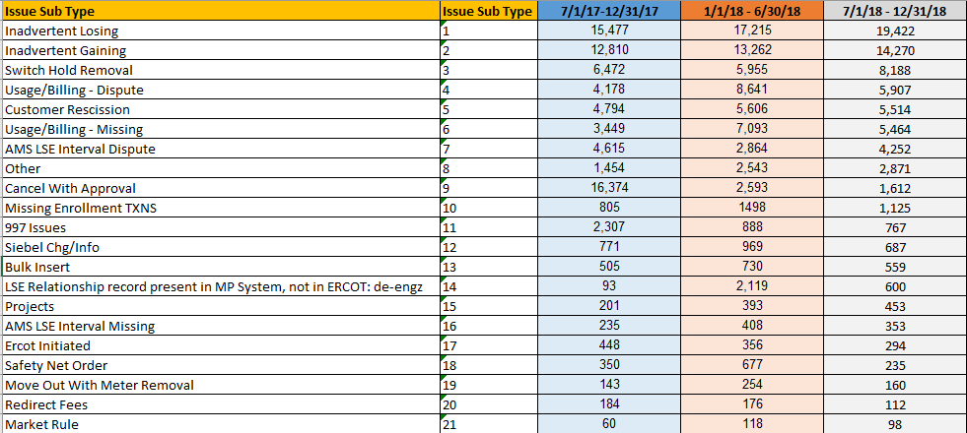

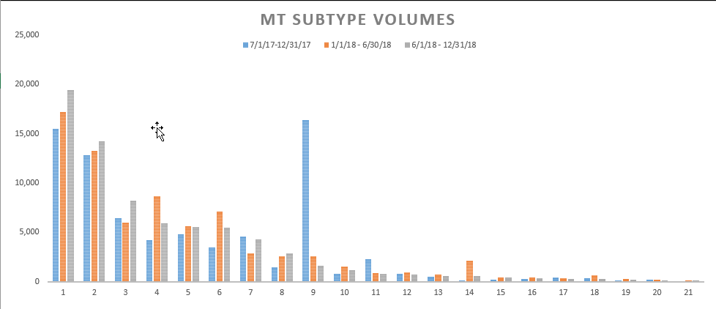

- Usage and Billing Discussion
  - Working group reviewed MT columns needed to create a U&B-Dispute report:
Usage and Billing - Dispute
Report 1 Purpose: Average days open per TDSP
Report 2 Purpose: Number of UNEX per REP
Report 3 Purpose: Volumes by MP
Data Requirements: Transition Date, Submit Date, (Complete, Pending Complete), TDSP field, and the TRAN TYPE, Transition States, CR, STATUS,
Initial Findings: Approximately 50% of the U&B Disputes were initiated by one MP.
Suggested MT Enhancement: A checkbox or dropdown box that would denote if the dispute resulted in retract rebills. This would give the market a good idea how many valid disputes are being requested.

Next Meeting
- TDTMS WG will next meet at the ERCOT MetCenter on June 20th.
- The next MT Subtype to be reviewed by the working group will be Switch Holds.

Action Items | Due Date
TDTMS leadership review MT enhancement log prior to next meeting | 6/20/2019

