

April 2019 ERCOT Monthly Operations Report

Reliability and Operations Subcommittee Meeting

June 6, 2019

Table of Contents

1. Report Highlights 3

2. Frequency Control 4

2.1. Frequency Events 4

2.2. Responsive Reserve Events 5

2.3. Load Resource Events 5

3. Reliability Unit Commitment 5

4. Wind Generation as a Percent of Load 6

5. Largest Net-Load Ramp 6

6. COP Error Analysis 7

7. Congestion Analysis 9

7.1. Notable Constraints 9

7.2. Generic Transmission Constraint Congestion 13

7.3. Manual Overrides 13

7.4. Congestion Costs for Calendar Year 2019 14

8. System Events 15

8.1. ERCOT Peak Load 15

8.2. Load Shed Events 15

8.3. Stability Events 15

8.4. Notable PMU Events 15

8.5. DC Tie Curtailment 16

8.6. TRE/DOE Reportable Events 16

8.7. New/Updated Constraint Management Plans 16

8.8. New/Modified/Removed RAS 16

8.9. New Procedures/Forms/Operating Bulletins 16

9. Emergency Conditions 16

9.1. OCNs 16

9.2. Advisories 16

9.3. Watches 16

9.4. Emergency Notices 17

10. Application Performance 17

10.1. TSAT/VSAT Performance Issues 17

10.2. Communication Issues 17

10.3. Market System Issues 17

11. Model Updates 17

Appendix A: Real-Time Constraints 20

# 

# Report Highlights

* The unofficial ERCOT peak for April was 51,635 MW.
* There were seven frequency events in April.
* There was six instances where Responsive Reserves were deployed.
* There were three RUC commitments in April.
* Congestion in the North Load Zone (LZ) and West LZ can be mostly attributed to outages and high Panhandle wind generation. Congestion in the South LZ was due to planned outages and high wind generation. Congestion in the Houston area was minimal. There were 26 days on the Panhandle GTC and 3 days on the North Edinburg – Lobo GTC in April.
* There were two DC Tie curtailments in April.

# Frequency Control

## Frequency Events

The ERCOT Interconnection experienced three frequency events in April, all of which resulted from a Resource trip. The average event duration was approximately 0:04:40.

A summary of the frequency events is provided below. The reported frequency events meet one of the following criteria: Delta Frequency is 60 mHz or greater; the MW loss is 350 MW or greater; resource trip event triggered RRS deployment. Frequency events that have been identified as Frequency Measurable Events (FME) for purposes of BAL-001-TRE-1 analysis are highlighted in blue. When analyzing frequency events, ERCOT evaluates PMU data according to industry standards. Events with an oscillating frequency of less than 1 Hz are considered to be inter-area, while higher frequencies indicate local events. Industry standards specify that damping ratio for inter-area oscillations should be 3.0% or greater. For the frequency events listed below, the ERCOT system met these standards and transitioned well after each disturbance.

|  |  |  |  |  |  |  |  |  |  |  |
| --- | --- | --- | --- | --- | --- | --- | --- | --- | --- | --- |
| **Date and Time** | **Delta Frequency** | **Max/Min Frequency** | **Duration of Event[1]** | **PMU Data[2]** | | | **MW Loss** | **Load** | **Wind** | **Inertia** |
| **(Hz)[3]** | **(Hz)** | **Oscillation Mode (Hz)** | | **Damping Ratio** | **(MW)** | **%** | **(GW-s)[4]** |
| 4/11/2019 3:37 | 0.170 | 59.814 | 0:05:48 | 0.80 | 8% | | 664.037 | 30,874 | 44% | 157,521 |
| 4/18/2019 17:04 | 0.145 | 59.856 | 0:04:56 | 0.76 | 16% | | 897.549 | 40,069 | 41% | 205,973 |
| 4/19/2019 8:00 | 0.080 | 59.893 | 0:04:42 | None | None | | 340.77 | 33,029 | 25% | 201,495 |
| 4/21/2019 15:30 | 0.117 | 59.898 | 0:06:21 | None | None | | 423.214 | 40,226 | 32% | 174,778 |
| 4/25/2019 11:20 | 0.104 | 59.857 | 0:02:53 | None | None | | 554.64 | 39,151 | 7% | 250,067 |
| 4/30/2019 9:37 | 0.121 | 59.866 | 0:04:11 | 0.76 | 9% | | 576.024 | 42,609 | 21% | 232,039 |
| 4/30/2019 21:11 | 0.116 | 59.870 | 0:03:49 | 0.68 | 10% | | 595 | 46,473 | 21% | 250,837 |

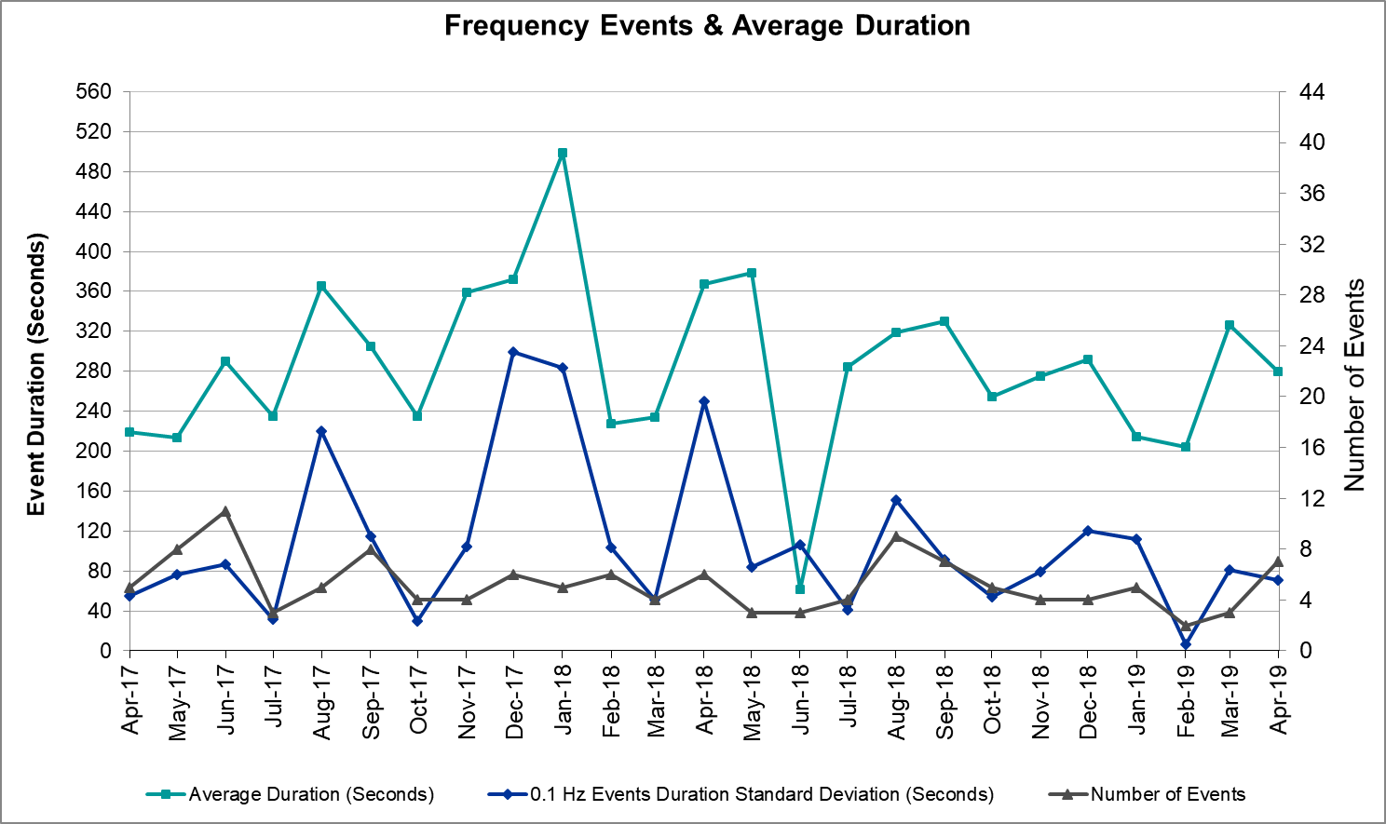

(Note: All data on this graph encompasses frequency event analysis based on BAL-001-TRE-1.)

## Responsive Reserve Events

There were six events where Responsive Reserve MWs were released to SCED in April. The events highlighted in blue were related to frequency events reported in Section 2.1 above.

|  |  |  |  |  |
| --- | --- | --- | --- | --- |
| **Date and Time Released to SCED** | **Date and Time Recalled** | **Duration of Event** | **Maximum MWs Released** | **Comments** |
| 4/11/2019 3:38 | 4/11/2019 3:42 | 00:04:48 | 1034 |  |
| 4/18/2019 17:04 | 4/18/2019 17:09 | 00:04:24 | 775 |  |
| 4/19/2019 8:01 | 4/19/2019 8:05 | 00:04:36 | 638 |  |
| 4/25/2019 11:20 | 4/25/2019 11:23 | 00:03:04 | 1011 |  |
| 4/30/2019 9:37 | 4/30/2019 9:40 | 00:03:36 | 741 |  |
| 4/30/2019 21:11 | 4/30/2019 21:15 | 00:03:19 | 715 |  |

## Load Resource Events

None.

# Reliability Unit Commitment

ERCOT reports on Reliability Unit Commitments (RUC) on a monthly basis. Commitments are reported grouped by operating day and weather zone. The total number of hours committed is the sum of the hours for all the units in the specified region. Additional information on RUC commitments can be found on the MIS secure site at Grid 🡪 Generation 🡪 Reliability Unit Commitment.

There were no DRUC commitments in April.

There were three HRUC commitments in April.

|  |  |  |  |  |  |
| --- | --- | --- | --- | --- | --- |
| **Resource Location** | **# of Resources** | **Operating Day** | **Total # of Hours Committed** | **Total MWhs** | **Reason for Commitment** |
| Southern | 1 | 4/2/2019 | 6 | 1,486 | Congestion |
| North Central | 1 | 4/10/2019 | 8 | 944 | Congestion |
| North Central | 1 | 4/11/2019 | 8 | 944 | Congestion |

# Wind Generation as a Percent of Load



Wind Generation Record: 19,672 MW on 01/21/2019 at 19:19

Wind Penetration Record: 56.16% on 01/19/2019 03:10

# Largest Net-Load Ramp

The net-load ramp is defined as the change in net-load (load minus wind and PVGR generation) during the defined time horizon. Such a variation in net-load needs to be accommodated in grid operations to ensure that the reliability of the grid is satisfactorily maintained. The largest net-load ramp during 5-min, 10-min, 15-min, 30-min and 60-min in April 2019 is 1,123 MW, 1,668 MW, 1,884 MW, 2,873 MW, and 4,868 MW, respectively. The comparison with respect to the historical values is given in the table below.

|  |  |  |  |  |  |
| --- | --- | --- | --- | --- | --- |
| **Month and Year** | **5 min** | **10 min** | **15 min** | **30 min** | **60 min** |
| April 2019 | 1123 MW | 1668 MW | 1884 MW | 2873 MW | 4868 MW |
| April 2014 | 796 MW | 1358 MW | 1868 MW | 3445 MW | 6274 MW |
| April 2015 | 835 MW | 1482 MW | 1985 MW | 3216 MW | 5330 MW |
| April 2016 | 1183 MW | 1666 MW | 2394 MW | 3804 MW | 5101 MW |
| April 2017 | 914 MW | 1492 MW | 2315 MW | 3779 MW | 6385 MW |
| April 2018 | 915 MW | 1360 MW | 1697 MW | 3278 MW | 5034 MW |
| 2014-2018 | 1494 MW | 1991 MW | 2780 MW | 4109 MW | 7218 MW |

# COP Error Analysis

COP Error is calculated as the capacity difference between the COP HSL and real-time HSL of the unit. Mean Absolute Error (MAE) stayed high over 6,000 MW until Day-Ahead at 12:00, then dropped significantly to 2,061 MW by Day-Ahead at 14:00. In the following chart, Under-Scheduling Error indicates that COP had less generation capacity than real-time and Over-Scheduling Error indicates that COP had more generation capacity than real-time. Under-Scheduling persisted from beginning of Day-Ahead to end of the Operating Day. Snapshot on the Operating Day considers all Operating Hours, including past hours. However, COP error for the Operating Hour freezes after the Adjustment Period.

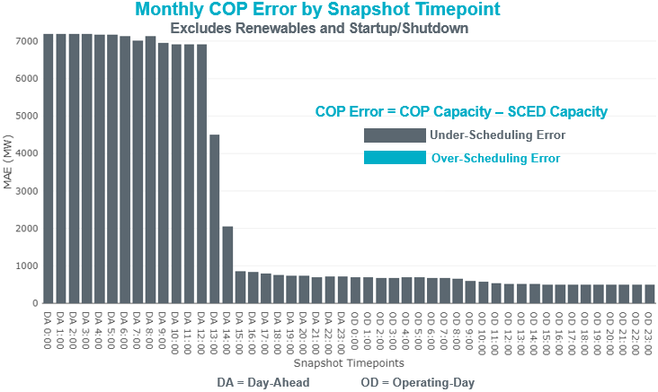

Monthly MAE for the Latest COP at the end of the Adjustment Period was 495 MW with median ranging from -456 MW for Hour-Ending (HE) 21 to -142 MW for HE 7. April 16th HE 7 had the largest Over-Scheduling Error (2,002 MW) and April 1st HE 1 had the largest Under-Scheduling Error (-2,735 MW).

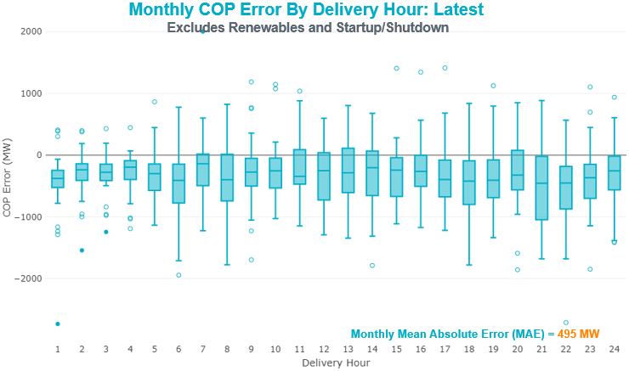

Monthly MAE for the Day-Ahead COP at 12:00 was 6,919 MW with median ranging from -10,500 MW for Hour-Ending (HE) 18 to -3,607 MW for HE 4. April 21st HE 7 had the largest Over-Scheduling Error (1,771 MW) and April 1st HE 8 had the largest Under-Scheduling Error (-15,922 MW).

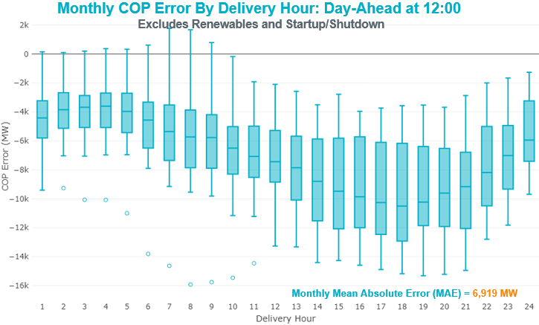

# Congestion Analysis

The total number of congestion events experienced by the ERCOT system increased in April. There were 29 instances over 26 days on the Generic Transmission Constraints (GTCs) in April.

## Notable Constraints

Nodal protocol section 3.20 specifies that ERCOT shall identify transmission constraints that are active or binding three or more times within a calendar month. As part of this process, ERCOT reports congestion that meets this criterion to ROS. In addition ERCOT also highlights notable constraints that have an estimated congestion rent exceeding $1,000,000 for a calendar month. These constraints are detailed in the table below. Rows highlighted in blue indicate the congestion was affected by one or more outages. For a list of all constraints activated in SCED for the month of April, please see Appendix A at the end of this report.

|  |  |  |  |  |
| --- | --- | --- | --- | --- |
| **Contingency Name** | **Overloaded Element** | **# of Days Constraint Active** | **Congestion Rent** | **Transmission Project** |
| Hcksw-Sagna-138kv | Eagle Mountain Ses - Eagle Mountain Compressor 138kV | 4 | $9,797,393.10 | Eagle Mountain-Calmont 138 kV Line (4253) |
| CRLNW-LWSSW 345kV | Ti Tnp - West Tnp 138kV | 4 | $6,535,510.45 |  |
| Basecase | PNHNDL GTC | 26 | $6,403,433.76 | LP&L Integration Tie Lines (43367 A,B,C) and Panhandle Loop |
| DCRMOD28 Odesa-Mdssw&Odehv 138 kV | Big Three Odessa Tap - Odessa Ehv Switch 138kV | 3 | $4,495,201.57 |  |
| Hlj-Wap&Bly 345kV | Dow Chemical - South Texas Project 345kV | 1 | $3,766,119.26 |  |
| Hecker_White_Pt 138kv | Whitepoint - Rincon 138kV | 2 | $3,673,251.55 |  |
| Basecase | Omega - Horse Hollow Generation Tie 345kV | 22 | $3,631,837.00 |  |
| Cagnon-Kendal 345 & Cico-Comfor 138 | Raymond F Barker - Comfort 138kV | 12 | $3,452,640.93 | Boerne Cico - Comfort - Kendall Transmission Line Upgrade (6982) |
| ODLAW SWITCHYARD to ASPHALT MINES LIN 1 | Hamilton Road - Maverick 138kV | 23 | $3,416,214.96 | Brackettville to Escondido: Construct 138 kV line (5206) |
| SAN MIGUEL 345_138 KV SWITCHYARDS to LOBO LIN 1 | North Laredo Switch - Piloncillo 138kV | 14 | $3,230,565.77 |  |
| CRLNW-LWSSW 345kV | Carrollton Northwest - Lakepointe Tnp 138kV | 3 | $2,935,446.99 | Northwest Carrollton - LakePointe TNP 138 kV Line (5548) |
| WHITEPOINT TRX 345A 345/138 | Lon Hill 345/1kV | 7 | $2,897,662.47 | Lon Hill: Replace 345/138 kV autotransformers (6106) |
| Solstice to FORT STOCKTON PLANT LIN 1 | Barrilla - Fort Stockton Switch 69kV | 6 | $2,762,835.00 | "Solstice: Build 345 kV station (5530) and Solstice to Bakersfield: Build 345 kV line (5539) |
| NORTH EDINBURG TRX 1382 345/138 | Haine Drive - La Palma 138kV | 1 | $2,698,811.46 | Pecos County Modification Project (7028, 44359)" |
| TWR (345) WHITE_PT-LON_HILL & STP | Lon Hill 345/1kV | 2 | $2,498,449.36 |  |
| Saldo-Klnsw 345kV | Killeen Switch 345/1kV | 10 | $2,404,921.82 | Lon Hill: Replace 345/138 kV autotransformers (6106) |
| NORTH EDINBURG TRX 1382 345/138 | Burns Sub - Rio Hondo 138kV | 9 | $1,819,352.61 |  |
| LEWISVILLE SWITCH to CORINTH SOUTH SWITCH LIN 1 | Argyle - Highlands Tnp 138kV | 7 | $1,612,365.11 |  |
| CRLNW-LWSSW 345kV | Jones Street Tnp - Lakepointe Tnp 138kV | 1 | $1,506,474.76 | Highlands TNP (1974) - Argyle (1984) 138-kV line upgrade (2017-NC 17) |
| PH ROBINSON to MEADOW LIN A | Mainland Tnp - Alvin Tnp 138kV | 13 | $1,296,579.38 | Lewisville - Lewisville Jones - Lakepointe 138 kV Line (45537) |
| Manual SOLSTICE to FTST 138kV | Barrilla - Fort Stockton Switch 69kV | 17 | $1,285,244.11 |  |
| Manual LOTEBUSH toYUCSW 138 kV | 16th Street Tnp - Woodward 2 138kV | 3 | $1,138,942.36 | "Solstice: Build 345 kV station (5530) and Solstice to Bakersfield: Build 345 kV line (5539) |
| Cagnon-Calavers&Braunig 345kV | Skyline - Calaveras 345kV | 4 | $1,040,076.88 | Pecos County Modification Project (7028, 44359)" |
| AJO to NELSON SHARPE LIN 1 | Burns Sub - Rio Hondo 138kV | 3 | $980,856.90 | Solstice: Build 345 kV station (5530) and Solstice to Bakersfield: Build 345 kV line (5539) |
| Basecase | Burns Sub - Heidelburg Sub 138kV | 6 | $860,432.81 | Skyline - Install a Fourth 345kV Autotransformer(3298) |
| COLETO CREEK to PAWNEE SWITCHING STATION LIN 1 | Coleto Creek - Rosata Tap 138kV | 8 | $776,126.44 |  |
| Scurry County South Switch TRX SCOSW_AT1 345/138 | Knapp - Scurry Chevron 138kV | 3 | $701,220.10 |  |
| DMTSW-SCOSW 345KV | Knapp - Scurry Chevron 138kV | 8 | $665,715.71 |  |
| Vensw-Evrsw 345kV | Fish Creek Switch - Cedar Hill Switch 138kV | 5 | $632,598.52 | Ennis Creek - Cogdell 69 kV Line (4554) & Ennis Creek 138 kV Switching Station (6269) |
| Lampas-Burnet&Corona 138kV | Starcke - Wirtz 138kV | 9 | $539,076.30 | Ennis Creek - Cogdell 69 kV Line (4554) & Ennis Creek 138 kV Switching Station (6269) |
| Riohondo-Nedin 345kV&Harlnsw 138kV | Burns Sub - Rio Hondo 138kV | 7 | $517,320.92 |  |
| LAQUINTA to LOBO LIN 1 | Bruni Sub 138/69kV | 13 | $431,578.89 |  |
| Fppyd2-Lytton_S & Holman 345kV | Gay Hill - Max Zuehlke 138kV | 4 | $423,988.19 |  |
| Fergus-Granmo&Wirtz-Starck 138kV | Flat Rock Lcra - Wirtz 138kV | 5 | $415,433.29 | Holland 69 kV Capacitors (5805) |
| Pig Creek to Solstice LIN 1 | Airport Tnp - 16th Street Tnp 138kV | 15 | $340,074.69 |  |
| BIG SPRING SWITCH to CHALK_69kV and McDonald Road_138kV | Lamesa - Jim Payne Poi 138kV | 5 | $317,384.73 | Wirtz to FlatRock to Paleface Transmission Line Upgrade (4465) |
| Fppyd2-Lytton_S & Holman 345kV | Fayetteville - Winchester 138kV | 4 | $293,469.41 | Solstice: Build 345 kV station (5530) and Solstice to Bakersfield: Build 345 kV line (5539) |
| Pig Creek to Solstice LIN 1 | General Tire Switch - Southwestern Portland Tap 138kV | 5 | $264,936.05 |  |
| Berghe-Kendal 345kv & Welfar-Boerne 138kv | Kendall - Cagnon 345kV | 4 | $232,304.93 | Upgrade the 138-kV Fayetteville - Winchester transmission line supporting circuit T165 to single 1433 ACSS/TW conductor and OPGW static. The planned T165 circuit rating is (MVA): Rate A=470, Rate B=470, Rate C=470. (6983) |
| COPPERAS COVE LCRA to KEMPNER LIN 1 | Starcke - Wirtz 138kV | 3 | $204,921.97 | Wolf - General Tire 138 kV Series Reactor (7100) |
| SANDY CREEK SWITCHYARD to PITSBURG LIN 1 | Starcke - Wirtz 138kV | 4 | $192,127.29 | Boerne Cico - Comfort - Kendall Transmission Line Upgrade (6982) |
| Pig Creek to Solstice LIN 1 | Woodward 2 - Rio Pecos 138kV | 17 | $174,566.31 |  |
| KLEBERG AEP to LOYOLA SUB LIN 1 | Loyola Sub 138/69kV | 7 | $164,367.62 |  |
| FORT MASON to YELLOW JACKET LIN 1 | Mason Aep - Fredricksburg Phillips Tap 69kV | 14 | $137,900.55 | Solstice: Build 345 kV station (5530) and Solstice to Bakersfield: Build 345 kV line (5539) |
| Pig Creek to Solstice LIN 1 | Fort Stockton Plant - Airport Tnp 138kV | 3 | $136,076.17 |  |
| BRACKETTVILLE to HAMILTON ROAD LIN 1 | Hamilton Road - Maverick 138kV | 16 | $133,977.17 | "Yellowjckt to Menard Phillips T 69 kV line: Rebld 69 kV line (6345) |
| ODLAW SWITCHYARD to ASPHALT MINES LIN 1 | Escondido - Ganso 138kV | 10 | $123,793.03 | Mason to Fort Mason: Rebuild 69 kV line (5794) - 138 kV conversion" |
| ODLAW SWITCHYARD to ASPHALT MINES LIN 1 | Maxwell - Whiting 138kV | 4 | $116,283.91 |  |
| Solstice to ALAMITO CREEK LIN 1 | Airport Tnp - 16th Street Tnp 138kV | 3 | $110,467.80 | Brackettville to Escondido: Construct 138 kV line (5206) |
| Bighil-Kendal 345kV | Yellow Jacket - Fort Mason 138kV | 9 | $108,740.20 | Eagle Pass to Escondido: Rebuild 138kV line (4489) |
| SAN ANGELO RED CREEK to SAN ANGELO BEN FICKLIN LIN 1 | San Angelo Power Station 138/69kV | 4 | $100,898.54 | Brackettville to Escondido: Construct 138 kV line (5206) |
| FERGUSON to SANDY CREEK SWITCHYARD LIN 1 | Ctec Buchanan - Kingsland 2 69kV | 3 | $100,256.83 | Solstice: Build 345 kV station (5530) and Solstice to Bakersfield: Build 345 kV line (5539) |
| VICTORIA TRX 69A1 138/69 | Magruder - Victoria 138kV | 4 | $99,966.19 | "Yellowjckt to Menard Phillips T 69 kV line: Rebld 69 kV line (6345) |
| FRIEND RANCH to SONORA LIN 1 | Hamilton Road - Maxwell 138kV | 5 | $95,187.38 | Mason to Fort Mason: Rebuild 69 kV line (5794) - 138 kV conversion" |
| Solstice to LINTERNA LIN 1 | Barrilla - Fort Stockton Switch 69kV | 5 | $81,428.45 |  |
| Solstice to ALAMITO CREEK LIN 1 | Fort Stockton Plant - Airport Tnp 138kV | 5 | $59,526.17 |  |
| Solstice to ALAMITO CREEK LIN 1 | Woodward 2 - Rio Pecos 138kV | 7 | $56,904.38 |  |
| BOSQUE SWITCH to ELM MOTT LIN 1 | Bosque Switch - Rogers Hill Bepc 138kV | 5 | $50,465.88 | Brackettville to Escondido: Construct 138 kV line (5206) |
| RILEY-BOMSW 345KV | Bomarton (Oncor) - Seymour (Oncor) 69kV | 3 | $47,808.48 | "Solstice: Build 345 kV station (5530) and Solstice to Bakersfield: Build 345 kV line (5539) |
| Berghe-Kendal 345kv & Welfar 138kv | Kendall - Cagnon 345kV | 6 | $40,400.99 | Pecos County Modification Project (7028, 44359)" |
| Basecase | Rio Hondo - East Rio Hondo Sub 138kV | 3 | $35,151.57 |  |
| Bighil-Kendal 345kV | Yellow Jacket - Treadwell 138kV | 6 | $34,243.03 | Solstice: Build 345 kV station (5530) and Solstice to Bakersfield: Build 345 kV line (5539) |
| BRITTON ROAD to VENUS SWITCH LIN _C | Fish Creek Switch - Cedar Hill Switch 138kV | 4 | $32,542.04 |  |
| Basecase | Randado Aep - Zapata 138kV | 12 | $30,275.89 |  |
| COMANCHE SWITCH (Oncor) to COMANCHE PEAK SES LIN _A | Comanche Tap - Comanche Switch (Oncor) 138kV | 4 | $26,334.46 | Boerne Cico - Comfort - Kendall Transmission Line Upgrade (6982) |
| YELLOW JACKET TRX PS_1 138/138 | San Angelo Power Station 138/69kV | 3 | $21,833.58 |  |
| WICHITA FALLS SOUTH SWITCH to NEWPORT BEPC LIN _E | Bowie 138/69kV | 4 | $12,146.24 |  |
| Marbfa-Lakewy &Wirtz-Palefa 138kV | Flat Rock Lcra - Wirtz 138kV | 5 | $11,270.40 |  |
| ASPERMONT AEP to SPUR LIN 1 | Girard Tap - Spur 69kV | 4 | $9,417.76 | Zapata Reactor (44393) |
| Basecase | NE_LOB GTC | 3 | $7,638.27 |  |
| ZORN - HAYSEN 345KV | Kendall - Cagnon 345kV | 3 | $6,220.02 | San Angelo Power Station (6480) – Schkade (76320) 138-kV line terminal equipment upgrade |
| LOFTIN to COTTONWOOD ROAD SWITCH LIN 1 | Bowie 138/69kV | 7 | $5,936.99 |  |

## Generic Transmission Constraint Congestion

There were 26 days on the Panhandle GTC and 3 days on the North Edinburg – Lobo GTC in April. There was no activity on the remaining GTCs during the month.

Note: This is how many times a constraint has been activated to avoid exceeding a GTC limit, it does not imply an exceedance of the GTC occurred or that the GTC was binding.

## Manual Overrides

None.

## Congestion Costs for Calendar Year 2019

The following table represents the top twenty active constraints for the calendar year based on the estimated congestion rent attributed to the congestion. ERCOT updates this list on a monthly basis.

|  |  |  |  |  |
| --- | --- | --- | --- | --- |
| **Contingency** | **Binding Element** | **# of 5-min SCED Intervals** | **Estimated Congestion Rent** | **Transmission Project** |
| Elmcreek-Skyline 345kV | Hill Country - Marion 345kV | 961 | $26,958,430.36 | Zorn to Marion 2nd 345-kV Transmission Line Addition (4473) |
| CRLNW-LWSSW 345kV | Ti Tnp - West Tnp 138kV | 2,496 | $18,908,859.77 |  |
| Manual LOTEBUSH toYUCSW 138 kV | 16th Street Tnp - Woodward 2 138kV | 4,906 | $14,675,595.13 | Solstice: Build 345 kV station (5530) and Solstice to Bakersfield: Build 345 kV line (5539) |
| Basecase | PNHNDL GTC | 11,661 | $13,650,310.35 | LP&L Integration Tie Lines (43367 A,B,C) and Panhandle Loop |
| Hcksw-Sagna-138kv | Eagle Mountain Ses - Eagle Mountain Compressor 138kV | 650 | $9,797,393.10 | Eagle Mountain-Calmont 138 kV Line (4253) |
| DMTSW-SCOSW 345KV | Knapp - Scurry Chevron 138kV | 3,203 | $9,750,942.24 | Ennis Creek - Cogdell 69 kV Line (4554) & Ennis Creek 138 kV Switching Station (6269) |
| CAGNON to KENDALL LIN 1 | Cico - Comfort 138kV | 3,052 | $9,726,100.36 | Boerne Cico - Comfort - Kendall Transmission Line Upgrade (6982) |
| Solstice to LINTERNA LIN 1 | Barrilla - Fort Stockton Switch 69kV | 14,077 | $9,251,017.29 | Solstice: Build 345 kV station (5530) and Solstice to Bakersfield: Build 345 kV line (5539) Pecos County Modification Project (7028, 44359) |
| CRLNW-LWSSW 345kV | Carrollton Northwest - Lakepointe Tnp 138kV | 1,344 | $9,028,752.71 | Northwest Carrollton - LakePointe TNP 138 kV Line (5548) |
| SAN MIGUEL 345_138 KV SWITCHYARDS to LOBO LIN 1 | North Laredo Switch - Piloncillo 138kV | 4,444 | $8,390,480.88 |  |
| CRLNW-LWSSW 345kV | Jones Street Tnp - Lakepointe Tnp 138kV | 1,092 | $7,964,100.80 | Lewisville - Lewisville Jones - Lakepointe 138 kV Line (45537) |
| CPSES-JONSW&EVRSW 345kV | Hood - Decordova Dam 138kV | 172 | $7,948,529.13 |  |
| Solstice to FORT STOCKTON PLANT LIN 1 | Barrilla - Fort Stockton Switch 69kV | 4,050 | $7,942,539.46 | Solstice: Build 345 kV station (5530) and Solstice to Bakersfield: Build 345 kV line (5539) Pecos County Modification Project (7028, 44359) |
| WHITEPOINT TRX 345A 345/138 | Lon Hill 345/1kV | 847 | $7,109,227.27 | Lon Hill: Replace 345/138 kV autotransformers (6106) |
| DCRMOD28 Odesa-Mdssw&Odehv 138 kV | Big Three Odessa Tap - Odessa Ehv Switch 138kV | 725 | $6,842,223.72 |  |
| WHITEPOINT TRX 345A 345/138 | Lon Hill 345/1kV | 744 | $6,251,701.79 | Lon Hill: Replace 345/138 kV autotransformers (6106) |
| Basecase | Omega - Horse Hollow Generation Tie 345kV | 3,456 | $5,976,742.26 |  |
| NORTH EDINBURG TRX 1382 345/138 | North Edinburg 345/1kV | 328 | $5,776,017.31 | Stewart Road: Construct 345 kV cut-in (5604) |
| ODLAW SWITCHYARD to ASPHALT MINES LIN 1 | Hamilton Road - Maverick 138kV | 6,247 | $5,262,655.01 | Brackettville to Escondido: Construct 138 kV line (5206) |
| Saldo-Klnsw 345kV | Killeen Switch 345/1kV | 1,791 | $5,161,503.72 |  |

# System Events

## ERCOT Peak Load

The unofficial ERCOT peak load[5] for the month was 51,635 MW and occurred on April 10th, during hour ending 10:00.

## Load Shed Events

None.

## Stability Events

None.

## Notable PMU Events

ERCOT analyzes PMU data for any significant system disturbances that do not fall into the Frequency Events category reported in section 2.1. The results are summarized in this section once the analysis has been completed.

None.

## DC Tie Curtailment

|  |  |  |  |  |  |
| --- | --- | --- | --- | --- | --- |
| **Date** | **DC Tie** | **Curtailing Period** | **# of Tags Curtailed** | **Initiating Event** | **Curtailment Reason[6][7]** |
| 04/08/2019 | DC-R | HE15 | 1 | XNED258, loss of N Edinburg 345/138 kV transformer overloads RIOHONDO – MV_BURNS 138kV | Local Congestion |
| 04/09/2019 | DC-R | HE21-22 | 5 | XNED258, loss of N Edinburg 345/138 kV transformer overloads RIOHONDO – MV_BURNS 138kV | Local Congestion |

## TRE/DOE Reportable Events

* Calpine submitted an EOP-004 report for April 18, 2019 Reportable Event Type: Physical Threat to a Facility.
* Calpine submitted an EOP-004 report for April 22, 2019 Reportable Event Type: Physical Threat to a Facility.

## New/Updated Constraint Management Plans

None.

## New/Modified/Removed RAS

None.

## New Procedures/Forms/Operating Bulletins

None.

# Emergency Conditions

## OCNs

None.

## Advisories

|  |  |
| --- | --- |
| **Date and Time** | **Description** |
| 04/04/2019 13:31 | ERCOT issued an advisory for DAM timeline postponement for OD 04/05/2019. |

## Watches

None.

## Emergency Notices

None.

# Application Performance

## TSAT/VSAT Performance Issues

None.

## Communication Issues

None.

## Market System Issues

None.

# Model Updates

The Downstream Production Change (DPC) process allows ERCOT to make changes in the on-line Network Operations Model without loading a completely new model. The purpose of this process is to allow for reliable grid operations as system conditions change between designated Network Operations Model database loads. The DPC process is limited in scope to just those items listed below, with equipment ratings updates being the most common. ERCOT has seen a rise in the use of the DPC process to make on-line updates to the Network Operations Model in recent years, instead of through the standard Network Operations Model Change Request process.

* Static Line ratings (Interim Update)
* Dynamic Line ratings (non-Interim Update)
* Autotransformer ratings (non-Interim Update)
* Breaker and Switch Normal status (Interim Update)
* Contingency Definitions (Interim Update)
* RAP and RAS changes or additions (Interim Update)
* Net Dependable and Reactive Capability (NDCRC) values (Interim Update)
* Impedance Updates (non-Interim)

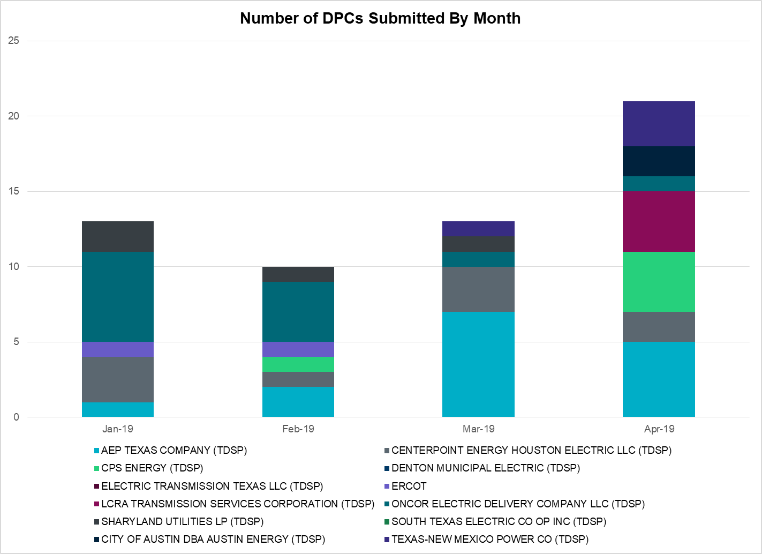

|  |  |
| --- | --- |
| **Transmission Operator** | **Number of DPCs in April** |
| AEP TEXAS COMPANY (TDSP) | 5 |
| BRAZOS ELECTRIC POWER CO OP INC (TDSP) | 0 |
| CENTERPOINT ENERGY HOUSTON ELECTRIC LLC (TDSP) | 2 |
|  | 2 |
| CPS ENERGY (TDSP) | 4 |
| DENTON MUNICIPAL ELECTRIC (TDSP) | 0 |
| ELECTRIC TRANSMISSION TEXAS LLC (TDSP) | 0 |
| ERCOT | 0 |
| LCRA TRANSMISSION SERVICES CORPORATION (TDSP) | 4 |
| ONCOR ELECTRIC DELIVERY COMPANY LLC (TDSP) | 1 |
| SHARYLAND UTILITIES LP (TDSP) | 0 |
| SOUTH TEXAS ELECTRIC CO OP INC (TDSP) | 0 |
| TEXAS MUNICIPAL POWER AGENCY (TDSP) | 0 |
| TEXAS-NEW MEXICO POWER CO (TDSP) | 3 |

# Appendix A: Real-Time Constraints

The following is a complete list of constraints activated in SCED for the month of April. Full contingency descriptions can be found in the Standard Contingencies List located on the MIS secure site at Grid 🡪 Generation 🡪 Reliability Unit Commitment.

|  |  |  |  |  |
| --- | --- | --- | --- | --- |
| **Contingency** | **Constrained Element** | **From Station** | **To Station** | **# of Days Constraint Active** |
| BASE CASE | PNHNDL | n/a | n/a | 26 |
| SBRAUVA8 | HAMILT_MAVERI1_1 | HAMILTON | MAVERICK | 23 |
| BASE CASE | HHGTOM_1 | HHGT | OMEGA | 22 |
| SPIGSOL8 | RIOPEC_WOODW21_1 | WOODWRD2 | RIOPECOS | 17 |
| MSOLFTS8 | BARL_FTSW1_1 | FTSW | BARL | 17 |
| SBRAHAM8 | HAMILT_MAVERI1_1 | HAMILTON | MAVERICK | 16 |
| SPIGSOL8 | TNAF_TNFS_1 | TNAF | 16TH_ST | 15 |
| SFORYEL8 | FRPHIL_MASN1_1 | MASN | FRPHILLT | 14 |
| SLOBSA25 | NLARSW_PILONC1_1 | NLARSW | PILONCIL | 14 |
| SLAQLOB8 | BRUNI_69_1 | BRUNI | BRUNI | 13 |
| SMDOPHR5 | 138_ALV_MNL_1 | ALVIN | MAINLAND | 13 |
| DCAGCO58 | 122T122_1 | COMFOR | RAYBAR | 12 |
| BASE CASE | RANDAD_ZAPATA1_1 | ZAPATA | RANDADO | 12 |
| BASE CASE | RANDAD_ZAPATA1_1 | RANDADO | ZAPATA | 12 |
| DSALKLN5 | KLNSW_MR1H | KLNSW | KLNSW | 10 |
| SBRAUVA8 | ESCOND_GANSO1_1 | GANSO | ESCONDID | 10 |
| DBIGKEN5 | FORTMA_YELWJC1_1 | YELWJCKT | FORTMA | 9 |
| XNED258 | BURNS_RIOHONDO_1 | RIOHONDO | MV_BURNS | 9 |
| DLAMCOR8 | 654T654_1 | WIRTZ | STARCK | 9 |
| SCOLPAW5 | COLETO_ROSATA1_1 | COLETO | ROSATA | 8 |
| SCTHHA38 | HAMILT_MAXWEL1_1 | MAXWELL | HAMILTON | 8 |
| DMTSCOS5 | 6437__F | SCRCV | KNAPP | 8 |
| SKLELOY8 | LOYOLA_69_1 | LOYOLA | LOYOLA | 7 |
| SCRDLOF9 | BOW_FMR1 | BOW | BOW | 7 |
| XWHI58 | LON_HILL_382H | LON_HILL | LON_HILL | 7 |
| SCRNLWS8 | 587__A | ARGYL | LWSVH | 7 |
| DRIOHAR5 | BURNS_RIOHONDO_1 | RIOHONDO | MV_BURNS | 7 |
| SALMBA28 | RIOPEC_WOODW21_1 | WOODWRD2 | RIOPECOS | 7 |
| BASE CASE | BURNS_HEIDLBRG_1 | MV_BURNS | MV_HBRG4 | 6 |
| DBIGKEN5 | TREADW_YELWJC1_1 | TREADWEL | YELWJCKT | 6 |
| SSOLFTS8 | BARL_FTSW1_1 | FTSW | BARL | 6 |
| DBERWE58 | 459T459_1 | KENDAL | CAGNON | 6 |
| DVENEVR5 | 3180__A | FCRSW | CDHSW | 5 |
| SBOSELM5 | 1030__B | BOSQUESW | RGH | 5 |
| SWCSBOO8 | BARL_FTSW1_1 | FTSW | BARL | 5 |
| SSONFRI8 | HAMILT_MAXWEL1_1 | MAXWELL | HAMILTON | 5 |
| DFLCMGS5 | 6095__D | LMESA | JPPOI | 5 |
| DFERSTA8 | 38T365_1 | WIRTZ | FLATRO | 5 |
| SPIGSOL8 | 6345__B | GNTSW | SPRTP | 5 |
| DMARPA_8 | 38T365_1 | WIRTZ | FLATRO | 5 |
| SALMBA28 | TNAF_FTS_1 | FTST | TNAF | 5 |
| DCAGBRA5 | N5_P4_2_1 | CALAVERS | SKYLINE | 4 |
| DFPPHOL5 | 367T347_1 | MAXZUE | GAYHIL | 4 |
| DCRLLSW5 | 588_A_1 | LWSVW | LWVTI | 4 |
| SBRAUVA8 | MAXWEL_WHITIN1_1 | MAXWELL | WHITING | 4 |
| SSANPIT8 | 654T654_1 | WIRTZ | STARCK | 4 |
| XVI2C89 | MAGRUD_VICTOR2_1 | VICTORIA | MAGRUDER | 4 |
| SCMNCPS5 | 651__B | CMNSW | CMNTP | 4 |
| SBRTVEN5 | 3180__A | FCRSW | CDHSW | 4 |
| SLKAWFS8 | BOW_FMR1 | BOW | BOW | 4 |
| SSPUASP8 | GIRA_T_SPUR1_1 | SPUR | GIRA_TAP | 4 |
| SSPUASP8 | GIRA_T_SPUR1_1 | GIRA_TAP | SPUR | 4 |
| SBENSAR8 | SAPOWER_69T1 | SAPOWER | SAPOWER | 4 |
| DBERBO58 | 459T459_1 | KENDAL | CAGNON | 4 |
| DFPPHOL5 | 176T165_1 | FAYETT | WINCHE | 4 |
| DHCKSAG8 | 6260__C | EMSES | EMMCP | 4 |
| SSPUASP8 | SPUR_69_1 | SPUR | SPUR | 3 |
| DCRMO228 | 6500__B | ODEHV | BTHOT | 3 |
| DWIRSTA8 | 46T193_1 | FERGUS | SANDCR | 3 |
| BASE CASE | NE_LOB | n/a | n/a | 3 |
| BASE CASE | RIOHND_ERIOHND_1 | MV_RIOHO | RIOHONDO | 3 |
| SSANFER8 | 35T291_1 | CTECBU | KING_2 | 3 |
| SCAGKEN5 | 74T148_1 | COMFOR | CICO | 3 |
| SN_SAJO5 | BURNS_RIOHONDO_1 | RIOHONDO | MV_BURNS | 3 |
| XYEL88 | SAPOWER_69T1 | SAPOWER | SAPOWER | 3 |
| SALMBA28 | TNAF_TNFS_1 | TNAF | 16TH_ST | 3 |
| MLOTYUC8 | 16TH_WRD2_1 | WOODWRD2 | 16TH_ST | 3 |
| DZORHAY5 | 459T459_1 | KENDAL | CAGNON | 3 |
| XSCO158 | 6437__F | SCRCV | KNAPP | 3 |
| SCOPLAM8 | 654T654_1 | WIRTZ | STARCK | 3 |
| DRILBOW5 | 6856__B | BMRTN | SMOUR | 3 |
| DRENCRL5 | 588_A_1 | LWSVW | LWVTI | 3 |
| DCRLLSW5 | 591__A | LKPNT | CRLNW | 3 |
| SPIGSOL8 | TNAF_FTS_1 | FTST | TNAF | 3 |
| DHCKSAG8 | 6265__A | EMSES | MRSDO | 2 |
| SDOWMOO8 | DOWNIES_AX1H | DOWNIES | DOWNIES | 2 |
| SNORODE5 | FTST_SOLSTI1_1 | FTST | SOLSTICE | 2 |
| SBTPBNT8 | MYRA_VAL_1 | MYRA | VALYVIEW | 2 |
| SN_SAJO5 | WESLCO_HIDLBRG_1 | MV_HBRG4 | MV_WESL4 | 2 |
| DMGSMDS5 | 6475__C | ODEHV | TROTP | 2 |
| SILLFTL8 | HAMILT_MAXWEL1_1 | MAXWELL | HAMILTON | 2 |
| DLYTFPP5 | 176T165_1 | FAYETT | WINCHE | 2 |
| SPB2ARY8 | 6345__B | GNTSW | SPRTP | 2 |
| XMDS58 | 6475__C | ODEHV | TROTP | 2 |
| DWH_STP5 | LON_HILL_382H | LON_HILL | LON_HILL | 2 |
| STHRSIG8 | NORMAN_PETTUS1_1 | PETTUS | NORMANNA | 2 |
| DBBSRCH5 | 1210__C | NVARO | HAN1 | 2 |
| DPHRAL58 | 138_ALV_MNL_1 | ALVIN | MAINLAND | 2 |
| DSCOFAR5 | 6437__F | SCRCV | KNAPP | 2 |
| SSCUSU28 | ASPM_CONA1_1 | CONA | ASPM | 2 |
| XNED258 | NEDIN_138L | NEDIN | NEDIN | 2 |
| DHECWHI8 | RINCON_WHITE_2_1 | WHITE_PT | RINCON | 2 |
| DLAMCOR8 | 83T196_1 | STARCK | PALEFA | 2 |
| SSANPIT8 | 83T196_1 | STARCK | PALEFA | 2 |
| SN_SLON5 | BURNS_HEIDLBRG_1 | MV_BURNS | MV_HBRG4 | 2 |
| XHHG58 | HHGT_T2H | HHGT | HHGT | 2 |
| MLOTYUC8 | RIOPEC_WOODW21_1 | RIOPECOS | WOODWRD2 | 2 |
| DCRLLSW5 | 3180__A | FCRSW | CDHSW | 2 |
| SSCUSU28 | ASPM_CONA1_1 | ASPM | CONA | 2 |
| BASE CASE | BURNS_RIOHONDO_1 | RIOHONDO | MV_BURNS | 2 |
| SSOLFTS8 | FTST_69T1 | FTST | FTST | 2 |
| SN_SAJO5 | HAINE__LA_PAL1_1 | LA_PALMA | HAINE_DR | 2 |
| SALAN_28 | LON_HILL_382H | LON_HILL | LON_HILL | 2 |
| SSCLWF28 | NVKSW_FMR1 | NVKSW | NVKSW | 2 |
| DRENCRL5 | CRLNW_MR1H | CRLNW | CRLNW | 2 |
| SBRAUVA8 | GANSO_MAVERI1_1 | MAVERICK | GANSO | 2 |
| DCC1DUKE | NEDIN_1382 | NEDIN | NEDIN | 2 |
| DCDHVEN5 | 3180__A | FCRSW | CDHSW | 2 |
| DFERSTA8 | 32T311_1 | BURNET | BERTRA | 2 |
| DCHBJOR5 | CD_TX_87_A | CD | TX | 2 |
| SW_BW_25 | CRTVLE_EINSTEN_1 | EINSTEIN | CRTRVLLE | 2 |
| DPHRBBP8 | CA_DE_96_A | DE | CA | 2 |
| DHLJBLY5 | DOWSTP27_A | STP | DOW | 1 |
| SRAYRI28 | RAYMND2_69A1 | RAYMND2 | RAYMND2 | 1 |
| SPB2ARY8 | RIOPEC_WOODW21_1 | RIOPECOS | WOODWRD2 | 1 |
| SSONFRI8 | SANTIA_SAPOWE1_1 | SANTIAGO | SAPOWER | 1 |
| DB_DAIR8 | VALADE_WOOLRI3_1 | VALADEZ | WOOLRIDG | 1 |
| SLOLVIC8 | VICTOR_V_DUPS1_1 | VICTORIA | V_DUPSW | 1 |
| SSCLWF28 | 6840__B | NVKSW | ANARN | 1 |
| DLAMCOR8 | 71T124_1 | PHILJC | MILLER | 1 |
| SMGIENW8 | 921__D | ENSSW | TRU | 1 |
| BASE CASE | 940__C | ENWSW | WXHCH | 1 |
| SSOLFTS8 | ALPINE_BRONCO1_1 | BRONCO | ALPINE | 1 |
| DWAPHLJ5 | JCKSTP18_A | STP | JCK | 1 |
| SN_SLON5 | LON_HILL_382L | LON_HILL | LON_HILL | 1 |
| SALMBA28 | RIOPEC_WDWRDT1_1 | WDWRDTP | RIOPECOS | 1 |
| SN_SAJO5 | WES_MV_W_1 | MV_WESL4 | WESLACO | 1 |
| DFORELK5 | 1400__G | LWSNR | BSPTP | 1 |
| DVENLIG5 | 530__C | VENSW | BRTRD | 1 |
| DKRWLWS5 | 584__A | KRMSW | ARGYL | 1 |
| DZORHAY5 | BERGHE_AT1H | BERGHE | BERGHE | 1 |
| DWH_STP5 | BLESSI_LOLITA1_1 | BLESSING | LOLITA | 1 |
| XBOM58 | BOMSW_MR2L | BOMSW | BOMSW | 1 |
| SCALPAI8 | CONA_SHHA1_1 | SHHA | CONA | 1 |
| SSPUASP8 | DKEC_GIRA_T1_1 | GIRA_TAP | DKEC | 1 |
| XLON58 | LON_HILL_382H | LON_HILL | LON_HILL | 1 |
| XLON58 | LON_HILL_382L | LON_HILL | LON_HILL | 1 |
| SOBWAP5 | OB_WAP98_A | WAP | OB | 1 |
| SPAUSAR8 | SAPOWER_69T1 | SAPOWER | SAPOWER | 1 |
| SWOORI38 | TNAF_TNFS_1 | 16TH_ST | TNAF | 1 |
| XPH258 | 138_ALV_MNL_1 | ALVIN | MAINLAND | 1 |
| SPB2ARY8 | 16TH_WRD2_1 | WOODWRD2 | 16TH_ST | 1 |
| SZEPCMN8 | 670__C | CMPBW | BRNSO | 1 |
| DENWSTE8 | 943__A | ENWSW | ENSSW | 1 |
| SASPPAI8 | ASPM_69T1 | ASPM | ASPM | 1 |
| DWH_STP5 | BURNS_RIOHONDO_1 | RIOHONDO | MV_BURNS | 1 |
| DCHB_NB5 | CD_TX_87_A | CD | TX | 1 |
| SMDOOAS5 | CD_TX_87_A | CD | TX | 1 |
| DMLSENT5 | ELKTN_MR3L | ELKTN | ELKTN | 1 |
| SSALTMP5 | KLNSW_MR1L | KLNSW | KLNSW | 1 |
| SWHILON5 | LON_HILL_382H | LON_HILL | LON_HILL | 1 |
| SPAWCAL5 | PAWNEE_XF1 | PAWNEE | PAWNEE | 1 |
| SFORRAY8 | RAYBURN_69_2 | RAYBURN | RAYBURN | 1 |
| DWEBCNT5 | 310__A | LIGSW | NORSW | 1 |
| DGABGEA8 | 469T469_1 | WHITES | BLOCKH | 1 |
| SGRDCD28 | 6200__D | SHRSW | PRKRW | 1 |
| DAUSGAR5 | AUSTRO_AT1L | AUSTRO | AUSTRO | 1 |
| SGIBGRE8 | BRIRCRT_SER_1 | BRIRCRT | BRIRCRT | 1 |
| DMARZOR5 | CLEASP_AT2H | CLEASP | CLEASP | 1 |
| XPAW58 | COLETO_ROSATA1_1 | COLETO | ROSATA | 1 |
| BASE CASE | DOWNIES_AX1H | DOWNIES | DOWNIES | 1 |
| MSOLFTS8 | FTST_69T1 | FTST | FTST | 1 |
| SPIGSOL8 | FTST_TOMBST1_1 | FTST | TOMBSTNE | 1 |
| DVICEDN8 | KAM_PRTL_1 | PRTLAVS | KAMEYS | 1 |
| SLOLBLE8 | KAM_PRTL_1 | PRTLAVS | KAMEYS | 1 |
| UB_2B_D1 | LON_HILL_382H | LON_HILL | LON_HILL | 1 |
| XN_S58 | LON_HILL_382H | LON_HILL | LON_HILL | 1 |
| DELMSAN5 | PAWNEE_SPRUCE_1 | PAWNEE | CALAVERS | 1 |
| DAUSDES8 | 211T147_1 | GILLCR | MCNEIL_ | 1 |
| DLAMCOR8 | 247T124_1 | PALEFA | PHILJC | 1 |
| SWHIBUT8 | 372T359_1 | GABRIE | GLASSC | 1 |
| DSCOFAR5 | 6216__A | SHRNE | BCKSW | 1 |
| SPLDLME8 | 6610__A | BUZSW | CHATP | 1 |
| DWIRSTA8 | 924T214_1 | FORTMA | GILLES | 1 |
| DAUSGAR5 | AUSTRO_AT1H | AUSTRO | AUSTRO | 1 |
| DSTEXP12 | BLESSI_LOLITA1_1 | LOLITA | BLESSING | 1 |
| SI_DI_48 | I_DUPP_I_DUPS2_1 | I_DUPP1 | I_DUPSW | 1 |
| DHLJBLY5 | JCKSTP18_A | STP | JCK | 1 |
| DCHBJOR5 | LANMB_86_A | MB | LAN | 1 |
| DFPPFAY5 | MAGRUD_VICTOR2_1 | VICTORIA | MAGRUDER | 1 |
| BASE CASE | MAXWEL_WHITIN1_1 | MAXWELL | WHITING | 1 |
| SSACRED8 | PAULAN_SANORT1_1 | PAULANN | SANORTH | 1 |
| SCISPUT8 | SOUTHA_VINSON1_1 | SOUTHABI | VINSON | 1 |
| DNORCDH5 | 3180__A | FCRSW | CDHSW | 1 |
| SPLDLME8 | 6135__A | GUNSW | GYVLM | 1 |
| SKLCKL28 | 83T196_1 | STARCK | PALEFA | 1 |
| SENSENW8 | 940__C | ENWSW | WXHCH | 1 |
| SATKDAN8 | BRIRCRT_SER_1 | BRIRCRT | BRIRCRT | 1 |
| SN_SAJO5 | BURNS_HEIDLBRG_1 | MV_BURNS | MV_HBRG4 | 1 |
| SNORODE5 | CASSAV_MERR1_1 | CASSAVA | MERR | 1 |
| SBRAHAM8 | ESCOND_GANSO1_1 | GANSO | ESCONDID | 1 |
| DBCVPSA8 | MTSPSA94_A | PSA | MTS | 1 |
| SPAWSAN5 | SANMIGL_ATBH | SANMIGL | SANMIGL | 1 |
| DBWNTWI5 | SAPOWE_SAST1_1 | SAPOWER | SAST | 1 |
| XBLE58 | SAR_FRAN_1 | FRANKC | SARGNTS | 1 |
| BASE CASE | SWEETWN3_XT2 | SWEETWN3 | SWEETWN3 | 1 |
| SMDOPHR5 | 138_FWP_MNL_1 | MAINLAND | FRWYPARK | 1 |
| SPIGSOL8 | 16TH_WRD2_1 | 16TH_ST | WOODWRD2 | 1 |
| SFLCMDL5 | 6095__D | LMESA | JPPOI | 1 |
| XSH1R58 | 6415__C | HLSES | LKWOD | 1 |
| DDMTGLD8 | 6474__A | SUNSW | MGSES | 1 |
| SKNADM28 | 6474__A | SUNSW | MGSES | 1 |
| DENWSTE8 | 941__C | ENWSW | ENSSO | 1 |
| DAUSSND5 | AUSTRO_AT1H | AUSTRO | AUSTRO | 1 |
| DNB_JOR5 | BCVPSA03_A | PSA | BCV | 1 |
| DAUSDUN8 | CKT_1004_1 | TRIDGE | HWRDLN | 1 |
| DAUSDUN8 | CKT_972_1 | HWRDLN | MCNEIL | 1 |
| SSPUASP8 | DKEC_JATN1_1 | JATN | DKEC | 1 |
| SKINKLE8 | FALFUR_PREMON1_1 | FALFUR | PREMONT | 1 |
| XNED258 | HAINE__LA_PAL1_1 | LA_PALMA | HAINE_DR | 1 |
| SODLBRA8 | HAMILT_MAVERI1_1 | HAMILTON | MAVERICK | 1 |
| DBBSRCH5 | 1250__C | BTLTP | JEWET | 1 |
| DLIGVNS5 | 530__C | VENSW | BRTRD | 1 |
| XCRL58 | 588_A_1 | LWSVW | LWVTI | 1 |
| DCRLLSW5 | 590__B | LWVJS | LKPNT | 1 |
| DBBSRCH5 | 921__D | ENSSW | TRU | 1 |
| SPAUSAR8 | COKEST_REDCRE1_1 | REDCREEK | COKESTRE | 1 |

1. The Duration of Event is defined as the time it takes for the frequency to recover to pre-disturbance frequency or 60 Hz as applicable.
2. PMU reports are typically generated when frequency drops below 59.9, but PMU data is available for other events.
3. Delta Frequency is defined as the difference between the starting point of the frequency event (t(0) or “A-point”) and minimum/maximum frequency (“C-Point”).
4. Currently, the Critical Inertia Level for ERCOT is approximately 100,000 MW-s (Source: link)
5. This is the hourly integrated peak demand as published in the ERCOT D&E report.
6. All DC Tie Curtailments are posted publically on the ERCOT Market Information System. See that posting for additional details for the event(s) in question.
7. See DC Tie Operating Procedure (<http://www.ercot.com/mktrules/guides/procedures>) for more details.