PWG Meeting Notes – March 29th, 2019
WebEx only
9:30 am

Attendees:

Sam Pak – Oncor
Sheri Wiegand – TXU
Kathy Scott – CNP
Diana Rehfeldt – TNMP
Carolyn Reed – CNP
Bill Boswell - ERCOT
Jim Lee – AEP
Eric Blakey – Just Energy
Randy Roberts - ERCOT
Phil Bracy – ERCOT
Teresa Turner – Oncor
Jordan Troublefield - ERCOT

- Sheri Wiegand, Chair 2018, read Antitrust Admonition and reviewed the agenda
- Meeting minutes from January 24th were reviewed and approved

- NPRR923 >Weather Responsiveness Determination Process
  - Currently the NPRR is awaiting the Impact Analysis and then will be reviewed at PRS on 4/11. If approved, will move to TAC on 4/24 for final approval.
  - Next year, the report will be labeled “INVESTIGATING” and a compliance column will be added indicating 99% of revisions are complete
  - Randy Roberts presented the follow-up Weather Sensitivity report that will close out WS for 2018

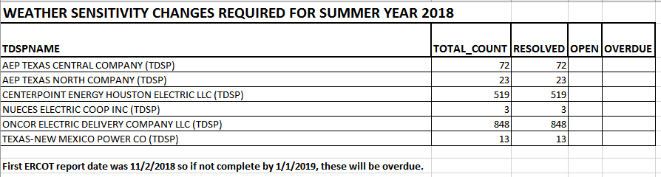

- Sam had requested the report to be run on the 10th of the month, however, current protocols call for the first day of the month in November. The revisions will be due 90 days after the first run
- Phil Bracy confirmed the language will be grey boxed until effective

- Business Annual Validation Review
  - The WG suggested revisions to the AV Task List to differentiate AV from WS. ACTION: Bill will make the revisions and forward to Sheri for circulation to the team. Once updated, Sheri will use the revised matrix in an update to RMS.
  - REVISED Matrix: (taking into consideration WG and Randy Roberts suggested edits)

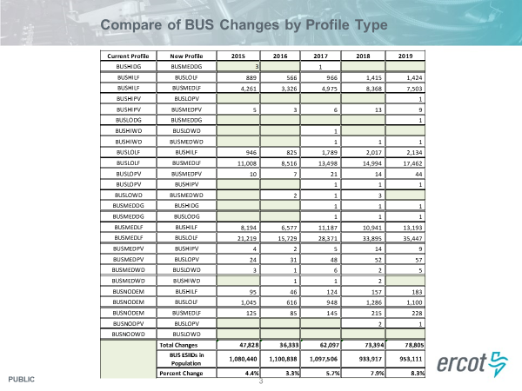

- UPDATE: All TDSPs have prepared systems for the revised default profile as BUSLOLF moving from BUSMEDLF.
- 2019 AV continued to see the higher number of revisions moving from the old default profile BUSMEDLF. Next year’s Business AV is expected to see lower volumes in these buckets.
- Three year look back will remove Sharyland from next year’s AV.
- Revision volumes are higher likely due to the load growth experienced in certain TDSP territories.
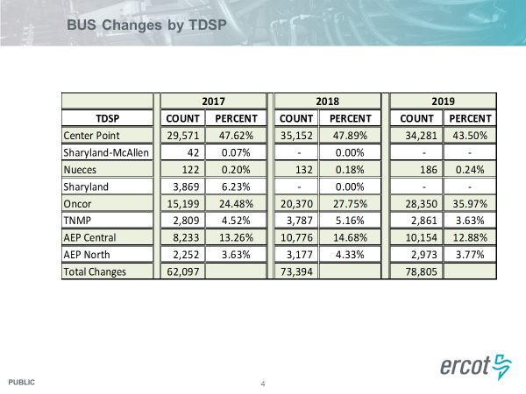

- Other Business – Randy Roberts brought up the earlier NRRR regarding BUSIDRRQ language and daily reads. TDSPs confirmed the grey box language will not change as the other TDSPs (AEP and CNP) have not completed their rate cases disassociating 4CP with the meter asset and the BUSIDRRQ profile. Randy will be developing a presentation for RMS, which will be reviewed initially at the next PWG meeting in May and then RMS in June.

- Reviewed Meeting Plan for 2019
  - May 10th @ 9:30 am, WebEx
    - Review 2018 UFE report
    - Update on Business Annual Validation
    - Review Randy’s presentation on BUSIDRRQ and daily settlement data
  - November 8th @ 9:30 am, WebEx
    - Review AV update
    - 2019 Accomplishments / 2020 Goals
    - Weather Sensitivity report

- Meeting adjourned @ 10:20 am

