

March 2019 ERCOT Monthly Operations Report

Reliability and Operations Subcommittee Meeting

May 2, 2019

Table of Contents

1. Report Highlights 2

2. Frequency Control 3

2.1. Frequency Events 3

2.2. Responsive Reserve Events 4

2.3. Load Resource Events 4

3. Reliability Unit Commitment 4

4. Wind Generation as a Percent of Load 5

5. Largest Net-Load Ramp 5

6. COP Error Analysis 6

7. Congestion Analysis 8

7.1. Notable Constraints 8

7.2. Generic Transmission Constraint Congestion 11

7.3. Manual Overrides 11

7.4. Congestion Costs for Calendar Year 2019 11

8. System Events 13

8.1. ERCOT Peak Load 13

8.2. Load Shed Events 13

8.3. Stability Events 13

8.4. Notable PMU Events 13

8.5. DC Tie Curtailment 13

8.6. TRE/DOE Reportable Events 13

8.7. New/Updated Constraint Management Plans 13

8.8. New/Modified/Removed RAS 13

8.9. New Procedures/Forms/Operating Bulletins 14

9. Emergency Conditions 14

9.1. OCNs 14

9.2. Advisories 14

9.3. Watches 14

9.4. Emergency Notices 14

10. Application Performance 14

10.1. TSAT/VSAT Performance Issues 14

10.2. Communication Issues 14

10.3. Market System Issues 14

11. Model Updates 15

Appendix A: Real-Time Constraints 17

# Report Highlights

* The unofficial ERCOT peak for March was 60,652 MW.
* There were three frequency events in March.
* There was three instances where Responsive Reserves were deployed.
* There was one RUC commitment in March.
* Congestion in the North Load Zone (LZ) can be mostly attributed to outages and storms. Congestion in the South LZ was due to high DC_R export and outages. Congestion in the West LZ was mostly due to storms. Congestion in the Houston area was minimal. There were 16 days on the Panhandle GTC and 1 day on the McCamey GTC in March.
* There two DC Tie curtailments in March.

# Frequency Control

## Frequency Events

The ERCOT Interconnection experienced three frequency events in March, all of which resulted from a Resource trip. The average event duration was approximately 0:05:26.

A summary of the frequency events is provided below. The reported frequency events meet one of the following criteria: Delta Frequency is 60 mHz or greater; the MW loss is 350 MW or greater; resource trip event triggered RRS deployment. Frequency events that have been identified as Frequency Measurable Events (FME) for purposes of BAL-001-TRE-1 analysis are highlighted in blue. When analyzing frequency events, ERCOT evaluates PMU data according to industry standards. Events with an oscillating frequency of less than 1 Hz are considered to be inter-area, while higher frequencies indicate local events. Industry standards specify that damping ratio for inter-area oscillations should be 3.0% or greater. For the frequency events listed below, the ERCOT system met these standards and transitioned well after each disturbance.

|  |  |  |  |  |  |  |  |  |  |  |
| --- | --- | --- | --- | --- | --- | --- | --- | --- | --- | --- |
| **Date and Time** | **Delta Frequency** | **Max/Min Frequency** | **Duration of Event[1]** | **PMU Data[2]** | | | **MW Loss** | **Load** | **Wind** | **Inertia** |
| **(Hz)[3]** | **(Hz)** | **Oscillation Mode (Hz)** | | **Damping Ratio** | **(MW)** | **%** | **(GW-s)[4]** |
| 3/2/2019 3:18 | 0.227 | 59.774 | 0:06:57 | None | None | | 1224.4 | 33,942 | 20% | 211,920 |
| 3/11/2019 21:24 | 0.151 | 59.823 | 0:04:23 | None | None | | 610.645 | 39,387 | 13% | 225,633 |
| 3/21/2019 13:39 | 0.148 | 59.865 | 0:04:58 | 0.67 | 13% | | 650.155 | 36,714 | 2% | 231,504 |

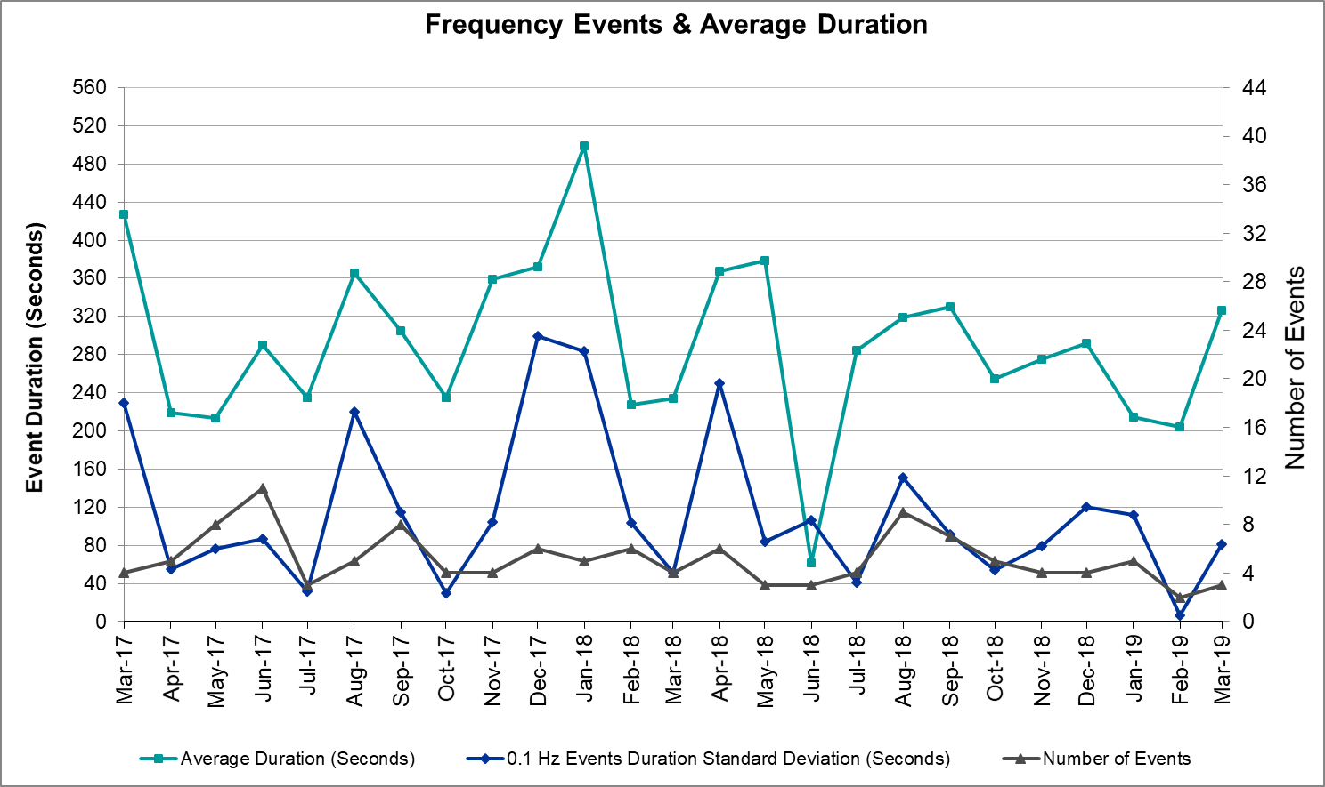

(Note: All data on this graph encompasses frequency event analysis based on BAL-001-TRE-1.)

## Responsive Reserve Events

There were three events where Responsive Reserve MWs were released to SCED in March. The events highlighted in blue were related to frequency events reported in Section 2.1 above.

|  |  |  |  |  |
| --- | --- | --- | --- | --- |
| **Date and Time Released to SCED** | **Date and Time Recalled** | **Duration of Event** | **Maximum MWs Released** | **Comments** |
| 3/2/2019 3:19 | 3/2/2019 3:24 | 00:05:36 | 1211 |  |
| 3/11/2019 21:24 | 3/11/2019 21:28 | 00:04:16 | 955 |  |
| 3/21/2019 13:40 | 3/21/2019 13:44 | 00:04:03 | 513 |  |

## Load Resource Events

None.

# Reliability Unit Commitment

ERCOT reports on Reliability Unit Commitments (RUC) on a monthly basis. Commitments are reported grouped by operating day and weather zone. The total number of hours committed is the sum of the hours for all the units in the specified region. Additional information on RUC commitments can be found on the MIS secure site at Grid 🡪 Generation 🡪 Reliability Unit Commitment.

There were no DRUC commitments in March.

There was one HRUC commitment in March.

|  |  |  |  |  |  |
| --- | --- | --- | --- | --- | --- |
| **Resource Location** | **# of Resources** | **Operating Day** | **Total # of Hours Committed** | **Total MWhs** | **Reason for Commitment** |
| Southern | 1 | 3/30/2019 | 8 | 2,505 | XWHI58 |

# Wind Generation as a Percent of Load



Wind Generation Record: 19,672 MW on 01/21/2019 at 19:19

Wind Penetration Record: 56.16% on 01/19/2019 03:10

# Largest Net-Load Ramp

The net-load ramp is defined as the change in net-load (load minus wind and PVGR generation) during the defined time horizon. Such a variation in net-load needs to be accommodated in grid operations to ensure that the reliability of the grid is satisfactorily maintained. The largest net-load ramp during 5-min, 10-min, 15-min, 30-min and 60-min in March 2019 is 912 MW, 1,487 MW, 1,902 MW, 3,186 MW, and 5,548 MW, respectively. The comparison with respect to the historical values is given in the table below.

|  |  |  |  |  |  |
| --- | --- | --- | --- | --- | --- |
| **Month and Year** | **5 min** | **10 min** | **15 min** | **30 min** | **60 min** |
| March 2019 | 912 MW | 1487 MW | 1902 MW | 3186 MW | 5548 MW |
| March 2014 | 822 MW | 1381 MW | 1895 MW | 3237 MW | 5257 MW |
| March 2015 | 958 MW | 1615 MW | 2146 MW | 3341 MW | 5661 MW |
| March 2016 | 979 MW | 1635 MW | 2149 MW | 2967 MW | 5070 MW |
| March 2017 | 888 MW | 1522 MW | 1837 MW | 3321 MW | 5395 MW |
| March 2018 | 1375 MW | 1688 MW | 2069 MW | 3576 MW | 5957 MW |
| 2014-2018 | 1494 MW | 1991 MW | 2780 MW | 4109 MW | 7218 MW |

# OP Error Analysis

COP Error is calculated as the capacity difference between the COP HSL and real-time HSL of the unit. Mean Absolute Error (MAE) stayed high over 8,000 MW until Day-Ahead at 12:00, then dropped significantly to 1,794 MW by Day-Ahead at 14:00. In the following chart, Under-Scheduling Error indicates that COP had less generation capacity than real-time and Over-Scheduling Error indicates that COP had more generation capacity than real-time. Under-Scheduling persisted from beginning of Day-Ahead to end of the Operating Day. Snapshot on the Operating Day considers all Operating Hours, including past hours. However, COP error for the Operating Hour freezes after the Adjustment Period.

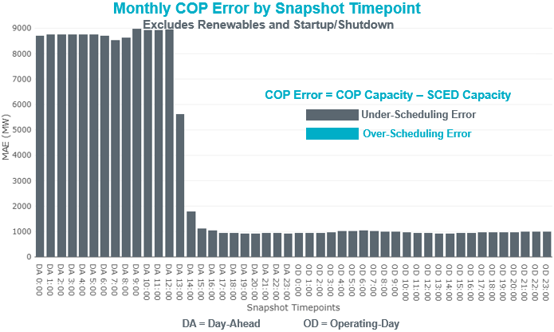

Monthly MAE for the Latest COP at the end of the Adjustment Period was 986 MW with median ranging from -1,119 MW for Hour-Ending (HE) 6 to -839 MW for HE 7. March 4th HE 9 had the largest Over-Scheduling Error (901 MW) and March 18 HE 10 had the largest Under-Scheduling Error (-2,974 MW).

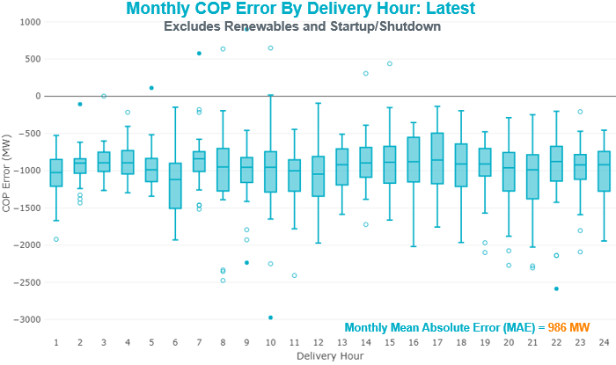

Monthly MAE for the Day-Ahead COP at 12:00 was 8,606 MW with median ranging from -11,303 MW for Hour-Ending (HE) 21 to -5,661 MW for HE 2. March 27th HE 2 had the largest Over-Scheduling Error (-489 MW) and March 5th HE 9 had the largest Under-Scheduling Error (-20,762 MW).

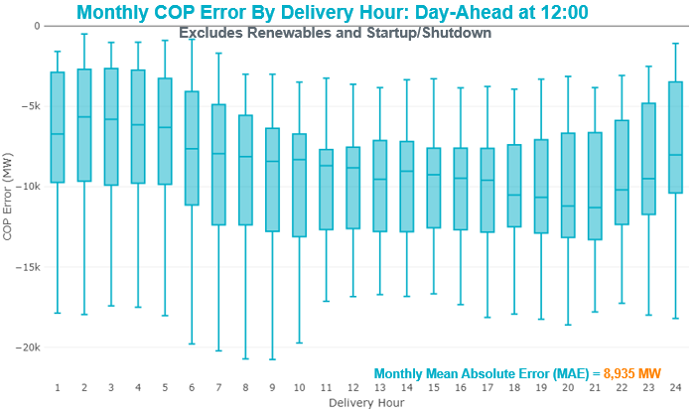

# Congestion Analysis

The total number of congestion events experienced by the ERCOT system decreased in March. There were 17 instances over 17 days on the Generic Transmission Constraints (GTCs) in March.

## Notable Constraints

Nodal protocol section 3.20 specifies that ERCOT shall identify transmission constraints that are active or binding three or more times within a calendar month. As part of this process, ERCOT reports congestion that meets this criterion to ROS. In addition ERCOT also highlights notable constraints that have an estimated congestion rent exceeding $1,000,000 for a calendar month. These constraints are detailed in the table below. Rows highlighted in blue indicate the congestion was affected by one or more outages. For a list of all constraints activated in SCED for the month of March, please see Appendix A at the end of this report.

|  |  |  |  |  |
| --- | --- | --- | --- | --- |
| **Contingency Name** | **Overloaded Element** | **# of Days Constraint Active** | **Congestion Rent** | **Transmission Project** |
| CRLNW-LWSSW 345kV | Ti Tnp - West Tnp 138kV | 13 | $12,373,349.32 |  |
| CPSES-JONSW&EVRSW 345kV | Hood - Decordova Dam 138kV | 1 | $7,948,529.13 |  |
| Manual LOTEBUSH toYUCSW 138 kV | 16th Street Tnp - Woodward 2 138kV | 18 | $7,754,722.55 | Solstice: Build 345 kV station (5530) and Solstice to Bakersfield: Build 345 kV line (5539) |
| CRLNW-LWSSW 345kV | Jones Street Tnp - Lakepointe Tnp 138kV | 5 | $6,457,626.04 | Lewisville - Lewisville Jones - Lakepointe 138 kV Line (45537) |
| NORTH EDINBURG TRX 1382 345/138 | North Edinburg 345/1kV | 2 | $5,263,855.37 | Stewart Road: Construct 345 kV cut-in (5604) |
| Solstice to LINTERNA LIN 1 | Barrilla - Fort Stockton Switch 69kV | 30 | $4,519,885.74 | Solstice: Build 345 kV station (5530) and Solstice to Bakersfield: Build 345 kV line (5539) Pecos County Modification Project (7028, 44359) |
| WHITEPOINT TRX 345A 345/138 | Lon Hill 345/1kV | 4 | $4,211,564.80 | Lon Hill: Replace 345/138 kV autotransformers (6106) |
| Saldo-Klnsw 345kV | Killeen Switch 345/1kV | 5 | $2,756,581.90 | Killeen Sw. Sta. 345/138 kV Autotransformer Replacement (5624) |
| Basecase | Omega - Horse Hollow Generation Tie 345kV | 7 | $2,344,905.27 |  |
| Manual LOTEBUSH toYUCSW 138 kV | Woodward 2 - Rio Pecos 138kV | 15 | $2,141,192.68 | Solstice: Build 345 kV station (5530) and Solstice to Bakersfield: Build 345 kV line (5539) |
| CHB-KG & JOR-NB 345kV | Bigvue - Power Systems-Arco Cogen 138kV | 7 | $2,108,891.41 |  |
| SAN MIGUEL 345_138 KV SWITCHYARDS to LOBO LIN 1 | North Laredo Switch - Piloncillo 138kV | 14 | $2,087,595.15 |  |
| Basecase | PNHNDL GTC | 16 | $2,061,894.68 | LP&L Integration Tie Lines (43367 A,B,C) and Panhandle Loop |
| Basecase | Burns Sub - Heidelburg Sub 138kV | 3 | $1,896,479.29 |  |
| GREENS BAYOU - KING 345KV | Greens Bayou 345/1kV | 3 | $1,816,197.06 |  |
| Fergus-Granmo&Wirtz-Starck 138kV | Flat Rock Lcra - Wirtz 138kV | 28 | $1,739,313.23 | Wirtz to FlatRock to Paleface Transmission Line Upgrade (4465) |
| Wirtz-Burnet&Starck 138kV | Flat Rock Lcra - Wirtz 138kV | 1 | $1,715,532.23 | Wirtz to FlatRock to Paleface Transmission Line Upgrade (4465) |
| McCampbell to PORTLAND LIN 1 | Whitepoint - Rincon 138kV | 4 | $1,562,482.73 |  |
| DMTSW-SCOSW 345KV | Knapp - Scurry Chevron 138kV | 15 | $1,453,197.47 | Ennis Creek - Cogdell 69 kV Line (4554) & Ennis Creek 138 kV Switching Station (6269) |
| CRLNW-LWSSW 345kV | Carrollton Northwest - Lakepointe Tnp 138kV | 4 | $1,404,408.70 | Northwest Carrollton - LakePointe TNP 138 kV Line (5548) |
| TWR (345) HLJ-WAP64 & BLY-WAP72 | Jones Creek - South Texas Project 345kV | 3 | $1,095,498.32 | Freeport Master Plan (6668A) |
| Riohondo-Nedin 345kV&Harlnsw 138kV | Burns Sub - Rio Hondo 138kV | 8 | $938,907.23 |  |
| ODLAW SWITCHYARD to ASPHALT MINES LIN 1 | Hamilton Road - Maverick 138kV | 14 | $849,903.37 | Brackettville to Escondido: Construct 138 kV line (5206) |
| Bighil-Kendal 345kV | Yellow Jacket - Treadwell 138kV | 8 | $369,240.88 |  |
| INGLESIDE COGEN SWITCH to OXYCHEM INGLESIDE LIN 1 | Dupont Pp1 - Ingleside - Dupont Switch - Ingleside 138kV | 3 | $346,942.56 |  |
| CAGNON to KENDALL LIN 1 | Cico - Comfort 138kV | 3 | $339,470.63 | Boerne Cico - Comfort - Kendall Transmission Line Upgrade (6982) |
| Entpr-Trses & Mlses-Scses 345kV | Lufkin Switch - Nacogdoches South Tap 138kV | 5 | $314,377.41 | Lufkin Sw. Sta. - Herty North Sw. Sta. 345 kV Line (5475) & Nacogdoches Southeast_HertyN 345kV Line (5467) |
| Bighil-Kendal 345kV | Yellow Jacket - Fort Mason 138kV | 10 | $309,681.76 | Yellowjckt to Menard Phillips T 69 kV line: Rebld 69 kV line (6345) Mason to Fort Mason: Rebuild 69 kV line (5794) - 138 kV conversion |
| NORTH McCAMEY to ODESSA EHV SWITCH LIN 1 | 16th Street Tnp - Woodward 2 138kV | 8 | $249,118.94 | Solstice: Build 345 kV station (5530) and Solstice to Bakersfield: Build 345 kV line (5539) |
| Fppyd2-Lytton_S & Holman 345kV | Fayetteville - Winchester 138kV | 6 | $237,015.23 | Fayetteville - Winchester Transmission Line Upgrade (6983) |
| KLEBERG AEP to LOYOLA SUB LIN 1 | Loyola Sub 138/69kV | 6 | $219,580.22 |  |
| LAQUINTA to LOBO LIN 1 | Bruni Sub 138/69kV | 7 | $216,267.94 | Holland 69 kV Capacitors (5805) |
| North Lamar POI to LORAINE SOUTH POI LIN _A | Eskota Switch - Trent 69kV | 4 | $197,881.08 |  |
| WOLF SWITCHING STATION to Monahans Tap 2 LIN _G | General Tire Switch - Southwestern Portland Tap 138kV | 6 | $190,821.73 | Wolf - General Tire 138 kV Series Reactor (7100) |
| ARCADIA to HIWAY 9 LIN 1 | Morris Street - Westside Aep 138kV | 4 | $186,822.92 |  |
| FLAT TOP TNP to Pig Creek LIN 2 | Musquiz - Country Road 101 Tap 138kV | 7 | $182,306.94 | Pig Creek to County Road 101: Rebuild 138 kV line (7046) |
| PAWNEE SWITCHING STATION TRX XF1 345/138 | Coleto Creek - Victoria 138kV | 6 | $156,615.65 |  |
| FORT MASON to YELLOW JACKET LIN 1 | Mason Aep - Fredricksburg Phillips Tap 69kV | 5 | $128,745.81 | Yellowjckt to Menard Phillips T 69 kV line: Rebld 69 kV line (6345) Mason to Fort Mason: Rebuild 69 kV line (5794) - 138 kV conversion |
| MCELMURRAY to ESKOTA SWITCH LIN 1 | Eskota Switch - Trent 69kV | 4 | $91,776.28 |  |
| RIO HONDO to LAS PULGAS LIN 1 | Raymondville 2 138/69kV | 5 | $74,032.98 | Harlingen SS- Raymondville #2: Convert to 138 kV (6167) |
| Pig Creek to Solstice LIN 1 | Woodward 2 - Rio Pecos 138kV | 12 | $71,602.97 | Solstice: Build 345 kV station (5530) and Solstice to Bakersfield: Build 345 kV line (5539) |
| POWER SYSTEMS-ARCO COGEN to BIGVUE LIN A | Jefferson - South Channel 138kV | 3 | $66,276.58 | South Channel to Jefferson Ckt.06 (6095) |
| Pig Creek to Solstice LIN 1 | Airport Tnp - 16th Street Tnp 138kV | 7 | $62,698.85 | Solstice: Build 345 kV station (5530) and Solstice to Bakersfield: Build 345 kV line (5539) |
| Twinbu-Sarc&Bwnsw 345kV | San Angelo Power Station 138/69kV | 4 | $55,398.41 |  |
| LON HILL to WHITEPOINT LIN 1 | Lon Hill 138/1kV | 3 | $43,489.60 |  |
| JEFFERSON to SOUTH CHANNEL LIN A | Bigvue - Power Systems-Arco Cogen 138kV | 4 | $33,127.00 |  |
| ODLAW SWITCHYARD to ASPHALT MINES LIN 1 | Escondido - Ganso 138kV | 8 | $22,430.15 | Brackettville to Escondido: Construct 138 kV line (5206) |
| SUN SWITCH to SCURRY SWITCH LIN 1 | Aspermont Aep - Aspermont Continental 69kV | 11 | $19,827.02 | Aspermont: Replace the 138/69 kV autotransformer (6569) |
| Marbfa-Lakewy &Wirtz-Palefa 138kV | Flat Rock Lcra - Wirtz 138kV | 11 | $14,952.92 | Wirtz to FlatRock to Paleface Transmission Line Upgrade (4465) |
| YELLOW JACKET TRX PS_1 138/138 | San Angelo Power Station 138/69kV | 4 | $14,651.86 |  |
| BOSQUE SWITCH to ELM MOTT LIN 1 | Bosque Switch - Rogers Hill Bepc 138kV | 4 | $14,192.28 |  |
| SCHKAD to TWIN BUTTES LIN 1 | San Angelo Power Station 138/69kV | 5 | $13,884.84 |  |
| FORT LANCASTER to ILLINOIS #4 LIN 1 | Hamilton Road - Maxwell 138kV | 6 | $12,313.60 | Brackettville to Escondido: Construct 138 kV line (5206) |
| BRACKETTVILLE to HAMILTON ROAD LIN 1 | Hamilton Road - Maverick 138kV | 3 | $11,904.82 | Brackettville to Escondido: Construct 138 kV line (5206) |
| Ryssw-Forsw 345kV | Forney Switch 345/1kV | 6 | $11,449.20 | Forney Sw. Sta. Second 600 MVA, 345/138 kV Autotransformer (12TPIT0080) |
| CHB-KG & JOR-NB 345kV | Jefferson - South Channel 138kV | 5 | $10,997.42 | South Channel to Jefferson Ckt.06 (6095) |
| Basecase | Lakeway - Marshall Ford 138kV | 5 | $10,666.69 | T180 Lakeway - Marshall Ford MLSE Upgrade (7163) |
| CALAVERAS to PAWNEE SWITCHING STATION LIN 1 | Pawnee Switching Station 345/138kV | 3 | $9,862.61 |  |
| TWR (345) WHITE_PT-LON_HILL & STP | Blessing - Lolita 138kV | 5 | $9,728.04 |  |
| SAN ANGELO RED CREEK to SAN ANGELO PAULANN LIN 1 | San Angelo Power Station 138/69kV | 3 | $8,834.08 |  |
| TWR (138) BCV-CV03 & GBY-PSA03 | Lychem - Power Systems-Arco Cogen 138kV | 5 | $7,364.17 |  |
| ASPERMONT AEP to SPUR LIN 1 | Spur 138/69kV | 4 | $6,731.98 |  |
| LOFTIN to COTTONWOOD ROAD SWITCH LIN 1 | Bowie 138/69kV | 9 | $5,048.81 |  |
| Basecase | Randado Aep - Zapata 138kV | 11 | $3,915.24 | Zapata Reactor (44393) |
| MILLER CREEK to PALEFACE LIN 1 | Granite Mountain - Marble Falls 138kV | 4 | $3,389.68 | T195 Granite Mountain - Marble Falls MLSE Upgrade (7164) |
| JEFFERSON to COLLEGE LIN A | Jefferson - South Channel 138kV | 4 | $3,290.78 | South Channel to Jefferson Ckt.06 (6095) |
| ASPERMONT AEP to SPUR LIN 1 | Girard Tap - Spur 69kV | 3 | $2,809.15 |  |

## Generic Transmission Constraint Congestion

There were 16 days on the Panhandle GTC and 1 day on the McCamey GTC in March. There was no activity on the remaining GTCs during the month.

Note: This is how many times a constraint has been activated to avoid exceeding a GTC limit, it does not imply an exceedance of the GTC occurred or that the GTC was binding.

## Manual Overrides

None.

## Congestion Costs for Calendar Year 2019

The following table represents the top twenty active constraints for the calendar year based on the estimated congestion rent attributed to the congestion. ERCOT updates this list on a monthly basis.

|  |  |  |  |  |
| --- | --- | --- | --- | --- |
| **Contingency** | **Binding Element** | **# of 5-min SCED Intervals** | **Estimated Congestion Rent** | **Transmission Project** |
| Elmcreek-Skyline 345kV | Hill Country - Marion 345kV | 961 | $26,958,430.36 |  |
| Manual LOTEBUSH toYUCSW 138 kV | 16th Street Tnp - Woodward 2 138kV | 4,629 | $13,536,652.77 | Solstice: Build 345 kV station (5530) and Solstice to Bakersfield: Build 345 kV line (5539) |
| CRLNW-LWSSW 345kV | Ti Tnp - West Tnp 138kV | 1,967 | $12,373,349.32 |  |
| Solstice to LINTERNA LIN 1 | Barrilla - Fort Stockton Switch 69kV | 13,652 | $9,169,588.84 | Barrilla Junction to Ft. Stockton SW: Rebuild 69 kV line (7027) |
| CAGNON to KENDALL LIN 1 | Cico - Comfort 138kV | 2,696 | $9,133,087.35 | Boerne Cico - Comfort - Kendall Transmission Line Upgrade (6982) |
| DMTSW-SCOSW 345KV | Knapp - Scurry Chevron 138kV | 2,990 | $9,085,226.52 | Ennis Creek - Cogdell 69 kV Line (4554) & Ennis Creek 138 kV Switching Station (6269) |
| CPSES-JONSW&EVRSW 345kV | Hood - Decordova Dam 138kV | 172 | $7,948,529.13 |  |
| CRLNW-LWSSW 345kV | Jones Street Tnp - Lakepointe Tnp 138kV | 990 | $6,457,626.04 |  |
| WHITEPOINT TRX 345A 345/138 | Lon Hill 345/1kV | 744 | $6,251,701.79 |  |
| NORTH EDINBURG TRX 1382 345/138 | North Edinburg 345/1kV | 328 | $5,776,017.31 | Stewart Road: Construct 345 kV cut-in (5604) |
| ODESSA EHV SWITCH to MOSS SWITCH LIN _A | Woodward 2 - Rio Pecos 138kV | 1,256 | $5,125,308.07 |  |
| Basecase | PNHNDL GTC | 7,711 | $5,047,741.07 | LP&L Integration Tie Lines (43367 A,B,C) and Panhandle Loop |
| Bighil-Kendal 345kV | Hamilton Road - Maverick 138kV | 4,488 | $4,995,191.88 | Brackettville to Escondido: Construct 138 kV line (5206) |
| SAN MIGUEL 345_138 KV SWITCHYARDS to LOBO LIN 1 | North Laredo Switch - Piloncillo 138kV | 2,306 | $4,509,445.51 |  |
| Entpr-Trses & Mlses-Scses 345kV | Lufkin Switch - Nacogdoches South Tap 138kV | 3,117 | $4,233,749.83 | Lufkin - Nacogdoches Southeast 138 kV Line (4827) |
| WHITEPOINT TRX 345A 345/138 | Lon Hill 345/1kV | 499 | $4,211,564.80 |  |
| CRLNW-LWSSW 345kV | Cooper Creek Substation - Arco 138kV | 1,766 | $3,639,343.48 | 138kV Cooper Creek - Arco Line Reconstruction (44181) |
| TWR (345) HLJ-WAP64 & BLY-WAP72 | Jones Creek - South Texas Project 345kV | 1,416 | $3,438,097.38 | Freeport Master Plan |
| Fergus-Granmo&Wirtz-Starck 138kV | Flat Rock Lcra - Wirtz 138kV | 11,117 | $2,962,440.59 | Wirtz to FlatRock to Paleface Transmission Line Upgrade (4465) |
| Manual LOTEBUSH toYUCSW 138 kV | Woodward 2 - Rio Pecos 138kV | 2,137 | $2,909,420.19 | Solstice: Build 345 kV station (5530) and Solstice to Bakersfield: Build 345 kV line (5539) |

# System Events

## ERCOT Peak Load

The unofficial ERCOT peak load[5] for the month was 60,652 MW and occurred on March 5th, during hour ending 08:00.

## Load Shed Events

None.

## Stability Events

None.

## Notable PMU Events

ERCOT analyzes PMU data for any significant system disturbances that do not fall into the Frequency Events category reported in section 2.1. The results are summarized in this section once the analysis has been completed.

None.

## DC Tie Curtailment

|  |  |  |  |  |  |
| --- | --- | --- | --- | --- | --- |
| **Date** | **DC Tie** | **Curtailing Period** | **# of Tags Curtailed** | **Initiating Event** | **Curtailment Reason[6][7]** |
| 03/13/2019 | DC-R | HE18 | 1 | XNED258, loss of N Edinburg 345/138 kV transformer #2 overloads N Edinburg 345/138 kV transformer #1 | Local Congestion |
| 03/14/2019 | DC-L | HE13 | 1 | Unknown reason | DC Tie Forced Outage |

## TRE/DOE Reportable Events

* ERCOT submitted an EOP-004 report for March 02, 2019 Reportable Event Type: Generation Loss.
* Luminant submitted an EOP-004 report for March 02, 2019 Reportable Event Type: Generation Loss.

## New/Updated Constraint Management Plans

None.

## New/Modified/Removed RAS

None.

## New Procedures/Forms/Operating Bulletins

None.

# Emergency Conditions

## OCNs

|  |  |
| --- | --- |
| **Date and Time** | **Description** |
| 02/27/2019 12:06 | ERCOT issued an OCN for a potential extreme cold weather for operating day 3/3/2019 through 3/7/19 |

## Advisories

|  |  |
| --- | --- |
| **Date and Time** | **Description** |
| 03/13/2019 01:13 | ERCOT issued an advisory due to severe weather in the Central and North Texas areas. |
| 03/26/2019 13:22 | ERCOT issued an advisory for DAM timeline postponement for OD 03/27/2019. |

## Watches

|  |  |
| --- | --- |
| **Date and Time** | **Description** |
| 03/20/2019 00:31 | ERCOT issued a watch for HRUC timeline deviation for Hour Ending 02:00. |

## Emergency Notices

None.

# Application Performance

## TSAT/VSAT Performance Issues

None.

## Communication Issues

None.

## Market System Issues

None.

# Model Updates

The Downstream Production Change (DPC) process allows ERCOT to make changes in the on-line Network Operations Model without loading a completely new model. The purpose of this process is to allow for reliable grid operations as system conditions change between designated Network Operations Model database loads. The DPC process is limited in scope to just those items listed below, with equipment ratings updates being the most common. ERCOT has seen a rise in the use of the DPC process to make on-line updates to the Network Operations Model in recent years, instead of through the standard Network Operations Model Change Request process.

* Static Line ratings (Interim Update)
* Dynamic Line ratings (non-Interim Update)
* Autotransformer ratings (non-Interim Update)
* Breaker and Switch Normal status (Interim Update)
* Contingency Definitions (Interim Update)
* RAP and RAS changes or additions (Interim Update)
* Net Dependable and Reactive Capability (NDCRC) values (Interim Update)
* Impedance Updates (non-Interim)

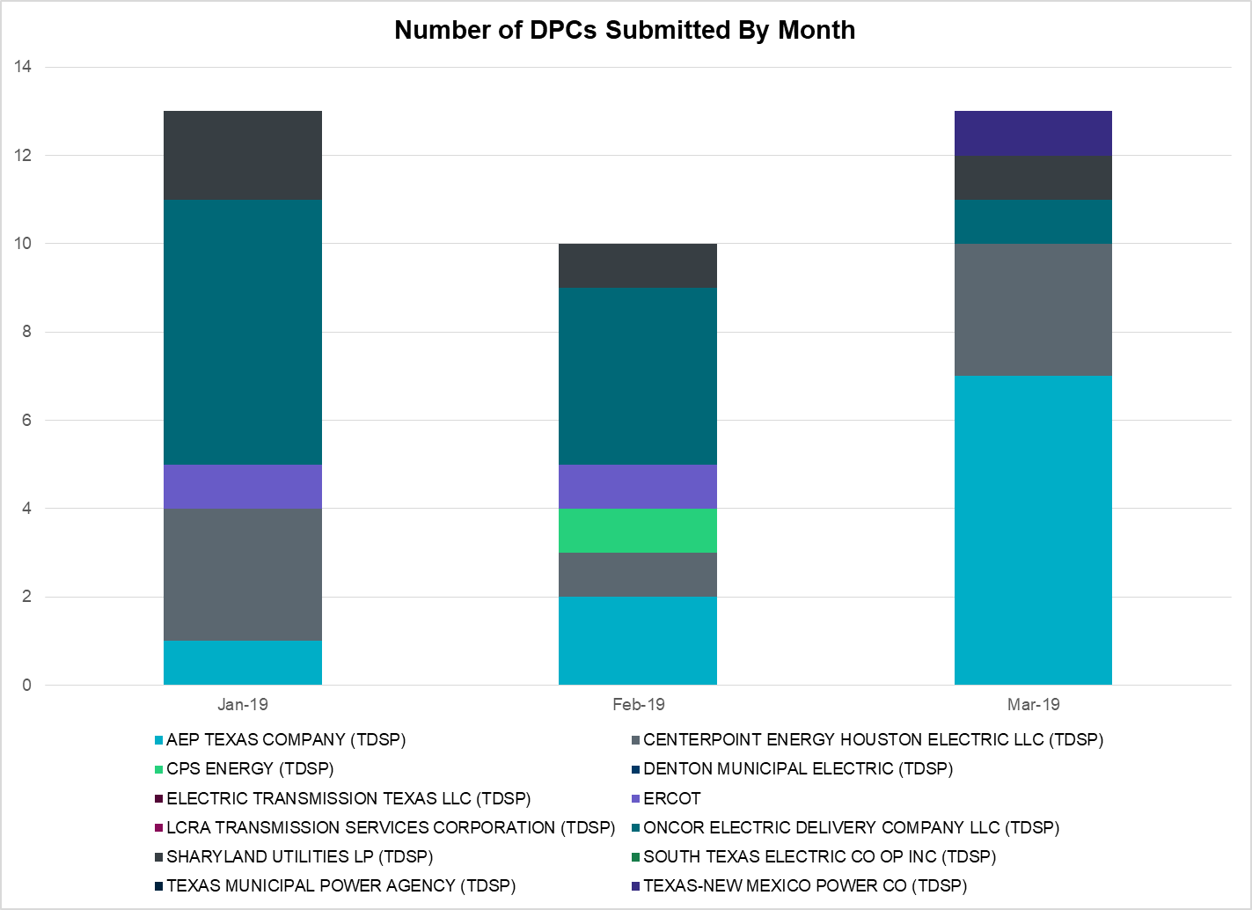

|  |  |
| --- | --- |
| **Transmission Operator** | **Number of DPCs in March** |
| AEP TEXAS COMPANY (TDSP) | 7 |
| BRAZOS ELECTRIC POWER CO OP INC (TDSP) | 0 |
| CENTERPOINT ENERGY HOUSTON ELECTRIC LLC (TDSP) | 3 |
| CPS ENERGY (TDSP) | 0 |
| DENTON MUNICIPAL ELECTRIC (TDSP) | 0 |
| ELECTRIC TRANSMISSION TEXAS LLC (TDSP) | 0 |
| ERCOT | 0 |
| LCRA TRANSMISSION SERVICES CORPORATION (TDSP) | 0 |
| ONCOR ELECTRIC DELIVERY COMPANY LLC (TDSP) | 1 |
| SHARYLAND UTILITIES LP (TDSP) | 1 |
| SOUTH TEXAS ELECTRIC CO OP INC (TDSP) | 0 |
| TEXAS MUNICIPAL POWER AGENCY (TDSP) | 0 |
| TEXAS-NEW MEXICO POWER CO (TDSP) | 1 |

# Appendix A: Real-Time Constraints

The following is a complete list of constraints activated in SCED for the month of March. Full contingency descriptions can be found in the Standard Contingencies List located on the MIS secure site at Grid 🡪 Generation 🡪 Reliability Unit Commitment.

|  |  |  |  |  |
| --- | --- | --- | --- | --- |
| **Contingency** | **Constrained Element** | **From Station** | **To Station** | **# of Days Constraint Active** |
| SWCSBOO8 | BARL_FTSW1_1 | FTSW | BARL | 30 |
| DFERSTA8 | 38T365_1 | WIRTZ | FLATRO | 28 |
| MLOTYUC8 | 16TH_WRD2_1 | WOODWRD2 | 16TH_ST | 18 |
| BASE CASE | PNHNDL | n/a | n/a | 16 |
| DMTSCOS5 | 6437__F | SCRCV | KNAPP | 15 |
| MLOTYUC8 | RIOPEC_WOODW21_1 | RIOPECOS | WOODWRD2 | 15 |
| SLOBSA25 | NLARSW_PILONC1_1 | NLARSW | PILONCIL | 14 |
| SBRAUVA8 | HAMILT_MAVERI1_1 | HAMILTON | MAVERICK | 14 |
| DCRLLSW5 | 588_A_1 | LWSVW | LWVTI | 13 |
| SPIGSOL8 | RIOPEC_WOODW21_1 | WOODWRD2 | RIOPECOS | 12 |
| BASE CASE | RANDAD_ZAPATA1_1 | ZAPATA | RANDADO | 11 |
| DMARPA_8 | 38T365_1 | WIRTZ | FLATRO | 11 |
| SSCUSU28 | ASPM_CONA1_1 | CONA | ASPM | 11 |
| SSCUSU28 | ASPM_CONA1_1 | ASPM | CONA | 11 |
| BASE CASE | RANDAD_ZAPATA1_1 | RANDADO | ZAPATA | 11 |
| DBIGKEN5 | FORTMA_YELWJC1_1 | YELWJCKT | FORTMA | 10 |
| SCRDLOF9 | BOW_FMR1 | BOW | BOW | 9 |
| SNORODE5 | 16TH_WRD2_1 | WOODWRD2 | 16TH_ST | 8 |
| DBIGKEN5 | TREADW_YELWJC1_1 | TREADWEL | YELWJCKT | 8 |
| SBRAUVA8 | ESCOND_GANSO1_1 | GANSO | ESCONDID | 8 |
| DRIOHAR5 | BURNS_RIOHONDO_1 | RIOHONDO | MV_BURNS | 8 |
| SPIGSOL8 | TNAF_TNFS_1 | TNAF | 16TH_ST | 7 |
| DCHB_NB5 | BCVPSA03_A | PSA | BCV | 7 |
| BASE CASE | HHGTOM_1 | HHGT | OMEGA | 7 |
| SWCSBOO8 | FTST_69T1 | FTST | FTST | 7 |
| SFLAPIG8 | CR101T_MUSQUI1_1 | MUSQUIZ | CR101TAP | 7 |
| SLAQLOB8 | BRUNI_69_1 | BRUNI | BRUNI | 7 |
| SWLFMON8 | 6345__B | GNTSW | SPRTP | 6 |
| DRYSFOR5 | FORSW_MR3H | FORSW | FORSW | 6 |
| XPAW58 | COLETO_VICTOR2_1 | COLETO | VICTORIA | 6 |
| SILLFTL8 | HAMILT_MAXWEL1_1 | MAXWELL | HAMILTON | 6 |
| SKLELOY8 | LOYOLA_69_1 | LOYOLA | LOYOLA | 6 |
| DFPPHOL5 | 176T165_1 | FAYETT | WINCHE | 6 |
| BASE CASE | 223T180_1 | MARSFO | LAKEWY | 5 |
| DSALKLN5 | KLNSW_MR1H | KLNSW | KLNSW | 5 |
| DBCVPSA8 | LHMPSA08_A | PSA | LHM | 5 |
| DWH_STP5 | BLESSI_LOLITA1_1 | BLESSING | LOLITA | 5 |
| SSCHTWI8 | SAPOWER_69T1 | SAPOWER | SAPOWER | 5 |
| SRAYRI28 | RAYMND2_69A1 | RAYMND2 | RAYMND2 | 5 |
| DCRLLSW5 | 590__B | LWVJS | LKPNT | 5 |
| DBCVPSA8 | LHMLY_08_A | LHM | LY | 5 |
| DENTSCS5 | 1350__E | NCSTP | LFKSW | 5 |
| SFORYEL8 | FRPHIL_MASN1_1 | MASN | FRPHILLT | 5 |
| DCHB_NB5 | JFSSC_06_A | JFS | SC | 5 |
| BASE CASE | 223T180_1 | LAKEWY | MARSFO | 5 |
| SMCEESK8 | ESKSW_TRNT1_1 | TRNT | ESKSW | 4 |
| SSPJFS8 | JFSSC_06_A | JFS | SC | 4 |
| SMCEESK8 | ESKSW_TRNT1_1 | ESKSW | TRNT | 4 |
| DWIRGRA8 | 43T365_1 | FLATRO | PALEPE | 4 |
| XWHI58 | LON_HILL_382H | LON_HILL | LON_HILL | 4 |
| SARCHIW8 | MORRIS_WESTSI1_1 | MORRIS | WESTSIDE | 4 |
| SPORWH28 | RINCON_WHITE_2_1 | WHITE_PT | RINCON | 4 |
| SPHIMIL8 | 342T195_1 | GRANMO | MARBFA | 4 |
| SSPUASP8 | SPUR_69_1 | SPUR | SPUR | 4 |
| DCRLLSW5 | 591__A | LKPNT | CRLNW | 4 |
| SBOSELM5 | 1030__B | BOSQUESW | RGH | 4 |
| SPHIMIL8 | 223T180_1 | LAKEWY | MARSFO | 4 |
| SSWDMGS8 | ESKSW_TRNT1_1 | TRNT | ESKSW | 4 |
| DBWNTWI5 | SAPOWER_69T1 | SAPOWER | SAPOWER | 4 |
| XYEL88 | SAPOWER_69T1 | SAPOWER | SAPOWER | 4 |
| SSCJFS8 | BCVPSA03_A | PSA | BCV | 4 |
| SSWDMGS8 | ESKSW_TRNT1_1 | ESKSW | TRNT | 4 |
| BASE CASE | BURNS_RIOHONDO_1 | RIOHONDO | MV_BURNS | 3 |
| SSPUASP8 | GIRA_T_SPUR1_1 | GIRA_TAP | SPUR | 3 |
| SWHILON5 | LON_HILL_382L | LON_HILL | LON_HILL | 3 |
| BASE CASE | BURNS_HEIDLBRG_1 | MV_BURNS | MV_HBRG4 | 3 |
| SSPUASP8 | GIRA_T_SPUR1_1 | SPUR | GIRA_TAP | 3 |
| SBRAHAM8 | HAMILT_MAVERI1_1 | HAMILTON | MAVERICK | 3 |
| SPAWCAL5 | PAWNEE_XF1 | PAWNEE | PAWNEE | 3 |
| DGBY_KG5 | GBY_AT1 | GBY | GBY | 3 |
| SCAGKEN5 | 74T148_1 | COMFOR | CICO | 3 |
| SBCVPSA8 | JFSSC_06_A | JFS | SC | 3 |
| SOXYIN28 | I_DUPP_I_DUPS2_1 | I_DUPP1 | I_DUPSW | 3 |
| SCTHHA38 | HAMILT_MAXWEL1_1 | MAXWELL | HAMILTON | 3 |
| DWAPHLJ5 | JCKSTP18_A | STP | JCK | 3 |
| SPAUSAR8 | SAPOWER_69T1 | SAPOWER | SAPOWER | 3 |
| SMOSYUC8 | 16TH_WRD2_1 | WOODWRD2 | 16TH_ST | 2 |
| SALIKIN8 | FALFUR_PREMON1_1 | FALFUR | PREMONT | 2 |
| XBOM58 | BOMSW_MR2H | BOMSW | BOMSW | 2 |
| SBRYGIB8 | GRE_GIBC_1 | GIBCRK | GREENS_P | 2 |
| SGRMGRS8 | GRMSW_FMR1 | GRMSW | GRMSW | 2 |
| DDMTGLD8 | 6240__C | DPCRK | SACRC | 2 |
| SSPUMW18 | ASPM_CONA1_1 | CONA | ASPM | 2 |
| XNED258 | NEDIN_138H | NEDIN | NEDIN | 2 |
| DBBSRCH5 | 1250__C | BTLTP | JEWET | 2 |
| SODLBRA8 | ESCOND_GANSO1_1 | GANSO | ESCONDID | 2 |
| DGARBRA8 | HOCHOC25_1 | HOC | HOC | 2 |
| DDMTGLD8 | 6240__C | SACRC | DPCRK | 2 |
| DSALKLN5 | 641__A | KLNSW | KLELM | 2 |
| XPAW58 | COLETO_ROSATA1_1 | COLETO | ROSATA | 2 |
| SPORWH28 | HECKER_WHITE_2_1 | WHITE_PT | HECKER | 2 |
| SNORODE5 | LINTER_SOLSTI1_1 | LINTERNA | SOLSTICE | 2 |
| DBERWE58 | 459T459_1 | KENDAL | CAGNON | 2 |
| SSPUMW18 | ASPM_CONA1_1 | ASPM | CONA | 2 |
| XFRE89 | GILLES_AT1 | GILLES | GILLES | 2 |
| DJFSCGR8 | JFSSC_06_A | JFS | SC | 2 |
| SFTLMES8 | NORTMC_SANTAR1_1 | NORTMC | SANTARIT | 2 |
| DFERGRM8 | SANDCR_AT1 | SANDCR | SANDCR | 2 |
| SMDOOAS5 | SN_STR26_A | SN | STR | 2 |
| SDMTSC25 | 6437__F | SCRCV | KNAPP | 2 |
| SBRBI8 | HOCHOC25_1 | HOC | HOC | 2 |
| DCAGBRA5 | N5_P4_2_1 | CALAVERS | SKYLINE | 2 |
| SSANPIT8 | PITSBU_AT1 | PITSBU | PITSBU | 2 |
| DTWIBGL8 | SAPOWER_69T1 | SAPOWER | SAPOWER | 2 |
| SPB2ARY8 | 16TH_WRD2_1 | WOODWRD2 | 16TH_ST | 2 |
| SWLFMON8 | 16TH_WRD2_1 | WOODWRD2 | 16TH_ST | 2 |
| DMTSCOS5 | 6474__A | SUNSW | MGSES | 2 |
| SMGIENW8 | 921__D | ENSSW | TRU | 2 |
| SBEVASH8 | BIG_BRUN_1 | BIGWELS | BRUNDGS | 2 |
| BASE CASE | MCCAMY | n/a | n/a | 1 |
| SFAICOR8 | 38T365_1 | WIRTZ | FLATRO | 1 |
| SWLFECT8 | 6100__F | DHIDE | NOTSW | 1 |
| DMTSCOS5 | 6437__A | KNAPP | BCKSW | 1 |
| DWIRSTA8 | 924T214_1 | FORTMA | GILLES | 1 |
| SASPPAI8 | ASPM_CONA1_1 | ASPM | CONA | 1 |
| SBLESTP5 | COLETO_VICTOR2_1 | COLETO | VICTORIA | 1 |
| DGRMGRS8 | GRMSW_FMR1 | GRMSW | GRMSW | 1 |
| DRIOHAR5 | HAINE__LA_PAL1_1 | LA_PALMA | HAINE_DR | 1 |
| SSIEMOL8 | LARDVN_LASCRU1_1 | LARDVNTH | LASCRUCE | 1 |
| BASE CASE | LINTER_SOLSTI1_1 | LINTERNA | SOLSTICE | 1 |
| XWHI58 | LON_HILL_382L | LON_HILL | LON_HILL | 1 |
| DWIRSTA8 | 37T187_1 | FERGUS | SHERSH | 1 |
| DWLFARY8 | 6100__F | DHIDE | NOTSW | 1 |
| SWLFECT8 | 6101__A | NOTSW | CHEYT | 1 |
| SWCSBOO8 | ALPINE_BRONCO1_1 | BRONCO | ALPINE | 1 |
| DAUSLOS5 | CKT_3121_1 | HOLMAN | LYTTON_S | 1 |
| DSTPDOW5 | CKT_3124_1 | STP | HLJ | 1 |
| SVICCO28 | COLETO_VICTOR2_1 | COLETO | VICTORIA | 1 |
| SFREGIL8 | FREDER_AT2 | FREDER | FREDER | 1 |
| SODLBRA8 | HAMILT_MAVERI1_1 | HAMILTON | MAVERICK | 1 |
| DRILBOW5 | LIBR_PAUL1_1 | PAUL | LIBR | 1 |
| DFLAPLU8 | MAGRUD_VICTOR2_1 | VICTORIA | MAGRUDER | 1 |
| DLONWAR5 | MELONC_RINCON1_1 | RINCON | MELONCRE | 1 |
| XLK2W89 | OLSE_BOS_1 | BOSQUESW | OLSEN | 1 |
| DWIRSTA8 | 342T195_1 | GRANMO | MARBFA | 1 |
| SFAICOR8 | 43T365_1 | FLATRO | PALEPE | 1 |
| SPIGSOL8 | 6100__G | ACSSW | AMTBT | 1 |
| DELMTEX5 | BLESSI_LOLITA1_1 | BLESSING | LOLITA | 1 |
| SN_SAJO5 | BURNS_RIOHONDO_1 | RIOHONDO | MV_BURNS | 1 |
| DCPSJON5 | HOOD_DECRDVA_1 | DCDAM | HOD | 1 |
| SBROALP9 | LINTER_SOLSTI1_1 | LINTERNA | SOLSTICE | 1 |
| XN_S58 | LON_HILL_382H | LON_HILL | LON_HILL | 1 |
| SCITNUE8 | MORRIS_NUECES1_1 | NUECES_B | MORRIS | 1 |
| SPB2ARY8 | RIOPEC_WOODW21_1 | RIOPECOS | WOODWRD2 | 1 |
| SCOLLON5 | VICTO_WARBU_1A_1 | VICTORIA | WARBURTN | 1 |
| SWLFECT8 | 6100__G | ACSSW | AMTBT | 1 |
| DWLFARY8 | 6101__A | NOTSW | CHEYT | 1 |
| SN_SLON5 | BURNS_RIOHONDO_1 | RIOHONDO | MV_BURNS | 1 |
| SLOBSA25 | CATARI_PILONC1_1 | PILONCIL | CATARINA | 1 |
| XLO2N58 | CELANE_KLEBER1_1 | CELANEBI | KLEBERG | 1 |
| SDOWMOO8 | DOWNIES_AX1H | DOWNIES | DOWNIES | 1 |
| XVIC89 | GREENL_WEAVER1_1 | GREENLK | WEAVERRD | 1 |
| SI_DI_48 | I_DUPP_I_DUPS2_1 | I_DUPP1 | I_DUPSW | 1 |
| SBAKBIG5 | LINTER_SOLSTI1_1 | LINTERNA | SOLSTICE | 1 |
| SWHILON5 | LON_HILL_382H | LON_HILL | LON_HILL | 1 |
| SBOSELM5 | WHTNY_MR2L | WHTNY | WHTNY | 1 |
| DWIRSTA8 | 38T365_1 | WIRTZ | FLATRO | 1 |
| SPIGSOL8 | 6345__B | GNTSW | SPRTP | 1 |
| DCHB_NB5 | BCVLY_03_A | BCV | LY | 1 |
| DBIGKEN5 | HAMILT_MAVERI1_1 | HAMILTON | MAVERICK | 1 |
| SCBYCTR5 | JFSSC_06_A | JFS | SC | 1 |
| SCOLKEN8 | MAGRUD_VICTOR2_1 | VICTORIA | MAGRUDER | 1 |
| BASE CASE | MCADO_SPUR_1A_1 | MWEC | SPUR | 1 |
| DBCVPSA8 | MTSPSA94_A | PSA | MTS | 1 |
| SSONFRI8 | SANTIA_SAPOWE1_1 | SANTIAGO | SAPOWER | 1 |
| DWIRSTA8 | 342T195_1 | MARBFA | GRANMO | 1 |
| DMTSCOS5 | 6240__C | SACRC | DPCRK | 1 |
| SSWDMGS8 | 6780__A | ESKSW | LONGWRTH | 1 |
| DLAMCOR8 | 83T196_1 | STARCK | PALEFA | 1 |
| SLOBSA25 | ASHERT_CATARI1_1 | CATARINA | ASHERTON | 1 |
| SVICCOL8 | COLETO_VICTOR1_1 | COLETO | VICTORIA | 1 |
| DSTEXP12 | COLETO_VICTOR2_1 | COLETO | VICTORIA | 1 |
| DFERGRM8 | CORONA_AT4 | CORONA | CORONA | 1 |
| DLONWAR5 | FANNIN_GOLIAD1_1 | FANNINS | GOLIAD | 1 |
| SSCHTWI8 | FORTMA_YELWJC1_1 | YELWJCKT | FORTMA | 1 |
| SGILNU78 | GILA_HIWAY_1_1 | GILA | HIWAY_9 | 1 |
| SCLEMAR5 | MAGRUD_VICTOR2_1 | VICTORIA | MAGRUDER | 1 |
| SWLFMON8 | RIOPEC_WOODW21_1 | RIOPECOS | WOODWRD2 | 1 |
| SPIGSOL8 | TNAF_FTS_1 | FTST | TNAF | 1 |
| SSTAWI28 | 38T365_1 | WIRTZ | FLATRO | 1 |
| SAVMBSP8 | 6137__B | GUNSW | FLGRV | 1 |
| SMCEABS8 | CAPELL_MERK1_1 | MERK | CAPELLA | 1 |
| SJARDIL8 | DIL_COTU_1 | DILLEYSW | COTULAS | 1 |
| DBIGKEN5 | HAMILT_MAXWEL1_1 | MAXWELL | HAMILTON | 1 |
| DLONWAR5 | NCARBI_SEADRF1_1 | NCARBIDE | SEADRFTC | 1 |
| BASE CASE | THOMASTN_PS1 | THOMASTN | THOMASTN | 1 |

1. The Duration of Event is defined as the time it takes for the frequency to recover to pre-disturbance frequency or 60 Hz as applicable.
2. PMU reports are typically generated when frequency drops below 59.9, but PMU data is available for other events.
3. Delta Frequency is defined as the difference between the starting point of the frequency event (t(0) or “A-point”) and minimum/maximum frequency (“C-Point”).
4. Currently, the Critical Inertia Level for ERCOT is approximately 100,000 MW-s (Source: link)
5. This is the hourly integrated peak demand as published in the ERCOT D&E report.
6. All DC Tie Curtailments are posted publically on the ERCOT Market Information System. See that posting for additional details for the event(s) in question.
7. See DC Tie Operating Procedure (<http://www.ercot.com/mktrules/guides/procedures>) for more details.