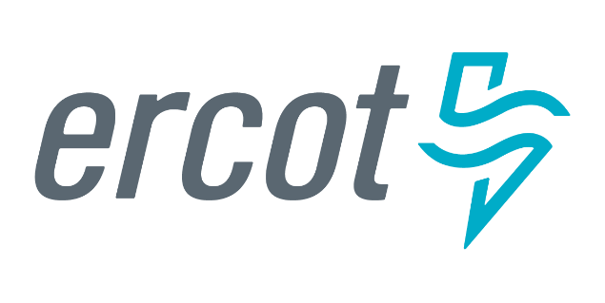 |  |  |  | System Planning
Monthly Status Report
March 2019

 |  | Report Highlights
- ERCOT is currently reviewing proposed transmission improvements with a total estimated cost of $603.59 Million as of March 31, 2019.
- Transmission Projects endorsed in 2019 total $73.21 Million as of March 31, 2019.
- All projects (in engineering, routing, licensing and construction) total approximately $5.07 Billion as of March 1, 2019.
- Transmission Projects energized in 2019 total about $89.98 Million as of March 1, 2019.

Regional Planning Group Project Reviews
- Garland Power & Light (GPL) and Oncor have jointly submitted the North Garland Reliability Infrastructure Project (N-GRIP). This is a Tier 1 project that is estimated to cost $78 million. The ERCOT independent review for this project is currently placed on hold per the request of GPL.
- AEPSC has submitted the LRGV Import Project. This is a Tier 1 project that is estimated to cost $73.4 million. AEPSC has also requested that ERCOT provide conditional endorsement for an additional $357.2 million project. This project is currently under ERCOT Independent Review.
- AEPSC has submitted the Naval Base-North Padre 69 kV Transmission Project. This is a Tier 3 project that is estimated to cost $30.9 million. This project completed the RPG review on March 5, and ERCOT has issued the acceptance letter.
- AEPSC has submitted the Pecos County Project Modification. This is a Tier 3 project that includes $2 million of additional cost due to the modification. This project completed the RPG review on March 5, and ERCOT has issued the acceptance letter.
- Sharyland has submitted the Lubbock Power and Light (LP&L) ERCOT Integration Project Alternative Modified Option 4ow. This is a Tier 3 project that includes $6.31 million of additional cost if the PUCT selects the modification alternative. This project completed the RPG review on March 8, and ERCOT has issued the acceptance letter.
- AEPSC has submitted the Refugio County Project Modification. This is a Tier 3 project that includes no additional cost due to the modification. This project completed the RPG review on March 27, and ERCOT has issued the acceptance letter.
- PEC has submitted the Burnet-Bertram-Andice Transmission Line Overhaul Project. This is a Tier 3 project that is estimated to cost $34.99 million. This project is currently under RPG study mode.
- TNMP has submitted the Ward and Winkler County Transmission Improvement Project. This is a Tier 2 project that is estimated to cost $60 million. This project has been submitted for RPG comments.

More information on current and past RPG projects can be found on the ERCOT MIS Secure (digital certificate required): https://mis.ercot.com/pps/tibco/mis/Pages/Grid+Information/RegionalPlanning
Past email communication on RPG projects can be found on the ERCOT listserve by signing up for the REGPLANGROUP list: http://lists.ercot.com/scripts/wa-ERCOT.exe?A0=REGPLANGROUP

Planning Model Activities
The short-term calendar of major planning model events is as follows:
- July 1, 2019 Post 19SSWG Base Cases and TPIT
- July 31, 2019 Post 19SSWG Contingency definitions and Planning Data Dictionary
The following table shows interconnection projects that met Planning Guide section 6.9(1) and 6.9(2) and were modeled in the SSWG cases as either complete or as a simple model in accordance with Planning Guide section 6.9.
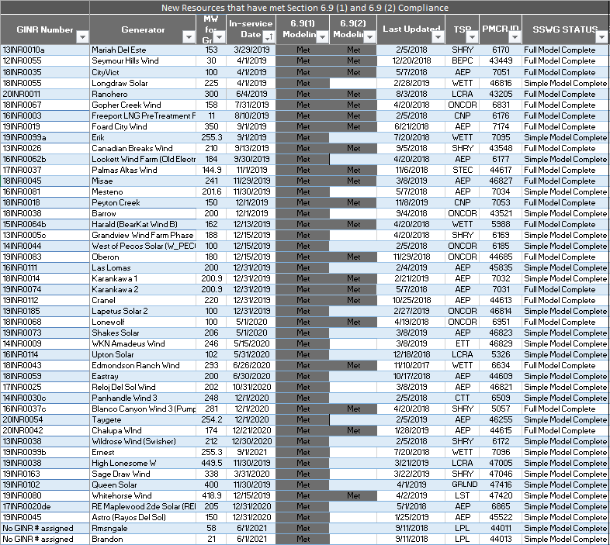

Permian Basin Oil Rig Count
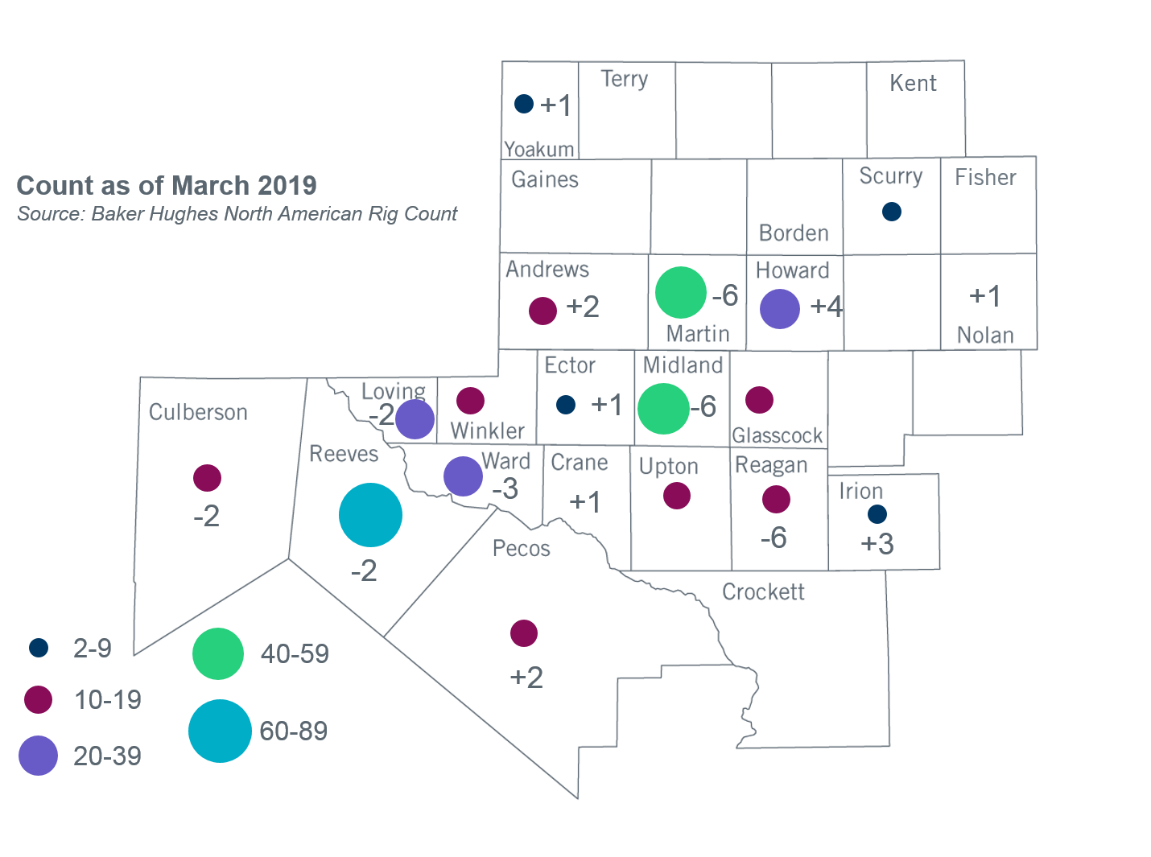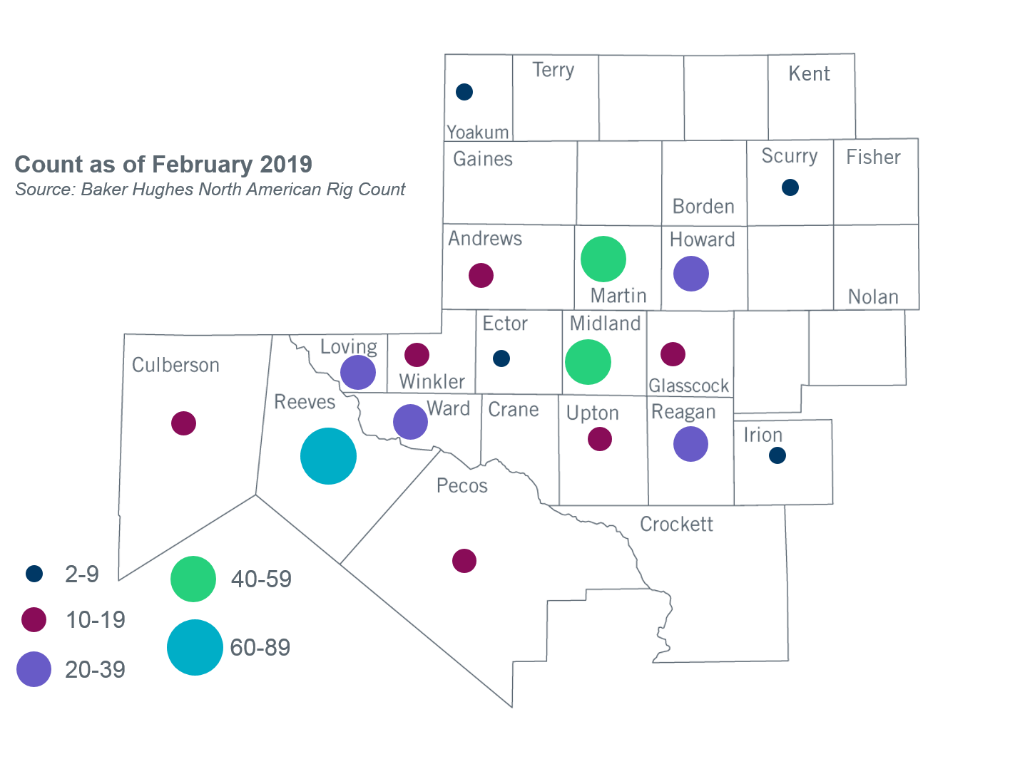

Other Notable Activities
- ERCOT has started the 2019 Regional Transmission Plan (RTP). The start cases for the 2019 RTP were posted on the MIS Secure Website on March 15, 2019.
- To address PUC Order 46304 Directive 6 and 8, ERCOT is currently conducting studies to determine what transmission upgrades, if any, are necessary to manage congestion resulting from power flows over the Southern Cross DC Tie and if the Southern Cross DC Tie should be required to provide or procure voltage support service. The studies are expected to be complete in Q2, 2019.
- As a follow up to the 2018 Panhandle and South Texas Stability and System Strength Assessment, ERCOT is currently conducting a study to assess the stability of the Panhandle region with improved PSCAD models of the transmission and generation facilities in the study region. ERCOT expects to share the results with stakeholders in May.
- ERCOT, in coordination with DWG, completed the 2019 DWG Flat Start case development.
- The SPWG completed the 2019 CY base case on March 29th and has begun the 2020-2024 Future Year (FY) case build.
- ERCOT is currently conducting the Delaware Basin area load integration study. The purpose of the study is to identify potential reliability needs and transmission upgrades for the load (planned and conceptual) that may appear in the area for the longer term planning horizon.

+/- symbol indicates the increase or decrease from the previous month in oil rigs present in each county. There are 352 rigs, including a total decrease of 9 oil rigs, in the Permian Basin from February to March 2019.

