TMTP Proposed Bank Change Language

*During the course of business it might be necessary for a Market Participant to change the banking information it is currently using.  The changes may be caused by any number of reasons including bank mergers or upgrades to newer releases of American National Standards Institute (ANSI) standards.  Additionally, these changes may result in new routing codes, account numbers, format changes to the remittance advice or other changes that would affect one party’s ability to deliver and/or reconcile invoices and payments. When a bank change is necessary, it is the responsibility of the Market Participant to inform their trading partners and coordinate with them on an appropriate time that testing can be accommodated. Since banking is point to point the ERCOT Flight Administrator is not required to be notified for a change.*

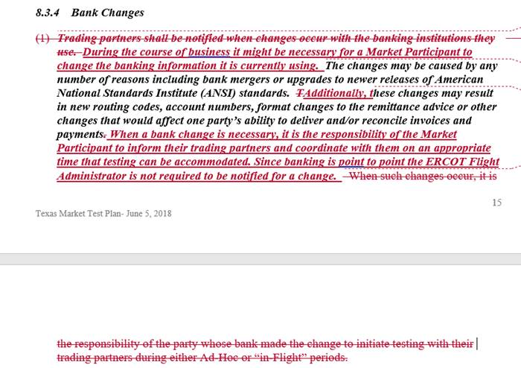

The TMTP is written more “In flight” and “ad hoc”.  I asked Paul earlier what the 10 established CRs tested in the last 2018 adhoc period.  Paul said it was either bank change or service provider change.  So the question to me is what real service do IBANK04 and ENR01 do for established SPs, certified CRs, and TDSPs?  If we all agree this is really unnecessary testing and we can simplify testing then we might suggest cutting the ad hoc language altogether.  We would have to add language in the document obligating “certified” CRs to coordinate activities with trading partners, but if its connectivity and penny that should be less time and effort for everyone.  Below is the TMPT TOC.

Texas Market Test Plan

1              OVERVIEW          4

1.1          Certification Plan              4

1.2          Texas Market Test Plan Revision 5

2              PRE-FLIGHT ACTIVITIES  5

3              STANDARDS       6

4              FLIGHT RESPONSIBILITIES             7

4.1.1      Prior to Testing 7

4.1.2      During ERCOT’s Technical Certification Testing (Occurs during Business Hours on a Retail Business Day)                8

4.1.3      Production          9

5              FLIGHT ADMINISTRATOR REQUIREMENTS             10

6              ESCALATION PROCEDURES          11

7              RETAIL TESTING WEBSITE              11

7.1          Testing Worksheet          12

7.1.1      Contacts              12

7.1.2      Exceptions to the Test Plan          12

7.1.3      Manually-Assisted Processes      13

7.2          Testing to Production Checklist  13

8              FLIGHT DEFINITIONS, REQUIREMENTS AND SCHEDULE    13

8.1          Flight Schedule 13

8.2          In-Flight Period 13

8.2.1      New Market Participant 14

8.2.2      Retail Market Subcommittee (RMS) Approved Market Enhancements      14

8.2.3      New Service Territory/ New Trading Partnership 14

8.2.4      Market Participant Changes to a Non-Established Market Interface Service Provider         14

8.3          Ad Hoc Period   14

8.3.1      Current Market Participant adds a new additional Data Universal Numbering System (DUNS) Number by certified Retail Electric Provider (REP)              15

8.3.2      New Service Territory/ New Trading Partnership 15

8.3.3      Current Market Participant Changes to an “Established” Market Interface Service Provider                15

8.3.4      Bank Changes    15

8.3.5      Additional Functionality 16

8.4          Payment Type Changes 16

8.5          System Change 16

8.6          Emergency or Out-of-Flight Changes       16

8.7          Other testing requirements        17

9              APPENDICES      17

Appendix A - Testing Worksheet 17

Appendix B - Resources 17

Appendix D - Texas Retail Market Test Bed Load Form     18

Appendix E - Testing Requirements Matrix           18

Appendix F – Glossary of Terms & Acronyms Used in this Document not defined in Section 2 of the ERCOT Protocols                18

Appendix G – Approved Test Flights Schedule     19