

February 2019 ERCOT Monthly Operations Report

Reliability and Operations Subcommittee Meeting

April 4, 2019

Table of Contents

1. Report Highlights 2

2. Frequency Control 3

2.1. Frequency Events 3

2.2. Responsive Reserve Events 4

2.3. Load Resource Events 4

3. Reliability Unit Commitment 4

4. Wind Generation as a Percent of Load 5

5. Largest Net-Load Ramp 5

6. COP Error Analysis 6

7. Congestion Analysis 8

7.1. Notable Constraints 8

7.2. Generic Transmission Constraint Congestion 11

7.3. Manual Overrides 11

7.4. Congestion Costs for Calendar Year 2019 11

8. System Events 13

8.1. ERCOT Peak Load 13

8.2. Load Shed Events 13

8.3. Stability Events 13

8.4. Notable PMU Events 13

8.5. DC Tie Curtailment 13

8.6. TRE/DOE Reportable Events 13

8.7. New/Updated Constraint Management Plans 13

8.8. New/Modified/Removed RAS 13

8.9. New Procedures/Forms/Operating Bulletins 14

9. Emergency Conditions 14

9.1. OCNs 14

9.2. Advisories 14

9.3. Watches 14

9.4. Emergency Notices 14

10. Application Performance 14

10.1. TSAT/VSAT Performance Issues 14

10.2. Communication Issues 14

10.3. Market System Issues 14

11. Model Updates 15

Appendix A: Real-Time Constraints 17

# Report Highlights

* The unofficial ERCOT peak for February was 53,731 MW.
* There were two frequency events in February.
* There was two instances where Responsive Reserves were deployed.
* There were two RUC commitments in February.
* Congestion in the South Load Zone (LZ) can be mostly attributed to high generation and outages. Congestion in the West LZ was mostly due to high West generation and planned outages. Congestion in the Houston area was minimal. There were 22 days on the Panhandle GTC in February.
* There were no DC Tie curtailments in February.

# Frequency Control

## Frequency Events

The ERCOT Interconnection experienced two frequency events in February, all of which resulted from a Resource trip. The average event duration was approximately 0:03:25.

A summary of the frequency events is provided below. The reported frequency events meet one of the following criteria: Delta Frequency is 60 mHz or greater; the MW loss is 350 MW or greater; resource trip event triggered RRS deployment. Frequency events that have been identified as Frequency Measurable Events (FME) for purposes of BAL-001-TRE-1 analysis are highlighted in blue. When analyzing frequency events, ERCOT evaluates PMU data according to industry standards. Events with an oscillating frequency of less than 1 Hz are considered to be inter-area, while higher frequencies indicate local events. Industry standards specify that damping ratio for inter-area oscillations should be 3.0% or greater. For the frequency events listed below, the ERCOT system met these standards and transitioned well after each disturbance.

|  |  |  |  |  |  |  |  |  |  |  |
| --- | --- | --- | --- | --- | --- | --- | --- | --- | --- | --- |
| **Date and Time** | **Delta Frequency** | **Max/Min Frequency** | **Duration of Event[1]** | **PMU Data[2]** | | | **MW Loss** | **Load** | **Wind** | **Inertia** |
| **(Hz)[3]** | **(Hz)** | **Oscillation Mode (Hz)** | | **Damping Ratio** | **(MW)** | **%** | **(GW-s)[4]** |
| 2/26/2019 6:30 | 0.105 | 59.904 | 0:03:20 | No PMU Data Available | | | 413.763 | 38,219 | 26% | 211,523 |
| 2/26/2019 19:21 | 0.146 | 59.877 | 0:03:29 | 0.69 | 6.0% | | 658.199 | 39,847 | 18% | 218,029 |

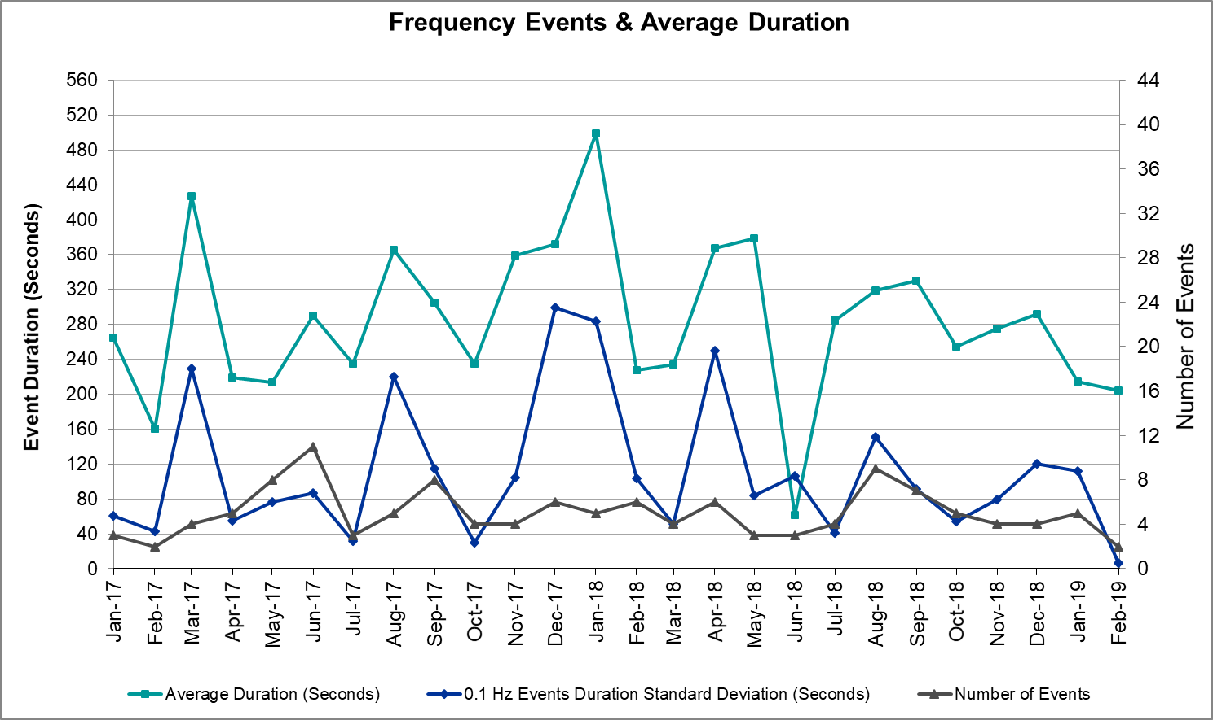

(Note: All data on this graph encompasses frequency event analysis based on BAL-001-TRE-1.)

## Responsive Reserve Events

There were two event where Responsive Reserve MWs were released to SCED in February. The events highlighted in blue were related to frequency events reported in Section 2.1 above.

|  |  |  |  |  |
| --- | --- | --- | --- | --- |
| **Date and Time Released to SCED** | **Date and Time Recalled** | **Duration of Event** | **Maximum MWs Released** | **Comments** |
| 2/26/2019 6:30 | 2/26/2019 6:33 | 00:02:28 | 53 |  |
| 2/26/2019 19:22 | 2/26/2019 19:24 | 00:02:28 | 465 |  |

## Load Resource Events

None.

# Reliability Unit Commitment

ERCOT reports on Reliability Unit Commitments (RUC) on a monthly basis. Commitments are reported grouped by operating day and weather zone. The total number of hours committed is the sum of the hours for all the units in the specified region. Additional information on RUC commitments can be found on the MIS secure site at Grid 🡪 Generation 🡪 Reliability Unit Commitment.

There were no DRUC commitments in February.

There were two HRUC commitments in February.

|  |  |  |  |  |  |
| --- | --- | --- | --- | --- | --- |
| **Resource Location** | **# of Resources** | **Operating Day** | **Total # of Hours Committed** | **Total MWhs** | **Reason for Commitment** |
| Southern | 1 | 2/10/2019 | 11 | 3,527 | XWHI58 |
| East | 1 | 2/19/2019 | 3 | 1,506 | DENTSCS5 |

# Wind Generation as a Percent of Load



Wind Generation Record: 19,672 MW on 01/21/2019 at 19:19

Wind Penetration Record: 56.16% on 01/19/2019 03:10

# Largest Net-Load Ramp

The net-load ramp is defined as the change in net-load (load minus wind and PVGR generation) during the defined time horizon. Such a variation in net-load needs to be accommodated in grid operations to ensure that the reliability of the grid is satisfactorily maintained. The largest net-load ramp during 5-min, 10-min, 15-min, 30-min and 60-min in Feb. 2019 is 1092 MW, 1787 MW, 2393 MW, 3712 MW, and 6540 MW, respectively. The comparison with respect to the historical values is given in the table below.

|  |  |  |  |  |  |
| --- | --- | --- | --- | --- | --- |
| **Month and Year** | **5 min** | **10 min** | **15 min** | **30 min** | **60 min** |
| Feb. 2019 | 1092 MW | 1787 MW | 2393 MW | 3712 MW | 6540 MW |
| Feb. 2018 | 1494 MW | 1706 MW | 2003 MW | 3419 MW | 5628 MW |
| Feb. 2017 | 1051 MW | 1744 MW | 2268 MW | 3228 MW | 5346 MW |
| Feb. 2016 | 999 MW | 1658 MW | 2144 MW | 3504 MW | 5923 MW |
| Feb. 2015 | 1131 MW | 1763 MW | 2470 MW | 4031 MW | 6910 MW |
| Feb. 2014 | 971 MW | 1610 MW | 2164 MW | 3516 MW | 5960 MW |
| 2014-2018 | 1494 MW | 1991 MW | 2780 MW | 4109 MW | 7218 MW |

# COP Error Analysis

COP Error is calculated as the capacity difference between the COP HSL and real-time HSL of the unit. Mean Absolute Error (MAE) stayed high over 8,000 MW until Day-Ahead at 12:00, then dropped significantly to 2,032 MW by Day-Ahead at 14:00. In the following chart, Under-Scheduling Error indicates that COP had less generation capacity than real-time and Over-Scheduling Error indicates that COP had more generation capacity than real-time. Under-Scheduling persisted from beginning of Day-Ahead to end of the Operating Day. Snapshot on the Operating Day considers all Operating Hours, including past hours. However, COP error for the Operating Hour freezes after the Adjustment Period.

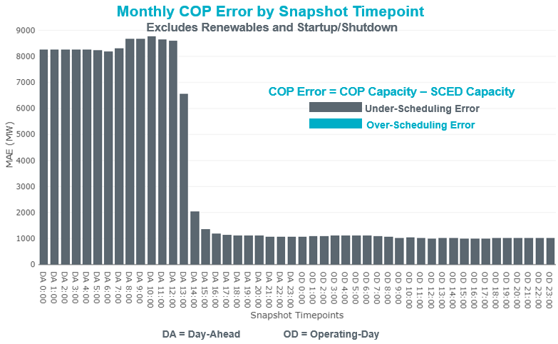

Monthly MAE for the Latest COP at the end of the Adjustment Period was 1,029 MW with median ranging from -1,124 MW for Hour-Ending (HE) 6 to -843 MW for HE 14. February 20th HE 19 had the largest Over-Scheduling Error (160 MW) and February 28th HE 10 had the largest Under-Scheduling Error (-3,462 MW).

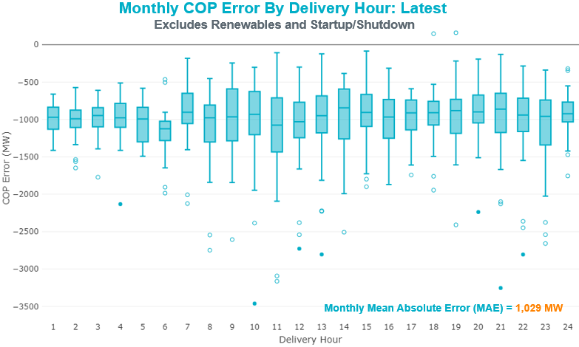

Monthly MAE for the Day-Ahead COP at 12:00 was 8,606 MW with median ranging from -9,796 MW for Hour-Ending (HE) 12 to -4,272 MW for HE 2. February 4th HE 24 had the largest Over-Scheduling Error (-685 MW) and February 8th HE 10 had the largest Under-Scheduling Error (-19,763 MW).

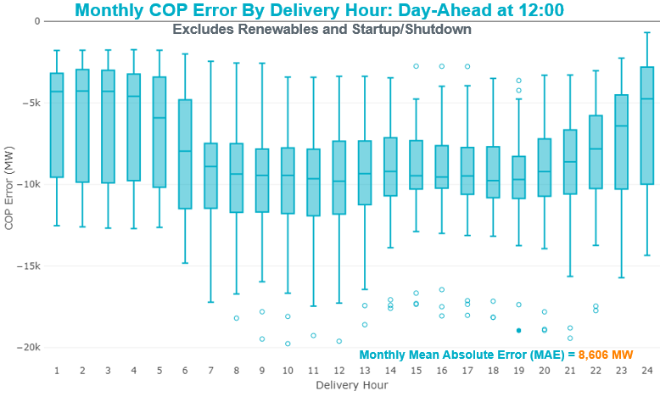

# Congestion Analysis

The total number of congestion events experienced by the ERCOT system increased slightly in February. There were 22 instances over 22 days on the Generic Transmission Constraints (GTCs) in February.

## Notable Constraints

Nodal protocol section 3.20 specifies that ERCOT shall identify transmission constraints that are active or binding three or more times within a calendar month. As part of this process, ERCOT reports congestion that meets this criterion to ROS. In addition ERCOT also highlights notable constraints that have an estimated congestion rent exceeding $1,000,000 for a calendar month. These constraints are detailed in the table below. Rows highlighted in blue indicate the congestion was affected by one or more outages. For a list of all constraints activated in SCED for the month of February, please see Appendix A at the end of this report.

|  |  |  |  |  |
| --- | --- | --- | --- | --- |
| **Contingency Name** | **Overloaded Element** | **# of Days Constraint Active** | **Congestion Rent** | **Transmission Project** |
| Elmcreek-Skyline 345kV | Hill Country - Marion 345kV | 5 | $26,958,430.36 |  |
| Manual LOTEBUSH toYUCSW 138 kV | 16th Street Tnp - Woodward 2 138kV | 13 | $5,781,930.22 | Lynx: Expand 138 kV station (45503) & Far West Texas Project |
| DMTSW-SCOSW 345KV | Knapp - Scurry Chevron 138kV | 17 | $5,475,694.21 | Ennis Creek - Cogdell 69 kV Line (4554) & Ennis Creek 138 kV Switching Station (6269) |
| Bighil-Kendal 345kV | Hamilton Road - Maverick 138kV | 23 | $4,118,598.53 | Brackettville to Escondido: Construct 138 kV line (5206) |
| Solstice to LINTERNA LIN 1 | Barrilla - Fort Stockton Switch 69kV | 27 | $3,967,313.65 | Rio Pecos – Fort Stockton - Barilla 138 kV line upgrade (7027, 7028, 44359, 44361) |
| McCampbell to PORTLAND LIN 1 | Whitepoint 138/69kV | 6 | $2,721,422.03 | Whitepoint: Install 100 MVAR Reactor (6165) |
| Basecase | PNHNDL GTC | 22 | $2,637,661.46 | LP&L Integration Tie Lines (43367 A,B,C) and Panhandle Loop |
| CRLNW-LWSSW 345kV | Cooper Creek Substation - Arco 138kV | 11 | $2,110,532.06 | 138kV Cooper Creek - Arco Line Reconstruction (44181) |
| Bighil-Kendal 345kV | Yellow Jacket - Treadwell 138kV | 13 | $2,058,330.96 |  |
| Entpr-Trses & Mlses-Scses 345kV | Lufkin Switch - Nacogdoches South Tap 138kV | 8 | $1,506,213.16 | Lufkin Sw. Sta. - Herty North Sw. Sta. 345 kV Line (5475) & Nacogdoches Southeast_HertyN 345kV Line (5467) |
| TWR (345) HLJ-WAP64 & BLY-WAP72 | Dow Chemical - South Texas Project 345kV | 4 | $930,326.89 | Freeport Master Plan |
| Fergus-Granmo&Wirtz-Starck 138kV | Flat Rock Lcra - Wirtz 138kV | 24 | $884,548.39 | Wirtz to FlatRock to Paleface Transmission Line Upgrade (4465) |
| wett_sand_bluff to wett_bearkat LIN 1 | Einstein - St. Lawrence 138kV | 6 | $806,144.91 | WETT Bearkat Area Transmission Improvements Project |
| Manual LOTEBUSH toYUCSW 138 kV | Woodward 2 - Rio Pecos 138kV | 11 | $768,227.51 | Lynx: Expand 138 kV station (45503) |
| TWR (345) WHITE_PT-LON_HILL & STP | Blessing - Lolita 138kV | 8 | $461,505.72 |  |
| SAN MIGUEL 345_138 KV SWITCHYARDS to LOBO LIN 1 | North Laredo Switch - Piloncillo 138kV | 7 | $431,940.68 |  |
| FLAT TOP TNP to Pig Creek LIN 2 | Musquiz - Country Road 101 Tap 138kV | 14 | $328,326.02 | Pig Creek to County Road 101: Rebuild 138 kV line (7046) |
| BLESSING TRX 1382 345/138 | Sargent Sub - Franklins Camp Sub 69kV | 4 | $306,437.29 | Sargent Road 345/138 kV autotransformer (11TPIT0034) |
| Bighil-Kendal 345kV | Escondido - Ganso 138kV | 9 | $288,865.87 | Brackettville to Escondido: Construct 138 kV line (5206) |
| JARDIN to DILLEY SWITCH AEP LIN 1 | Dilley Switch Aep - Cotulla Sub 69kV | 3 | $181,644.23 | Rebuild Dilley to Cotulla 69 kV line (5222) |
| NORTH EDINBURG TRX 1382 345/138 | North Edinburg 345/1kV | 3 | $171,506.14 | Stewart Road: Construct 345 kV cut-in (5604) |
| Pig Creek to Solstice LIN 1 | Woodward 2 - Rio Pecos 138kV | 18 | $129,102.44 | Lynx: Expand 138 kV station (45503) |
| SUN SWITCH to SCURRY SWITCH LIN 1 | Aspermont Aep - Aspermont Continental 69kV | 18 | $128,414.08 | Aspermont: Replace the 138/69 kV autotransformer (6569) |
| Pig Creek to Solstice LIN 1 | Airport Tnp - 16th Street Tnp 138kV | 13 | $119,304.57 | Far West Texas Project |
| BOWMAN SWITCH TRX BOMSW_3_1 345/138 | Bowman Switch 138/1kV | 3 | $116,946.47 | Brackettville to Escondido: Construct 138 kV line (5206) |
| HAMILTON ROAD to WHITING LIN 1 | Hamilton Road - Maverick 138kV | 8 | $110,857.73 | Brackettville to Escondido: Construct 138 kV line (5206) |
| Bighil-Kendal 345kV | Sonora 138/69kV | 3 | $103,660.85 | Carver: Build new 138 kV station (5979) |
| DMTSW-SCOSW 345KV | Morgan Creek Ses - Sun Switch 138kV | 10 | $95,816.93 |  |
| Bighil-Kendal 345kV | San Angelo Power Station - Treadwell 138kV | 3 | 83,732 |  |
| Bighil-Kendal 345kV | Yellow Jacket - Fort Mason 138kV | 3 | $60,262.39 | Yellowjckt to Menard Phillips T 69 kV line: Rebld 69 kV line (6345) Mason to Fort Mason: Rebuild 69 kV line (5794) - 138 kV conversion |
| FORT MASON to YELLOW JACKET LIN 1 | Mason Aep - Fredricksburg Phillips Tap 69kV | 3 | $59,470.68 | Yellowjckt to Menard Phillips T 69 kV line: Rebld 69 kV line (6345) Mason to Fort Mason: Rebuild 69 kV line (5794) - 138 kV conversion |
| KLEBERG AEP to LOYOLA SUB LIN 1 | Loyola Sub 138/69kV | 4 | $38,823.80 |  |
| RIO HONDO to LAS PULGAS LIN 1 | Raymondville 2 138/69kV | 3 | $17,461.18 | Harlingen SS- Raymondville #2: Convert to 138 kV (6167) |
| SCURRY SWITCH to SALT CREEK BEPC LIN 1 | Aspermont Aep - Aspermont Continental 69kV | 3 | $16,981.24 | Aspermont: Replace the 138/69 kV autotransformer (6569) |
| Basecase | Randado Aep - Zapata 138kV | 7 | $5,865.99 | Zapata Reactor (44393) |
| FORT LANCASTER to ILLINOIS #4 LIN 1 | Hamilton Road - Maxwell 138kV | 5 | $4,952.86 | Brackettville to Escondido: Construct 138 kV line (5206) |
| LAQUINTA to LOBO LIN 1 | Bruni Sub 138/69kV | 3 | $4,463.93 | Holland 69 kV Capacitors (5805) |
| Solstice to LINTERNA LIN 1 | Fort Stockton Plant 138/69kV | 9 | $4,362.79 | Ft. Stockton SW to Rio Pecos: Rebuild 69 kV line (7027,7028) |
| Basecase | Lakeway - Marshall Ford 138kV | 3 | $3,281.54 | T180 Lakeway - Marshall Ford MLSE Upgrade (7163) |
| TWR (345) WHITE_PT-LON_HILL & STP | Pettus - Normanna 69kV | 3 | $1,470.22 | Beeville Area Upgrades - Approved Tier 1 Project Borglum: Construct a new 138/69 kV station (5165), Borglum to Three Rivers: Rebuild 69 kV line (5166), Borglum to Tuleta: Build new double circuit 138/69 kV line (5167) |

## Generic Transmission Constraint Congestion

There were 22 days on the Panhandle GTC in February. There was no activity on the remaining GTCs during the month.

Note: This is how many times a constraint has been activated to avoid exceeding a GTC limit, it does not imply an exceedance of the GTC occurred or that the GTC was binding.

## Manual Overrides

None.

## Congestion Costs for Calendar Year 2019

The following table represents the top twenty active constraints for the calendar year based on the estimated congestion rent attributed to the congestion. ERCOT updates this list on a monthly basis.

|  |  |  |  |  |
| --- | --- | --- | --- | --- |
| **Contingency** | **Binding Element** | **# of 5-min SCED Intervals** | **Estimated Congestion Rent** | **Transmission Project** |
| Elmcreek-Skyline 345kV | Hill Country - Marion 345kV | 961 | 26,958,430.36 |  |
| CAGNON to KENDALL LIN 1 | Cico - Comfort 138kV | 2,419 | 8,793,616.72 | Boerne Cico - Comfort - Kendall Transmission Line Upgrade (6982) |
| DMTSW-SCOSW 345KV | Knapp - Scurry Chevron 138kV | 2,142 | 7,632,029.06 | Ennis Creek - Cogdell 69 kV Line (4554) & Ennis Creek 138 kV Switching Station (6269) |
| WHITEPOINT TRX 345A 345/138 | Lon Hill 345/1kV | 744 | 6,251,701.79 | Lon Hill: Replace 345/138 kV autotransformers (6106) |
| Manual LOTEBUSH toYUCSW 138 kV | 16th Street Tnp - Woodward 2 138kV | 1,943 | 5,781,930.22 | Far West Texas Project |
| ODESSA EHV SWITCH to MOSS SWITCH LIN _A | Woodward 2 - Rio Pecos 138kV | 1,256 | 5,125,308.07 | Lynx: Expand 138 kV station (45503) |
| Bighil-Kendal 345kV | Hamilton Road - Maverick 138kV | 4,480 | 4,995,191.88 | Brackettville to Escondido: Construct 138 kV line (5206) |
| Solstice to LINTERNA LIN 1 | Barrilla - Fort Stockton Switch 69kV | 8,670 | 4,649,703.09 | Barrilla Junction to Ft. Stockton SW: Rebuild 69 kV line (7027) |
| Entpr-Trses & Mlses-Scses 345kV | Lufkin Switch - Nacogdoches South Tap 138kV | 2,728 | 3,919,372.41 | Lufkin - Nacogdoches Southeast 138 kV Line (4827) |
| CRLNW-LWSSW 345kV | Cooper Creek Substation - Arco 138kV | 1,766 | 3,639,343.48 | 138kV Cooper Creek - Arco Line Reconstruction (44181) |
| Basecase | PNHNDL GTC | 5,655 | 2,985,846.40 | LP&L Integration Tie Lines (43367 A,B,C) and Panhandle Loop |
| McCampbell to PORTLAND LIN 1 | Whitepoint 138/69kV | 697 | 2,721,422.03 | Whitepoint: Install 100 MVAR Reactor (6165) |
| SAN MIGUEL 345_138 KV SWITCHYARDS to LOBO LIN 1 | North Laredo Switch - Piloncillo 138kV | 1,390 | 2,421,850.36 |  |
| Bighil-Kendal 345kV | Yellow Jacket - Treadwell 138kV | 2,169 | 2,371,924.13 |  |
| TWR (345) HLJ-WAP64 & BLY-WAP72 | Jones Creek - South Texas Project 345kV | 1,001 | 2,342,599.06 | Freeport Master Plan |
| TWR (345) HLJ-WAP64 & BLY-WAP72 | Dow Chemical - South Texas Project 345kV | 996 | 2,205,664.31 | Freeport Master Plan |
| ODESSA EHV SWITCH to MOSS SWITCH LIN _A | 16th Street Tnp - Woodward 2 138kV | 1,824 | 1,853,758.90 | Far West Texas Project |
| Fergus-Granmo&Wirtz-Starck 138kV | Flat Rock Lcra - Wirtz 138kV | 7,066 | 1,223,127.36 | Wirtz to FlatRock to Paleface Transmission Line Upgrade (4465) |
| Lon_Hill-Nedin 345kV&Orngrov 138kV | Falfurrias - Premont 69kV | 157 | 1,012,234.34 | Premont - Falfurrias 69 kV Line (6203) |
| Vlyso-Prssw&Vlses 345kV | Sherman Texas Inst - Bells North Poi 138kV | 630 | 934,435.84 |  |

# System Events

## ERCOT Peak Load

The unofficial ERCOT peak load[5] for the month was 53,731 MW and occurred on February 8th, during hour ending 08:00.

## Load Shed Events

None.

## Stability Events

None.

## Notable PMU Events

ERCOT analyzes PMU data for any significant system disturbances that do not fall into the Frequency Events category reported in section 2.1. The results are summarized in this section once the analysis has been completed.

|  |  |  |  |  |  |  |
| --- | --- | --- | --- | --- | --- | --- |
| **Date and Time** | **Duration of Oscillation** | **Dominant Oscillation Mode** | **Oscillation Signals** | **Max Peak to Peak Oscillation**  **(in PMUs)** | | **Comments** |
| 2/19/2019  00:13 | 32 min | 0.72 Hz | Real Power | | ~10 MW | Due to a dominant mode of 0.72 Hz, a forced oscillation originating in south Dallas excited the ERCOT North-South system mode, and PMUs in the Rio Grande Valley recorded similar oscillations during this time period. |
| Current Magnitude | | ~20 Amps |
| Voltage Angle | | ~1.5° |

## DC Tie Curtailment

None.

## TRE/DOE Reportable Events

* BPUB submitted an EOP-004 report for February 07, 2019 Reportable Event Type: Complete loss of monitoring capability.

## New/Updated Constraint Management Plans

* Updated MP_2018_07

## New/Modified/Removed RAS

None.

## New Procedures/Forms/Operating Bulletins

None.

# Emergency Conditions

## OCNs

|  |  |
| --- | --- |
| **Date and Time** | **Description** |
| 02/27/2019 12:06 | ERCOT issued an OCN for a potential extreme cold weather for operating day 3/3/2019 through 3/7/19 |

## Advisories

|  |  |
| --- | --- |
| **Date and Time** | **Description** |
| 02/03/2019 17:28 | ERCOT issued an advisory for DRUC timeline deviation. |

## Watches

None.

## Emergency Notices

None.

# Application Performance

## TSAT/VSAT Performance Issues

None.

## Communication Issues

None.

## Market System Issues

None.

# Model Updates

The Downstream Production Change (DPC) process allows ERCOT to make changes in the on-line Network Operations Model without loading a completely new model. The purpose of this process is to allow for reliable grid operations as system conditions change between designated Network Operations Model database loads. The DPC process is limited in scope to just those items listed below, with equipment ratings updates being the most common. ERCOT has seen a rise in the use of the DPC process to make on-line updates to the Network Operations Model in recent years, instead of through the standard Network Operations Model Change Request process.

* Static Line ratings (Interim Update)
* Dynamic Line ratings (non-Interim Update)
* Autotransformer ratings (non-Interim Update)
* Breaker and Switch Normal status (Interim Update)
* Contingency Definitions (Interim Update)
* RAP and RAS changes or additions (Interim Update)
* Net Dependable and Reactive Capability (NDCRC) values (Interim Update)
* Impedance Updates (non-Interim)

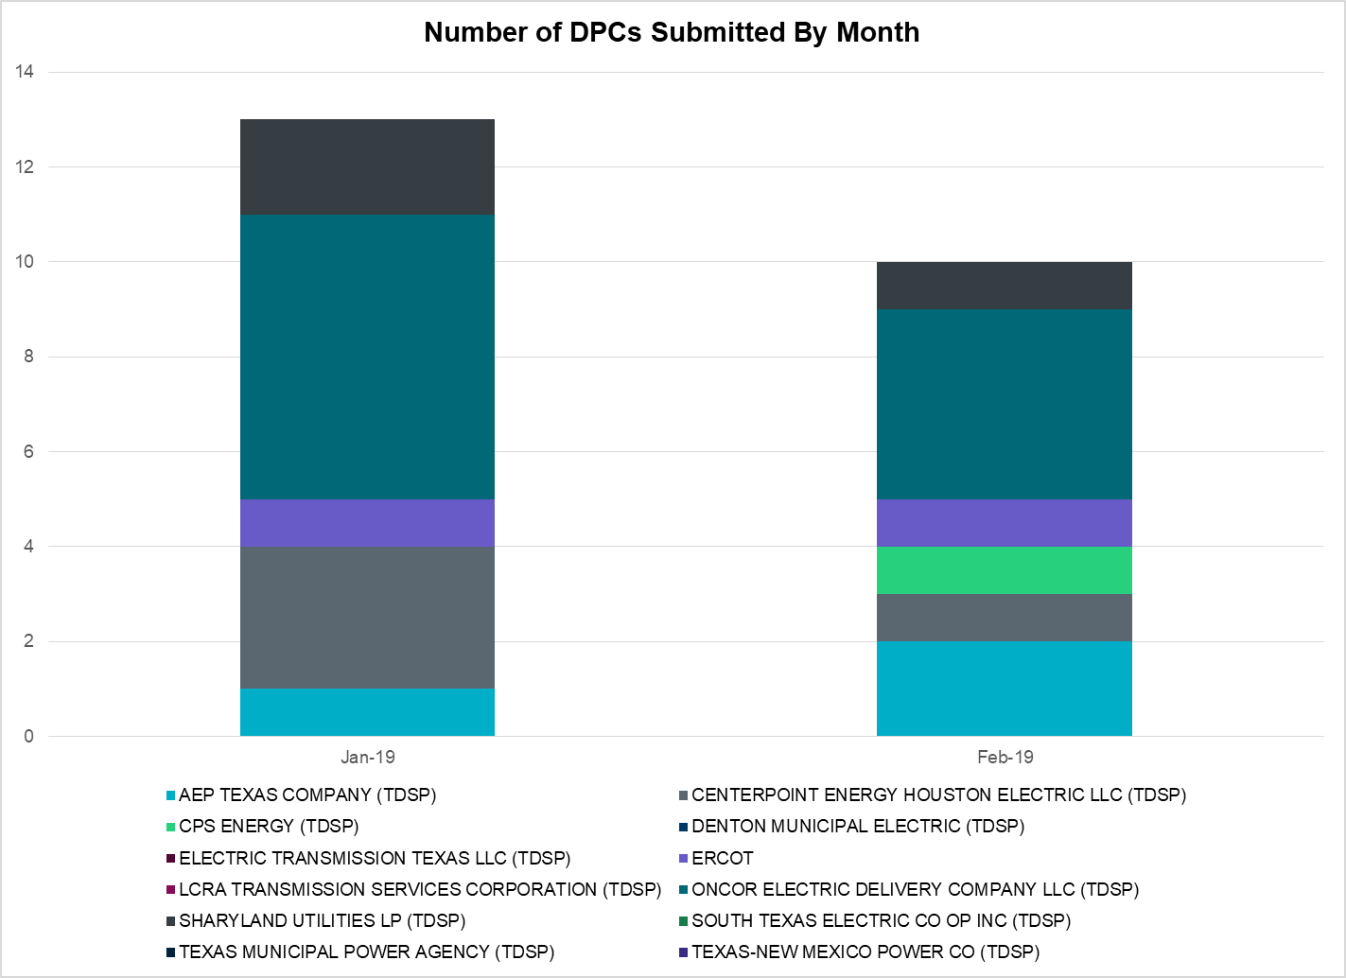

|  |  |
| --- | --- |
| **Transmission Operator** | **Number of DPCs in February** |
| AEP TEXAS COMPANY (TDSP) | 2 |
| BRAZOS ELECTRIC POWER CO OP INC (TDSP) | 0 |
| CENTERPOINT ENERGY HOUSTON ELECTRIC LLC (TDSP) | 1 |
| CPS ENERGY (TDSP) | 1 |
| DENTON MUNICIPAL ELECTRIC (TDSP) | 0 |
| ELECTRIC TRANSMISSION TEXAS LLC (TDSP) | 0 |
| ERCOT | 1 |
| LCRA TRANSMISSION SERVICES CORPORATION (TDSP) | 0 |
| ONCOR ELECTRIC DELIVERY COMPANY LLC (TDSP) | 4 |
| SHARYLAND UTILITIES LP (TDSP) | 1 |
| SOUTH TEXAS ELECTRIC CO OP INC (TDSP) | 0 |
| TEXAS MUNICIPAL POWER AGENCY (TDSP) | 0 |
| TEXAS-NEW MEXICO POWER CO (TDSP) | 0 |

# Appendix A: Real-Time Constraints

The following is a complete list of constraints activated in SCED for the month of February. Full contingency descriptions can be found in the Standard Contingencies List located on the MIS secure site at Grid 🡪 Generation 🡪 Reliability Unit Commitment.

|  |  |  |  |  |
| --- | --- | --- | --- | --- |
| **Contingency** | **Constrained Element** | **From Station** | **To Station** | **# of Days Constraint Active** |
| SWCSBOO8 | BARL_FTSW1_1 | FTSW | BARL | 27 |
| DFERSTA8 | 38T365_1 | WIRTZ | FLATRO | 24 |
| DBIGKEN5 | HAMILT_MAVERI1_1 | HAMILTON | MAVERICK | 23 |
| BASE CASE | PNHNDL | n/a | n/a | 22 |
| SSCUSU28 | ASPM_CONA1_1 | CONA | ASPM | 18 |
| SPIGSOL8 | RIOPEC_WOODW21_1 | WOODWRD2 | RIOPECOS | 18 |
| SPIGSOL8 | RIOPEC_WOODW21_1 | RIOPECOS | WOODWRD2 | 18 |
| SSCUSU28 | ASPM_CONA1_1 | ASPM | CONA | 18 |
| DMTSCOS5 | 6437__F | SCRCV | KNAPP | 17 |
| DMARPA_8 | 38T365_1 | WIRTZ | FLATRO | 16 |
| SFLAPIG8 | CR101T_MUSQUI1_1 | MUSQUIZ | CR101TAP | 14 |
| DBIGKEN5 | TREADW_YELWJC1_1 | TREADWEL | YELWJCKT | 13 |
| MLOTYUC8 | 16TH_WRD2_1 | WOODWRD2 | 16TH_ST | 13 |
| SPIGSOL8 | TNAF_TNFS_1 | TNAF | 16TH_ST | 13 |
| DCRLLSW5 | COOPERCK_ARCO_1 | COOPERCK | ARCO | 11 |
| MLOTYUC8 | RIOPEC_WOODW21_1 | RIOPECOS | WOODWRD2 | 11 |
| DMTSCOS5 | 6474__A | SUNSW | MGSES | 10 |
| SWCSBOO8 | FTST_69T1 | FTST | FTST | 9 |
| DBIGKEN5 | ESCOND_GANSO1_1 | GANSO | ESCONDID | 9 |
| DWH_STP5 | BLESSI_LOLITA1_1 | BLESSING | LOLITA | 8 |
| DENTSCS5 | 1350__E | NCSTP | LFKSW | 8 |
| SCTHHA38 | HAMILT_MAVERI1_1 | HAMILTON | MAVERICK | 8 |
| BASE CASE | RANDAD_ZAPATA1_1 | RANDADO | ZAPATA | 7 |
| SLOBSA25 | NLARSW_PILONC1_1 | NLARSW | PILONCIL | 7 |
| SPORWH28 | WHITE_PT_69A1 | WHITE_PT | WHITE_PT | 6 |
| SW_BW_25 | EINSTEN_STLAWR_1 | EINSTEIN | STLWRNCE | 6 |
| SILLFTL8 | HAMILT_MAXWEL1_1 | MAXWELL | HAMILTON | 5 |
| DELMELM5 | HILL_MAR_2_1 | MARION | HILLCTRY | 5 |
| SKLELOY8 | LOYOLA_69_1 | LOYOLA | LOYOLA | 4 |
| SPHIMIL8 | 342T195_1 | GRANMO | MARBFA | 4 |
| DWAPHLJ5 | DOWSTP27_A | STP | DOW | 4 |
| XBLE58 | SAR_FRAN_1 | FRANKC | SARGNTS | 4 |
| DBIGKEN5 | FORTMA_YELWJC1_1 | YELWJCKT | FORTMA | 3 |
| DBIGKEN5 | SONR_69-1 | SONR | SONR | 3 |
| BASE CASE | 223T180_1 | LAKEWY | MARSFO | 3 |
| XNED258 | NEDIN_138H | NEDIN | NEDIN | 3 |
| SSPUMW18 | ASPM_CONA1_1 | ASPM | CONA | 3 |
| SJARDIL8 | DIL_COTU_1 | DILLEYSW | COTULAS | 3 |
| XBOM58 | BOMSW_MR2L | BOMSW | BOMSW | 3 |
| DBIGKEN5 | SAPOWE_TREADW1_1 | SAPOWER | TREADWEL | 3 |
| SCAGKEN5 | 74T148_1 | COMFOR | CICO | 3 |
| SLAQLOB8 | BRUNI_69_1 | BRUNI | BRUNI | 3 |
| DWH_STP5 | NORMAN_PETTUS1_1 | PETTUS | NORMANNA | 3 |
| SRAYRI28 | RAYMND2_69A1 | RAYMND2 | RAYMND2 | 3 |
| SFORYEL8 | FRPHIL_MASN1_1 | MASN | FRPHILLT | 3 |
| DMLSENT5 | 1350__E | NCSTP | LFKSW | 2 |
| XWHI58 | LON_HILL_381H | LON_HILL | LON_HILL | 2 |
| DBERWE58 | 459T459_1 | KENDAL | CAGNON | 2 |
| SBRAUVA8 | HAMILT_MAVERI1_1 | HAMILTON | MAVERICK | 2 |
| SCTHHA38 | HAMILT_MAXWEL1_1 | MAXWELL | HAMILTON | 2 |
| DWIRSTA8 | 342T195_1 | GRANMO | MARBFA | 2 |
| SPHIMIL8 | 223T180_1 | LAKEWY | MARSFO | 2 |
| SWLFMON8 | 6345__B | GNTSW | SPRTP | 2 |
| DRIOHAR5 | BURNS_RIOHONDO_1 | RIOHONDO | MV_BURNS | 2 |
| SILLFTL8 | CTHR_SONR1_1 | SONR | CTHR | 2 |
| SBAKBIG5 | LINTER_SOLSTI1_1 | LINTERNA | SOLSTICE | 2 |
| SARRLOT8 | 16TH_WRD2_1 | WOODWRD2 | 16TH_ST | 2 |
| DWIRSTA8 | 223T180_1 | LAKEWY | MARSFO | 2 |
| DMARPA_8 | 43T365_1 | FLATRO | PALEPE | 2 |
| DELMTEX5 | BLESSI_LOLITA1_1 | BLESSING | LOLITA | 2 |
| SKNADM28 | 6474__A | SUNSW | MGSES | 2 |
| SCOLKEN8 | MAGRUD_VICTOR2_1 | VICTORIA | MAGRUDER | 2 |
| DWIRGRA8 | 231T323_1 | PALEPE | MARSFO | 2 |
| SARMRA38 | RAYMND2_69A1 | RAYMND2 | RAYMND2 | 2 |
| DELMSAN5 | BLESSI_LOLITA1_1 | BLESSING | LOLITA | 2 |
| SPAWSAN5 | PAWNEE_XF1 | PAWNEE | PAWNEE | 2 |
| SBOSELM5 | 1030__B | BOSQUESW | RGH | 2 |
| SSONFRI8 | HAMILT_MAXWEL1_1 | MAXWELL | HAMILTON | 2 |
| SMDLODE5 | 16TH_WRD2_1 | WOODWRD2 | 16TH_ST | 2 |
| SPLDLME8 | 6135__A | GUNSW | GYVLM | 1 |
| DENWSTE8 | 921__D | ENSSW | TRU | 1 |
| SCOLBAL8 | BALLIN_HUMBLT1_1 | BALLINGE | HUMBLTAP | 1 |
| XNC1A99 | BIGTRE_V_DUPS1_1 | V_DUPSW | BIGTRE | 1 |
| SCOLPAW5 | COLETO_ROSATA1_1 | COLETO | ROSATA | 1 |
| BASE CASE | EOLATA_PAINTR1_1 | PAINTROC | EOLATAP | 1 |
| SI_DI_38 | I_DUPP_I_DUPS1_1 | I_DUPP1 | I_DUPSW | 1 |
| SSCLWF28 | NVKSW_FMR1 | NVKSW | NVKSW | 1 |
| SARRLOT8 | RIOPEC_WOODW21_1 | RIOPECOS | WOODWRD2 | 1 |
| SBLESTP5 | SAR_FRAN_1 | FRANKC | SARGNTS | 1 |
| SMDOPHR5 | 138_ALV_MNL_1 | ALVIN | MAINLAND | 1 |
| SCLETE25 | 16TH_WRD2_1 | WOODWRD2 | 16TH_ST | 1 |
| DNAVLEG5 | 40__A | JEWET | BBSES | 1 |
| SPAIPAI8 | ASPM_CONA1_1 | ASPM | CONA | 1 |
| SBEVASH8 | BIG_BRUN_1 | BIGWELS | BRUNDGS | 1 |
| BASE CASE | CRMW1T_EDEN1_1 | CRMW1TP | EDEN | 1 |
| SBUNLON8 | FALFUR_PREMON1_1 | FALFUR | PREMONT | 1 |
| SBAKBIG5 | HAMILT_MAVERI1_1 | HAMILTON | MAVERICK | 1 |
| DJFSCGR8 | JFSSC_06_A | JFS | SC | 1 |
| SNORODE5 | LINTER_SOLSTI1_1 | LINTERNA | SOLSTICE | 1 |
| SSCLWF28 | 6840__B | NVKSW | ANARN | 1 |
| DSTPWHI5 | BLESSI_LOLITA1_1 | BLESSING | LOLITA | 1 |
| SPAIPAI8 | CONA_SHHA1_1 | SHHA | CONA | 1 |
| BASE CASE | CRMW1T_EOLATA1_1 | EOLATAP | CRMW1TP | 1 |
| BASE CASE | ESCOND_GANSO1_1 | GANSO | ESCONDID | 1 |
| SCISPUT8 | ESTES_PECAN_1_1 | PECAN_BY | ESTES | 1 |
| DBIGKEN5 | FRIR_ROCKSP1_1 | FRIR | ROCKSPRS | 1 |
| SMDOOAS5 | GN_TC_37_A | TC | GN | 1 |
| SPHIMIL8 | 32T311_1 | BURNET | BERTRA | 1 |
| DBERBO58 | 459T459_1 | KENDAL | CAGNON | 1 |
| SWLFECT8 | 6100__G | ACSSW | AMTBT | 1 |
| DELMSAN5 | COLETO_ROSATA1_1 | COLETO | ROSATA | 1 |
| SCTHHA38 | ESCOND_GANSO1_1 | GANSO | ESCONDID | 1 |
| BASE CASE | HAMILT_MAVERI1_1 | HAMILTON | MAVERICK | 1 |
| DELMSAN5 | PLESNTN_TORDLO_1 | TORDILLO | PLSNTOS | 1 |
| SW_BW_25 | RKYROAD_STILES_1 | RCKYROAD | STILES | 1 |
| SPIGSOL8 | 16TH_WRD2_1 | 16TH_ST | WOODWRD2 | 1 |
| UWOOWOO1 | 16TH_WRD2_1 | WOODWRD2 | 16TH_ST | 1 |
| DFERSTA8 | 32T311_1 | BURNET | BERTRA | 1 |
| XRAD89 | ASPM_CONA1_1 | ASPM | CONA | 1 |
| BASE CASE | BALLIN_PAINTR1_1 | BALLINGE | PAINTROC | 1 |
| SSANPIT8 | CRMW1T_EDEN1_1 | CRMW1TP | EDEN | 1 |
| DBIGKEN5 | GANSO_MAVERI1_1 | MAVERICK | GANSO | 1 |
| SHAMMAX8 | MAXWEL_WHITIN1_1 | MAXWELL | WHITING | 1 |
| SMCEESK8 | MKLT_TRNT1_1 | TRNT | MKLT | 1 |
| DSTNCPS8 | OLSE_BOS_1 | BOSQUESW | OLSEN | 1 |
| DCPSJON5 | 6017__A | MBDSW | DCSES | 1 |
| SPIGSOL8 | 6100__G | ACSSW | AMTBT | 1 |
| SSACSUN8 | 6474__A | SUNSW | MGSES | 1 |
| DELMMAR5 | HILL_MAR_2_1 | MARION | HILLCTRY | 1 |
| DELMSAN5 | MAGRUD_VICTOR2_1 | VICTORIA | MAGRUDER | 1 |
| XVI2C89 | MAGRUD_VICTOR2_1 | VICTORIA | MAGRUDER | 1 |
| DFERSTA8 | 43T365_1 | FLATRO | PALEPE | 1 |
| SWLFECT8 | 6100__F | DHIDE | NOTSW | 1 |
| SCRDLOF9 | BOW_FMR1 | BOW | BOW | 1 |
| SLKAWFS8 | BOW_FMR1 | BOW | BOW | 1 |
| DVICV_D8 | FORMOS_LOLITA1_1 | LOLITA | FORMOSA | 1 |
| SMDOPHR5 | G138_10C_1 | FRDSWOOD | SEMINOLE | 1 |
| BASE CASE | GANSO_MAVERI1_1 | MAVERICK | GANSO | 1 |
| SSPUASP8 | GIRA_T_SPUR1_1 | SPUR | GIRA_TAP | 1 |
| DBWNKLN5 | HAMILT_MAVERI1_1 | HAMILTON | MAVERICK | 1 |
| XFTS89 | LINTER_SOLSTI1_1 | LINTERNA | SOLSTICE | 1 |
| DMCEBUT8 | MKLT_TRNT1_1 | TRNT | MKLT | 1 |
| SFTLMES8 | NORTMC_SANTAR1_1 | NORTMC | SANTARIT | 1 |
| SCISPUT8 | SOUTHA_VINSON1_1 | SOUTHABI | VINSON | 1 |
| DWIRGRA8 | 32T311_1 | BURNET | BERTRA | 1 |
| DWIRGRA8 | 38T365_1 | WIRTZ | FLATRO | 1 |
| DMTSCOS5 | 6437__A | KNAPP | BCKSW | 1 |
| DBIGKEN5 | BALLIN_PAINTR1_1 | BALLINGE | PAINTROC | 1 |
| SOXYIN28 | I_DUPP_I_DUPS2_1 | I_DUPP1 | I_DUPSW | 1 |
| DWH_STP5 | VICTO_WARBU_1A_1 | VICTORIA | WARBURTN | 1 |

1. The Duration of Event is defined as the time it takes for the frequency to recover to pre-disturbance frequency or 60 Hz as applicable.
2. PMU reports are typically generated when frequency drops below 59.9, but PMU data is available for other events.
3. Delta Frequency is defined as the difference between the starting point of the frequency event (t(0) or “A-point”) and minimum/maximum frequency (“C-Point”).
4. Currently, the Critical Inertia Level for ERCOT is approximately 100,000 MW-s (Source: link)
5. This is the hourly integrated peak demand as published in the ERCOT D&E report.