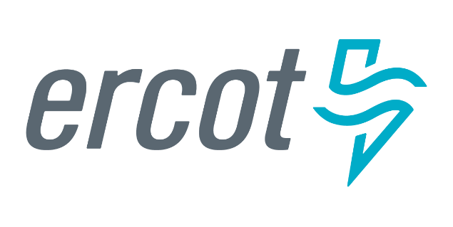 |  |  |  | System Planning
Monthly Status Report
February 2019

 |  | Report Highlights
- ERCOT is currently reviewing proposed transmission improvements with a total estimated cost of $547.81 Million as of February 28, 2019.
- Transmission Projects endorsed in 2019 total $34 Million as of February 28, 2019.
- All projects (in engineering, routing, licensing and construction) total approximately $5.07 Billion as of March 1, 2019.
- Transmission Projects energized in 2019 total about $89.98 Million as of March 1, 2019.

Regional Planning Group Project Reviews
- Garland Power & Light (GPL) and Oncor have jointly submitted the North Garland Reliability Infrastructure Project (N-GRIP). This is a Tier 1 project that is estimated to cost $78 million. The ERCOT independent review for this project is currently placed on hold per the request of GPL.
- AEPSC has submitted the LRGV Import Project. This is a Tier 1 project that is estimated to cost $73.4 million. AEPSC has also requested that ERCOT provide conditional endorsement for an additional $357.2 million project. This project is currently under ERCOT Independent Review.
- Sharyland Utilities has submitted a request to withdraw the Driver – Einstein 138 kV Line Project. This project is no longer under ERCOT Independent Review.
- AEPSC has submitted the Naval Base-North Padre 69 kV Transmission Project. This is a Tier 3 project that is estimated to cost $30.9 million. This project has been submitted for RPG comments.
- AEPSC has submitted the Pecos County Project Modification. The Pecos County Project was originally accepted in February 2018, after the RPG review. The latest submittal is for a modification to the previously accepted project. In accordance with ERCOT Protocol Section 3.11.4.10 (1), this submittal is being processed as a Tier 3 project. The project has been submitted for RPG comments. The additional cost incurred by the modification is estimated to be $2 million.
- Sharyland has submitted the Lubbock Power and Light (LP&L) ERCOT Integration Project Alternative Modified Option 4ow. The latest submittal is for a modification to the Option 4ow project plan that was authorized by the PUCT (in Docket No. 47576). In accordance with ERCOT Protocol Section 3.11.4.10 (1), this submittal is being processed as a Tier 3 project. The project has been submitted for RPG comments. The additional cost that may be incurred if the PUCT selects the modification alternative is estimated to be $6.31 million.
- AEPSC has submitted the Refugio County Project Modification. The Refugio County Project was originally accepted in April 2017, after the RPG review. The latest submittal is for a modification to the previously accepted project. In accordance with ERCOT Protocol Section 3.11.4.10 (1), this submittal is being processes as a Tier 3 project. The project has been submitted for RPG comments. There is no additional cost incurred by the modification.

More information on current and past RPG projects can be found on the ERCOT MIS Secure (digital certificate required): https://mis.ercot.com/pps/tibco/mis/Pages/Grid+Information/RegionalPlanning
Past email communication on RPG projects can be found on the ERCOT listserve by signing up for the REGPLANGROUP list: http://lists.ercot.com/scripts/wa-ERCOT.exe?A0=REGPLANGROUP

Planning Model Activities
The short-term calendar of major planning model events is as follows:
- March 31, 2019 Post 18SSWG U2 Contingency definitions and Planning Data Dictionary
- July 1, 2019 Post 19SSWG Base Cases and TPIT
- July 31, 2019 Post 19SSWG Contingency definitions and Planning Data Dictionary
The following table shows interconnection projects that met Planning Guide section 6.9(1) and 6.9(2) and were modeled in the SSWG cases as either complete or as a simple model in accordance with Planning Guide section 6.9.
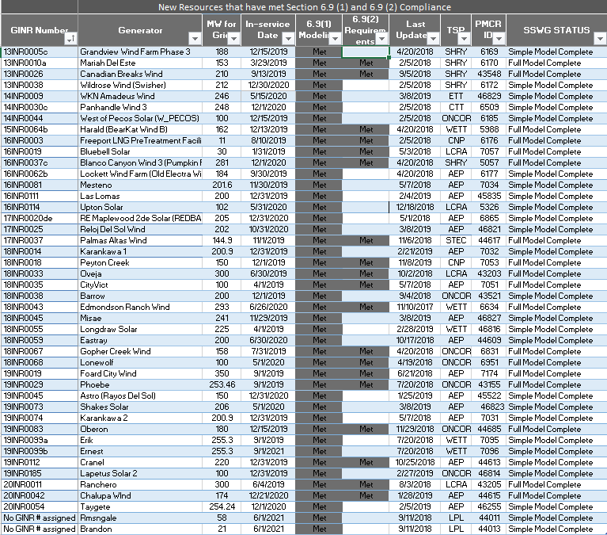

Permian Basin Oil Rig Count
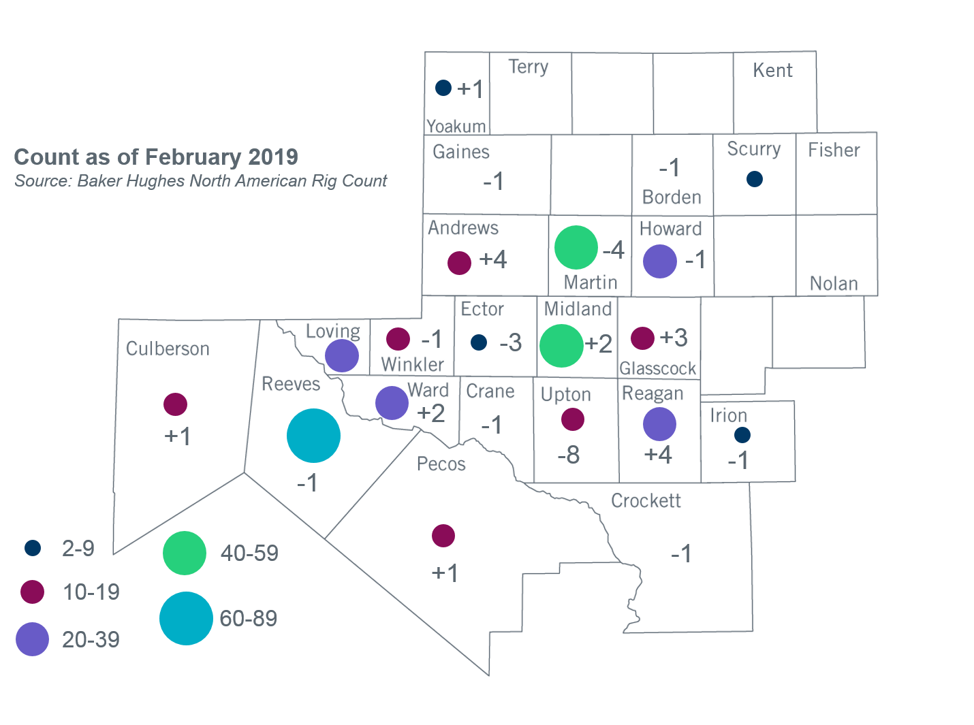
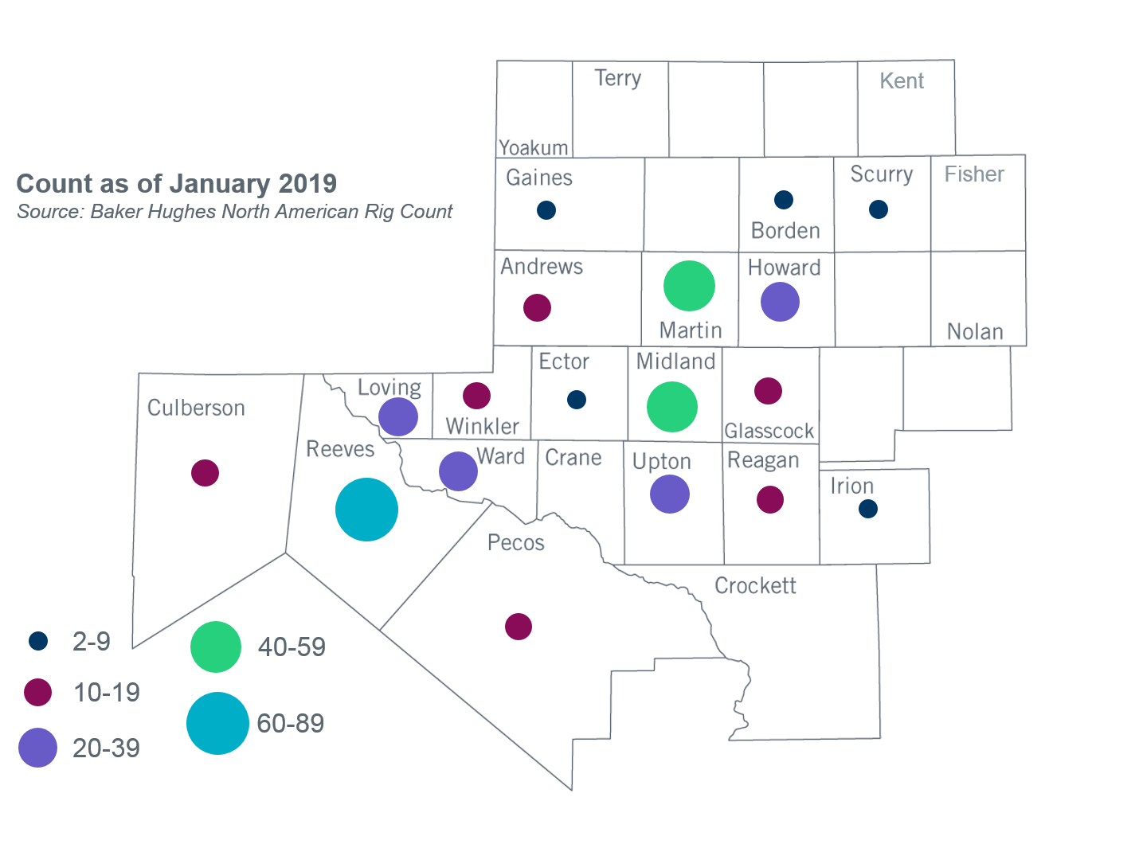

Other Notable Activities
- ERCOT has started its 2019 Regional Transmission Plan case building process. The load review process, as required by Planning Guide Section 3.1.7, is currently in progress. TSPs are requested to provide updates/justification for submitted load levels to be used in the 2019 RTP cases based on their review of ERCOT-provided load comparisons.
- To address PUC Order 46304 Directive 6 and 8, ERCOT is currently conducting studies to determine what transmission upgrades, if any, are necessary to manage congestion resulting from power flows over the Southern Cross DC Tie and if Southern Cross DC Tie should be required to provide or procure voltage support service. This study is expected to be complete in Q1, 2019.
- As a follow up to the 2018 Panhandle and South Texas Stability and System Strength Assessment, ERCOT is currently conducting a study to assess the stability of the Panhandle region with the improved detailed PSCAD models of the transmission and generation facilities in the study region. This study is expected to be complete in Q1, 2019.
- ERCOT, in coordination with DWG, has been working on finalizing the 2019 DWG Flat Start case development. This process is expected to be complete in March, 2019.
- The SPWG has begun the 2019 CY base case development.
- ERCOT is currently conducting the Delaware Basin area load integration study. The purpose of the study is to identify potential reliability needs and transmission upgrades for the load (planned and conceptual) that may appear in the area for the longer term planning horizon.

+/- symbol indicates the increase or decrease from the previous month in oil rigs present in each county. There are 361 rigs, including a total decrease of 11 oil rigs, in the Permian Basin from January to February 2019.

