January 2019 ERCOT Monthly Operations Report
Reliability and Operations Subcommittee Meeting
March 7, 2019

Table of Contents
1. Report Highlights 2
2. Frequency Control 3
2.1. Frequency Events 3
2.2. Responsive Reserve Events 4
2.3. Load Resource Events 4
3. Reliability Unit Commitment 4
4. Wind Generation as a Percent of Load 5
5. Largest Net-Load Ramp 5
6. COP Error Analysis 6
7. Congestion Analysis 8
7.1. Notable Constraints 8
7.2. Generic Transmission Constraint Congestion 11
7.3. Manual Overrides 11
7.4. Congestion Costs for Calendar Year 2019 11
8. System Events 13
8.1. ERCOT Peak Load 13
8.2. Load Shed Events 13
8.3. Stability Events 13
8.4. Notable PMU Events 13
8.5. DC Tie Curtailment 13
8.6. TRE/DOE Reportable Events 13
8.7. New/Updated Constraint Management Plans 13
8.8. New/Modified/Removed RAS 13
8.9. New Procedures/Forms/Operating Bulletins 14
9. Emergency Conditions 14
9.1. OCNs 14
9.2. Advisories 14
9.3. Watches 14
9.4. Emergency Notices 14
10. Application Performance 14
10.1. TSAT/VSAT Performance Issues 14
10.2. Communication Issues 14
10.3. Market System Issues 14
11. Model Updates 15
Appendix A: Real-Time Constraints 17

Report Highlights
- The unofficial ERCOT peak for January was 54,670 MW.
- There were five frequency events in January. PMU data indicates the ERCOT system transitioned well.
- There was one instance where Responsive Reserves were deployed.
- There were no RUC commitments in January.
- Congestion in the North and South Load Zone (LZ) can be mostly attributed to high generation and outages. Congestion in the West LZ was mostly due to high West generation and planned outages. Congestion in the Houston area was mostly due to high generation and planned outages. There were 21 days on the Panhandle GTC in January. There was no activity on the remaining GTCs during the month.
- There was one DC Tie curtailment in January.
- A new wind generation record of 19,672 MW was set on 01/21/2019 at 19:19.
- A new wind penetration record of 56.16% was set on 01/19/2019 03:10.

Frequency Control

Frequency Events
The ERCOT Interconnection experienced five frequency events in January, all of which resulted from a Resource trip. The average event duration was approximately 0:03:35.

A summary of the frequency events is provided below. The reported frequency events meet one of the following criteria: Delta Frequency is 60 mHz or greater; the MW loss is 350 MW or greater; resource trip event triggered RRS deployment. Frequency events that have been identified as Frequency Measurable Events (FME) for purposes of BAL-001-TRE-1 analysis are highlighted in blue. When analyzing frequency events, ERCOT evaluates PMU data according to industry standards. Events with an oscillating frequency of less than 1 Hz are considered to be inter-area, while higher frequencies indicate local events. Industry standards specify that damping ratio for inter-area oscillations should be 3.0% or greater. For the frequency events listed below, the ERCOT system met these standards and transitioned well after each disturbance.

Date and Time | Delta Frequency | Max/Min Frequency | Duration of Event | PMU Data |  |  | MW Loss | Load | Wind | Inertia
 | (Hz) | (Hz) |  | Oscillation Mode (Hz) |  | Damping Ratio |  | (MW) | % | (GW-s)
1/2/2019 11:25 | 0.056 | 59.912 | 0:05:05 | No PMU data available |  |  | 367.71 | 51,340 | 2% | 311,339
1/10/2019 12:14 | 0.086 | 59.909 | 0:04:34 | No PMU data available |  |  | 382.843 | 39,919 | 26% | 220,223
1/22/2019 7:05 | 0.093 | 59.870 | 0:04:36 | 0.89 | 14% |  | 657.153 | 39,573 | 36% | 182,427
1/22/2019 13:42 | 0.106 | 59.940 | 0:00:30 | No PMU data available |  |  | 461.298 | 37,908 | 37% | 195,513
1/27/2019 6:03 | 0.106 | 59.909 | 0:03:08 | No PMU data available |  |  | 294.5 | 43,559 | 19% | 257,750

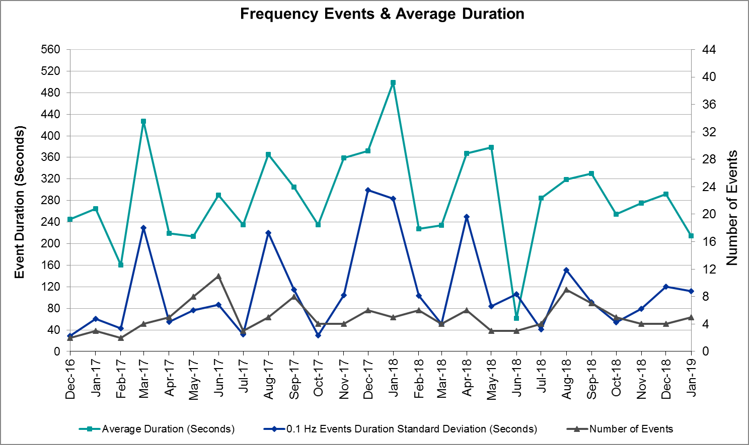
(Note: All data on this graph encompasses frequency event analysis based on BAL-001-TRE-1.)

Responsive Reserve Events
There was one event where Responsive Reserve MWs were released to SCED in January. The events highlighted in blue were related to frequency events reported in Section 2.1 above.

Date and Time Released to SCED | Date and Time Recalled | Duration of Event | Maximum MWs Released
1/22/2019 7:05 | 1/22/2019 7:10 | 00:05:00 | 729

Load Resource Events
None.

Reliability Unit Commitment
ERCOT reports on Reliability Unit Commitments (RUC) on a monthly basis. Commitments are reported grouped by operating day and weather zone. The total number of hours committed is the sum of the hours for all the units in the specified region. Additional information on RUC commitments can be found on the MIS secure site at Grid Generation Reliability Unit Commitment.

There were no DRUC commitments in January.

There were no HRUC commitments in January.

Wind Generation as a Percent of Load
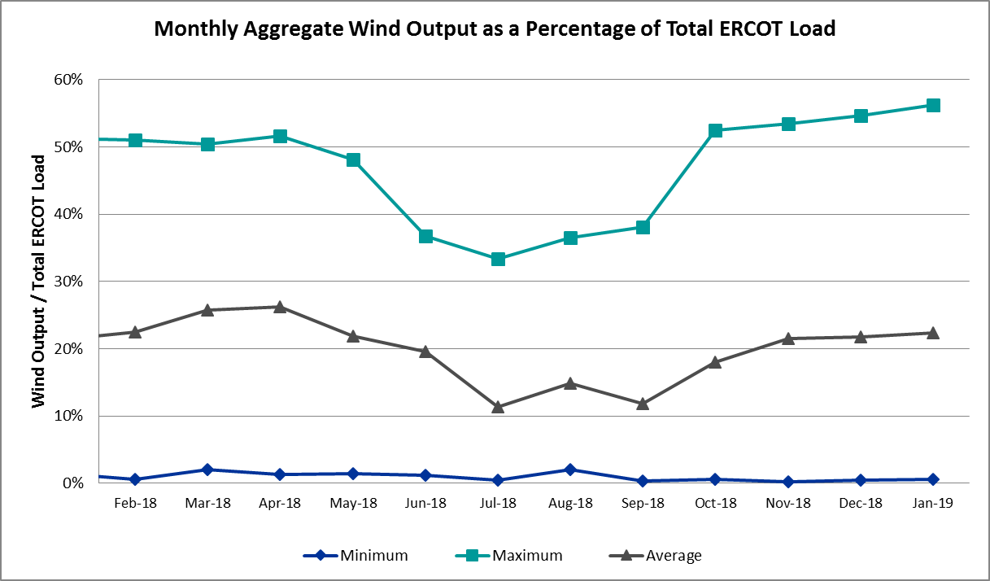

Wind Generation Record: 19,672 MW on 01/21/2019 at 19:19
Wind Penetration Record: 56.16% on 01/19/2019 03:10

Largest Net-Load Ramp
Net-load ramp is defined as the change in net-load (load minus wind and PVGR generation) during a defined time horizon. Variation in net-load needs to be accommodated in grid operations to ensure that the reliability of the grid is satisfactorily maintained. The largest net-load ramp during January for 5-min, 10-min, 15-min, 30-min and 60-min intervals in comparison to the historical values is given in the table below.

Month and Year | 5 min | 10 min | 15 min | 30 min | 60 min
Jan. 2019 | 1087 MW | 1719 MW | 2308 MW | 4033 MW | 7786 MW
Jan. 2018 | 1091 MW | 1824 MW | 2498 MW | 3901 MW | 6824 MW
Jan. 2017 | 959 MW | 1680 MW | 2160 MW | 3511 MW | 6181 MW
Jan. 2016 | 950 MW | 1548 MW | 2076 MW | 3737 MW | 6213 MW
Jan. 2015 | 1025 MW | 1609 MW | 2150 MW | 3737 MW | 6496 MW
Jan. 2014 | 891 MW | 1602 MW | 2082 MW | 3606 MW | 6340 MW
2014-2018 | 1494 MW | 1991 MW | 2780 MW | 4109 MW | 7218 MW

COP Error Analysis
COP Error is calculated as the capacity difference between the COP HSL and real-time HSL of the unit. Mean Absolute Error (MAE) stayed high over 8,000 MW until Day-Ahead at 12:00, then dropped significantly to 1,575 MW by Day-Ahead at 14:00. In the following chart, Under-Scheduling Error indicates that COP had less generation capacity than real-time and Over-Scheduling Error indicates that COP had more generation capacity than real-time. Under-Scheduling persisted from beginning of Day-Ahead to end of the Operating Day. Snapshot on the Operating Day considers all Operating Hours, including past hours. However, COP error for the Operating Hour freezes after the Adjustment Period.
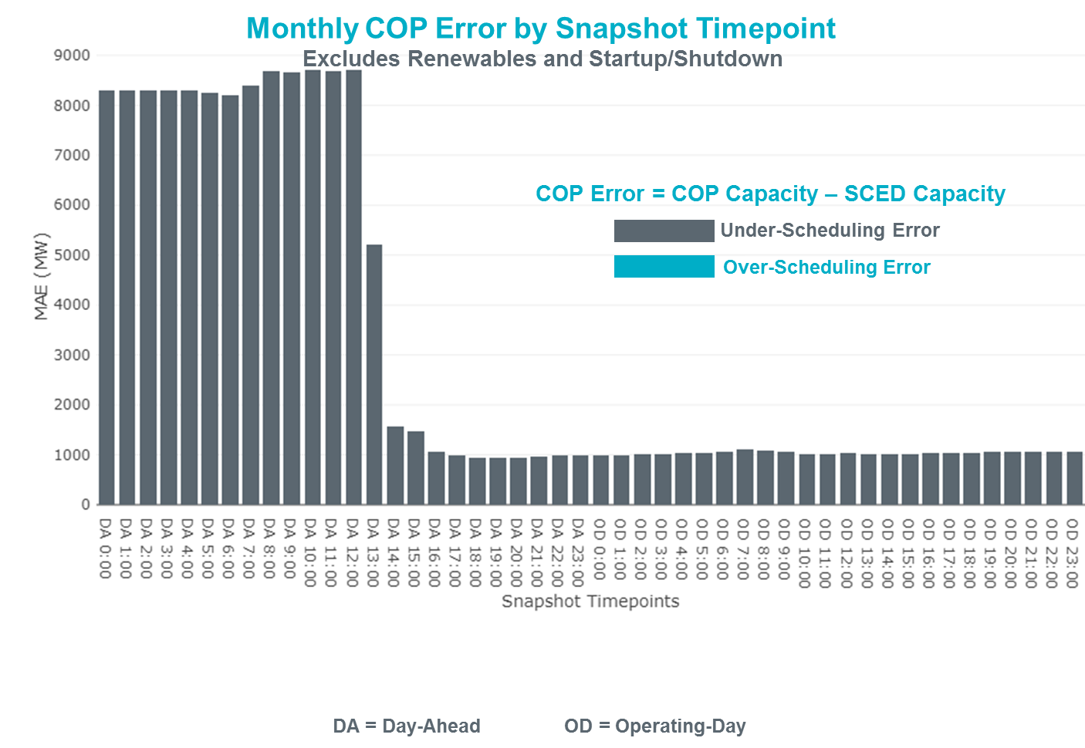
Monthly MAE for the Latest COP at the end of the Adjustment Period was 1,064 MW with median ranging from -1,223 MW for Hour-Ending (HE) 11 to -819 MW for HE 7. January 24th HE 12 had the largest Over-Scheduling Error (576 MW) and January 2nd HE 23 had the largest Under-Scheduling Error (-3,681 MW).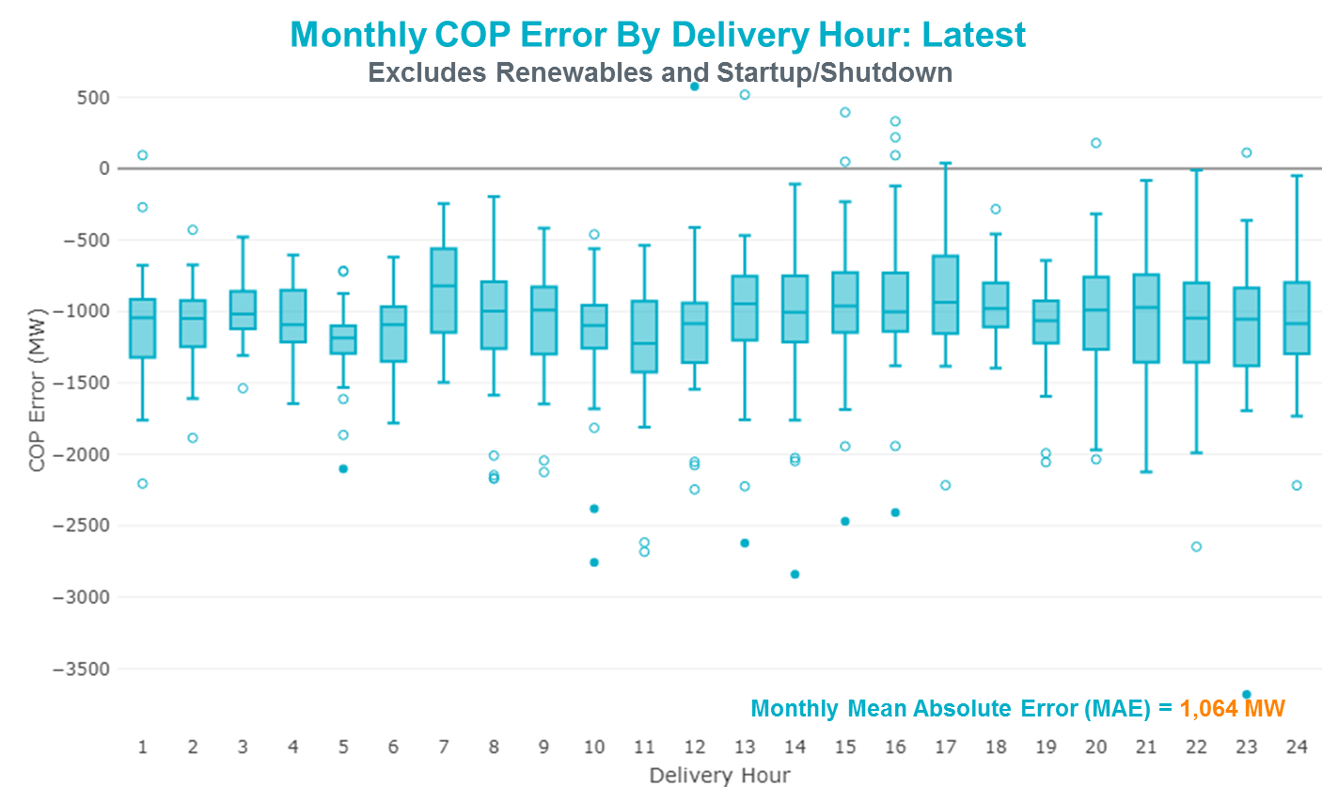
Monthly MAE for the Day-Ahead COP at 12:00 was 8,704 MW with median ranging from -10,423 MW for Hour-Ending (HE) 19 to -6,006 MW for HE 24. January 10th HE 24 had the largest Over-Scheduling Error (878 MW) and January 2nd HE 14 had the largest Under-Scheduling Error (-18,908 MW).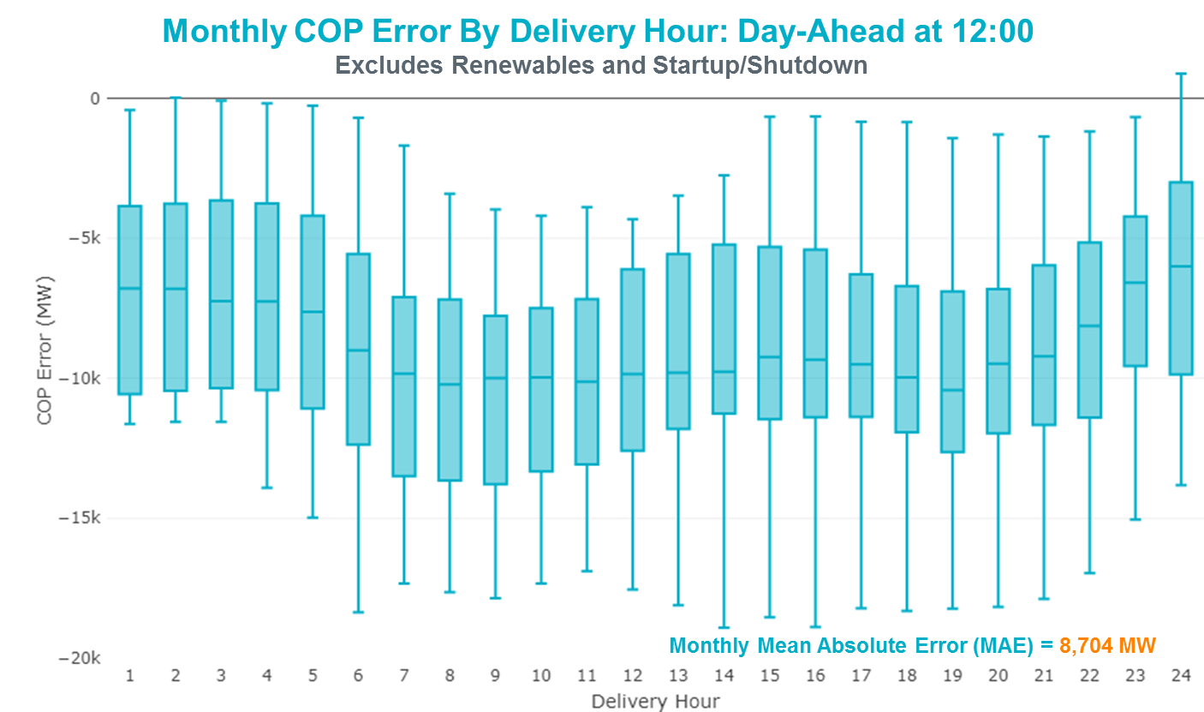

Congestion Analysis
The total number of congestion events experienced by the ERCOT system decreased in January. There were 21 instances over 21 days on the Generic Transmission Constraints (GTCs) in January.

Notable Constraints
Nodal protocol section 3.20 specifies that ERCOT shall identify transmission constraints that are active or binding three or more times within a calendar month. As part of this process, ERCOT reports congestion that meets this criterion to ROS. In addition ERCOT also highlights notable constraints that have an estimated congestion rent exceeding $1,000,000 for a calendar month. These constraints are detailed in the table below. Rows highlighted in blue indicate the congestion was affected by one or more outages. For a list of all constraints activated in SCED for the month of January, please see Appendix A at the end of this report.

Contingency Name | Overloaded Element | # of Days Constraint Active | Congestion Rent | Transmission Project
CAGNON to KENDALL LIN 1 | Cico - Comfort 138kV | 17 | $8,793,616.72 | Boerne Cico - Comfort - Kendall Transmission Line Upgrade (6982)
WHITEPOINT TRX 345A 345/138 | Lon Hill 345/1kV | 6 | $6,250,009.03
ODESSA EHV SWITCH to MOSS SWITCH LIN _A | Woodward 2 - Rio Pecos 138kV | 13 | $5,125,308.07 | Lynx: Build a 138 kV Station (5535)
Entpr-Trses & Mlses-Scses 345kV | Lufkin Switch - Nacogdoches South Tap 138kV | 18 | $2,413,159.25 | Lufkin - Nacogdoches Southeast 138 kV Line (4827)
TWR (345) HLJ-WAP64 & BLY-WAP72 | Jones Creek - South Texas Project 345kV | 7 | $2,342,599.06 | Freeport Master Plan
DMTSW-SCOSW 345KV | Knapp - Scurry Chevron 138kV | 11 | $2,156,334.84 | Ennis Creek - Cogdell 69 kV Line (4554) & Ennis Creek 138 kV Switching Station (6269)
SAN MIGUEL 345_138 KV SWITCHYARDS to LOBO LIN 1 | North Laredo Switch - Piloncillo 138kV | 9 | $1,989,909.68
ODESSA EHV SWITCH to MOSS SWITCH LIN _A | 16th Street Tnp - Woodward 2 138kV | 16 | $1,852,287.79 | Far West Texas Project
CRLNW-LWSSW 345kV | Cooper Creek Substation - Arco 138kV | 7 | $1,528,811.42 | 138kV Cooper Creek - Arco Line Reconstruction (44181)
TWR (345) HLJ-WAP64 & BLY-WAP72 | Dow Chemical - South Texas Project 345kV | 4 | $1,275,337.42 | Freeport Master Plan
Lon_Hill-Nedin 345kV&Orngrov 138kV | Falfurrias - Premont 69kV | 2 | $1,012,234.34 | Premont - Falfurrias 69 kV Line (6203)
Vlyso-Prssw&Vlses 345kV | Sherman Texas Inst - Bells North Poi 138kV | 6 | $934,435.84
CEDAR HILLS TRX T1 138/69 | Carlsbad Tap - San Angelo Grape Creek 69kV | 3 | $932,110.18
Bighil-Kendal 345kV | Hamilton Road - Maverick 138kV | 10 | $876,593.35 | Brackettville to Escondido: Construct 138 kV line (5206)
ERALIO TAP to SKIDMORE LIN 1 | Sandia Sub - Casa Blanca 69kV | 3 | $761,440.78
Solstice to LINTERNA LIN 1 | Barrilla - Fort Stockton Switch 69kV | 28 | $682,389.45 | Far West Texas Project
KLEBERG AEP to LOYOLA SUB LIN 1 | Loyola Sub 138/69kV | 12 | $635,593.69
COMANCHE SWITCH (Oncor) to COMANCHE PEAK SES LIN _A | Comanche Tap - Comanche Switch (Oncor) 138kV | 3 | $598,342.53
COLETO CREEK to PAWNEE SWITCHING STATION LIN 1 | Coleto Creek - Rosata Tap 138kV | 6 | $440,313.08
SOUTH LANE CITY to LANE CITY LIN 1 | Sargent Sub - Franklins Camp Sub 69kV | 8 | $424,241.14
Basecase | PNHNDL GTC | 21 | $348,184.93 | LP&L Option 4ow & Panhandle Loop (5180, 5208)
NORTH EDINBURG TRX 1382 345/138 | North Edinburg 345/1kV | 3 | $340,655.80 | Stewart Road: Construct 345 kV cut-in (5604)
Fergus-Granmo&Wirtz-Starck 138kV | Flat Rock Lcra - Wirtz 138kV | 24 | $338,578.97 | Wirtz to FlatRock to Paleface Transmission Line Upgrade (4465)
Bighil-Kendal 345kV | Yellow Jacket - Treadwell 138kV | 12 | $313,593.16 | Treadwell: Build temporary tap (6396)
WOODWARD 1 TRX XF 138/35 | 16th Street Tnp - Woodward 2 138kV | 3 | $263,530.06 | Far West Texas Project
COLETO CREEK to PAWNEE SWITCHING STATION LIN 1 | Coleto Creek - Victoria 138kV | 8 | $227,144.41 | Coleto Creek to Tuleta: New 138 kV Line (16TPIT0034)
BOWMAN SWITCH TRX BOMSW_3_2 345/138 | Fisher Road Switch - Wichita Falls 138kV | 3 | $226,162.69
Elmcreek-STP 345kV | Sargent Sub - Franklins Camp Sub 69kV | 3 | $205,831.57
Pig Creek to Solstice LIN 1 | Airport Tnp - 16th Street Tnp 138kV | 23 | $195,856.82 | Far West Texas Project
ARMSTRONG AEP to YTURRIA SUB LIN 1 | Raymondville 2 138/69kV | 4 | $148,650.47
FRIEND RANCH to SONORA LIN 1 | Sonora 138/69kV | 7 | $142,772.22 | Carver: Build new 138 kV station (5979)
LAQUINTA to LOBO LIN 1 | Bruni Sub 138/69kV | 6 | $135,134.98
WICHITA FALLS SOUTH SWITCH to NEWPORT BEPC LIN _E | Bowie 138/69kV | 5 | $122,667.51
JEFFERSON to COLLEGE LIN A | Jefferson - South Channel 138kV | 8 | $120,172.05
LON HILL to COLETO CREEK LIN 1 | Coleto Creek - Victoria 138kV | 5 | $103,158.81 | Coleto Creek to Tuleta: New 138 kV Line (16TPIT0034)
Pig Creek to Solstice LIN 1 | Woodward 2 - Rio Pecos 138kV | 20 | $87,547.27 | Lynx: Build a 138 kV Station (5535)
LAQUINTA to LOBO LIN 1 | Falfurrias - Premont 69kV | 3 | $84,699.09 | Premont - Falfurrias 69 kV Line (6203)
Riohondo-Nedin 345kV&Harlnsw 138kV | Burns Sub - Rio Hondo 138kV | 3 | $68,100.68
PADUCAH REA TAP to PADUCAH CLARE STREET LIN 1 | Spur 138/69kV | 10 | $47,909.79
Basecase | Randado Aep - Zapata 138kV | 12 | $40,968.42 | Zapata Reactor (44393)
Grses-Pkrsw 345kV | Barton Chapel Wind Farm - Oran Sub 138kV | 3 | $37,472.44
Jfs-Pa&Cgr-Phr 138kV | Jefferson - South Channel 138kV | 5 | $30,698.16
LOFTIN to COTTONWOOD ROAD SWITCH LIN 1 | Bowie 138/69kV | 4 | $22,679.77
SUN SWITCH to SCURRY SWITCH LIN 1 | Aspermont Aep 138/69kV | 4 | $21,067.44
GUNSIGHT SWITCH to GETTY VEALMOOR TAP LIN _A | Chevron Ackerly Tap - Buzzard Draw Switch 69kV | 5 | $17,114.60
DMTSW-SCOSW 345KV | Morgan Creek Ses - Sun Switch 138kV | 4 | $16,916.51
SUN SWITCH to SCURRY SWITCH LIN 1 | Aspermont Aep - Aspermont Continental 69kV | 3 | $16,123.54 | Aspermont: Replace the 138/69 kV autotransformer (6569)
Victoria-V_Dupsw 138kV | Greenlake - Weaver Road 69kV | 6 | $14,837.55
Solstice to LINTERNA LIN 1 | Fort Stockton Plant 138/69kV | 6 | $13,304.04 | Ft. Stockton SW to Rio Pecos: Rebuild 69 kV line (7028)
HAMILTON ROAD to WHITING LIN 1 | Hamilton Road - Maverick 138kV | 3 | $8,630.47 | Brackettville to Escondido: Construct 138 kV line (5206)
LISTON to BATES LIN 1 | Garza 138/69kV | 3 | $8,348.06
FLAT TOP TNP to Pig Creek LIN 2 | Musquiz - Country Road 101 Tap 138kV | 15 | $7,868.15
SUN SWITCH to SCURRY SWITCH LIN 1 | Wolfgang - Rotan 69kV | 7 | $6,508.52 | Wolfgang to Rotan 69 kV line: Rebuild 69 kV line (5970)
FORT LANCASTER to ILLINOIS #4 LIN 1 | Hamilton Road - Maxwell 138kV | 3 | $4,429.64
Cagnon-Kendal 345 & Cico-Comfor 138 | Mason Creek - Bandera 138kV | 17 | $2,451.31
SCURRY SWITCH to SALT CREEK BEPC LIN 1 | Wolfgang - Rotan 69kV | 4 | $1,790.55 | Wolfgang to Rotan 69 kV line: Rebuild 69 kV line (5970)

Generic Transmission Constraint Congestion
There were 21 days on the Panhandle GTC in January. There was no activity on the remaining GTCs during the month.

Note: This is how many times a constraint has been activated to avoid exceeding a GTC limit, it does not imply an exceedance of the GTC occurred or that the GTC was binding.

Manual Overrides
None.

Congestion Costs for Calendar Year 2019
The following table represents the top twenty active constraints for the calendar year based on the estimated congestion rent attributed to the congestion. ERCOT updates this list on a monthly basis.

Contingency | Binding Element | # of 5-min SCED Intervals | Estimated Congestion Rent | Transmission Project
CAGNON to KENDALL LIN 1 | Cico - Comfort 138kV | 2,240 | 8,793,616.72 | Boerne Cico - Comfort - Kendall Transmission Line Upgrade (6982)
WHITEPOINT TRX 345A 345/138 | Lon Hill 345/1kV | 582 | 6,250,009.03
ODESSA EHV SWITCH to MOSS SWITCH LIN _A | Woodward 2 - Rio Pecos 138kV | 1,256 | 5,125,308.07 | Lynx: Build a 138 kV Station (5535)
Entpr-Trses & Mlses-Scses 345kV | Lufkin Switch - Nacogdoches South Tap 138kV | 1,839 | 2,413,159.25 | Lufkin - Nacogdoches Southeast 138 kV Line (4827)
TWR (345) HLJ-WAP64 & BLY-WAP72 | Jones Creek - South Texas Project 345kV | 1,001 | 2,342,599.06 | Freeport Master Plan
DMTSW-SCOSW 345KV | Knapp - Scurry Chevron 138kV | 666 | 2,156,334.84 | Ennis Creek - Cogdell 69 kV Line (4554) & Ennis Creek 138 kV Switching Station (6269)
SAN MIGUEL 345_138 KV SWITCHYARDS to LOBO LIN 1 | North Laredo Switch - Piloncillo 138kV | 920 | 1,989,909.68
ODESSA EHV SWITCH to MOSS SWITCH LIN _A | 16th Street Tnp - Woodward 2 138kV | 1,760 | 1,852,287.79 | Far West Texas Project
CRLNW-LWSSW 345kV | Cooper Creek Substation - Arco 138kV | 620 | 1,528,811.42 | 138kV Cooper Creek - Arco Line Reconstruction (44181)
TWR (345) HLJ-WAP64 & BLY-WAP72 | Dow Chemical - South Texas Project 345kV | 584 | 1,275,337.42 | Freeport Master Plan
Lon_Hill-Nedin 345kV&Orngrov 138kV | Falfurrias - Premont 69kV | 157 | 1,012,234.34 | Premont - Falfurrias 69 kV Line (6203)
Vlyso-Prssw&Vlses 345kV | Sherman Texas Inst - Bells North Poi 138kV | 630 | 934,435.84
CEDAR HILLS TRX T1 138/69 | Carlsbad Tap - San Angelo Grape Creek 69kV | 246 | 932,110.18
Bighil-Kendal 345kV | Hamilton Road - Maverick 138kV | 1,109 | 876,593.35 | Brackettville to Escondido: Construct 138 kV line (5206)
ERALIO TAP to SKIDMORE LIN 1 | Sandia Sub - Casa Blanca 69kV | 372 | 761,440.78
Solstice to LINTERNA LIN 1 | Barrilla - Fort Stockton Switch 69kV | 3,707 | 682,389.45 | Barrilla Junction to Ft. Stockton SW: Rebuild 69 kV line (7027)
KLEBERG AEP to LOYOLA SUB LIN 1 | Loyola Sub 138/69kV | 978 | 635,593.69
Elmcreek-Sanmigl 345kV | Coleto Creek - Rosata Tap 138kV | 154 | 612,939.46
COMANCHE SWITCH (Oncor) to COMANCHE PEAK SES LIN _A | Comanche Tap - Comanche Switch (Oncor) 138kV | 246 | 598,342.53
CHB-KG & JOR-NB 345kV | Grant - Teco 138kV | 127 | 579,729.90

System Events

ERCOT Peak Load
The unofficial ERCOT peak load for the month was 54,670 MW and occurred on January 24th, during hour ending 08:00.

Load Shed Events
None.

Stability Events
None.

Notable PMU Events
ERCOT analyzes PMU data for any significant system disturbances that do not fall into the Frequency Events category reported in section 2.1. The results are summarized in this section once the analysis has been completed.

There were no PMU events in January.

DC Tie Curtailment
Date | DC Tie | Curtailing Period | # of Tags Curtailed | Initiating Event | Curtailment Reason
01/25/2019 | DC-S | HE9, HE10 | 1 | SBEVASH8, loss of Asherton to Bevo 138 kV, overloads Hamilton to Maverick 138 kV | Local Congestion

TRE/DOE Reportable Events
None.

New/Updated Constraint Management Plans
- Updated MP_2018_07

New/Modified/Removed RAS
None.

New Procedures/Forms/Operating Bulletins
Procedure Title | POB
DC Tie Desk | 879
Real Time Desk | 880
Reliability Risk Desk | 881
Scripts Desk | 882
Shift Supervisor Desk | 883
Transmission and Security Desk | 884

Emergency Conditions

OCNs
Date and Time | Description
12/30/2018 14:27 | ERCOT issued an OCN for a potential extreme cold weather for operating day 1/2/2019 and 1/3/2019.

Advisories
Date and Time | Description
01/28/2019 13:26 | ERCOT issued an advisory postponing the deadline for the posting of the DAM solution for Operating Day January 29th, 2019 due to an internal issue.

Watches
None.

Emergency Notices
None.

Application Performance

TSAT/VSAT Performance Issues
None.

Communication Issues
None.

Market System Issues
None.

Model Updates
The Downstream Production Change (DPC) process allows ERCOT to make changes in the on-line Network Operations Model without loading a completely new model. The purpose of this process is to allow for reliable grid operations as system conditions change between designated Network Operations Model database loads. The DPC process is limited in scope to just those items listed below, with equipment ratings updates being the most common. ERCOT has seen a rise in the use of the DPC process to make on-line updates to the Network Operations Model in recent years, instead of through the standard Network Operations Model Change Request process.

- Static Line ratings (Interim Update)
- Dynamic Line ratings (non-Interim Update)
- Autotransformer ratings (non-Interim Update)
- Breaker and Switch Normal status (Interim Update)
- Contingency Definitions (Interim Update)
- RAP and RAS changes or additions (Interim Update)
- Net Dependable and Reactive Capability (NDCRC) values (Interim Update)
- Impedance Updates (non-Interim)

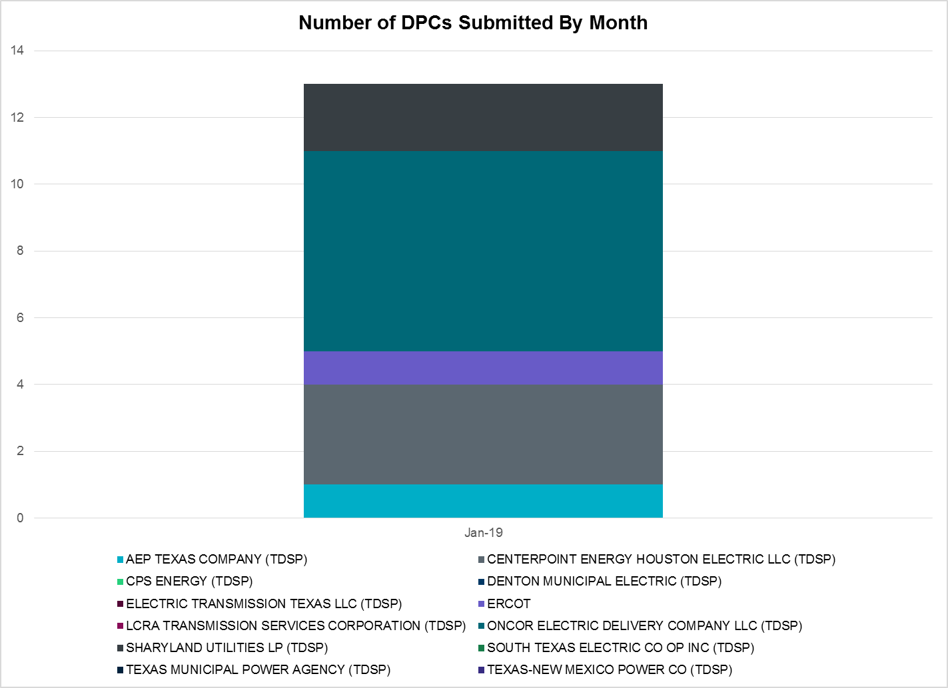

Transmission Operator | Number of DPCs in January
AEP TEXAS COMPANY (TDSP) | 1
BRAZOS ELECTRIC POWER CO OP INC (TDSP) | 0
CENTERPOINT ENERGY HOUSTON ELECTRIC LLC (TDSP) | 3
CPS ENERGY (TDSP) | 0
DENTON MUNICIPAL ELECTRIC (TDSP) | 0
ELECTRIC TRANSMISSION TEXAS LLC (TDSP) | 0
ERCOT | 1
LCRA TRANSMISSION SERVICES CORPORATION (TDSP) | 0
ONCOR ELECTRIC DELIVERY COMPANY LLC (TDSP) | 6
SHARYLAND UTILITIES LP (TDSP) | 2
SOUTH TEXAS ELECTRIC CO OP INC (TDSP) | 0
TEXAS MUNICIPAL POWER AGENCY (TDSP) | 0
TEXAS-NEW MEXICO POWER CO (TDSP) | 0

Appendix A: Real-Time Constraints
The following is a complete list of constraints activated in SCED for the month of January. Full contingency descriptions can be found in the Standard Contingencies List located on the MIS secure site at Grid Generation Reliability Unit Commitment.

Contingency | Constrained Element | From Station | To Station | # of Days Constraint Active
SWCSBOO8 | BARL_FTSW1_1 | FTSW | BARL | 28
DFERSTA8 | 38T365_1 | WIRTZ | FLATRO | 24
SPIGSOL8 | TNAF_TNFS_1 | TNAF | 16TH_ST | 23
BASE CASE | PNHNDL | n/a | n/a | 21
SPIGSOL8 | RIOPEC_WOODW21_1 | RIOPECOS | WOODWRD2 | 20
DMARPA_8 | 38T365_1 | WIRTZ | FLATRO | 19
DENTSCS5 | 1350__E | NCSTP | LFKSW | 18
SCAGKEN5 | 74T148_1 | COMFOR | CICO | 17
DCAGCO58 | 583T583_1 | BANDER | MASOCR | 17
SMDLODE5 | 16TH_WRD2_1 | WOODWRD2 | 16TH_ST | 16
SFLAPIG8 | CR101T_MUSQUI1_1 | CR101TAP | MUSQUIZ | 15
SMDLODE5 | RIOPEC_WOODW21_1 | RIOPECOS | WOODWRD2 | 13
DBIGKEN5 | TREADW_YELWJC1_1 | TREADWEL | YELWJCKT | 12
BASE CASE | RANDAD_ZAPATA1_1 | RANDADO | ZAPATA | 12
SKLELOY8 | LOYOLA_69_1 | LOYOLA | LOYOLA | 12
DMTSCOS5 | 6437__F | SCRCV | KNAPP | 11
DBIGKEN5 | HAMILT_MAVERI1_1 | HAMILTON | MAVERICK | 10
SPADPAD9 | SPUR_69_1 | SPUR | SPUR | 10
SLOBSA25 | NLARSW_PILONC1_1 | NLARSW | PILONCIL | 9
SCOLPAW5 | COLETO_VICTOR1_1 | COLETO | VICTORIA | 8
SLCLAN8 | SAR_FRAN_1 | FRANKC | SARGNTS | 8
SSPJFS8 | JFSSC_06_A | JFS | SC | 8
DWAPHLJ5 | JCKSTP18_A | STP | JCK | 7
DCRLLSW5 | COOPERCK_ARCO_1 | COOPERCK | ARCO | 7
SSCUSU28 | ROTN_WOLFGA1_1 | ROTN | WOLFGANG | 7
SSONFRI8 | SONR_69-1 | SONR | SONR | 7
SLAQLOB8 | BRUNI_69_1 | BRUNI | BRUNI | 6
XWHI58 | LON_HILL_381H | LON_HILL | LON_HILL | 6
DVICV_D8 | GREENL_WEAVER1_1 | WEAVERRD | GREENLK | 6
DVLYVLS5 | 565__O | BNPOI | SHRTI | 6
SWCSBOO8 | FTST_69T1 | FTST | FTST | 6
SCOLPAW5 | COLETO_ROSATA1_1 | COLETO | ROSATA | 6
SAVMBSP8 | 6610__A | BUZSW | CHATP | 5
SCOLLON5 | COLETO_VICTOR1_1 | COLETO | VICTORIA | 5
DJFSCGR8 | JFSSC_06_A | JFS | SC | 5
SLKAWFS8 | BOW_FMR1 | BOW | BOW | 5
DMTSCOS5 | 6474__A | SUNSW | MGSES | 4
SPHIMIL8 | 342T195_1 | GRANMO | MARBFA | 4
SSCUSU28 | ASPM_69T1 | ASPM | ASPM | 4
SSPUMW18 | ROTN_WOLFGA1_1 | WOLFGANG | ROTN | 4
SCRDLOF9 | BOW_FMR1 | BOW | BOW | 4
DWAPHLJ5 | DOWSTP27_A | STP | DOW | 4
SARMRA38 | RAYMND2_69A1 | RAYMND2 | RAYMND2 | 4
XWOO85 | 16TH_WRD2_1 | WOODWRD2 | 16TH_ST | 3
XHAM88 | SONR_69-1 | SONR | SONR | 3
SSCUSU28 | ASPM_CONA1_1 | ASPM | CONA | 3
SSKISIN9 | CSA_SAN_1 | CASA_BLA | SANDIAS | 3
SLISBAT8 | GARZA_69A1 | GARZA | GARZA | 3
DELMTEX5 | SAR_FRAN_1 | FRANKC | SARGNTS | 3
DRIOHAR5 | BURNS_RIOHONDO_1 | RIOHONDO | MV_BURNS | 3
XNED258 | NEDIN_138H | NEDIN | NEDIN | 3
DGRSPKR5 | 6377__A | BRTSW | ORANS | 3
XCED289 | CARLBD_SAGC1_1 | SAGC | CARLBDTP | 3
SILLFTL8 | HAMILT_MAXWEL1_1 | MAXWELL | HAMILTON | 3
BASE CASE | 223T180_1 | LAKEWY | MARSFO | 3
SLAQLOB8 | FALFUR_PREMON1_1 | FALFUR | PREMONT | 3
SCTHHA38 | HAMILT_MAVERI1_1 | HAMILTON | MAVERICK | 3
SCMNCPS5 | 651__B | CMNSW | CMNTP | 3
SCTHHA38 | HAMILT_MAXWEL1_1 | MAXWELL | HAMILTON | 3
XBOM358 | 6558__B | FSHSW | WFALS | 3
XSAP89 | BENFIC_SAPOWE1_1 | SAPOWER | BENFICKL | 2
DELMSAN5 | PAWNEE_SPRUCE_1 | PAWNEE | CALAVERS | 2
DPHRCTR5 | GN_TC_37_A | TC | GN | 2
DCHB_NB5 | BG_GT_37_A | GT | BG | 2
SCISPUT8 | ESTES_PECAN_1_1 | PECAN_BY | ESTES | 2
UWOOWOO1 | 16TH_WRD2_1 | WOODWRD2 | 16TH_ST | 2
DCAGCI58 | 255T279_1 | PIPECR | MEDILA | 2
SCLETE25 | 6095__D | LMESA | JPPOI | 2
DCHB_NB5 | BCVPSA03_A | PSA | BCV | 2
DELMSAN5 | COLETO_ROSATA1_1 | COLETO | ROSATA | 2
BASE CASE | COLETO_VICTOR1_1 | COLETO | VICTORIA | 2
SGEOGEO8 | CSA_SAN_1 | CASA_BLA | SANDIAS | 2
SFORYEL8 | FRPHIL_MASN1_1 | MASN | FRPHILLT | 2
SBIGDIL8 | NLARSW_PILONC1_1 | NLARSW | PILONCIL | 2
SPB2ARY8 | RIOPEC_WOODW21_1 | RIOPECOS | WOODWRD2 | 2
SCOLBAL8 | BALLIN_HUMBLT1_1 | BALLINGE | HUMBLTAP | 2
DMARPA_8 | 43T365_1 | FLATRO | PALEPE | 2
SMGIENW8 | 921__D | ENSSW | TRU | 2
DZORHAY5 | BERGHE_AT1L | BERGHE | BERGHE | 2
SLCLAN8 | COLETO_VICTOR1_1 | COLETO | VICTORIA | 2
SFORYEL8 | FRPHIL_GILLES1_1 | GILLES | FRPHILLT | 2
SHAMMAX8 | SONR_69-1 | SONR | SONR | 2
SVICCO28 | COLETO_ROSATA1_1 | COLETO | ROSATA | 2
DCC1_VIC | COLETO_VICTOR1_1 | COLETO | VICTORIA | 2
SCOLKEN8 | COLETO_VICTOR1_1 | COLETO | VICTORIA | 2
DLONOR58 | FALFUR_PREMON1_1 | FALFUR | PREMONT | 2
DWH_STP5 | LON_HILL_381L | LON_HILL | LON_HILL | 2
SCOLKEN8 | MAGRUD_VICTOR2_1 | VICTORIA | MAGRUDER | 2
SASPPAI8 | ASPM_69T1 | ASPM | ASPM | 2
SLOBSA25 | CATARI_PILONC1_1 | PILONCIL | CATARINA | 2
DCHB_NB5 | GN_TC_37_A | TC | GN | 2
SCANCIT8 | MORRIS_WESTSI1_1 | MORRIS | WESTSIDE | 2
SRAYRI28 | RAYMND2_69A1 | RAYMND2 | RAYMND2 | 2
SPB2ARY8 | 16TH_WRD2_1 | WOODWRD2 | 16TH_ST | 2
SILLFTL8 | CTHR_SONR1_1 | SONR | CTHR | 2
SVICCO28 | COLETO_VICTOR2_1 | COLETO | VICTORIA | 2
SPIGSOL8 | 16TH_WRD2_1 | 16TH_ST | WOODWRD2 | 1
SBUNLON8 | FALFUR_PREMON1_1 | FALFUR | PREMONT | 1
DBERWE58 | 459T459_1 | KENDAL | CAGNON | 1
SLOBSA25 | CSA_SAN_1 | CASA_BLA | SANDIAS | 1
DDR_JFS8 | JFSSC_06_A | JFS | SC | 1
SCHBCBY5 | JFSSC_06_A | JFS | SC | 1
SPAWCAL5 | KENEDS_ROSATA1_1 | ROSATA | KENEDSW | 1
XWHI58 | LON_HILL_381L | LON_HILL | LON_HILL | 1
SALMBA28 | TNAF_TNFS_1 | TNAF | 16TH_ST | 1
DKENCA58 | V3_W1_1 | V3 | W1 | 1
SSIGSAN8 | BEEVIL_THREER1_1 | BEEVILLE | THREER69 | 1
BASE CASE | CSA_SAN_1 | CASA_BLA | SANDIAS | 1
XSHE89 | GN_S_I_XT2H | GN_S_I | GN_S_I | 1
SDUKNED8 | HEC_NEDIN2_1 | HEC | NEDIN | 1
SSCLWF28 | NVKSW_FMR1 | NVKSW | NVKSW | 1
SCLETE25 | 16TH_WRD2_1 | WOODWRD2 | 16TH_ST | 1
DNAVLEG5 | 505__A | THSES | SAMSW | 1
SRICGRS8 | 6840__B | NVKSW | ANARN | 1
SALIKIN8 | FALFUR_PREMON1_1 | FALFUR | PREMONT | 1
XCB3Y58 | JFSSC_06_A | JFS | SC | 1
SN_SLON5 | LOYOLA_69_1 | LOYOLA | LOYOLA | 1
DCAGCO58 | MOUNTO_AT1 | MOUNTO | MOUNTO | 1
DELMSAN5 | NORMAN_PETTUS1_1 | PETTUS | NORMANNA | 1
DELMSAN5 | POT_OAKS_1 | OAKS9 | POTEETS | 1
BASE CASE | SONR_69-1 | SONR | SONR | 1
SCAMUVA9 | SONR_69-1 | SONR | SONR | 1
SFLAPIG8 | 16TH_WRD2_1 | WOODWRD2 | 16TH_ST | 1
SSANFER8 | 35T291_1 | CTECBU | KING_2 | 1
DWIRGRA8 | 43T365_1 | FLATRO | PALEPE | 1
SSCLWF28 | 6840__B | NVKSW | ANARN | 1
DZORHAY5 | BERGHE_AT1H | BERGHE | BERGHE | 1
DBIGKEN5 | ESCOND_GANSO1_1 | GANSO | ESCONDID | 1
DBWNKLN5 | GANSO_MAVERI1_1 | MAVERICK | GANSO | 1
BASE CASE | HAMILT_MAVERI1_1 | HAMILTON | MAVERICK | 1
SCITNUE8 | MORRIS_NUECES1_1 | NUECES_B | MORRIS | 1
SILLFTL8 | OZNR_OZONA1_1 | OZONA | OZNR | 1
DWH_STP5 | SAR_FRAN_1 | FRANKC | SARGNTS | 1
BASE CASE | SWEETWN3_XT2 | SWEETWN3 | SWEETWN3 | 1
DCAGCO58 | 342T195_1 | GRANMO | MARBFA | 1
DVLYANA5 | 390__A | PRSSW | MNSES | 1
SBROALP9 | BARL_FTSW1_1 | FTSW | BARL | 1
SDOWMOO8 | DOWNIES_AX1H | DOWNIES | DOWNIES | 1
SWHILON5 | NUECES_WHITE_2_1 | WHITE_PT | NUECES_B | 1
DMLSENT5 | 1350__E | NCSTP | LFKSW | 1
DWIRSTA8 | 38T365_1 | WIRTZ | FLATRO | 1
DCAGTA58 | H3_K0_1 | H3 | K0 | 1
DCHB_NB5 | JFSSC_06_A | JFS | SC | 1
SCBYCTR5 | JFSSC_06_A | JFS | SC | 1
SHAMMAX8 | MAXWEL_WHITIN1_1 | MAXWELL | WHITING | 1
DFERWIR8 | SANDCR_AT1 | SANDCR | SANDCR | 1
DFERSTA8 | 32T311_1 | BURNET | BERTRA | 1
DCAGCI58 | 342T195_1 | GRANMO | MARBFA | 1
SDENN_D8 | COOPERCK_ARCO_1 | COOPERCK | ARCO | 1
SPADPAD9 | GIRA_T_SPUR1_1 | SPUR | GIRA_TAP | 1
XHIL158 | HILLCTRY_MR4L | HILLCTRY | HILLCTRY | 1
SHOLNLA8 | NLARSW_PILONC1_1 | NLARSW | PILONCIL | 1
SALMBA28 | RIOPEC_WOODW21_1 | WOODWRD2 | RIOPECOS | 1
DLAMCOR8 | 342T195_1 | GRANMO | MARBFA | 1
SSTELO29 | CSA_SAN_1 | CASA_BLA | SANDIAS | 1
DDILCOT8 | DIL_COTU_1 | COTULAS | DILLEYSW | 1
SBREHIG8 | 367T347_1 | MAXZUE | GAYHIL | 1

The Duration of Event is defined as the time it takes for the frequency to recover to pre-disturbance frequency or 60 Hz as applicable.
PMU reports are typically generated when frequency drops below 59.9, but PMU data is available for other events.
Delta Frequency is defined as the difference between the starting point of the frequency event (t(0) or “A-point”) and minimum/maximum frequency (“C-Point”).
Currently, the Critical Inertia Level for ERCOT is approximately 100,000 MW-s (Source: link)
This is the hourly integrated peak demand as published in the ERCOT D&E report.
All DC Tie Curtailments are posted publically on the ERCOT Market Information System. See that posting for additional details for the event(s) in question.
See DC Tie Operating Procedure (http://www.ercot.com/mktrules/guides/procedures) for more details.

