FlighTrak Users Guide

Table of Contents
1. Overview 4
1.1. What is FlighTrak 4
1.2. FlighTrak Objectives 4
1.3. Process Improvements 4
1.4. Additions to the Flight Sign Up Deadlines 4
2. Login Procedures 5
2.1. Placeholder 5
2.2. Placeholder 2 5
3. MP Admin Functions Need More Info for Multi Co users 5
3.1. MP Admin Creates New User 5
3.2. MP Admin Modifies User 9
3.3. MP Admin Deletes User 13
4. Dashboards 14
4.1. General Dashboard 14
4.2. Current Flight Tasks Dashboard 15
4.3. Pre-Flight (CR) Dashboard 17
4.4. Pre-Flight (SP) Dashboard 18
4.5. Pre-Flight (TDSP) Dashboard 19
4.6. Flight Progress 20
5. Flight Registration 21
5.1. Flight Registration New CR 21
5.2. Flight Registration Existing CR 31
5.3. MP Withdraws from Flight after completed registration. 32
6. Testing Specifications 34
6.1. CR or SP Provides/Reviews Testing Specifications 34
6.2. TDSP Provides/Reviews Testing Specifications NEED to UPDATE 38
6.3. Test Bed Loading 40
6.4. Download the Test Bed 46
7. Test Scripts 49
7.1. Connectivity Scripts Overview 49
7.2. Test Scripts Overview 60

Overview

What is FlighTrak
FlighTrak is the replacement for the external web interface utilized for the purpose of executing Protocol mandated ERCOT certification of retail Market Participants (ETOD).

FlighTrak Objectives
    - Refresh the technology associated with the certification interface to incorporate current browser and security requirements.
      - Comply with ERCOT web access standards.
      - Enforce visibility and update permissions based on DUNs and assigned roles.
    - Increased visibility of defined steps required to complete ERCOT certification associated primarily with the following.
      - New LSE entering the ERCOT Retail Market.
      - Existing LSE changing system parameters required to operate in the ERCOT retail market.
    - Capture and make available auditable logs of registration and certification data associated with changes to MP and potential MP specifications.
      - Minimize the need for one-off mail, email, and phone calls.
      - Market Participant availability of ERCOT certification and connectivity specifications.

Process Improvements
    - No need to send status emails.
    - No need to send an email each time a transaction has been sent.
    - No need to manually update the checklist. Transactions received by ERCOT will automatically move script issues forward.
    - MPs will only need to manually update scripts in FlighTrak in order to:
      - Begin Working a Script.
      - Indicate that a P2P transaction was sent or received.
      - Escalate an issue to ERCOT or other involved Market Participant.
      - Investigate transactions that failed validations.
    - Information provided by FlighTrak on why the transaction failed.
    - Market Interface Service Providers (MISPs) will be selected by the CR during the Registration process, ensuring confidentiality in that process.

Additions to the Flight Sign Up Deadlines
    - Since Flight Registration will be completed inside the FlighTrak tool, new CRs (brand new CRs and DUNS+4 entities) will need to submit their LSE application and fee to ERCOT far enough in advance for them to be verified and then set up in the tool. This will need to be completed early enough to allow the AR/BAR time to complete the Registration form prior to 5:00 pm on the signup deadline.
    - Since existing CRs are already set up in the system, the only deadline applicable to them is the signup deadline.
    - The exception that would add more deadlines to existing CRs, is if the existing CR wishes to test with a MISP that is not set up in FlighTrak. In this case, the CR must provide contact information for the New MISP to ERCOT so that they can be set up in the system before the deadline for the CR to complete the registration process.

Login Procedures

Placeholder

Placeholder 2

MP Admin Functions Need More Info for Multi Co users
Only the Authorized Rep/Backup Authorized Rep (AR/BAR) have the privileges to designate users for Admin roles. For New CRs, this is done during the registration process. For existing CRs that need to add, remove, or modify any Admin users, the AR/BAR will send that information in an email to FlighTrak@ercot.com. ERCOT will update the account(s) for the MP Admin(s) according to the info received from the AR/BAR.

This section contains information on the MP Admin Functions of adding, modifying, and removing users for the FlighTrak Tool.

MP Admin Creates New User
- Click the New button at the top of the page. (Fig 3.1a)
Fig 3.1a
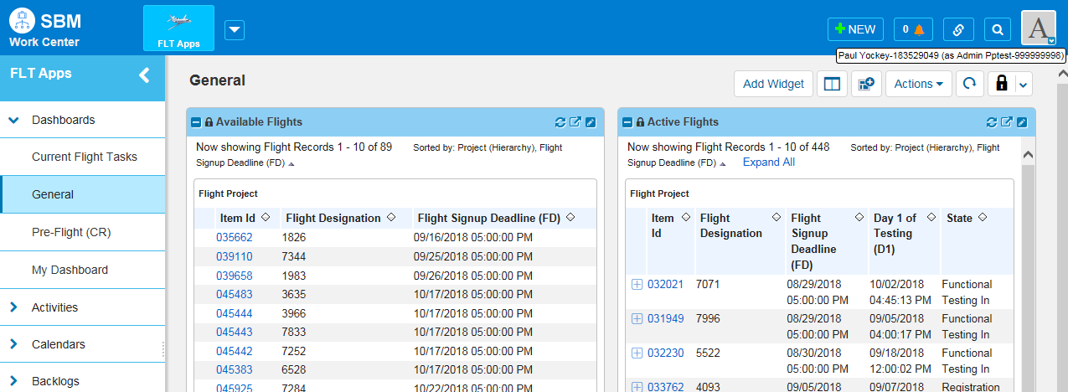
- Select Add New User. (Fig 3.1b)

Fig 3.1b
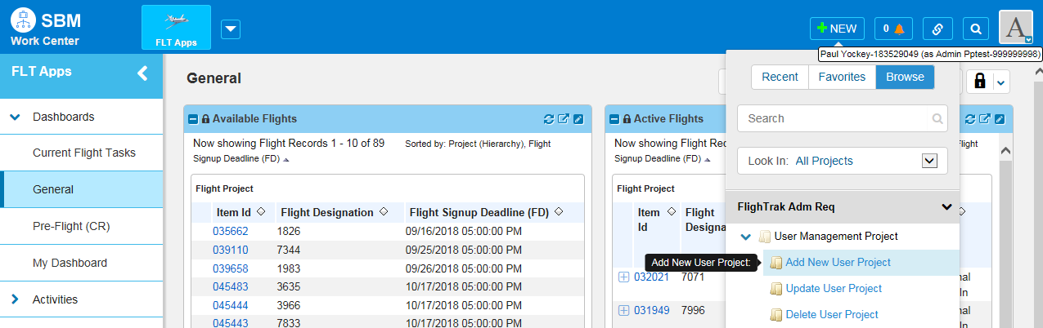
- Enter First Name, Last Name, Employee ID (this must be unique to each user), Email Address, and Phone Number, then click OK. (Fig 3.1c)
Fig 3.1c
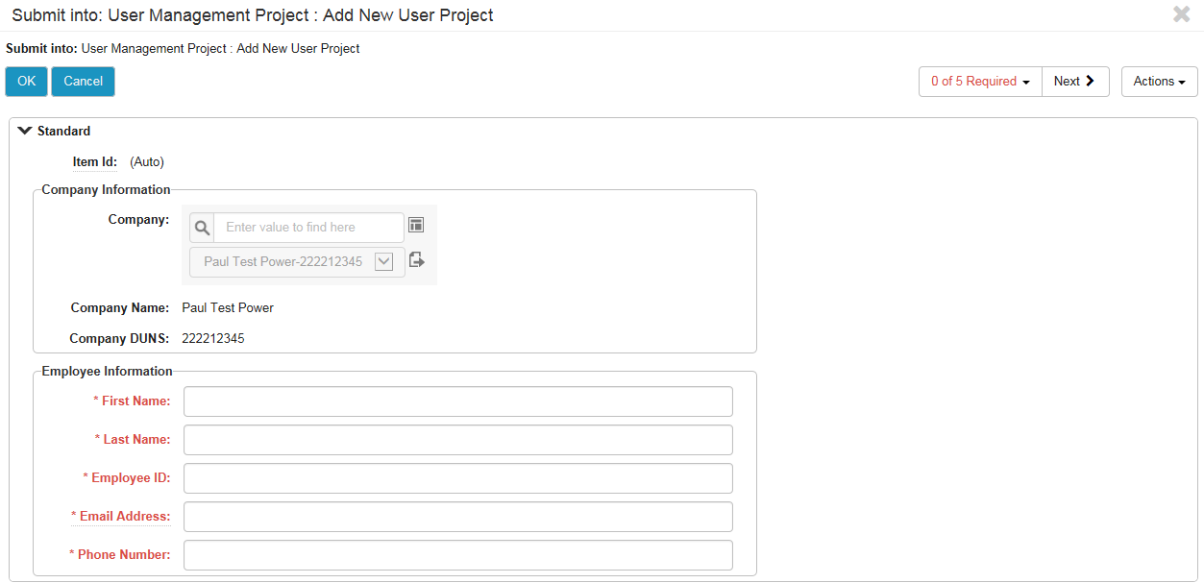
- Provide the user’s email address.
NOTE: the Email Address must be unique and cannot be a distribution list, there will be other places to add distribution lists.

Fig 3.1d
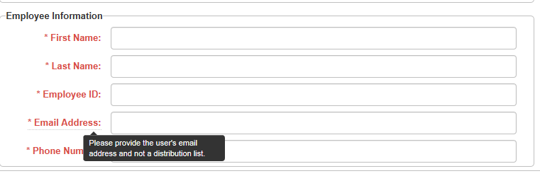
- Once info is entered, click OK. (Fig 3.1e)
Fig 3.1e
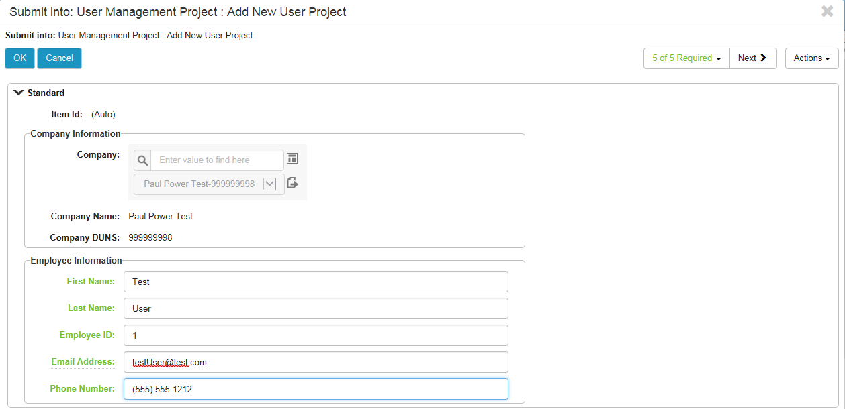
- An error message will be displayed if the email address is not unique. (Fig 3.1f)

Fig 3.1f
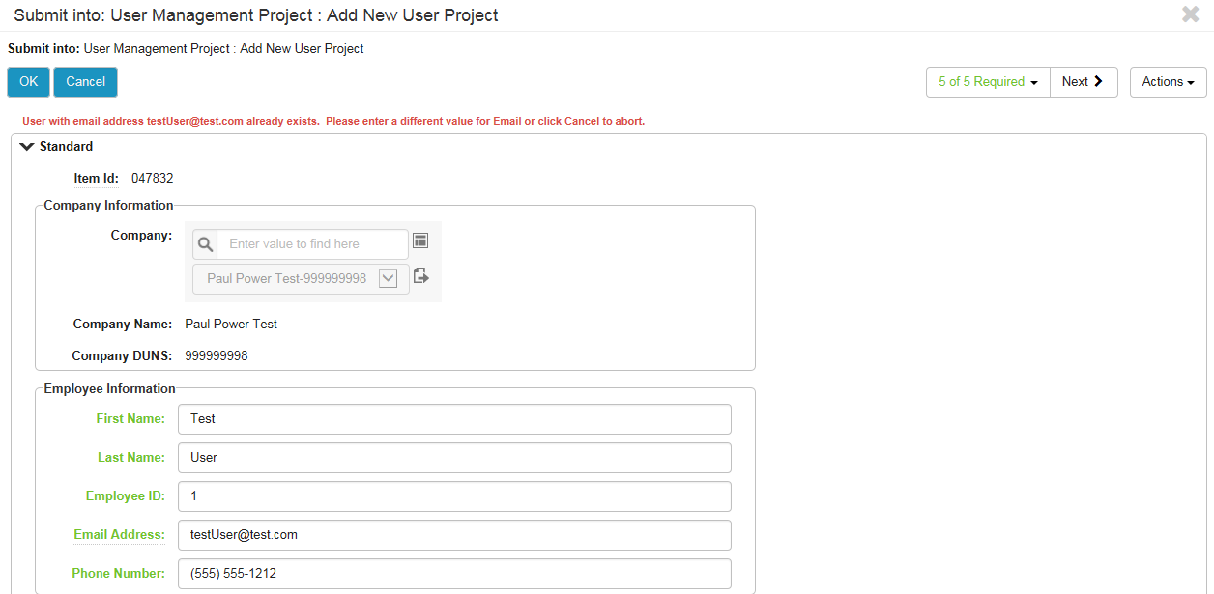
- Enter the updated value for the email address and click OK.
Fig 3.1g
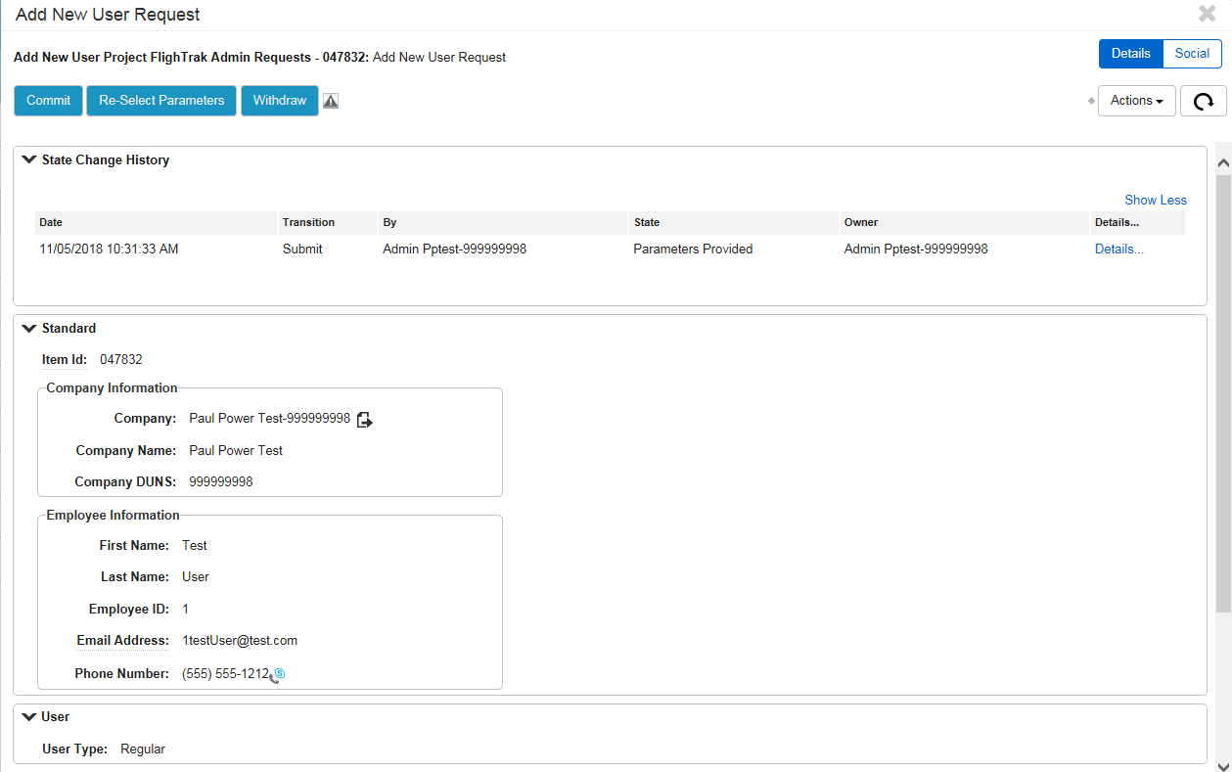
- Verify info is correct, then click Commit. (Fig 3.1g)

Fig 3.1h
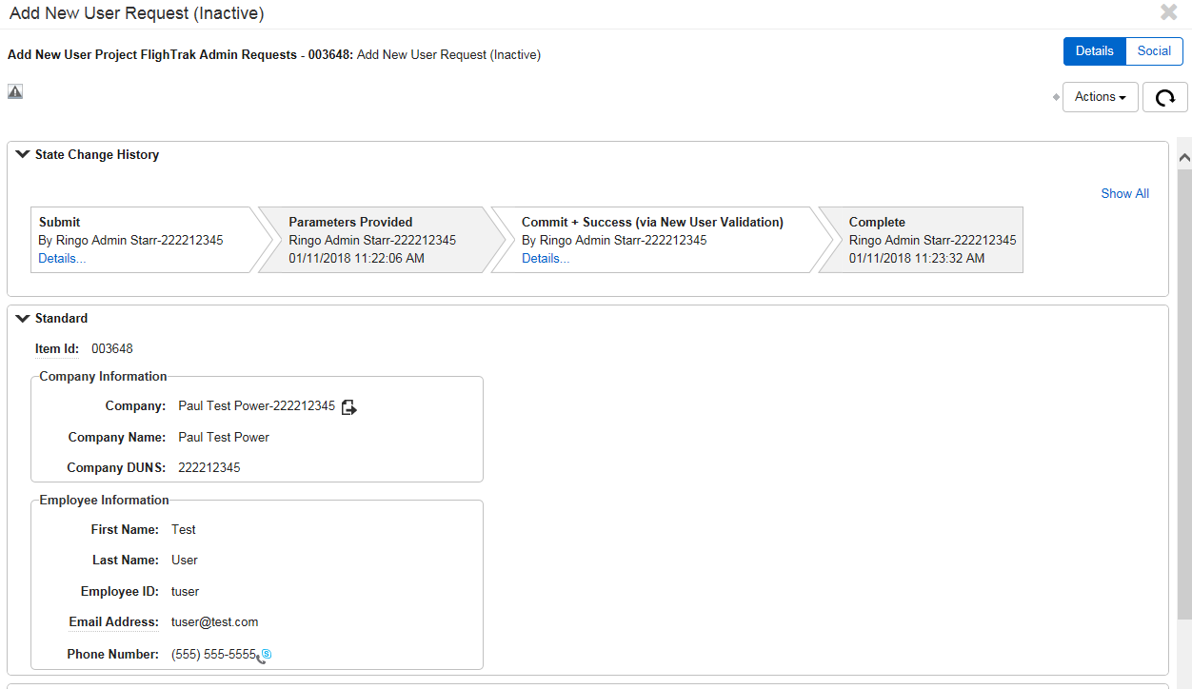
- The addition is complete and the request is closed. (Fig 3.1h)

MP Admin Modifies User
- Click the New button at the top of the page
Fig 3.2a
- Select update user. (Fig 3.2b)

Fig 3.2b
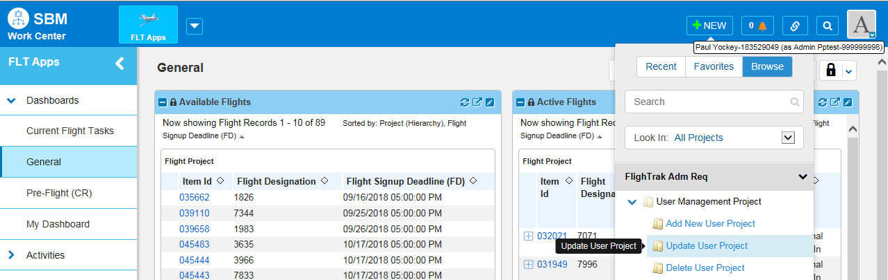
- Chose Contact to update from the drop down menu. (Fig 3.2c)
Fig 3.2c
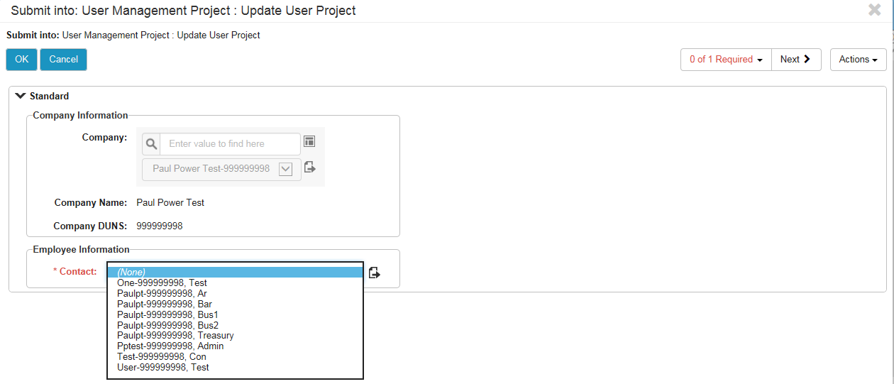
Fig 3.2d
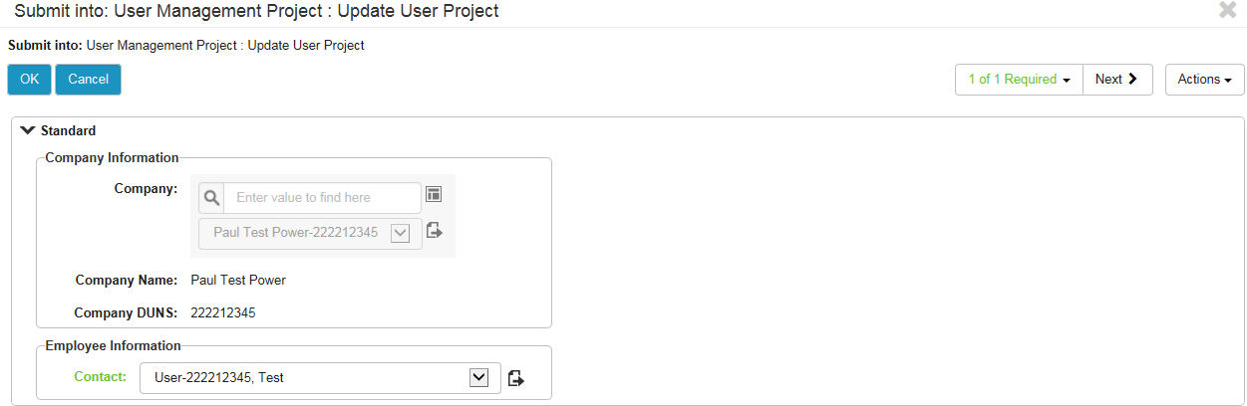
- Click OK. (Fig 3.2d)
- The user is selected.
- Click Edit User. (Fig 3.2e)
Fig 3.2e
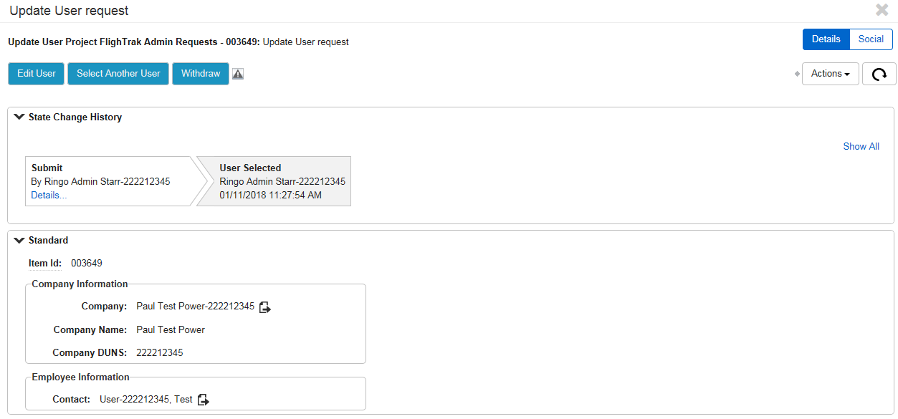
- Make necessary changes and click ok (Fig 3.2f).
Fig 3.2f
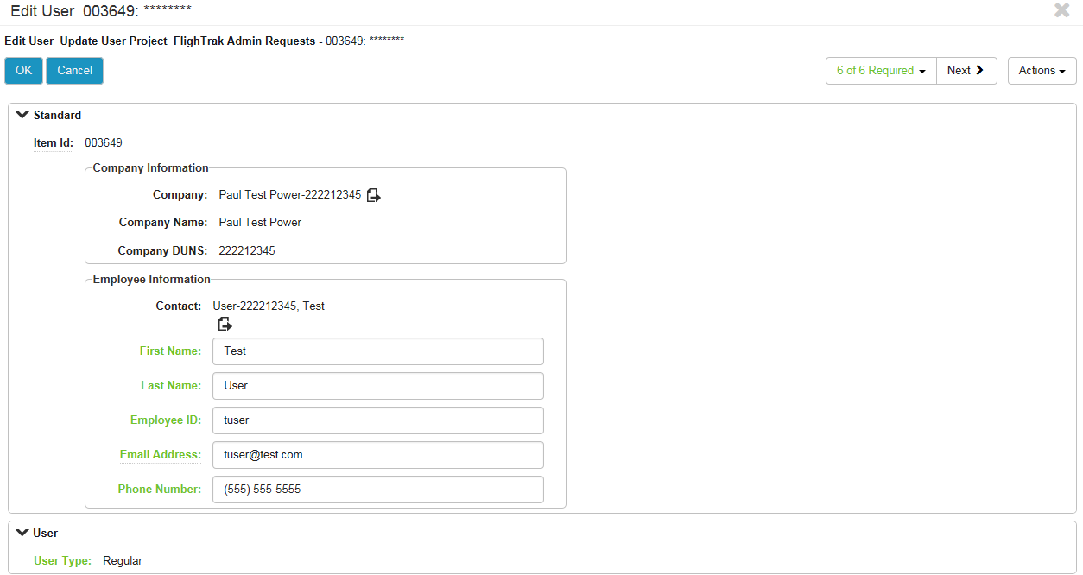
- Verify info and click Commit. (Fig 3.2g)

Fig 3.2g
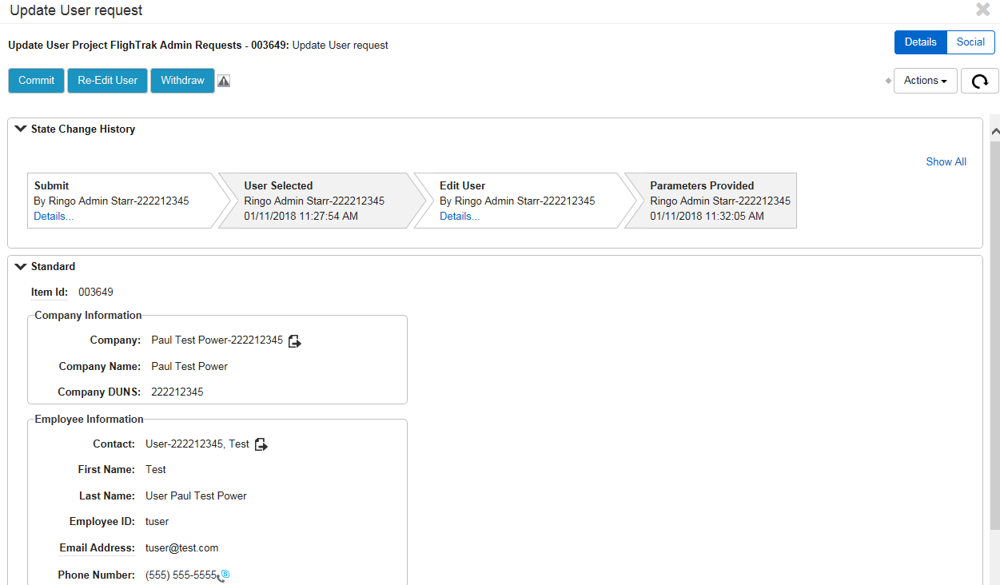
- Changes are complete and the request is closed (Fig 3.2h).
Fig 3.2h
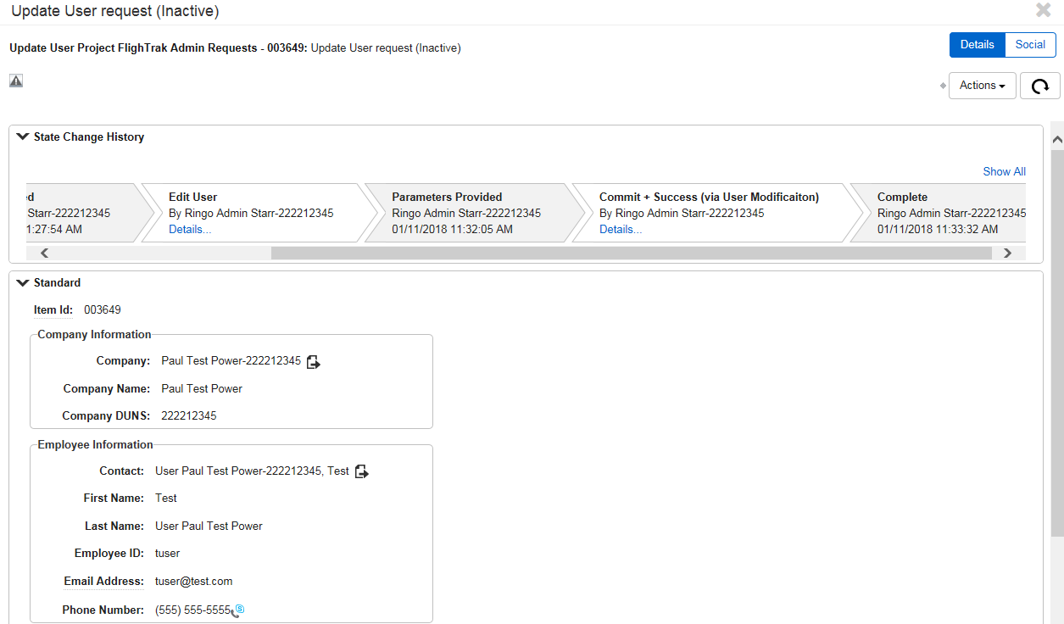

MP Admin Deletes User
    - Click the New button at the top of the page.
Fig 3.3a
    - Select delete user. (Fig 3.3b)

Fig 3.3b
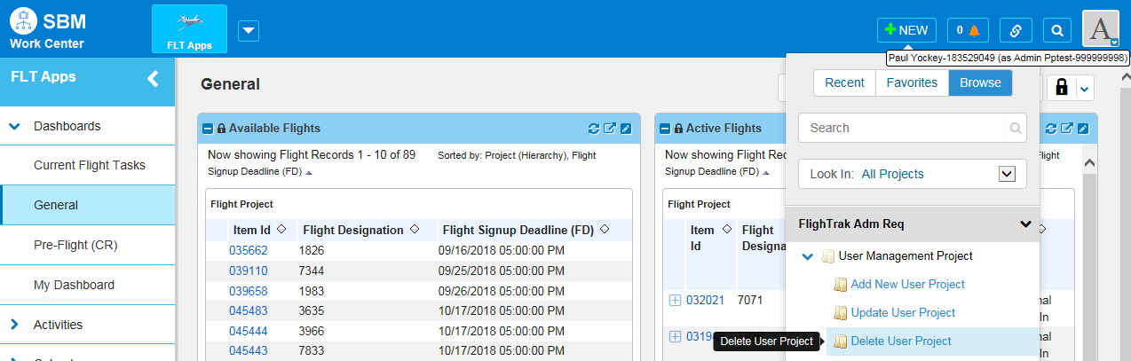
    - Choose Contact to modify (Fig 3.3c).
Fig 3.3c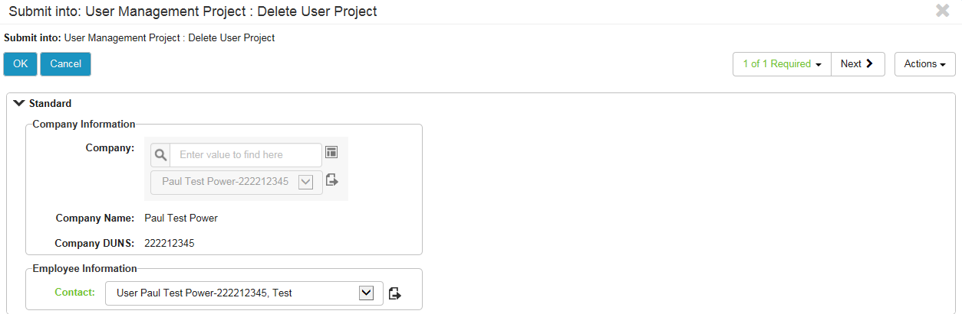
    - Click OK.
    - The user is selected. (Fig 3.3d)

Fig 3.3d
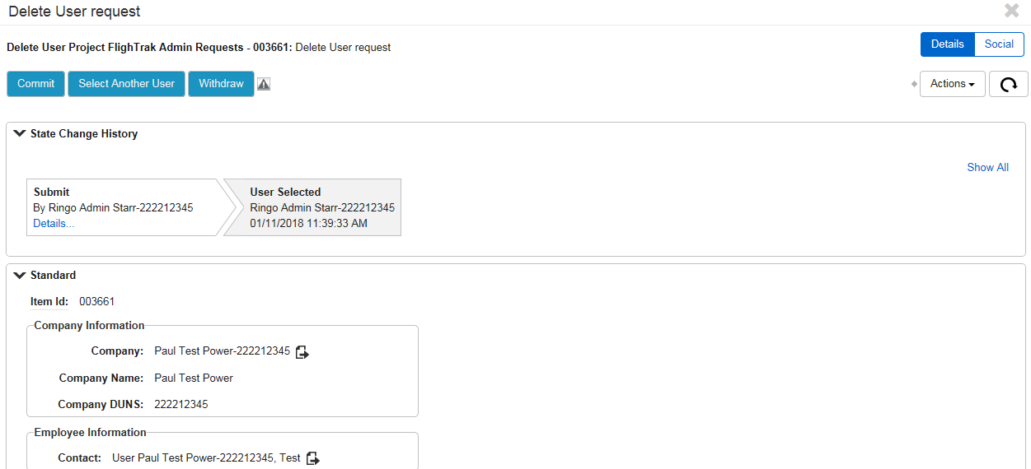
    - Verify user to delete then click Commit. (Fig 3.3d)
Fig 3.3e
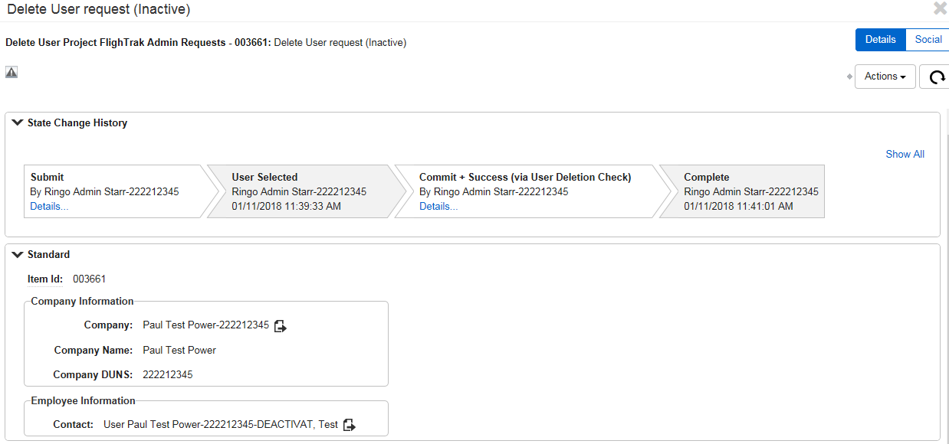
    - User is shown as Deactivated and the request is closed (Fig 3.3e).

Dashboards
There are multiple preset Dashboards in FlighTrak. Each dashboard contains different reports to help you find issues and navigate through FlighTrak.

General Dashboard
The General Dashboard consists of 4 different reports (Fig 4.1a).
- Available Flights
- Active Flights
- My Company Testing Information
- Flight Information Websites
Fig 4.1a
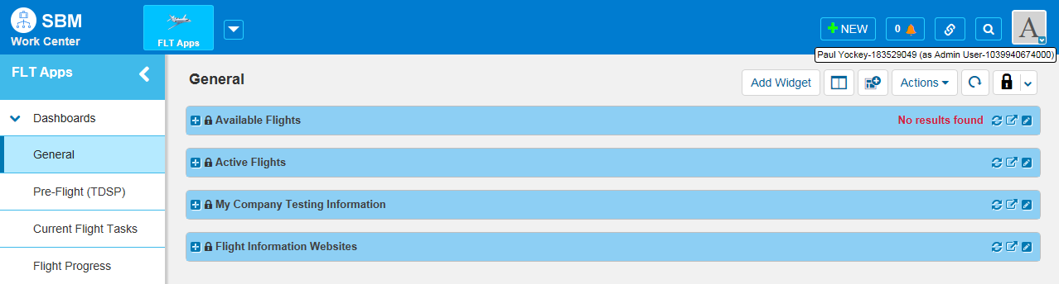
    - Available Flights
This report shows the flights that are available for signup. It includes the Item ID, Flight Designation, and the Flight Signup Deadline. This will be used when signing up for upcoming test flights.
    - Active Flights
This report shows the active flight, if there is one. It includes the Item ID, Flight Designation, Flight Signup Deadline, Day 1 of Testing date, and the State of the flight. If there is not currently an active Flight, the report will show no results. If a flight is active, it will not be displayed in the Available Flights report.
    - My Company Testing Information
This report shows the link to your current Company Testing Information. It includes the Item ID, Company Name, and the DUNS number.
    - Flight Information Websites
This report shows links to websites and documents that contain useful information about testing related subjects for the Texas Retail Market. This has information about the current flight as well as links to help with registration questions.

Current Flight Tasks Dashboard
The Current Flight Tasks Dashboard consists of 6 different reports (Fig 4.2a and Fig 4.2b).
- Scripts that are Ready to Begin
- My Script Tasks
- ERCOT Script Tasks
- Testing Partner Script Tasks
- Active Script Issues
- Completed Script Issues

Fig 4.2a
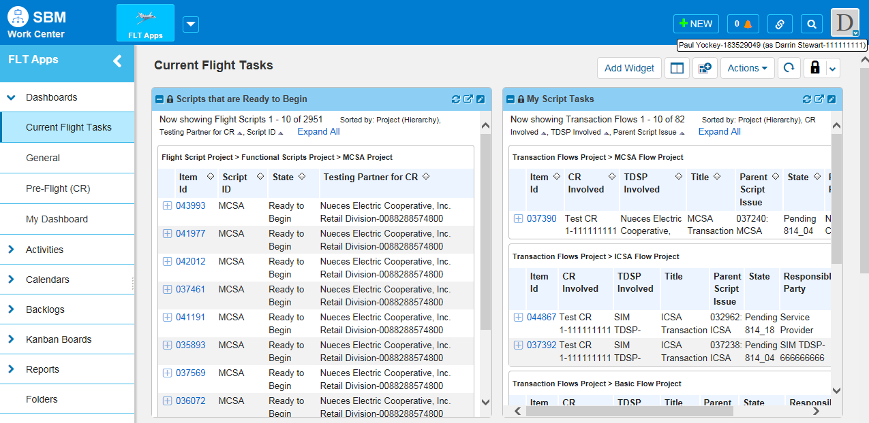
Fig 4.2b
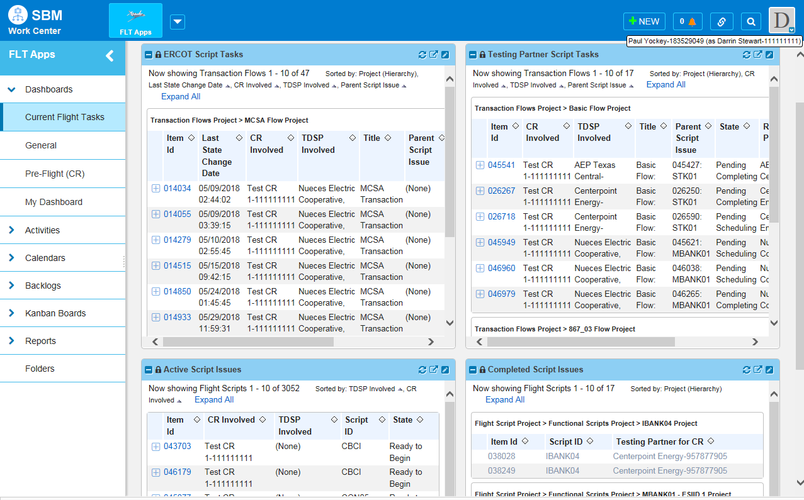

    - Scripts that are Ready to Begin
This report shows Scripts that are currently ready to begin. It includes the Item ID, Script ID, State, and the Testing Partner.

    - My Script Tasks
This report shows tasks that I am responsible for completing. It includes the Item ID, CR Involved, TDSP Involved, Title, Parent Script Issue, State, Responsible Party, and Current Instructions.

    - ERCOT Script Tasks
This report shows tasks that are pending ERCOT action. It includes the Item ID, Last State Change Date, CR Involved, TDSP Involved, Title, Parent Script Issue, State, Responsible Party, and Current Instructions.

    - Testing Partner Script Tasks
This report show Issues that are pending Testing Partner action. It includes the Item ID, CR Involved, TDSP Involved, Title, Parent Script Issue, State, Responsible Party, and Current Instructions. On a CR’s dashboard this report would show tasks for which the TDSP is the responsible party and vice versa.

    - Active Script Issues
This report shows Scripts that are active. It includes the Item ID, CR Involved, TDSP Involved, Script ID, and State.

    - Completed Script Issues
This report shows the completed script issues. It includes the Item ID, Script ID, and Testing Partner for CR.

Pre-Flight (CR) Dashboard
The Pre-Flight (CR) Dashboard consists of 3 reports (Fig 4.3a).
- Flight Registration Records
- CR Test Specs
- CR Scripts Test Bed
Fig 4.3a
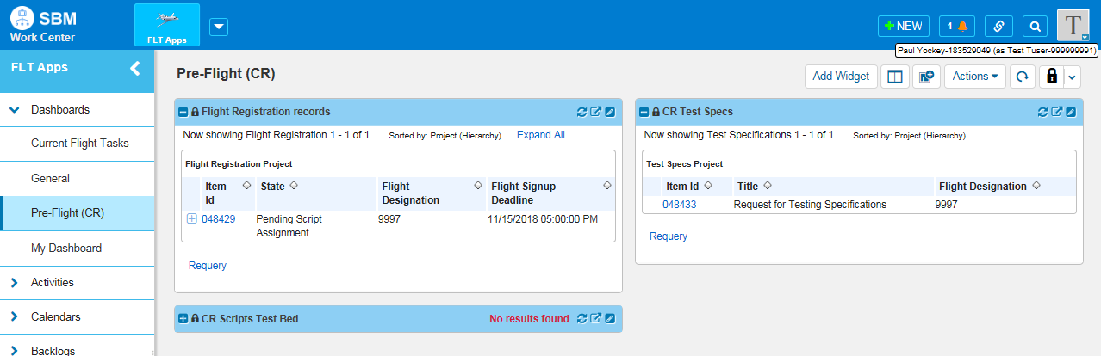

    - Flight Registration Records
This Report shows the registration records for the CR. It includes the Item Id, State, Flight Designation, and Flight Signup Deadline.

    - CR Test Specs
This report shows the current state of the CR testing specs. It includes the Item Id, Title, and Flight Designation.

    - CR Scripts Test Bed.
This report shows the Test Bed info for the CR once the scripts have been assigned. It includes the Item Id, Flight, CR Involved, TDSP Involved, Script ID, Customer 1, Customer 2, ESI ID, Zip Code, Meter #, Customer Name 1, Customer Name 2, Rate Class/Meter Type, DOE #, Membership Account Number 1, Membership Account Number 2, Serv Loc, and Cycle. Click here for Test Bed downloading instructions.
NOTE: If any of the TDSPs have not yet submitted their Test Beds, the ESIIDs will show as ESIID1 or ESIID2 and there will not be a Zip Code populated. This is not complete and should not be used.

Pre-Flight (SP) Dashboard
The Pre-Flight (CR) Dashboard consists of 2 reports (Fig 4.4a).
- SP Test Specs
- CR Scripts Test Bed
Fig 4.4a
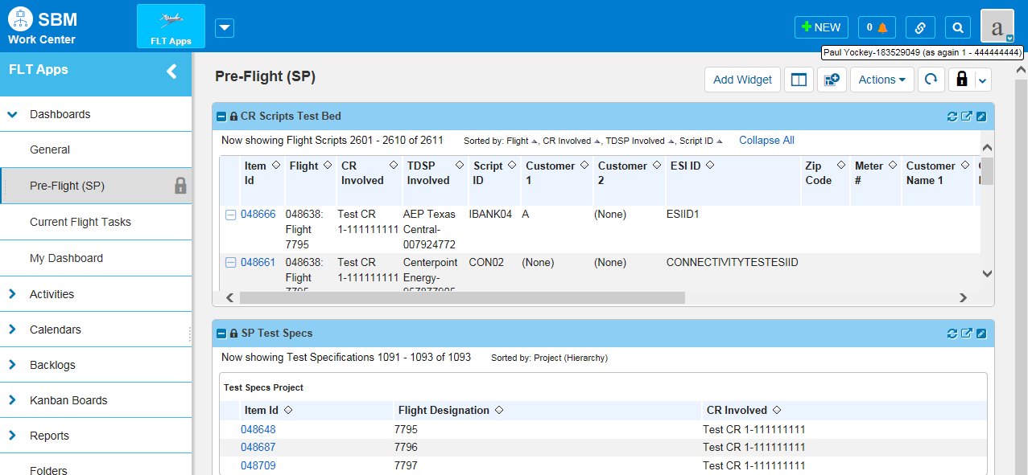
    - SP Test Specs
This report shows the current state of the CR/SP testing specs. It includes the Item Id, Title, and Flight Designation.

    - CR Scripts Test Bed.
This report shows the Test Bed info for all of the CRs that the SP is testing for once the scripts have been assigned. It includes the Item Id, Flight, CR Involved, TDSP Involved, Script ID, Customer 1, Customer 2, ESI ID, Zip Code, Meter #, Customer Name 1, Customer Name 2, Rate Class/Meter Type, DOE #, Membership Account Number 1, Membership Account Number 2, Serv Loc, and Cycle.
NOTE: If any of the TDSPs have not yet submitted their Test Beds, the ESIIDs will show as ESIID1 or ESIID2 and there will not be a Zip Code populated. This is not complete and should not be used.

Pre-Flight (TDSP) Dashboard
The Pre-Flight (TDSP) Dashboard contains 2 reports (Fig 4.5a).
- TDSP Test Specs
- Test Pairings for the Current Flight
Fig 4.5a
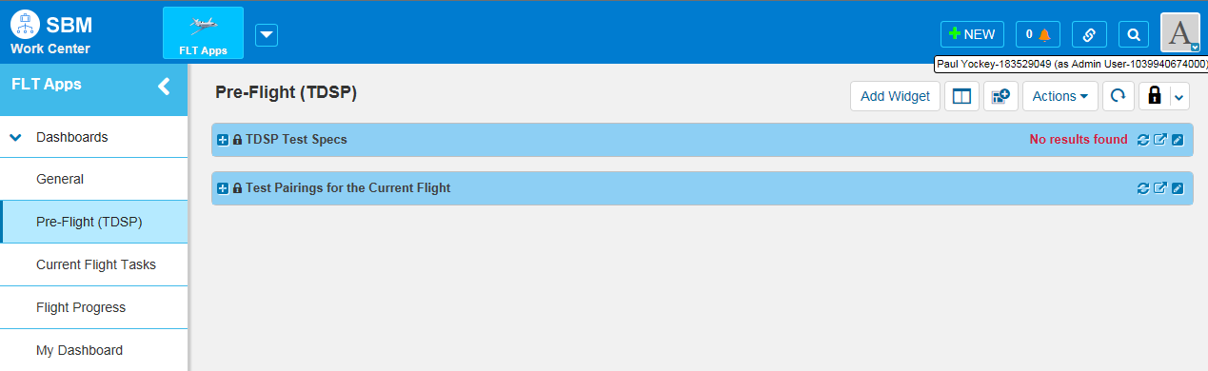
    - TDSP Test Specs
This report shows the current state of the TDSP testing specs. It includes the Item Id, Title, and Flight Designation (Fig 4.5b).
Fig 4.5b
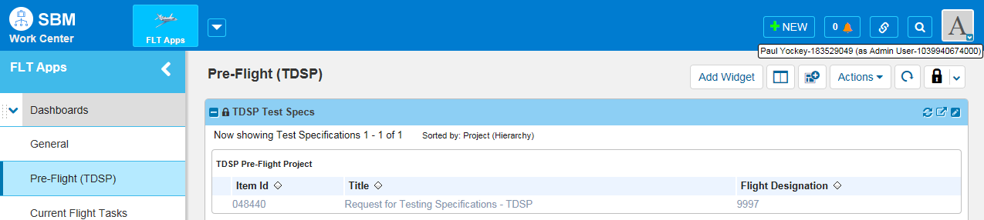
    - Test Pairings for the Current Flight
This report shows the flight pairings for the current flight. It includes the Item Id, Primary MP, Service Provider, Testing Partner and Flight Designation (Fig 4.5c)

Fig 4.5c
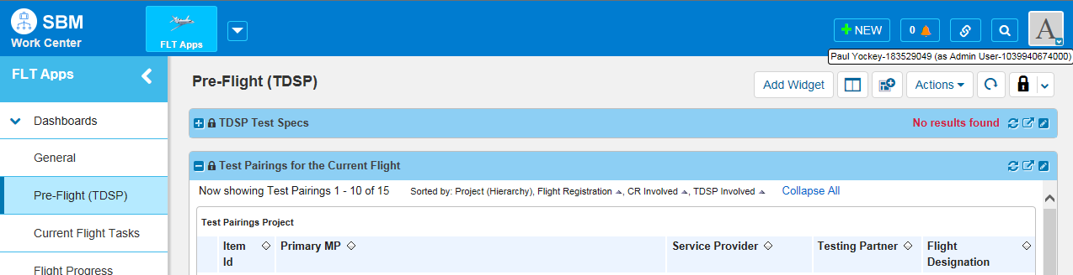

Flight Progress
The Flight Progress Dashboard contains 2 reports (Fig 4.6a).
- Active Script Issues
- Completed Script Issues
Fig 4.6a
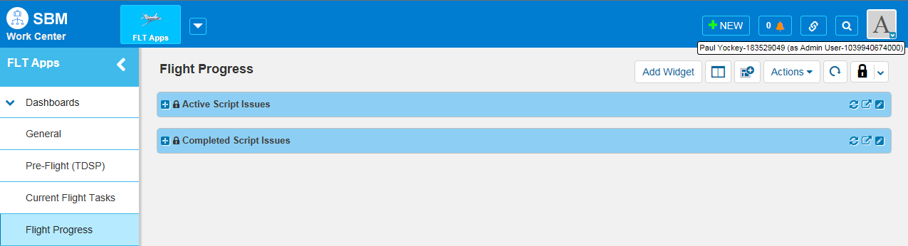

    - Active Script Issues
This report shows the Item Id, CR Involved, TDSP Involved, Script ID, ESIID, and State for script issues that are still active.
Fig 4.6b
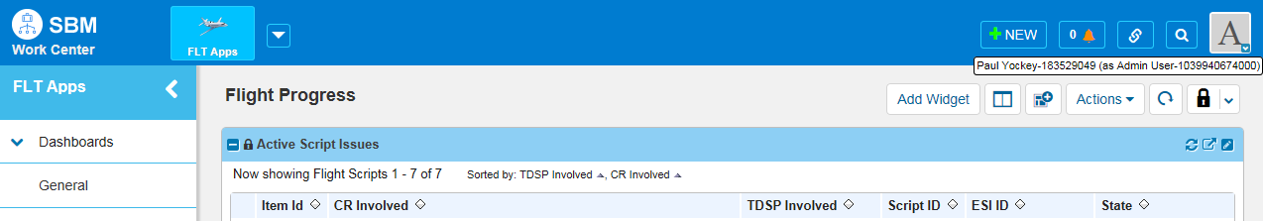
    - Completed Script Issues
This report shows the Item Id, CR Involved, Script ID, and Testing Partner for CR for script issues that have been completed (Fig 4.6c).

Fig 4.6c
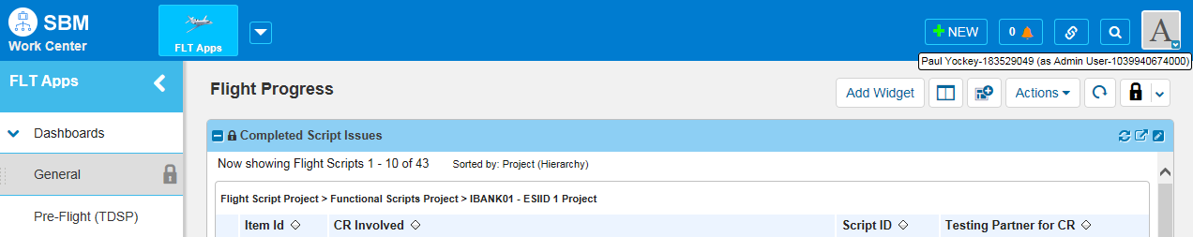

Flight Registration

This section Contains information concerning registration processes for Flight Testing in the ERCOT Market.

Flight Registration New CR
Please see the Approved Test Flight Schedule for registration step completion deadlines. This can be found on the ercot.com website at http://www.ercot.com/services/rq/lse/trt/index.html under Key Documents.

    - Application and Fee are submitted to ERCOT. (ERCOT Legal will have 1 week to confirm information/DUNS and that fee was received).
    - Client Services will send out an email to the AR/BAR requesting the contact information for the user(s) that they would like to be set up in FlighTrak as the Admin. The AR/BAR will send that information to FlighTrak@ercot.com
    - ERCOT will create the account for the MP admin.
    - The MP admin will create user accounts for AR/BAR.
    - ERCOT will confirm the users match the AR/BAR provided on the application.
    - ERCOT will assign the AR/BAR roles to the appropriate users.
    - The MP AR/BAR will submit the flight registration by looking in the Available Flights report on the General dashboard (Fig 5.1a), or searching for the Flight number (Fig 5.1b) and clicking the issue number that returns. (Fig 5.1c)
NOTE: This is test data. During normal times, there will be no more than 3 flights to choose from.

Fig 5.1a
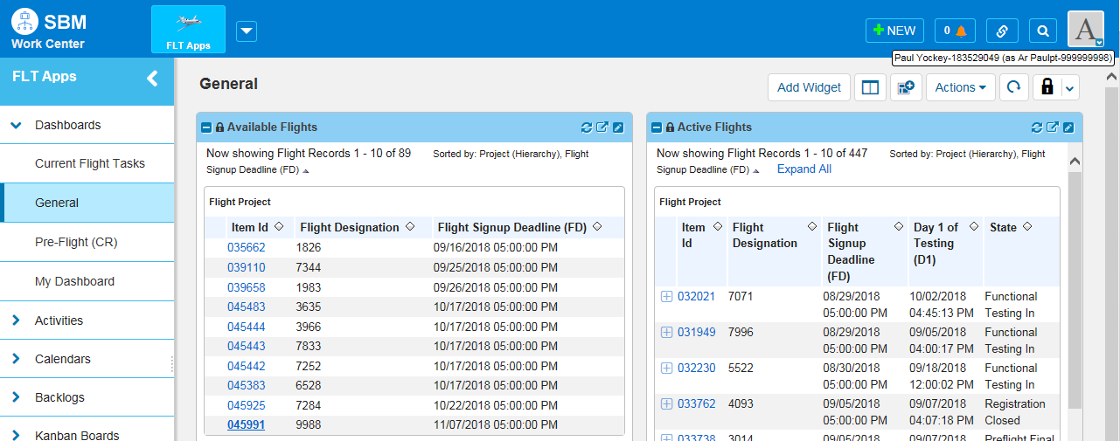
Fig 5.1b
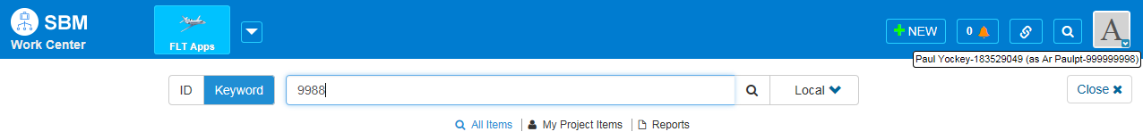

Fig 5.1c
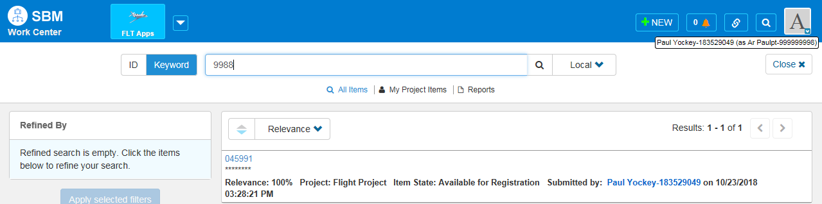
    - Only the AR/BAR has privileges to submit a Flight Registration. If a non AR/BAR attempts to register for a flight, the Register button is not available. (Fig 5.1d)

Fig 5.1d
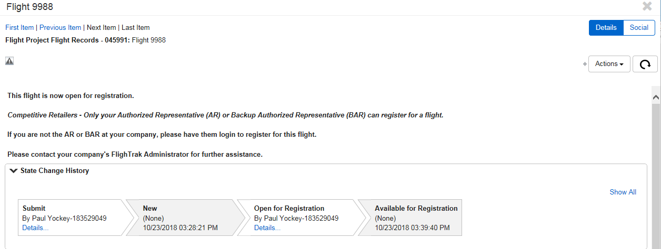
    - Once a Flight is selected by the AR/BAR, the following screen will appear. It contains key dates for the selected Flight. (Fig 5.1e)
Fig 5.1e
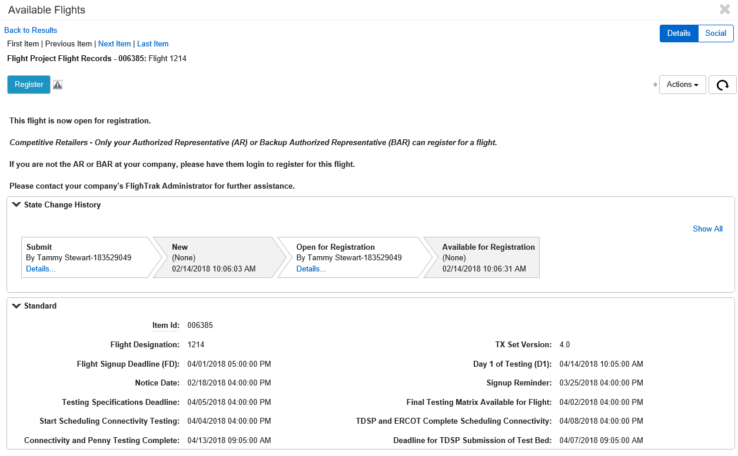
    - If an AR/BAR tries to submit a Flight Registration for a flight they are already registered for, the following page will appear with notice in red that the company is already registered for that particular flight. (Fig 5.1f)

Fig 5.1f
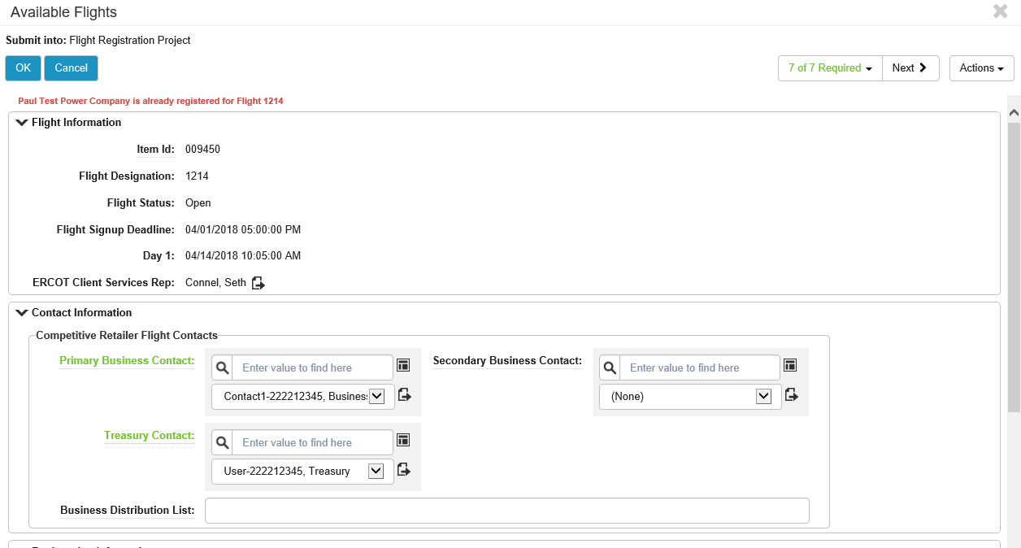
    - The following pop-up will appear when the registration is cancelled. Click OK to cancel the operation (Fig 5.1g).
Fig 5.1g
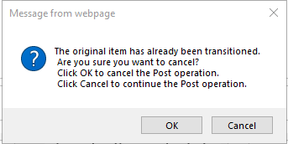
    - When an AR/BAR logs in to submit a Flight Registration, the following Registration Information will be requested.
- Competitive Retailer Contacts (Fig 5.1h).
  - Click the search icon next to each contact entry to populate the dropdown list with currently active users.
NOTE: All contacts to be used must be in the system prior to registration. This is done by the MP Admin and must be completed before the AR/BAR can register for a flight.
NOTE: The AR/BAR can add a Distribution List for business contacts (Fig 5.1i).

Fig 5.1h
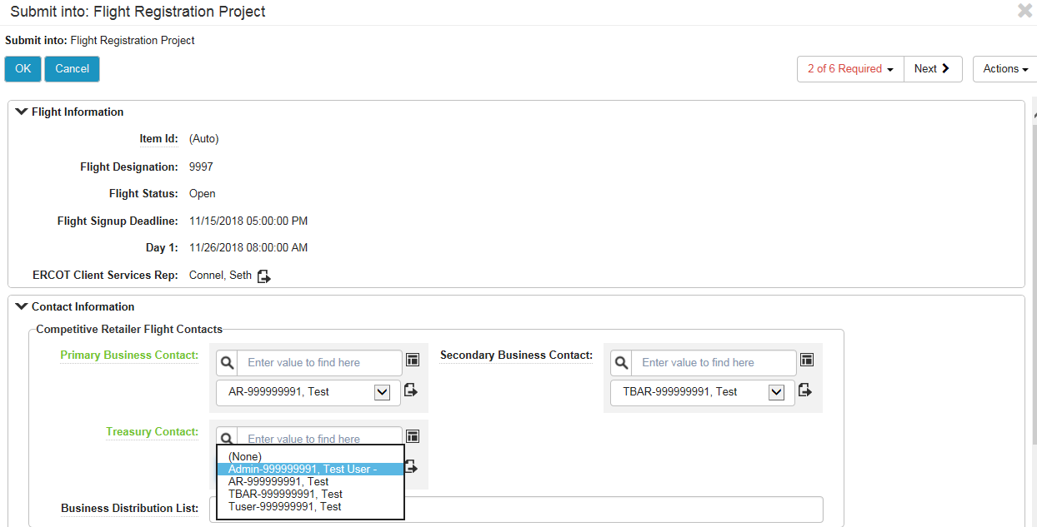

Fig 5.1i
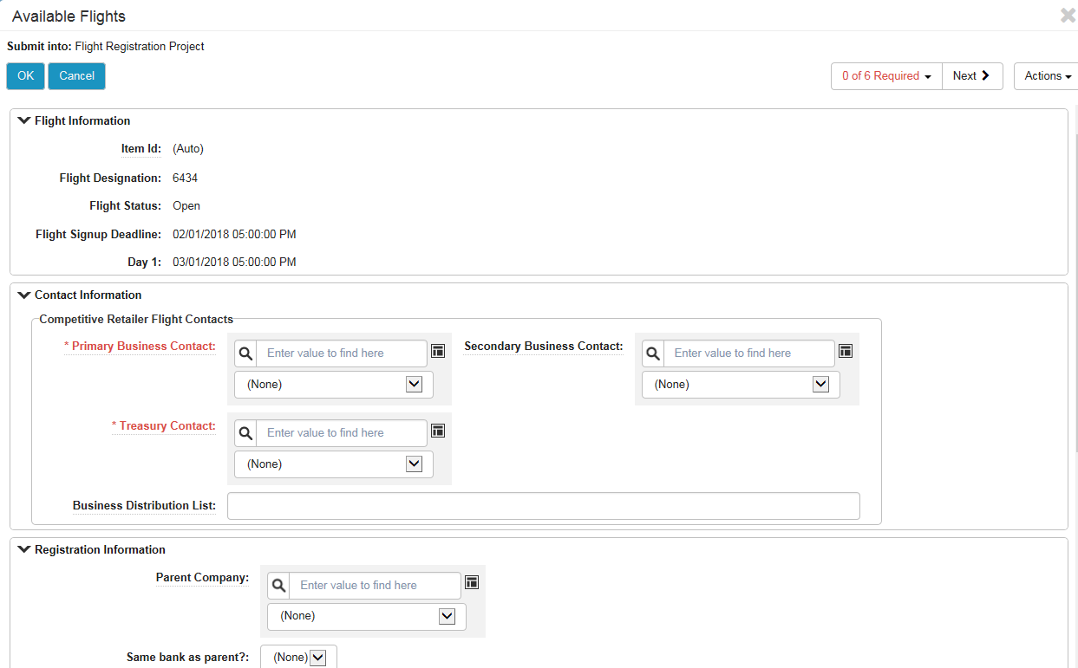
- Registration Information (Fig 5.1j).
NOTE: If the New MP is a DUNS+4 entity, every entry in this section must match the Parent company for the New MP to be tested under the “Testing Umbrella” of the Parent Company (Fig 5.1j), otherwise, the DUNS+4 entity will test as a New MP.

Fig 5.1j
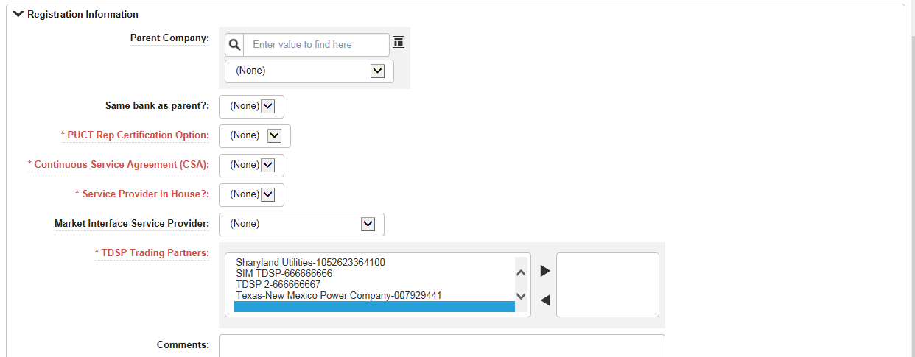
    - If all required fields are not completed when the form is submitted, an error message naming the fields that are invalid will be shown (Fig 5.1k).

Fig 5.1k
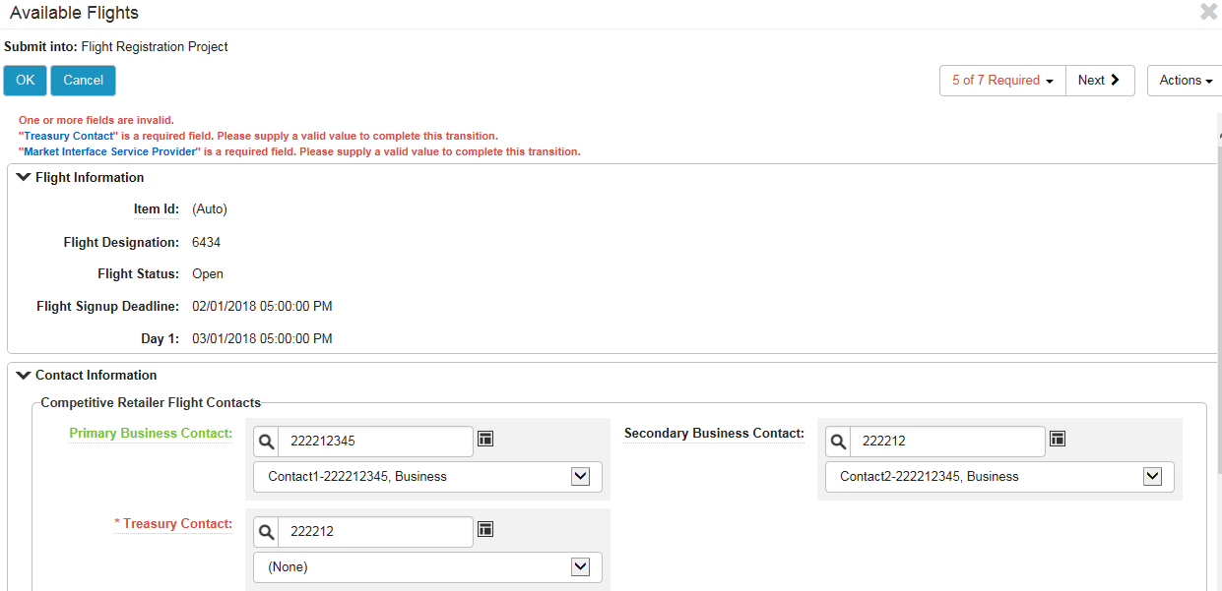
    - Once all fields are complete, click OK.

Fig 5.1l
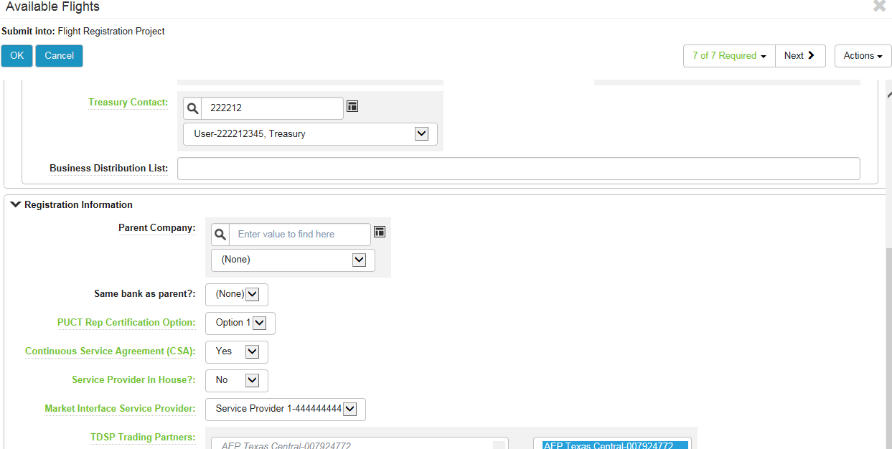
    - The workflow moves to Pending Submittal (Fig 5.1m).

Fig 5.1m
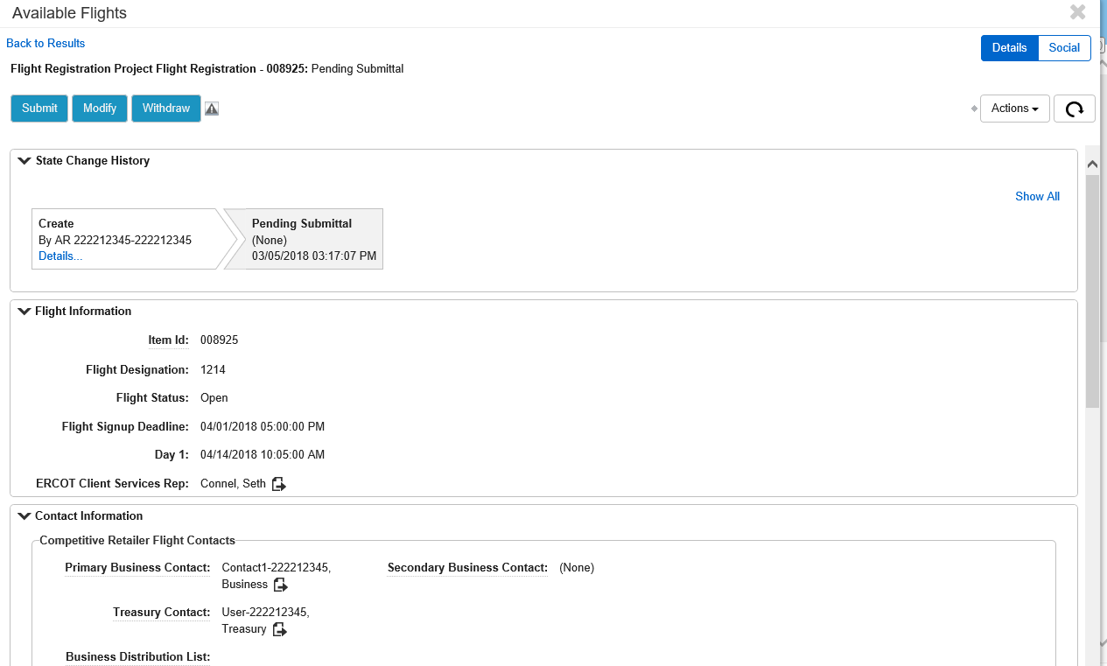
    - At this time, the submitter may Submit, Modify, or Withdraw the submittal (Fig 5.1m).
    - Once the Registration is submitted, the workflow moves to ERCOT for Registration Review (Fig 5.1n).

Fig 5.1n
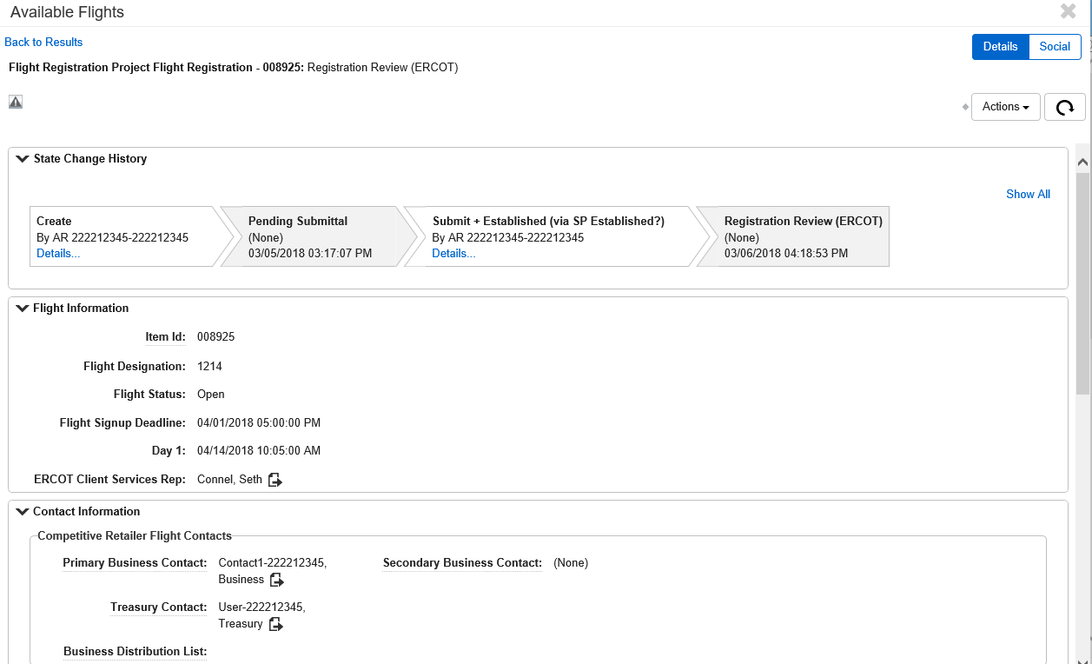
    - If ERCOT returns to the CR, the issue can be found in the Pre-Flight (CR) Dashboard in the Flight Registration records report (Fig 5.1o). The issue will transition back to Pending Submittal (Fig 5.1p).
Fig 5.1o
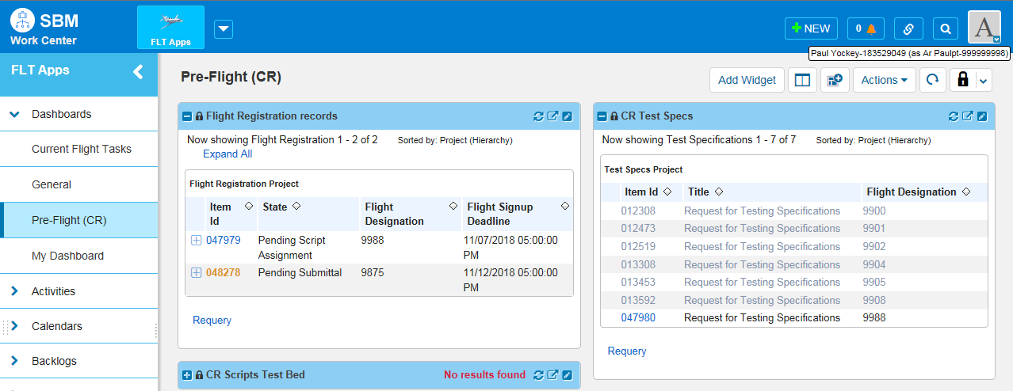

Fig 5.1p
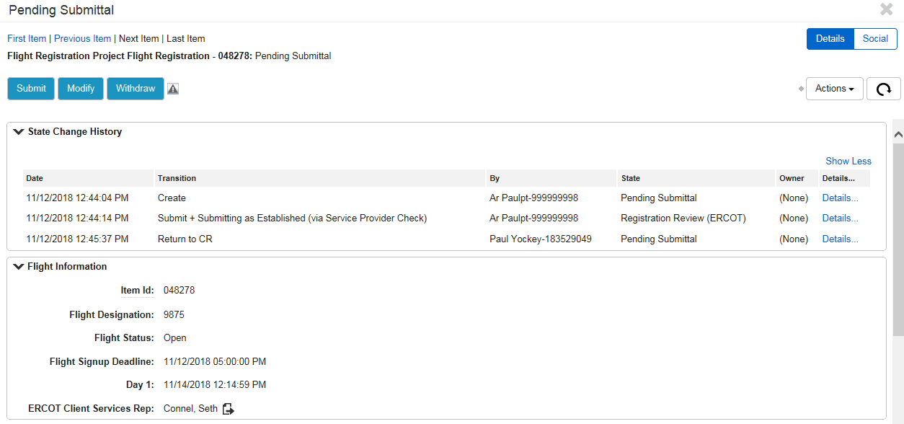

    - Click on Details for the Return to CR, or scroll to the bottom of the page to see comments from ERCOT (Fig 5.1q).

Fig 5.1q
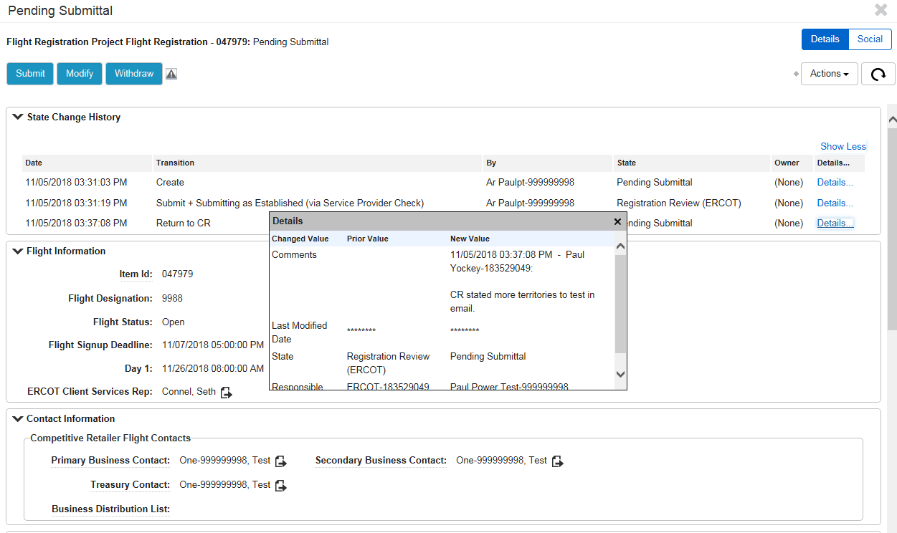
    - Click Modify to make the updates needed.
    - Once the updates have been made, click OK.
    - Click the Submit button to send back to ERCOT for Registration Review.
    - The registration moves to Registration Review (ERCOT) (Fig 5.1r).
Fig 5.1r
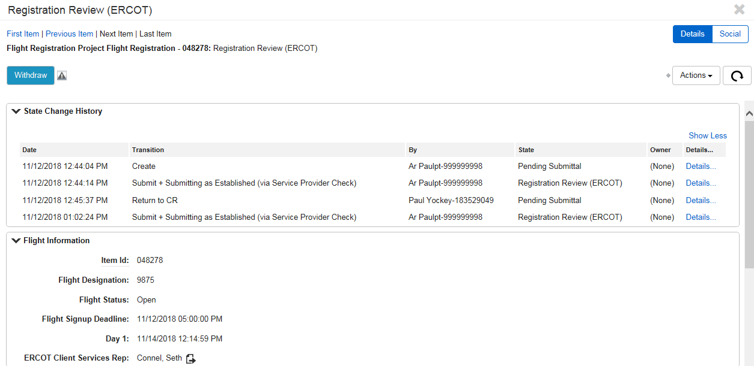
    - ERCOT approves the submission, or returns to CR for updates. Once approved, the workflow moves to the state of Pending Script Assignment (Fig 5.1s).
Fig 5.1s
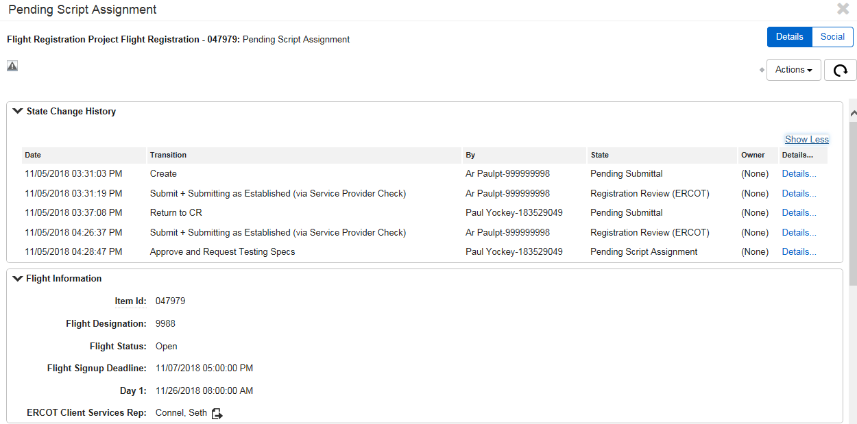
    - A new issue is opened for Request for Testing Specifications, and can be found in the Pre-Flight (CR) Dashboard in the CR Test Specs report (Fig 5.1t).

Fig 5.1t
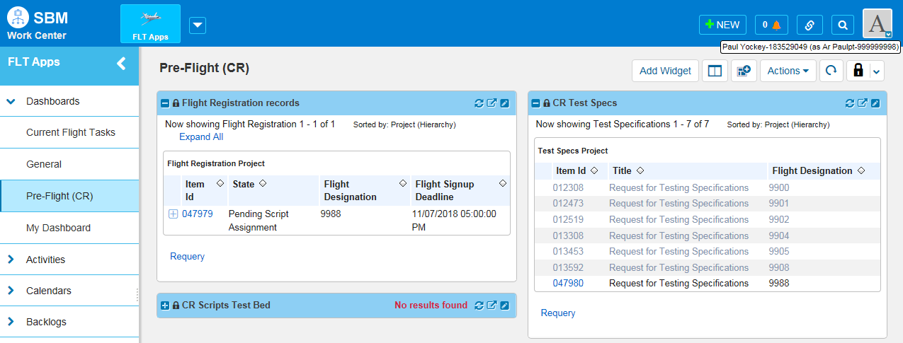
    - The Request for Testing Specifications issue can be accesses by any active user for the MP (Fig 5.1t), or by any user of the selected Service Provider in the Pre-Flight (SP) Dashboard (Fig 5.1u).

Fig 5.1u
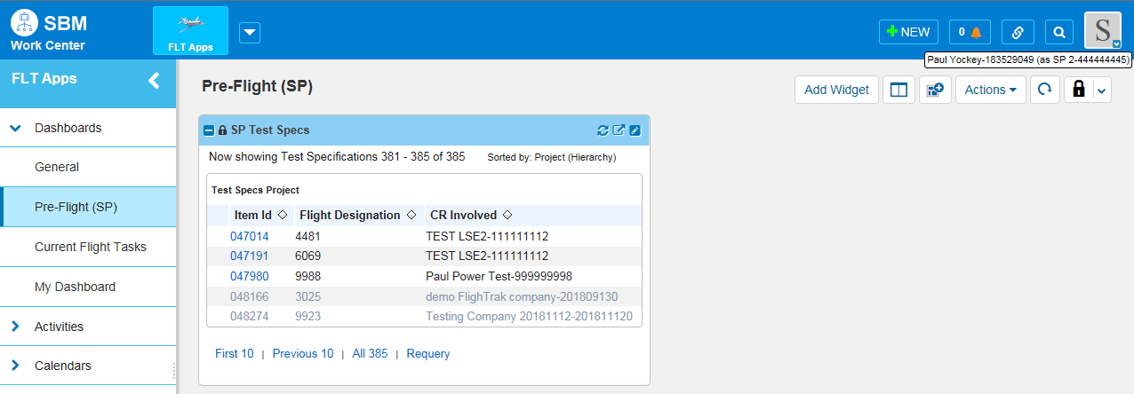

Flight Registration Existing CR
    - Only the AR/BAR has privileges to submit a Flight Registration.
    - When an AR/BAR logs in to submit a Flight Registration, registration information from the previous Flight tested will be auto-populated (Fig 5.2a).

Fig 5.2a
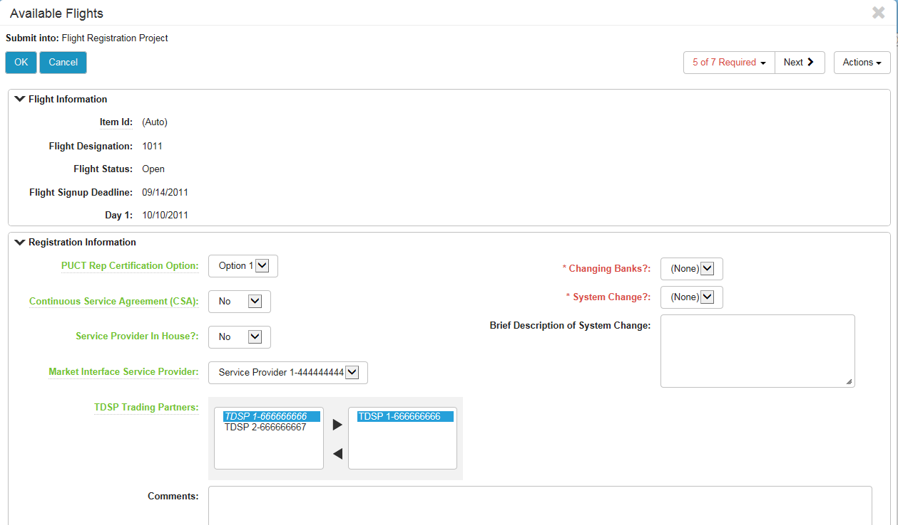
    - Select the options for Changing Banks and System Change (Fig 5.2a)
    - Verify or update all Registration Information.
    - Once all required info is complete, click OK.
    - The State moves to Registration Review by ERCOT.
    - Refer to section 5.1 numbers 17 thru 26 for next steps.

MP Withdraws from Flight after completed registration.
The AR or BAR are the only users that can withdraw a company from a flight.

- Pull up the Flight registration for your company and open the workflow. This can be done by looking in the Available Flights report on the General dashboard, or searching for the Flight number or opening the Flight Registration record report.
Fig 5.3a
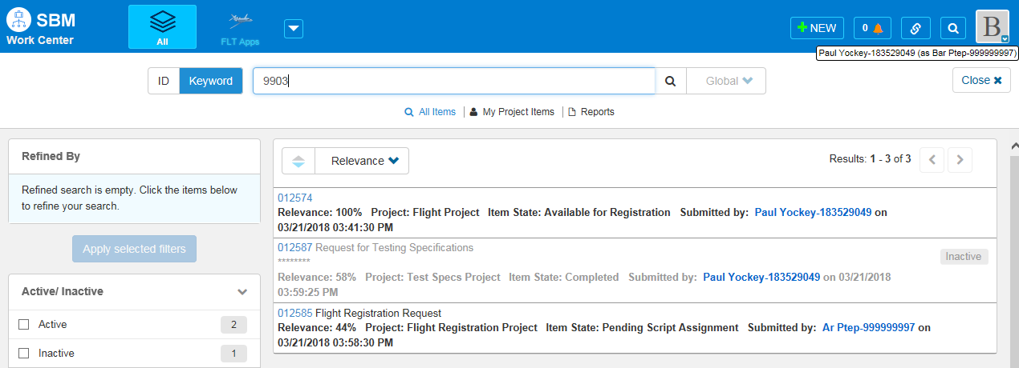
Fig 5.3b
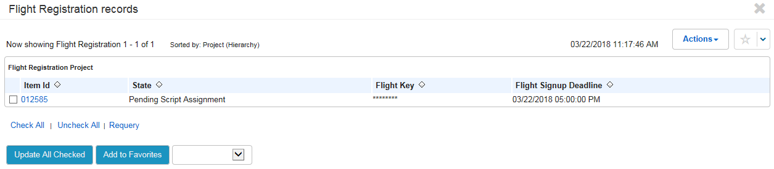
- Once the workflow is open, click the Cancel button to cancel the registration for the selected Flight (Fig 5.3c).
Fig 5.3c
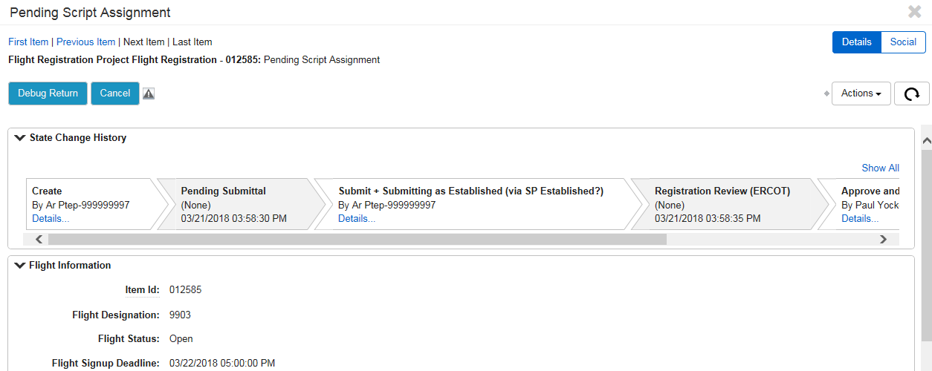
- The registration is now cancelled and has moved to Cancelled (Inactive) state (Fig 5.3d).
Fig 5.3d
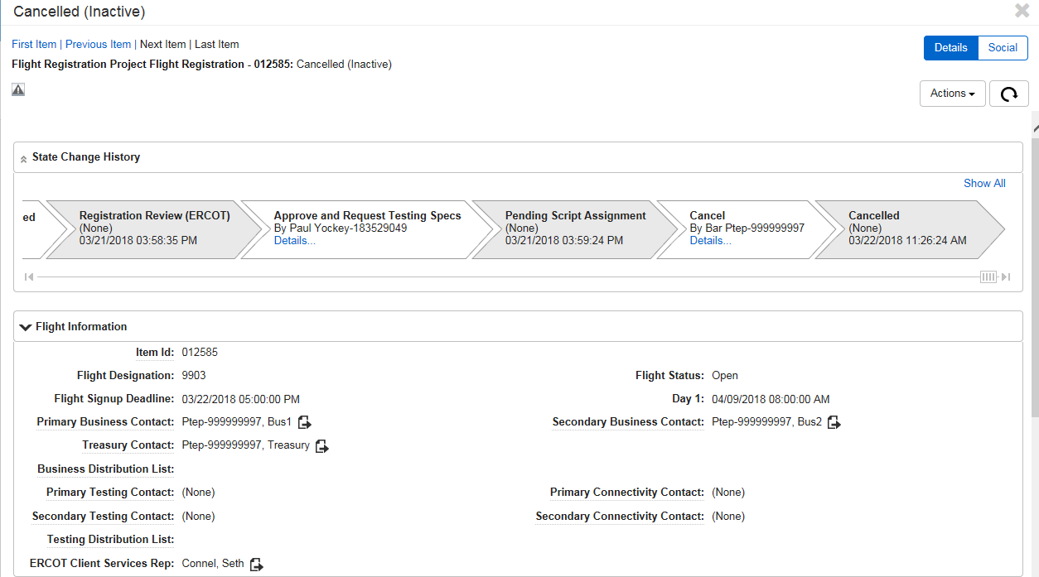

Testing Specifications

CR or SP Provides/Reviews Testing Specifications
    - Once the flight registration has been approved by ERCOT, a Request for Testing Specifications issue is created. This can be found by going to the Pre-Flight (CR) dashboard under the CR Test Specs report (Fig 6.1a) or the Pre-Flight (SP) dashboard using the SP Test Specs report (Fig 6.1b).
Fig 6.1a
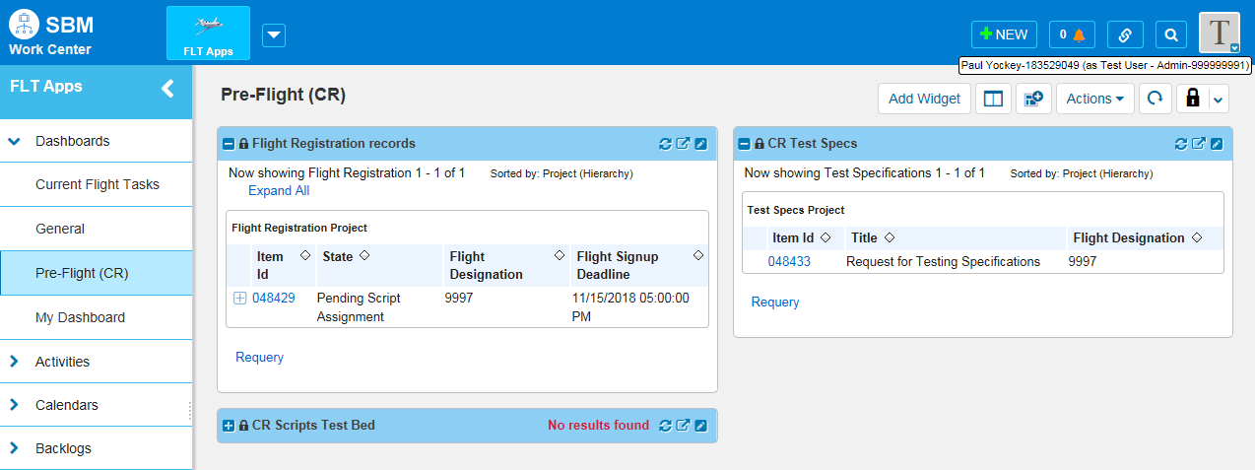

Fig 6.1b
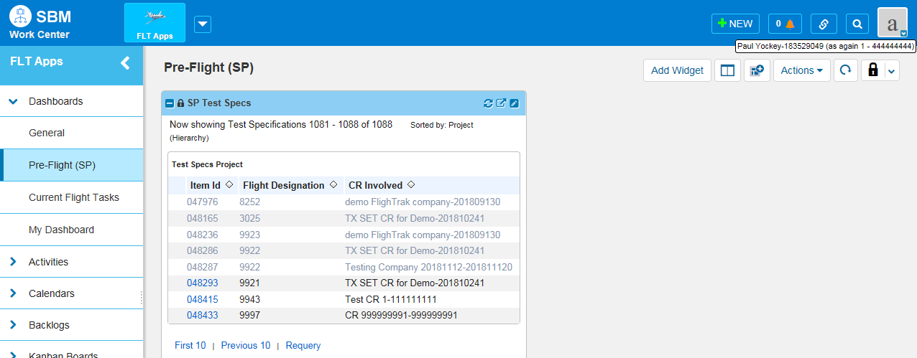
    - The CR or the designated SP now Provides/Reviews the Testing Specifications. Click on the Item Id to open the issue (Fig 5.1b).
    - The issue for the Request for Testing Specifications opens (Fig 6.1c).

Fig 6.1c
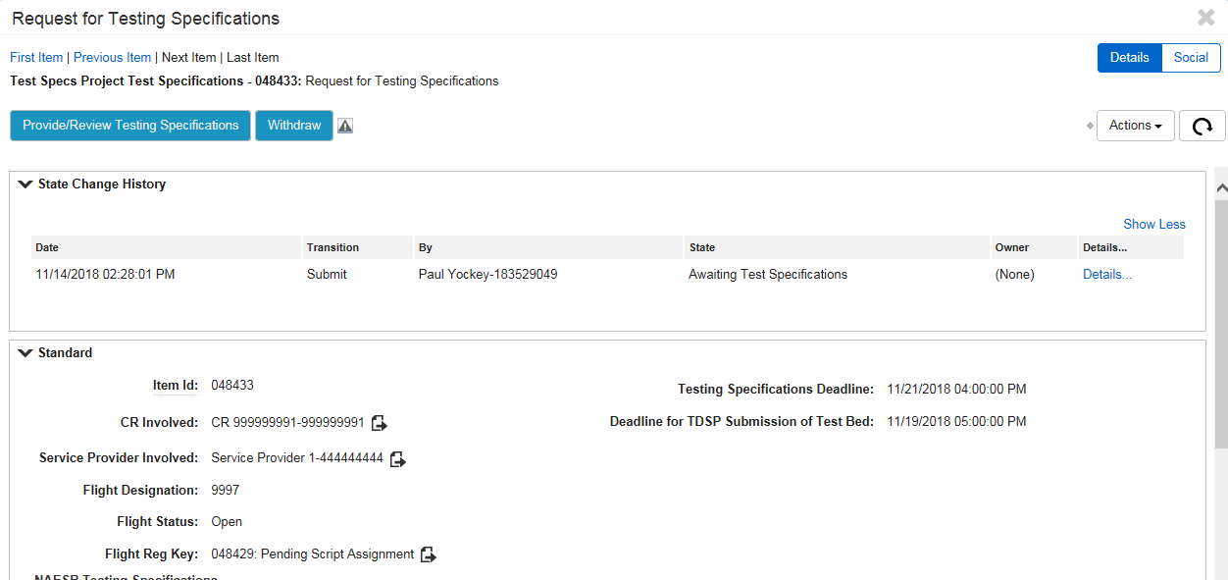
    - The CR or the designated SP clicks the Provide/Review Testing Specifications button (Fig 6.1c).
    - The CR or the designated SP fills out the required fields for NAESB Testing Specifications (Fig 6.1d) and the Testing and Connectivity Contacts (Fig 6.1e).

NOTE: This is where the Testing Distribution List email address can be added for use in the Flight Test.

Fig 6.1d
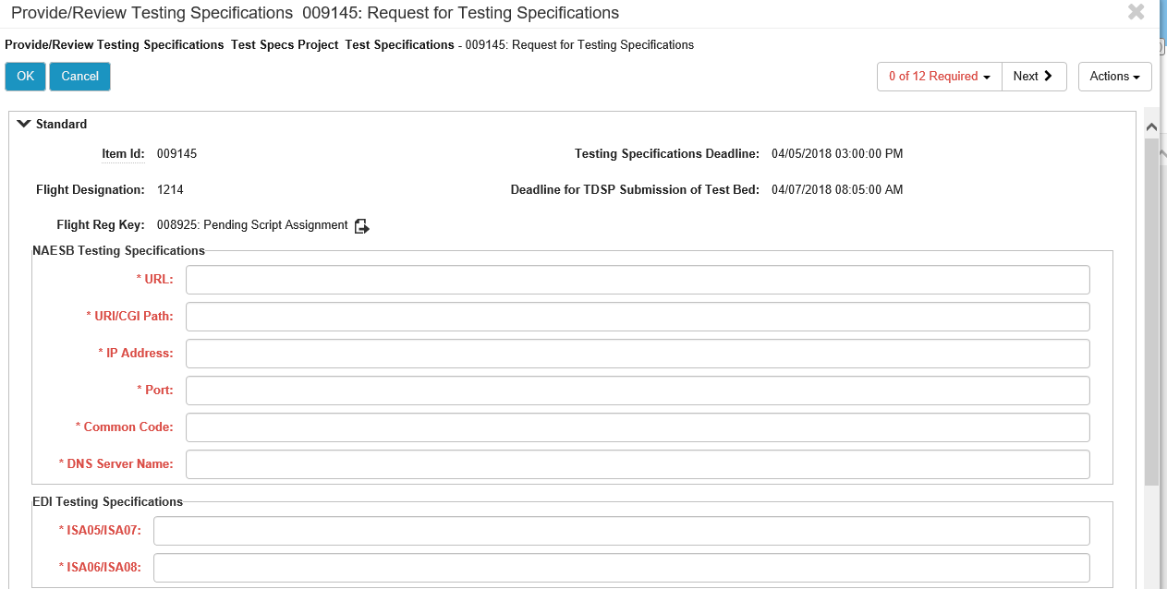

Fig 6.1e
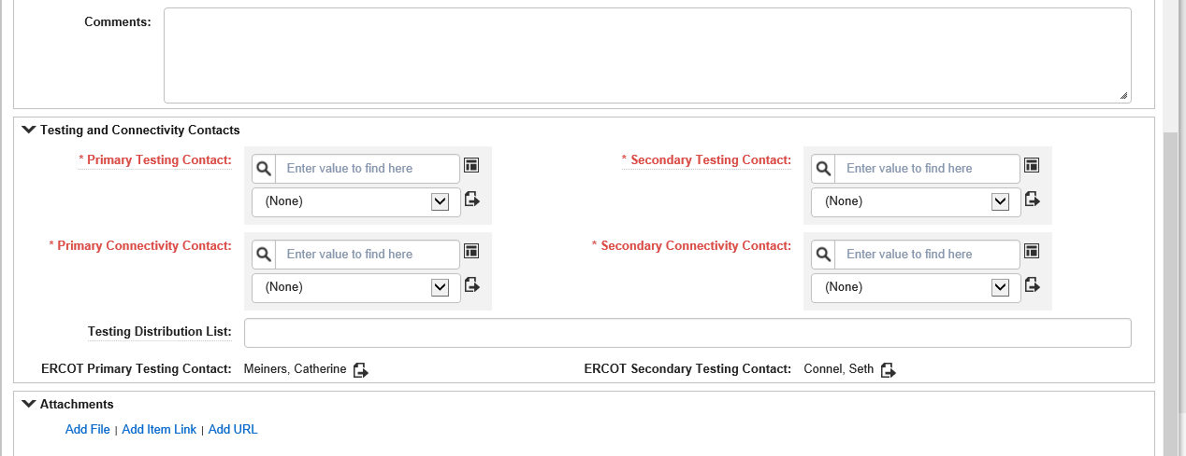
    - Once all required fields are complete, click OK (Fig 6.1f).

Fig 6.1f
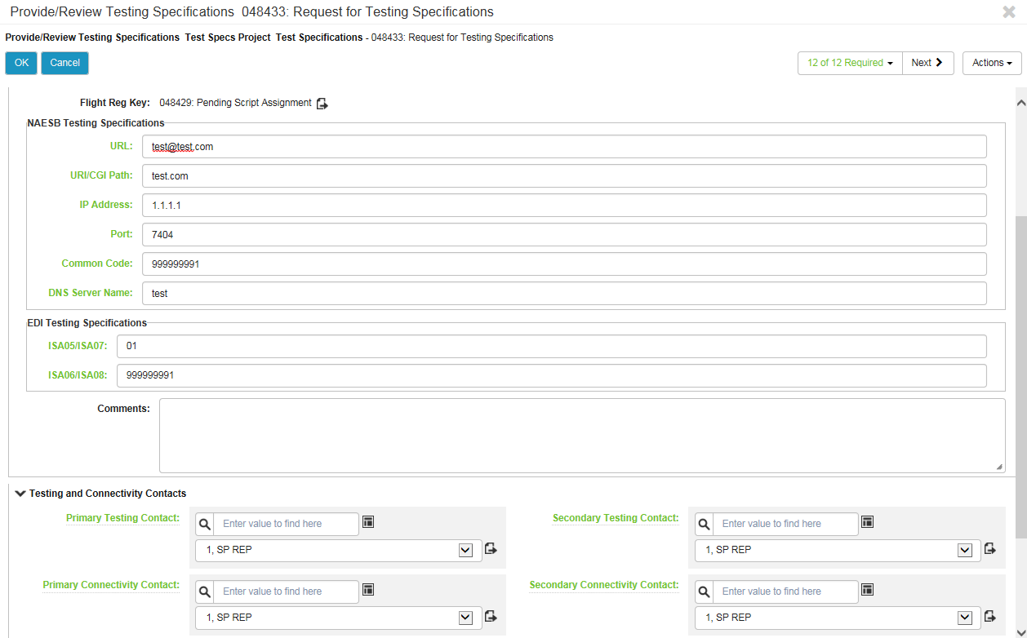
    - The workflow then returns to ERCOT for approval (Fig 6.1g).

Fig 6.1g
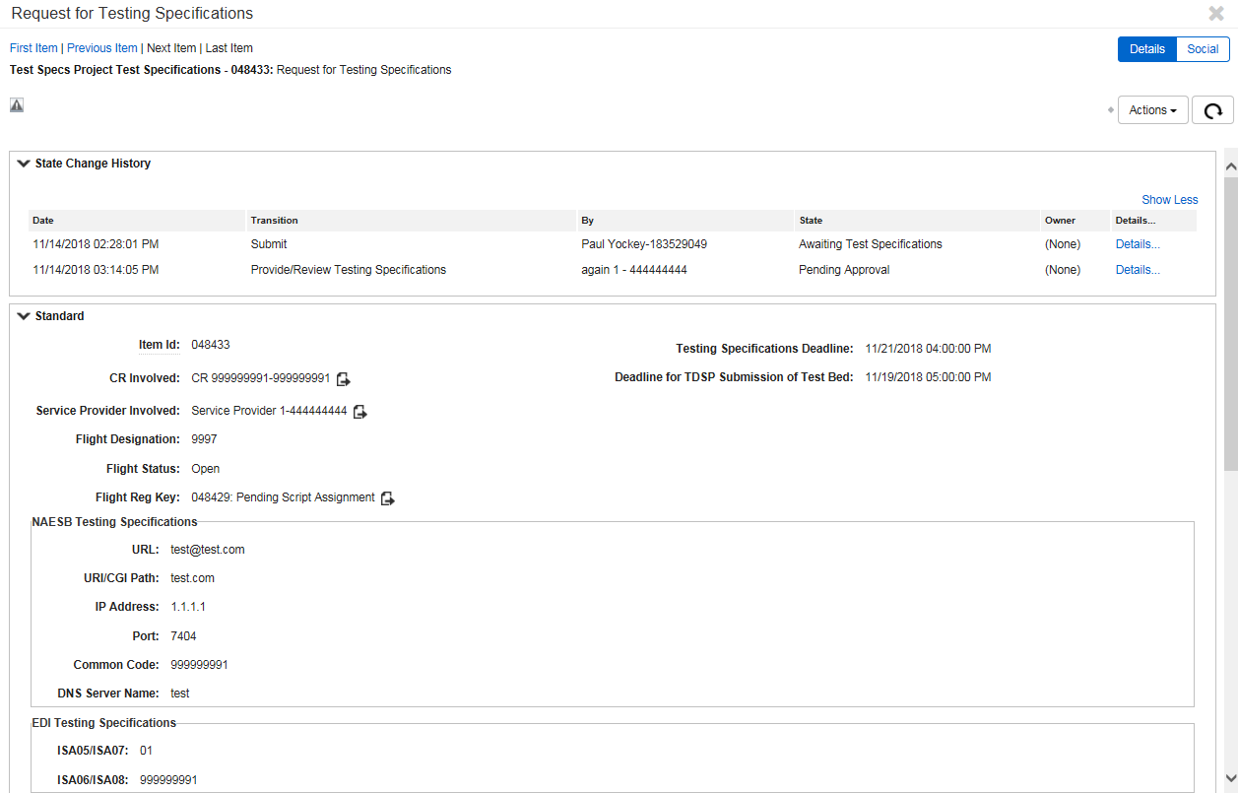
    - If ERCOT rejects the Testing Specification that were submitted, the issue will be back under the Pre-Flight (CR) dashboard under the CR Test Specs report (Fig 6.1a) or the Pre-Flight (SP) dashboard using the SP Test Specs report (Fig 6.1b).
    - To see why ERCOT rejected the submittal, click the Details on the Request for Testing Specifications and a popup window will appear with the comments (Fig 6.1h).
Fig 6.1h
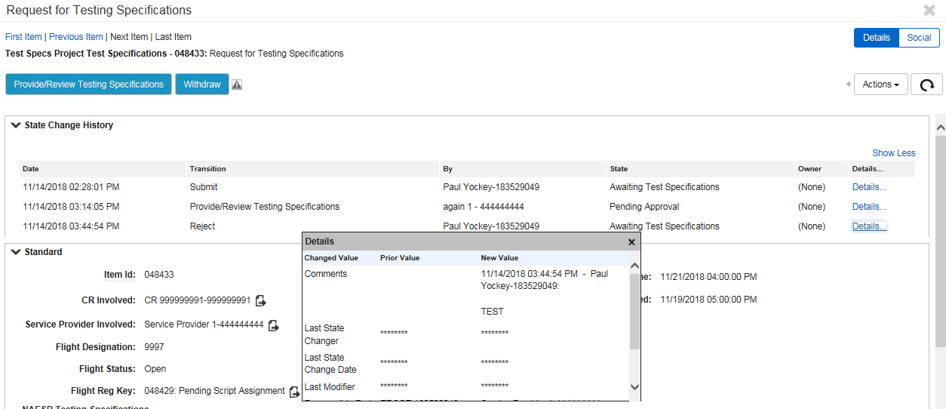
    - The CR or designated SP repeats steps 4 thru 7 in section 6.1, updating whatever caused the reject.
    - Once ERCOT approves the Testing Specifications, the Request for Testing Specifications issue move to a state of Approved (Fig 6.1i).
Fig 6.1i
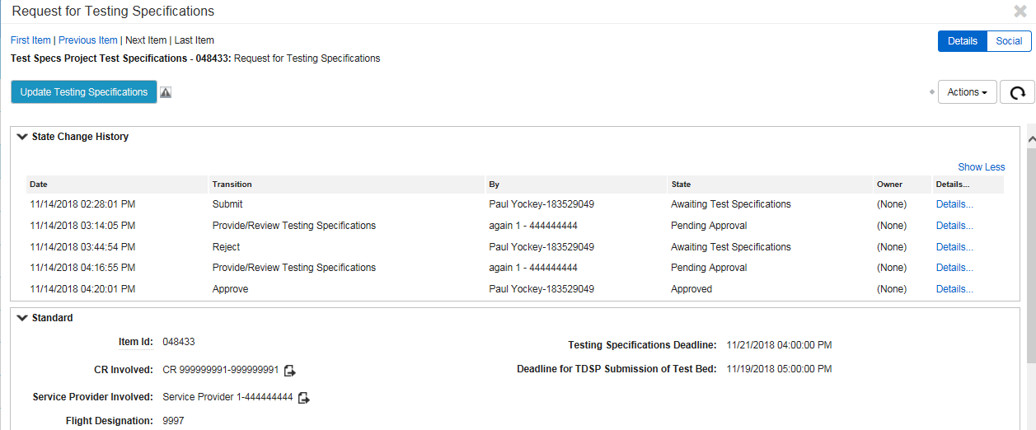

TDSP Provides/Reviews Testing Specifications NEED to UPDATE
    - The TDSP goes to the Pre-Flight (TDSP) dashboard (Fig 6.2a).

Fig 6.2a
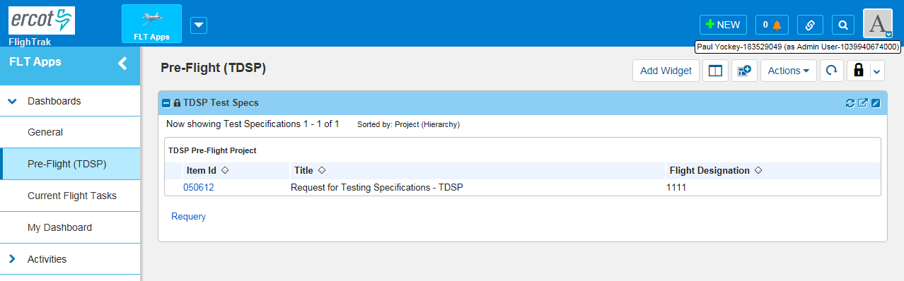

    - Click the Item Id that is returned in the report (Fig 6.2b).

Fig 6.2b
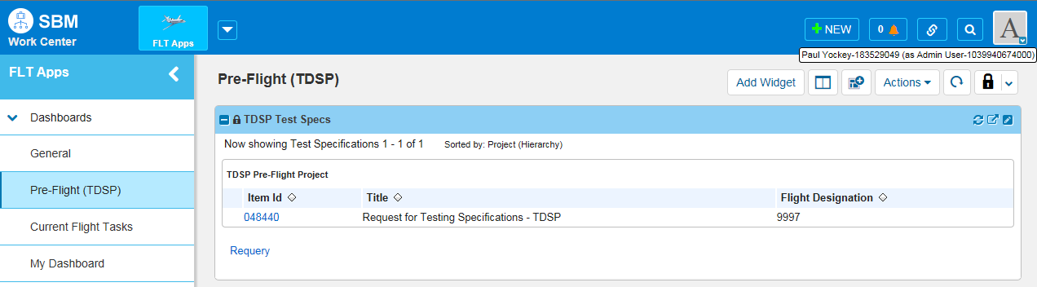
    - This issue for the Request for Testing Specifications opens (Fig 6.2c).
    - Click the Provide/Review Testing Specifications button (Fig 6.2c).
Fig 6.2c
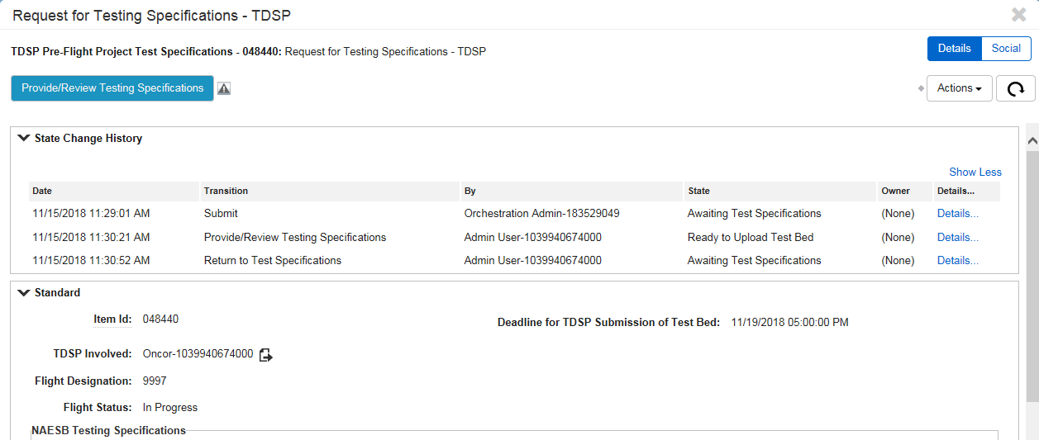
    - Review and/or update the Testing Specifications (Fig 6.2d).
NOTE: This is where the Testing Distribution List email address can be added.
    - Click OK (Fig 6.2d).

Fig 6.2d
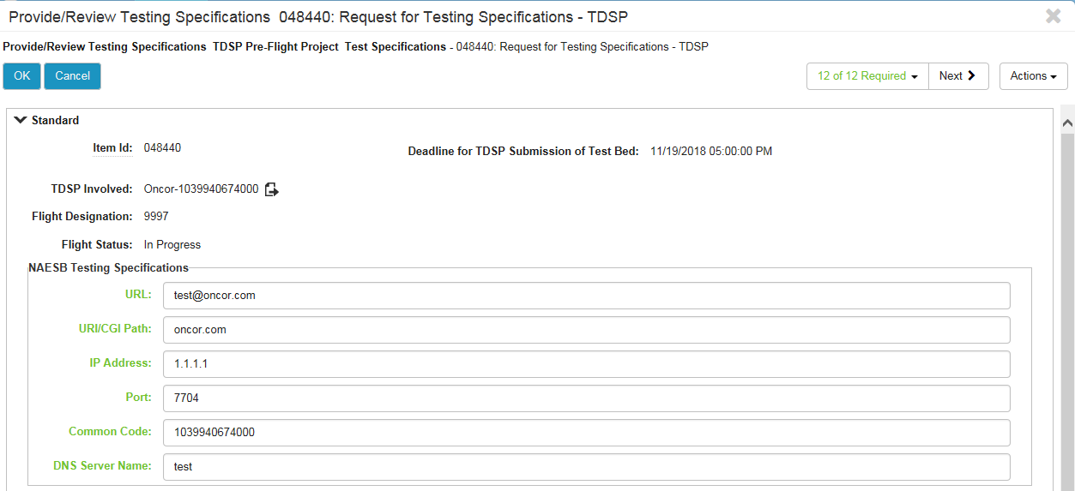
    - The flow then transitions to the request to attach the Test Bed (Fig 6.2e). Continue to section 6.3 Test Bed Loading.
Fig 6.2e
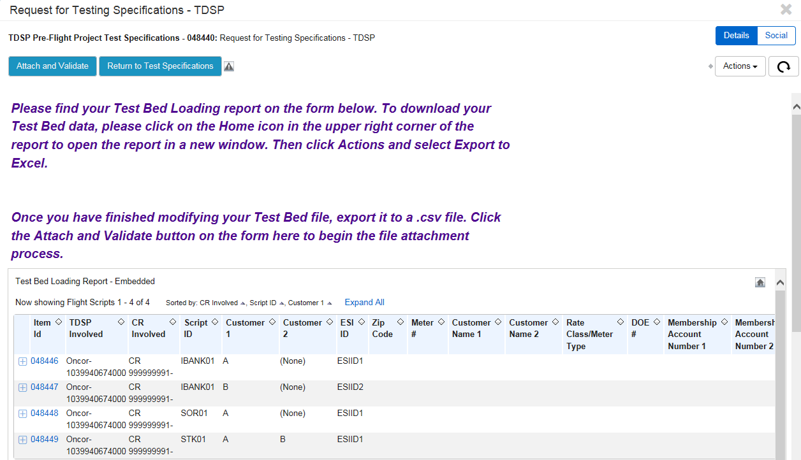

Test Bed Loading
    - Once the TDSP has completed Request for Testing Specifications and Review/Update their testing specifications, the Test Bed loading portion of the Request for Testing Specifications opens.
    - The following screen will appear with info for the Test Bed. Follow the on-screen instructions to download, modify, and upload you Test Bed file (Fig 6.3a).
Fig 6.3a
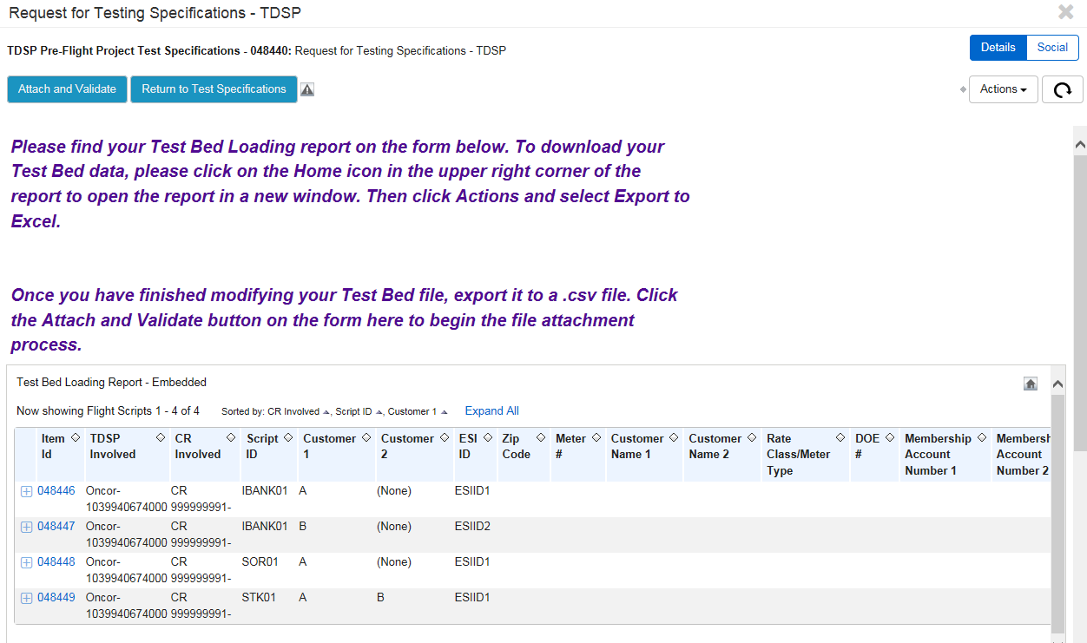
    - Download your Test Bed data.
- Click the Home icon in the upper right corner of the report (Fig 63.a) to open the report in a new window (Fig 6.3b).

Fig 6.3b
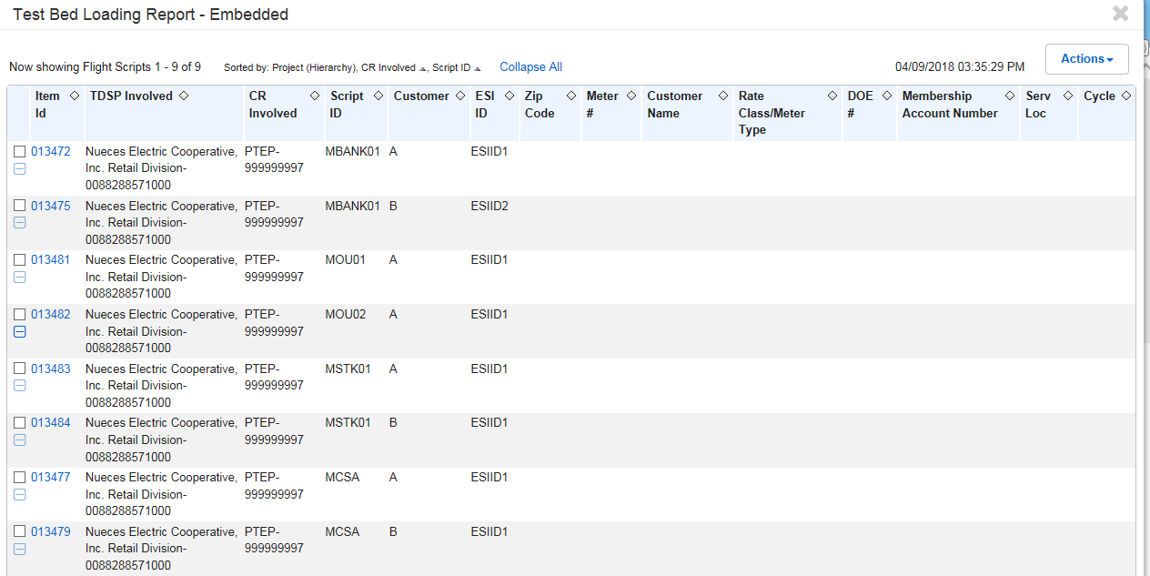
- Click Actions and select Export to Excel (Fig 6.3c).
- This page opens in a new windows tab.
Fig 6.3c
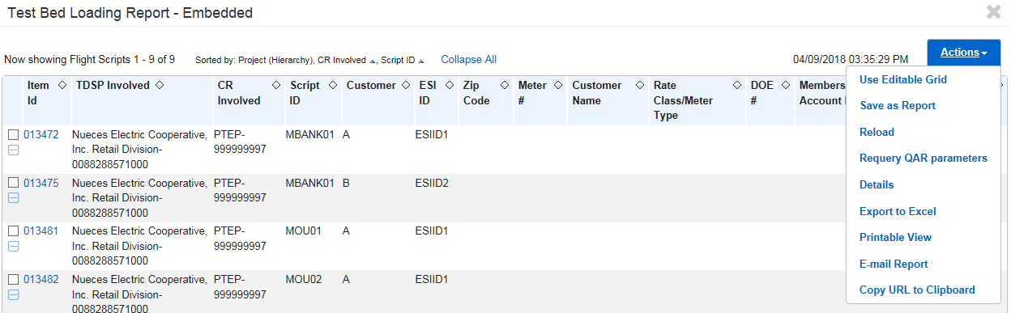
- Choose the Save as option to save to a place you can retrieve it from (Fig 6.3d).

Fig 6.3d
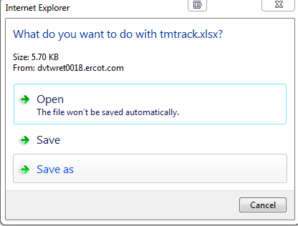
- Close the Test Bed Loading Report – Embedded tab.
- Add the info needed for your testbed to the downloaded file (Fig 6.3e).

Fig 6.3e
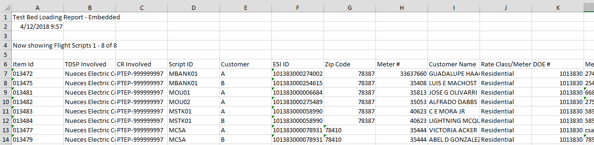
- Once your info has been added, remove the header rows and the column name row (Fig 6.3e).
Fig 6.3f
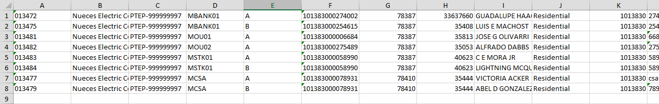
- Once you have finished modifying your Test Bed file (Fig 6.3f), export it to a .csv file (Fig 6.3g).

Fig 6.3g
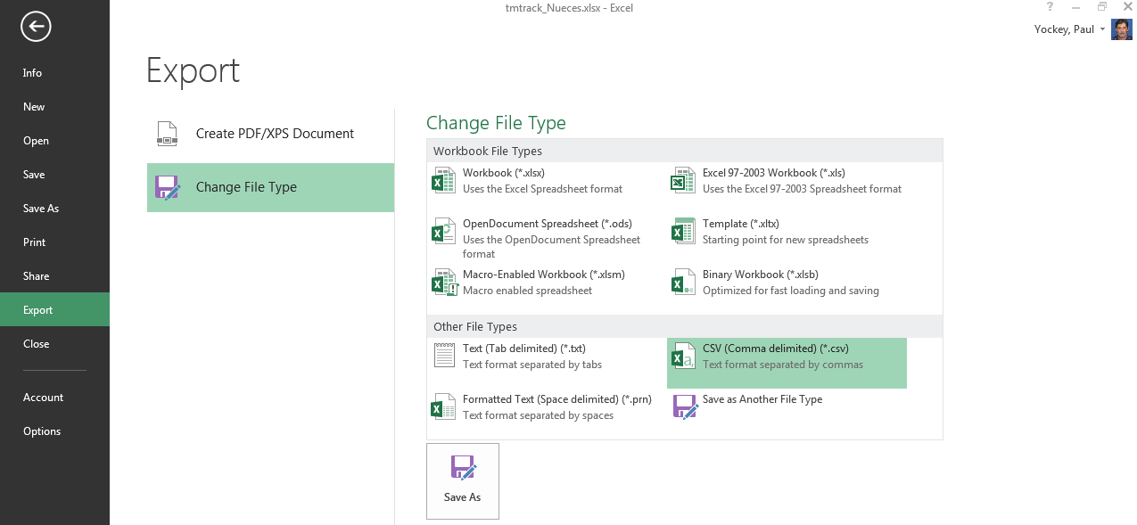
- Click the Attach and Validate button on the form to begin the attachment process.

NOTE: The word “File” at the upper right of the window is red (Fig 6.3h).

Fig 6.3h
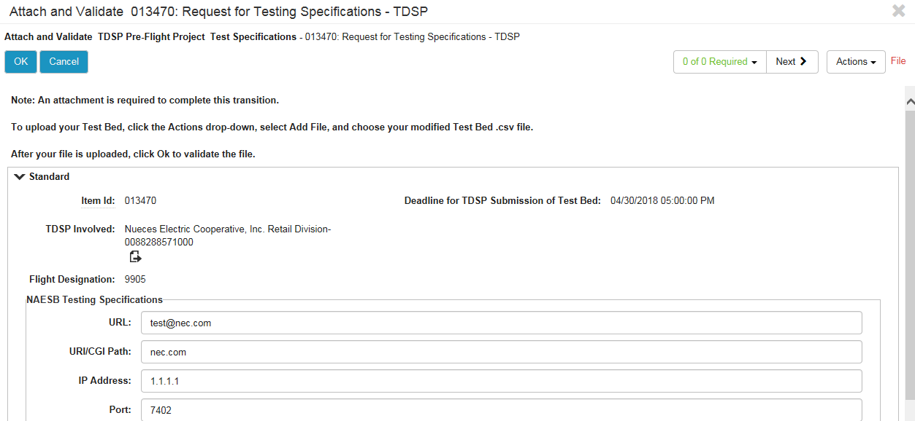
- Follow the on screen instructions.
- Click the Actions drop-down (Fig 6.3h).

Fig 6.3i
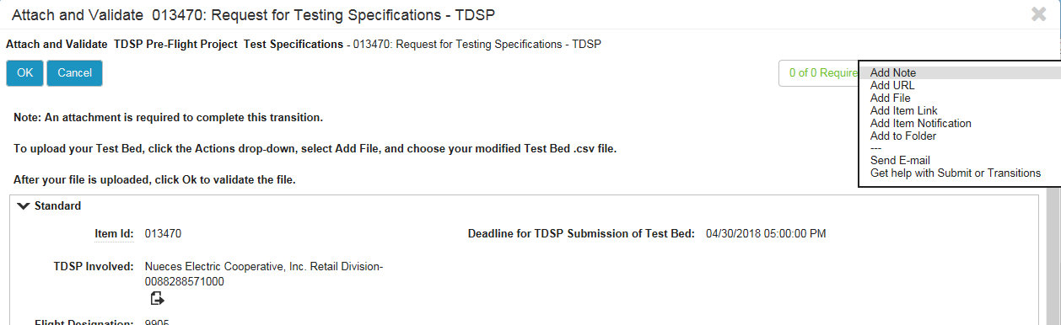
- Select Add File (Fig 6.3i).
Fig 6.3j
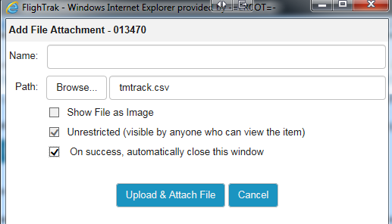
- Choose your modified Test Bed.csv file (Fig 6.3j).
- Click Upload & Attach File (Fig 6.3j).
Fig 6.3k
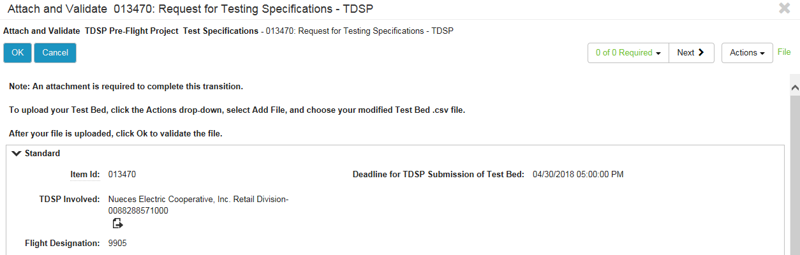
- The word “File” in the upper right of the window is now green (Fig 6.3k).
- After you file is uploaded, click OK to validate the file (Fig 6.3k).
    - Submit the Test Bed using the Submit button (Fig 6.3l).

Fig 6.3l
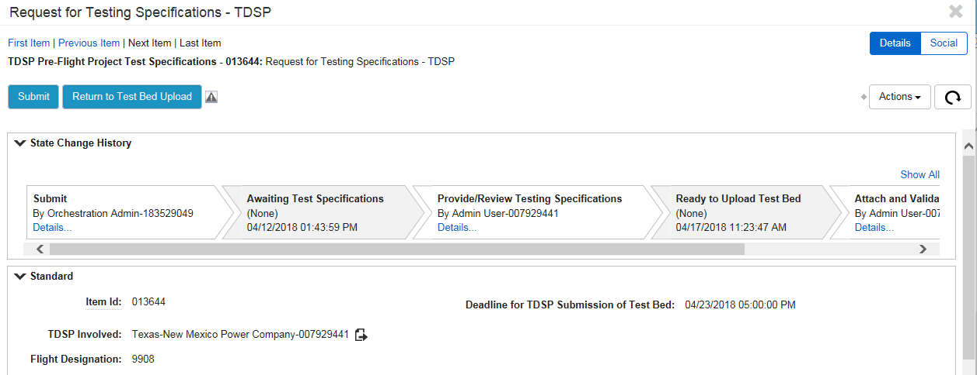
    - The Test Bed flow moves to ERCOT Review (Fig 6.3m).

Fig 6.3m
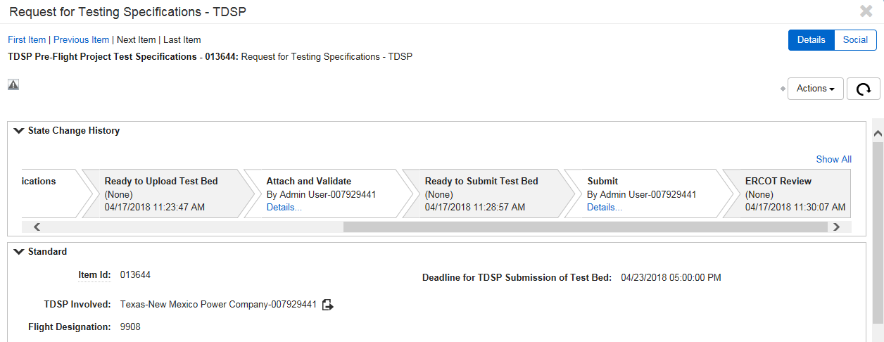
    - Once ERCOT approves the Test Bed, the Request for Testing Specifications issue is transitioned to completed state and becomes inactive (Fig 6.3n).
Fig 6.3n
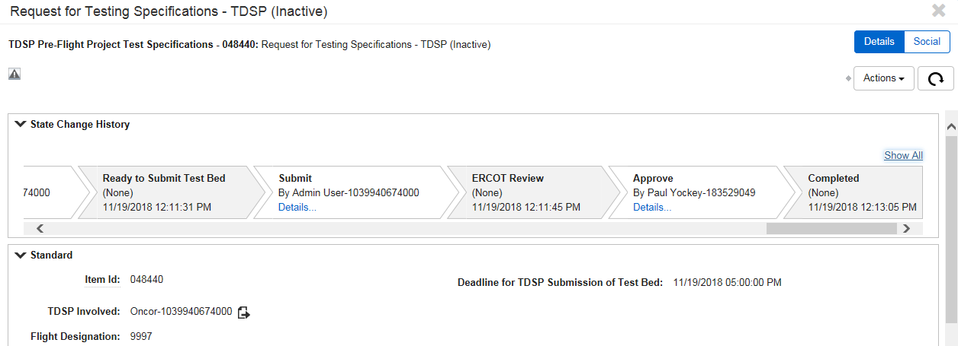

Download the Test Bed
Both the CR and the designated Service Provider can download the Test Bed for a CR. The CR Test Beds can be accessed on the Pre-Flight (CR) and Pre-Flight (SP) dashboards using the CR Scripts Test Bed report.
NOTE: This report is available before the TDSPs have submitted their Test Beds. The ESI ID will be listed as ESIID1 and ESIID2 until the Test Beds have been submitted. Once a Test Bed is submitted by a TDSP, and is approved by ERCOT, the ESI ID will be populated in the report. It is possible for some ESI IDs to be updated and some not until all TDSPs have submitted their Test Beds.
    - The user goes to the Pre-Flight (CR) or Pre-Flight (SP) dashboard (Fig 6.4a).

Fig 6.4a
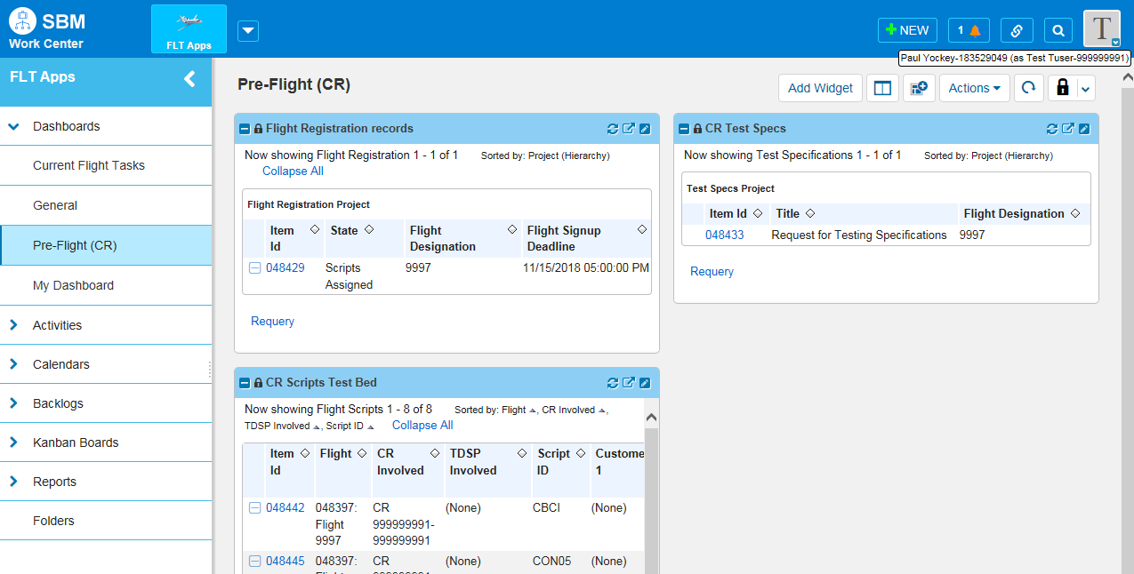
    - Click the Zoom button on the CR Scripts Test Bed report (Fig 6.4b).

Fig 6.4b
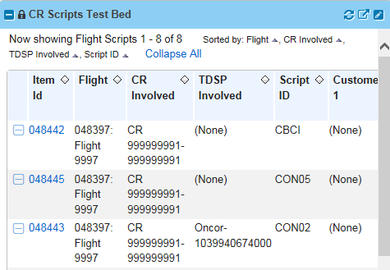
    - A new window opens with the CR Scripts Test Bed (Fig 6.4c).

Fig 6.4c
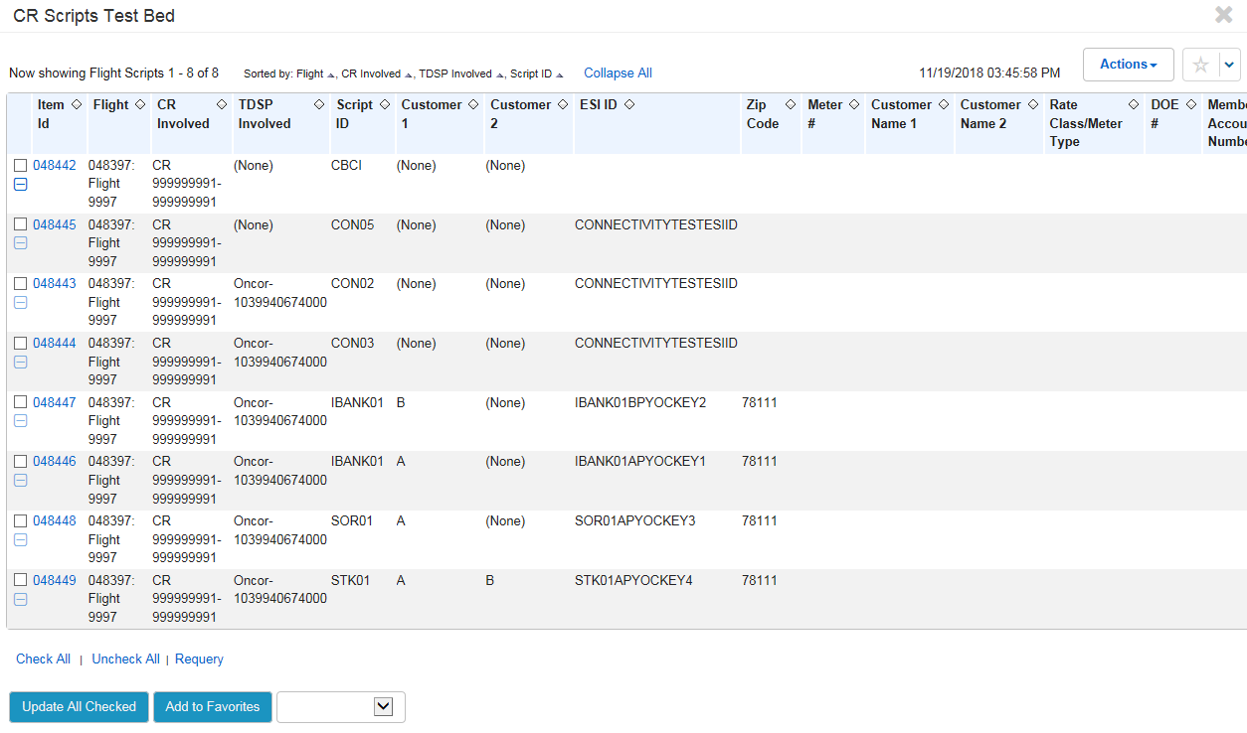
    - Click the Actions dropdown and select Export to Excel (Fig 6.4d).

Fig 6.4d
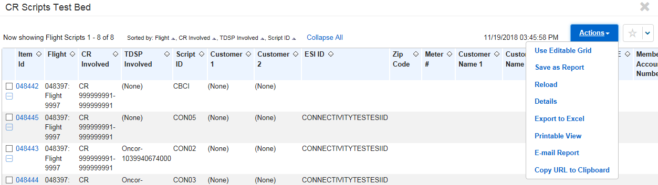
    - Choose Save as when the download popup window appears (Fig 6.4e).

Fig 6.4e
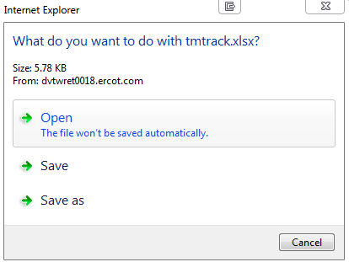
    - The Test Bed is saved to the location you choose, and has all the information that is on the report in the FlighTrak tool (Fig 6.4f).
Fig 6.4f
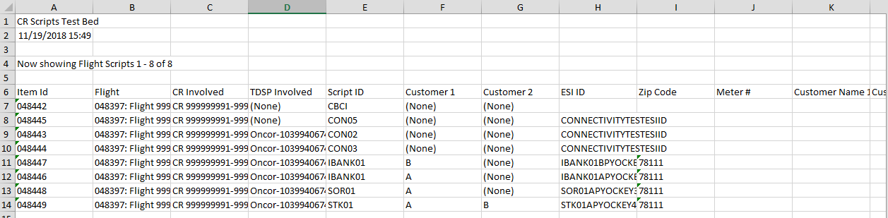
    - Close the zoomed CR Scripts Test Bed window and you are returned to the Pre-Flight (CR) or Pre-Flight (SP) dashboard.

Test Scripts
The Test Scripts are comprised of issue flows. The acknowledgement of transactions sent and received are mostly verified by the ERCOT system.

Connectivity Scripts Overview
Once ERCOT has approved all of the Test Beds from the TDSPs, ERCOT will open the Flight for Connectivity Testing. ERCOT and the CRs are the entities that will start the connectivity scripts. The CR will begin CON02 and CON03. ERCOT will begin CON05.
As the examples in this section illustrate, there can be multiple flows in a script. This section outlines a total flow, and how to navigate between the different flows of a script.
    - To begin working on the connectivity scripts, the CR will open the Current Flight Tasks dashboard (Fig 7.1a).
Fig 7.1a
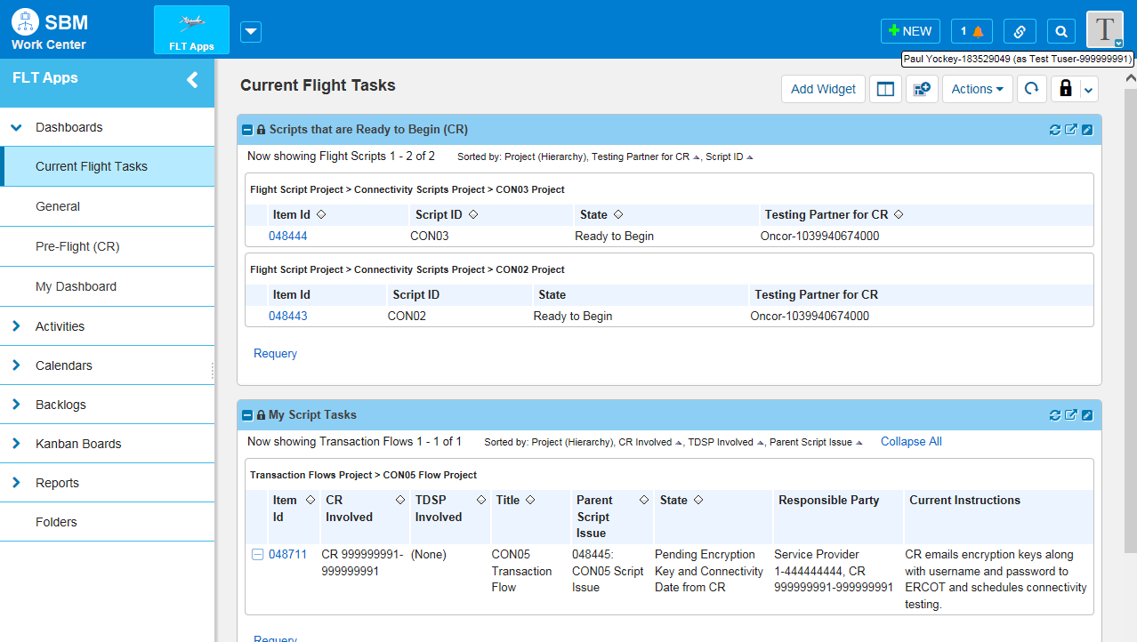
    - The Scripts that are Ready to Begin (CR) report shows the scripts pending CR/SP action to begin (Fig 7.1a).
    - Click the Item Id of the script. The script issue flow opens. For this example, CON03 is being used (Fig 7.1a).

Fig 7.1b
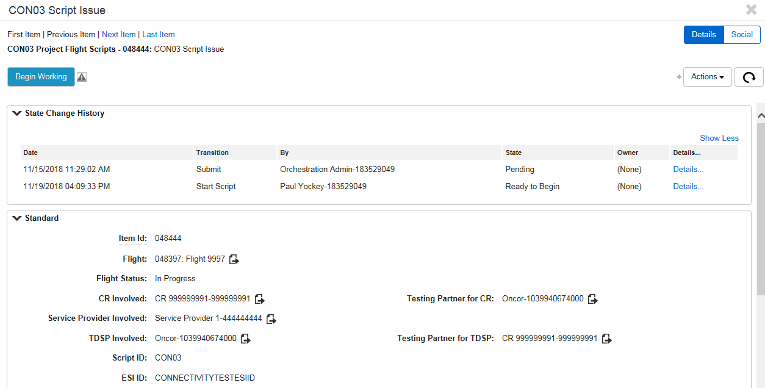
    - Click the Begin Working button (Fig 7.1b).
    - The script issue flow now begins. Follow the Current Instructions on the flow. For this example, the next step is to click the Bank Info Provided by CR button (Fig 7.1c).
Fig 7.1c
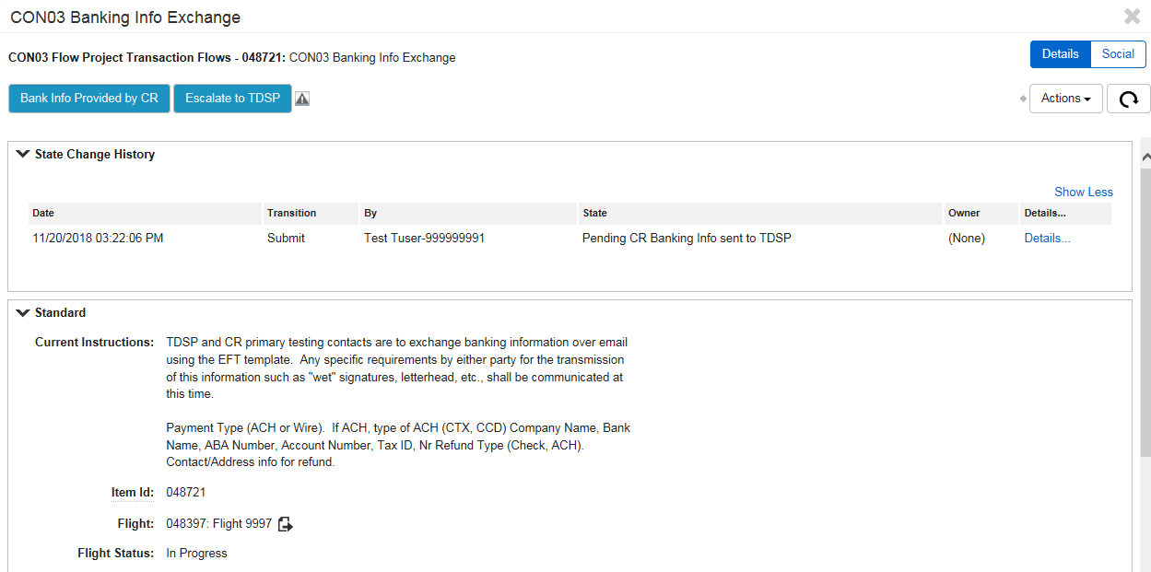
    - The issue flow is now transitioned to Pending TDSP Banking Info sent to CR (Fig 7.1d).

Fig 7.1d
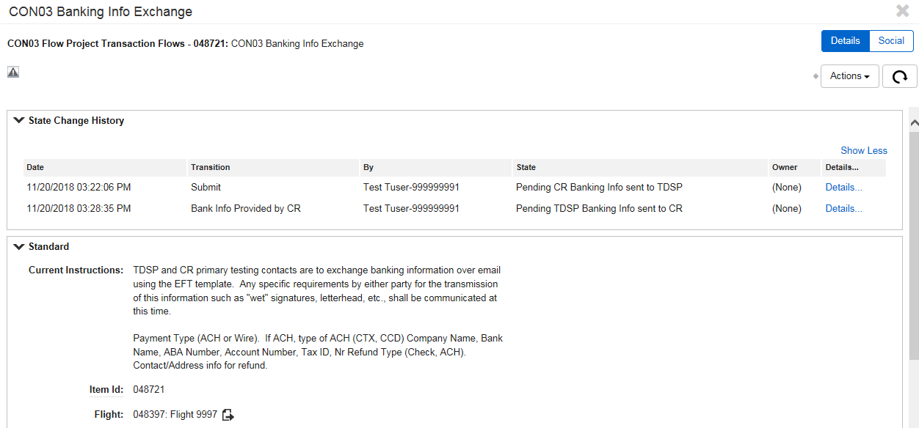
    - Close the script flow window.
    - On the Current Flight Tasks dashboard, click the refresh button (Fig 7.1e). The issue is now under the Testing Partner Script Tasks report (Fig 7.1f).
Fig 7.1e
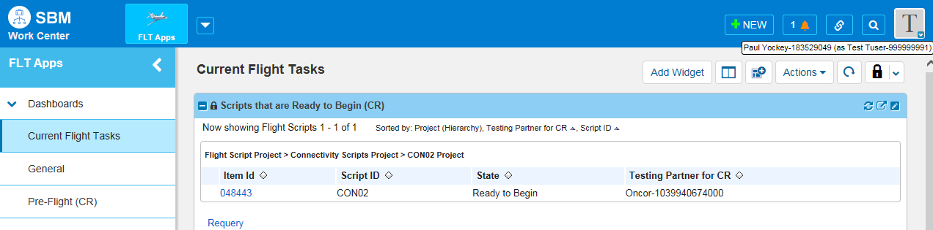

Fig 7.1f
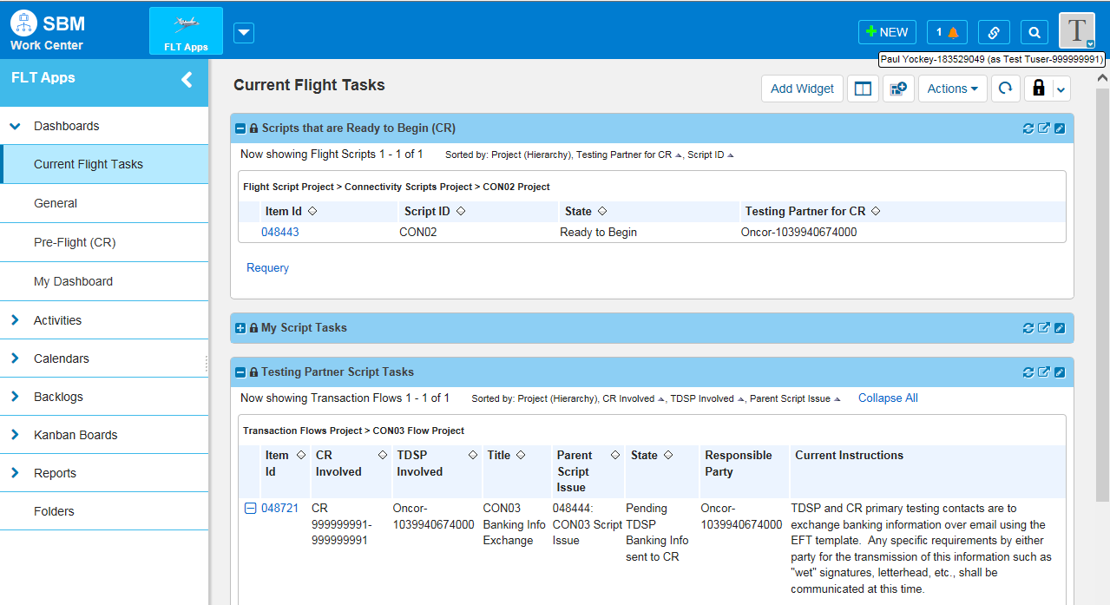
    - Once the TDSP send their banking info to the CR, the TDSP clicks Task Complete and new sub-flow is created for the Bank Transfer (Fig 7.1g).
Fig 7.1g
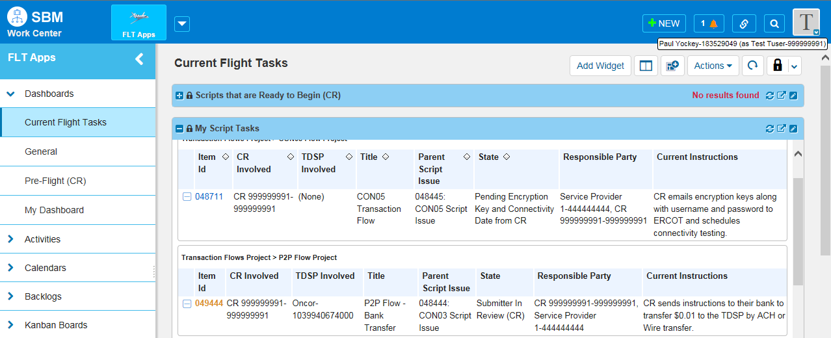
    - Click on the Item Id for the sub-flow P2P Flow – Bank Transfer (Fig 7.1g). The sub-flow opens and shows the flow in progress along with Current Instructions and other info pertaining to this –sub-flow (Fig 7.1h).

Fig 7.1h
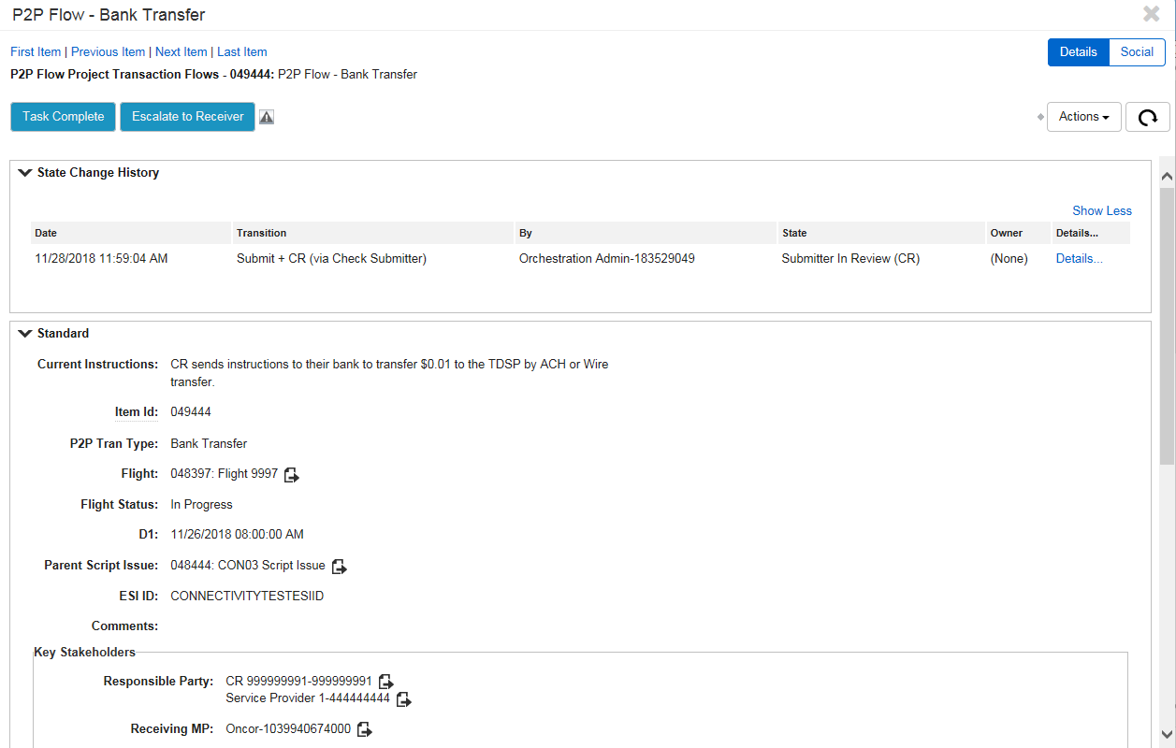
    - The original CON03 flow is available to view by going to the Active Script Issue report (Fig 7.1i).
Fig 7.1i
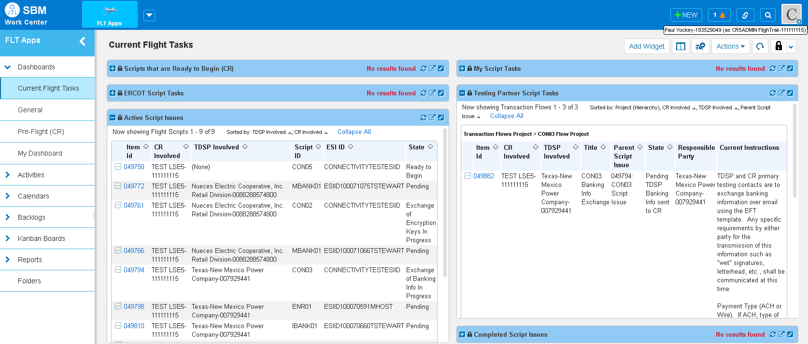

    - The CON03 Script Flow is opened and is showing the State of P2P Bank Transfer in Progress.

Fig 7.1j
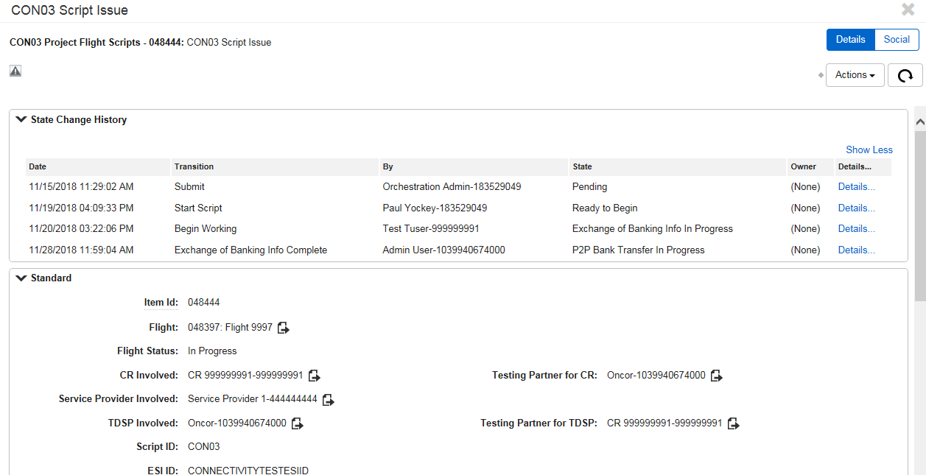
    - To return to the sub-flow P2P Flow – Bank Transfer, go to the My Script Tasks report and select the P2P Flow – Bank Transfer (Fig 7.1k).
Fig 7.1k
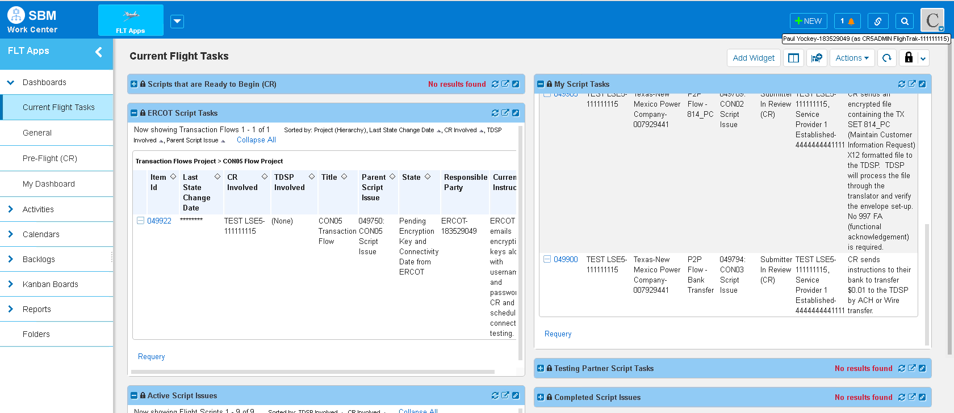

Fig 7.1l
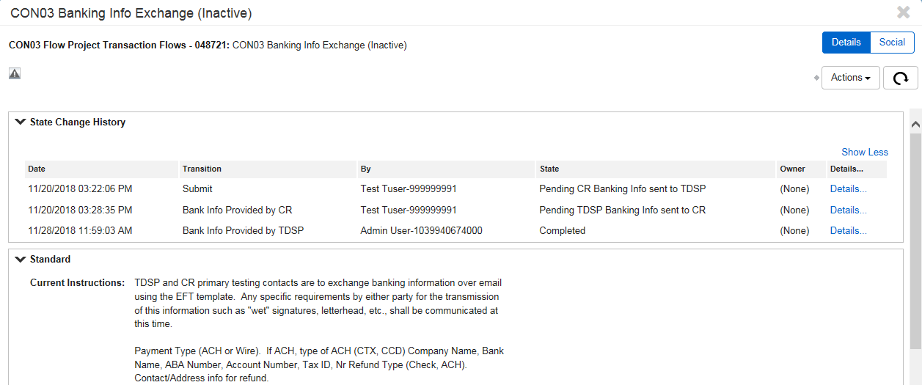
Fig 7.1m
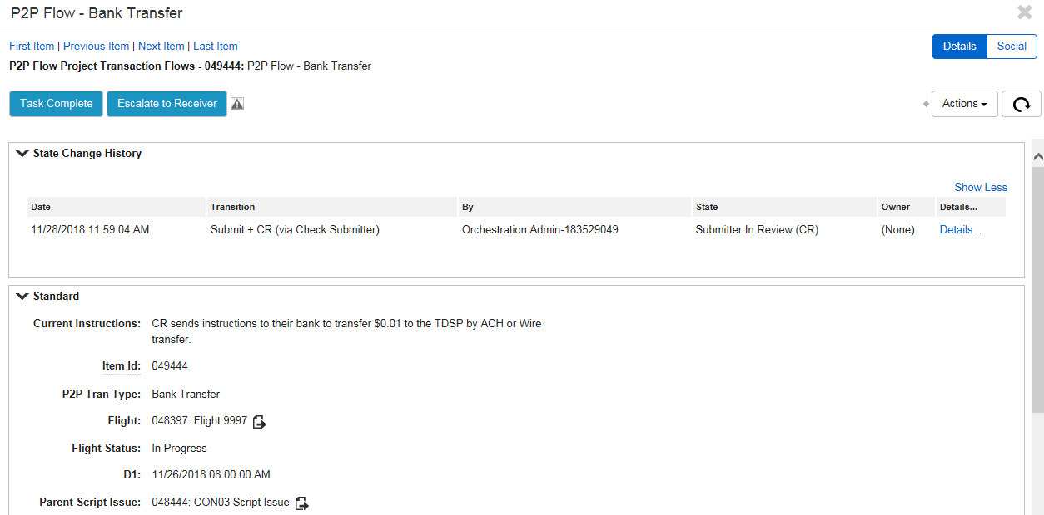
    - Once the CR sends instructions to their bank to make the transfer, the CR clicks the Task Complete button.
    - The Bank Transfer sub-flow is now transitioned to a state of Receiver in Review.

Fig 7.1n
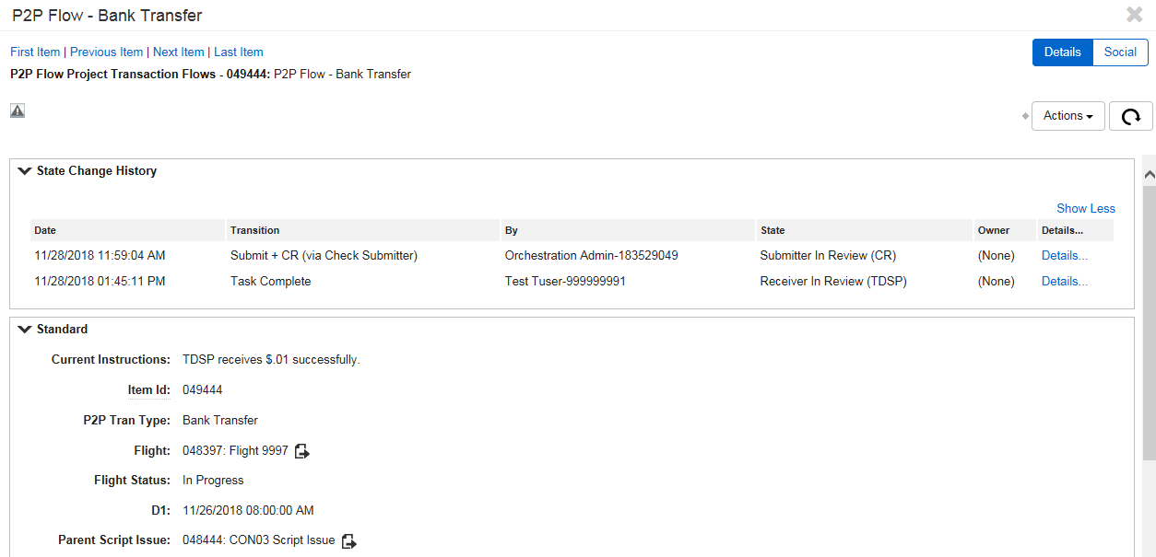
    - The TDSP now has the option to complete the task by clicking the Task Complete button once they received the payment, or escalating back to the CR if they have not received the payment or there is a problem with the transfer.
Fig 7.1o
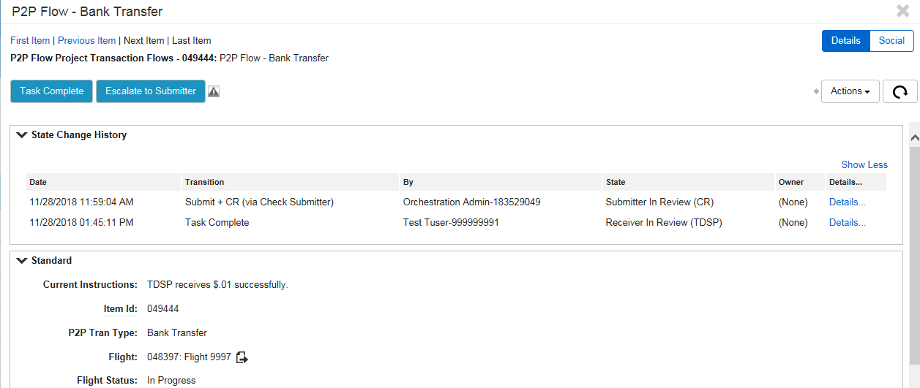
    - If the TDSP escalates back to the CR, comments are required.

Fig 7.1p
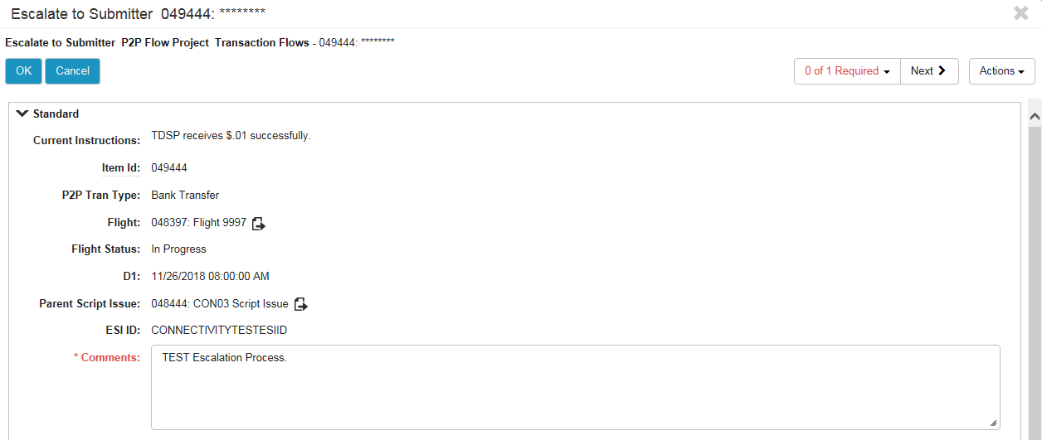
    - The Bank Transfer sub-flow is now transitioned to a state of Escalated to Submitter.
Fig 7.1q
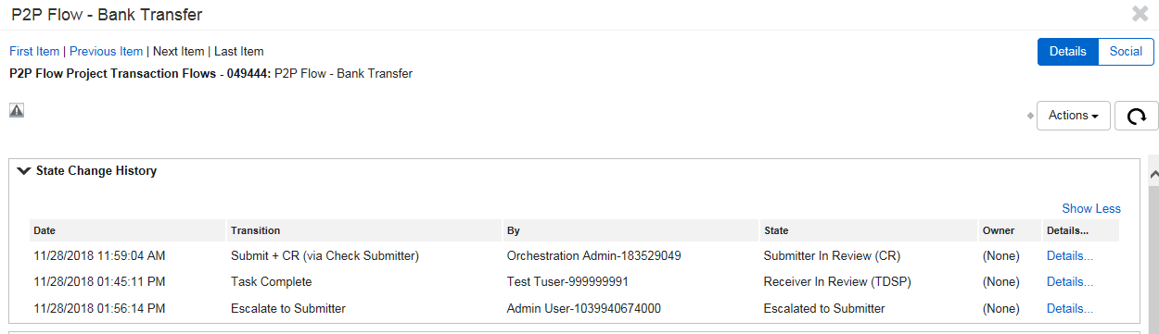
    - The sub-flow is now under the My Script Tasks report again in the CRs Current Flight Tasks dashboard.
Fig 7.1r
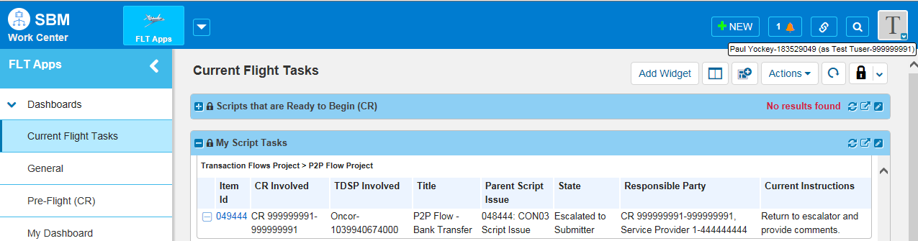
    - Once the CR takes care of the escalation, the will click the Return to Receiver button, then add comments and send the sub-flow back to the TDSP by clicking the OK button.

Fig 7.1s
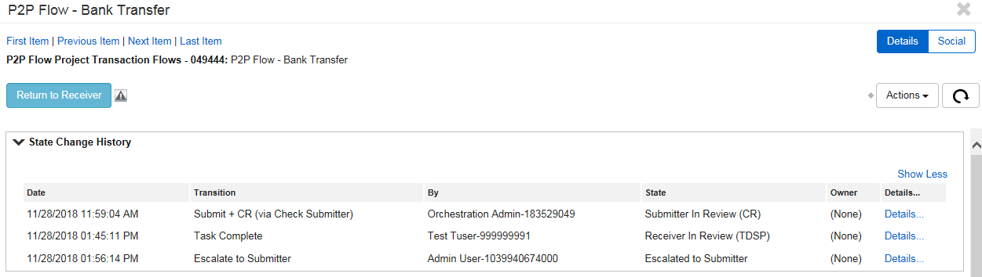
Fig 7.1t
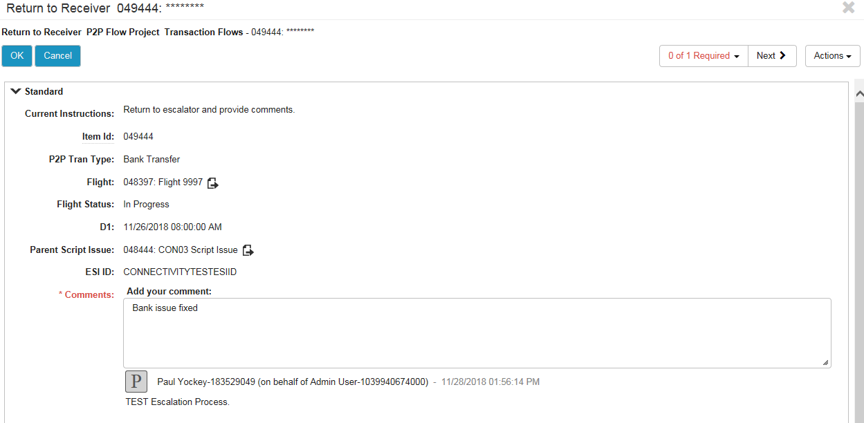
    - The sub-flow is now in the state of Receiver in Review.
Fig 7.1u
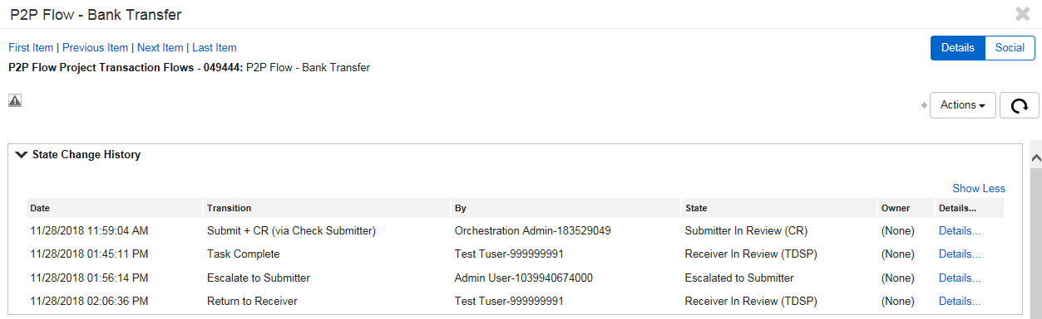
    - Once the TDSP receives the Bank Transfer, they will open the sub-flow and click the Task Complete button.

Fig 7.1v
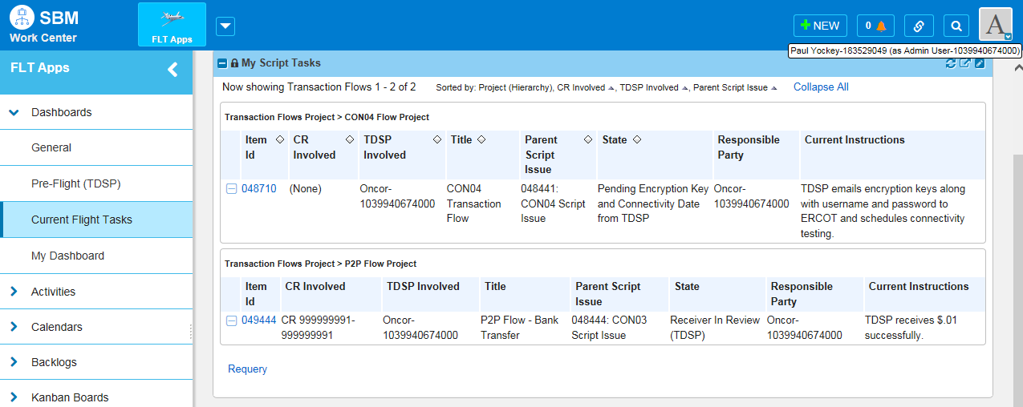
    - The sub-flow transitions to the state of completed.
Fig 7.1w
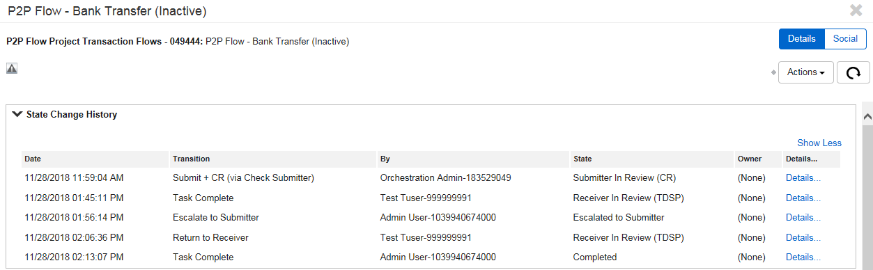
    - The script flow can now be found under the Completed Script Issues report in the Current Flight Tasks dashboard.

Fig 7.1x
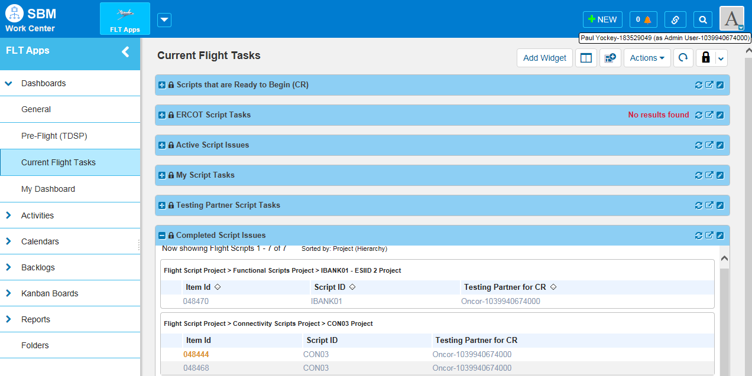
    - The CON03 Script is now in a state of Script Passed and is inactive.
Fig 7.1y
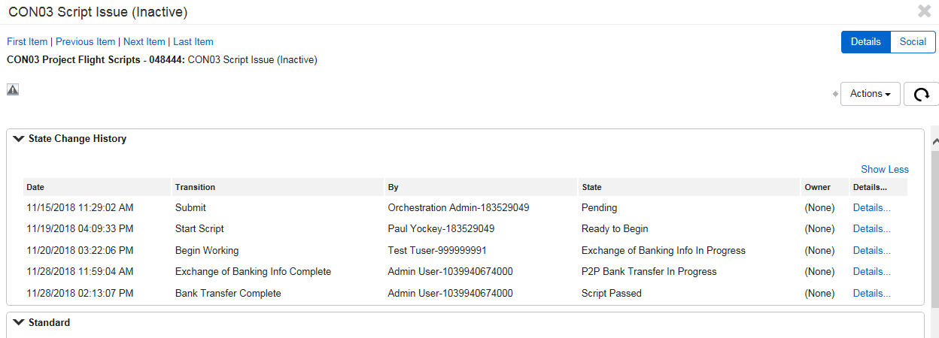

Test Scripts Overview

