System Planning

Monthly Status Report
January 2019

Report Highlights
- ERCOT is currently reviewing proposed transmission improvements with a total estimated cost of $527.7 Million as of January 31, 2019.
- Transmission Projects endorsed in 2019 total $34 Million as of January 31, 2019.
- All projects (in engineering, routing, licensing and construction) total approximately $6.03 Billion as of October 15, 2018.
- Transmission Projects energized in 2018 total about $1.44 Billion as of October 15, 2018.

Regional Planning Group Project Reviews
- Garland Power & Light (GPL) and Oncor have jointly submitted the North Garland Reliability Infrastructure Project (N-GRIP). This is a Tier 1 project that is estimated to cost $78 million. The ERCOT independent review for this project is currently placed on hold per the request of GPL.
- AEPSC has submitted the LRGV Import Project. This is a Tier 1 project that is estimated to cost $73.4 million. AEPSC has also requested that ERCOT provide conditional endorsement for an additional $357.2 million project. This project is currently under ERCOT Independent Review.
- Sharyland Utilities has submitted the Driver – Einstein 138 kV Line Project. This is a Tier 2 project that is estimated to cost $19.1 million. This project is currently under ERCOT Independent Review.
- AEPSC has submitted the Eldorado Live Oak to Sonora 69 kV Line Rebuild Project. This is a Tier 3 project that is estimated to cost $34 million. This project has completed the RPG review, and ERCOT has issued the RPG acceptance letter.

More information on current and past RPG projects can be found on the ERCOT MIS Secure (digital certificate required): https://mis.ercot.com/pps/tibco/mis/Pages/Grid+Information/RegionalPlanning
Past email communication on RPG projects can be found on the ERCOT listserve by signing up for the REGPLANGROUP list: http://lists.ercot.com/scripts/wa-ERCOT.exe?A0=REGPLANGROUP

Planning Model Activities
The short-term calendar of major planning model events is as follows:
- March 1, 2019 Post 18SSWG Update 2 Base Cases and TPIT
- March 31, 2019 Post Contingency definitions and Planning Data Dictionary
The following table shows interconnection projects that met Planning Guide section 6.9(1) and 6.9(2) and were modeled in the SSWG cases as either complete or as a simple model in accordance with Planning Guide section 6.9. The 6.9(2) Deadlines shown in red have received a notification that the 60-day deadline has past and the set of planning data has not been received.
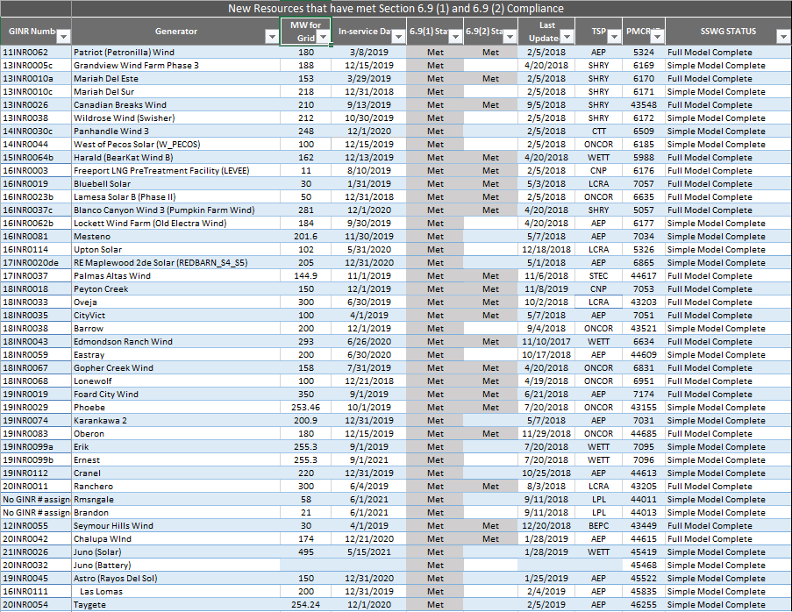

Permian Basin Oil Rig Count
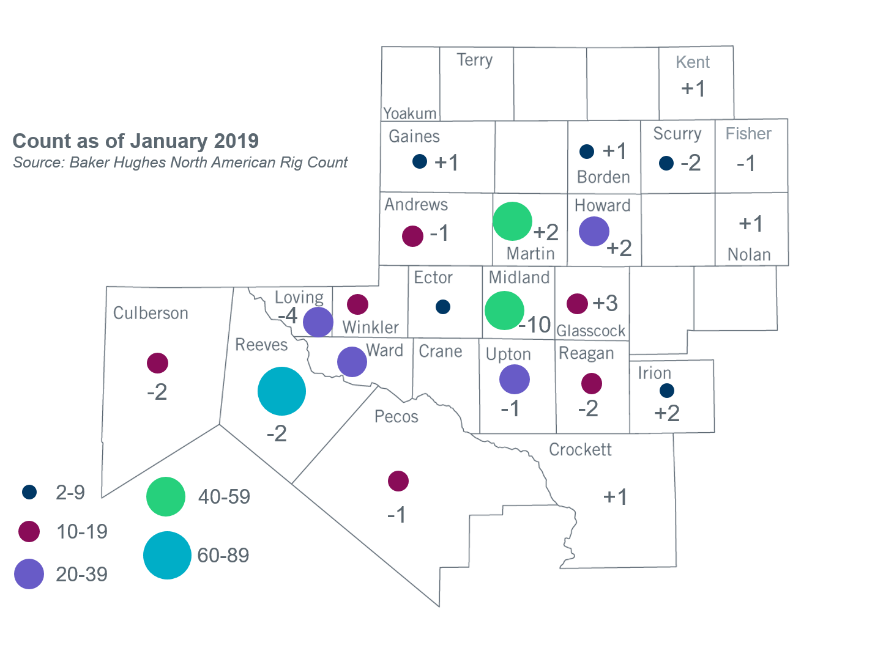
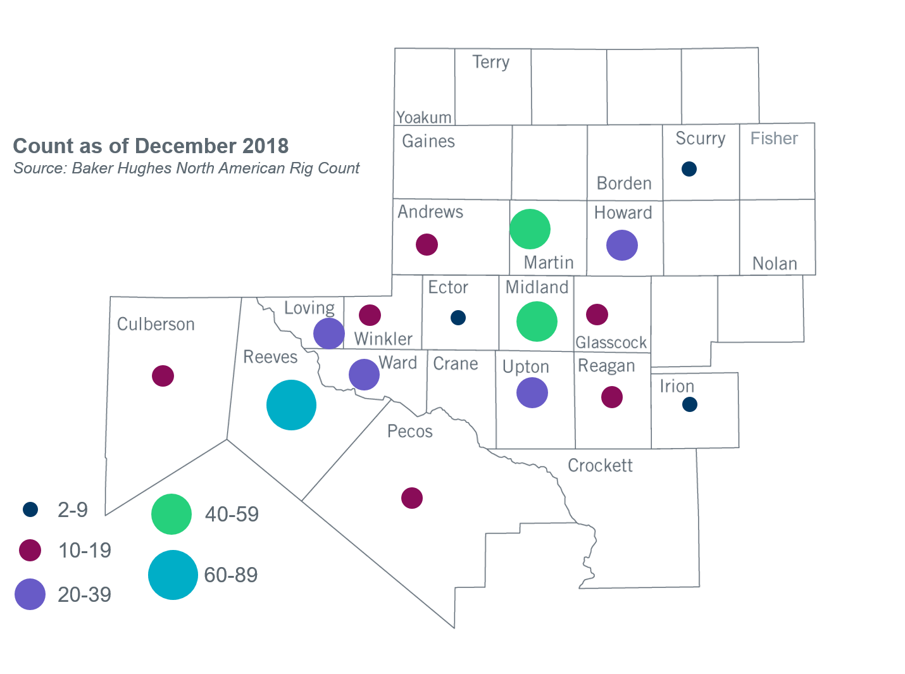

Other Notable Activities
- ERCOT has started its 2019 Regional Transmission Plan case building process. The load review process, as required by Planning Guide Section 3.1.7, is currently in progress. TSPs are requested to provide updates/justification for submitted load levels to be used in the 2019 RTP cases based on their review of ERCOT-provided load comparisons.
- To address PUC Order 46304 Directive 6 and 8, ERCOT is currently conducting studies to determine what transmission upgrades, if any, are necessary to manage congestion resulting from power flows over the Southern Cross DC Tie and if Southern Cross DC Tie should be required to provide or procure voltage support service. This study is expected to be complete in Q1, 2019.
- As a follow up to the 2018 Panhandle and South Texas Stability and System Strength Assessment, ERCOT is currently conducting a study to assess the stability of the Panhandle region with the improved detailed PSCAD models of the transmission and generation facilitites in the study region. This study is expected to be complete in Q1, 2019.
- ERCOT, in coordination with DWG, has started the 2019 DWG Flat Start case development and is expected to be complete in February, 2019.
- The SPWG has begun the 2019 CY base case development.
- ERCOT is currently conducting the Delaware Basin area load integration study. The purpose of the study is to identify potential reliability needs and transmission upgrades for the load (planned and conceptual) that may appear in the area for the longer term planning horizon.

+/- symbol indicates the increase or decrease from the previous month in oil rigs present in each county. There are 372 rigs, including a total decrease of 13 oil rigs, in the Permian Basin from December 2018 to January 2019.

