PUC Project No. 46304
Oversight Relating to the Southern Cross Transmission (SCT) DC Tie
Determination Regarding How to Model SCT DC Tie (Directive 5)

Date: 2/7/2019
Market stakeholder input: PLWG 9/20/2017, 10/18/2017, 11/13/2017, 1/29/2018, 2/26/2018, ROS 3/1/2018, 4/5/2018, 2/7/2019
PLWG action: On 2/26/18, PLWG voted to endorse this Directive 5, Planning Model Considerations determination.
ROS action: On 3/1/18, ROS discussed this topic and reviewed this document. No further action was taken; on 4/5/18, ROS voted to endorse this Directive 5, Planning Model Considerations determination. On 1/10/2019, ERCOT presented this Directive 5, Determination Regarding How to Model SCT DC Tie which was updated to more fully respond to the Directive 5 issues. No further action was taken. On 2/7/2019, ROS voted to endorse this Directive 5, Determination Regarding How to Model SCT DC Tie.
Directive #5 – Planning model considerations | ERCOT shall study and determine how best to model the Southern Cross DC tie in its transmission planning cases, make any necessary revisions to its standards, guides, systems, and protocols as appropriate, and certify to the Commission when it has completed these actions.

Determination: ERCOT has determined that existing procedures set forth in ERCOT Protocols and Guides can be used for purposes of determining how to model the SCT DC tie’s physical equipment. Further, using information set forth in a prior SCT study and after consultation with the Planning Working Group (PLWG), ERCOT has established flow assumptions that will be used in ERCOT’s initial transmission planning study for the SCT DC Tie. Finally, the ERCOT Board has approved a revision to the ERCOT Planning Guide that establishes when a new DC tie, such as the SCT DC tie, should be included in the planning models. No further revisions to ERCOT Protocols or Guides are necessary in order to effectuate ERCOT’s determinations regarding how to best model the SCT DC Tie.
Stakeholders provided input on the following four questions relevant to directive 5:
- Q1- How should the physical DC tie equipment be represented in the Planning models?
- Q2- What import/ export assumptions should be used in the Planning models and planning studies?
- Q3- What criteria should be used for evaluating transmission system upgrades related to Southern Cross and other DC ties?
- Q4- When should Southern Cross be included in the Planning models?

Q1 - How should the physical DC tie equipment be represented in the Planning models?

The existing working group (Steady State Work Group (SSWG), System Protection Working Group (SPWG), and Dynamics Working Group (DWG)) procedure manuals adequately address the modeling of DC tie equipment and that these existing procedures can be used to model the SCT DC tie physical equipment.

Q2- What import/ export assumptions should be used in the Planning models and planning studies?
PLWG reviewed a summary of the results from a study that was submitted by SCT as part of Ellen Wolfe’s testimony in the Southern Cross CCN proceeding (PUC Docket No. 45624). Based on that study, as well as stakeholder input regarding what should be considered reasonable DC tie flow assumptions, stakeholders have agreed that the following table represents a reasonable initial set of flow assumptions to be used in modeling the SCT DC tie:
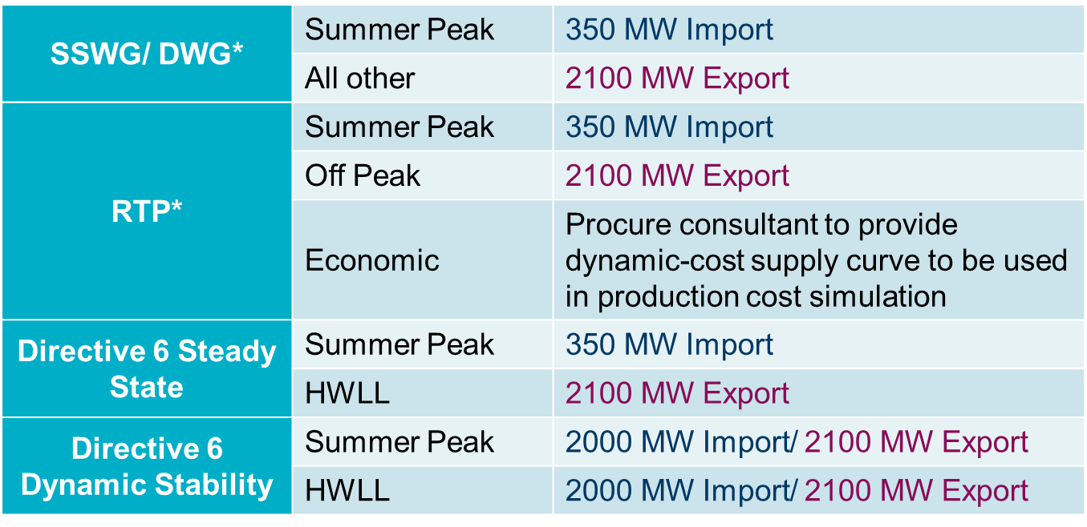
ERCOT is using the above assumptions in completing the transmission planning study required by directive 6; however, these assumptions could be revised by ERCOT at some time in future if warranted by a change in circumstances. ERCOT also expects that these assumptions will be revised after the SCT DC tie comes into operation upon receiving actual operating data from the SCT DC tie. ERCOT will notify the Commission if it deviates from the above assumptions for the SCT DC tie in its planning cases prior to energization of the tie. As a general matter, specific flow assumptions for DC ties are not memorialized in the ERCOT Protocols or Guides; accordingly, no changes to the ERCOT Protocols or Guides are required for ERCOT to begin using the above assumptions in its planning models. Rather, SSWG and DWG may incorporate these assumptions in the models as deemed appropriate by those groups, and the Regional Planning Group (RPG) can provide comments on the appropriateness of using the above assumptions in the Regional Transmission Plan (RTP) at the time the respective study scopes for those studies are discussed.
Q3- What criteria should be used for evaluating transmission system upgrades related to Southern Cross and other DC ties?
This question goes beyond the scope of directive 5 and is more appropriate for resolution as part of directive 6, which requires ERCOT to determine if transmission upgrades are necessary to manage congestion over the SCT DC tie. In any event, in conducting the directive 6 study, ERCOT intends to use the transmission planning criteria already set forth in ERCOT Protocol Section 3.11.2 and Section 4 of the ERCOT Planning Guide.

Q4- When should Southern Cross be included in the Planning models?
ERCOT has determined that a new DC tie should be added to the models when there is a high likelihood that the DC tie will be constructed. Because ERCOT Protocols and Guides contained no language stating when a new DC tie should be added to the ERCOT models, ERCOT sponsored Planning Guide Revision Request (PGRR) 068, Addition of a Proposed DC Tie to the Planning Models, which was approved by the ERCOT Board of Directors on December 11, 2018. PGRR068 provides that a new DC tie will be added to the planning models when ERCOT receives a signed interconnection agreement from the TSP, including written notice from the TSP that the DC Tie developer has provided notice to proceed with the construction of the interconnection and the financial security required to fund the interconnection facilities, as well as the data necessary to model the DC tie.

Directive 6 requires ERCOT to “study and determine what transmission upgrades, if any, are necessary to manage congestion resulting from power flows over the Southern Cross DC tie, make any necessary revisions to its standards, guides, systems, and protocols as appropriate, and certify to the Commission when it has completed these actions.” Work on directive 6 is not yet complete.
As noted in the table above, ERCOT expects to retain a consultant to provide supply curve information that would be used in evaluating whether a project satisfies economic project criteria, as described in ERCOT Protocols Section 3.11.2(4). In light of the cost associated with retaining a consultant, ERCOT does not expect to engage someone for this purpose until SCT meets the criteria for inclusion in the ERCOT planning models set forth in Planning Guide Revision Request (PGRR) 068, as described herein.

