

ERCOT Nodal ICCP Communication Handbook
V3.09
October 15, 2018

Executive Summary of Revisions
This executive summary is intended to provide an overview of revisions made to this handbook in response to market feedback received during reviews conducted with the Network Data Support Working Group (NDSWG), the Qualified Scheduling Entity Managers Working Group (QMWG), and the Transition Plan Task Force (TPTF) during the Fourth Quarter (Q4) 2008 through Q1 2009. While the majority of market feedback was incorporated into the current version of this document as described below, a few issues have been identified for possible future consideration and/or resolution as facilitated by ERCOT’s existing stakeholder process. These issues include:
- Determining which elements in this handbook may constitute binding requirements.
- Reconciling this handbook as needed with any applicable performance measurements specified in Protocols and/or Operating Guides.
- (Bastrop Energy) NPRR188- Gray box in handbook for MVA Inter-Control Center Communications Protocol (ICCP) points on Lines and Transformers required by current Protocols (reference Nodal Protocol Section 6.5.7.1.13, Data Inputs and Outputs for the Real-Time Sequence and Security Constrained Economic Dispatch (SCED), Paragraph (1)(a)(ii)). For this version the MVA values are removed gray boxed pending Board approval of NPRR188.
Update- this issue closed with Sep 2009 Board approval of NPRR188 and removed from handbook.
- (Tenaska) Considering the possibility of including a Qualifying Facility (QF) flag in telemetry if a design change is considered to allow QFs to operate in a selective QF/Non-QF capacity.

General Changes:
General clean-ups/true-ups were provided throughout this handbook, as follows:
- Non-substantive updates were made for grammar, syntax, acronyms, references, units, and numbering.
- The Revision History table was reformatted to reflect a consolidated set of all revisions made to the handbook since the v2.0 baseline was approved by TPTF in December 2007.
- All Wide Area Network (WAN) attachments and corresponding references were removed due to this information being addressed by other existing documentation.

Qualified Scheduling Entity (QSE) Data Table Changes:
Additions:
- Added Time of Dispatch from SCED as this is an important piece of data for settlement purposes (Tables 19 and 22).
Removals:
- Removed Controllable Load Resource (CLR) telemetry as SCED does not dispatch CLRs (Table 19).
- Removed power consumption (scheduled, low, and maximum) from Non-CLR data received from QSEs (Tables 20 and 30).
General Clarifications/Modifications:
- Moved wind-forecast data to QSE table from Transmission Service Provider (TSP) table (Table 20).
- Clarified CLR data to be received from QSEs (Tables 20 and 26).
- Clarified line items for “Any agreed-upon additional Resource data (multiple data items)” (Tables 24 and 25).
- Inserted a footnote to clarify ERCOT request for Net MVAR measurement from non-Controllable Loads (Tables 20 and 28).
- Inserted a footnote clarifying that a CLR’s power consumption (scheduled, low, and maximum) shall be telemetered using a positive sign convention per Nodal Protocol Revision Request (NPRR) 162, Change the Sign Convention of Net Real Power Consumption, Low Power Consumption (LPC), and Maximum Power Consumption (MPC) of Load Resources (Tables 20 and 28).
- Updated all RealQTimeTag ICCP Data Types to RealQ (Table 19) and removed Time of Dispatch of Base Point RealQTimeTag (telemetry time) as this data is inherent to Base Point value received (Table 22).

TSP Data Table Changes:
Additions:
- None (Board approval of NPRR188 removed additional MVA requirements originally proposed in earlier versions)
Removals:
- Removed Reactor MW, Capacitor MW, and Capacitor Status ICCP data types (Table 31).
- Removed Total ERCOT Generation Operating Reserve from Data Available for Reading by All Market Participants (Table 45).
General Clarifications/Modifications:
- Moved wind forecast data to QSE table from TSP table (Table 29).
- Moved Switch Status from Per-Load Data received from TSP (Table 36) to Switch Status Data Received from TSP (Table 37).
- Changed data type to RealQ for Capacity Megavars (Table 29).

Table of Contents
1. Introduction 7
1.1 User Prerequisites 7
1.2 Handbook Organization 8
1.3 Conventions Used in this Handbook 9
1.4 About ERCOT ICCP Data Object Naming Conventions 10
1.5 References 11
1.6 Glossary 11
2. Connecting to the ERCOT Wide Area Network 13
2.1 Network Topology Overview 13
2.2 Market Participant Site WAN Connections 14
2.3 Implementation Procedures 15
2.3.1 Getting Connected 15
2.3.2 Defining Data Using the ICCP Service Request (the Bilateral Agreement) 16
3. High Availability Data Connections 17
3.1 ERCOT EMS/SCADA System Architecture Overview 17
3.2 Market Participant Connections in the High Data Availability Architecture 19
3.2.1 Market Participants with a Single Site 19
3.2.2 Market Participants with a Primary and DR Site 22
3.2.3 Market Participants using Single-use Associations 25
3.2.4 ICCP Node Failures 26
4. ERCOT ICCP Standards, Policies, and Conventions 28
4.1 ICCP Connections 28
4.1.1 Establishing ICCP Associations 29
4.1.2 Association Restrictions (Peer Communication) 31
4.1.3 Association Identifiers 31
4.1.4 Protocol Selectors 32
4.1.5 TCP Port Number 32
4.1.6 System Connections 32
4.2 The ICCP Protocol 33
4.2.1 Supported Features 33
4.2.2 ICCP Version 34
4.2.3 Bilateral Tables 34
4.2.3.1 Bilateral Table Names 34
4.2.3.2 Bilateral Table Version Management 35
4.2.4 ICCP Conformance Blocks 36
4.2.5 ERCOT MMS PDU Size 36
4.3 ICCP Data Exchange Conventions 36
4.3.1 ICCP Domains Explained 37
4.3.2 Domain Naming Conventions 38
4.3.3 Data Set Naming Conventions 40
4.4 Data Quality 40
4.4.1 Quality Codes Illustrated 43
4.4.2 Detail Quality Code Definitions 46
4.4.2.1 ICCP Quality Codes from Market Participants to ERCOT 46
4.4.2.2 ICCP Quality Codes from ERCOT to Market Participants 49
4.5 Data Semantics 52
4.5.1 Status Indication Semantic Conventions 52
4.5.2 Resource Status Codes 52
4.5.3 Combined Cycle Configuration Number 53
4.5.4 Units of Measure for Measured Values 54
4.5.5 Sign Conventions 54
5. QSE ICCP Data Exchange Requirements 57
5.1 QSE Transfer Set Definition Standards 57
5.2 QSE ICCP Object Naming Conventions 58
5.3 Data Sent to QSEs 66
5.4 Data Received from QSEs 67
6. TSP ICCP Data Exchange Requirements 71
6.1 TSP Transfer Set Definition Standards 71
6.2 TSP ICCP Object Naming Conventions 72
6.3 Data Received from TSPs 77
6.4 Optional TSP Data Exchange 78
7. Data Available to All Market Participants 79
Appendix A Sample Association Information Exchange Form (AIEF) 85
Index 91

List of Tables:
Table 1 AP Title Format 33
Table 2 Required ICCP Supported Features 35
Table 3 ERCOT's Determination of a REPLACED Value when Current Provider is Market Participant 43
Table 4 ERCOT's Determination of a REPLACED Value when Current Provider is ERCOT 44
Table 5 ERCOT SCADA Quality Code and ICCP Validity Code Translation to SCADA Quality Codes 44
Table 6 ICCP Attributes for Telemetered Points from Market Participants to ERCOT 48
Table 7 ICCP Attributes for Calculated Points from Market Participants to ERCOT 49
Table 8 ICCP Attributes for Manually Entered Points from Market Participants to ERCOT 49
Table 9 ICCP Attributes for State Estimated Points from Market Participants to ERCOT 50
Table 10 ICCP Attributes for Telemetered Points from ERCOT to Market Participants 51
Table 11 ICCP Attributes for Calculated Points from ERCOT to Market Participants 52
Table 12 ICCP Attributes for Manually Entered Points from ERCOT to Market Participants 52
Table 13 ICCP Attributes for State Estimated Points from ERCOT to Market Participants 53
Table 14 Status Indication Semantic Conventions 54
Table 15 Resource Status Codes 54
Table 16 Semantic Conventions for Measured Values 56
Table 17 ERCOT ICCP Data Sign Conventions 56
Table 18 QSE Generation Transfer Set Requirements 60
Table 19 ICCP Object Names for Generation Control and Regulation Data Sent to QSEs 62
Table 20 ICCP Object Names for Generation Control and Regulation Data Received from QSEs 62
Table 21 Per-QSE Data Sent to QSE 68
Table 22 Per-Resource Data Sent to QSE 68
Table 23 Per-Hub Data Sent to QSE 68
Table 24 Per-Load Zone Data Sent to QSE 68
Table 25 Real-Time Reserve Data Sent to QSE 68
Table 26 Per-QSE Data Received from QSE 69
Table 27 Per-Plant Data Received from QSE 69
Table 28 Per-Generation Resource Data Received from QSE 69
Table 29 Per-Load Resource Data Received from QSE 70
Table 30 Per-Wind Resource Data Received from QSE 71
Table 31 Per- PhotoVoltaic Resource Data Received from QSE 71
Table 32Per-Non-Controllable Load Resource Data Received from QSE 71
Table 33 ERCOT TSP ICCP Data Object Naming Conventions 75
Table 34 TSP Dynamic Ratings Naming Convention 77
Table 35 Per-Buss Data Received from TSP 79
Table 36 Per-Transformer Data Received from TSP 79
Table 37 Per-Transmission Line Data Received from TSP 79
Table 38 Per-Reactor (Inductive or Capacitive) Data Received from TSP 79
Table 39 Per-Circuit Breaker Data Received from TSP 79
Table 40 Per-Load Data Received from TSP 79
Table 41 Switch Status Data Received from TSP 79
Table 42 Per-DC Injection Point Data Received from TSP 80
Table 43 Per-Block Load Transfer Point Data Received from TSP 80
Table 44 Per-Weather Zone Tie Line Data Received from TSP 80
Table 45 Per-Dynamic Rating Data Received from TSP 80
Table 46 ICCP Object Names for Data Available to All Market Participants 82
Table 47 Data Available for Reading by All Market Participants 85

List of Figures
Figure 1 ERCOT Wide Area Network Overview 24
Figure 2 Market Participant Site Diagram 25
Figure 3 Sample ICCP Change Request Form 26
Figure 4 ERCOT High Availability Architecture and Data Connections 30
Figure 5 Single Site Data Path Failure Scenario 32
Figure 6 Single Site Data Path Restore Scenario 33
Figure 7 Dual Site Data Path Failure Scenario 34
Figure 8 Dual Site Data Path Restore Scenario 36
Figure 9 Single-use Association Failure Scenario 37
Figure 10 Single-use Association Restore Scenario 38
Figure 11 ICCP Network Protocol Suite 40
Figure 12 Types of ICCP Associations 41
Figure 13 Single-use Association (ERCOT Server) 42
Figure 14 Single-use Association (Market Participant Server) 43
Figure 15 Domain Names and Their Implementation 50
Figure 16 ERCOT Power Flow Sign Conventions 67

Introduction
The ERCOT Nodal ICCP Communication Handbook sets practices, conventions, and fundamental parameters required for Market Participants to exchange data with ERCOT using the ICCP protocol in the Texas Nodal Market. Also included in the Handbook is a description of the physical network infrastructure ERCOT has implemented to facilitate connections between ERCOT facilities and those of the Market Participants.
The Handbook specifies important configuration and functional requirements for ICCP implementations so that the Market Participant’s system will interoperate with ERCOT’s system. Market Participants and, if applicable, their vendors will need this information to include the required features and to build the proper delivered ICCP configuration. Such information includes addressing specifications, naming conventions, required ICCP Conformance Blocks, and required features of the specified Conformance Blocks.
The Handbook also includes practices for units of measure, value semantics, sign conventions and quality code semantics. This information is needed by Market Participants in order to exchange the correct values between the Market Participants’ EMS/SCADA systems and the ICCP subsystem.
The ERCOT Nodal ICCP Communication Handbook addresses the requirements for connecting to the ERCOT WAN ICCP only. Other connections such as the Web Portal, application interfaces, and operating standards are discussed in other documents such as the Texas Protocols, Texas Enterprise Integration External Interfaces Specification, TAC-approved Telemetry Standards, and the Texas Market Operating Guides.

This ERCOT ICCP Communication Handbook shall be used in conjunction with the Texas Protocols, Texas Operating Guides, and TAC-approved Nodal Telemetry Standards to facilitate the communication needs of ERCOT and Market Participants to effectively manage system and market requirements. Protocols and Operating Guides have authoritative precedence over any discrepancy in the ERCOT ICCP Communication Handbook.
Anyone using this document should have:
- A general knowledge of data communications concepts
- A working knowledge of Energy Management System functions and concepts
- Familiarity with modern data communications technology
- Knowledge of ICCP concepts
- Knowledge of TCP/IP protocol concepts
- General knowledge of the International Standards Organization’s Open System Interconnection model.

Additionally, Market Participants should be familiar with the ERCOT Communication Network and have a general knowledge of their local EMS/SCADA System. Handbook Organization
This ERCOT Nodal ICCP Communication Handbook has been organized to aid the reader in finding essential information easily. The Handbook groups the material into the following three general topics:
- Equipment, equipment interconnections, connection procedures and physical layer protocols necessary to physically connect a Market Participant’s systems to ERCOT’s systems,
- ICCP parameters, standards, and conventions required for every Market Participant to successfully communicate with ERCOT,
- ICCP parameters and data exchange requirements for each type of Market Participant (QSE or TSP) to reliably exchange operational data with ERCOT on a day to day basis.
Section 1, Introduction describes the purpose and scope of the ERCOT Nodal ICCP Communication Handbook. It includes:
- What the reader should know in order to get the most out of the Handbook (Error: Reference source not found),
- This section covering the Handbook organization (Handbook Organization),
- Typographical conventions used for describing parameters, constants, and other components of the presentation (1.3 Conventions Used in this Handbook),
- Explanation of the ICCP Object naming conventions including the relationship between naming convention tables and data exchange tables (1.5 About ERCOT ICCP Data Object Naming Conventions),
- References to other documents that are useful or necessary for complete treatment of the Handbook subject matter (1.6 References),
- Definitions of terms specific to the scope of the Handbook and not found in the Texas Nodal Protocols (1.7Glossary).
Section 2, Connecting to the ERCOT Wide Area Network presents an overview of the ERCOT WAN, connection procedures, and data definition procedures. A detailed illustration of the connection architecture and the ERCOT-provided equipment at the Market Participant’s site(s) is also included.
Market Participants can refer to ERCOT Operating Guide Section 7 for a more detailed explanation about the Wide Area Network.
Section 3, High Availability Data Connections, describes ERCOT’s EMS architecture implementing dual connections to Market Participants and explains the Market Participant’s connection support requirements.
Section 4, ERCOT ICCP Standards, Policies, and Conventions, provides details on the ICCP client/server architecture and describes parameters necessary for all Market Participants to successfully establish communication with ERCOT using ICCP. Included in this section are Association identifiers, naming conventions, units of measure, sign conventions, and state semantics for status indication points and Resource Status.
Section 5, QSE ICCP Data Exchange Requirements is dedicated to QSEs and Section 6, TSP ICCP Data Exchange Requirements is dedicated to TSPs. These sections are organized in the same manner. They specify ICCP Transfer Set parameters, object naming conventions, and data to be exchanged.
Section 7, Data Available to All Market Participants describes data produced by ERCOT that is made available to any interested Market Participant.
Appendix A, Gives an example of the AIEF with form completion instructions.

1.3 Conventions Used in this Handbook
To enhance readability, a few simple formatting conventions are used in the Handbook. Data formats and information specifications are presented in the form of both variable data and fixed constants. The following font attribute conventions are used in the Handbook:
Variable fields display placeholders for values to be filled in with data that depends on the Market Participant’s system. Variable data is shown in this format.
Fixed constants are fields whose values are defined and do not change from system to system. Constant values are shown in this format.
Some sections may lack detail that is being developed for inclusion in the Handbook, but not available as of the publication date. To avoid publication delay, comments are entered in this box style providing a summary of the information to be included. This is essentially a “TBD” comment.
The Handbook has been formatted for double-sided printing. Users are encouraged to take advantage of this document characteristic. The Handbook can also be printed using single-sided printing yielding high-quality results.
Although most of the document is in black & white, a number of illustrations are presented in color to facilitate the idea being illustrated. The color illustrations may not render well if printed in black & white.

- Change control process
The Network Data Support Working Group (NDSWG) will review and coordinate all changes to the ERCOT ICCP Communications Handbook. ERCOT staff and any ERCOT Market Participant as defined by the ERCOT Protocols can submit changes to the NDSWG. It will be NDSWG’s responsibility to review all substantive changes and update the document as required.
NDSWG or ERCOT Staff will provide notice of proposed changes to Market Participant Stakeholders groups, such as the QSE Managers Working Group (QMWG), if proposed changes directly affect the representatives and seek their guidance with all proposed changes.
If any ERCOT Staff or the ERCOT Stakeholder that submitted a change request to this Handbook, disagrees with NDSWG’s decision regarding the requested change, the requestor may, at their discretion, take the issue to the ROS and have the ROS arbitrate the change.
ERCOT may make alignment revisions to the Handbook for the aligning language in the Protocols with related language in the Handbook. ERCOT will post the revised Handbook and provide notification to the NDSWG and QMWG within 10 Business Days of ERCOT Board approval of the associated Nodal Protocol Revision Request (NPRR).
Upon NDSWG review, the revised Handbook will be submitted to the ROS for review and approval of all changes.

1.5 About ERCOT ICCP Data Object Naming Conventions
There is a close relationship between the data exchange tables (Table 21 through Table 31 Per- PhotoVoltaic Resource Data Received from QSE, Table through Table 45 ) and the tables that define ICCP Data Object naming conventions (Table 19, Table 20, Table , and Table ). However, the two sets of tables have quite different purposes. The data exchange tables identify data enumerated in the Texas Protocols that Market Participants and ERCOT must provide to each other as applicable. The naming convention tables provide a mechanism to identify and exchange the data specified in the data exchange tables using ICCP. In other words, the data exchange tables specify what data is be exchanged, while the naming convention tables describe how the data is exchanged.
Because the naming convention tables define conventions, it is useful for the conventions to be forward-looking and provide support for presently known data as well as anticipated future data. Therefore, conventions are established for data types or measurements that do not appear in the data exchange tables. There is no inconsistency in the greater scope of the naming conventions versus the presently specified data to be exchanged.
Market Participants are not expected to change existing ICCP Data Object names. Market Participants are asked to follow the naming conventions established in this Handbook for new ICCP objects. In particular, the TSPs have a large number of ICCP object names that work just fine even though many of the names do not adhere to the conventions established is this Handbook. If a TSP, for reasons other than alignment with these conventions, decides to create a new set of ICCP object names for Nodal, then adherence to the conventions for the new objects would be preferred. However, it is perfectly acceptable to use existing ICCP object names in the Nodal Market.
In regard to determining what should be placed in the fields of the ICCP object names per the specified conventions, guidance can be taken from the following TAC statement:
“The Transmission Element Naming Conventions approved by TAC applies to bus names, line breaker and switch names, and substation names. According to the Transmission Element Naming Conventions, Bus names are a maximum of 12 characters in length and must be unique. Transmission Breakers and Switches representing the same Transmission Breaker or Switch within the same substation shall have the first 14 characters unique. All other Transmission Elements representing the same Transmission Element shall have the first 14 characters unique within the Transmission Element type and substation names representing the same substation within ERCOT shall be limited to 8 characters.”
ICCP object names are limited to 32 characters and specifically 8-character station names and 8-character equipment names. In order to easily map the ICCP object name to the Transmission Element name the ICCP object name should closely resemble or be derived from the Transmission Element name when possible.

1.6 References
The references are listed here in two sections. The References to Standards section is primarily for those interested in delving deeper into ICCP technology. A study of these sources is not essential to the Market Participant’s ability to operate an ICCP node. It is assumed that the Market Participant’s ICCP vendor is familiar with the standards referenced in this section.
The ERCOT Publications section refers to additional documents that are essential to working with ERCOT, both for startup and day-to-day operation.
References to Standards:
IEC 870-6-503 Tase.2 Services and Protocol Version 2000
IEC 870-6-802 Tase.2 Object Models Version 2000
RFC 791 Internet Protocol (IP)
RFC 793 Transport Control Protocol (TCP)
RFC 1918 Address Allocation for Private intranets
RFC 1006/RFC 2126 ISO Transport Service over TCP
ERCOT Publications:
Texas Nodal Protocols July 2009
Texas Nodal Market ICCP Certification Test Plan
Texas Nodal Market Operating Guide Section 7
Texas Nodal Enterprise Integration External Interfaces Specification
Texas Nodal Market ICCP Service Request Process
ICCP Change Request Form
ICCP Change Request Form Example

1.7Glossary
Term | Definition
AIEF | Association Information Exchange Form. Used to establish the parameters necessary for Market Participants to successfully connect to the ERCOT systems. A sample AIEF is provided in
Current Provider | Defines the supplier of a value. The Current Provider is a SCADA attribute which is either REMOTE, or LOCAL. When a value is received via ICCP, the Current Provider is the Market Participant and is marked REMOTE in SCADA. A value produced by the ERCOT operator, ERCOT’s state estimator, ERCOT’s calculation processor, or other ERCOT application is considered LOCAL.
Current Source | An ICCP attribute that specifies the device or process supplying a value. The Current Source can be TELEMETERED – the value has been obtained from a field measurement device or state detector, MANUAL – the value has been obtained from an operator, CALCULATED – the related value has been produced by a calculation that is based on other possibly telemetered values, ESTIMATED – the value has been produced by the State Estimator.
ICCP | Inter-Control Center Communication Protocol. A utility industry international standard communication protocol designed to facilitate data exchange between EMS/SCADA systems. ICCP is the common name for TASE.2, the Telecommunication Application Service Element defined in ISO/IEC 60870-6. TASE.2 is a utility industry specific definition of the use of the more general Manufacturing Message Specification (MMS) standardized in ISO/IEC 9506.
ICCP Client | The role of an ICCP node that acquires data from an ICCP server. The client defines the data to be received, the conditions under which the data is to be received, and enables and disables the reception of that data.
ICCP Node | The computer connected to the data exchange network that performs ICCP client functions, ICCP server functions, or both.
ICCP Server | The role of an ICCP node that makes data available to an ICCP client. The ICCP server responds to requests for data exchange definitions, requests to enable data exchange, and requests to disable data exchange. The ICCP server sends data to a requesting ICCP client based on the conditions of transfer defined by the ICCP client.
Normal Provider | An attribute maintained in SCADA that defines whether a value is received via ICCP (REMOTE) or produced by ERCOT (LOCAL) under normal operating circumstances. See Current Provider. When the Normal Provider is not equal to the Current Provider, the value is considered to have been replaced by the Current Provider.
Normal Source | In the ERCOT system, Normal Source is an attribute maintained in SCADA that defines the device or process that supplies a value under normal operating circumstances. See Current Source. Although ICCP includes a Normal Source attribute, it is not used in the ERCOT system. When the Normal Source defined in SCADA is not equal to the Current Source received from ICCP, the related value’s Normal Source is considered to have been replaced by its Current Source.
Normal Value | An ICCP attributes that indicates whether the related status indication is NORMAL or ABNORMAL.
WAN | Wide Area Network. Refers to both the ERCOT MPLS Network and the ERCOT DACS Network. The MPLS Network is the primary network used by Market Participants to exchange data with ERCOT. The DACS network acts as a backup for the MPLS Network.

Connecting to the ERCOT Wide Area Network

Network Topology Overview
ERCOT has implemented a TCP/IP based Wide Area Network (WAN) that supports the transfer of data between ERCOT and Market Participants. ERCOT Staff or its contractors monitor and manage the ERCOT WAN. WAN Installation and maintenance responsibility is specified in the Nodal Operating Guide Section 7.
All QSEs representing generation resources are required to communicate with ERCOT via the WAN. ERCOT will, from time to time, identify specific TSPs and any other QSEs (i.e. representing load resources) that are required to connect to the WAN. Any Market Participant required to connect must complete and submit the communication connection documentation as required in Section .
The ERCOT WAN will not allow the exchange of data directly between Market Participants.
The ERCOT WAN is a redundant network comprised of the following network architectures:
- Private MPLS Network; and
- Private Point-to-Point DACS Network.
Figure 1 is an overview of the ERCOT WAN.
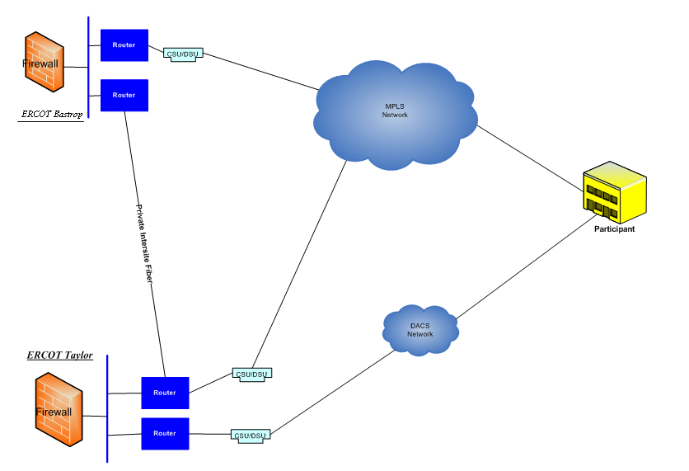
Figure 1 ERCOT Wide Area Network Overview
The MPLS network is the primary means of communicating with ERCOT. If a link on the MPLS network between ERCOT and a particular Market Participant fails, the MPLS link connecting the Market Participant through the alternate ERCOT site will be used. The DACS network will only be used if both MPLS links between ERCOT and a Market Participant fails.

2.2 Market Participant Site WAN Connections
Figure 2 describes the equipment and connections supporting operational, engineering, and market data exchange between ERCOT and Market Participants. This Market Participant Site Diagram illustrates the essential elements of the equipment and physical layer protocols used in the Market Participant’s interface to ERCOT. All equipment shown in Figure 2 is located at the Market Participant’s site.
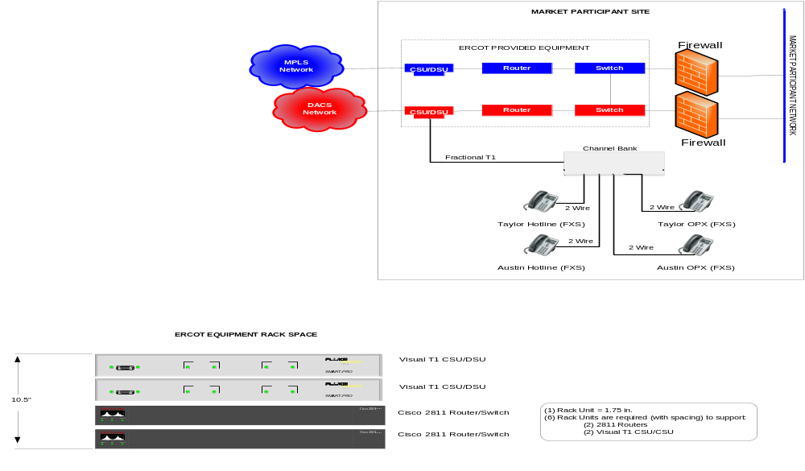
Figure 2 Market Participant Site Diagram
In the network infrastructure connection, ERCOT sets its line of demarcation to be a connection between a redundant pair of Ethernet switches provided by ERCOT and the firewall provided by the Market Participant. The interface “across the line of demarcation” between the ERCOT switch and the Market Participant’s firewall is provided by a minimum Category 5 10/100 BaseT Ethernet cable. The ERCOT switches auto-negotiate for network bandwidth (10 or 100 Mbps) and Duplex (full/half).
It can be seen in Figure 2 that the ERCOT provided equipment brings the redundant infrastructure into the Market Participant’s site that is necessary to meet the reliability requirements stated in the Texas Nodal Protocols. On the Market Participant’s side of the line of demarcation, it is the Market Participant’s responsibility to provide an internal network infrastructure that also meets the Texas Nodal Protocol’s communication reliability requirements. Therefore, the Market Participant is free to choose routers, firewalls, and other network equipment that best meets the reliability and performance requirements of the Market Participant’s internal network infrastructure.
The interconnecting Ethernet Switches form a Routing LAN that supports the routing of traffic over either the MPLS network or the DACS network. Traffic from the Market Participant’s system is exchanged over this network using ICCP, HTTPS, FTP, or other Application protocols as required by the various application services. This Handbook details the use of ICCP only.

2.3 Implementation Procedures

Getting Connected

Market Participants are required to use the ERCOT WAN for exchanging data with ERCOT via ICCP. The data to be exchanged is defined in Section 5, QSE ICCP Data Exchange Requirements, for QSEs and Section 6, TSP ICCP Data Exchange Requirements, for TSPs. In order to initiate the connection process, Market Participants must complete and submit the Wide-Area Network application. To receive a WAN Application contact ERCOT Client Services. Refer to Operating Guides Section 7, Telemetry and Communication, for details on WAN specifications and data communication.. Defining Data Using the ICCP Service Request (the Bilateral Agreement)
During the process of establishing the WAN connections, the Market Participants must also define the data to be exchanged with ERCOT. This process uses the ICCP Service Request process. The ICCP Service Request supported by the ICCP Change Request Form is ERCOT’s implementation of the ICCP Bilateral Agreement.
The ICCP Service Request Process creates secure historical central records of telemetry change requests to ensure accuracy and consistency in managing ICCP changes. Market Participants will submit ICCP changes using the ICCP Change Request Form to the ERCOT ICCP team through the Market Information System (MIS). The ICCP team processes these changes as received and performs a series of checks with the Market Participant to verify the accuracy of the changes (ICCP point additions/ deletions) before and after they are loaded into the system.
Figure 3 is an example of an ICCP Change Request Form:
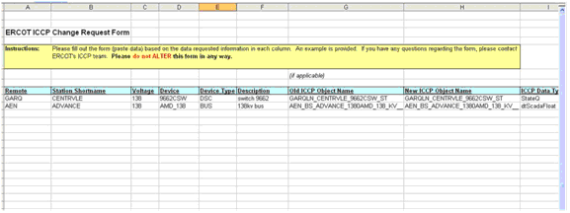
Figure 3 Sample ICCP Change Request Form
A Market Participant accesses the Texas Market Link (TML) through ERCOT.com and creates a Service Request by clicking on the Service Request link. The link is the Market Participant’s conduit to acquire the ICCP Change Request Form and initiate coordination with the ERCOT ICCP team. The process is fully described in the document entitled ICCP Service Request Process. The ICCP Service Request Process document is available through the TML.
ERCOT also makes available an ERCOT ICCP Change Request Form Example spreadsheet that contains examples of the ICCP objects and their names for the various types of QSE Resources.

High Availability Data Connections
In the Texas Nodal Market, ERCOT has taken advantage of the robust communications infrastructure by implementing two live connections with each Market Participant to improve data availability. This section explains the system architecture ERCOT has implemented internally, and describes how this architecture works with various Market Participant configurations.

ERCOT EMS/SCADA System Architecture Overview
Figure 4 presents a high level overview of the ERCOT High Availability Data configuration. With this configuration ERCOT will receive live data from the Market Participant’s active ICCP server using ERCOT’s ICCP clients at both the primary (Taylor) and backup locations (Bastrop) simultaneously. If the Taylor link becomes unavailable, ERCOT will use the data from the Bastrop ICCP node without action taken by ERCOT or Market Participant staff. This parallel operation increases the availability of the ICCP data acquisition functions to 99.9999%, ensuring that the availability requirements of the Texas Nodal Protocols and TAC-approved Telemetry Standards will be met.
Supporting this increased availability requires that ERCOT establish two ICCP Associations with the Market Participant’s active ICCP node(s). One Association will be with ERCOT’s ICCP node at Taylor, and the other will be with ERCOT’s ICCP node at Bastrop. The Market Participant’s ICCP server in the active node will provide a Domain for each ERCOT ICCP client, the ICCP client at Taylor, and the ICCP client at Bastrop. For Market Participants having two active ICCP nodes, as explained in Section , Market Participant Connections in the High Data Availability Architecture, ERCOT will establish one Association with each active node.
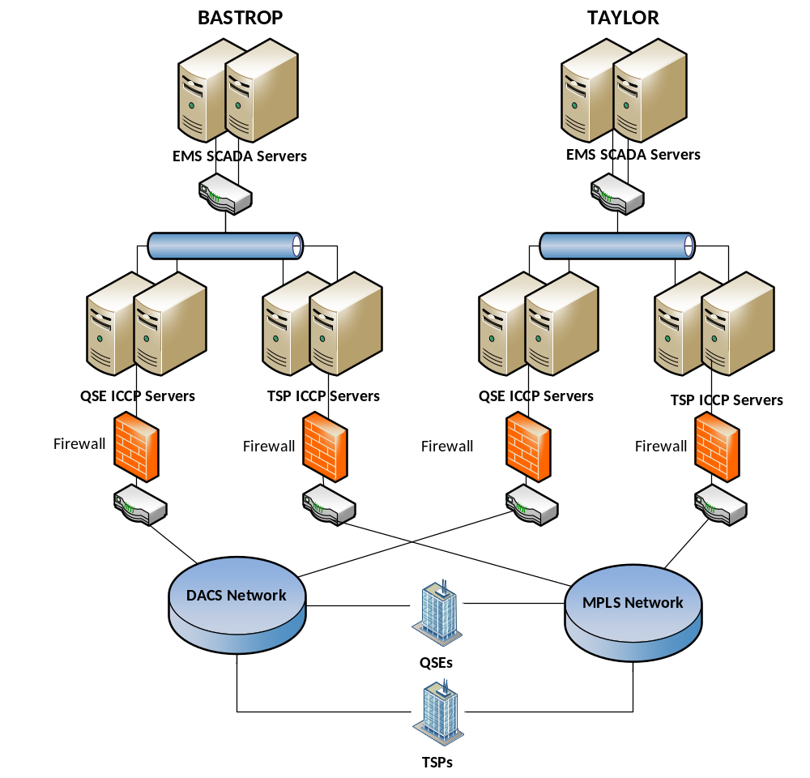
Figure 4 ERCOT High Availability Architecture and Data Connections
Market Participant systems that support dual data sources can take advantage of this configuration as well. ERCOT’s ICCP nodes at Taylor and Bastrop also act as live ICCP servers for Market Participants. Market Participants choosing to receive ERCOT data from two sources can, through their ICCP client request data from both ERCOT ICCP servers.
The term dual data sources means that the ERCOT EMS can retrieve the same point having the same value from two different ICCP nodes. The term does not mean that the same physical quantity is being measured by two different devices. The two ICCP Domains the Market Participant configures in its ICCP server are exact copies, contain the same ICCP Object names, and the ICCP Object values are always identical. The only difference between the two Domains is their Domain Name. The expectation is that a single point in the Market Participant’s SCADA database has its value placed in both ICCP server Domains.

Market Participant Connections in the High Data Availability Architecture
Market Participants communicate with ERCOT with a variety of ICCP configurations. Some of these configurations are discussed here to give the Market Participant a fundamental understanding of how the high data availability architecture works under normal conditions and under failure conditions. The configurations presented are:
- Redundant ICCP nodes at a single site with Dual-use Associations
- Redundant ICCP nodes at a primary and DR site with Dual-use Associations
- Redundant ICCP nodes with Single-use Associations
These illustrated scenarios show how the high data availability architecture responds to communication link failures. Section for ICCP Node Failures discusses how the architecture would respond to ICCP node failures. The intent of the configuration scenarios is to provide enough of an understanding of how the architecture works so that the idea can be easily extended to any particular system configuration.
Note that since the scenarios use data path failure as the basis for explaining how the high data availability architecture works, the backup ICCP node is not shown. Including the backup node does not contribute to the explanation and leaving it out makes the illustrations visually cleaner. The participation of the backup ICCP node in a node failure condition is discussed, as mentioned above.

Market Participants with a Single Site
This scenario takes the case where a Market Participant has a single redundant ICCP node set at one site. The Market Participant does not have a DR site and the backup ICCP node is not “hot”. In this configuration, the Market Participant’s primary (active) ICCP node is configured to support two Associations with ERCOT. These two associations have been configured only to support ERCOT’s dual data source requirement. In this scenario, The Market Participant’s EMS does not support dual data sources. Figure 5, Single Site Data Path Failure Scenario, illustrates the effect of one Association failing, and Figure 6, Single Site Data Path Restore Scenario, shows what happens when the failed Association is restored.
Market Participant EMS
/
SCADA
Client
Server Domain
ACME
_
ERCOT
_
NQSE
_
A
Client
Server Domain
ACME
_
ERCOT
_
NQSE
_
B
Association
1
Association
2
ERCOT EMS
/
SCADA
Taylor
ERCOT EMS
/
SCADA
Bastrop
Client
Server Domain
ERCOT
_
ACME
_
NQSE
_
A
Client
Server Domain
ERCOT
_
ACME
_
NQSE
_
B
Market Participant EMS
/
SCADA
Client
Server Domain
ACME
_
ERCOT
_
NQSE
_
A
Client
Server Domain
ACME
_
ERCOT
_
NQSE
_
B
Association
1
Association
2
ERCOT EMS
/
SCADA
Taylor
ERCOT EMS
/
SCADA
Bastrop
Client
Server Domain
ERCOT
_
ACME
_
NQSE
_
A
Client
Server Domain
ERCOT
_
ACME
_
NQSE
_
B
Data Path
Failure
Configuration
1
Data Path Failure Scenario
:
Market Participant has
a redundant ICCP node at a single site
.
Note that in this scenario
,
the Market Participant’s backup ICCP node is not shown for
simplicity
.
The left and right sides of the figure represent the same systems in
two different states
.
On the left all data paths are in their normal
state
.
On the right
,
the data path supporting Association
1
has
failed
,
and the systems have reconfigured to use the remaining
available data paths
.
Data path operational
Data path available but not in use
Data path failed
ICCP Node
Legend
:
Figure 5 Single Site Data Path Failure Scenario

The left side of Figure 5 shows the state of the two Associations after both systems have connected and are exchanging data under normal conditions. Since they are Dual-use Associations, ERCOT initiated both Associations. That is, the Market Participant’s ICCP nodes are passive waiting for the ERCOT connection request.
After connecting, traffic is flowing in both directions over Association 1. ERCOT’s Bastrop ICCP client is receiving data from the Market Participant’s ICCP server over Association 2, and ERCOT’s EMS is making data available to the Market Participant via the Bastrop ICCP server. However, the Market Participant’s ICCP client uses only Association 1 to receive data from ERCOT. That is, the Market Participant’s EMS is providing data to both ICCP servers (server instances) and receiving data from the one active ICCP client.
When the data paths supporting Association 1 fail, the Market Participant’s EMS will need to start the second ICCP client to reestablish a client relationship with the Bastrop ICCP server as shown on the right side of Figure 5. Although the Market Participant’s EMS will know that the ICCP client data path is no longer operating, there will be no signal from ERCOT related to Association 2. ERCOT’s EMS will simply use the data from the Bastrop ICCP server until communication over Association 1 is reestablished. In this configuration ERCOT does not attempt to establish a new association. While the ERCOT EMS is using the data from the Bastrop ICCP server, the Taylor ICCP node continuously attempts to reestablish Association 1. Market Participants should check with their EMS vendors to determine what must be done to switch to an alternate ICCP client instance without failing over to their backup ICCP node. With Dual-use Associations the Market Participant’s ICCP node cannot initiate an Association with ERCOT. It must instead establish a client/server relationship with the Bastrop ICCP server using the existing Association 2.
The left side of Figure 6 is a replica of the right side of Figure 5 to illustrate the transition from a failed data path to its restoration.
Market Participant EMS
/
SCADA
Client
Server Domain
ACME
_
ERCOT
_
NQSE
_
A
Client
Server Domain
ACME
_
ERCOT
_
NQSE
_
B
Association
1
Association
2
ERCOT EMS
/
SCADA
Taylor
ERCOT EMS
/
SCADA
Bastrop
Client
Server Domain
ERCOT
_
ACME
_
NQSE
_
A
Client
Server Domain
ERCOT
_
ACME
_
NQSE
_
B
Market Participant EMS
/
SCADA
Client
Server Domain
ACME
_
ERCOT
_
NQSE
_
A
Client
Server Domain
ACME
_
ERCOT
_
NQSE
_
B
Association
1
Association
2
ERCOT EMS
/
SCADA
Taylor
ERCOT EMS
/
SCADA
Bastrop
Client
Server Domain
ERCOT
_
ACME
_
NQSE
_
A
Client
Server Domain
ERCOT
_
ACME
_
NQSE
_
B
Data Path
Restored
Configuration
1
Data Path Restore Scenario
:
This is the same
configuration as that shown in Configuration
1
Data Path Failed
Scenario
.
The left side of this figure represents the state of the systems after
link failure and is identical to the right side of Configuration
1
Link
Failure Scenario
.
The right side illustrates the state of the systems
after the failed link has been restored
.
Data path operational
Data path available but not in use
Data path failed
ICCP Node
Legend
:
Figure 6 Single Site Data Path Restore Scenario
When the data paths supporting Association 1 are restored as shown on the right side of Figure 6, the systems stabilize in a slightly different state than before the data paths failed. The Taylor ICCP node reestablishes Association 1, ERCOT’s Taylor ICCP client returns to receiving data from the Market Participant’s ICCP server over Association 1, and ERCOT data provided to the Market Participant continues to be available in the Taylor ICCP server over Association 1.
The Market Participant’s ICCP client can continue to receive data from the Bastrop ICCP server. Since both the Taylor and Bastrop ICCP nodes are symmetrical, are peers, and their data is equally valid and timely, there is no need for the Market Participant’s EMS to switch back to Association 1.

Market Participants with a Primary and DR Site
This scenario takes the case where a Market Participant has two non-redundant ICCP nodes. One node is located at the Market Participant’s primary operating site, and the other node is located at the DR site. The node at the DR site acts as a “hot” backup, receiving data from the primary EMS and exchanging data with ERCOT, but not sending data to the primary EMS until instructed to do so. Figure 7, Dual Site Data Path Failure Scenario, illustrates this configuration. Since this scenario is concerned with a data path failure between ERCOT and the Market Participant, the Market Participant’s backup EMS is not shown for simplicity.
Data Path
Failure
Configuration
2
Data Path Failure Scenario
:
Market Participant has
a non
-
redundant ICCP node at a primary site and a non
-
redundant
ICCP node at a DR site
.
The DR ICCP node acts as a backup to
the primary site ICCP node
.
Note that in this failure scenario
,
the
Market Participant’s backup EMS node is not shown for simplicity
.
The left and right sides of the figure represent the same systems in
two different states
.
On the left all data paths are in their normal
state
.
On the right
,
the data path supporting Association
1
has
failed
,
and the systems have reconfigured accordingly
.
In this
configuration
,
the data continues to flow through the DR site
,
and
then to the primary site SCADA
/
EMS
.
Market Participant EMS
/
SCADA
Primary Site
DR ICCP
Node
Association
1
Association
2
ERCOT EMS
/
SCADA
Taylor
ERCOT EMS
/
SCADA
Bastrop
Client
Server Domain
ERCOT
_
ACME
_
NQSE
_
A
Client
Server Domain
ERCOT
_
ACME
_
NQSE
_
B
Client
Server Domain
ACME
_
ERCOT
_
NQSE
_
B
Client
Server Domain
ACME
_
ERCOT
_
NQSE
_
A
Primary ICCP
Node
Market Participant EMS
/
SCADA
Primary Site
DR ICCP
Node
Association
1
Association
2
ERCOT EMS
/
SCADA
Taylor
ERCOT EMS
/
SCADA
Bastrop
Client
Server Domain
ERCOT
_
ACME
_
NQSE
_
A
Client
Server Domain
ERCOT
_
ACME
_
NQSE
_
B
Client
Server Domain
ACME
_
ERCOT
_
NQSE
_
B
Client
Server Domain
ACME
_
ERCOT
_
NQSE
_
A
Primary
ICCP Node
Data path operational
Data path available but not in use
Data path failed
ICCP Node
Legend
:
Figure 7 Dual Site Data Path Failure Scenario
The left side of Figure 7 shows the state of the two Associations after both ICCP nodes have connected and are exchanging data under normal conditions. Association 1 is established between the Taylor ICCP node and the Market Participant’s primary site, and Association 2 between the Bastrop ICCP node and the Market Participant’s DR site. Since they are Dual-use Associations, ERCOT initiated both Associations. That is, the Market Participant’s ICCP nodes are passive waiting for the ERCOT connection request.
After connecting, traffic is flowing over both Associations. ERCOT’s Bastrop ICCP node is exchanging data with the Market Participant’s primary site over Association 1, and Bastrop and the DR site are exchanging data over Association 2.
When the data paths supporting Association 1 fail, the Market Participant’s EMS will need to start the second ICCP client to reestablish a client relationship with the Bastrop ICCP server as shown on the right side of Figure 5. Although the Market Participant’s EMS will know that the ICCP client data path is no longer operating, there will be no signal from ERCOT related to Association 2. ERCOT’s EMS will simply use the data from the Bastrop ICCP server until communication over Association 1 is reestablished. In this configuration ERCOT does not attempt to establish a new association. While the ERCOT EMS is using the data from the Bastrop ICCP server, the Taylor ICCP node continuously attempts reestablish Association 1. Market Participants should check with their EMS vendors to determine what must be done to switch to an alternate ICCP client instance without failing over to their backup ICCP node. With Dual-use Associations the Market Participant’s ICCP node cannot initiate an Association with ERCOT. It must instead establish a client/server relationship with the Bastrop ICCP server using the existing Association 2.
The left side of Figure 8, Dual Site Data Path Restore Scenario, is a replica of the right side of Figure 7 to illustrate the transition from a failed data path to its restoration.
Data Path
Restored
Configuration
2
Link Restored Scenario
:
This is the same
configuration as that shown in Configuration
2
Data Path Failed
Scenario
.
The left side of this figure represents the state of the systems after
the data path supporting Association
1
has failed and is identical to
the right side of Configuration
2
Data Path Failure Scenario
.
The
right side illustrates the state of the systems after the failed data
path has been restored
.
Market Participant EMS
/
SCADA
Primary Site
DR ICCP
Node
Association
1
Association
2
ERCOT EMS
/
SCADA
Taylor
ERCOT EMS
/
SCADA
Bastrop
Client
Server Domain
ERCOT
_
ACME
_
NQSE
_
A
Client
Server Domain
ERCOT
_
ACME
_
NQSE
_
B
Client
Server Domain
ACME
_
ERCOT
_
NQSE
_
B
Client
Server Domain
ACME
_
ERCOT
_
NQSE
_
A
Primary ICCP
Node
Market Participant EMS
/
SCADA
Primary Site
DR ICCP
Node
Association
1
Association
2
ERCOT EMS
/
SCADA
Taylor
ERCOT EMS
/
SCADA
Bastrop

Client
Server Domain
ERCOT
_
ACME
_
NQSE
_
A
Client
Server Domain
ERCOT
_
ACME
_
NQSE
_
B
Client
Server Domain
ACME
_
ERCOT
_
NQSE
_
B
Client
Server Domain
ACME
_
ERCOT
_
NQSE
_
A
Primary
ICCP Node
Data path operational
Data path available but not in use
Data path failed
ICCP Node
Legend
:
Figure 8 Dual Site Data Path Restore Scenario
When the data paths supporting Association 1 are restored as shown on the right side of Figure 8, the systems stabilize in a slightly different state than before the data paths failed. The Taylor ICCP node reestablishes Association 1, ERCOT’s Taylor ICCP client returns to receiving data from the Market Participant’s ICCP server over Association 1, and ERCOT data provided to the Market Participant continues to be available in the Taylor ICCP server over Association 1.
The Market Participant’s ICCP client can continue to receive data from the Bastrop ICCP server. Since both the Taylor and Bastrop ICCP nodes are symmetrical, are peers, and their data is equally valid and timely, there is no need for the Market Participant’s EMS to switch back to Association 1.
Note that Market Participants having redundant ICCP nodes at a single site, with the backup ICCP node being “hot,” operates exactly as described in this scenario. It does not matter where the backup ICCP node is located.
Note also that the reaction of ERCOT’s architecture to data path failures is the same in this scenario as it is in the scenario of Section Market Participants with a Single Site, ERCOT’s architecture does not distinguish between two ICCP server domains in a single ICCP node versus two ICCP server domains in separate ICCP nodes.

Market Participants using Single-use Associations
This scenario illustrates the case where a Market Participant has a single redundant ICCP node set at one site. The Market Participant does not have a DR site and the backup ICCP node is not “hot”. In this configuration, the Market Participant’s primary (active) ICCP node is configured to support up to three Single-use Associations with ERCOT. In this scenario, The Market Participant’s EMS does not support dual data sources. Figure 9, Single-use Association Failure Scenario, illustrates the effect of one Association failing, and Figure 10, Single-use Association Restore Scenario, shows what happens when the failed Association is restored.

ERCOT EMS
/
SCADA
Taylor
ERCOT EMS
/
SCADA
Bastrop
Client
Server Domain
ERCOT
_
ACME
_
NQSE
_
A
Client
Server Domain
ERCOT
_
ACME
_
NQSE
_
B
Data Path
Failure
Configuration
3
Link Failure on Single Use Associations Scenario
:
Market Participant has a redundant ICCP node at a single site
implementing single use associations
.
Note that in this link failure
scenario
,
the Market Participant’s backup ICCP node is not shown
for simplicity
.
The left and right sides of the figure represent the same systems in
two different states
.
On the left all links and data paths are in their
normal state
.
On the right
,
the link supporting Association
1
has
failed
,
and the systems have reconfigured to use the remaining
available data paths
.
This scenario shows one ICCP client instance in the Market
Participant’s ICCP node
.
The location of the client function
changes merely to keep the drawing uncluttered
.
Data path operational
Data path available but not in use
Data path failed
ICCP Node
Legend
:
Market Participant EMS
/
SCADA
Client
Server Domain
ACME
_
ERCOT
_
NQSE
_
A
Server Domain
ACME
_
ERCOT
_
NQSE
_
B
ERCOT EMS
/
SCADA
Taylor
ERCOT EMS
/
SCADA
Bastrop
Client
Server Domain
ERCOT
_
ACME
_
NQSE
_
A
Client
Server Domain
ERCOT
_
ACME
_
NQSE
_
B
Market Participant EMS
/
SCADA
Server Domain
ACME
_
ERCOT
_
NQSE
_
A
Client
Server Domain
ACME
_
ERCOT
_
NQSE
_
B
Association
1
Association
2
Association
3
Association
1
Association
3
Figure 9 Single-use Association Failure Scenario
The left side of Figure 9 shows the state of the three Associations after both systems have connected and are exchanging data under normal conditions. ERCOT established Association 2 and the Market Participant independently established Association 1. ERCOT’s Bastrop ICCP client also establishes Association 3 with the Market Participant’s second ICCP server Domain.
When the data paths supporting Association 1 and 2 fail, the Market Participant’s ICCP client reestablishes Association 1 with ERCOT’s Bastrop ICCP server.
The left side of Figure 10 is a replica of the right side of Figure 9 to illustrate the transition from a failed data path to its restoration.
Client
Server Domain
ERCOT
_
ACME
_
NQSE
_
A
Client
Server Domain
ERCOT
_
ACME
_
NQSE
_
B
Data Path
Restored
Configuration
3
Link Restored on Single Use Associations
Scenario
:
Market Participant has a redundant ICCP node at a
single site implementing single use associations
.
Note that in this
link failure scenario
,
the Market Participant’s backup ICCP node is
not shown for simplicity
.
The left side of this figure represents the state of the systems after
link failure and is identical to the right side of Configuration
3
Link
Failure Scenario
.
The right side illustrates the state of the systems
after the failed link has been restored
.
This scenario shows one ICCP client instance in the Market
Participant’s ICCP node
.
The location of the client function
changes merely to keep the drawing uncluttered
.
Data path operational
Data path available but not in use
Data path failed
ICCP Node
Legend
:
Association
2
Association
1
Market Participant EMS
/
SCADA
Server Domain
ACME
_
ERCOT
_
NQSE
_
A
Client
Server Domain
ACME
_
ERCOT
_
NQSE
_
B
ERCOT EMS
/
SCADA
Taylor
ERCOT EMS
/
SCADA
Bastrop
Client
Server Domain
ERCOT
_
ACME
_
NQSE
_
A
Client
Server Domain
ERCOT
_
ACME
_
NQSE
_
B
Market Participant EMS
/
SCADA
Server Domain
ACME
_
ERCOT
_
NQSE
_
A
Server Domain
ACME
_
ERCOT
_
NQSE
_
B
ERCOT EMS
/
SCADA
Taylor
ERCOT EMS
/
SCADA
Bastrop
Association
1
Association
3
Association
3
Figure 10 Single-use Association Restore Scenario
When the data paths supporting Associations 1 and 2 are restored as shown on the right side of Figure 10, the systems stabilize in a slightly different state than before the data paths failed. ERCOT’s Taylor ICCP client returns to receiving data from the Market Participant’s ICCP server over Association 2, and ERCOT data provided to the Market Participant continues to be available in the Taylor ICCP server.
The Market Participant’s ICCP client can continue to receive data from the Bastrop ICCP server. Since both the Taylor and Bastrop ICCP nodes are symmetrical, are peers, and their data is equally valid and timely, there is no need for the Market Participant’s EMS to switch back to Association 1.

ICCP Node Failures
The configuration scenarios presented above were designed to give the reader a fundamental understanding of how ERCOT’s high data availability architecture generally behaves when the network data paths change. ERCOT’s architecture will react in a similar manner to ICCP node failures, since a node failure also causes loss of the data path.
Market Participant configurations providing a separate ICCP node acting as a “hot” backup, such as those represented in Section Market Participants with a Primary and DR Site, will cause the ERCOT architecture to behave in exactly the same way as described in that section when the data path is lost either because the primary Market Participant ICCP node failed or because the Taylor ICCP node failed. When the failed node is restored, the final operational state will be the same as that shown on the right side of Figure 9.
Market Participant configurations having redundant ICCP nodes that operate as a “cold” backup will cause loss of communication until the Market Participant’s backup ICCP node becomes operational. However, for those configurations, if the Taylor ICCP node fails, the ERCOT EMS will use the data path from the Bastrop ICCP node, as shown on the right side of either Figure 5 or Figure 7, until the Taylor ICCP node failover completes.

ERCOT ICCP Standards, Policies, and Conventions
This part of the ICCP Handbook defines the Texas Nodal Market implementation of ICCP. In order for the ICCP Clients and Servers throughout the Texas Nodal Market to successfully connect and exchange information with ERCOT, many components of ICCP and its underlying protocol stack must be configured in all ICCP nodes in a coordinated way.
The only non-critical convention specified in this section can be found in Section Data Set Naming Conventions. The Data Set naming convention is a recommendation to assist support engineers while examining ICCP node operation. All other parts of Section , ICCP Data Exchange Conventions, should be followed as policy.

ICCP Connections
The protocol suite configured for the ERCOT ICCP network is OSI over TCP/IP using the Transport mapping layer specified in RFC 1006 and its extended functionality in RFC 2126. The complete profile for the ERCOT network is illustrated in Figure 11, ICCP Network Protocol Suite. Note in the figure that the line of demarcation distinguishes between ERCOT-provided equipment and Market Participant-provided equipment.
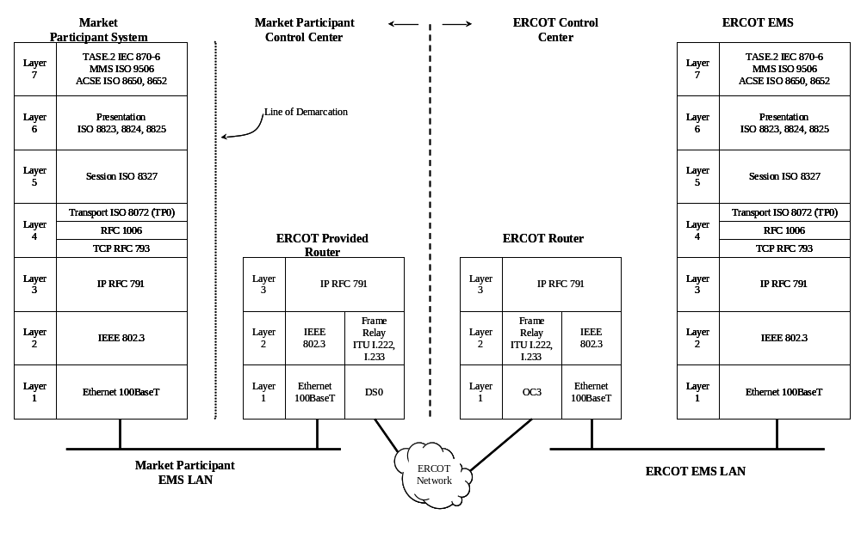
Figure 11 ICCP Network Protocol Suite
There will be variations at the physical layer (Layer 1) dependent on the Market Participant’s local communications architecture. For example, the ICCP component of the Market Participant’s EMS could be connected to the network router via other connection types such as any variation of Ethernet connections or a serial link such as an HSSI, RS-232, etc. Market Participants establishing links will coordinate their configurations and schedules with ERCOT in preparation of link commissioning and testing.

Establishing ICCP Associations
An ICCP Association is equivalent to a TCP connection. ICCP Associations can be formed as “single-use” or “dual-use” Associations. These Associations have to do with the client/server role taken by the Market Participant in its data exchange with ERCOT. The Market Participant’s system acts as client when it receives data from ERCOT because of a request for the data. The Market Participant’s EMS acts as a server when it sends data to ERCOT as requested. A given ICCP node perceives its client and server roles to be separate and independent data exchange processes. Environments exist where one side acts only as a client and the other acts only as a server, although this is unlikely to be the case for any ICCP node communicating with ERCOT.
A Single-use Association is one where one side of the Association always performs the client role and the other side performs the server role. With Single-use Associations, two Associations are required in order for each side to act as both a client and a server. With a Dual-use Association, one Association supports both ends acting as both client and server. The concept is illustrated in Figure 12, Types of ICCP Associations,.
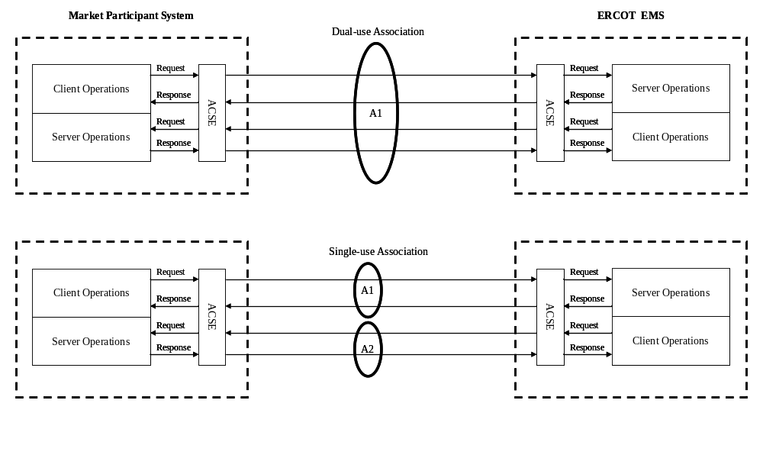
Figure 12 Types of ICCP Associations
ICCP vendors have taken different approaches to supporting Association use. Some systems allow only one type while others allow both. ERCOT supports both kinds of Associations in order to be compatible with any system. However, to conserve resources and simplify system management, ERCOT requires Market Participants to establish Dual-use Associations if their ICCP nodes support it, even if they also support Single-use Associations.
The ICCP standard specifies that when Single-use Associations are established, the client always initiates the Association. For Dual-use Associations, the establishing side is determined by agreement. ERCOT requires that ERCOT always establish Associations when a Dual-use Association is configured.
When Single-use Associations are implemented, ERCOT will establish the client-side Association with the Market Participant’s server function, and the Market Participant must establish the client-side Association with ERCOT’s server function in compliance with the ICCP standard.
ERCOT implements a “hunt list” (a list of IP addresses provided by the Market Participant) that specifies the order in which ERCOT is to search for the active ICCP server. ERCOT attempts to connect to each IP address in the order specified until the Market Participant’s ICCP server responds. With Dual-use Associations the Market Participant’s ICCP node waits until ERCOT opens the Association, then the Market Participant’s ICCP client initializes the ERCOT ICCP server.
With Single-use Associations, ERCOT performs the same hunt, connection, and Market Participant ICCP server initialization, but only that client/server relationship is established. The Market Participant’s ICCP client independently performs a similar hunt for an active ERCOT ICCP server.
Figure 13, Single-use Association (ERCOT Server), and Figure 14, Single-use Association (Market Participant Server), shows how the ICCP clients of ERCOT and the Market Participant independently control data exchange transactions over a set of Single-use Associations. The figures show that in all cases the client makes requests over the Association assigned to its client role, and receives data from the server over that same Association. As the figures suggest, data exchange with ERCOT presently makes use of ICCP Conformance Blocks 1 and 2 only.
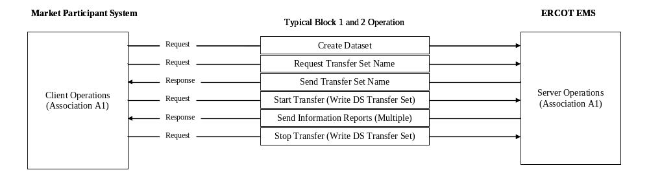
Figure 13 Single-use Association (ERCOT Server)
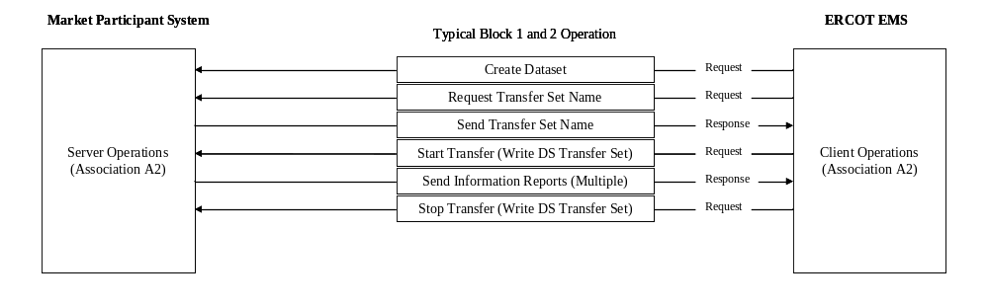
Figure 14 Single-use Association (Market Participant Server)

Association Restrictions (Peer Communication)
The network architecture establishes Circuits between each Market Participant and ERCOT. Although it is theoretically possible for Market Participants to establish peer Associations with each other, all such traffic would pass through routers located at ERCOT. The ERCOT routers are configured to accept only traffic that originates with a Market Participant and is destined to ERCOT. Therefore, peer communication between Market Participants is not allowed via the ERCOT communications infrastructure.

Association Identifiers
Association identifiers follow the ERCOT standard format described in this section.
Table 1 AP Title Format
Field Name | Format (or Value) | Description
ISO Prefix | 0002 | A standard ISO AP Title designator for applications using MMS. It stands for (joint-iso-ccitt)
Naming Hierarchy | 0016 | A standard designator indicating that the AP Title follows the country-based naming hierarchy.
Org ID | 0001 | ERCOT’s Organization Identifier.
Market Participant ID | 00AA 00AA 00AA 00AA | The Market Participant’s ICCP identifier. This identifier is also used in Domain names and Bilateral Table Names. The assigned Market Participants’ ICCP identifiers are included on the Association Information Exchange Form (AIEF). A sample AIEF is provided in
Node ID | 00AA | The text representation of an integer designating the node number of the Market Participant’s ICCP node. The primary control center ICCP node is typically node “1” and the backup is typically node “2”.
Application ID | 0073 | This value specifies that ICCP is the application in use on this Association.
The format shown as 00AA is a sequence of four integers. The first two integers are zeros, and the last two are the decimal representation of an ASCII character. As an example of a valid AP Title, ERCOT’s primary control center ICCP node would specify an AP Title of:
0002 0016 0001 0065 0067 0077 0069 0049 0073
The Market Participant ID and Node ID fields above represent the text string ACME1.

Protocol Selectors
Protocol selectors are numerical identifiers for the Presentation Selector, Session Selector, and Transport Selector. They are specified as two 8-bit decimal integers of the form NN NN, as in 00 01.
Although most systems specify 00 01 for all protocol selectors, the values required are dependent on the ICCP vendor’s system. ERCOT’s local ICCP implementation does not require protocol selectors to be unique between ICCP nodes. Therefore, ERCOT can support any protocol selector identification scheme as required by the various Market Participant systems. As a result, Market Participants are free to specify the desired protocol selector values on the AIEF.

TCP Port Number
ICCP uses the TCP port number 102. This is the IETF officially assigned TCP port for all connections to a system implementing RFC 1006/2126. TCP Port 102 is the port number for the Transport Layer Service Access Point (TSAP) for Transport Class 0.

System Connections
ERCOT operates the following systems:
- Primary ICCP Node at Taylor
- Backup ICCP Node at Bastrop
- Development System Node
The choice of network, circuit, and routers that traffic traverses is automatically determined by the routing protocols and the network’s architecture. The intermediate network elements operate under dynamic routing so that circuit failure recovery does not involve the end systems. However, fixed IP addresses are assigned to each of ERCOT’s ICCP nodes. The IP addresses and AP Titles of the ERCOT ICCP nodes are provided on the AIEF. The Market Participant must respond to these addresses when processing Association Initiation requests.
In order to ensure that ERCOT establishes an Association with the correct Market Participant ICCP node, ERCOT will list IP addresses and AP Titles for Market Participant nodes in the following order on the AIEF:
- The primary node at the primary operating facility
- The backup node at the primary operating facility
- The primary node at the secondary operating facility
- The backup node at the secondary operating facility
Finally, ERCOT will list an additional IP address for the Market Participant’s development/test ICCP node. This node will not be included in the search list for operational nodes. However, the development/test node address is included in the ERCOT directory to support testing exercises with Market Participants during their development phase or for problem resolution.
The search list is limited to the ICCP nodes that the Market Participant has actually implemented. For example, if a Market Participant implements a redundant ICCP node configuration at a single site, only the first two items in the above list are searched. The instructions included in the sample AIEF in explain how the Market Participant describes its actual ICCP node configuration.
A development/test ICCP node address will be assigned to a Market Participant whether or not the Market Participant actually has such an ICCP node. The AIEF includes a field for the Market Participant to indicate whether such an ICCP node exists. If a Market Participant later acquires a development/test ICCP node, this is the address ERCOT will use to access the node.
ERCOT assigns these IP addresses to the Market Participant’s ICCP nodes recognizing that the Market Participant may implement Network Address Translation (NAT) in its firewalls/routers. Using NAT, the Market Participant can assign internal IP addresses to the ICCP nodes that are compatible with the Market Participant’s corporate LAN addressing plan. Market Participants are strongly encouraged to implement such an address translation scheme inside the line of demarcation. Market Participants choosing not to implement NAT may have to contend with IP address conflicts.

The ICCP Protocol
The ICCP documents listed in the references refer to the ICCP protocol standard. These documents provide a comprehensive definition of the ICCP protocol. Be aware that those documents are oriented toward ICCP protocol developers. Nevertheless, interested readers are encouraged to review the standard since an understanding of the ICCP architecture and terminology will facilitate communication with ICCP product vendors.

Supported Features
During Association establishment, the client accesses the ICCP standard object named Supported_Features. This object returns a bit string that specifies the ICCP Conformance Blocks supported in the server. All ICCP implementations shall provide the features listed in Table 2 Required ICCP Supported Features.
Table 2 Required ICCP Supported Features
Conformance Block | Bit Position
Block 1 | 0
Block 2 | 1

ICCP Version
ICCP defines a variable called TASE2_Version. A client reads this variable after an Association is established to determine whether it can interoperate with the ICCP server. The ICCP versions supported are:
MajorVersionNumber = 1996 MinorVersionNumber = 8
Or
MajorVersionNumber = 2000 MinorVersionNumber = 8
ICCP Clients shall conform to one of these ICCP versions. The variable TASE2_Version is VMD-specific, meaning that it is a system-wide global value not associated with any particular Domain. TASE2_Version should be considered as a hard-coded value imbedded in the ICCP vendor’s product release as opposed to a configuration parameter.

Bilateral Tables
Bilateral Tables reflect a security mechanism ICCP defines to control access to data objects. A Bilateral Table is a computer-generated reflection of a Bilateral Agreement. A Bilateral Agreement is a formal document stating the objects a data owner is willing to provide to a data user. Bilateral Agreements and Bilateral Tables provide for contractual agreements between data exchange partners.
In practical application, few electric utility organizations implement the full methodology suggested by the ICCP standard for Bilateral Agreements. Such a formal, contractual process is unrealistic due to the long lead-times that would be needed to effect a change in the objects exchanged between companies. Instead of engaging in continuously negotiated data exchange contracts, ISOs typically develop a data privacy policy defining the acceptable use and accessibility of a data owner’s objects.
ERCOT’s approach to the Bilateral Agreement encompasses security and privacy agreements that take place as part of the Market Participant’s registration process, the WAN Connection Agreement, and other documents as appropriate. ERCOT’s implementation of the Bilateral Table is reflected in the ICCP Service Request process introduced in Section Defining Data Using the ICCP Service Request (the Bilateral Agreement).

Bilateral Table Names
Various ICCP designs take different approaches to implementing Bilateral Tables. Most systems do not implement a particular Bilateral Table data structure. Rather, the definition of data objects includes access control attributes and the objects are assigned to Domains. Access control attributes combined with Domain assignment implement the concept of the Bilateral Table. Regardless of the specific internal implementation, ICCP exposes a Bilateral Table identifier designed to ensure that the data object access list between ERCOT and a particular Market Participant is consistent. In the ICCP standard, this identifier is called the Bilateral Table Version. However, this Handbook refers to the ICCP Bilateral Table Version as the Bilateral Table Name.
The ERCOT naming convention for the Bilateral Table Name includes a text identifier and version number. The number portion of the Bilateral Table Name is typically incremented each time the Bilateral Agreement changes. In the ERCOT system, the Bilateral Table Version number will rarely change.
Bilateral Table Name mismatches result in a failure to establish an Association. Furthermore, Bilateral Table Name changes require Associations to be restarted. ERCOT requires that Associations always function when physically possible. No procedure should be defined that would artificially cause an Association to fail. The following Bilateral Table Version management procedure is designed to be consistent with this policy.

Bilateral Table Version Management
Bilateral Table Names have the form:
ERCT_pppp_nnnn
Where:
pppp is the company identifier for the Market Participant
nnnn is the Bilateral Table version number
The following example specifies a Bilateral Table Name for an Association between ERCOT and Acme:
ERCT_ACME_0001
The initial Bilateral Table Name is specified on the AIEF. There shall be only one Bilateral Table Name related to an Association between ERCOT and a given Market Participant. Specifically, the data object access list that ERCOT’s ICCP server provides to the Market Participant is identified under the same Bilateral Table Name as the data object access list that the Market Participant’s ICCP server provides to ERCOT. Once the Bilateral Table Name is defined, only the version number will subsequently change.
In order to facilitate frequent and rapid changes to the Bilateral Table, the Bilateral Table Version number will change infrequently. Simply adding or deleting objects from a Market Participant’s Domain does not require a change to the Bilateral Table Version.
The first Bilateral Table Version shall always be 0001. This version number will not change without the agreement of ERCOT. Any change to the version number must be performed as part of a test similar to, though not as extensive as, the ICCP Certification Test. The version number should only be changed when the data object list is modified so extensively that ERCOT and the Market Participant agree that it is in the best interest of both parties to re-synchronize the Bilateral Table.
The effect of this policy is to ensure that Associations can be established even if the Bilateral Table between the client and server disagree. In this situation, when the client requests an object which it can no longer access, an object access error will be reported. The client can then simply remove the object’s definition either programmatically or by human intervention.
It is also possible that new items will be made available in the server of which the client is not aware. To avoid this problem, the client can periodically retrieve the names of all the objects in the server to which the client has access. The client can then compare this list with the objects defined in its database. If any missing objects are discovered, and deemed by the client to be important, the client can add the objects to the database.
Be aware that whether or not a tool is available from the vendor to access the data object list, most changes are implemented as part of power system modeling. Updating the model involves a formalized exchange of model information between ERCOT and the Market Participant. There may be some exceptions where data not related to the model is exchanged, but any database changes important to the client will usually be conveyed by the people involved in making the changes.

ICCP Conformance Blocks
This section describes the ICCP Conformance Blocks required to support the exchange of data between ERCOT and its Market Participants. The required ICCP Conformance Blocks are:
- Block 1 – Basic services including transfer of real-time data periodically.
- Block 2 – Transfer of real-time data by exception.
ICCP Conformance Blocks 1 and 2 are used to exchange real-time information about data elements. These data elements typically correspond to points in an EMS or SCADA system. In ICCP-speak these points are called Data Value Objects. Conformance Block 1 functionality is limited to direct value reads and periodic value reporting. Block 2 adds reporting by exception and a variety of report generating triggers. Conformance Block 2 provides the most efficient mechanisms for real-time data exchange.
Although a client can read individual Data Value Objects, the greatest flexibility results from organizing points into Data Sets. Data Sets are lists of Data Value Objects. Each Data Value Object referenced in a Data Set can be of any data type.
A Transfer Set is a data structure that specifies the conditions under which the server should send the content of a Data Set to the client. Transfer Set parameters are specified by the client. Parameters include such things as a reference to a Data Set (what is to be transferred), the conditions of transfer (when data should be transferred), and any limitations on the data report (such as Report By Exception (RBE)). After setting the Transfer Set parameters, the client creates the Transfer Set in the server, and then starts the Transfer Set.
Transfer Set parameters and ERCOT usage standards are described in more detail in Section ICCP Data Exchange Conventions.

ERCOT MMS PDU Size
Data exchange with ERCOT using ICCP shall support a maximum MMS PDU size of 32000 bytes. ICCP negotiates the actual maximum MMS PDU size during connection establishment.

ICCP Data Exchange Conventions
This section discusses the data exchange conventions that are common to both TSPs and QSEs. The common conventions apply to Domain names, Data Set Names, and Data Object names for data that is provided to all Market Participants. Conventions for Data Object names that are unique to each Market Participant type and requirements for Transfer Set parameters can be found in the individual sections for each Market Participant type. Refer to Section 5, QSE ICCP Data Exchange Requirement, for QSE conventions and requirements, and Section 6, TSP ICCP Data Exchange Requirements, for TSP requirements and conventions.

ICCP Domains Explained
ICCP vendors design their Domain architectures in various ways because the ICCP standard does not impose any specific design requirements on Domain implementation. Domain implementation in the ICCP server is usually straightforward, since a storage area for each ICCP client is obviously needed to segregate the values for one client from those for other clients. Each of these storage areas is distinguished by the Domain name.
An ICCP client does not require a separate storage area to contain the values accessed from individual servers. It is only required that the client provide the correct Domain name when an access request is made. However, most ICCP vendors do set aside separate storage areas in the client so that a named Data Value Object accessed from one server won’t override the same object name accessed from another server. Because of this artifact of implementation, vendors sometimes adopt the terminology of a “remote” Domain versus a “local” Domain. Unfortunately, the meaning of “remote” versus “local” is nonstandard, so it may have the opposite meaning between different vendors.
Under the assumption that “local” means “in the server”, vendor documentation often speaks of creating a “remote” Domain and a “local” Domain having the same name. For example, a vendor might include in its ICCP documentation instructions to create a local Domain with the name ACME_ERCT_NTSP in Acme’s ICCP node providing transmission services. The documentation might also refer to the creation of a remote Domain with the same name in another ICCP node, such as ERCOT’s node. The local Domain simply means that the user is configuring a storage area in its server that will contain the values to be retrieved by the client node (ERCOT), which will refer to the name ACME_ERCT_NTSP.
The vendor may then discuss creating a remote Domain named ERCT_ACME_NTSP in the Acme node. In this case the Acme node, acting as a client, will retrieve data objects from the Domain named ERCT_ACME_NTSP in the ERCOT node which is acting as a server. These values will then be stored in a named region being set aside for that purpose.
The fact that vendors use the non-standard terms “local” and “remote”, and assign arbitrary meanings to the terms, is more confusing than helpful. The ICCP standard does assign well-defined meanings to the terms “client” and “server” and describes ICCP operations in those terms. Specifically, a “server” makes values available to interconnected computers, and a “client”, requests the available values. Servers define (and create) Domains and clients refer to them when requesting data. The illustration given in Figure 15, Domain Names and Their Implementation, describes the intent of the standard and the effect of its interpretation by the product vendors.
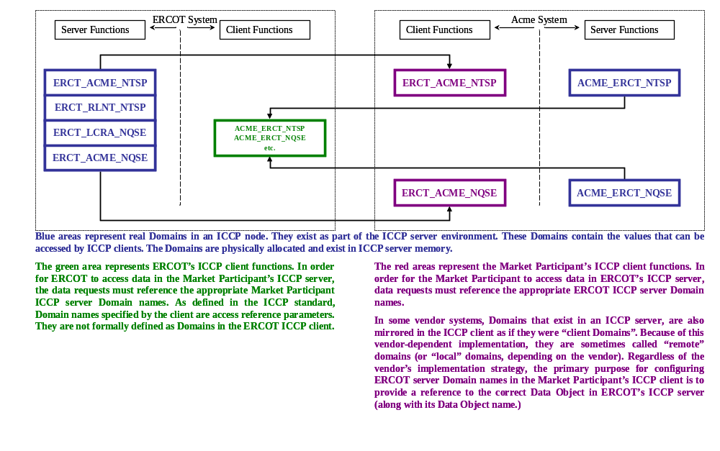
Figure 15 Domain Names and Their Implementation
The above discussion of Domains is given to avoid confusion about the information on the AIEF. The point here is that a Domain is always a server specification. Domains are never assigned to client nodes.

Domain Naming Conventions
Every ICCP server shall implement Domains. These are conceptual containers for data to be exchanged between a particular client and server. Domains are server specific. That is, a Domain is configured in a server to contain the values a particular client can access. The client must then know the name of the Domain in the server to which it has access in order to access those values. ERCOT implements a Domain for each Market Participant, and requires that each Market Participant acting as a server implement a Domain for ERCOT.
Domain names have the form:
ssss_cccc_tttt_x
Where:
ssss is the company identifier for the server
cccc is the company identifier for the client
tttt identifies the type of Market Participant
x identifies the ICCP Node that hosts the domain
Values for tttt are assigned by ERCOT to each Market Participant. Examples of these modifiers are:
NQSE identifies a Nodal Qualified Scheduling Entity
NTSP identifies a Nodal Transmission Service Provider
NREP identifies a Nodal agent such as an aggregator
The value for x is expected to be a letter that identifies a particular ICCP node. In this context, an ICCP node is the primary and backup pair typically installed at a site. Since the backup ICCP node sitting next to the primary node is not operational until a failover is required, the configuration of both nodes is typically identical, including the value of x in the domain name. So, a primary/backup pair at Market Participant site A would both use a server domain name ending in, say, A, whereas the primary/backup pair at an alternative site would both have a server domain name ending in, say, B. If, however, the backup ICCP node runs hot (or live), and ERCOT is expected to use the running backup as the alternate data source, then the domain names should be made unique. It is conceivable that a Market Participant might host ICCP servers in such a way that up to four domain names might be implemented where x could take on the values A, B, C, and D.
Shown here are examples of Domain Names for the client/server Association where the server is ERCOT and the client is Acme Services. Note that in this example Acme is both a Transmission Service Provider and a Qualified Scheduling Entity:
ERCT_ACME_NTSP_A
ERCT_ACME_NQSE_A
ERCOT stores the values accessible to Acme in each Domain as appropriate. Acme then includes the relevant Domain name in its access requests. Conversely, Acme’s system, when acting as a server would contain Domains for ERCOT configured as:
ACME_ERCT_NTSP_A
ACME_ERCT_NTSP_B
ACME_ERCT_NQSE_A
ACME_ERCT_NQSE_B
ERCOT then uses these names when accessing data from the Acme ICCP server(s). Section 3, High Availability Data Connections, discusses the various supporting ICCP node configurations in greater detail.
Domain Names are defined on the AIEF. ERCOT will assign Domain Names consistent with the naming convention specified here.

Data Set Naming Conventions
Data Set names follow a convention similar to the Domain naming convention as follows:
ssss_cccc_nnnn
Where:
ssss is the company identifier for the server
cccc is the company identifier for the client
nnnn is a sequence number that uniquely defines the Data Set
If ERCOT were to create five Data Sets in the Acme server, the Data Sets would have the following names:
ACME_ERCOT_0001
ACME_ERCOT_0002
ACME_ERCOT_0003
ACME_ERCOT_0004
ACME_ERCOT_0005
A similar set of data sets created in the ERCOT server by Acme would have the following names:
ERCOT_ACME_0001
ERCOT_ACME_0002
ERCOT_ACME_0003
ERCOT_ACME_0004
ERCOT_ACME_0005
Clients create Data Sets in the server, so it would seem unnecessary to include the name of the server since every data set in a given server would include the name of the server. However, doing so facilitates identification of Data Set locations when printed reports from different systems are combined in a single document.

Data Quality
ERCOT recognizes the following categories of ICCP data quality:
- Validity
- Current Source
- Normal Value
Validity is the attribute that SCADA systems treat as a point’s quality code. The Validity attribute values provided in ICCP are VALID, NOT_VALID, HELD, and SUSPECT. Each SCADA system vendor must translate between these attribute values and some meaningful equivalent SCADA quality code. This section on data quality includes an extensive definition of the kind of translation between SCADA quality codes and the ICCP Validity attribute that is necessary for consistency of meaning between ERCOT’s SCADA system and those of the Market Participants.
Current Source is an attribute that identifies how a measured value or status indication is acquired. The Current Source can be any of: TELEMETERED, CALCULATED, ESTIMATED, or MANUAL. The Current Source of a value can change at any time. If a SCADA system knows the normal source of a value, ICCP’s Current Source attribute can be used to determine whether or not the value has been replaced, and what source replaced it.
The Normal Value attribute is supported for status indications only. This attribute has the values NORMAL, or ABNORMAL. The Normal Value attribute allows the data provider to specify whether the state of a status point is considered to be normal, or off-normal.
ERCOT also distinguishes between a value received from a Market Participant and a value produced by ERCOT (referred to here as the Provider). Table 3, ERCOT’s Determination of a REPLACED Value when Current Provider is Market Participant, and Table 4, ERCOT's Determination of a REPLACED Value when Current Provider is ERCOT, illustrate ERCOT’s treatment in its SCADA system of the various combinations of Normal Source, Current Source, Normal Provider and Current Provider. The tables tell a simple story. They show that when the provider is a Market Participant, REMOTE is set in the ERCOT SCADA database; otherwise REMOTE is not set. If the Current Provider is equal to the Normal Provider and the Current Source is equal to the Normal Source, REPLACED is not set; otherwise, REPLACED is set.
The only exception is when a Market Participant sends a Current Source as TELEMETERED, and ERCOT has the Normal Source configured as MANUAL. In this case the Current Source is assumed to be MANUAL, so REPLACED is not set. This exception is included to support systems that always report a value as TELEMETERED even if the Market Participant’s operator always manually enters the value.
In Table 3 ERCOT is not shown as a Normal Provider because there is no case where a Market Participant (as the Current Provider) would override a value that is always produced by ERCOT. In Table 4 the TELEMETERED column has been eliminated because there is no case where ERCOT (as the Current Provider) would override any value with a value that has been telemetered by ERCOT. ERCOT does not do telemetry. All telemetered values are acquired from Market Participants. Entries in the tables showing n/a indicate other combinations that are not expected to arise.
Table 3 ERCOT's Determination of a REPLACED Value when Current Provider is Market Participant
Normal  Provider | ICCP  Normal Source Attribute | ICCP Current Source Attribute (Current Provider is Market Participant)
Normal  Provider | ICCP  Normal Source Attribute | TELEMETERED | CALCULATED | ESTIMATED | MANUAL
MP | TELEMETERED  (Field Telemetered) | REMOTE  GOOD | REMOTE  CALC_REPLACED | REMOTE  SE_REPLACED | REMOTE  MANUALLY_REPLACED
MP | CALCULATED | n/a | REMOTE  GOOD | REMOTE  SE_REPLACED | REMOTE  MANUALLY_REPLACED
MP | ESTIMATED  (State Estimator) | n/a | n/a | REMOTE  GOOD | REMOTE  MANUALLY_REPLACED
MP | MANUAL  (MP Operator Entered – Non-Field Telemetered) | REMOTE  GOOD | REMOTE  CALC_REPLACED | REMOTE  SE_REPLACED | REMOTE  GOOD
Table 4 ERCOT's Determination of a REPLACED Value when Current Provider is ERCOT
Normal  Provider | ICCP  Normal Source Attribute | ICCP Current Source Attribute (Current Provider is ERCOT)
Normal  Provider | ICCP  Normal Source Attribute | CALCULATED | ESTIMATED | MANUAL  (ERCOT Operator Entered)
MP | TELEMETERED  (Field Telemetered) | CALC_REPLACED | SE_REPLACED | MANUALLY_REPLACED
MP | CALCULATED | CALC_REPLACED | SE_REPLACED | MANUALLY_REPLACED
MP | ESTIMATED  (State Estimator) | CALC_REPLACED | SE_REPLACED | MANUALLY_REPLACED
MP | MANUAL  (Operator Entered – Non-Field Telemetered) | CALC_REPLACED | SE_REPLACED | MANUALLY_REPLACED
ERCOT | TELEMETERED  (Field Telemetered) | CALC_REPLACED | SE_REPLACED | MANUALLY_REPLACED
ERCOT | CALCULATED | GOOD | SE_REPLACED | MANUALLY_REPLACED
ERCOT | ESTIMATED  (State Estimator) | n/a | GOOD | MANUALLY_REPLACED
ERCOT | MANUAL  (Operator Entered – Non-Field Telemetered) | CALC_REPLACED | SE_REPLACED | GOOD
Table 5 ERCOT SCADA Quality Code and ICCP Validity Code Translation to SCADA Quality Codes
Current Source | ICCP Validity
Current Source | NOT_VALID | HELD | SUSPECT | VALID
TELEMETERED | BAD | OLD (Stale) | OLD (Stale) | GOOD
CALCULATED | BAD | OLD (Stale) | OLD (Stale) | GOOD
ESTIMATED | n/a | n/a | n/a | GOOD
MANUAL | n/a | (no SCADA translation) | n/a | GOOD
In addition to the various “REPLACED” codes, the quality of the value exchanged is also provided. Table 5, ERCOT SCADA Quality Code and ICCP Validity Code Translation to SCADA Quality Codes, shows the translation of the ICCP Validity attribute into SCADA quality codes. The combination of Source, Provider, and Validity may cause multiple flags to be set for a point. The combination is capable of telling a rich story about the related value.

Quality Codes Illustrated
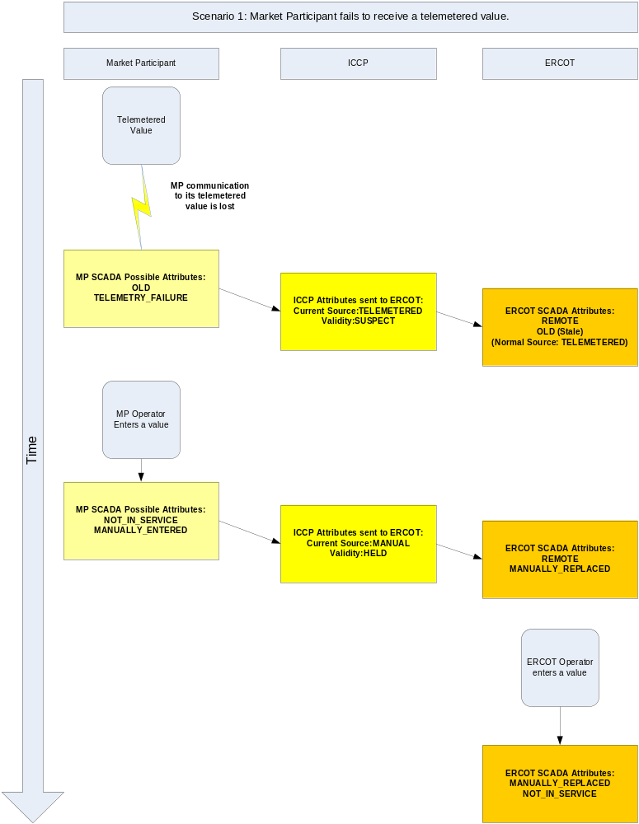

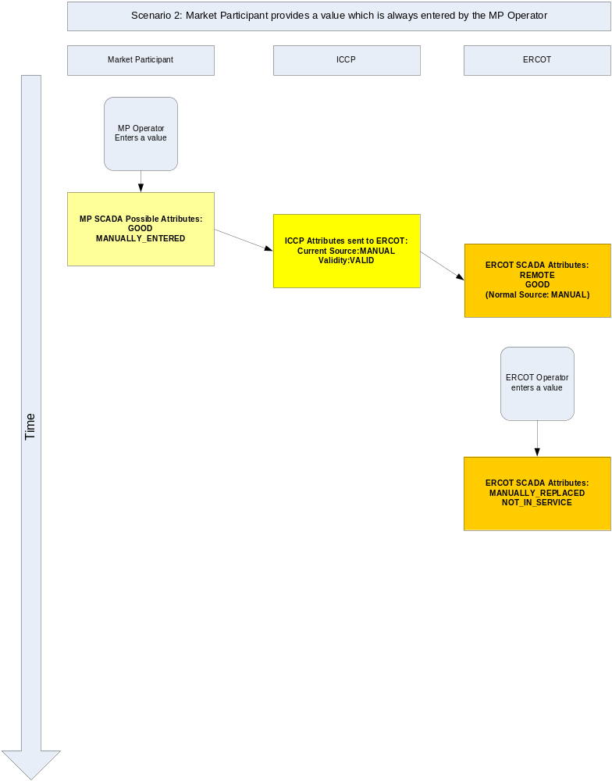

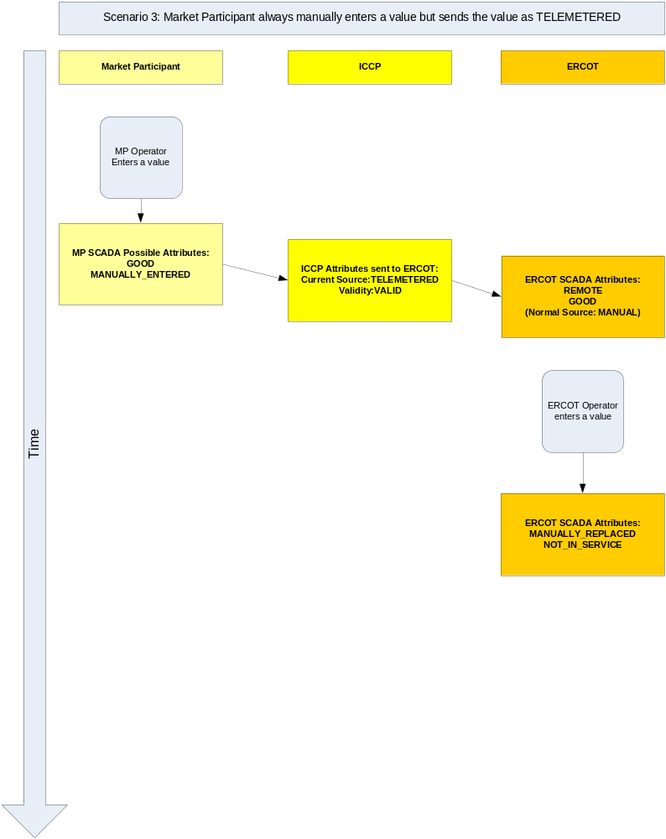

Detail Quality Code Definitions
Although tables and illustrations are helpful in understanding quality code translation processes, vendors implementing translation algorithms need to know the specific criteria that drive the translation. Table 6 through Table 9 describes in detail the conditions under which the Market Participant sets the various ICCP Data Object attributes for status indications and measured values sent to ERCOT. Each table discusses the attribute requirements for a different Normal Source. In a similar way Table 10 through Table 13 specifies the circumstances under which ERCOT sets ICCP Data Object attributes for status indications and measured values sent to Market Participants.

ICCP Quality Codes from Market Participants to ERCOT
Table 6 ICCP Attributes for Telemetered Points from Market Participants to ERCOT
ICCP Quality Class | ICCP Attribute value to be sent from Market Participant to ERCOT | Condition under which ICCP Attribute value is to be sent to ERCOT.
Validity | VALID | The measured value or status indication is valid and can be trusted by ERCOT.
Validity | HELD | Point has been taken off scan by the Market Participant or otherwise removed from service. The value or status indication associated with this ICCP quality code must be the last good value obtained by the Market Participant, or a value that has been substituted by the Operator (see Current Source / MANUAL) below. ERCOT expects that when the Market Participant’s Operator manually enters a value or state, the point is also taken off scan.
Validity | SUSPECT | Any of the following: old value or state due to telemetry failure or failure to acquire a new value within the specified scan time (stale), considered suspect by the data owner, or otherwise should not be considered by ERCOT to be current. The measured value or status indication associated with this ICCP quality code must be the last good value obtained by the Market Participant.
Validity | NOT_VALID | The measured value or status indication is invalid due to data acquisition/conversion errors or the initial value has never been established. The measured value or status indication associated with this ICCP quality code must be the last good value obtained by the Market Participant. If the measured value or status indication has never been initialized, the value or status indication associated with this quality code must be a predefined default value.
Current Source | TELEMETERED | The measured value or status indication was acquired from a field device, which is the normal source of this value or status indication.
Current Source | CALCULATED | Although the measured value or status indication is normally acquired from a field device, it has been replaced by a calculated value.
Current Source | MANUAL | Although the measured value or status indication is normally acquired from a field device, it has been replaced by the Market Participant’s Operator.
Current Source | ESTIMATED | Although the value or status indication is normally acquired from a field device, it has been replaced by the Market Participant’s State Estimator.
Normal Value | NORMAL | For status indications, the state reported is considered to be normal. For other data types, the Normal Value attribute has no meaning.
Normal Value | ABNORMAL | For status indications, the state reported is considered to be normal. For other data types, the Normal Value attribute has no meaning.
COVClass = COV | COVCounter > 0 | Number of state changes that occurred between acquisitions of a status point. Use of COV is optional. As an alternative, each state change can be sent to ERCOT without the COV attribute (COVClass = NOCOV)

Table 7 ICCP Attributes for Calculated Points from Market Participants to ERCOT
ICCP Quality Class | ICCP Attribute value to be sent from Market Participant to ERCOT | Condition under which ICCP Attribute value is to be sent to ERCOT.
Validity | VALID | The value or status indication is valid and can be trusted by ERCOT.
Validity | HELD | Must be set if any of the points on which the calculated value is based have been taken off scan by the Market Participant or otherwise removed from service.
Validity | SUSPECT | Must be set if any of the points on which the calculated value is based are any of the following: old value or state due to telemetry failure or failure to acquire a new value within the specified scan time (stale), considered suspect by the data owner, or otherwise should not be considered by ERCOT to be current.
Validity | NOT_VALID | Must be set if any of the points on which the calculated value is based is invalid due to data acquisition/conversion errors or the initial value has never been established. NOT_VALID may also be set if the calculation processor has not yet populated this point with a value. In this case, the value or status indication associated with this quality code must be a predefined default value.
Current Source | TELEMETERED | See Table 6. ERCOT does not anticipate a condition where a calculated point would be replaced with a telemetered value or status indication.
Current Source | CALCULATED | The Validity attribute is processed as discussed above. No additional processing is applied.
Current Source | MANUAL | The Validity attribute is processed as discussed above. The point will also be considered as Manually Replaced by the Operator.
Current Source | ESTIMATED | ERCOT does not anticipate a condition where a normally calculated value would be replaced by the State Estimator.
Normal Value | NORMAL | For status indications, the state reported is considered to be normal. For other data types, the Normal Value attribute has no meaning.
Normal Value | ABNORMAL | For status indications, the state reported is considered to be abnormal. For other data types, the Normal Value attribute has no meaning.
COVClass = COV | COVCounter > 0 | Number of state changes that occurred between acquisitions of a status point. Use of COV is optional. As an alternative, each state change can be sent to ERCOT without the COV attribute (COVClass = NOCOV)

Table 8 ICCP Attributes for Manually Entered Points from Market Participants to ERCOT
ICCP Quality Class | ICCP Attribute value to be sent from Market Participant to ERCOT | Condition under which ICCP Attribute value is to be sent to ERCOT.
Validity | VALID | The value or status indication is valid and can be trusted by ERCOT.
Validity | HELD | HELD is never set when the Normal Source is also MANUAL.
Validity | SUSPECT | SUSPECT is never set.
Validity | NOT_VALID | When an Operator enters a value, NOT_VALID is never set. However, if NOT_VALID is received by ERCOT for a normally Operator Entered value or status indication, ERCOT will interpret this to mean that the Operator has not yet entered a value for this point.
Current Source | TELEMETERED | ERCOT does not anticipate a condition where a normally Operator entered value would be replaced with a telemetered value or status indication. However, if the Market Participant reports the Current Source as TELEMETERED, ERCOT will consider the Current Source as MANUAL.
Current Source | CALCULATED | ERCOT does not anticipate a condition where a normally Operator Entered value would be replaced by an output of the calculation processor.
Current Source | MANUAL | The Validity attribute is processed as discussed above. No additional processing is applied.
Current Source | ESTIMATED | ERCOT does not anticipate a condition where a normally Operator-entered value would be replaced by the State Estimator.
Normal Source |  | The ICCP attribute Normal Source is not processed by ERCOT. The Normal Source of a point is configured locally in the ERCOT real-time SCADA database.
Normal Value | NORMAL | For status indications, the state reported is considered to be normal. For other data types, the Normal Value attribute has no meaning.
Normal Value | ABNORMAL | For status indications, the state reported is considered to be abnormal. For other data types, the Normal Value attribute has no meaning.
COVClass = COV | COVCounter > 0 | Number of state changes that occurred between acquisitions of a status point. Use of COV is optional. As an alternative, each state change can be sent to ERCOT without the COV attribute (COVClass = NOCOV)

Table 9 ICCP Attributes for State Estimated Points from Market Participants to ERCOT
ICCP Quality Class | ICCP Attribute value to be sent from Market Participant to ERCOT | Condition under which ICCP Attribute value is to be sent to ERCOT.
Validity | VALID | The value or status indication is valid and can be trusted by ERCOT.
Validity | HELD | Indicates that the Operator or other process has prevented the State Estimator from populating this point.
Validity | SUSPECT | The State Estimator normally would not set SUSPECT. However, if a Market Participant’s system sends the SUSPECT quality, ERCOT will interpret this as meaning that the Market Participant’s State Estimator failed to produce a result that can be trusted by ERCOT. The value or status indication associated with this point should be the last good value produced by the State Estimator.
Validity | NOT_VALID | The Market Participant’s State Estimator is not expected to set NOT_VALID. However, if a Market Participant’s system sends the NOT_VALID quality, ERCOT will interpret this as meaning that the Market Participant’s State Estimator has not yet populated this point with a resultant value or status indication. In this case, the value or status indication associated with this quality code must be a predefined default value.
Current Source | TELEMETERED | ERCOT does not anticipate a condition where a normally State Estimated point would be replaced with a telemetered value or status indication.
Current Source | CALCULATED | ERCOT does not anticipate a condition where a normally State Estimated value would be replaced by an output of the calculation processor.
Current Source | MANUAL | The Validity attribute is processed as discussed above. The point will also be considered as Manually Replaced by the Operator.
Current Source | ESTIMATED | The Validity attribute is processed as discussed above. No additional processing is applied.
Normal Value | NORMAL | For status indications, the state reported is considered to be normal. For other data types, the Normal Value attribute has no meaning.
Normal Value | ABNORMAL | For status indications, the state reported is considered to be abnormal. For other data types, the Normal Value attribute has no meaning.
COVClass = COV | COVCounter > 0 | Number of state changes that occurred between acquisitions of a status point. Use of COV is optional. As an alternative, each state change can be sent to ERCOT without the COV attribute (COVClass = NOCOV)

ICCP Quality Codes from ERCOT to Market Participants
Table 10 ICCP Attributes for Telemetered Points from ERCOT to Market Participants
ICCP Quality Class | ICCP Attribute value to be sent from Market Participant to ERCOT | Condition under which ICCP Attribute value is to be sent to ERCOT.
Validity | VALID | The measured value or status indication is valid and can be trusted by the Market Participant.
Validity | HELD | Indicates that the related point has been removed from scan by ERCOT.
Validity | SUSPECT | The measured value or status indication is OLD (stale) because it has been removed from scan either by ERCOT or the data provider. The measured value or status indication may also have been received from the data provider in any of the following conditions: old due to telemetry failure or failure to acquire a new value within the specified scan time (stale). The measured value or status indication associated with this ICCP quality code will be the last good value obtained by the ERCOT.
Validity | NOT_VALID | The measured value or status indication is invalid due to data acquisition/conversion errors experienced by the data provider or the initial value has never been established. The measured value or status indication associated with this ICCP quality code will be the last good value obtained by the data provider. If the measured value or status indication has never been initialized, the value or status indication associated with this quality code will be a predefined default value.
Current Source | TELEMETERED | Always set.
Normal Value | NORMAL | For status indications, the state reported is considered to be normal. For other data types, the Normal Value attribute has no meaning.
Normal Value | ABNORMAL | For status indications, the state reported is considered to be normal. For other data types, the Normal Value attribute has no meaning.
COVClass = COV | COVCounter > 0 | Number of state changes that occurred between acquisitions of a status point. Use of COV is optional. As an alternative, each state change can be sent to ERCOT without the COV attribute (COVClass = NOCOV)

Table 11 ICCP Attributes for Calculated Points from ERCOT to Market Participants
ICCP Quality Class | ICCP Attribute value to be sent from Market Participant to ERCOT | Condition under which ICCP Attribute value is to be sent to ERCOT.
Validity | VALID | The value or status indication is valid and can be trusted by Market Participant.
Validity | HELD | The point has been inhibited from being updated by the calculation processor.
Validity | SUSPECT | Set if any of the points on which the calculated value is based SUSPECT.
Validity | NOT_VALID | Set if any of the points on which the calculated value is based are NOT_VALID. NOT_VALID may also be set if the calculation processor has not yet populated this point with a value. In this case, the value or status indication associated with this quality code will be a predefined default value.
Current Source | CALCULATED | Always set.
Normal Value | NORMAL | For status indications, the state reported is considered to be normal. For other data types, the Normal Value attribute has no meaning.
Normal Value | ABNORMAL | For status indications, the state reported is considered to be abnormal. For other data types, the Normal Value attribute has no meaning.
COVClass = COV | COVCounter > 0 | Number of state changes that occurred between acquisitions of a status point. Use of COV is optional. As an alternative, each state change can be sent to ERCOT without the COV attribute (COVClass = NOCOV)

Table 12 ICCP Attributes for Manually Entered Points from ERCOT to Market Participants
ICCP Quality Class | ICCP Attribute value to be sent from Market Participant to ERCOT | Condition under which ICCP Attribute value is to be sent to ERCOT.
Validity | VALID | The value or status indication is valid and can be trusted by Market Participant.
Validity | HELD | Never set.
Validity | SUSPECT | Never set.
Validity | NOT_VALID | When an Operator enters a value, NOT_VALID is never set. However, if NOT_VALID is received by ERCOT from a data provider, ERCOT will interpret this to mean that the data provider’s Operator has not yet entered a value for this point. Points that are normally entered by the ERCOT Operator will also produce NOT_VALID if the ERCOT Operator has not yet entered a value for the point.
Current Source | MANUAL | Always set.
Normal Value | NORMAL | For status indications, the state reported is considered to be normal. For other data types, the Normal Value attribute has no meaning.
Normal Value | ABNORMAL | For status indications, the state reported is considered to be abnormal. For other data types, the Normal Value attribute has no meaning.
COVClass = COV | COVCounter > 0 | Number of state changes that occurred between acquisitions of a status point. Use of COV is optional. As an alternative, each state change can be sent to ERCOT without the COV attribute (COVClass = NOCOV)

Table 13 ICCP Attributes for State Estimated Points from ERCOT to Market Participants
ICCP Quality Class | ICCP Attribute value to be sent from Market Participant to ERCOT | Condition under which ICCP Attribute value is to be sent to ERCOT.
Validity | VALID | The value or status indication is valid and can be trusted by Market Participant.
Validity | HELD | Indicates that the related point has been inhibited from being updated by the State Estimator.
Validity | SUSPECT | The State Estimator normally would not set SUSPECT. However, if a data provider’s system sets the SUSPECT quality, ERCOT will interpret this quality code as meaning that the Market Participant’s State Estimator failed to produce a result that can be trusted by ERCOT. ERCOT will pass SUSPECT to the receiving Market Participant along with the last good value produced by the data provider’s State Estimator.
Validity | NOT_VALID | Neither the data provider’s nor ERCOT’s State Estimator is expected to set NOT_VALID. However, if a data provider’s system sets NOT_VALID, ERCOT will interpret this quality code as meaning that the data provider’s State Estimator has not yet populated this point with a resultant value or status indication. ERCOT will also produce NOT_VALID if ERCOT’s State Estimator has not yet populated this point with a resultant value. In this case, the value or status indication associated with this quality code will be a predefined default value.
Current Source | ESTIMATED | Always set.
Normal Value | NORMAL | For status indications, the state reported is considered to be normal. For other data types, the Normal Value attribute has no meaning.
Normal Value | ABNORMAL | For status indications, the state reported is considered to be abnormal. For other data types, the Normal Value attribute has no meaning.
COVClass = COV | COVCounter > 0 | Number of state changes that occurred between acquisitions of a status point. Use of COV is optional. As an alternative, each state change can be sent to ERCOT without the COV attribute (COVClass = NOCOV)

Data Semantics
In order to assure full interoperability between ERCOT and its Market Participants, certain data values must have common semantics. These semantics are defined in this section. Each Market Participant’s system shall provide the required data conversion functions to ensure that values are sent to ERCOT with the meanings defined here.

Status Indication Semantic Conventions
The convention for status values shall be as defined in Table 14, Status Indication Semantic Conventions.
Table 14 Status Indication Semantic Conventions
00 | 01 | 10 | 11 | Device
Between | Tripped | Closed | Invalid | Recloser
Between | Off | On | Invalid | Recloser
Invalid | Off | On | Invalid | Breaker
Invalid | Open | Closed | Invalid | Breaker
Invalid | Auto | Manual | Invalid | Any
Invalid | Normal | Alarm | Invalid | Any
Invalid | Local | Remote | Invalid | Any
Invalid | Raise | Lower | Invalid | Transformer
Invalid | Not Ready | Ready | Invalid | Any
Invalid | Off Line | Available | Invalid | Any
Invalid | UnBlocked | Blocked | Invalid | Generator Raise/Lower Block Status
Invalid | Out of Service | In Service | Invalid | AVR/PSS

Resource Status Codes
The Resource Status Codes given in Table 15, Resource Status Codes, provide the encoding required for Market Participants to convey Resource Status to ERCOT as required in Nodal Protocol clause 3.9.1, Current Operating Plan (COP) Criteria, (4), and 6.4.5, Resource Status. The encoding method allows for up to 255 different status values for each Resource type.
The Status Codes have been chosen so that, when viewed as hexadecimal values, codes 00116 through 0FF16 apply to Generation Resources and codes 10116 through 1FF16 apply to Load Resources. This method provides an organized way to support the expansion of both categories, and codes within categories. Status codes 00016 (010) and 10016 (25610) are reserved to provide for the possibility that ERCOT receives a resource status point value that has not been set; a condition that may temporarily exist during system startup and initialization.
Table 15 Resource Status Codes
Resource Category | Status Code | Status Acronym | Status Description
Generation Resource | 000 | n/a | Resource status has not been defined.
Generation Resource | 001 | ONRUC | On-Line and the hour is a RUC-Committed Interval
Generation Resource | 002 | ONREG | On-Line Resource with Energy Offer Curve providing Regulation Service
Generation Resource | 003 | ON | On-Line Resource with Energy Offer Curve
Generation Resource | 004 | ONDSR | On-Line Dynamically Scheduled Resource
Generation Resource | 005 | ONOS | On-Line Resource with Output Schedule
Generation Resource | 006 | ONOSREG | On-Line Resource with Output Schedule providing Regulation Service
Generation Resource | 007 | ONDSRREG | On-Line Dynamically Scheduled Resource providing Regulation Service
Generation Resource | 008 | ONTEST | On-Line Test with Output Schedule
Generation Resource | 009 | ONEMR | On-Line EMR (available for commitment or dispatch only for ERCOT-declared Emergency Conditions; the QSE may appropriately set LSL and HSL to reflect operating limits
Generation Resource | 010 | ONRR | On-Line as a synchronous condenser (hydro) providing Responsive Reserve but unavailable for dispatch by SCED and available for commitment by RUC
Generation Resource | 011 | OUT | Off-Line and unavailable
Generation Resource | 012 | OFFNS | Off -Line but reserved for Non-Spin
Generation Resource | 013 | OFF | Off-Line but available for commitment by DAM and RUC
Generation Resource | 014 | EMR | Available for commitment only for ERCOT-declared Emergency Condition events; the QSE may appropriately set LSL and HSL to reflect operating limits
Generation Resource | 015 | SHUTDOWN | The Resource is On-Line and in a shutdown sequence, and has no Ancillary Service Obligations. This Resource status is only to be used for Real-Time telemetry purposes
Generation Resource | 016 | STARTUP | The Resource is On-Line and in a startup sequence and has no Ancillary Service Obligations. This Resource status is only to be used for Real-Time telemetry purposes
Generation Resource | 017 | FRRSUP | On-Line Resource with FRRS-UP obligation
Generation Resource | 018 | ONOPTOUT | On-Line hour is a RUC Buy-Back hour
Generation Resource | 019 | OFFQS | Offline – QSGR available for SCED development
Load Resource | 256 | n/a | Resource status has not been defined
Load Resource | 257 | ONRGL | Available for dispatch of Regulation Service by LFC and for any remaining dispatchable capacity by SCED with an RTM Energy Bid
Load Resource | 258 | ONCLR | Available for dispatch of a Controllable Load Resource by SCED with an RTM Energy Bid
Load Resource | 259 | ONRL | Available for dispatch of Responsive Reserve Service, excluding Controllable Load Resources
Load Resource | 260 | OUTL | Not available
Load Resource | 261 | FRRSDN | On-Line Controllable Load Resource with FRRS-Down obligation
Load Resource | 262 | FRRSUP | On-Line Controllable Load Resource with FRRS-Up obligation

Combined Cycle Configuration Number
The combined cycle configuration number is assigned by the QSE for each registered configuration. The first configuration registered should be assigned the number 1, the second configuration number 2, and so on. The value zero should not be assigned to a configuration.

Units of Measure for Measured Values
Values representing measured values are to be provided in the units defined in Table 16, Semantic Conventions for Measured Values.
Table 16 Semantic Conventions for Measured Values
Value Semantics | Unit of Measure
Power | Megawatts (MW)
Energy | Megawatt-hours (MWh)
Reactive | Megavar (MVAR)
Loss | Megawatt-hour (MWh)
Frequency | Cycles per Second (Hz)
Voltage | Kilovolts (kV)
Current | Amps (A)
Temperature | Degrees Celsius (°C)
Barometric Pressure | Millibars
Wind Speed | Miles Per Hour (MPH)
Wind Direction | Degrees
Penalty Factor | Actual factor value

Sign Conventions
Table 17, ERCOT ICCP Data Sign Conventions, defines ERCOT power flow sign conventions. Figure 16, ERCOT Power Flow Sign Conventions, provides an illustrated representation of the power flow sign conventions.
Table 17 ERCOT ICCP Data Sign Conventions
Equipment Type | Measurement | Sign Convention
Buss | Voltage | Always positive
Buss | Frequency | Always positive
Transformer | Megawatts | Positive = flow into transformer
Transformer | Megavars | Positive = flow into transformer
Line | Megawatts | Positive = flow out of substation
Line | Megavars | Positive = flow out of substation
Reactor or Capacitor | Megavars | Positive = supplying vars
Circuit Breaker | Megawatts | Positive = flow out of buss section into equipment
Circuit Breaker | Megavars | Positive = flow out of buss section into equipment
Load | Megawatts | Always Positive
Load | Megavars | Always Positive
DC Injection | Megawatts | Positive = flow out of substation

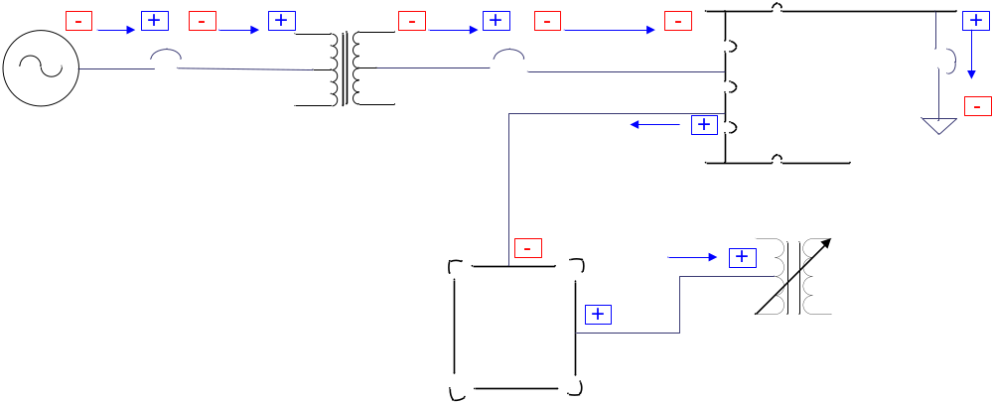
Figure 16 ERCOT Power Flow Sign Conventions

QSE ICCP Data Exchange Requirements

QSE Transfer Set Definition Standards
There are three types of Transfer Sets within ICCP. Data exchange in the ERCOT system requires only the Data Set Transfer Set. A Transfer Set specifies the conditions under which a referenced Data Set is to be transferred from the server to the client. As a minimum, the QSE’s ICCP server shall support the following Transfer Set transmission parameters:
Start Time Defines the time that the server is to begin monitoring conditions that will trigger a Data Set Information Report to be sent to the client. In addition to a valid time value, a time value of zero shall be supported
Interval Defines the frequency at which a periodic Data Set Information Report will be sent to the client. This value shall be ignored unless Interval Timeout is specified as a Transmission Condition.
Buffer Time Defines the amount of time the server will wait after an object changes before generating the Data Set Information Report. Buffer Time is applicable only to the Object Change Transmission Condition.
Integrity Check Defines the frequency at which all of the objects in the Data Set will be sent to the client. Integrity Check is applicable only if Report by Exception (RBE) is specified.
Report By Exception RBE specifies whether the Data Set Information Report will contain all the objects in the Data Set or only the objects which have changed since the last Data Set Information Report.
The Transfer Set also includes a parameter that specifies the Transmission Condition. That is, the condition(s) that the server must monitor once Start Time arrives. As a minimum, the QSE’s ICCP server shall support the following Transmission Conditions:
Interval Timeout This condition specifies that a Data Set Information Report shall be sent to the client each time Interval expires.
Object Change This condition specifies that a Data Set Information Report shall be sent to the client whenever any object in the Data Set changes.
Integrity Timeout This condition specifies that the entire Data Set is to be sent to the client in a Data Set Information Report whenever Integrity Check expires.
To receive generation and regulation signals from ERCOT, QSEs are required to use the Transfer Set parameters specified in Table 18, Generation Transfer Set Requirements. The QSE will acquire generation and regulation signals from ERCOT using two Data Sets that the QSE must create in the ERCOT QSE ICCP Servers. One Data Set will reference the data points produced for the QSE by ERCOT’s 5-minute Security Constrained Economic Dispatch (SCED) application; while the other Data Set will reference the regulation signals produced every 4 seconds by ERCOT’s Load Frequency Control (LFC) application. Each such Data Set must use the Transfer Set parameters specified in Table 18.
Table 18 QSE Generation Transfer Set Requirements
Transfer Set Parameter | Value | Comments
Start Time | Zero | Indicates that Start Time is Now.
Interval | n/a | Not used when the Transmission Condition is Object Change.
Buffer Time | 1 sec | Allows time for multiple values to be stored in the Data Set before sending to QSE.
Integrity Check | n/a | Integrity check is not applicable when RBE is false.
RBE | False | When false, causes all objects referenced in the related Data Set to be transferred when any object in the Data Set changes.
Interval Timeout | False | When false, indicates that a periodic transfer is not enabled.
Object Change | True | Specifies that the Data Set Information Report be sent whenever an object in the Data Set changes.
Integrity Timeout | False | When false, indicates that integrity check is not enabled.
These Transfer Set Parameters ensure that each new set of control signals produced by SCED and LFC will be transferred to the QSE. Furthermore, although SCED generally runs every 5 minutes, and LFC runs every 4 seconds, each production of a new value by either application will be transferred to the QSE client regardless of the application execution cycles.
The key components of Table 18, QSE Generation Transfer Set Requirements, are the Object Change and RBE parameters. When Object Change is True and RBE is False, all values in the Data Set will be transferred to the QSE client when any value in the Data Set is changed.

QSE ICCP Object Naming Conventions
The ERCOT convention for generation control and regulation ICCP Object names exchanged with QSEs is illustrated in the following name descriptor. The object name is composed of six fields as follows:
cccctttssssssssddddeeeeeeeeuuuu
Where:
cccc is the 1 to 4-character company name
ttt is the 1 to 3-character equipment type descriptor
ssssssss is the 1 to 8-character station name
dddd is the 1 to 4-character data descriptor
eeeeeeee is the 1 to 8-character equipment name
uuuu is the 1 to 4-character unit of measure
If the number of characters in a field is less than the specified maximum field length, use the underscore character to separate the string from the next field of the object name. The unit of measure field never has trailing underscores. An underscore should not be used as a component name separator within a field (i.e., BUSS_1). Although a dollar sign ($) can be used to separate parts of a name (as in BUSS$1), use of no separators is preferred (as in BUSS1). Avoiding underscores within a field ensures that a person reading the name can easily distinguish the parts of the object name.
Table 19 lists the naming conventions for data objects ERCOT sends to QSEs. Table 20 lists the naming conventions for data objects ERCOT receives from QSEs.
QSEs may also provide data for equipment not monitored by TSPs but are required by ERCOT. The naming conventions and other requirements for exchanging this data with ERCOT can be found in Section 6.
Table 19 ICCP Object Names for Generation Control and Regulation Data Sent to QSEs
Resource or Equipment Type | Type Descriptor | Data | Data Descriptor | Unit of Measure | ICCP Data Type | ICCP Object Name Example  Cccctttssssssssddddeeeeeeeeuuuu
QSE | QSE | Regulation Down | REGD | MW | RealQ | ACMQQSEQSE_REGDQSE_MW
QSE | QSE | Regulation Up | REGU | MW | RealQ | ACMQQSEQSE_REGUQSE_MW
QSE | QSE | Responsive Reserve | RR | MW | RealQ | ACMQQSEQSE_RR_QSE_MW
QSE | QSE | FRRS-UP Requirement | FURQ | MW | RealQ | ACMQQSEQSE_FURQ_QSE_MW
QSE | QSE | FRRS-Down Requirement | FDRQ | MW | RealQ | ACMQQSEQSE_FDRQ_QSE_MW
Generation Unit | UN | Locational Marginal Price | LMP | USD | RealQ | ACMQUN_GENSUB_LMP_UNIT1_USD
Generation Unit | UN | Base Point | BP | MW | RealQ | ACMQUN_GENSUB_BP_UNIT1_MW
Generation Unit | UN | Updated Desired Base Point | UDBP | MW | RealQ | ACMQUN_GENSUB_UDBP_UNIT1_MW
Generation Unit | UN | Non-Spin Deployed | NDPL | ST | StateQ | ACMQUN_GENSUB_NDPL_UNIT1_ST
Generation Unit | UN | Curtailment Flag | SBBH | ST | StateQ | ACMQUN_GENSUB_SBBH_UNIT1_ST
Generation Unit | UN | SCCT Mitigation Flag | SCCT | ST | StateQ | ACMQUN_GENSUB_SCCT_UNIT1_ST
Table 20 ICCP Object Names for Generation Control and Regulation Data Received from QSEs
Resource or Equipment Type | Type Descriptor | Data | Data Descriptor | Unit of Measure | ICCP Data Type | ICCP Object Name Example  cccctttssssssssddddeeeeeeeeuuuu
Generation Unit | UN | Net Power Flow | NPF | MW | RealQ | ACMQUN_GENSUB_NPF_UNIT1_MW
 |  |  |  | MV | RealQ | ACMQUN_GENSUB_NPF_UNIT1_MV
Generation Unit | UN | Gross Power Flow | GPF | MW | RealQ | ACMQUN_GENSUB_GPF_UNIT1_MW
 |  |  |  | MV | RealQ | ACMQUN_GENSUB_GPF_UNIT1_MV
Generation Unit | UN | Breaker Status | BRKR | ST | StateQ | ACMQUN_GENSUB_BRKRUNIT1_ST
Generation Unit | UN | AVR Status | AVR | ST | StateQ | ACMQUN_GENSUB_AVR_UNIT1_ST
Generation Unit | UN | PSS Status | PSS | ST | StateQ | ACMQUN_GENSUB_PSS_UNIT1_ST
Generation Unit | UN | Combine-cycle Configuration Number | CCC | INDX | DiscreteQ | ACMQUN_GENSUB_CCC_UNIT1_INDX
Generation Unit | UN | Combine-cycle Non Frequency Responsive Capacity | NFRC | MW | RealQ | ACMQUN_GENSUB_NFRCUNIT1_MW
Generation Unit | UN | Dynamically Scheduled Resource Schedule | DSRS | MW | RealQ | ACMQUN_GENSUB_DSRSUNIT1_MW
Generation Unit | UN | Emergency Ramp Rate Up | EURR | MW | RealQ | ACMQUN_GENSUB_EURRUNIT1_MW
Generation Unit | UN | Emergency Ramp Rate Down | EDRR | MW | RealQ | ACMQUN_GENSUB_EDRRUNIT1_MW
Generation Unit | UN | FRRS Up Participation Factor | FUPF | None (0-1) | RealQ | ACMQUN_GENSUB_FUPFUNIT1_MW
Generation Unit | UN | FRRS Up Responsibility | FURS | MW | RealQ | ACMQUN_GENSUB_FURSUNIT1_MW
Generation Unit | UN | High Emergency Limit | HEL | MW | RealQ | ACMQUN_GENSUB_HEL_UNIT1_MW
Generation Unit | UN | High Sustained Limit | HSL | MW | RealQ | ACMQUN_GENSUB_HSL_UNIT1_MW
Generation Unit | UN | Lower Block Status | LBST | ST | StateQ | ACMQUN_GENSUB_LBSTUNIT1_ST
Generation Unit | UN | Low Emergency Limit | LEL | MW | RealQ | ACMQUN_GENSUB_LEL_UNIT1_MW
Generation Unit | UN | Low Sustained Limit | LSL | MW | RealQ | ACMQUN_GENSUB_LSL_UNIT1_MW
Generation Unit | UN | Normal Ramp Rate Up | NURR | MW | RealQ | ACMQUN_GENSUB_NURRUNIT1_MW
Generation Unit | UN | Normal Ramp Rate Down | NDRR | MW | RealQ | ACMQUN_GENSUB_NDRRUNIT1_MW
Generation Unit | UN | Non-Spin Responsibility | NSRS | MW | RealQ | ACMQUN_GENSUB_NSRSUNIT1_MW
Generation Unit | UN | Non-spin Schedule | NSSC | MW | RealQ | ACMQUN_GENSUB_NSSCUNIT1_MW
Generation Unit | UN | Number of Turbines Online | NTON | INDX | DiscreteQ | ACMQUN_GENSUB_NTONUNIT1_INDX
Generation Unit | UN | Number of Turbines OfflineError: Reference source not found | NTOF | INDX | DiscreteQ | ACMQUN_GENSUB_NTOFUNIT1_INDX
Generation Unit | UN | Number of Turbines Unknown StatusError: Reference source not found | NTUN | INDX | DiscreteQ | ACMQUN_GENSUB_NTUNUNIT1_INDX
Generation Unit | UN | Number of Inverters Online | NION | INDX | DiscreteQ | ACMQUN_GENSUB_NIONUNIT1_INDX
Generation Unit | UN | Number of Inverters Offline | NIOF | INDX | DiscreteQ | ACMQUN_GENSUB_NIOFUNIT1_INDX
Generation Unit | UN | Number of Inverters Unknown Status | NIUN | INDX | DiscreteQ | ACMQUN_GENSUB_NIUNUNIT1_INDX
Generation Unit | UN | Raise Block Status | RBST | ST | StateQ | ACMQUN_GENSUB_RBSTUNIT1_ST
Generation Unit | UN | Regulation Down Participation Factor | RDPF | None (0-1) | RealQ | ACMQUN_GENSUB_RDPFUNIT1_MW
Generation Unit | UN | Regulation Down Responsibility | RDRS | MW | RealQ | ACMQUN_GENSUB_RDRSUNIT1_MW
Generation Unit | UN | Responsive Reserve Responsibility | RRRS | MW | RealQ | ACMQUN_GENSUB_RRRSUNIT1_MW
Generation Unit | UN | Responsive Reserve Ancillary Service Schedule | RRSC | MW | RealQ | ACMQUN_GENSUB_RRSCUNIT1_MW
Generation Unit | UN | Resource Status | RST | INDX | DiscreteQ | ACMQUN_GENSUB_RST_UNIT1_INDX
Generation Unit | UN | Regulation Up Participation Factor | RUPF | None (0-1) | RealQ | ACMQUN_GENSUB_RUPFUNIT1_MW
Generation Unit | UN | Regulation Up Responsibility | RURS | MW | RealQ | ACMQUN_GENSUB_RURSUNIT1_MW
Generation Unit | UN | Maximum Operating State of Charge  (Only for storage resource modeled as BOTH Generation Resource and Controllable Load Resource) | MXOS | MWh | RealQ | ACMQUN_GENSUB_MXOSUNIT1_MWH
Generation Unit | UN | Minimum Operating State of Charge  (Only for storage resource modeled as BOTH Generation Resource and Controllable Load Resource) | MNOS | MWh | RealQ | ACMQUN_GENSUB_MNOSUNIT1_MWH
Generation Unit | UN | State of Charge  (Only for storage resource modeled as BOTH Generation Resource and Controllable Load Resource) | SOC | MWh | RealQ | ACMQUN_GENSUB_SOC_UNIT1_MWH
Generation Unit | UN | Maximum Operating Discharge Power Limit  (Only for storage resource modeled as BOTH Generation Resource and Controllable Load Resource) | MXDP | MW | RealQ | ACMQUN_GENSUB_MXDPUNIT1_MW
Generation Unit | UN | Maximum Operating Charge Power Limit  (Only for storage resource modeled as BOTH Generation Resource and Controllable Load Resource) | MXCP | MW | RealQ | ACMQUN_GENSUB_MXCPUNIT1_MW
Wind Resource Weather Station | WS | Barometric Pressure | BAROM | MILB | RealQ | ACMEWS_WNDSUB_0180BAROM1_MILB
Wind Resource Weather Station | WS | Wind Direction | ANAMOM | DEG | RealQ | ACMEWS_WNDSUB_0180ANAMOM1_DEG
Wind Resource Weather Station | WS | Wind Speed | ANAMOM | MPH | RealQ | ACMEWS_WNDSUB_0180ANAMOM1_MPH
Wind Resource Weather Station | WS | Temperature | THERMO | DEGC | RealQ | ACMEWS_WNDSUB_0180THERMO1_DEGC
Controllable Load Resource | CLR | Net Load | NPF | MW | RealQ | ACLQCLRSUBONE_NPF_LOAD1_MW
Controllable Load Resource | CLR | Net Load | NPF | MV | RealQ | ACLQCLRSUBONE_NPF_LOAD1_MV
Controllable Load Resource | CLR | Emergency Ramp Rate Up | EURR | MW | RealQ | ACLQCLRSUBONE_EURRLOAD1_MW
Controllable Load Resource | CLR | Emergency Ramp Rate Down | EDRR | MW | RealQ | ACLQCLRSUBONE_EDRRLOAD1_MW
Controllable Load Resource | CLR | Lower Block Status | LBST | ST | StateQ | ACLQCLRSUBONE_LBSTLOAD1_ST
Controllable Load Resource | CLR | Normal Ramp Rate Up | NURR | MW | RealQ | ACLQCLRSUBONE_NURRLOAD1_MW
Controllable Load Resource | CLR | Normal Ramp Rate Down | NDRR | MW | RealQ | ACLQCLRSUBONE_NDRRLOAD1_MW
Controllable Load Resource | CLR | Non-Spin Responsibility | NSRS | MW | RealQ | ACLQCLRSUBONE_NSRSLOAD1_MW
Controllable Load Resource | CLR | Non-Spin Schedule | NSSC | MW | RealQ | ACLQCLRSUBONE_NSSCLOAD1_MW
Controllable Load Resource | CLR | Raise Block Status | RBST | ST | StateQ | ACLQCLRSUBONE_RBSTLOAD1_ST
Controllable Load Resource | CLR | Regulation Down Participation Factor | RDPF | None (0-1) | RealQ | ACLQCLRSUBONE_RDPFLOAD1_MW
Controllable Load Resource | CLR | FRRS Down Participation Factor | FDPF | None (0-1) | RealQ | ACLQCLRSUBONE_FDPFLOAD1_MW
Controllable Load Resource | CLR | FRRS Up Participation Factor | FUPF | None (0-1) | RealQ | ACLQCLRSUBONE_FUPFLOAD1_MW
Controllable Load Resource | CLR | Regulation Down Responsibility | RDRS | MW | RealQ | ACLQCLRSUBONE_RDRSLOAD1_MW
Controllable Load Resource | CLR | Responsive Reserve Responsibility | RRRS | MW | RealQ | ACLQCLRSUBONE_RRRSLOAD1_MW
Controllable Load Resource | CLR | Responsive Reserve Schedule | RRSC | MW | RealQ | ACLQCLRSUBONE_RRSCLOAD1_MW
Controllable Load Resource | CLR | Resource Status | RST | ST | DiscreteQ | ACLQCLRSUBONE_RST_LOAD1_INDX
Controllable Load Resource | CLR | Regulation Up Participation Factor | RUPF | MW | RealQ | ACLQCLRSUBONE_RUPFLOAD1_MW
Controllable Load Resource | CLR | Regulation Up Responsibility | RURS | MW | RealQ | ACLQCLRSUBONE_RURSLOAD1_MW
Controllable Load Resource | CLR | Load Resource Breaker Status | LRCB | ST | StateQ | ACLQCLRSUBONE_LRCBLOAD1_ST
Controllable Load Resource | CLR | Scheduled Power Consumption | SPC | MW | RealQ | ACLQCLRSUBONE_SPC_LOAD1_MW
Controllable Load Resource | CLR | Scheduled Power Consumption + 2 Hours | SPC2 | MW | RealQ | ACLQCLRSUBONE_SPC2LOAD1_MW
Controllable Load Resource | CLR | Load Resource Low Power Consumption | LPC | MW | RealQ | ACLQCLRSUBONE_LPC_LOAD1_MW
Controllable Load Resource | CLR | Load Resource Maximum Power Consumption | MPC | MW | RealQ | ACLQCLRSUBONE_MPC_LOAD1_MW
Controllable Load Resource | CLR | FRRS Down Responsibility | FDRS | MW | RealQ | ACLQCLRSUBONE_FDRSLOAD1_MW
Controllable Load Resource |  | FRRS UP Responsibility | FURS | MW | RealQ | ACLQCLRSUBONE_FURSLOAD1_MW
 |  | Maximum Operating State of Charge  (Only for storage resource modeled as ONLY Controllable Load Resource) | MXOS | MWh | RealQ | ACLQCLRSUBONE_MXOSLOAD1_MWH
 |  | Minimum Operating State of Charge  (Only for storage resource modeled as ONLY Controllable Load Resource) | MNOS | MWh | RealQ | ACLQCLRSUBONE_MNOSLOAD1_MWH
 |  | State of Charge  (Only for storage resource modeled as ONLY Controllable Load Resource) | SOC | MWh | RealQ | ACLQCLRSUBONE_SOC_LOAD1_MWH
 |  | Maximum Operating Discharge Power Limit  (Only for storage resource modeled as ONLY Controllable Load Resource) | MXDP | MW | RealQ | ACLQCLRSUBONE_MXDPLOAD1_MWH
 |  | Maximum Operating Charge Power Limit  (Only for storage resource modeled as ONLY Controllable Load Resource) | MXCP | MW | RealQ | ACLQCLRSUBONE_MXCPLOAD1_MWH
Non-Controllable Load Resource | LR | Net Load | NPF | MW | RealQ | ACLQLR_SUBONE_NPF_LOAD2_MW
Non-Controllable Load Resource | LR | High-set Under-frequency Relay Status | HSUF | ST | StateQ | ACLQLR_SUBONE_HSUFLOAD2_ST
Non-Controllable Load Resource | LR | Load Resource Breaker Status | LRCB | ST | StateQ | ACLQLR_SUBONE_LRCBLOAD2_ST
Non-Controllable Load Resource | LR | Resource Status | RST | ST | DiscreteQ | ACLQLR_SUBONE_RST_LOAD2_INDX
Non-Controllable Load Resource | LR | Responsive Reserve Responsibility | RRRS | MW | RealQ | ACLQLR_SUBONE_RRRSLOAD2_MW
Non-Controllable Load Resource | LR | Responsive Reserve Schedule | RRSC | MW | RealQ | ACLQLR_SUBONE_RRSCLOAD2_MW
Non-Controllable Load Resource | LR | Load Resource Low Power ConsumptionError: Reference source not found | LPC | MW | RealQ | ACLQLRSUBONE_LPC_LOAD2_MW
Non-Controllable Load Resource | LR | Load Resource Maximum Power ConsumptionError: Reference source not found | MPC | MW | RealQ | ACLQLRSUBONE_MPC_LOAD2_MW
Generation Plant | GP | Plant Auxiliary Load | LOAD | MW | RealQ | ACMQGP_GENSUB_LOADGENSUB_MW
QSE | QSE | System Frequency | FREQ | HZ | RealQ | ACMQQSEQSE_FREQQSE_HZ
QSE | QSE | DSR Load | DSRL | MW | RealQ | ACMQQSEQSE_DSRLQSE_MW

Data Sent to QSEs
Table 21 Per-QSE Data Sent to QSE
Per-QSE Data Sent to QSE | Frequency (sec) | Nodal Protocol Reference
Regulation Up MW | 4 | 6.5.7.6.2.1 (8)
Regulation Down MW | 4 | 6.5.7.6.2.1 (8)
Responsive Reserve MW | 4 | 6.5.7.6.2.2 (12)
FRRS-Up Requirement | 4 | 6.5.7.6.2.1 (8)
FRRS-Down Requirement | 4 | 6.5.7.6.2.1 (8)

Table 22 Per-Resource Data Sent to QSE
Per-Generation Resource Data Sent to QSE | Frequency (sec) | Nodal Protocol Reference
Updated Desired Generation | 4 | 6.5.7.6.1 (4)
Resource Base Point MW | 300 (or on demand) | 6.5.7.4 (b)
Other possible information (multiple values) for Base Point | 300 (or on demand) | 6.5.7.4 (d)
Flag indicating SCED dispatched Base Point below HDL (Curtailment Flag) | 300 (or on demand) | 6.5.7.0
Flag indicating Non-Spin deployment | 300 (or on demand) | 6.5.7.6.2.3(11)
Flag indicating that the Resource is identified for mitigation | 300 (or on demand) | 6.5.7.4(f)

Table 23 Per-Hub Data Sent to QSE
Per-Hub Data Sent to QSE | Frequency (min) | Nodal Protocol Reference
Hub LMP | 5 (or on demand) | 6.3.2 (2) table

Table 24 Per-Load Zone Data Sent to QSE
Per-Buss Data Sent to QSE | Frequency (min) | Nodal Protocol Reference
Load Zone LMP | 5 (or on demand) | 6.3.2 (2) table

Table 25 Real-Time Reserve Data Sent to QSE
System Wide Reserve Data Sent to QSE | Frequency (min) | Nodal Protocol Reference
Total Real-Time Online Reserve | 5 (or on demand) | 6.3.2 (2) table
Total Real-Time Offline Reserve | 5 (or on demand) | 6.3.2 (2) table
Real-Time On-line Reserve Price Adder | 5 (or on demand) | 6.3.2 (2) table
Real-Time Off-line Reserve Price Adder | 5 (or on demand) | 6.3.2 (2) table
Real-Time On-Line Reliability Deployment Price Adder | 5 (or on demand) | 6.3.2 (2) table
Total Online Resources’ HASL | 5 (or on demand) | 6.3.2 (2) table
Total Online Resources’ LASL | 5 (or on demand) | 6.3.2 (2) table
Total Deployed ERS MW | 5 (or on demand) | 6.3.2 (2) table
Total Deployed RRS MW from Load Resources | 5 (or on demand) | 6.3.2 (2) table
Total sum of RUC-committed and RMR Units’ LDL | 5 (or on demand) | 6.3.2 (2) table

Data Received from QSEs
Table 26 Per-QSE Data Received from QSE
Per-QSE Data Received from QSE | Frequency (sec) | Nodal Protocol Reference
Frequency (system) | 2 | 6.5.7.6.1 (3)
Any agreed-upon additional Resource data (multiple data items) | various | 6.5.5.2 (2) e  6.5.5.2 () (implied)

Table 27 Per-Plant Data Received from QSE
Per-Plant Data Received from QSE | Frequency (sec) | Nodal Protocol Reference
Power to standby transformers serving Plant auxiliary Load (MW) | 10 | 6.5.5.2 (2) e
Switch status not monitored by TSP (possibly multiple switches) | 10 | 6.5.5.2 (2) f
Any agreed-upon additional Resource data (multiple data items) | various | 6.5.5.2 (implied)

Table 28 Per-Generation Resource Data Received from QSE
Per-Generation Resource Data Received from QSE | Frequency (sec) | Nodal Protocol Reference
Combined Cycle configuration number | 2 | 6.5.5.2 (8) b
Resource Status | 2 | 6.4.5 (1)  6.5.5.1 (1)
Generation Resource Net MW (to be used in LFC and SCED) | 2 | 6.5.5.2 (2) a
Generation Resource Net MVAR | 2 | 6.5.5.2 (2)d
Generation Resource Gross MW | 2 | 6.5.5.2 (2) b
Generation Resource Gross MVAR | 2 | 6.5.5.2 (2) c
Generation Resource Breaker status | 2 | 6.5.5.2 (2) f
Generation Resource AVR Status | 2 | 6.5.5.2 (2) g
Generation Resource PSS Status | 2 | 6.5.5.2 (2) g
Generation Resource High Sustained Limit (HSL) | 2 | 6.4.5 (1)  6.5.5.2 (2) i  6.5.7.1.13 (1) (d) (ii) (B)
Generation Resource Low Sustained Limit (LSL) | 2 | 6.4.5 (1)  6.5.5.2 (2) l  6.5.7.1.13 (1) (d) (ii) (C)
Generation Resource High Emergency Limit (HEL) | 2 | 6.5.5.2 (2) j
Generation Resource Low Emergency Limit (LEL) | 2 | 6.5.5.2 (2) k
Generation Resource Responsive Reserve Ancillary Service Schedule | 2 | 6.5.5.2 (2) m
Generation Resource Non-Spin Ancillary Service Schedule | 2 | 6.5.5.2 (2) m
Generation Resource Reg-Up participation factor | 2 | 6.5.5.2 (2) o
Generation Resource Reg-Down participation factor | 2 | 6.5.5.2 (2) o
Generation Resource FRRS-Up participation factor | 2 | 6.5.5.2 (2) o
Generator Reg-Up Ancillary Service Resource Responsibility | 2 | 6.5.5.2 (2) n
Generator Reg-Down Ancillary Service Resource Responsibility | 2 | 6.5.5.2 (2) n
Generator FRRS-Up Ancillary Service Resource Responsibility | 2 | 6.5.5.2 (2) p
Generator Responsive Reserve Ancillary Service Resource Responsibility | 2 | 6.5.5.2 (2) n
Generator Non-Spin Ancillary Service Resource Responsibility | 2 | 6.5.5.2 (2) n
Generation Resource Raise block status | 2 | 6.5.5.2 (6)
Generation Resource Lower block status | 2 | 6.5.5.2 (6)
Generation Resource Normal Ramp Rate | 2 | 6.4.5 (1)
Generation Resource Emergency Ramp Rate | 2 | 6.4.5 (1)
Generation Resource DSR Schedule | 2 | 6.5.7.6.1 (8) i
DSR Load | 2 | 6.4.2.5 (3) a
Generator Step-up transformers tap position | 10 | 6.5.7.1.13 (1) (d) (ii) (A)
Number of Turbines/Generators Online | 10 | 3.15(12)  6.5.5.2(4)
Number of Turbines Offline | 10 | 3.15(12)
Number of Turbine Unknown | 10 | 3.15(12)
Number of Inverters Online | 10 | 3.15(13)
Number of Inverters Offline | 10 | 3.15(13)
Number of Inverters Unknown | 10 | 3.15(13)
Maximum Operating State of Charge  (Only for storage resource modeled as BOTH Generation Resource and Controllable Load Resource) | 2 | 6.5.5.2 (2) (g)
Minimum Operating State of Charge  (Only for storage resource modeled as BOTH Generation Resource and Controllable Load Resource) | 2 | 6.5.5.2 (2) (g)
State of Charge  (Only for storage resource modeled as BOTH Generation Resource and Controllable Load Resource) | 2 | 6.5.5.2 (2) (g)
Maximum Operating Discharge Power Limit  (Only for storage resource modeled as BOTH Generation Resource and Controllable Load Resource) | 2 | 6.5.5.2 (2) (g)
Maximum Operating Charge Power Limit  (Only for storage resource modeled as BOTH Generation Resource and Controllable Load Resource) | 2 | 6.5.5.2 (2) (g)
Any agreed-upon additional Resource data (multiple data items) | various | 6.5.5.2 (2) g

Table 29 Per-Load Resource Data Received from QSE
Per-Load Resource Data Received from QSE | Frequency (sec) | Nodal Protocol Reference
Load Resource MW | 2 | 6.5.5.2 (5) a
Resource Status | 2 | 6.4.5 (1)  6.5.5.2 (5) k
Load Resource breaker status | 2 | 6.5.5.2 (5) c
High-set under-frequency relay status (if required for qualification) | 2 | 6.5.5.2 (5) h
Controllable Load Resource Scheduled Power Consumption | 2 | 6.5.5.2 (5) i
Controllable Load Resource Scheduled Power Consumption plus 2 hours | 2 | 6.5.5.2 (5) m
Controllable Load Resource Net Reactive Power | 2 | 6.5.5.2 (5) j
Controllable Load Resource Low Power Consumption (LPC) | 2 | 6.5.5.2 (5) d
Controllable Load Resource Maximum Power Consumption (MPC) | 2 | 6.5.5.2 (5) e
Controllable Load Resource Responsive Reserve Ancillary Service Schedule | 2 | 6.5.5.2 (5) f
Controllable Load Resource Non-Spin Ancillary Service Schedule | 2 | 6.5.5.2 (5) f
Controllable Load Resource Reg-Up participation factor | 2 | 6.5.5.2 (5) f
Controllable Load Resource Reg-Down participation factor | 2 | 6.5.5.2 (5) f
Controllable Load Resource FRRS-Down Responsibility | 2 | 6.5.5.2 (5) l
Controllable Load Resource FRRS-Up participation factor | 2 | 6.5.5.2 (5) f
Controllable Load Resource FRRS-Down participation factor | 2 | 6.5.5.2 (5) f
Controllable Load Resource FRRS-Up Responsibility | 2 | 6.5.5.2 (5) l
Load Resource Reg-Up Ancillary Service Resource Responsibility | 2 | 6.5.5.2 (5) g
Load Resource Reg-Down Ancillary Service Resource Responsibility | 2 | 6.5.5.2 (5) g
Load Resource Responsive Reserve Ancillary Service Resource Responsibility | 2 | 6.5.5.2 (5) g
Load Resource Non-Spin Ancillary Service Resource Responsibility | 2 | 6.5.5.2 (5) g
Controllable Load Resource Raise block status | 2 | 6.5.5.2 (7)
Controllable Load Resource Lower block status | 2 | 6.5.5.2 (7)
Controllable Load Resource Normal Ramp Rate | 2 | 6.5.5.2 (5) b
Controllable Load Resource Emergency Ramp Rate | 2 | 6.5.5.2 (5) b
Maximum Operating State of Charge  (Only for storage resource modeled as ONLY Controllable Load Resource) | 2 | 6.5.5.2 (2) (g)
Minimum Operating State of Charge  (Only for storage resource modeled as ONLY Controllable Load Resource) | 2 | 6.5.5.2 (2) (g)
State of Charge  (Only for storage resource modeled as ONLY Controllable Load Resource) | 2 | 6.5.5.2 (2) (g)
Maximum Operating Discharge Power Limit  (Only for storage resource modeled as ONLY Controllable Load Resource) | 2 | 6.5.5.2 (2) (g)
Maximum Operating Charge Power Limit  (Only for storage resource modeled as ONLY Controllable Load Resource) | 2 | 6.5.5.2 (2) (g)

Table 30 Per-Wind Resource Data Received from QSE
Per Wind Resource Data Received from QSE | Frequency (sec) | Nodal Protocol Reference
Wind Speed | 10 | 6.5.7.1.13 (1) (e)  4.2.2 (1) (implied)
Wind Direction | 10 | 4.2.2 (1) (implied)
Temperature | 10 | 4.2.2 (1) (implied)
Barometric Pressure | 10 | 4.2.2 (1) (implied)
Table 31 Per- PhotoVoltaic Resource Data Received from QSE
Per Wind Resource Data Received from QSE | Frequency (sec) | Nodal Protocol Reference
Wind Speed | 10 | 4.2.3(1) (implied)
Wind Direction | 10 | 4.2.3(1) (implied)
Temperature | 10 | 4.2.3(1) (implied)
Barometric Pressure | 10 | 4.2.3(1) (implied)
Back Panel Temperature | 10 | 4.2.3(1) (implied)
Plane of Array Irradiance | 10 | 4.2.3(1) (implied)
Table 32Per-Non-Controllable Load Resource Data Received from QSE
Per-Non-Controllable Load Resource Data Received from QSE | Frequency (sec) | Nodal Protocol Reference
Load Resource Net MW | 2 | 3.6 (implied)
Load Resource Net MVAR | 2 | 3.6 (implied)
High-set under-frequency relay status | 2 | 3.6 (implied)
Load Resource breaker status | 2 | 3.6 (implied)
Load Resource status | 2 | 3.6 (implied)
Responsive reserve responsibility | 2 | 3.6 (implied)
Responsive reserve schedule | 2 | 3.6 (implied)

TSP ICCP Data Exchange Requirements

TSP Transfer Set Definition Standards
There are three types of Transfer Sets within ICCP. Data exchange in the ERCOT system requires only the Data Set Transfer Set. A Transfer Set specifies the conditions under which a referenced Data Set is to be transferred from the server to the client. As a minimum, the TSP’s ICCP server shall support the following Transfer Set transmission parameters:
Start Time Defines the time that the server is to begin monitoring conditions that will trigger a Data Set Information Report to be sent to the client. In addition to a valid time value, a time value of zero shall be supported
Interval Defines the frequency at which a periodic Data Set Information Report will be sent to the client. This value shall be ignored unless Interval Timeout is specified as a Transmission Condition. Limitations on the value of Interval can be.
Buffer Time Defines the amount of time the server will wait after an object changes before generating the Data Set Information Report. Buffer Time is applicable only to the Object Change Transmission Condition.
Integrity Check Defines the frequency at which all of the objects in the Data Set will be sent to the client. Integrity Check is applicable only if RBE is specified. Limitations on the value of Integrity Check are the same as those for Interval and can be found in the Workbook.
RBE Specifies whether the Data Set Information Report will contain all the objects in the Data Set or only the objects which have changed since the last Data Set Information Report.
The Transfer Set also includes a parameter that specifies the Transmission Condition. That is, the condition(s) that the server must monitor once Start Time arrives. As a minimum, the TSP’s ICCP server shall support the following Transmission Conditions:
Interval Timeout This condition specifies that a Data Set Information Report shall be sent to the client each time Interval expires.
Object Change This condition specifies that a Data Set Information Report shall be sent to the client whenever any object in the Data Set changes.
Integrity Timeout This condition specifies that the entire Data Set is to be sent to the client in a Data Set Information Report whenever Integrity Check expires.
Data Sets and Transfer Sets are used to organize data into different timing groups and exception reporting groups. In its ICCP server role, ERCOT will be processing data requests from many Market Participants. In order to minimize the performance impact on the ERCOT system, TSPs receiving data from ERCOT’s ICCP server shall adhere to the following Transfer Set and Data Set limitations:
- Status data shall always be acquired using Report by Exception. The Interval Timeout shall be 30 minutes or longer.
- Values representing analog measurements and counters shall be acquired at an Interval of 30 seconds or longer.
- Data Sets shall not contain mixed data types that would cause a conflict in the Transfer Set limitations specified above. More specifically, Data Sets containing analog measurements and counters shall not also contain status values unless the status values therein are a direct component of the measurements or counters.

TSP ICCP Object Naming Conventions
The ERCOT convention for ICCP Object names exchanged with TSPs is illustrated in the following name descriptor. The object name is composed of six fields as follows:
cccctttssssssssvvvveeeeeeeeuuuu
Where:
cccc is the 1 to 4-character company name
ttt is the 1 to 3-character equipment type descriptor
ssssssss is the 1 to 8-character station name
vvvv is the 4-digit voltage level. The last digit of this name field is to the right of an implied decimal point. For example, if the voltage level is 138KV, then the digits 1380 would be entered. If the voltage level is 13.8KV, then the digits would be 0138.
eeeeeeee is the 1 to 8-character equipment name
uuuu is a 1 to 4-character units specification of the measured value
If the number of characters in a field is less than the specified maximum field length, use the underscore character to separate the string from the next field of the object name. The unit of measure field never has trailing underscores. An underscore should not be used as a component name separator within a field (i.e., BUSS_1). Although a dollar sign ($) can be used to separate parts of a name (as in BUSS$1), use of no separators is preferred (as in BUSS1). Avoiding underscores within a field ensures that a person reading the name can easily distinguish the parts of the object name.
Table 29, ERCOT TSP ICCP Data Object Naming Conventions, lists the types of data objects exchanged with TSPs and the labeling conventions for each.
Table 33 ERCOT TSP ICCP Data Object Naming Conventions
Device | Type Descriptor | Measurement | Unit | ICCP Data Type | ICCP Object Name Example  cccctttssssssssvvvveeeeeeeeuuuu
Buss | BS | Voltage | KV | RealQ | ACMEBS_EXASUB_3450BUS1A_KV
Buss | BS | Frequency | HZ | RealQ | ACMEBS_EXASUB_3450BUS1A_HZ
Transformer | XF | Megawatts | MW | RealQ | ACMEXF_EXASUB_1380AUTO1_MW
Transformer | XF | Megavars | MV | RealQ | ACMEXF_EXASUB_1380AUTO1_MV
Transformer | XF | Tap Position | TAP | DiscreteQ | ACMEXF_EXASUB_1380AUTO1_TAP
Transformer | XF | Status | ST | StateQ | ACMEXF_EXASUB_1380AUTO1_ST
Line | LN | Megawatts | MW | RealQ | ACMELN_EXASUB_0690SBASBB1_MW
Line | LN | Megavars | MV | RealQ | ACMELN_EXASUB_0690SBASBB1_MV
Line | LN | Amperes | AMP | RealQ | ACMELN_EXASUB_0690SBASBB1_AMP
Line | LN | Temperature | DEGC | RealQ | ACMELN_EXASUB_0690SBASBB1_DEGC
Line | LN | Status | ST | StateQ | ACMELN_EXASUB_0690SBASBB1_ST
Reactor | SH | Megavars | MV | RealQ | ACMESH_EXASUB_1380SHU1__MV
Reactor | SH | Status | ST | StateQ | ACMESH_EXASUB_1380SHU1__ST
Breaker | CB | Megawatts | MW | RealQ | ACMECB_EXASUB2_3450OCB3580_MW
Breaker | CB | Megavars | MV | RealQ | ACMECB_EXASUB2_3450OCB3580_MV
Breaker | CB | Status | ST | StateQ | ACMECB_EXASUB2_3450OCB3580_ST
Voltage Regulator | VR | Voltage | KV | RealQ | ACMEVR_EXASUB2_3450VR5_KV
Voltage Regulator | VR | Status | ST | StateQ | ACMEVR_EXASUB2_3450VR5_ST
Switch (Telemetered) | SW | Status | ST | StateQ | ACMESW_EXASUB2_3450BS1BS2_ST
Switch (Non-Telemetered) | SW | Status | ST | State | ACMESW_EXASUB2_3450BS1BS2_ST
Load | LD | Megawatts | MW | RealQ | ACMELD_EXASUB1_0690XLD1__MW
Load | LD | Megavars | MV | RealQ | ACMELD_EXASUB1_0690XLD1__MV
DC Injection | DC | Megawatts | MW | RealQ | ACMEDC_DCTME_3450DC1__MW
DC Injection | DC | Megavars | MV | RealQ | ACMEDC_DCTME_3450DC1_MV
DC Injection | DC | Status | ST | StateQ | ACMEDC_DCTME_3450DC1__ST
Block Load Transfer Point | BLT | Megawatts | MW | RealQ | ACMEBLTMEXTPA_3450SWA__MW
Block Load Transfer Point | BLT | Megavars | MV | RealQ | ACMEBLTMEXTPA_3450SWA__MV
Block Load Transfer Point | BLT | Status | ST | StateQ | ACMEBLTMEXTPA_3450SWA__ST
Capacitor | CP | Megavars | MV | RealQ | ACMECP_EXASUB_1380CP1__MV

The ERCOT convention for ICCP Objects supporting Dynamic Ratings exchanged with TSPs is illustrated in the following name descriptor. The object name is composed of six fields as follows:
cccctttssssssssvvvveeeeeeeeuuuu
Where:
cccc is the 1 to 4-character company name
ttt is the 1 to 3-character dynamic rating type descriptor
ssssssss is the 1 to 8-character buss name terminating one end of the line segment
vvvv is the 4-digit voltage level. The last digit of this name field is to the right of an implied decimal point. For example, if the voltage level is 138KV, then the digits 1380 would be entered. If the voltage level is 13.8KV, then the digits would be 0138.
eeeeeeee is the 1 to 8-character buss name terminating the other end of the line segment
uuuu is a 1 to 4-character units specification of the measured value
If the number of characters in a field is less than the specified maximum field length, use the underscore character to separate the string from the next field of the object name. The unit of measure field never has trailing underscores. An underscore should not be used as a component name separator within a field (i.e., BUSS_1). Although a dollar sign ($) can be used to separate parts of a name (as in BUSS$1), use of no separators is preferred (as in BUSS1). Avoiding underscores within a field ensures that a person reading the name can easily distinguish the parts of the object name.
Table lists the currently defined line measurements exchanged with TSPs for Dynamic Ratings and the labeling conventions for each. Note that TSPs will send a subset of the data defined in Table , depending on how they have chosen to convey Dynamic Ratings to ERCOT.
Table 34 TSP Dynamic Ratings Naming Convention
Device | Type Descriptor | Measurement | Unit | ICCP Data Type | ICCP Object Name Example  cccctttssssssssvvvveeeeeeeeuuuu
Normal Rating | NRM | Megawatts | MW | RealQ | ACMENRMEXABUSS10690SBASBB1_MW
Normal Rating | NRM | Megavars | MV | RealQ | ACMENRMEXABUSS10690SBASBB1_MV
Normal Rating | NRM | Megavolts/amps | MVA | RealQ | ACMENRMEXABUSS10690SBASBB1_MVA
Normal Rating | NRM | Amperes | AMP | RealQ | ACMENRMEXABUSS10690SBASBB1_AMP
Normal Rating | NRM | Temperature | DEGC | RealQ | ACMENRMEXABUSS10690SBASBB1_DEGC
Normal Rating | NRM | Status | ST | StateQ | ACMENRMEXABUSS10690SBASBB1_ST
Emergency Rating | EMG | Megawatts | MW | RealQ | ACMEEMGEXABUSS10690SBASBB1_MW
Emergency Rating | EMG | Megavars | MV | RealQ | ACMEEMGEXABUSS10690SBASBB1_MV
Emergency Rating | EMG | Megavolts/amps | MVA | RealQ | ACMEEMGEXABUSS10690SBASBB1_MVA
Emergency Rating | EMG | Amperes | AMP | RealQ | ACMEEMGEXABUSS10690SBASBB1_AMP
Emergency Rating | EMG | Temperature | DEGC | RealQ | ACMEEMGEXABUSS10690SBASBB1_DEGC
Emergency Rating | EMG | Status | ST | StateQ | ACMEEMGEXABUSS10690SBASBB1_ST
15-minute Rating | 15M | Megawatts | MW | RealQ | ACME15MEXABUSS10690SBASBB1_MW
15-minute Rating | 15M | Megavars | MV | RealQ | ACME15MEXABUSS10690SBASBB1_MV
15-minute Rating | 15M | Megavolts/amps | MVA | RealQ | ACME15MEXABUSS10690SBASBB1_MVA
15-minute Rating | 15M | Amperes | AMP | RealQ | ACME15MEXABUSS10690SBASBB1_AMP
15-minute Rating | 15M | Temperature | DEGC | RealQ | ACME15MEXABUSS10690SBASBB1_DEGC
15-minute Rating | 15M | Status | ST | StateQ | ACME15MEXABUSS10690SBASBB1_ST

Bit configurations for status indication and units of measure and sign conventions for measured quantities are specified in Section .

Data Received fromTSPs

Table 35 Per-Buss Data Received from TSP
Per-Buss Data Received from TSP | Frequency (sec) | Nodal Protocol Reference
Buss Voltage kV | 10 | 6.5.7.1.13 (1) (a) (i)

Table 36 Per-Transformer Data Received from TSP
Per-Transformer Data Received from TSP | Frequency (sec) | Nodal Protocol Reference
Transformer Flow MW | 10 | 6.5.7.1.13 (1) (a) (ii)
Transformer Flow MVAR | 10 | 6.5.7.1.13 (1) (a) (ii)
LTC Tap Position | 10 | 6.5.7.1.13 (1) (a) (iv)

Table 37 Per-Transmission Line Data Received from TSP
Per-Transmission Line Data Received from TSP | Frequency (sec) | Nodal Protocol Reference
Line Flow MW | 10 | 6.5.7.1.13 (1) (a) (ii)
Line Flow MVAR | 10 | 6.5.7.1.13 (1) (a) (ii)

Table 38 Per-Reactor (Inductive or Capacitive) Data Received from TSP
Per-Reactor (Inductive or Capacitive) Data Received from TSP | Frequency (sec) | Nodal Protocol Reference
Reactor MVAR | 10 | 6.5.7.1.13 (1) (a) (ii)

Table 39 Per-Circuit Breaker Data Received from TSP
Per-Circuit Breaker Data Received from TSP | Frequency (sec) | Nodal Protocol Reference
Breaker Status | 10 | 6.5.7.1.13 (1) (a) (iii)

Table 40 Per-Load Data Received from TSP
Per-Load Data Received from TSP | Frequency (sec) | Nodal Protocol Reference
Load in MW | 10 | 3.10.7.5.2 (1)
Load in MVAR | 10 | 3.10.7.5.2 (1)

Table 41 Switch Status Data Received from TSP
Per-Circuit Breaker Data Received from TSP | Frequency (sec) | Nodal Protocol Reference
Switch Status | 10 | 6.5.7.1.13 (1) (a) (iii)

Table 42 Per-DC Injection Point Data Received from TSP
Per-DC Injection Point Data Received from TSP | Frequency (sec) | Nodal Protocol Reference
DC Injection in MW | 10 | 3.10.7.2 (3)
DC Injection in MVAR | 10 | 3.10.7.2 (3)
DC Tie Status | 10 | 3.10.7.2 (3) (implied)

Table 43 Per-Block Load Transfer Point Data Received from TSP
Per-Block Load Transfer Point Data Received from TSP | Frequency (sec) | Nodal Protocol Reference
Switching Device Status at BLT points | 10 | 6.5.9.5 (i)
BLT MW | 10 | 6.5.9.5(i)
BLT MVAR | 10 | 6.5.9.5(i)

Table 44 Per-Weather Zone Tie Line Data Received from TSP
Per Weather Zone Tie Line Data Received from TSP | Frequency (sec) | Nodal Protocol Reference
Temperature | 10 | 6.5.7.1.13 (1) (e)  6.5.7.1.7 (1)
Wind Speed (if available) | 10 | 6.5.7.1.13 (1) (e)  6.5.7.1.7 (1)

Optional TSP Data Exchange
The data specified in the following tables included in this section may not be exchanged by all TSPs. For Dynamic Ratings, TSPs may alternatively provide ERCOT with a table of equipment ratings versus temperatures from which ERCOT will calculate ratings based on the temperature value provided in Table 44 , Per-Weather Zone Tie Line Data Received from TSP.
Table 45 Per-Dynamic Rating Data Received from TSP
Per Dynamic Rating Data Received from TSP | Frequency (min) | Nodal Protocol Reference
Line ID | 10 | 3.10.8.1 (1) (a)
From Station | 10 | 3.10.8.1 (1) (b)
To Station | 10 | 3.10.8.1 (1) (c)
Normal Rating | 10 | 3.10.8.1 (1) (d)
Emergency Rating | 10 | 3.10.8.1 (1) (d)
15-Minute Rating | 10 | 3.10.8.1 (1) (d)

Data Available to All Market Participants
The data specified in Table 45, Data Available for Reading by All Market Participants, is provided in the SCADA database and is available to all Market Participants via ICCP. This data is also available to Market Participants in ERCOT’s MIS secure area which is a system separate from the EMS. For access using ICCP, Table , Object Names for Data Available to All Market Participants, lists the ICCP objects Market Participants use to access the data from ERCOT’s ICCP server. The ICCP Object names for this system wide data conform to the following the naming convention. The object name is composed of the constant string ERCTSYS_followed by two fields as follows:
ERCTSYS_dddduuuu
Where:
dddd is the 1 to 4-character data descriptor
uuuu is the 1 to 4-character unit of measure
Data descriptors less than 4 characters are followed by a single underscore “_”. So if a data descriptor is DR, it would be entered as DR_uuuu. The unit of measure field never has trailing underscores.
Table 46ICCP Object Names for Data Available to All Market Participants
Data Scope | Type Descriptor | Data | Data Descriptor | Unit of Measure | ICCP Data Type | ICCP Object Name  ERCTSYS_dddduuuu
System Wide | SYS | Responsive Reserve Capacity from Load Resources excluding Controllable Load Resources | RRLD | MW | RealQ | ERCTSYS_RRLDMW
System Wide | SYS | Responsive Reserve Capacity from Generation Resources | RRGN | MW | RealQ | ERCTSYS_RRGNMW
System Wide | SYS | Responsive Reserve Capacity from Controllable Load Resources | RRCL | MW | RealQ | ERCTSYS_RRCLMW
System Wide | SYS | Non-Spinning Reserve available from On-Line Generation Resources with Energy Offer Curves | NSOG | MW | RealQ | ERCTSYS_NSOGMW
System Wide | SYS | Non-Spinning Reserve available from undeployed Load Resources | NSUD | MW | RealQ | ERCTSYS_NSUDMW
System Wide | SYS | Non-Spinning Reserve available from Off-Line Generation Resources | NSOF | MW | RealQ | ERCTSYS_NSOFMW
System Wide | SYS | Non-Spinning Reserve available from Resources with Output Schedules | NSNS | MW | RealQ | ERCTSYS_NSNSMW
System Wide | SYS | Undeployed Reg-Up | URUP | MW | RealQ | ERCTSYS_URUPMW
System Wide | SYS | Undeployed Reg-Down | URDN | MW | RealQ | ERCTSYS_URDNMW
System Wide | SYS | Available capacity with Energy Offer Curves in the ERCOT System that can be used to increase Base Points in SCED | ACUP | MW | RealQ | ERCTSYS_ACUPMW
System Wide | SYS | Available capacity with Energy Offer Curves in the ERCOT System that can be used to decrease Base Points in SCED | ACDN | MW | RealQ | ERCTSYS_ACDNMW
System Wide | SYS | Available capacity without Energy Offer Curves in the ERCOT System that can be used to increase Base Points in SCED | CUP | MW | RealQ | ERCTSYS_CUP_MW
System Wide | SYS | Available capacity without Energy Offer Curves in the ERCOT System that can be used to decrease Base Points in SCED | CDN | MW | RealQ | ERCTSYS_CDN_MW
System Wide | SYS | ERCOT-wide Physical Responsive Capability | PRCP | MW | RealQ | ERCTSYS_PRCPMW
System Wide | SYS | Total ERCOT Load | ERLD | MW | RealQ | ERCTSYS_ERLDMW
System Wide | SYS | Emergency Base Point (on/off) | EMBP | ST | StateQ | ERCTSYS_EMBP
System Wide | SYS | Total ERCOT Generation | ERGN | MW | RealQ | ERCTSYS_ERGNMW
System Wide | SYS | Total ERCOT Wind Generation | WIND | MW | RealQ | ERCTSYS_WINDMW
System Wide | SYS | Far West Load | FWST | MW | RealQ | ERCTSYS_FWSTMW
System Wide | SYS | West Load | WEST | MW | RealQ | ERCTSYS_WESTMW
System Wide | SYS | Coast Load | COST | MW | RealQ | ERCTSYS_COSTMW
System Wide | SYS | East Load | EAST | MW | RealQ | ERCTSYS_EASTMW
System Wide | SYS | North Load | NRTH | MW | RealQ | ERCTSYS_NRTHMW
System Wide | SYS | North Central Load | NTCN | MW | RealQ | ERCTSYS_NTCNMW
System Wide | SYS | South Central Load | SOCN | MW | RealQ | ERCTSYS_SOCNMW
System Wide | SYS | Sothern Load | STRN | MW | RealQ | ERCTSYS_STRNMW
System Wide | SYS | Time of Dispatch from SCED | SCTM | SEC | RealQ | ERCTSYS_SCTM
System Wide | SYS | Responsive reserve capacity of deployed generation resource and controllable load resources. | RCDR | MW | RealQ | ERCTSYS_RCDRMW
System Wide | SYS | Responsive reserve capacity of additional capacity from non-procured Load Resources excluding Controllable Load Resources. | RCUP | MW | RealQ | ERCTSYS_RCUPMW
System Wide | SYS | Responsive reserve responsibility of generation resources | RRGR | MW | RealQ | ERCTSYS_RRGRMW
System Wide | SYS | Responsive reserve responsibility of load resources excluding controllable load resources. | RRNL | MW | RealQ | ERCTSYS_RRNLMW
System Wide | SYS | Responsive reserve responsibility of controllable load resources. | RRLR | MW | RealQ | ERCTSYS_RRLRMW
System Wide | SYS | Non-spin reserve responsibility of on-line generation resources with energy offer curves. | NROC | MW | RealQ | ERCTSYS_NROCMW
System Wide | SYS | Non-spin reserve responsibility of on-line generation resources with output schedules. | NROS | MW | RealQ | ERCTSYS_NROSMW
System Wide | SYS | Non-spin reserve responsibility of load resources. | NRLD | MW | RealQ | ERCTSYS_NRLDMW
System Wide | SYS | Non-spin reserve responsibility of off-line generation resources excluding quick start generation resources. | NROG | MW | RealQ | ERCTSYS_NROGMW
System Wide | SYS | Non-spin reserve responsibility of quick start generation resources | NRQS | MW | RealQ | ERCTSYS_NRQSMW
System Wide | SYS | Regulation capacity of deployed reg-up | DRUC | MW | RealQ | ERCTSYS_DRUCMW
System Wide | SYS | Regulation responsibility of reg-up | RGUR | MW | RealQ | ERCTSYS_RGURMW
System Wide | SYS | Regulation responsibility of reg-down | RGDR | MW | RealQ | ERCTSYS_RGDRMW
System Wide | SYS | System available capacity to increase generation resource base points in the next 5 minutes in SCED (HDL) | IBG5 | MW | RealQ | ERCTSYS_IBG5MW
System Wide | SYS | System available capacity to decrease generation resource base points in the next 5 minutes in SCED (LDL) | DBG5 | MW | RealQ | ERCTSYS_DBG5MW
System Wide | SYS | Available capacity from resources participating in SCED plus the Reg-Up and RRS from Load Resources and the Net Power Consumption minus the Low Power Consumption from Load Resources with a validated Real-Time RRS schedule. | RVON | MW | RealQ | ERCTSYS_RVONMW
System Wide | SYS | Available capacity from resources included in FR21 plus reserves from resources that could be made available to SCED in 30 minutes. | RVOO | MW | RealQ | ERCTSYS_RVOOMW
System Wide | SYS | Aggregate telemetered HSL capacity for Resources with a telemetered Resource Status of EMR | HSLE | MW | RealQ | ERCTSYS_HSLEMW
System Wide | SYS | Aggregate telemetered HSL capacity for Resources with a telemetered Resource Status of OUT | HSLO | MW | RealQ | ERCTSYS_HSLOMW
System Wide | SYS | Aggregate net telemetered consumption for Resources with a telemetered Resource Status of OUTL | HSLL | MW | RealQ | ERCTSYS_HSLLMW
System Wide | SYS | Regulation capacity of deployed reg-down. | DRDC | MW | RealQ | ERCTSYS_DRDCMW
System Wide | SYS | Total Deployed ERS MW | EMDT | MW | RealQ | ERCTSYS_EMDTMW
System Wide | SYS | Total Deployed RRS MW from Load Resources | LRDT | MW | RealQ | ERCTSYS_LRDTMW
System Wide | SYS | Total Online Resources’ HASL | ONHT | MW | RealQ | ERCTSYS_ONHTMW
System Wide | SYS | Total Online Resources’ LASL | ONLT | MW | RealQ | ERCTSYS_ONLTMW
System Wide | SYS | Real-Time On-Line Reliability Deployment Price Adder | ORPA | USD | RealQ | ERCTSYS_ORPAUSD
System Wide | SYS | Total sum of RUC-committed and RMR Units’ LDL | RULT | MW | RealQ | ERCTSYS_RULTMW
System Wide | SYS | Total Real-Time On-Line Reserves (MW) | ONRS | MW | RealQ | ERCTSYS_ONRSMW
System Wide | SYS | Total Real-Time Off-Line Reserves (MW) | OFRS | MW | RealQ | ERCTSYS_OFRSMW
System Wide | SYS | Real-Time On-Line Reserve Price Adders ($/MWh) | ONPA | USD | RealQ | ERCTSYS_ONPAUSD
System Wide | SYS | Real-Time Off-Line Reserve Price Adders ($/MWh) | OFPA | USD | RealQ | ERCTSYS_OFPAUSD

Table 47Data Available for Reading by All Market Participants
Data Available for Reading by Market Participants | Frequency (sec) | Nodal Protocol Reference
Responsive Reserve Capacity from Generation Resources | 10 | 6.5.7.5 (1) a
Responsive Reserve Capacity from Load Resources excluding Controllable Load Resources | 10 | 6.5.7.5 (1) b
Responsive Reserve Capacity from Controllable Load Resources | 10 | 6.5.7.5 (1) c
Non-Spinning Reserve available from On-Line Generation Resources with Energy Offer Curves | 10 | 6.5.7.5 (1) d
Non-Spinning Reserve available from undeployed Load Resources | 10 | 6.5.7.5 (1) e
Non-Spinning Reserve available from Off-Line Generation Resources | 10 | 6.5.7.5 (1) f
Non-Spinning Reserve available from Resources with Output Schedules | 10 | 6.5.7.5 (1) g
Undeployed Reg-Up | 10 | 6.5.7.5 (1) h
Undeployed Reg-Down | 10 | 6.5.7.5 (1) h
Available capacity with Energy Offer Curves in the ERCOT System that can be used to increase Base Points in SCED | 10 | 6.5.7.5 (1) i
Available capacity with Energy Offer Curves in the ERCOT System that can be used to decrease Base Points in SCED | 10 | 6.5.7.5 (1) j
Available capacity without Energy Offer Curves in the ERCOT System that can be used to increase Base Points in SCED | 10 | 6.5.7.5 (1) k
Available capacity without Energy Offer Curves in the ERCOT System that can be used to decrease Base Points in SCED | 10 | 6.5.7.5 (1) l
The ERCOT-wide Physical Responsive Capability | 10 | 6.5.7.5 (1) m
Total ERCOT Load | 10
Emergency Base Point (on/off) | On demand | 6.5.9 (1)
Total ERCOT Generation | 10
Total ERCOT Wind Generation | 10
Far West Load | 10
West Load | 10
Coast Load | 10
East Load | 10
North Load | 10
North Central Load | 10
South Central Load | 10
Sothern Load | 10
Time of Dispatch for SCED | 300 (or on demand) | 6.5.7.4(c)
Responsive reserve capacity of deployed generation resource and controllable load resources. | 10 | 6.5.7.5
Responsive reserve capacity of additional capacity from non-procured Load Resources excluding Controllable Load Resources. | 10 | 6.5.7.5
Responsive reserve responsibility of generation resources | 10 | 6.5.7.5
Responsive reserve responsibility of load resources excluding controllable load resources. | 10 | 6.5.7.5
Responsive reserve responsibility of controllable load resources. | 10 | 6.5.7.5
Non-spin reserve responsibility of on-line generation resources with energy offer curves. | 10 | 6.5.7.5
Non-spin reserve responsibility of load resources. | 10 | 6.5.7.5
Non-spin reserve responsibility of off-line generation resources excluding quick start generation resources. | 10 | 6.5.7.5
Non-spin reserve responsibility of on-line generation resources with output schedules. | 10 | 6.5.7.5
Non-spin reserve responsibility of quick start generation resources. | 10 | 6.5.7.5
Aggregate telemetered HSL capacity for Resources with a telemetered Resource Status of EMR | 10 | 3.2.3
Aggregate net telemetered consumption for Resources with a telemetered Resource Status of OUTL | 10 | 3.2.3
Aggregate telemetered HSL capacity for Resources with a telemetered Resource Status of OUT | 10 | 3.2.3
System available capacity to increase generation resource base points in the next 5 minutes in SCED (HDL). | 10 | 6.5.7.5
Regulation capacity of deployed reg-down. | 10 | 6.5.7.5
Regulation capacity of deployed reg-up. | 10 | 6.5.7.5
System available capacity to decrease generation resource base points in the next 5 minutes in SCED (LDL). | 10 | 6.5.7.5
Regulation responsibility of reg-down. | 10 | 6.5.7.5
Regulation responsibility of reg-up. | 10 | 6.5.7.5
Available capacity from resources participating in SCED plus the Reg-Up and RRS from Load Resources and the Net Power Consumption minus the Low Power Consumption from Load Resources with a validated Real-Time RRS schedule. | 10 | 6.5.7.5
Available capacity from resources included in FR21 plus reserves from resources that could be made available to SCED in 30 minutes. | 10 | 6.5.7.5
Total Deployed ERS MW | 10 | 6.5.7.3
Total Deployed RRS MW from Load Resources | 10 | 6.5.7.3
Total Online Resources’ HASL | 10 | 6.5.7.3
Total Online Resources’ LASL | 10 | 6.5.7.3
Real-Time On-Line Reliability Deployment Price Adder | 10 | 6.5.7.3
Total sum of RUC-committed and RMR Units’ LDL | 10 | 6.5.7.3
Total Real-Time On-Line Reserves (MW) | 10 | 6.5.7.3
Total Real-Time Off-Line Reserves (MW) | 10 | 6.5.7.3
Real-Time On-Line Reserve Price Adders ($/MWh) | 10 | 6.5.7.3
Real-Time Off-Line Reserve Price Adders ($/MWh) | 10 | 6.5.7.3

Sample Association Information Exchange Form (AIEF)
The form illustrated in this appendix is used by Market Participants and ERCOT to exchange the information needed for configuring ICCP nodes. The form is designed for electronic transmittal (via email). ERCOT sends this form to the Market Participant in response to a request for a connection.
The AIEF consists of four forms, at least two of which must be completed. Two forms are required if you have only one site. Additional sites require additional forms.
The first form is the Network Information Form and is applicable to all ICCP nodes that will connect to ERCOT. The other forms are identical to each other, and one is completed for each Market Participant site. In this illustration, only one per-site form is shown. When preparing to connect via ICCP, the forms completed are:
Network Information Form  (required) | This form provides information applicable to all ICCP nodes. It includes platform identification, Domain and Bilateral Table names and Association type. This form must be completed.
Primary Site ICCP Node Form  (required) | This form provides information specific to the primary and backup ICCP nodes located at your primary operating site. Most of the information on this form provides addressing information. This form must be completed. If you have a third ICCP node at the primary site, identify it on the Secondary Site ICCP node Form. It will be evident by the information you provided in your Site Surveys that the third node is located at this site.
Secondary Site ICCP Node Form  (completed only if you implement a secondary site) | This form provides information specific to the primary and backup ICCP nodes located at your secondary operating site. This form contains the same information fields as the Primary Site ICCP Node Form. You may refer to this site as your backup or disaster recovery site. We use the term “secondary site” to avoid confusion with the backup ICCP node. This form must be completed if you are installing ICCP nodes at a secondary site. If you have a development or training system at a secondary site that you wish to use as an operational backup (and no other backup site), then this ICCP node is considered by ERCOT to be your secondary site node.
Alternate Site ICCP Node Form  (completed only if you implement a third site) | This form provides information specific to one or more ICCP nodes that may be located at a third facility. Some Market Participants may have a development or training system not located at the primary or secondary sites, but in addition to them, that they might use as a third level of backup. ERCOT does not maintain such a site. Note that if your development or training system will not be used as an operational backup, do not identify it on this form. Such ICCP nodes do not need to be known by ERCOT.

Most of the information on the AIEF is defined by ERCOT on the basis of the Site Survey information provided with the Market Participant’s Connection Agreement. ERCOT sets up the addresses and other parameters required to complete the connection, and then sends the AIEF to the Market Participant. The information provided by ERCOT is shown in the fields shaded in light gray. The Market Participant completes the unshaded fields and returns the form to ERCOT.
Once ERCOT receives the completed AIEF, ERCOT configures its ICCP nodes to communicate with those of the Market Participant. However, the links will remain turned off (disabled) until the Market Participant communicate its readiness to perform the Certification Tests.
The AIEF cover page contains fields for the Market Participant to enter contact information. This information should apply to the person who will be working with ERCOT to configure the ICCP nodes and validate the connection. Instructions for completing each of the form fields are given in the forms.

Electric Reliability Council of Texas
Texas Nodal Market
Association Information Exchange Form (AIEF)

Date Completed by Market Participant:
Market Participant Company Name:
Contact Name:
Mailing Address:
City, State, Zip:
Phone:
Email:

ERCOT Name: | Electric Reliability Council of Texas
Contact Name:
Mailing Address: | 2705 West Lake Drive
City, State, Zip: | Taylor, Texas 76574
Phone:
Email:

Nodal Version: 1.0

Network Information Form
Form Entry Description | ERCOT A | ERCOT B | Market Participant A | Market Participant B
ICCP Vendor: | GE | GE
Vendor Software Version: | e-terracomm ver 3.0 | e-terracomm ver 3.0
ICCP Server Hardware Platform: | IBM | IBM
ICCP Server Operating System: | Windows 2012Server | Windows 2012 Server
ICCP Major Version Number | (set to match MP version) | (set to match MP version) | (1996 or 2000) | (Must be the same as Client A)
Domain Name:  The Domain name which each company’s client will use to access the other company’s server. Each entity hosts two domains, Domain A and Domain B. The domain names listed for ERCOT are the two names available for the Market Participant’s client to access ERCOT’s ICCP server. Conversely, the Domain names shown in the Market Participant columns are the two Domain names the Market Participant must assign to ERCOT’s domain in the Market Participant’s ICCP server(s). The Per-Site ICCP Node Forms contain a field for the Market Participant to indicate which ICCP Node hosts each Domain name. | ERCT_XXXX_NTSP_A  or  ERCT_XXXX_NQSE_A  or  ERCT_XXXX_NREP_A | ERCT_XXXX_NTSP_B  or  ERCT_XXXX_NQSE_B  or  ERCT_XXXX_NREP_B | XXXX_ERCT_NTSP_A  or  XXXX_ERCT_NQSE_A  or  XXXX_ERCT_NREP_A | XXXX_ERCT_NTSP_B  or  XXXX_ERCT_NQSE_B  or  XXXX_ERCT_NREP_B
Association Type:  Specify either “Single” or “Dual”. If the Market Participant’s ICCP product is capable of Dual-use associations, then “Dual” must be specified and configured. Enter “Single” in the Market Participant’s column only if Dual cannot be supported. ERCOT will configure its ICCP nodes to match the specification you enter here. Therefore you can assume that ERCOT has placed the same specification in the ERCOT column. ERCOT will be the initiator when the Association type is specified as “Dual”. |  |  | Dual  or  Single | Must be same as Market Participant A Association Type
Initial Bilateral Table Name:  This is the assigned Bilateral Table Name according to the ERCOT naming standard, including the Bilateral Table Version number. | ERCT_XXXX_0001 | ERCT_XXXX_0001 | ERCT_XXXX_0001 | ERCT_XXXX_0001

Per-Site ICCP Node Form
Form Entry Description | ERCOT Primary ICCP Node | ERCOT Backup ICCP Node | Market Participant Primary ICCP Node | Market Participant Backup ICCP Node
ICCP Node Name:  The name by which people refer to this Node. This name is not transmitted during any ICCP transactions, but is only used to facilitate verbal communication between company personnel. | ERPICCPTA | ERPICCPTB | Filled in by Market Participant | Filled in by Market Participant
ICCP Server Domain  Enter the Domain letter (A or B) of the ICCP server Domain hosted in each node. If a node hosts both Domains, enter both letters. | A | A | (A or B or both) | (A or B or both)
ICCP Node IP Address:  This is the IP address assigned by ERCOT to access the ICCP node on the company internal LAN. The Market Participant may assign this IP address directly to the applicable ICCP node, or use Network Address Translation in a Market Participant-provided router or firewall. | xxx.xxx.xxx.xxx | xxx.xxx.xxx.xxx | Market Participant’s Real address  xxx.xxx.xxx.xxx mapped to  xxx.xxx.xxx.xxx | Market Participant’s Real address  xxx.xxx.xxx.xxx mapped to  xxx.xxx.xxx.xxx
AP Title:  The Application Process Title given to the ICCP application instance. Note that the assignments follow the standard notation defined in the Nodal ICCP Communication Handbook as individual parameters. The format for entry of the AP Title in your system will depend on your vendor’s configuration user interface. | 2 16 1 69 82 67 84 49 73 | 2 16 1 69 82 67 84 50 73 | 2 16 1 XX XX XX XX 49 73 | 2 16 1 XX XX XX XX 50 73
AE Qualifier:  This parameter is required on some ICCP implementations if ICCP is communicating with multiple clients and/or servers. Refer to your vendor documentation to determine if a value is required. | 1 | 1 | 1 | 1
Presentation Selector (PSEL):  A 2-byte or 4-byte number used to select the correct instance of the session layer (e.g. 00 09 or 00 00 00 09) | 00 00 00 01 | 00 00 00 01 | 00 00 00 01 | 00 00 00 01
Session Selector (SSEL):  A 2-byte or 4-byte number used to select the correct instance of the session layer (e.g. 00 09 or 00 00 00 09) | 00 01 | 00 01 | 00 01 | 00 01
Transport Selector (TSEL):  A 2-byte or 4-byte number used to select the correct instance of the session layer (e.g. 00 09 or 00 00 00 09) | 00 01 | 00 01 | 00 01 | 00 01

Index

A
Access Control, 41
AE Qualifier, 97
AIEF, 38, 39, 42, 46, 91, 92, 93
Defined, 15
AP Title, 38, 39, 96
Association
Dual-use, 36
Single-use, 36, 37
Association Information Exchange Form. See AIEF
B
Bilateral Agreement, 41
Bilateral Table, 38, 41, 42, 91, 95
Identifier, 41
Name, 41, 42
Naming Conventions. See Naming Conventions
Version, 41, 42, 95
Buffer Time, 65, 66, 79
C
CALCULATED, 15, 47, 49, 50, 55, 56, 57, 59
Combined Cycle, 62, 70, 75
Company Identifier, 41, 45, 47
Current Provider, 15, 48, 49
Defined, 15
Current Source, 15, 47, 48, 49, 50, 55, 56, 57, 58, 59, 60
Defined, 15
D
DACS Network, 17, 20
Data Object Naming Conventions. See Naming Conventions
Data Set, 43, 46, 47, 65, 66, 79, 80
Data Set Naming Conventions. See Naming Conventions
Development System, 39
Domain Name, 46
Domain Naming Conventions. See Naming Conventions
Dynamic Ratings, 86
E
EMS, 11, 15, 35, 36, 43, 87
ESTIMATED, 15, 47, 49, 50, 55, 56, 57, 60
Ethernet connections, 35
H
High Availability Data, 23
I
ICCP
Associations, 12, 15, 23, 36, 37, 38, 39, 40, 41, 42, 46, 91, 93, 94
Associations Identifiers, 38
Client, 12, 36, 37, 40, 42, 43, 44, 45, 46, 47, 65, 79, 94
Conformance Blocks, 11, 37, 40, 42, 43
Defined, 15
Domain, 40, 41, 42, 43, 44, 45, 46, 91
Domain Name, 38, 43, 44, 45, 46, 94
Node, 39, 91, 96
Server, 12, 36, 37, 40, 42, 43, 44, 45, 46, 47, 65, 79, 94
Integrity Check, 65, 66, 79
Integrity Timeout, 65, 66, 79
Interval, 61, 65, 66, 79, 80
Interval Timeout, 65, 66, 79, 80
IP Address, 39, 40, 96
L
LFC Data, 65
line of demarcation, 19, 35, 40
LOCAL, 15
M
MANUAL, 15, 47, 48, 49, 50, 55, 56, 57, 59
MMS PDU Size, 43
MPLS Network, 17, 20
N
Naming Conventions, 11, 12, 14
Bilateral Tables, 41
Data Objects, 12, 13, 66, 67, 80, 81, 83, 84, 87, 88
Data Sets, 35, 46
Domains, 45, 46
Network Address Translation (NAT), 40
Nodal Protocols, 11, 12, 13, 14, 19, 23
Normal Provider, 48
Defined, 15
Normal Source, 48, 49, 56, 57
Defined, 15
Normal Value, 47, 48, 55, 56, 57, 58, 59, 60
Defined, 15
O
Object Change, 65, 66, 79
P
Physical Connections, 11
Physical layer, 12, 35
Physical Layer, 18
Presentation Selector (PSEL), 38, 97
Protocol Selectors, 38
Q
QSE, 12, 23, 46, 74, 75, 76, 94
Qualified Scheduling Entity. See QSE
R
RBE, 43, 65, 66, 79
REMOTE, 15, 48, 49
REP, 46
RFC 1006, 35, 39
S
SCED Data, 65
Session Selector (SSEL), 38, 97
Start Time, 65, 66, 79
T
TASE.2 Version, 40
TCP Port Number usage, 39
TCP/IP, 11, 17, 35
TELEMETERED, 15, 47, 48, 49, 50, 55, 56, 57, 58
Transfer Set, 43, 65, 66, 79, 80
Transmission Service Provider. See TSP
Transport, 39
Transport Layer Service Access Point (TSAP), 39
Transport Selector (TSEL), 38, 97
TSP, 12, 46, 74, 85, 86
W
WAN, 12, 17
Wide Area Network. See WAN

This version of the ERCOT ICCP communication Handbook is aligned with the Texas Nodal Protocols dated July 2009. Future versions of this Handbook will be realigned with revisions to the Texas Nodal Protocols as required.
See Texas Nodal Protocols (July 2009) Clause 3.10.7.5, Telemetry Criteria.
In this discussion the terms “node”, “client” and “server” have very specific meanings and refer to the roles assumed by the ICCP nodes under discussion. Refer to Section , 1.7Glossary, and Section , ICCP Domains Explained, for a complete explanation of the relationship between the terms “client”, “server”, and “Domain”.
Refer to Section , ICCP Connections, for a comparison of Single-use versus Dual-use Associations and the ERCOT connection policy regarding their use.
For information such as schedules, forecasts, and other similar data, ERCOT provides the Portal and Application Programming Interface (API) interfaces. Refer to the guides for these interfaces as well as the ERCOT XML specifications for more information.
TCP does not communicate with ICCP. Rather, it communicates with the ISO Transport service. The higher layers of the protocol stack then identify ICCP by the AP Title described in Section Association Identifiers.
In order to ensure the best possible performance from the ERCOT WAN, ERCOT has designed an IP addressing plan supporting efficient routing updates. Specifically, ERCOT makes extensive use of sub-netting to minimize traffic generated by the routing protocols (routing table updates). Participants also need the flexibility to implement their own addressing plans for the same reason. Implementing NAT allows both organizations to meet their performance requirements with a minimum of conflicts.
This is the function of the ICCP service called GetDataValueNames. The availability of a tool to access the data object list is product dependent. Participant’s should ask their vendors if such a tool is available.
If the Market Participant implements a single ICCP server to exchange data for both QSE services and TSP services, then two domains would be created in the Market Participant’s server, one named ACME_ERCT_NTSP and one named ACME_ERCT_NQSE.
This naming convention for Data Sets is a recommendation only. Some implementations create Data Set names internally so that the user has no control over their form. For those systems where the user can assign Data Set names, the convention specified here is the preferred form.
ERCOT ignores the ICCP attribute Normal Source. The normal source of a point is established by the bilateral agreement between ERCOT and the Market Participant, and is recorded locally in the ERCOT SCADA database.
When the Normal Source is MANUAL, there is no case where the data is replaced by a TELEMETERED value.
Please review Section , 1.5 About ERCOT ICCP Data Object Naming Conventions, for an explanation of the items defined here and an explanation of the purpose of the naming convention tables.
The meteorological data specified in Table 0, Per-Wind Resource Data Received from QSE, uses the naming convention given in Table , ERCOT TSP ICCP Data Object Naming Conventions, for weather station equipment.
The Generator Step-up Transformer Tap Position identified in Table 288, Per-Generation Resource Data Received from QSE, uses the naming convention given in Table for transformer equipment.
Refer to Section Combined Cycle Configuration Number, for the definition of the Combined Cycle configurations.
Number of Turbines Online, Offline and Unknown are used for WGR and AGR resources. Please see Protocol references in table 28 for additional details.
Number of Inverters Online, Offline and Unknown are used for PVGR resources. Please see Protocol references in table 28 for additional details.
A Load Resource’s Scheduled Power Consumption, Scheduled Power Consumption +2hours, Low Power Consumption (LPC) and Maximum Power Consumption (MPC) shall be telemetered to ERCOT by its QSE using a positive sign convention.
NET MVAR is required from Controllable Loads. The Nodal Protocols are silent on this issue where it concerns Non-Controllable Loads. ERCOT is requesting that Net MVAR be provided from Non-Controllable Loads if the measurement is available. Net MVAR is particularly needed for Transmission Level Voltages (>69kV). If telemetry is being taken from CTs and PTs at these levels, more than likely the reactive power measurements should be available through the power measurement instrumentation. If the Net Mvar measurement requires the installation of additional instrumentation then the MP is not required to provide the data. If ERCOT must have access to the measurement, then ERCOT will work with the MP via the processes defined in the TAC-approved Nodal Telemetry Standards.
NET MVAR is required from Controllable Loads. The Nodal Protocols are silent on this issue where it concerns Non-Controllable Loads. ERCOT is requesting that Net MVAR be provided from Non-Controllable Loads if the measurement is available. Net MVAR is particularly needed for Transmission Level Voltages (>69kV). If telemetry is being taken from CTs and PTs at these levels, more than likely the reactive power measurements should be available through the power measurement instrumentation. If the Net Mvar measurement requires the installation of additional instrumentation then the MP is not required to provide the data. If ERCOT must have access to the measurement, then ERCOT will work with the MP via the processes defined in the Nodal TAC-approved Telemetry Standards.
Please review Section 1.5 About ERCOT ICCP Data Object Naming Conventions, for an explanation of the items defined here and an explanation of the purpose of the naming convention tables.
Please review Section 1.5 About ERCOT ICCP Data Object Naming Conventions, for an explanation of the items defined here and an explanation of the purpose of the naming convention tables.
Please review Section 1.5 About ERCOT ICCP Data Object Naming Conventions, for an explanation of the items defined here and an explanation of the purpose of the naming convention tables.

