PWG Meeting Notes – December 4th, 2018
ERCOT MET Center, Room 168
1:00 – 2:00 PM

Attendees:
Calvin Opheim - ERCOT
Sam Pak – Oncor
Sheri Wiegand – TXU
Kathy Scott – CNP
Diana Rehfeldt – TNMP
Carolyn Reed – CNP
Phil Bracy, ERCOT
Jim Lee – AEP
Eric Blakey – Just Energy
Siara Levine – Hudson Energy
Randy Roberts, ERCOT – via WebEx

- Sheri Wiegand, Chair, read Antitrust Admonition and reviewed the agenda
- Meeting minutes from October 9th meeting were reviewed and approved as proposed

- Weather Sensitive/Non-Weather Sensitive Reporting
Randy Roberts presented the first Weather Sensitivity report that reflected outstanding issues effective 12/1/18. An additional report will be run 1/1/19 and any outstanding items will be considered overdue

WEATHER SENSITIVITY CHANGES REQUIRED FOR SUMMER YEAR 2018
TDSPNAME | TOTAL_COUNT | HOLD | RESOLVED
AEP TEXAS CENTRAL COMPANY (TDSP) | 72 |  | 44
AEP TEXAS NORTH COMPANY (TDSP) | 23 |  | 16
CENTERPOINT ENERGY HOUSTON ELECTRIC LLC (TDSP) | 519 |  | 518
NUECES ELECTRIC COOP INC (TDSP) | 3 |  | 3
ONCOR ELECTRIC DELIVERY COMPANY LLC (TDSP) | 848 | 2 | 11
TEXAS-NEW MEXICO POWER CO (TDSP) | 13 |  | 13
First ERCOT report date was 11/2/2018 so if not complete by 1/1/2019, these will be overdue.
11.4.3.1 - Weather Responsiveness Determination
(9)TSPs and/or DSPs shall successfully complete weather sensitivity code modifications (Load Profile ID changes) no later than 60 days after the ESI ID appears on the ERCOT report. Load Profile ID changes shall be effective as of the most current meter read date.

- 2018 Accomplishments / 2019 Goals
Below are the accomplishments and goals reviewed and approved with modifications by the WG
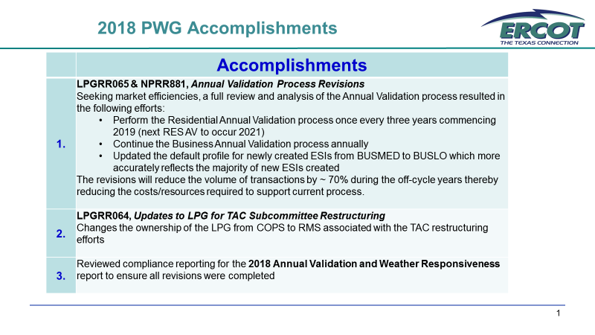
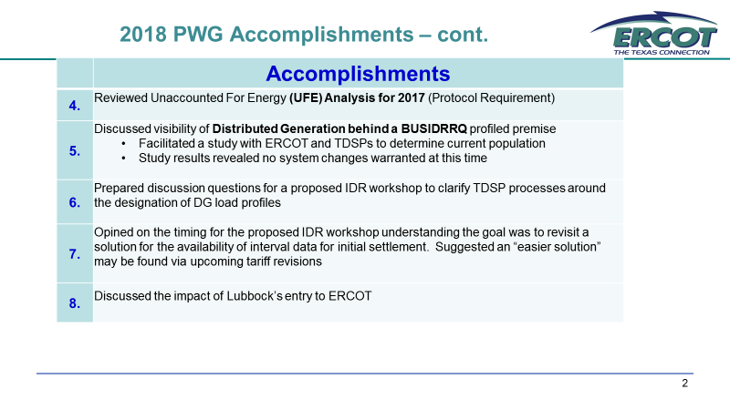
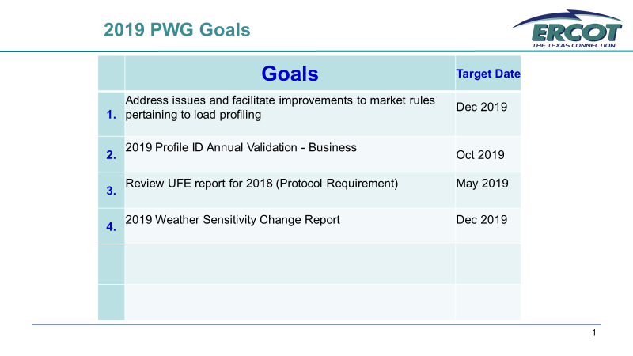
- Other Business –

- Lubbock’s entry to ERCOT
  - Calvin will be presenting the impact of Lubbock’s entry to ERCOT to WMS in January. ERCOT noted Lubbock’s AMS Deployment plan will be complete prior to entry. Currently a study is underway to assess competition in the area. Lubbock represents ~ 500 MWs of load. Typically, new Weather Zones are ~ 2000 MW. ERCOT will look for the recommendation if Lubbock is to be considered as a separate weather zone.

- IDR Workshop – Based on the WG’s earlier recommendations, an IDR Workshop to address IDR data for initial settlement will likely not be considered until 2020 – once upcoming rate cases (AEP and CNP) are complete.

- Clean up of LPGRR – an ‘orphaned’ section referenced remained in section 8.4 of the LPG. Phil suggested the section reference be removed (highlighted below). The WG approved and Phil will continue with the administrative clean up LGPRR.
(3) Requests for Load Profile Model changes shall be submitted to the Retail Market Subcommittee (RMS) and are subject to approval as outlined in Section 8.5, Approval Process for Load Profile Model Changes.
- Update on NPRR881 and LPGRR65
NPRR was approved by TAC on 11/29. Sam Pak had questioned data points of specifically YOY of changes of the newly created ESIs from BUSMED to BUSLO. The WG explained we generalized the impact based on the overall #s that move from BUSMED to BUSLO. We also provided the overall market numbers on the total counts of BUSMED vs BUSLO ESIs. Access to the report can be found as follows:
Market Information > Load Profiling > Key Docs > counts are updated monthly
From this data, overall counts show at least a 2:1 ration of BUSLO to BUSMED
Sam will provide data specifically on the # of defaulting ESIs that changed from MED to LOW LP

- Meeting Plan for 2019
Given the anticipated work load, the WG proposes to meet 4x next year, all via WebEx
  - January 24th @ 9:30 , WebEx
    - Leadership elections
    - Weather Sensitivity Update
    - Oncor’s follow up on BUSMED vs BUSLO new ESI revisions
  - March 29th @ 9:30, WebEx
    - Review Business AV report
  - May 10th @ 9:30 am, WebEx
    - Review 2018 UFE report
  - November 8th @ 9:30 am, WebEx
    - Review AV update
    - 2019 Accomplishments / 2020 Goals
    - Weather Sensitivity report
ACTION: Sheri will send a note to Phil Bracy, Stakeholder Services to request meeting times be placed on ERCOT calendar.

