December 2018 ERCOT Monthly Operations Report
Reliability and Operations Subcommittee Meeting
February 7, 2019

Table of Contents
1. Report Highlights 2
2. Frequency Control 3
2.1. Frequency Events 3
2.2. Responsive Reserve Events 4
2.3. Load Resource Events 4
3. Reliability Unit Commitment 4
4. Wind Generation as a Percent of Load 5
5. COP Error Analysis 5
6. Congestion Analysis 5
6.1. Notable Constraints 8
6.2. Generic Transmission Constraint Congestion 11
6.3. Manual Overrides 11
6.4. Congestion Costs for Calendar Year 2018 11
7. System Events 12
7.1. ERCOT Peak Load 13
7.2. Load Shed Events 14
7.3. Stability Events 14
7.4. Notable PMU Events 14
7.5. DC Tie Curtailment 14
7.6. TRE/DOE Reportable Events 14
7.7. New/Updated Constraint Management Plans 14
7.8. New/Modified/Removed RAS 14
7.9. New Procedures/Forms/Operating Bulletins 14
8. Emergency Conditions 15
8.1. OCNs 15
8.2. Advisories 15
8.3. Watches 15
8.4. Emergency Notices 15
9. Application Performance 15
9.1. TSAT/VSAT Performance Issues 15
9.2. Communication Issues 15
9.3. Market System Issues 16
10. Model Updates 16
Appendix A: Real-Time Constraints 18

Report Highlights
- The unofficial ERCOT peak for December was 51,934 MW.
- There were four frequency events in December. PMU data indicates the ERCOT system transitioned well.
- There were two instances where Responsive Reserves were deployed.
- There were two RUC commitments in December due to congestion.
- Congestion in the North and South Load Zone (LZ) can be mostly attributed to high generation and planned outages. Congestion in the West LZ was mostly due to high West generation and planned outages. Congestion in the Houston area was mostly due to planned outages. There were 17 days on the Panhandle GTC and 5 days on the Red Tap GTC in December. There was no activity on the remaining GTCs during the month.
- There were six DC Tie curtailments in December.
- A new wind generation record of 19,168 MW was set on 12/14/2018 at 00:07.
- A new wind penetration record of 54.64% was set on 12/27/2018 04:57.

Frequency Control

Frequency Events
The ERCOT Interconnection experienced four frequency events in December, all of which resulted from a Resource trip. The average event duration was approximately 0:04:52.

A summary of the frequency events is provided below. The reported frequency events meet one of the following criteria: Delta Frequency is 60 mHz or greater; the MW loss is 350 MW or greater; resource trip event triggered RRS deployment. Frequency events that have been identified as Frequency Measurable Events (FME) for purposes of BAL-001-TRE-1 analysis are highlighted in blue. When analyzing frequency events, ERCOT evaluates PMU data according to industry standards. Events with an oscillating frequency of less than 1 Hz are considered to be inter-area, while higher frequencies indicate local events. Industry standards specify that damping ratio for inter-area oscillations should be 3.0% or greater. For the frequency events listed below, the ERCOT system met these standards and transitioned well after each disturbance.

Date and Time | Delta Frequency | Max/Min Frequency | Duration of Event | PMU Data |  |  | MW Loss | Load | Wind | Inertia
 | (Hz) | (Hz) |  | Oscillation Mode (Hz) |  | Damping Ratio |  | (MW) | % | (GW-s)
12/2/2018 0:34 | 0.071 | 59.911 | 0:07:51 | No PMU data available |  |  | 483.25 | 39,100 | 34% | 186,383
12/23/2018 6:53 | 0.160 | 59.823 | 0:03:44 | 0.81 | 12.0% |  | 854.37 | 30,225 | 32% | 168,974
12/23/2018 18:28 | 0.091 | 59.910 | 0:03:36 | No PMU data available |  |  | 393.50 | 35,032 | 26% | 210,941
12/26/2018 9:24 | 0.096 | 59.887 | 0:04:17 | No PMU data available |  |  | 491.33 | 37,864 | 11% | 226,254

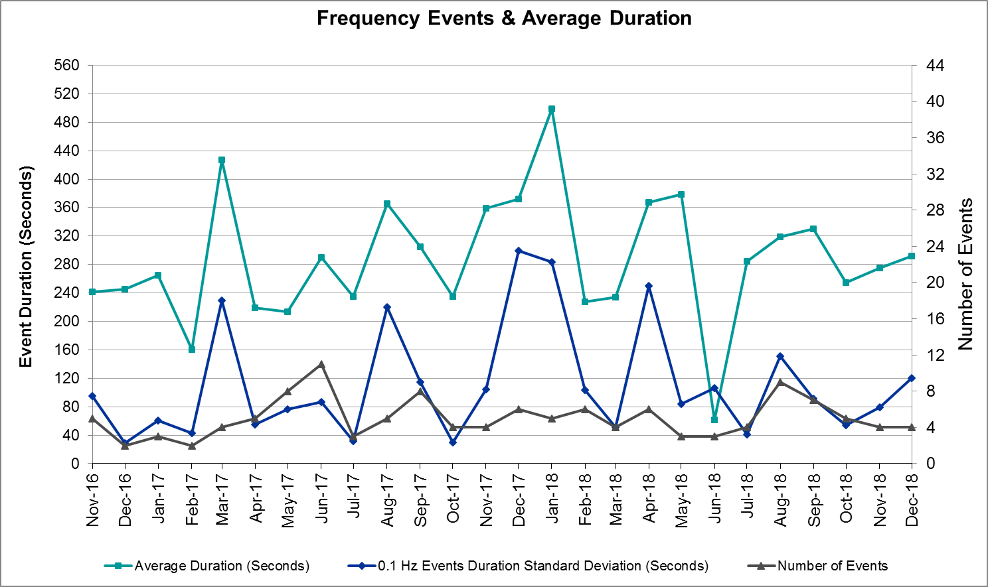
(Note: All data on this graph encompasses frequency event analysis based on BAL-001-TRE-1.)

Responsive Reserve Events
There were two events where Responsive Reserve MWs were released to SCED in December. The events highlighted in blue were related to frequency events reported in Section 2.1 above.

Date and Time Released to SCED | Date and Time Recalled | Duration of Event | Maximum MWs Released
12/23/2018 6:53 | 12/23/2018 6:56 | 00:03:31 | 523
12/26/2018 9:24 | 12/26/2018 9:27 | 00:03:08 | 447

Load Resource Events
None.

Reliability Unit Commitment
ERCOT reports on Reliability Unit Commitments (RUC) on a monthly basis. Commitments are reported grouped by operating day and weather zone. The total number of hours committed is the sum of the hours for all the units in the specified region. Additional information on RUC commitments can be found on the MIS secure site at Grid Generation Reliability Unit Commitment.

There were no DRUC commitments in December.

There were two HRUC commitments in December.

Resource Location | # of Resources | Operating Day | Total # of Hours Committed | Total MWhs | Reason for Commitment
Southern | 1 | 12/1/2018 | 6 | 1,466 | Congestion
Southern | 2 | 12/11/2018 | 10 | 3,132 | Congestion

Wind Generation as a Percent of Load
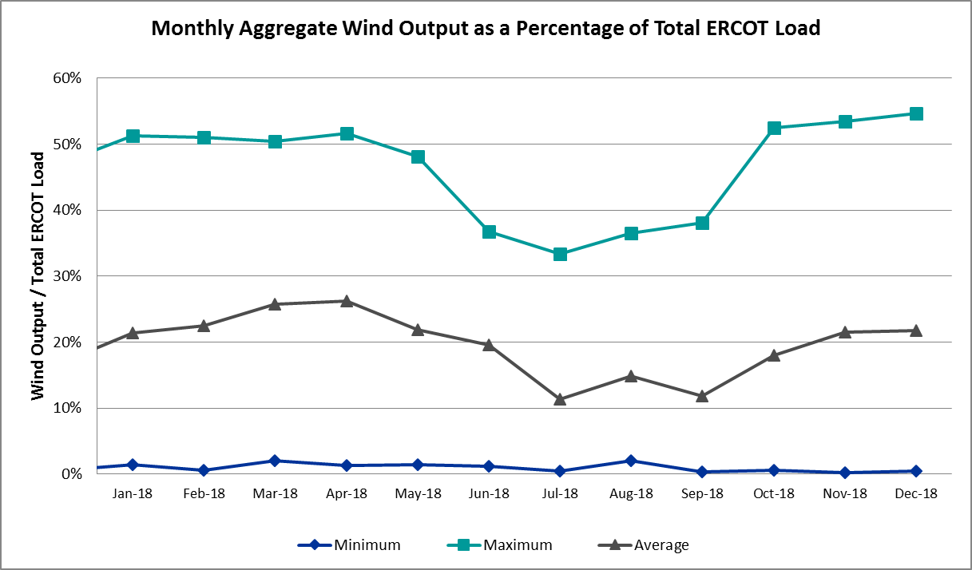

Wind Generation Record: 19,168 MW on 12/14/2018 at 00:07
Wind Penetration Record: 54.64% on 12/27/2018 at 04:57

COP Error Analysis
COP Error is calculated as the capacity difference between the COP HSL and real-time HSL of the unit. Mean Absolute Error (MAE) stayed high over 8,000 MW until Day-Ahead at 12:00, then dropped significantly to 1,490 MW by Day-Ahead at 14:00. In the following chart, Under-Scheduling Error indicates that COP had less generation capacity than real-time and Over-Scheduling Error indicates that COP had more generation capacity than real-time. Under-Scheduling persisted from beginning of Day-Ahead to end of the Operating Day. Snapshot on the Operating Day considers all Operating Hours, including past hours. However, COP error for the Operating Hour freezes after the Adjustment Period.
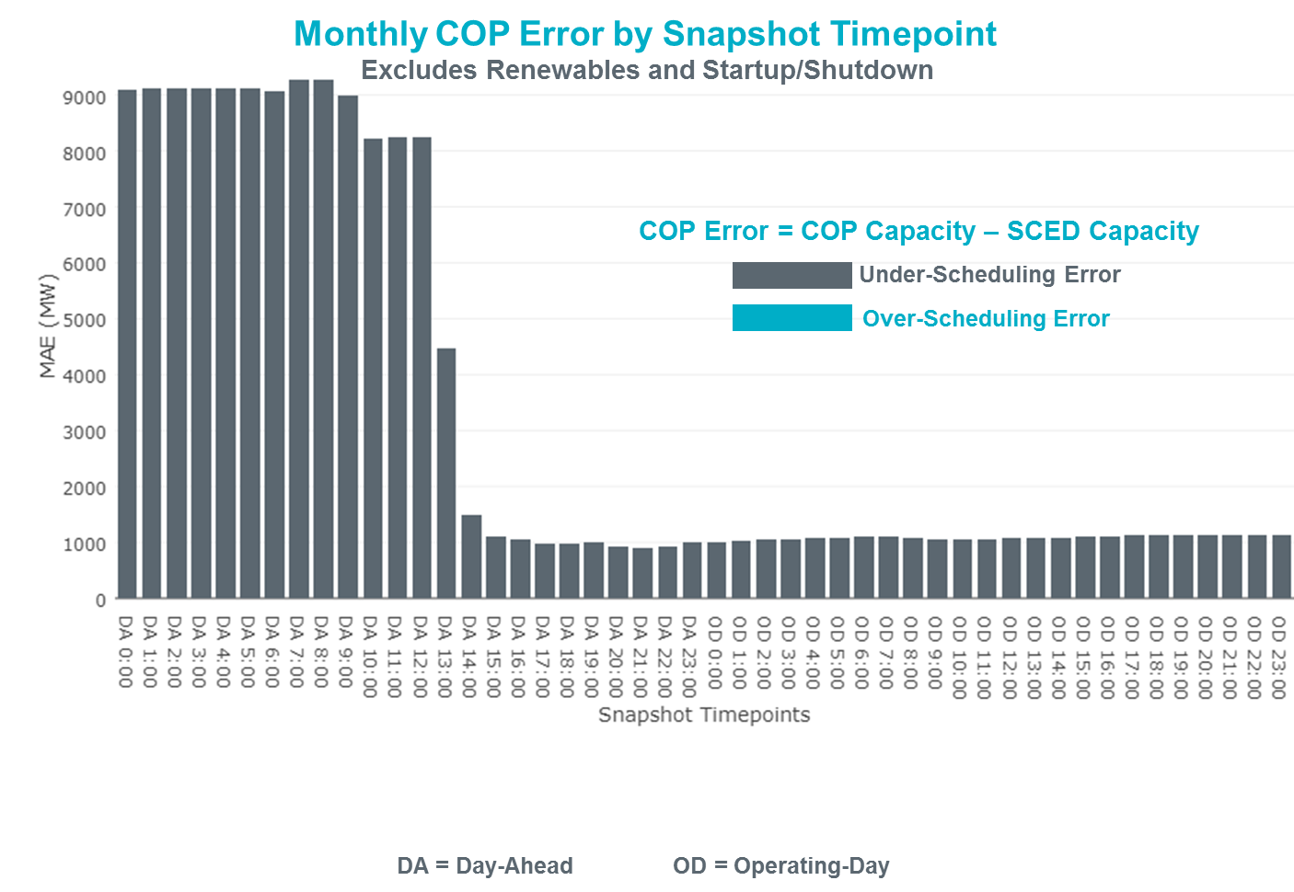
Monthly MAE for the Latest COP at the end of the Adjustment Period was 1,141 MW with median ranging from -1,265 MW for Hour-Ending (HE) 19 to -982 MW for HE 7. December 28th HE 5 had the largest Over-Scheduling Error (227 MW) and December 8th HE 23 had the largest Under-Scheduling Error (-3,507 MW).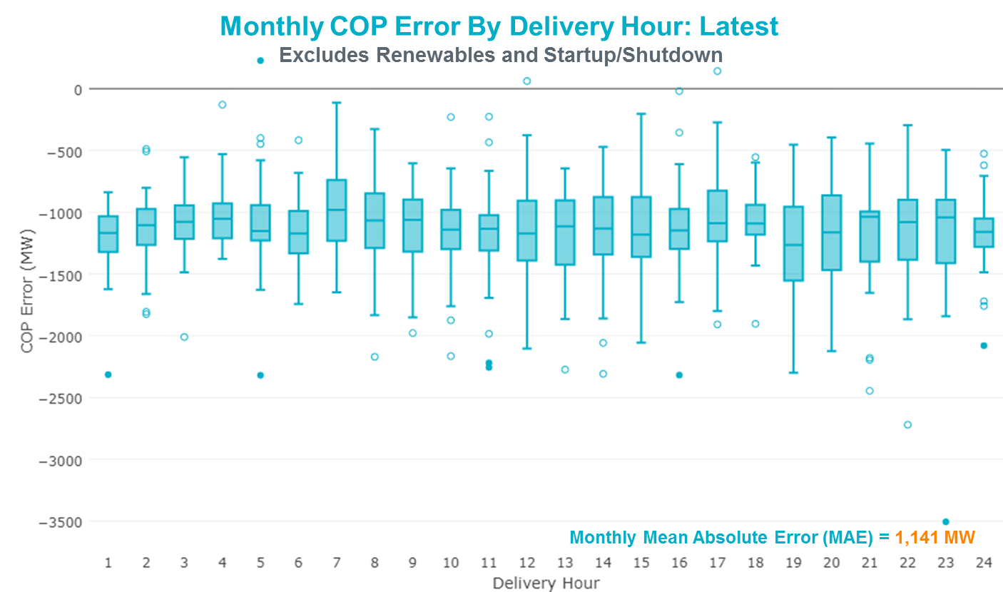
Monthly MAE for the Day-Ahead COP at 12:00 was 8,247 MW with median ranging from -9,855 MW for Hour-Ending (HE) 19 to -6,397 MW for HE 3. December 27th HE 5 had the largest Over-Scheduling Error (332 MW) and December 10th HE 8 had the largest Under-Scheduling Error (-18,861 MW).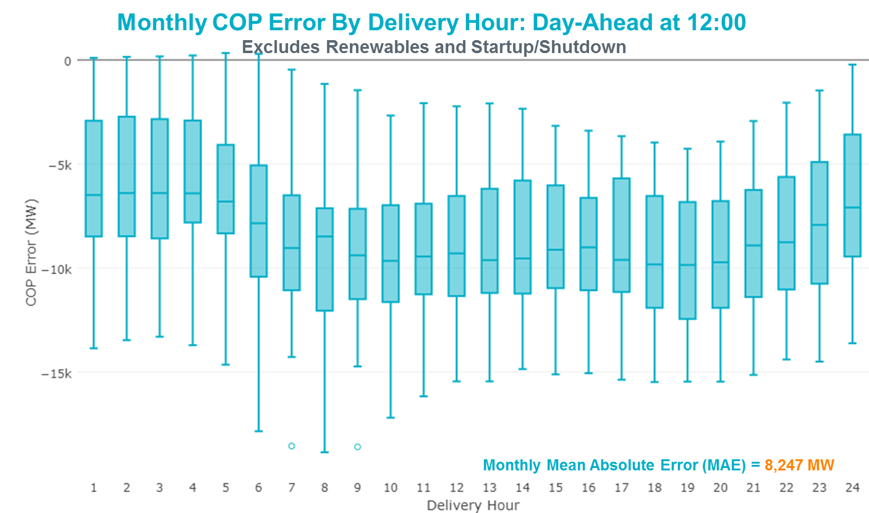

Congestion Analysis
The total number of congestion events experienced by the ERCOT system decreased in December. There were 22 instances over 22 days on the Generic Transmission Constraints (GTCs) in December.

Notable Constraints
Nodal protocol section 3.20 specifies that ERCOT shall identify transmission constraints that are active or binding three or more times within a calendar month. As part of this process, ERCOT reports congestion that meets this criterion to ROS. In addition ERCOT also highlights notable constraints that have an estimated congestion rent exceeding $1,000,000 for a calendar month. These constraints are detailed in the table below. Rows highlighted in blue indicate the congestion was affected by one or more outages. For a list of all constraints activated in SCED for the month of December, please see Appendix A at the end of this report.

Contingency Name | Overloaded Element | # of Days Constraint Active | Congestion Rent | Transmission Project
ODESSA EHV SWITCH to MOSS SWITCH LIN _A | 16th Street Tnp - Woodward 2 138kV | 22 | $8,799,593.11 | Far West Texas Project
ST. LAWRENCE to EINSTEIN LIN 1 | Carterville - Einstein 138kV | 5 | $8,672,347.52 | Bearkat Project (new 345kV circuit from Bearkat to Longshore)
ODESSA EHV SWITCH to MOSS SWITCH LIN _A | Woodward 2 - Rio Pecos 138kV | 10 | $8,164,879.83 | Lynx: Build a 138 kV Station (5535)
EVERMAN SWITCH TRX EVRSW_3_2 345/138 | Everman Switch 345/1kV | 4 | $7,794,514.40 | Everman Switch-Forest Hill Switch-Alcon Tap 138- kV line upgrade
EVERMAN SWITCH TRX EVRSW_3_2 345/138 | Everman Switch 138/1kV | 3 | $7,235,983.65
Entpr-Trses & Mlses-Scses 345kV | Lufkin Switch - Nacogdoches South Tap 138kV | 24 | $5,031,936.06 | Lufkin - Nacogdoches Southeast 138 kV Line (4827)
CRLNW-LWSSW 345kV | Cooper Creek Substation - Arco 138kV | 4 | $4,301,476.43 | 138kV Cooper Creek - Arco Line Reconstruction (44181)
TWR (345) HLJ-WAP64 & BLY-WAP72 | Dow Chemical - South Texas Project 345kV | 5 | $3,234,674.75
TWR (345) HLJ-WAP64 & BLY-WAP72 | Jones Creek - South Texas Project 345kV | 4 | $2,319,898.51
Vensw-Evrsw 345kV | Everman Switch 345/1kV | 1 | $1,950,077.72 | Everman Switch-Forest Hill Switch-Alcon Tap 138- kV line upgrade
SOUTH LANE CITY to LANE CITY LIN 1 | Sargent Sub - Franklins Camp Sub 69kV | 19 | $1,730,317.48
Riohondo-Nedin 345kV&Harlnsw 138kV | Burns Sub - Rio Hondo 138kV | 9 | $1,553,835.68
Bighil-Kendal 345kV | Yellow Jacket - Treadwell 138kV | 10 | $1,466,113.31 | Treadwell: Build temporary tap (6396)
Basecase | PNHNDL GTC | 17 | $1,442,920.32 | LP&L Option 4ow & Panhandle Loop (5180, 5208)
DMTSW-SCOSW 345KV | Knapp - Scurry Chevron 138kV | 8 | $1,353,620.35 | Ennis Creek - Cogdell 69 kV Line (4554) & Ennis Creek 138 kV Switching Station (6269)
KILLEEN SWITCH TRX KLNSW_3_2 345/138 | Killeen Switch 345/1kV | 2 | $1,319,575.76 | Killeen Sw. Sta. 345/138 kV Autotransformer Replacement
ODLAW SWITCHYARD to ASPHALT MINES LIN 1 | Hamilton Road - Maverick 138kV | 13 | $829,572.67 | Brackettville to Escondido: Construct 138 kV line (5206)
SAN MIGUEL 345_138 KV SWITCHYARDS to LOBO LIN 1 | North Laredo Switch - Piloncillo 138kV | 9 | $701,541.09
Fergus-Granmo&Wirtz-Starck 138kV | Flat Rock Lcra - Wirtz 138kV | 16 | $669,675.67 | Wirtz to FlatRock to Paleface Transmission Line Upgrade (4465)
THOMASTON to CUERO LCRA LIN 1 | Coleto Creek - Victoria 138kV | 3 | $549,857.72 | Coleto Creek to Tuleta: New 138 kV Line (16TPIT0034)
COMANCHE SWITCH (Oncor) to COMANCHE PEAK SES LIN _A | Comanche Tap - Comanche Switch (Oncor) 138kV | 5 | $472,413.22
COLETO CREEK to VICTORIA LIN 1 | Coleto Creek - Victoria 138kV | 7 | $464,146.83 | Coleto Creek to Tuleta: New 138 kV Line (16TPIT0034)
COLETO CREEK to VICTORIA LIN 1 | Cuero Lcra - Thomaston 138kV | 3 | $457,064.22
Hillctry-Marion 345kV | Marion 345/1kV | 3 | $423,220.78 | Marion Power Transformer Addition (Formerly Weil Road) (10TPIT0062)
KLEBERG AEP to LOYOLA SUB LIN 1 | Loyola Sub 138/69kV | 9 | $404,709.32
Basecase | Randado Aep - Zapata 138kV | 20 | $360,186.06 | Zapata Reactor (44393)
Pig Creek to Solstice LIN 1 | Airport Tnp - 16th Street Tnp 138kV | 23 | $322,234.34
CAGNON to KENDALL LIN 1 | Cico - Comfort 138kV | 6 | $296,915.01 | Boerne Cico - Comfort - Kendall Transmission Line Upgrade (6982)
LAQUINTA to LOBO LIN 1 | Bruni Sub 138/69kV | 13 | $295,637.89
JARDIN to DILLEY SWITCH AEP LIN 1 | Dilley Switch Aep - Cotulla Sub 69kV | 5 | $259,448.31
TWR (345) WHITE_PT-LON_HILL & STP | Pettus - Normanna 69kV | 3 | $241,581.25
VICTORIA CC1 Train | Coleto Creek - Victoria 138kV | 4 | $236,816.13 | Coleto Creek to Tuleta: New 138 kV Line (16TPIT0034)
Bighil-Kendal 345kV | Yellow Jacket - Fort Mason 138kV | 4 | $232,011.54
DMTSW-SCOSW 345KV | Morgan Creek Ses - Sun Switch 138kV | 8 | $194,620.51
PH ROBINSON to MEADOW LIN A | Mainland Tnp - Alvin Tnp 138kV | 5 | $159,408.96
COLETO CREEK to PAWNEE SWITCHING STATION LIN 1 | Coleto Creek - Victoria 138kV | 4 | $137,767.36 | Coleto Creek to Tuleta: New 138 kV Line (16TPIT0034)
Bighil-Kendal 345kV | Rocksprings - Friess Ranch 69kV | 4 | $133,526.68
COLETO CREEK to PAWNEE SWITCHING STATION LIN 1 | Coleto Creek - Rosata Tap 138kV | 3 | $99,399.03
FLAT TOP TNP to Pig Creek LIN 2 | Musquiz - Country Road 101 Tap 138kV | 17 | $96,738.02
GUNSIGHT SWITCH to GETTY VEALMOOR TAP LIN _A | Chevron Ackerly Tap - Buzzard Draw Switch 69kV | 11 | $80,587.03
FORT LANCASTER to ILLINOIS #4 LIN 1 | Hamilton Road - Maxwell 138kV | 6 | $76,730.66
FRIEND RANCH to SONORA LIN 1 | Sonora 138/69kV | 4 | $69,298.14 | Carver: Build new 138 kV station (5979)
FORMOSA GEN FORMOSG12 | Coleto Creek - Victoria 138kV | 4 | $59,611.70 | Coleto Creek to Tuleta: New 138 kV Line (16TPIT0034)
Bighil-Kendal 345kV | Hamilton Road - Maxwell 138kV | 4 | $59,571.78
Pig Creek to Solstice LIN 1 | Woodward 2 - Rio Pecos 138kV | 15 | $45,469.85 | Lynx: Build a 138 kV Station (5535)
KING RANCH GAS PLANT to FALFURRIAS LIN 1 | Falfurrias - Premont 69kV | 7 | $39,607.88 | Premont - Falfurrias 69 kV Line (6203)
LAQUINTA to LOBO LIN 1 | Falfurrias - Premont 69kV | 7 | $35,570.56 | Premont - Falfurrias 69 kV Line (6203)
BRACKETTVILLE to HAMILTON ROAD LIN 1 | Hamilton Road - Maverick 138kV | 4 | $34,764.75 | Brackettville to Escondido: Construct 138 kV line (5206)
Bighil-Kendal 345kV | San Angelo Power Station - Treadwell 138kV | 3 | $31,265.28
SUN SWITCH to SCURRY SWITCH LIN 1 | Aspermont Aep - Aspermont Continental 69kV | 5 | $25,186.42 | Aspermont: Replace the 138/69 kV autotransformer (6569)
ENNIS WEST SWITCH to WAXAHACHIE PUMP 1 LIN _C | Trumbull - Ennis Switch 138kV | 6 | $15,172.10
SUN SWITCH to SCURRY SWITCH LIN 1 | Wolfgang - Rotan 69kV | 5 | $9,526.90 | Wolfgang to Rotan 69 kV line: Rebuild 69 kV line (5970)
Bronco to ALPINE LIN 1 | Solstice - Linterna 138kV | 10 | $8,921.62 | Solstice to Clovis: Build 138 kV line (4531)
LOFTIN to COTTONWOOD ROAD SWITCH LIN 1 | Bowie 138/69kV | 3 | $8,566.10
Basecase | Rio Hondo - East Rio Hondo Sub 138kV | 3 | $8,411.08
Basecase | REDTAP GTC | 5 | $1,551.01

Generic Transmission Constraint Congestion
There were 17 days on the Panhandle GTC and 5 days on the Red Tap GTC in December. There was no activity on the remaining GTCs during the month.

Note: This is how many times a constraint has been activated to avoid exceeding a GTC limit, it does not imply an exceedance of the GTC occurred or that the GTC was binding.

Manual Overrides
None.

Congestion Costs for Calendar Year 2018
The following table represents the top twenty active constraints for the calendar year based on the estimated congestion rent attributed to the congestion. ERCOT updates this list on a monthly basis.

Contingency | Binding Element | # of 5-min SCED Intervals | Estimated Congestion Rent | Transmission Project
Solstice to LINTERNA LIN 1 | Yucca Drive Switch - Gas Pad 138kV | 17,620 | 251,851,642.32 | Yucca Drive-Barilla Junction (4549)
Basecase | PNHNDL GTC | 32,318 | 102,568,618.32 | LP&L Option 4ow & Panhandle Loop (5180, 5208)
CRLNW-LWSSW 345kV | Carrollton Northwest - Lakepointe Tnp 138kV | 13,115 | 60,311,425.16 | Oncor_NW Carrollton - LakePointe (5488)
LEWISVILLE SWITCH to JONES STREET TNP LIN _A | Ti Tnp - West Tnp 138kV | 3,103 | 35,839,701.17 | Congestion Management Plan # 4 and Stewart Road: Construct 345 kV cut-in (5604)
EMSES-SAGNA 138kV | Blue Mound - Wagley Robertson 138kV | 6,326 | 35,676,195.49 | Wagley Robertson (2076) - Blue Mound (2071) 138-kV line upgrade (2017RTP NC10)
NORTH EDINBURG TRX 1382 345/138 | North Edinburg 345/1kV | 1,460 | 35,354,554.62 | Stewart Road: Construct 345 kV cut-in (5604)
EVERMAN SWITCH TRX EVRSW_3_2 345/138 | Everman Switch 345/1kV | 2,647 | 28,831,610.51 | Everman Switch - Forest Hill Switch - Alcon Tap 138-kV line upgrade
DMTSW-SCOSW 345KV | Knapp - Scurry Chevron 138kV | 13,979 | 25,724,485.40 | Ennis Creek - Cogdell 69 kV Line (4554) & Ennis Creek 138 kV Switching Station (6269)
Basecase | VALIMP GTC | 601 | 19,938,471.66 | La Palma Dynamic Reactive (5588) and Pharr Dynamic Reactive (5596)
Bronco to ALPINE LIN 1 | Solstice - Linterna 138kV | 15,711 | 16,217,373.62 | Solstice to Clovis: Build 138 kV line (4531)
Ryssw-Forsw 345kV | Forney West - Forney Switch 138kV | 1,735 | 16,044,364.37 | Upgrade the Forney Sw- Forney West line section (MOD ID #3086)
SN-STR26 & BFP-VL82 | Hofman - Basf 138kV | 1,212 | 15,639,411.86 | BASF to HOFMAN to Lake Jackson Ckt.02 Upgrades
HCKSW-ALLNC&RNKSW 345kV | Blue Mound - Wagley Robertson 138kV | 921 | 15,529,710.27 | Wagley Robertson (2076) - Blue Mound (2071) 138-kV line upgrade (2017RTP NC10)
Castrvll-Razorbac&Txresrch 138kV | Hondo Creek Switching Station - Moore Switching Station 138kV | 605 | 15,342,875.43
Elmcreek-Sanmigl 345kV | Pawnee Switching Station - Calaveras 345kV | 2,108 | 14,407,954.05
CRLNW-LWSSW 345kV | Cooper Creek Substation - Arco 138kV | 2,667 | 14,367,597.40 | 138kV Cooper Creek - Arco Line Reconstruction (44181)
WOLF SWITCHING STATION to Monahans Tap 2 LIN _G | General Tire Switch - Southwestern Portland Tap 138kV | 2,868 | 13,959,263.32
Jewet-Sng 345kV | Btu_Jack_Creek - Twin Oak Switch 345kV | 6,339 | 13,859,000.31 | Houston Import Project (4458)
WOODWARD 1 TAP to WOODWARD 1 LIN 1 | 16th Street Tnp - Woodward 2 138kV | 2,632 | 13,666,794.32 | Far West Texas Project
NORTH PHARR to POLK AVENUE LIN 1 | North Mcallen - West Mcallen 138kV | 1,165 | 13,282,240.37 | North McAllen (8368) - West McAllen (8367) - South McAllen (8371) 138-kV line upgrades (2017 RTP S9)

System Events

ERCOT Peak Load
The unofficial ERCOT peak load for the month was 51,934 MW and occurred on December 10th, during hour ending 08:00.

Load Shed Events
None.

Stability Events
None.

Notable PMU Events
ERCOT analyzes PMU data for any significant system disturbances that do not fall into the Frequency Events category reported in section 2.1. The results are summarized in this section once the analysis has been completed.

There were no PMU events in December.

DC Tie Curtailment
Date | DC Tie | Curtailing Period | # of Tags Curtailed | Initiating Event | Curtailment Reason
12/09/2018 | DC-L | 07:00-09:00 | 1 | DC Tie trip with multiple alarms | DC Tie Forced Outage
12/10/2018 | DC-L | 06:00-24:00 | 3 | DC Tie trip | DC Tie Forced Outage
12/11/2018 | DC-R | 01:00 | 1 | Lost station service | DC Tie Forced Outage
12/16/2018 | DC-L | 08:00-12:00, 16:00-17:00 | 2 | Suspected fan issue | DC Tie Forced Outage
12/17/2018 | DC-L | 23:00-24:00 | 1 | Unable to ramp DC Tie to schedule | DC Tie Forced Outage
12/19/2018 | DC-L | 21:00-24:00 | 1 | Unable to ramp DC Tie to schedule | DC Tie Forced Outage

TRE/DOE Reportable Events
None.

New/Updated Constraint Management Plans
- Updated MP_2018_02

New/Modified/Removed RAS
None.

New Procedures/Forms/Operating Bulletins
Procedure Title | POB
DC Tie Desk | 871
Real Time Desk | 872
Reliability Risk Desk | 873
Reliability Unit Commitment Desk | 874
Resource Desk | 875
Scripts Desk | 876
Shift Supervisor Desk | 877
Transmission and Security Desk | 878

Emergency Conditions

OCNs
Date and Time | Description
12/30/2018 14:27 | ERCOT issued an OCN for a potential extreme cold weather for operating day 1/2/2019 and 1/3/2019.

Advisories
Date and Time | Description
12/19/2018 13:52 | ERCOT issued an advisory for DAM timeline deviation.

Watches
None.

Emergency Notices
None.

Application Performance

TSAT/VSAT Performance Issues
None.

Communication Issues
None.

Market System Issues
None.

Model Updates
The Downstream Production Change (DPC) process allows ERCOT to make changes in the on-line Network Operations Model without loading a completely new model. The purpose of this process is to allow for reliable grid operations as system conditions change between designated Network Operations Model database loads. The DPC process is limited in scope to just those items listed below, with equipment ratings updates being the most common. ERCOT has seen a rise in the use of the DPC process to make on-line updates to the Network Operations Model in recent years, instead of through the standard Network Operations Model Change Request process.

- Static Line ratings (Interim Update)
- Dynamic Line ratings (non-Interim Update)
- Autotransformer ratings (non-Interim Update)
- Breaker and Switch Normal status (Interim Update)
- Contingency Definitions (Interim Update)
- RAP and RAS changes or additions (Interim Update)
- Net Dependable and Reactive Capability (NDCRC) values (Interim Update)
- Impedance Updates (non-Interim)

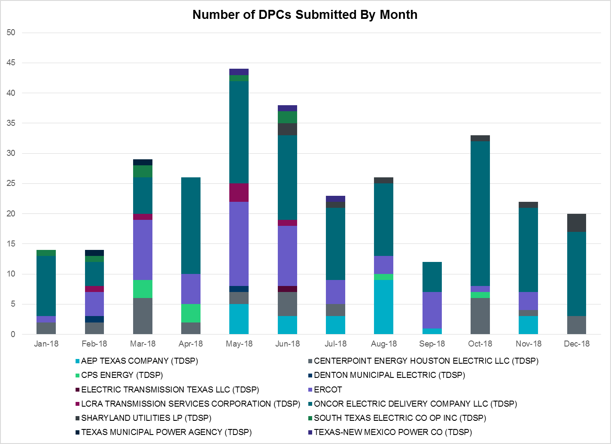

Transmission Operator | Number of DPCs in December
AEP TEXAS COMPANY (TDSP) | 0
BRAZOS ELECTRIC POWER CO OP INC (TDSP) | 0
CENTERPOINT ENERGY HOUSTON ELECTRIC LLC (TDSP) | 3
CPS ENERGY (TDSP) | 0
DENTON MUNICIPAL ELECTRIC (TDSP) | 0
ELECTRIC TRANSMISSION TEXAS LLC (TDSP) | 0
ERCOT | 0
LCRA TRANSMISSION SERVICES CORPORATION (TDSP) | 0
ONCOR ELECTRIC DELIVERY COMPANY LLC (TDSP) | 14
SHARYLAND UTILITIES LP (TDSP) | 3
SOUTH TEXAS ELECTRIC CO OP INC (TDSP) | 0
TEXAS MUNICIPAL POWER AGENCY (TDSP) | 0
TEXAS-NEW MEXICO POWER CO (TDSP) | 0

Appendix A: Real-Time Constraints
The following is a complete list of constraints activated in SCED for the month of December. Full contingency descriptions can be found in the Standard Contingencies List located on the MIS secure site at Grid Generation Reliability Unit Commitment.

Contingency | Constrained Element | From Station | To Station | # of Days Constraint Active
DENTSCS5 | 1350__E | NCSTP | LFKSW | 24
SPIGSOL8 | TNAF_TNFS_1 | 16TH_ST | TNAF | 23
SMDLODE5 | 16TH_WRD2_1 | WOODWRD2 | 16TH_ST | 22
BASE CASE | RANDAD_ZAPATA1_1 | RANDADO | ZAPATA | 20
SLCLAN8 | SAR_FRAN_1 | FRANKC | SARGNTS | 19
SFLAPIG8 | CR101T_MUSQUI1_1 | MUSQUIZ | CR101TAP | 17
BASE CASE | PNHNDL | n/a | n/a | 17
DFERSTA8 | 38T365_1 | WIRTZ | FLATRO | 16
SPIGSOL8 | RIOPEC_WOODW21_1 | RIOPECOS | WOODWRD2 | 15
SLAQLOB8 | BRUNI_69_1 | BRUNI | BRUNI | 13
SBRAUVA8 | HAMILT_MAVERI1_1 | HAMILTON | MAVERICK | 13
SAVMBSP8 | 6610__A | BUZSW | CHATP | 11
DBIGKEN5 | TREADW_YELWJC1_1 | TREADWEL | YELWJCKT | 10
SBROALP9 | LINTER_SOLSTI1_1 | LINTERNA | SOLSTICE | 10
SMDLODE5 | RIOPEC_WOODW21_1 | RIOPECOS | WOODWRD2 | 10
DRIOHAR5 | BURNS_RIOHONDO_1 | RIOHONDO | MV_BURNS | 9
SLOBSA25 | NLARSW_PILONC1_1 | NLARSW | PILONCIL | 9
SKLELOY8 | LOYOLA_69_1 | LOYOLA | LOYOLA | 9
DMTSCOS5 | 6474__A | SUNSW | MGSES | 8
DMTSCOS5 | 6437__F | SCRCV | KNAPP | 8
SVICCO28 | COLETO_VICTOR2_1 | COLETO | VICTORIA | 7
SLAQLOB8 | FALFUR_PREMON1_1 | FALFUR | PREMONT | 7
SKINFAL8 | FALFUR_PREMON1_1 | FALFUR | PREMONT | 7
SCAGKEN5 | 74T148_1 | COMFOR | CICO | 6
SMGIENW8 | 921__D | ENSSW | TRU | 6
SILLFTL8 | HAMILT_MAXWEL1_1 | MAXWELL | HAMILTON | 6
DWAPHLJ5 | DOWSTP27_A | STP | DOW | 5
SCMNCPS5 | 651__B | CMNSW | CMNTP | 5
SSTLEIN8 | CRTVLE_EINSTEN_1 | EINSTEIN | CRTRVLLE | 5
SSCUSU28 | ASPM_CONA1_1 | ASPM | CONA | 5
BASE CASE | REDTAP | n/a | n/a | 5
SMDOPHR5 | 138_ALV_MNL_1 | ALVIN | MAINLAND | 5
SSCUSU28 | ROTN_WOLFGA1_1 | WOLFGANG | ROTN | 5
SJARDIL8 | DIL_COTU_1 | DILLEYSW | COTULAS | 5
SWLFMON8 | 6345__B | GNTSW | SPRTP | 4
DCC1_VIC | COLETO_VICTOR1_1 | COLETO | VICTORIA | 4
SBRAHAM8 | HAMILT_MAVERI1_1 | HAMILTON | MAVERICK | 4
SCOLPAW5 | COLETO_VICTOR1_1 | COLETO | VICTORIA | 4
DBIGKEN5 | HAMILT_MAXWEL1_1 | MAXWELL | HAMILTON | 4
XEVR58 | EVRSW_MR1H | EVRSW | EVRSW | 4
SSONFRI8 | SONR_69-1 | SONR | SONR | 4
DCRLLSW5 | COOPERCK_ARCO_1 | COOPERCK | ARCO | 4
DBIGKEN5 | FORTMA_YELWJC1_1 | YELWJCKT | FORTMA | 4
DBIGKEN5 | FRIR_ROCKSP1_1 | FRIR | ROCKSPRS | 4
DWAPHLJ5 | JCKSTP18_A | STP | JCK | 4
UFO2FOR1 | COLETO_VICTOR1_1 | COLETO | VICTORIA | 4
DMARPA_8 | 38T365_1 | WIRTZ | FLATRO | 4
DHILMAR5 | MARION_AT2H | MARION | MARION | 3
SCRDLOF9 | BOW_FMR1 | BOW | BOW | 3
SSPUMW18 | ROTN_WOLFGA1_1 | WOLFGANG | ROTN | 3
SCOLPAW5 | COLETO_ROSATA1_1 | COLETO | ROSATA | 3
BASE CASE | RIOHND_ERIOHND_1 | MV_RIOHO | RIOHONDO | 3
DBIGKEN5 | SAPOWE_TREADW1_1 | SAPOWER | TREADWEL | 3
DWH_STP5 | NORMAN_PETTUS1_1 | PETTUS | NORMANNA | 3
SCTHHA38 | HAMILT_MAXWEL1_1 | MAXWELL | HAMILTON | 3
STHOCU28 | COLETO_VICTOR1_1 | COLETO | VICTORIA | 3
SWLFECT8 | 6100__F | DHIDE | NOTSW | 3
XEVR58 | EVRSW_MR1L | EVRSW | EVRSW | 3
SVICCO28 | CUELCA_THOMAS1_1 | CUERO | THOMASTN | 3
DTWIDIV5 | CRTVLE_EINSTEN_1 | EINSTEIN | CRTRVLLE | 2
SW_SDIV5 | CRTVLE_EINSTEN_1 | EINSTEIN | CRTRVLLE | 2
SCOLKEN8 | COLETO_VICTOR1_1 | COLETO | VICTORIA | 2
BASE CASE | 16TH_WRD2_1 | WOODWRD2 | 16TH_ST | 2
DCAGCO58 | 583T583_1 | BANDER | MASOCR | 2
SCOCBAR9 | ALPINE_PAIS1_1 | ALPINE | PAIS | 2
SVICCO28 | COLETO_ROSATA1_1 | COLETO | ROSATA | 2
XALM589 | ALMC_69T1 | ALMC | ALMC | 2
SCLNWLC8 | 1590__E | STNSW | SHMNE | 2
BASE CASE | KOCHTAP_VEALM_1 | VEALMOOR | KOCHTAP | 2
SPHIMIL8 | 342T195_1 | GRANMO | MARBFA | 2
SWCSBOO8 | ALPINE_BRONCO1_1 | BRONCO | ALPINE | 2
SW_BW_25 | CRTVLE_EINSTEN_1 | CRTRVLLE | EINSTEIN | 2
DMLSENT5 | ELKTN_MR3L | ELKTN | ELKTN | 2
XKLN358 | KLNSW_MR1H | KLNSW | KLNSW | 2
DWH_STP5 | SAR_FRAN_1 | FRANKC | SARGNTS | 2
SWCSBOO8 | ALPINE_PAIS1_1 | ALPINE | PAIS | 2
SILLFTL8 | CTHR_SONR1_1 | SONR | CTHR | 2
DVICV_D8 | GREENL_WEAVER1_1 | WEAVERRD | GREENLK | 2
BASE CASE | HHGTOM_1 | HHGT | OMEGA | 2
SRAYRI28 | RAYMND2_69A1 | RAYMND2 | RAYMND2 | 2
SHAMMAX8 | SONR_69-1 | SONR | SONR | 2
SNORODE5 | LINTER_SOLSTI1_1 | LINTERNA | SOLSTICE | 2
SBOSELM5 | 1030__B | BOSQUESW | RGH | 1
SMELRIN8 | COLETO_VICTOR1_1 | COLETO | VICTORIA | 1
SALIKIN8 | FALFUR_PREMON1_1 | FALFUR | PREMONT | 1
SSCUSU28 | GIRA_T_SPUR1_1 | SPUR | GIRA_TAP | 1
SBAKBIG5 | LINTER_SOLSTI1_1 | LINTERNA | SOLSTICE | 1
XWHI58 | LON_HILL_381H | LON_HILL | LON_HILL | 1
BASE CASE | MAXWEL_WHITIN1_1 | MAXWELL | WHITING | 1
DPHRAL58 | 138_FWP_MNL_1 | MAINLAND | FRWYPARK | 1
DBIGKEN5 | BONDRO_SONR1_1 | SONR | BONDROAD | 1
DVENEVR5 | EVRSW_MR1L | EVRSW | EVRSW | 1
DVENEVR5 | EVRSW_MR2H | EVRSW | EVRSW | 1
UFO2FOR1 | FORMOS_JOSLIN1_1 | JOSLIN | FORMOSA | 1
SDUKNED8 | HEC_NEDIN2_1 | HEC | NEDIN | 1
DHECWHI8 | RINCON_WHITE_2_1 | WHITE_PT | RINCON | 1
SSPUMW18 | SPUR_69_1 | SPUR | SPUR | 1
XLON58 | WHITE_PT_345A | WHITE_PT | WHITE_PT | 1
SPIGSOL8 | 16TH_WRD2_1 | 16TH_ST | WOODWRD2 | 1
DEMSSAG8 | 6270__B | BLMND | SAGNA | 1
DCPSJON5 | 651__B | CMNSW | CMNTP | 1
DWH_STP5 | BEEVIL_NORMAN1_1 | NORMANNA | BEEVILLE | 1
SLKAWFS8 | BOW_FMR1 | BOW | BOW | 1
BASE CASE | COLETO_VICTOR1_1 | COLETO | VICTORIA | 1
SCOLLON5 | COLETO_VICTOR1_1 | COLETO | VICTORIA | 1
SSPUMW18 | GIRA_T_SPUR1_1 | SPUR | GIRA_TAP | 1
SSONFRI8 | SANTIA_SAPOWE1_1 | SANTIAGO | SAPOWER | 1
DBERAN58 | 256T330_1 | DEVIHI | CRANMI | 1
SWLFECT8 | 6101__A | NOTSW | CHEYT | 1
DGRSPKR5 | 6377__A | BRTSW | ORANS | 1
SCOLBAL8 | BALLIN_HUMBLT1_1 | BALLINGE | HUMBLTAP | 1
DPHRCTR5 | BCVPSA03_A | PSA | BCV | 1
BASE CASE | CBEDYN-1_A | CBEC | DYN | 1
DKENCA58 | MARION_AT2H | MARION | MARION | 1
DMARPA_8 | 43T365_1 | FLATRO | PALEPE | 1
DSCOFAR5 | 6216__A | SHRNE | BCKSW | 1
SALMBA28 | COCS_FTST1_1 | FTST | COCS | 1
XLON58 | COLETO_VICTOR1_1 | COLETO | VICTORIA | 1
SSCUSU28 | CONA_SHHA1_1 | SHHA | CONA | 1
DAUSLOS5 | FAYETT_AT2L | FAYETT | FAYETT | 1
SLAQLOB8 | N_ELLA_PREMON1_1 | PREMONT | N_ELLA | 1
SDCSMBD5 | RKCRK_MR1H | RKCRK | RKCRK | 1
SSCUSU28 | ROBY_ROTN1_1 | ROTN | ROBY | 1
SPHIMIL8 | 223T180_1 | LAKEWY | MARSFO | 1
SAVMBSP8 | 6610__B | CHATP | KNOTT | 1
SENSENS8 | 940__C | ENWSW | WXHCH | 1
SFORYEL8 | FRPHIL_GILLES1_1 | GILLES | FRPHILLT | 1
SPY2WIC8 | LINTER_SOLSTI1_1 | LINTERNA | SOLSTICE | 1
XHAM88 | SONR_69-1 | SONR | SONR | 1
DELMTEX5 | WHITE_PT_345A | WHITE_PT | WHITE_PT | 1
DMLSENT5 | 1350__E | NCSTP | LFKSW | 1
XPH258 | 138_ALV_MNL_1 | ALVIN | MAINLAND | 1
BASE CASE | 223T180_1 | LAKEWY | MARSFO | 1
SWLVW_F5 | 6216__A | SHRNE | BCKSW | 1
DEMSSAG8 | 6270__D | HCKSW | WGROB | 1
SFORYEL8 | FRPHIL_MASN1_1 | MASN | FRPHILLT | 1
SVICCO28 | MAGRUD_THOMAS1_1 | THOMASTN | MAGRUDER | 1
DELMTEX5 | SAR_FRAN_1 | FRANKC | SARGNTS | 1
DSTEXP12 | 100027_D_1 | WND | WHTNY | 1
SBAKBIG5 | 16TH_WRD2_1 | WOODWRD2 | 16TH_ST | 1
SLCDYN8 | EB_WA_65_A | EB | WA | 1
SCISPUT8 | ESTES_PECAN_1_1 | PECAN_BY | ESTES | 1
BASE CASE | LINTER_SOLSTI1_1 | LINTERNA | SOLSTICE | 1
SCELN_S8 | LOYOLA_69_1 | LOYOLA | LOYOLA | 1
SMCEABS8 | MKLT_TRNT1_1 | TRNT | MKLT | 1
SCISPUT8 | SOUTHA_VINSON1_1 | SOUTHABI | VINSON | 1
BASE CASE | WHITE_PT_345A | WHITE_PT | WHITE_PT | 1

The Duration of Event is defined as the time it takes for the frequency to recover to pre-disturbance frequency or 60 Hz as applicable.
PMU reports are typically generated when frequency drops below 59.9, but PMU data is available for other events.
Delta Frequency is defined as the difference between the starting point of the frequency event (t(0) or “A-point”) and minimum/maximum frequency (“C-Point”).
Currently, the Critical Inertia Level for ERCOT is approximately 100,000 MW-s (Source: link)
This is the hourly integrated peak demand as published in the ERCOT D&E report.
All DC Tie Curtailments are posted publically on the ERCOT Market Information System. See that posting for additional details for the event(s) in question.
See DC Tie Operating Procedure (http://www.ercot.com/mktrules/guides/procedures) for more details.

