November 2018 ERCOT Monthly Operations Report
Reliability and Operations Subcommittee Meeting
January 10, 2019

Table of Contents
1. Report Highlights 2
2. Frequency Control 3
2.1. Frequency Events 3
2.2. Responsive Reserve Events 4
2.3. Load Resource Events 4
3. Reliability Unit Commitment 4
4. Wind Generation as a Percent of Load 5
5. COP Error Analysis 5
6. Congestion Analysis 5
6.1. Notable Constraints 8
6.2. Generic Transmission Constraint Congestion 11
6.3. Manual Overrides 11
6.4. Congestion Costs for Calendar Year 2018 11
7. System Events 12
7.1. ERCOT Peak Load 13
7.2. Load Shed Events 14
7.3. Stability Events 14
7.4. Notable PMU Events 14
7.5. DC Tie Curtailment 14
7.6. TRE/DOE Reportable Events 14
7.7. New/Updated Constraint Management Plans 14
7.8. New/Modified/Removed RAS 14
7.9. New Procedures/Forms/Operating Bulletins 14
8. Emergency Conditions 15
8.1. OCNs 15
8.2. Advisories 15
8.3. Watches 15
8.4. Emergency Notices 15
9. Application Performance 15
9.1. TSAT/VSAT Performance Issues 15
9.2. Communication Issues 15
9.3. Market System Issues 16
10. Model Updates 16
Appendix A: Real-Time Constraints 18

Report Highlights
- The unofficial ERCOT peak for November was 56,247 MW.
- There were four frequency events in November. PMU data indicates the ERCOT system transitioned well.
- There were two instances where Responsive Reserves were deployed.
- There were seven RUC commitments in November due to capacity, congestion, and voltage stability.
- Congestion in the North and South Load Zone (LZ) can be mostly attributed to high generation and planned outages. Congestion in the West LZ was mostly due to high West generation and planned outages. Congestion in the Houston area was mostly due to area load/generation pattern and planned outages. There were 19 days on the Panhandle GTC and 3 days on the Red Tap GTC in November. There was no activity on the remaining GTCs during the month.
- There were four DC Tie curtailments in November.
- A new wind generation record of 17,920 MW was set on 11/12/2018 at 15:32.

Frequency Control

Frequency Events
The ERCOT Interconnection experienced four frequency events in November, all of which resulted from a Resource trip. The average event duration was approximately 0:04:36.

A summary of the frequency events is provided below. The reported frequency events meet one of the following criteria: Delta Frequency is 60 mHz or greater; the MW loss is 350 MW or greater; resource trip event triggered RRS deployment. Frequency events that have been identified as Frequency Measurable Events (FME) for purposes of BAL-001-TRE-1 analysis are highlighted in blue. When analyzing frequency events, ERCOT evaluates PMU data according to industry standards. Events with an oscillating frequency of less than 1 Hz are considered to be inter-area, while higher frequencies indicate local events. Industry standards specify that damping ratio for inter-area oscillations should be 3.0% or greater. For the frequency events listed below, the ERCOT system met these standards and transitioned well after each disturbance.

Date and Time | Delta Frequency | Max/Min Frequency | Duration of Event | PMU Data |  | MW Loss | Load | Wind | Inertia
 | (Hz) | (Hz) |  | Oscillation Mode (Hz) | Damping Ratio |  | (MW) | % | (GW-s)
11/6/2018 7:53 | 0.068 | 59.930 | 0:05:15 | No PMU data available |  | 428.24 | 36,489 | 2% | 232,371
11/10/2018 9:25 | 0.110 | 59.905 | 0:05:58 | No PMU data available |  | 515.99 | 37,432 | 10% | 224,652
11/14/2018 22:30 | 0.096 | 59.918 | 0:04:14 | No PMU data available |  | 428.20 | 39,968 | 24% | 215,470
11/30/2018 15:51 | 0.083 | 59.928 | 0:02:55 | No PMU data available |  | 335.57 | 37,956 | 6% | 227,531

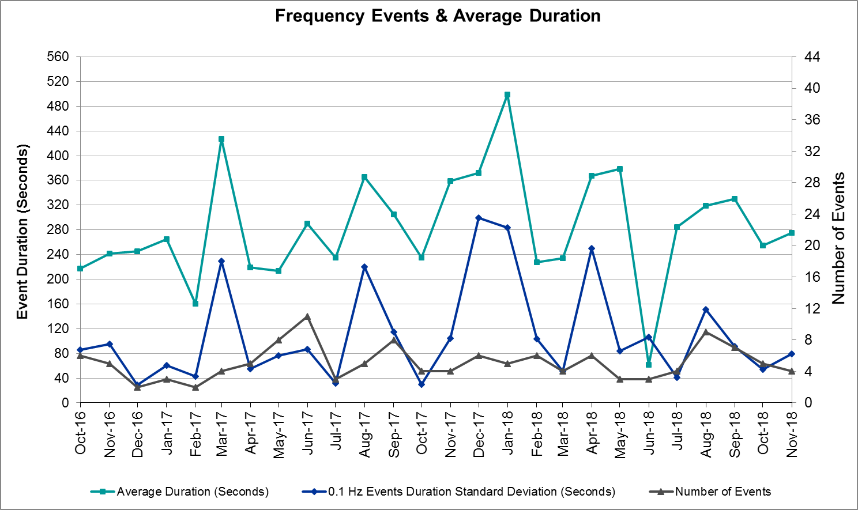
(Note: All data on this graph encompasses frequency event analysis based on BAL-001-TRE-1.)

Responsive Reserve Events
There were two events where Responsive Reserve MWs were released to SCED in November. The events highlighted in blue were related to frequency events reported in Section 2.1 above.

Date and Time Released to SCED | Date and Time Recalled | Duration of Event | Maximum MWs Released
11/3/2018 18:32 | 11/3/2018 18:38 | 00:05:28 | 584
11/10/2018 9:25 | 11/10/2018 9:28 | 00:03:08 | 243

Load Resource Events
None.

Reliability Unit Commitment
ERCOT reports on Reliability Unit Commitments (RUC) on a monthly basis. Commitments are reported grouped by operating day and weather zone. The total number of hours committed is the sum of the hours for all the units in the specified region. Additional information on RUC commitments can be found on the MIS secure site at Grid Generation Reliability Unit Commitment.

There were no DRUC commitments in November.

There were seven HRUC commitments in November.

Resource Location | # of Resources | Operating Day | Total # of Hours Committed | Total MWhs | Reason for Commitment
North Central | 4 | 11/13/2018 | 37 | 15,824 | Congestion, Capacity
East | 1 | 11/13/2018 | 6 | 3,012 | Congestion
Far West | 2 | 11/13/2018 | 16 | 2,990 | Capacity
South Central | 1 | 11/13/2018 | 8 | 1,944 | Capacity
North Central | 1 | 11/14/2018 | 4 | 1,560 | Congestion
Southern | 1 | 11/16/2018 | 2 | 649 | Congestion
Southern | 1 | 11/27/2018 | 2 | 457 | Valley Import

Wind Generation as a Percent of Load
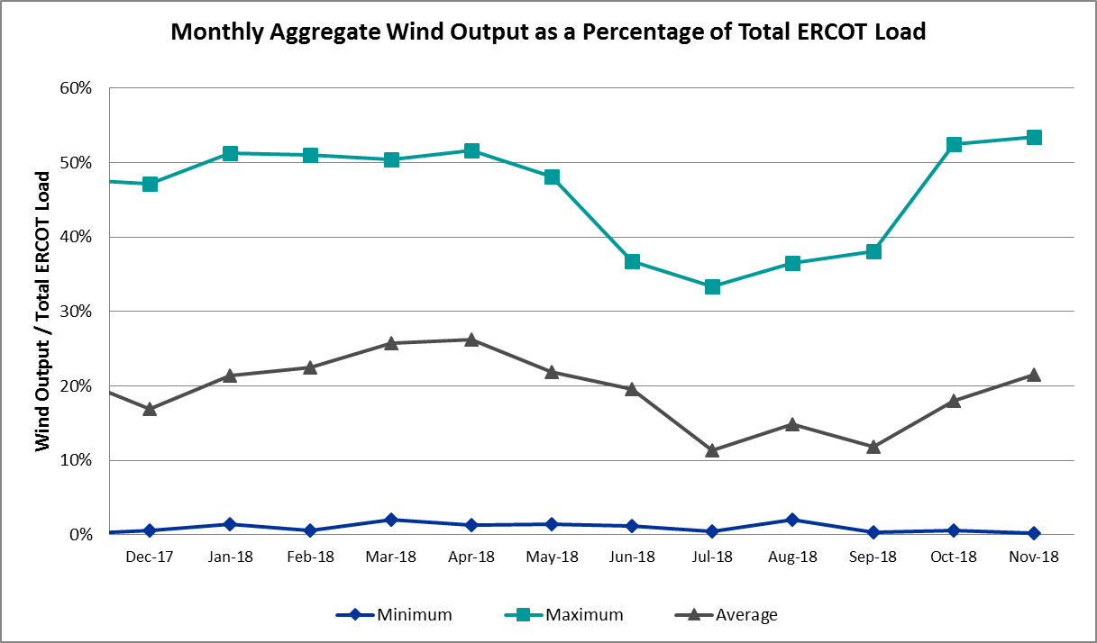

Wind Generation Record: 17,920 MW on 11/12/2018 at 15:32
Wind Penetration Record: 54.22% on 10/27/2017 at 04:00

COP Error Analysis
COP Error is calculated as the capacity difference between the COP HSL and real-time HSL of the unit. Mean Absolute Error (MAE) stayed high over 7,000 MW until Day-Ahead at 12:00, then dropped significantly to 1,376 MW by Day-Ahead at 14:00. In the following chart, Under-Scheduling Error indicates that COP had less generation capacity than real-time and Over-Scheduling Error indicates that COP had more generation capacity than real-time. Under-Scheduling persisted from beginning of Day-Ahead to end of the Operating Day. Snapshot on the Operating Day considers all Operating Hours, including past hours. However, COP error for the Operating Hour freezes after the Adjustment Period.
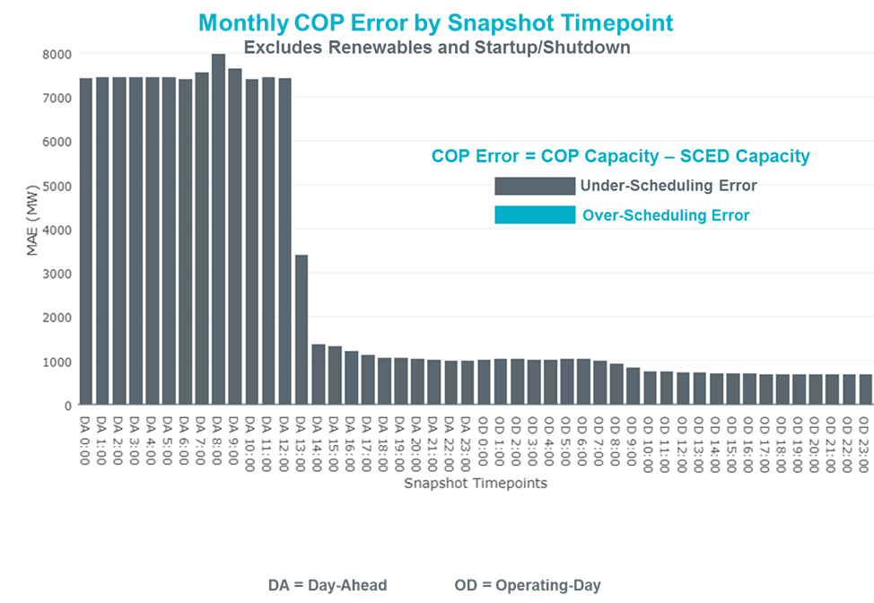
Monthly MAE for the Latest COP at the end of the Adjustment Period was 687 MW with median ranging from -783 MW for Hour-Ending (HE) 13 to -172 MW for HE 4. November 13th HE 14 had the largest Over-Scheduling Error (1630 MW) and November 29th HE 21 had the largest Under-Scheduling Error (-2,941 MW).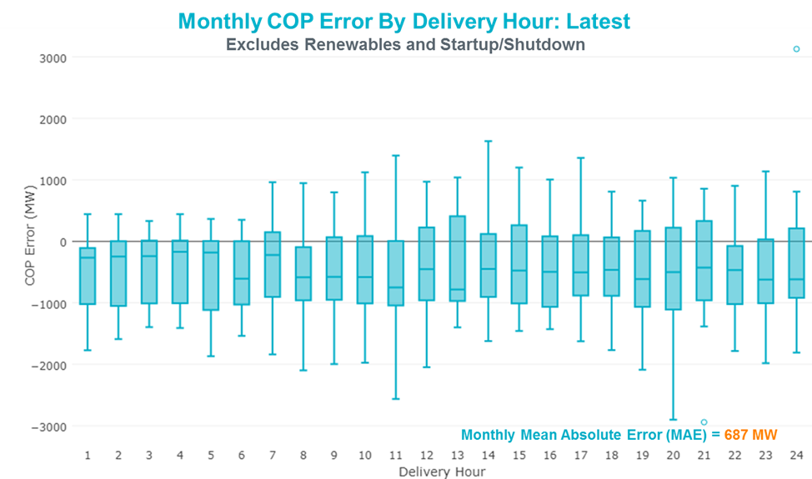
Monthly MAE for the Day-Ahead COP at 12:00 was 7,428 MW with median ranging from -9,276 MW for Hour-Ending (HE) 18 to -4,654 MW for HE 3. November 2nd HE 24 had the largest Over-Scheduling Error (1,506 MW) and November 6th HE 19 had the largest Under-Scheduling Error (-16,590 MW).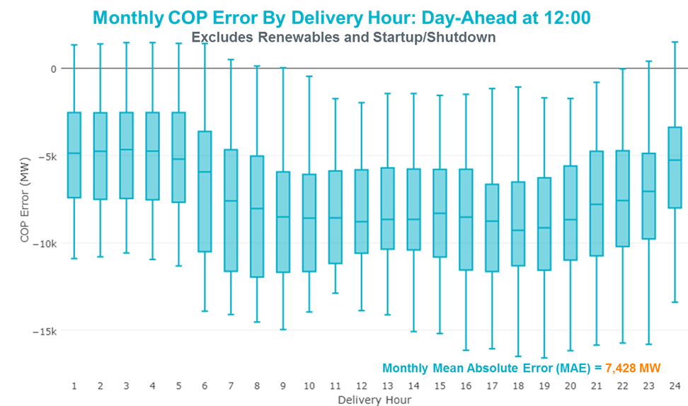

Congestion Analysis
The total number of congestion events experienced by the ERCOT system increased in November. There were 22 instances over 22 days on the Generic Transmission Constraints (GTCs) in November.

Notable Constraints
Nodal protocol section 3.20 specifies that ERCOT shall identify transmission constraints that are active or binding three or more times within a calendar month. As part of this process, ERCOT reports congestion that meets this criterion to ROS. In addition ERCOT also highlights notable constraints that have an estimated congestion rent exceeding $1,000,000 for a calendar month. These constraints are detailed in the table below. Rows highlighted in blue indicate the congestion was affected by one or more outages. For a list of all constraints activated in SCED for the month of November, please see Appendix A at the end of this report.

Contingency Name | Overloaded Element | # of Days Constraint Active | Congestion Rent | Transmission Project
CRLNW-LWSSW 345kV | Cooper Creek Substation - Arco 138kV | 17 | $10,058,795.83 | 138kV Cooper Creek - Arco Line Reconstruction (44181)
ODESSA EHV SWITCH to MOSS SWITCH LIN _A | Odessa Ehv Switch 345/1kV | 7 | $6,482,955.29
MEADOW TRX MDO_AT1 345/138 | Grant - Teco 138kV | 3 | $6,407,864.61 | TECO to Grant Ckt. 37 (5767)
GibbonsCreek-Limestone 345kV | Jewett - Singleton 345kV | 7 | $6,196,901.71
AIRLINE AEP to WESTSIDE AEP LIN 1 | Arcadia - Southside 138kV | 5 | $2,938,717.52
GibbonsCreek-Limestone 345kV | Jewett - Singleton 345kV | 2 | $2,682,891.32
Basecase | PNHNDL GTC | 19 | $2,336,937.23 | LP&L Option 4ow & Panhandle Loop (5180, 5208)
WHITEPOINT TRX 345A 345/138 | Lon Hill 345/1kV | 10 | $2,255,063.81 | Lon Hill: Replace 345/138 kV autotransformers (6101)
EVERMAN SWITCH TRX EVRSW_3_2 345/138 | Everman Switch 345/1kV | 3 | $2,096,049.90 | Everman Switch-Forest Hill Switch-Alcon Tap 138- kV line upgrade
ODESSA EHV SWITCH to MOSS SWITCH LIN _A | 16th Street Tnp - Woodward 2 138kV | 12 | $1,935,535.72 | Far West Texas Project
HIWAY_9 - CITGO_NO & INDUSTRI 69kV & 138 kV | Morris Street - Nueces Bay 138kV | 4 | $1,669,003.64 | Gila-Hwy9_ckt2: replace underground cable
CHB-KG & CBY-JOR 345kV | Brine - Langston 138kV | 1 | $1,579,594.54
MARTIN LAKE - SCSES and - ENTERPRISE | Elkton 138/1kV | 3 | $1,492,828.69 | Elkton 345/138 kV autotransformer (17TPIT0031)
BWNSW-KLNSW 345kV | Comanche Tap - Comanche Switch (Oncor) 138kV | 8 | $1,472,565.33
Bighil-Kendal 345kV | Yellow Jacket - Treadwell 138kV | 11 | $1,276,279.12 | Treadwell: Build temporary tap (6396)
Lostpi-Austro&Dunlap 345kV | Fayetteville 138/1kV | 1 | $1,251,214.20
Basecase | Omega - Horse Hollow Generation Tie 345kV | 16 | $1,251,044.23
DMTSW-SCOSW 345KV | Knapp - Scurry Chevron 138kV | 11 | $1,190,047.45 | Ennis Creek - Cogdell 69 kV Line (4554) & Ennis Creek 138 kV Switching Station (6269)
Fergus-Granmo&Wirtz-Starck 138kV | Flat Rock Lcra - Wirtz 138kV | 13 | $1,027,804.57 | Wirtz to FlatRock to Paleface Transmission Line Upgrade (4465)
EVERMAN SWITCH TRX EVRSW_3_3 345/138 | Everman Switch 345/1kV | 6 | $989,462.86 | Everman Switch-Forest Hill Switch-Alcon Tap 138- kV line upgrade
AIRLINE AEP to WESTSIDE AEP LIN 1 | Holly - Southside 138kV | 5 | $898,933.48 | Airline to Holly: Build new 138 kV line (5168)
ARCADIA to HIWAY 9 LIN 1 | Morris Street - Westside Aep 138kV | 4 | $892,328.07
Entpr-Trses & Mlses-Scses 345kV | Herty North Switch - Nacogdoches Se 138kV | 8 | $838,883.70 | Nacogdoches Southeast - Herty North 138 kV Line (4821)
SAN MIGUEL 345_138 KV SWITCHYARDS to LOBO LIN 1 | North Laredo Switch - Piloncillo 138kV | 7 | $818,796.43
ODLAW SWITCHYARD to ASPHALT MINES LIN 1 | Hamilton Road - Maverick 138kV | 14 | $814,836.67 | Brackettville to Escondido: Construct 138 kV line (5206)
Pig Creek to Solstice LIN 1 | Airport Tnp - 16th Street Tnp 138kV | 27 | $766,666.78
Solstice to ALAMITO CREEK LIN 1 | Conoco Comp Station - Fort Stockton Plant 69kV | 3 | $685,764.26
Riohondo-Nedin 345kV&Harlnsw 138kV | Burns Sub - Rio Hondo 138kV | 3 | $507,284.38
ST. LAWRENCE to EINSTEIN LIN 1 | Carterville - Einstein 138kV | 3 | $497,041.61 | Bearkat Project (new 345kV circuit from Bearkat to Longshore)
SOUTH LANE CITY to LANE CITY LIN 1 | Sargent Sub - Franklins Camp Sub 69kV | 9 | $445,385.15
ENNIS WEST SWITCH to WAXAHACHIE PUMP 1 LIN _C | Trumbull - Ennis Switch 138kV | 3 | $425,648.27
OAK CREEK AEP to CEDAR HILLS LIN 1 | San Angelo Concho - Veribest 69kV | 3 | $346,795.92
CAGNON to KENDALL LIN 1 | Cico - Comfort 138kV | 9 | $339,148.24 | Boerne Cico - Comfort - Kendall Transmission Line Upgrade (6982)
Bighil-Kendal 345kV | Rocksprings - Friess Ranch 69kV | 7 | $247,029.18
KLEBERG AEP to LOYOLA SUB LIN 1 | Loyola Sub 138/69kV | 5 | $246,764.04
ALAMITO CREEK TRX T2 138/69 | Alamito Creek 138/69kV | 3 | $238,254.04
JARDIN to DILLEY SWITCH AEP LIN 1 | Dilley Switch Aep - Cotulla Sub 69kV | 7 | $175,442.24
TWR (345) WHITE_PT-LON_HILL & STP | Pettus - Normanna 69kV | 4 | $164,215.30
WOLF SWITCHING STATION to ECTOR HARPER LIN _C | Dollarhide - No Trees Switch 138kV | 6 | $158,118.16 | Wink - No Trees - Andrew County South 138-kV line upgrades (7101)
MILLER CREEK to PALEFACE LIN 1 | Lakeway - Marshall Ford 138kV | 4 | $144,525.90 | T180 Lakeway - Marshall Ford MLSE Upgrade (7163)
SAMSW-THSES 345KV | Whitney - Whittney Dam 69kV | 6 | $133,714.70
FRIEND RANCH to SONORA LIN 1 | Sonora 138/69kV | 6 | $129,493.69 | Carver: Build new 138 kV station (5979)
Marbfa-Lakewy &Wirtz-Palefa 138kV | Flat Rock Lcra - Wirtz 138kV | 8 | $122,289.57 | Wirtz to FlatRock to Paleface Transmission Line Upgrade (4465)
Berghe-Kendal 345kv & Welfar 138kv | Kendall - Cagnon 345kV | 7 | $108,212.06
wett_sand_bluff to wett_bearkat LIN 1 | Carterville - Einstein 138kV | 4 | $90,238.27 | Bearkat Project (new 345kV circuit from Bearkat to Longshore)
COLETO CREEK to VICTORIA LIN 1 | Coleto Creek - Victoria 138kV | 8 | $84,934.84 | Coleto Creek to Tuleta: New 138 kV Line (16TPIT0034)
FORT MASON to YELLOW JACKET LIN 1 | Mason Aep - Fredricksburg Phillips Tap 69kV | 8 | $83,901.57
FORT LANCASTER to ILLINOIS #4 LIN 1 | Hamilton Road - Maxwell 138kV | 6 | $63,444.30
VICTORIA CC1 Train | Coleto Creek - Victoria 138kV | 4 | $60,542.07 | Coleto Creek to Tuleta: New 138 kV Line (16TPIT0034)
FLAT TOP TNP to Pig Creek LIN 2 | Musquiz - Country Road 101 Tap 138kV | 13 | $39,944.10
YELLOW JACKET TRX PS_1 138/138 | San Angelo Power Station - San Angelo Ben Ficklin 138kV | 4 | $39,220.95
BRACKETTVILLE to HAMILTON ROAD LIN 1 | Hamilton Road - Maverick 138kV | 7 | $38,756.35 | Brackettville to Escondido: Construct 138 kV line (5206)
Bighil-Kendal 345kV | San Angelo Power Station - Treadwell 138kV | 3 | $34,749.09
DMTSW-SCOSW 345KV | Bluff Creek Switch - Exxon Sharon Ridge 138kV | 3 | $28,967.61
LOFTIN to COTTONWOOD ROAD SWITCH LIN 1 | Bowie 138/69kV | 8 | $28,388.59
GUNSIGHT SWITCH to GETTY VEALMOOR TAP LIN _A | Chevron Ackerly Tap - Buzzard Draw Switch 69kV | 5 | $25,258.72
RIO HONDO to LAS PULGAS LIN 1 | Raymondville 2 138/69kV | 3 | $24,257.59
WICHITA FALLS SOUTH SWITCH to WINDTHORST SWITCH LIN _E | Olney 138/69kV | 3 | $23,590.86
EVERMAN SWITCH TRX EVRSW_3_3 345/138 | Everman Switch 345/1kV | 3 | $21,651.15 | Everman Switch-Forest Hill Switch-Alcon Tap 138- kV line upgrade
Basecase | Randado Aep - Zapata 138kV | 5 | $21,569.75
Bighil-Kendal 345kV | Hamilton Road - Maxwell 138kV | 6 | $20,170.10
SUN SWITCH to SCURRY SWITCH LIN 1 | Aspermont Aep - Aspermont Continental 69kV | 7 | $19,856.27
LAQUINTA to LOBO LIN 1 | Falfurrias - Premont 69kV | 3 | $14,488.07
HAMILTON ROAD TRX PS2 138/138 | Sonora 138/69kV | 3 | $12,820.89
WICHITA FALLS SOUTH SWITCH to NEWPORT BEPC LIN _E | Bowie 138/69kV | 5 | $10,473.71
HAMILTON ROAD to Maxwell LIN 1 | Sonora 138/69kV | 5 | $8,185.83
PADUCAH REA TAP to PADUCAH CLARE STREET LIN 1 | Spur 138/69kV | 7 | $7,249.67
Bronco to ALPINE LIN 1 | Solstice - Linterna 138kV | 14 | $6,302.48 | Solstice to Clovis: Build 138 kV line (4531)
BOSQUE SWITCH to ELM MOTT LIN 1 | Bosque Switch - Rogers Hill Bepc 138kV | 4 | $5,865.43
DMTSW-SCOSW 345KV | Morgan Creek Ses - Sun Switch 138kV | 5 | $5,740.87
Basecase | REDTAP GTC | 3 | $4,093.13
SUN SWITCH to SCURRY SWITCH LIN 1 | Aspermont Aep 138/69kV | 6 | $3,516.32 | Aspermont: Replace the 138/69 kV autotransformer (6569)

Generic Transmission Constraint Congestion
There were 19 days on the Panhandle GTC and 3 days on the Red Tap GTC in November. There was no activity on the remaining GTCs during the month.

Note: This is how many times a constraint has been activated to avoid exceeding a GTC limit, it does not imply an exceedance of the GTC occurred or that the GTC was binding.

Manual Overrides
None.

Congestion Costs for Calendar Year 2018
The following table represents the top twenty active constraints for the calendar year based on the estimated congestion rent attributed to the congestion. ERCOT updates this list on a monthly basis.

Contingency | Binding Element | # of 5-min SCED Intervals | Estimated Congestion Rent | Transmission Project
Solstice to LINTERNA LIN 1 | Yucca Drive Switch - Gas Pad 138kV | 17,620 | 251,851,642.32 | Yucca Drive-Barilla Junction (4549)
Basecase | PNHNDL GTC | 30,316 | 101,125,698.00 | LP&L Option 4ow & Panhandle Loop (5180, 5208)
CRLNW-LWSSW 345kV | Carrollton Northwest - Lakepointe Tnp 138kV | 13,115 | 60,311,425.16 | Oncor_NW Carrollton - LakePointe (5488)
LEWISVILLE SWITCH to JONES STREET TNP LIN _A | Ti Tnp - West Tnp 138kV | 3,103 | 35,839,701.17 | Congestion Management Plan # 4 and Stewart Road: Construct 345 kV cut-in (5604)
EMSES-SAGNA 138kV | Blue Mound - Wagley Robertson 138kV | 6,326 | 35,676,195.49 | Wagley Robertson (2076) - Blue Mound (2071) 138-kV line upgrade (2017RTP NC10)
NORTH EDINBURG TRX 1382 345/138 | North Edinburg 345/1kV | 1,460 | 35,354,554.62 | Stewart Road: Construct 345 kV cut-in (5604)
DMTSW-SCOSW 345KV | Knapp - Scurry Chevron 138kV | 13,516 | 24,564,235.92 | Ennis Creek - Cogdell 69 kV Line (4554) & Ennis Creek 138 kV Switching Station (6269)
EVERMAN SWITCH TRX EVRSW_3_2 345/138 | Everman Switch 345/1kV | 2,439 | 21,072,860.37 | Everman Switch - Forest Hill Switch - Alcon Tap 138-kV line upgrade
Basecase | VALIMP GTC | 601 | 19,938,471.66 | La Palma Dynamic Reactive (5588) and Pharr Dynamic Reactive (5596)
Bronco to ALPINE LIN 1 | Solstice - Linterna 138kV | 15,003 | 16,208,452.00 | Solstice to Clovis: Build 138 kV line (4531)
Ryssw-Forsw 345kV | Forney West - Forney Switch 138kV | 1,735 | 16,044,364.37 | Upgrade the Forney Sw- Forney West line section (MOD ID #3086)
SN-STR26 & BFP-VL82 | Hofman - Basf 138kV | 1,212 | 15,639,411.86
HCKSW-ALLNC&RNKSW 345kV | Blue Mound - Wagley Robertson 138kV | 921 | 15,529,710.27 | Wagley Robertson (2076) - Blue Mound (2071) 138-kV line upgrade (2017RTP NC10)
Castrvll-Razorbac&Txresrch 138kV | Hondo Creek Switching Station - Moore Switching Station 138kV | 605 | 15,342,875.43
Elmcreek-Sanmigl 345kV | Pawnee Switching Station - Calaveras 345kV | 2,108 | 14,407,954.05
WOLF SWITCHING STATION to Monahans Tap 2 LIN _G | General Tire Switch - Southwestern Portland Tap 138kV | 2,645 | 13,959,263.32
Jewet-Sng 345kV | Btu_Jack_Creek - Twin Oak Switch 345kV | 6,339 | 13,859,000.31 | Houston Import Project (4458)
WOODWARD 1 TAP to WOODWARD 1 LIN 1 | 16th Street Tnp - Woodward 2 138kV | 2,632 | 13,666,794.32 | Far West Texas Project
CRLNW-LWSSW 345kV | Cooper Creek Substation - Arco 138kV | 2,474 | 13,511,418.82
NORTH PHARR to POLK AVENUE LIN 1 | North Mcallen - West Mcallen 138kV | 1,165 | 13,282,240.37 | North McAllen (8368) - West McAllen (8367) - South McAllen (8371) 138-kV line upgrades (2017 RTP S9)

System Events

ERCOT Peak Load
The unofficial ERCOT peak load for the month was 56,247 MW and occurred on November 14th, during hour ending 08:00.

Load Shed Events
None.

Stability Events
None.

Notable PMU Events
ERCOT analyzes PMU data for any significant system disturbances that do not fall into the Frequency Events category reported in section 2.1. The results are summarized in this section once the analysis has been completed.

There were no PMU events in November.

DC Tie Curtailment
Date | DC Tie | Curtailing Period | # of Tags Curtailed | Initiating Event | Curtailment Reason
11/16/2018 | DC-L | 17:00-24:00 | 4 | Forced extension of planned outage | Forced extension of planned outage
11/21/2018 | DC-L | 19:00-24:00 | 2 | Forced extension of planned outage | Forced extension of planned outage
11/26/2018 | DC-L | 18:00, 20:00 & 23:00-24:00 | 1 | Forced extension of planned outage | Forced extension of planned outage
11/30/2018 | DC-L | 20:00 | 1 | Unable to ramp DC Tie to schedule | DC Tie Forced Outage

TRE/DOE Reportable Events
None.

New/Updated Constraint Management Plans
None.

New/Modified/Removed RAS
None.

New Procedures/Forms/Operating Bulletins
Procedure Title | POB
DC Tie Desk | 866
Scripts Desk | 867
Shift Supervisor Desk | 868
Transmission and Security Desk | 869
Communications Protocol | 870

Emergency Conditions

OCNs
Date and Time | Description
11/05/2018 08:54 | ERCOT issued an OCN for a projected reserve capacity shortage for hours ending 18:00 through 20:00. ERCOT requested all QSE's to update their COPs.
11/13/2018 03:12 | ERCOT issued an OCN for a projected Reserve Capacity Shortage for HE 19 to HE 23. ERCOT may and will commit Resources as needed.

Advisories
None.

Watches
None.

Emergency Notices
None.

Application Performance

TSAT/VSAT Performance Issues
None.

Communication Issues
None.

Market System Issues
None.

Model Updates
The Downstream Production Change (DPC) process allows ERCOT to make changes in the on-line Network Operations Model without loading a completely new model. The purpose of this process is to allow for reliable grid operations as system conditions change between designated Network Operations Model database loads. The DPC process is limited in scope to just those items listed below, with equipment ratings updates being the most common. ERCOT has seen a rise in the use of the DPC process to make on-line updates to the Network Operations Model in recent years, instead of through the standard Network Operations Model Change Request process.

- Static Line ratings (Interim Update)
- Dynamic Line ratings (non-Interim Update)
- Autotransformer ratings (non-Interim Update)
- Breaker and Switch Normal status (Interim Update)
- Contingency Definitions (Interim Update)
- RAP and RAS changes or additions (Interim Update)
- Net Dependable and Reactive Capability (NDCRC) values (Interim Update)
- Impedance Updates (non-Interim)

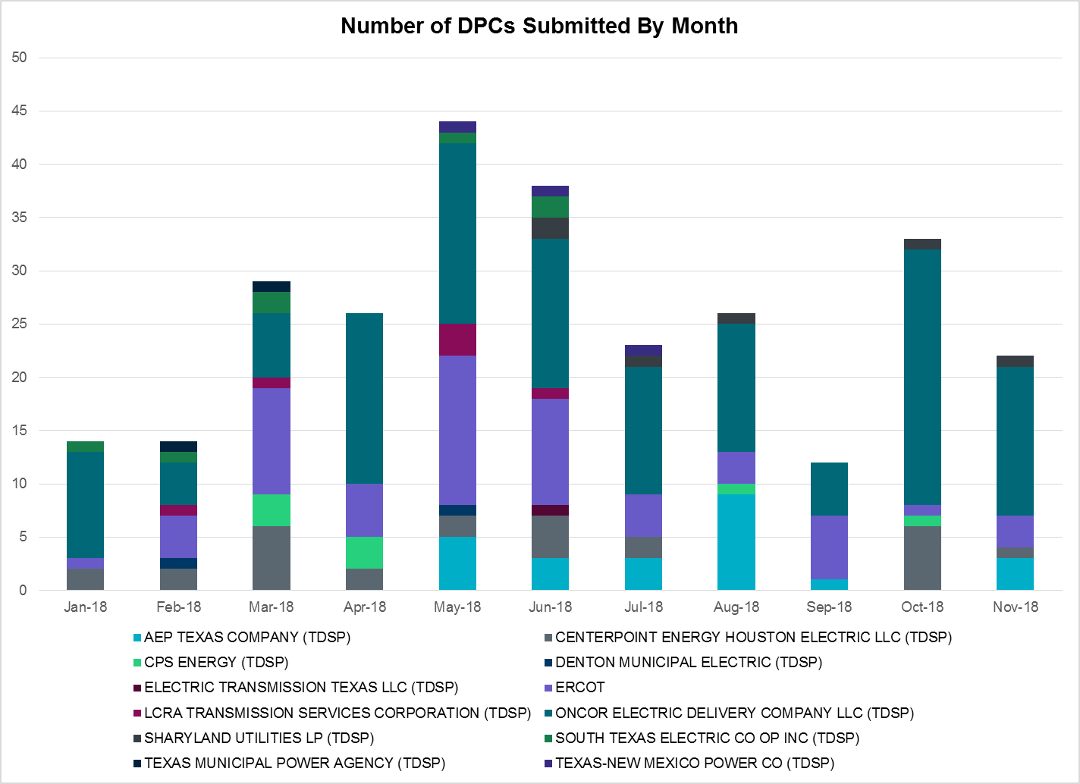

Transmission Operator | Number of DPCs in November
AEP TEXAS COMPANY (TDSP) | 3
BRAZOS ELECTRIC POWER CO OP INC (TDSP) | 0
CENTERPOINT ENERGY HOUSTON ELECTRIC LLC (TDSP) | 1
CPS ENERGY (TDSP) | 0
DENTON MUNICIPAL ELECTRIC (TDSP) | 0
ELECTRIC TRANSMISSION TEXAS LLC (TDSP) | 0
ERCOT | 3
LCRA TRANSMISSION SERVICES CORPORATION (TDSP) | 0
ONCOR ELECTRIC DELIVERY COMPANY LLC (TDSP) | 14
SHARYLAND UTILITIES LP (TDSP) | 1
SOUTH TEXAS ELECTRIC CO OP INC (TDSP) | 0
TEXAS MUNICIPAL POWER AGENCY (TDSP) | 0
TEXAS-NEW MEXICO POWER CO (TDSP) | 0

Appendix A: Real-Time Constraints
The following is a complete list of constraints activated in SCED for the month of November. Full contingency descriptions can be found in the Standard Contingencies List located on the MIS secure site at Grid Generation Reliability Unit Commitment.

Contingency | Constrained Element | From Station | To Station | # of Days Constraint Active
SPIGSOL8 | TNAF_TNFS_1 | 16TH_ST | TNAF | 27
BASE CASE | PNHNDL | n/a | n/a | 19
DCRLLSW5 | COOPERCK_ARCO_1 | COOPERCK | ARCO | 17
BASE CASE | HHGTOM_1 | HHGT | OMEGA | 16
SBRAUVA8 | HAMILT_MAVERI1_1 | HAMILTON | MAVERICK | 14
SBROALP9 | LINTER_SOLSTI1_1 | LINTERNA | SOLSTICE | 14
SFLAPIG8 | CR101T_MUSQUI1_1 | CR101TAP | MUSQUIZ | 13
DFERSTA8 | 38T365_1 | WIRTZ | FLATRO | 13
SMDLODE5 | 16TH_WRD2_1 | WOODWRD2 | 16TH_ST | 12
DBIGKEN5 | TREADW_YELWJC1_1 | TREADWEL | YELWJCKT | 11
DMTSCOS5 | 6437__F | SCRCV | KNAPP | 11
XWHI58 | LON_HILL_381H | LON_HILL | LON_HILL | 10
SLCLAN8 | SAR_FRAN_1 | FRANKC | SARGNTS | 9
SCAGKEN5 | 74T148_1 | COMFOR | CICO | 9
DMARPA_8 | 38T365_1 | WIRTZ | FLATRO | 8
DENTSCS5 | 1170__A | NCDSE | HNRSW | 8
DBWNKLN5 | 651__B | CMNSW | CMNTP | 8
SCRDLOF9 | BOW_FMR1 | BOW | BOW | 8
SFORYEL8 | FRPHIL_MASN1_1 | MASN | FRPHILLT | 8
SVICCO28 | COLETO_VICTOR2_1 | COLETO | VICTORIA | 8
SBRAHAM8 | HAMILT_MAVERI1_1 | HAMILTON | MAVERICK | 7
SSCUSU28 | ASPM_CONA1_1 | ASPM | CONA | 7
DGIBLIM5 | 260_A_1 | JEWET | SNG | 7
DBIGKEN5 | FRIR_ROCKSP1_1 | FRIR | ROCKSPRS | 7
DBERWE58 | 459T459_1 | KENDAL | CAGNON | 7
SPADPAD9 | SPUR_69_1 | SPUR | SPUR | 7
SMDLODE5 | ODEHV_MR2H | ODEHV | ODEHV | 7
SLOBSA25 | NLARSW_PILONC1_1 | NLARSW | PILONCIL | 7
SJARDIL8 | DIL_COTU_1 | DILLEYSW | COTULAS | 7
SSCUSU28 | ASPM_69T1 | ASPM | ASPM | 6
SSONFRI8 | SONR_69-1 | SONR | SONR | 6
SWLFECT8 | 6100__F | DHIDE | NOTSW | 6
SILLFTL8 | HAMILT_MAXWEL1_1 | MAXWELL | HAMILTON | 6
XEV2R58 | EVRSW_MR1H | EVRSW | EVRSW | 6
DBIGKEN5 | HAMILT_MAXWEL1_1 | MAXWELL | HAMILTON | 6
DSAMTHS5 | 100027_D_1 | WND | WHTNY | 6
DCAGCO58 | 583T583_1 | BANDER | MASOCR | 5
SAVMBSP8 | 6610__A | BUZSW | CHATP | 5
BASE CASE | RANDAD_ZAPATA1_1 | RANDADO | ZAPATA | 5
SCABWES8 | ARCADI_SOUTH_1_1 | ARCADIA | SOUTH_SI | 5
SKLELOY8 | LOYOLA_69_1 | LOYOLA | LOYOLA | 5
SLKAWFS8 | BOW_FMR1 | BOW | BOW | 5
SCABWES8 | HOLLY4_SOUTH_1_1 | HOLLY4 | SOUTH_SI | 5
DMTSCOS5 | 6474__A | SUNSW | MGSES | 5
SHAMMAX8 | SONR_69-1 | SONR | SONR | 5
SBOSELM5 | 1030__B | BOSQUESW | RGH | 4
DHWIND89 | MORRIS_NUECES1_1 | NUECES_B | MORRIS | 4
SW_BW_25 | CRTVLE_EINSTEN_1 | EINSTEIN | CRTRVLLE | 4
SARCHIW8 | MORRIS_WESTSI1_1 | MORRIS | WESTSIDE | 4
SPHIMIL8 | 223T180_1 | LAKEWY | MARSFO | 4
DCC1_VIC | COLETO_VICTOR1_1 | COLETO | VICTORIA | 4
XYEL88 | BENFIC_SAPOWE1_1 | SAPOWER | BENFICKL | 4
DWH_STP5 | NORMAN_PETTUS1_1 | PETTUS | NORMANNA | 4
DMLSENT5 | ELKTN_MR3L | ELKTN | ELKTN | 3
SLAQLOB8 | FALFUR_PREMON1_1 | FALFUR | PREMONT | 3
DRIOHAR5 | BURNS_RIOHONDO_1 | RIOHONDO | MV_BURNS | 3
SSTLEIN8 | CRTVLE_EINSTEN_1 | EINSTEIN | CRTRVLLE | 3
SSCLWF28 | OLN_FMR2 | OLN | OLN | 3
DBIGKEN5 | SAPOWE_TREADW1_1 | SAPOWER | TREADWEL | 3
SMGIENW8 | 921__D | ENSSW | TRU | 3
SALMBA28 | COCS_FTST1_1 | FTST | COCS | 3
SCEDOA28 | CONCHO_VRBS1_1 | CONCHO | VRBS | 3
STNNMDO8 | GN_TC_37_A | TC | GN | 3
DMTSCOS5 | 6216__A | BCKSW | SHRNE | 3
XEV2R58 | EVRSW_MR2H | EVRSW | EVRSW | 3
BASE CASE | HAMILT_MAXWEL1_1 | MAXWELL | HAMILTON | 3
BASE CASE | REDTAP | n/a | n/a | 3
SRAYRI28 | RAYMND2_69A1 | RAYMND2 | RAYMND2 | 3
XALM589 | ALMC_69T1 | ALMC | ALMC | 3
XHAM88 | SONR_69-1 | SONR | SONR | 3
XEVR58 | EVRSW_MR1H | EVRSW | EVRSW | 3
SPIGSOL8 | RIOPEC_WOODW21_1 | WOODWRD2 | RIOPECOS | 3
SPHIMIL8 | 342T195_1 | GRANMO | MARBFA | 2
DWH_STP5 | LON_HILL_381H | LON_HILL | LON_HILL | 2
DTWIDIV5 | CRTVLE_EINSTEN_1 | EINSTEIN | CRTRVLLE | 2
SW_BW_25 | EINSTEN_STLAWR_1 | EINSTEIN | STLWRNCE | 2
SCOLKEN8 | MAGRUD_VICTOR2_1 | VICTORIA | MAGRUDER | 2
DZORHAY5 | PAR_TRI_CNTY_1 | F5 | PARKWA | 2
DCAGCI58 | 89T204_1 | ZORN | HENNE | 2
DDILCOT8 | DIL_COTU_1 | DILLEYSW | COTULAS | 2
SLIGVEN5 | EVRSW_MR3H | EVRSW | EVRSW | 2
SFORYEL8 | HEXT_YELWJC1_1 | YELWJCKT | HEXT | 2
SCOLLON5 | VICTO_WARBU_1A_1 | VICTORIA | WARBURTN | 2
SMILHEN8 | 223T180_1 | LAKEWY | MARSFO | 2
DGIBLIM5 | 240__A | JEWET | SNG | 2
DZORSEG8 | 89T204_1 | ZORN | HENNE | 2
SBRAUVA8 | FRIR_ROCKSP1_1 | FRIR | ROCKSPRS | 2
DKENCA58 | PAR_TRI_CNTY_1 | F5 | PARKWA | 2
DMTSCOS5 | 6429__D | ENCRT | BRAND | 2
XLIG58 | LIGSW_MR1H | LIGSW | LIGSW | 2
XCLE58 | CLEASP_AT2L | CLEASP | CLEASP | 2
SPTFL8 | HK_TB_66_A | TB | HK | 2
DELMTEX5 | SAR_FRAN_1 | FRANKC | SARGNTS | 2
SCOLLON5 | COLETO_VICTOR1_1 | COLETO | VICTORIA | 2
SVANRAY8 | RAYBURN_69_2 | RAYBURN | RAYBURN | 2
SALMBA28 | 16TH_WRD2_1 | WOODWRD2 | 16TH_ST | 2
SWCSBOO8 | ALPINE_BRONCO1_1 | BRONCO | ALPINE | 2
SI_DI_48 | I_DUPP_I_DUPS2_1 | I_DUPP1 | I_DUPSW | 2
XWHI58 | LON_HILL_381L | LON_HILL | LON_HILL | 2
DSTEXP12 | 100027_D_1 | WND | WHTNY | 2
DCPSJON5 | 651__B | CMNSW | CMNTP | 2
XCED289 | CONCHO_VRBS1_1 | CONCHO | VRBS | 2
XCRD58 | CRD_CRD2 | CRD | CRD | 2
SKINFAL8 | FALFUR_PREMON1_1 | FALFUR | PREMONT | 2
SCOLPAW5 | COLETO_ROSATA1_1 | COLETO | ROSATA | 2
SNORODE5 | LINTER_SOLSTI1_1 | LINTERNA | SOLSTICE | 1
SCISPUT8 | SOUTHA_VINSON1_1 | SOUTHABI | VINSON | 1
SDOWUVA8 | UVALDE_W_BATE1_1 | UVALDE | W_BATESV | 1
SBWNCTL5 | 651__B | CMNSW | CMNTP | 1
SASPPAI8 | ASPM_69T1 | ASPM | ASPM | 1
SLVOSON8 | BENFIC_SAPOWE1_1 | SAPOWER | BENFICKL | 1
DELMTEX5 | BLESSI_MIDFIE1_1 | BLESSING | MIDFIELD | 1
BASE CASE | COLETO_VICTOR1_1 | COLETO | VICTORIA | 1
SVICCOL8 | COLETO_VICTOR1_1 | COLETO | VICTORIA | 1
SI_DI_38 | I_DUPP_I_DUPS1_1 | I_DUPP1 | I_DUPSW | 1
SMYRSPR8 | SJO_SJO2 | SJO | SJO | 1
DWIRSTA8 | 223T180_1 | LAKEWY | MARSFO | 1
DWIRSTA8 | 342T195_1 | GRANMO | MARBFA | 1
SALAN_28 | AIRLIN_CABANI1_1 | AIRLINE | CABANISS | 1
SDANBLE8 | CLMVLT_MIDFIE1_1 | MIDFIELD | CLMVLTAP | 1
SGILNU78 | GILA_HIWAY_1_1 | GILA | HIWAY_9 | 1
BASE CASE | LINTER_SOLSTI1_1 | LINTERNA | SOLSTICE | 1
SBIGV_D8 | PLACED_VICTOR1_1 | VICTORIA | PLACEDO | 1
DCRLLSW5 | 3180__A | FCRSW | CDHSW | 1
DZORHAY5 | 419T419_1 | MARION | CLEASP | 1
SRDODES8 | 940__C | ENWSW | WXHCH | 1
SSPUMW18 | ASPM_CONA1_1 | ASPM | CONA | 1
DCHBJOR5 | BRNLAN86_A | LAN | BRN | 1
SBLYWA25 | DOWSTP27_A | STP | DOW | 1
SFORYEL8 | FRPHIL_GILLES1_1 | FRPHILLT | GILLES | 1
DJEWSNG5 | JK_TOKSW_1 | TOKSW | JK_CK | 1
XVIC89 | PV_TAP_P_LAVA1_1 | PV_TAP | P_LAVACA | 1
SSPRVAL8 | SJO_SJO2 | SJO | SJO | 1
DBERBO58 | 459T459_1 | KENDAL | CAGNON | 1
SWLFECT8 | 6100__G | ACSSW | AMTBT | 1
DBIGKEN5 | BONDRO_SONR1_1 | SONR | BONDROAD | 1
SVICCO28 | COLETO_ROSATA1_1 | COLETO | ROSATA | 1
DAUSLOS5 | FAYETT_AT2L | FAYETT | FAYETT | 1
SFORYEL8 | HEXT_MASONS1_1 | HEXT | MASONSW | 1
UCOLCOL1 | MAGRUD_THOMAS1_1 | THOMASTN | MAGRUDER | 1
UDUPDUP1 | VICTOR_V_DUPS1_1 | VICTORIA | V_DUPSW | 1
SWLFECT8 | 6101__A | NOTSW | CHEYT | 1
SKEYWLV8 | 6135__A | GUNSW | GYVLM | 1
XLON58 | AIRLIN_CABANI1_1 | AIRLINE | CABANISS | 1
SN_SAJO5 | CELANE_N_SHAR1_1 | CELANEBI | N_SHARPE | 1
DWAPHLJ5 | DOWSTP27_A | STP | DOW | 1
SBRAUVA8 | ESCOND_GANSO1_1 | GANSO | ESCONDID | 1
XEV2R58 | EVRSW_MR2L | EVRSW | EVRSW | 1
DBIGKEN5 | FORTMA_YELWJC1_1 | YELWJCKT | FORTMA | 1
XVIC89 | GREENL_NCARBI1_1 | NCARBIDE | GREENLK | 1
DB_DAIR8 | NAVALBAS_NBA1 | NAVALBAS | NAVALBAS | 1
SHAYZO25 | PAR_TRI_CNTY_1 | F5 | PARKWA | 1
SWLFECT8 | 16TH_WRD2_1 | WOODWRD2 | 16TH_ST | 1
DLAMCOR8 | 223T180_1 | LAKEWY | MARSFO | 1
DCAGTA58 | 74T148_1 | COMFOR | CICO | 1
SN_SLON5 | AIRLIN_CABANI1_1 | AIRLINE | CABANISS | 1
SCOLPAW5 | COLETO_VICTOR1_1 | COLETO | VICTORIA | 1
BASE CASE | CRTVLE_EINSTEN_1 | EINSTEIN | CRTRVLLE | 1
SGARBAT8 | EINSTEN_STLAWR_1 | EINSTEIN | STLWRNCE | 1
DENTSCS5 | ELKTN_MR3L | ELKTN | ELKTN | 1
DHUTHUT5 | HUTTO_MR1H | HUTTO | HUTTO | 1
SMCEABS8 | MKLT_TRNT1_1 | TRNT | MKLT | 1
SCITNUE8 | MORRIS_NUECES1_1 | NUECES_B | MORRIS | 1
SP5CAG8 | U2_V2_1 | BRAUNIG | V2 | 1
DCAGCI58 | 255T279_1 | PIPECR | MEDILA | 1
DNAVWTR5 | 3180__A | FCRSW | CDHSW | 1
SMYRWOL8 | SJO_SJO2 | SJO | SJO | 1
DJEWSNG5 | TABOR_CSSW_1 | TABOR | CSSWCS | 1
DWH_STP5 | VICTO_WARBU_1A_1 | VICTORIA | WARBURTN | 1
DCPSES12 | 495__A | VENSW | EVRSW | 1
DVICV_D8 | GREENL_WEAVER1_1 | WEAVERRD | GREENLK | 1

The Duration of Event is defined as the time it takes for the frequency to recover to pre-disturbance frequency or 60 Hz as applicable.
PMU reports are typically generated when frequency drops below 59.9, but PMU data is available for other events.
Delta Frequency is defined as the difference between the starting point of the frequency event (t(0) or “A-point”) and minimum/maximum frequency (“C-Point”).
Currently, the Critical Inertia Level for ERCOT is approximately 100,000 MW-s (Source: link)
This is the hourly integrated peak demand as published in the ERCOT D&E report.
All DC Tie Curtailments are posted publically on the ERCOT Market Information System. See that posting for additional details for the event(s) in question.
See DC Tie Operating Procedure (http://www.ercot.com/mktrules/guides/procedures) for more details.

