RMTTF
Tuesday, November 13th
Centerpoint Offices, Houston

Debbie McKeever, co-Chair opened the meeting reading the Anti-trust Admonition
Agenda was reviewed.

Attending:
In Person
- Debbie McKeever Oncor
- Kathy Scott CNP
- Cevera White CNP
- Sheri Wiegand TXU
- Art Deller ERCOT
- Sam Pak Oncor
- Jim Lee AEP
- Carolyn Reed CNP
- Diana Rehfeldt TNMP
On the phone
- Phil Bracy ERCOT
- Jeff H ?

Minutes from the last meeting were approved as amended.

LMS Stats
56 of 111 completed YTD
626 of 872 completed All-time

February Training – Georgetown – February 19th & 20th
Registration to date:
  - Retail 101 – 3
  - TX SET – 4
ACTION: Sheri to follow up ERCOT quarterly notice to listserves (RMS, RMTTF, TXSET, TDTMS, COPS) for notification…
  - December 3rd
  - First week of January and wait for Art’s quarterly ERCOT notice
Same presenters as September 2018 training
Art reported ERCOT has developed a checklist to ensure all presentation materials and decks will be loaded prior to departure for training.

Reviewed LOGISTICS for training…
Printing the presentation for TX SET:
10 extra books printed for TX SET training
5 extra books for the Retail 101 training
Tomas – index cards, laminated transaction flow
Kathy – candy, name tags, markers
Sheri – laminated cards of transaction inventory
Art – color slides for Retail 101:
- Relationship room
- AMS data flow
- TX SET answer sheet (dots)
- TXSET small laminated cards
Color slides/handouts for TX SET:
- swimlanes as handout (not included in deck)
- handout for TX SET Transaction Inventory card (2 sheets)
  - answers to CP questions and transaction flows

GOALS & ACCOMPLISHMENTS
ACTION: Art will add the #s on attendance for slide 1. Sheri will add Cancel w/Approval to updated MT modules and “clean up” slides for RMTTF presentation at the December RMS
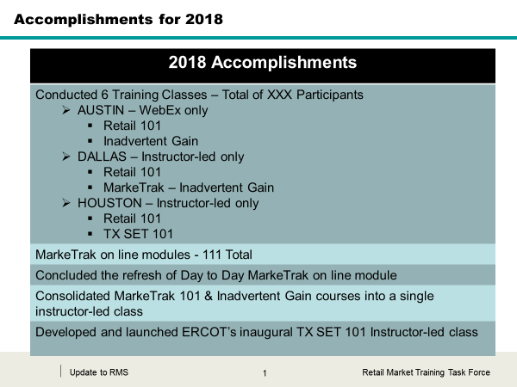
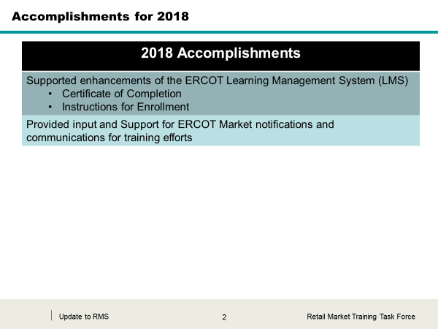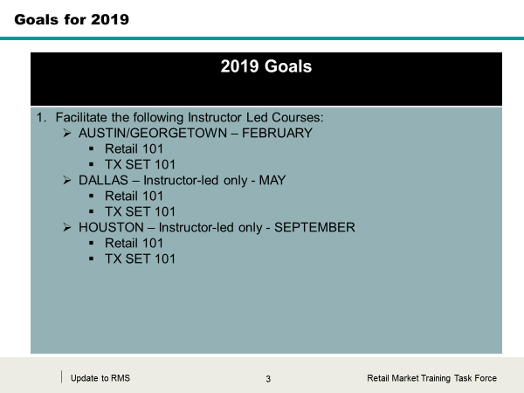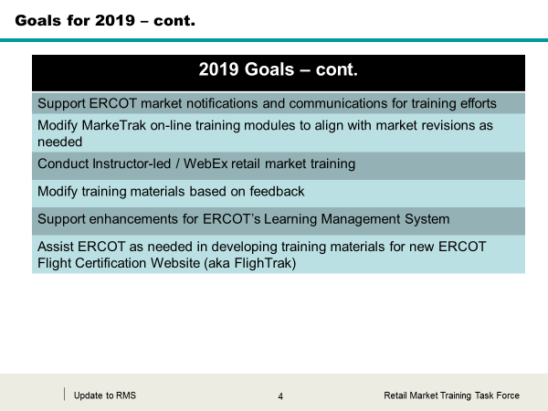

FUTURE TRAINING CONSIDERATIONS
- Mass Transition (POLR Event) on line module
- TXSET on line module
- FlighTrak Training
- MarkeTrak /IAG Training – WebEx only??

TXSET Training Deck Slide Additions
Draft slides were presented and modified as needed. Additional Solution to Stacking slides were not removed and will be considered at the next RMTTF meeting in January.
Some of the checkpoint questions were modified for clarity on REP A and REP B to Texans Energy and Cowboys Energy.

Meeting Dates for 2019
ACTION: Debbie will forward proposed meeting dates to ERCOT for scheduling.
Proposed Meeting Dates – RMTTF 2019
Date | Room Requested | Related info
Thursday, January 10 | 102 | MLK – Monday, January 21
Thursday, February 7 | 102
Thursday, March 7 | 102
Thursday, April 4 | 102 | Easter – Sunday, April 21
Friday, May 3 | Oncor EEC | Oncor, 1616 Woodall Rodgers Frwy. Dallas, TX 75202
Thursday, June 6 | 102
Thursday, July 11 | 102
Thursday, August 8 | 102
Thursday, September 5 | 102 | Labor Day – Monday, September 2nd
Thursday, October 3 | 102
Thursday, November 7 | 102
Thursday, December 5 | 102

PROPOSED AGENDA FOR JANUARY 10TH 2019
- Review logistics for February Georgetown training
- Finalize TXSET training deck
- Discuss RETAIL 101 revisions/clean-up
- Create Contact Sheet for training presenters in case of emergencies
- Discuss 2019 meeting dates

