NPRR850
25.5.1 | 25.5.1(1) – Suggest to add clarification that only (a) shall be settled and paid during Market Suspension. (b)-(h) will wait till after Market Restart.  25.5.1(2) – Suggest to remove (d)  25.5.1(6) – Suggest to reconcile with (1) and (2). Items currently listed in (6) are not a complete list.
25.5.2(1) | MSSUCADJ _{q,r,d} MSOCADJ _{q,r,d}  Need clarification on “Adjustment”, at least at high level:  - Adjustment for what? Amount difference based on actual verifiable costs? But adjustment based on verifiable costs is already covered by RVOMS and ROM.  - When to adjust? Will these variables be used in initial settlement, or only for payment reconciliation?
25.5.2(1) | MSAVGFP _{j} MSAVGFIP _{j} MSAVGFOP _{j}  What is j?
25.5.2(1) | Definition for t: Market Suspension Cost Guarantee is not defined.
25.5.5(2)(b) | One left parenthesis missing  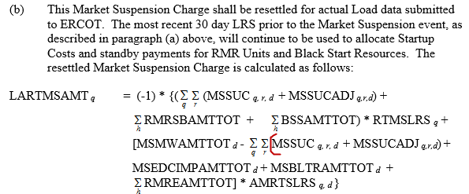
25.5.5(2)(a)  25.5.5(2)(b) | Instead of “The initial/resettled Market Suspension Charge is calculated as follows”, it should be “The initial/resettled Market Suspension Charge to each QSE for a given Operating Day during a Market Suspension event is calculated as follows”.
25.5.5(2)(b) | The Market Suspension Charge will be resettled for actual Load data submitted to ERCOT. ERCOT said they expect to have actual or TDSP estimated data for settlement. Suggest to add “or TDSP estimated Load data” the language.  Also, what if some actual load data never becomes available? (Out of MSWG scope)
25.5.5(2)(b) | The most recent 30 day LRS prior to the MS event will continue to be used to allocate Startup Costs and standby payments for RMR Units and Black Start Resources.  The market might have been functioning erroneously for some time before market suspension is declared. It might be problematic to use data from the most recent 30 days prior to the Market Suspension event. If the assumption is to use data from the most recent 30 good market days prior to Market Suspension, then there would be a gap between “∑d30” and the start of Market Suspension”, and protocol language should be provided for the settlement of that period. The definition of RTMSLRSq also needs to be revised to reflect a potential gap between “∑d30” and the start of “market suspension”.  Because we have a true up process for this and because charges are allocated on a load basis the expectation is we will have actual or TDSP estimated data for settlement. We should have good data but I’m not sure to what extent market issues would create load consumption issues (I’m sure none of us can think of all the possible scenarios). If we went with “good” days I think there would need to be a proposal and possibly some conversation in the stakeholder groups on how to define that period. If you want to bounce any language off of us we are happy to think about it

