
RIOO - Interconnection Services IE Guide
Version 1
11/30/2018

About this IE Guide
This guide provides information to assist Interconnection Entities (IEs) with performing tasks in the online Resource Integration and Ongoing Operations (RIOO) system that enables them to submit an Interconnection Request (INR) to create a new generation resource or an additional resource to an existing generation site as well as add Change Requests to modify your INR.
This guide also provides instructions for submitting Change Requests to:
- Submit the twice-a-year attestation (in February and August) that the resource registration data RARF is current.
- Declare water rights ownership
- Confirm that your project has met or will meet various Nodal protocols
- Request the Full Interconnection Study (FIS)
- Report a change of project ownership
- Manage contacts you have or want to add to your project in a backup or general capacity
- Cancel your requests
Contents
About ERCOT Interconnection Services 1
Accessing and Managing Your Interconnection Services Account 3
Logging into Your Account 3
Logging Out of Your Account 6
Changing Your Account Information 7
Changing Your Password 9
Resetting Your Forgotten Password 12
Creating an Interconnection Request 16
Completing the Interconnection Request Pages. 17
Reviewing Your Interconnection Request 26
Electronically Signing and Submitting Your Request 27
Corresponding with ERCOT About Your Request 30
Understanding Change Requests 33
Changing INR Details 35
Changing the Project Name 35
Changing the MWs 39
Changing the Project Dates 43
Attaching New Documents 47
Adding an Air Permit 51
Adding a Green House Gas Permit 55
Attesting that Your RARF is Current 59
Declaring Your Water Rights 64
Adding Confirmations 68
Confirming Study Mitigation Plans are Complete 68
Confirming the Voltage Regulations Are Met 72
Confirming the Primary Frequency Response Capablity 75
Confirming that the Power System Stabilizer is In Service 78
Confirming Breaker Interruption Capability 81
Confirming Subsyschronous Resonance Mitigation 85
Confirming the Phase Measurement Unit Installation 88
Requesting an FIS 92
Reporting a Change of Ownership 99
Managing the Contacts On Your Project 105
Viewing Project Contacts 105
Inviting New Contacts or Backups 106
Editing Contact Information 108
Removing a Contact from the Project 110
Canceling INRs and Change Requests 111
Index 114

About ERCOT Interconnection Services
ERCOT Interconnection Services enables you, as an Interconnection Entity, to create an interconnection request (referred to as an INR) for a new generation resource project, submit it to ERCOT online, and then modify it as necessary using Change Requests .
You must first sign up for Interconnection Services using the ERCOT Interconnection Services website and your mobile smartphone or SMS text-enabled phone.
After you have signed up, you can log in to your Interconnection Request List.
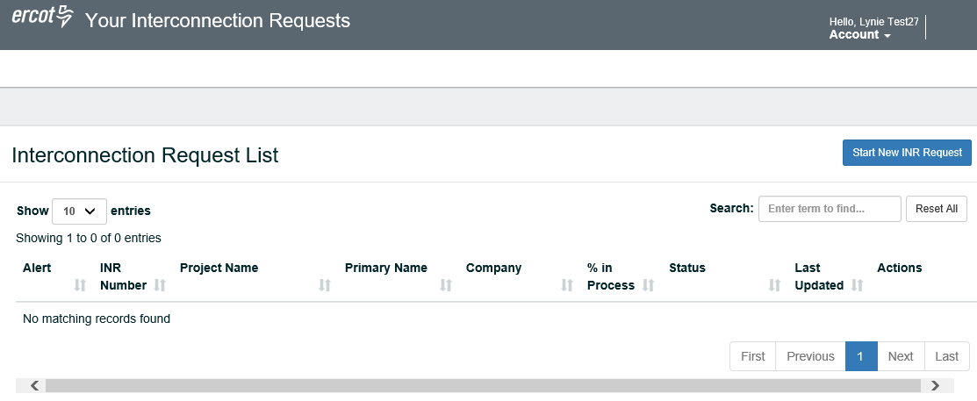
When you submit the INR, ERCOT will review your request and work with you to be sure all of the required information for creating the new resource (or a new addition to an existing one) is complete. If UD displays in the Alerts column of your INR, ERCOT has sent a message to you and needs you to update details in your INR.
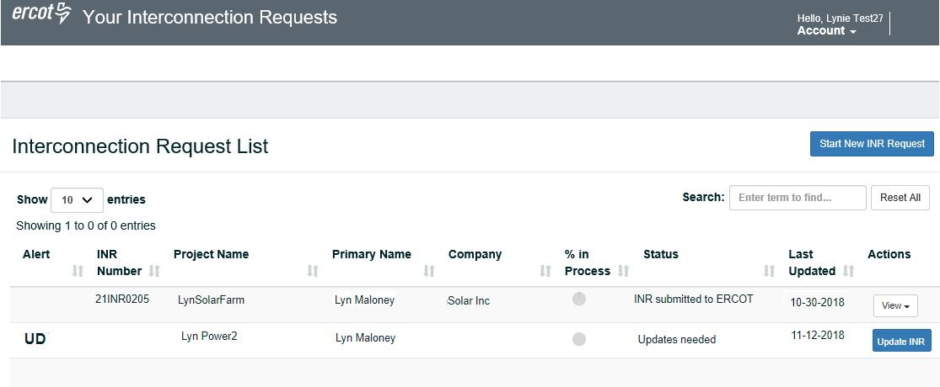
After ERCOT processes your request, the INR displays in your list with Add Change Request in the Actions column. You can use this Add Change Request action to:
Change INR details (Project Name, MWs, Dates)
Attach new documents
Add an Air Permit or Green House Gas permit
Add the required bi-annual attestations (during the month of February and then again the month of August) that your resource data RARF is current
Add your water rights declaration
Confirm study mitigation plans are complete
Confirm the voltage regulations are met
Confirm the primary frequency response capablity
Confirm that the Power System Stabilizer is in service
Confirm breaker interruption capability
Confirm Subsyschronous Resonance (SRS) mitigation
Confirm the Phase Measurement Unit installation
Request an FIS if you plan to go forward with your project
Let ERCOT know if you change ownership
The Manage Account action enables you to make changes your name, email address, or telephone information if changes occur. You can also change your password, which is stored in your Account information.
To return to the Interconnection Request List page from any Interconnection Services page, click at the top of the page.

Accessing and Managing Your Interconnection Services Account
Accessing your account involves logging into your Interconnection Request List with the login credentials you created when you signed in or that you have modified since sign up. You can modify modify your first and last name, the email address, telephone number, and password associated with your account.

Logging into Your Account
When you log into your account, an authentication code page may display if you did not check the Remember this browser checkbox the last time you logged in (or 30 days have passed since your last login). Follow the directions for authentication and then click the Remember this browser checkbox to prevent this from displaying for the next 30 days.

Log In Page
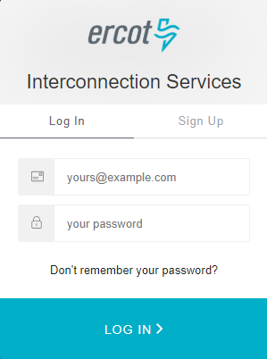
Type in the password associated with this account..
Type in the email address you entered when you signed up for the account.
Click the LOG IN > button.
The next action depends on the authentication method you are using for sign in:
For Auth0 Guardian, refer to the next page.
For Google Authenticator, refer to page 5.
For SMS Text Messaging, refer to page 6.

Auth0 Guardian Authentication Page
Go to the Guardian text message on your phone and swipe to open the message.
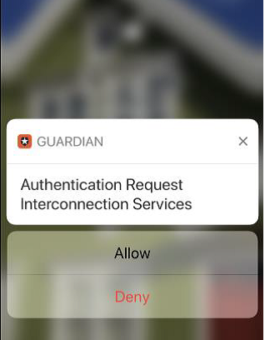
Tap the Allow button.

Interconnection Request List Page
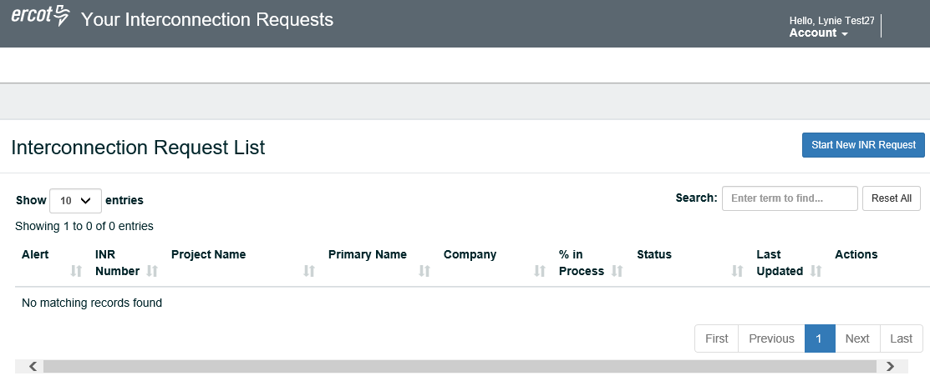

Google Authenticator Authentication Page
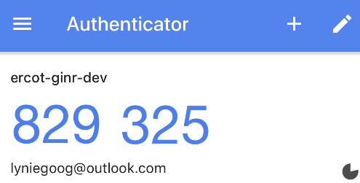
Go to your mobile phone and open Authenticator.
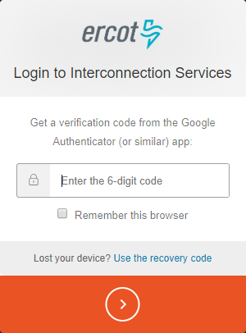
Type in the 6 numbers of your new code.
Click this Remember this browser checkbox to avoid having to do this every time you log in.
Click  to continue to the Interconnection Request List page.

Interconnection Request List Page

SMS Authentication Page
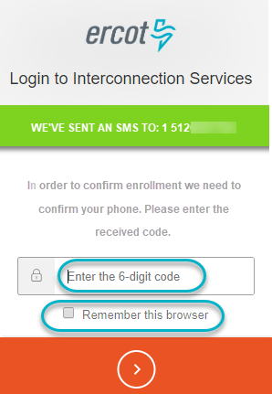
Go to your mobile phone and open the new authentication message.
Type in the 6 numbers of your new code.
Click this checkbox to avoid having to do this when you log in for the next 30 days.
Click to continue to the Interconnection Request List page.

Interconnection Request List Page

Logging Out of Your Account
You should log out of your account when you are finished performing tasks.

Your Interconnection Requests Page
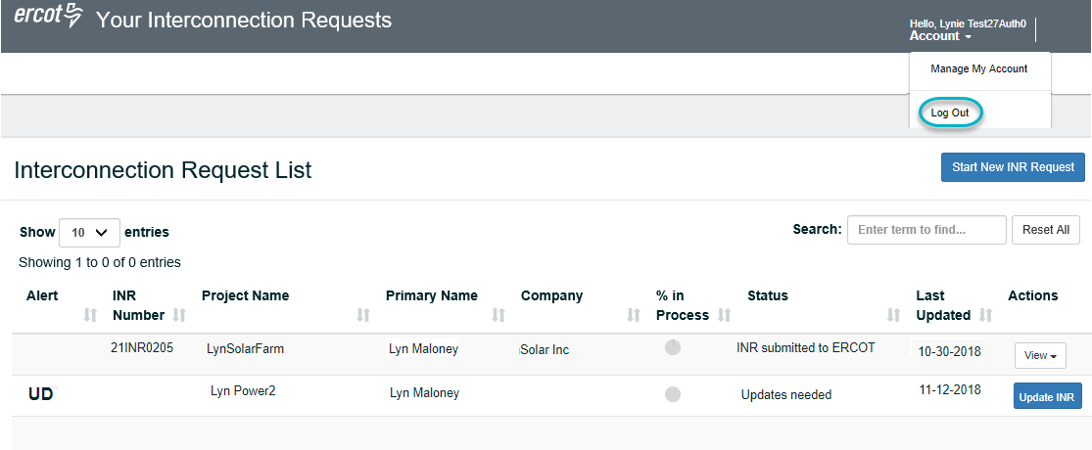
Locate the Account dropdown in the upper right of Your Interconnection Requests page.
Click the Account dropdown and click Log Out.

Changing Your Account Information
You can update your account to modify your information associated with your account, such as your email address and phone number.

Interconnection Requests Page
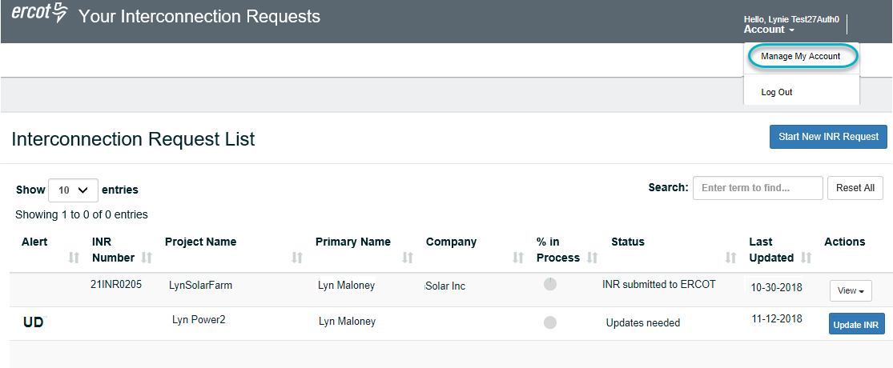
Locate the Account dropdown in the upper right corner of the Interconnection Requests page.
Click the Account dropdown on the upper right side of the page and click Manage My Account.

Your personal information Page
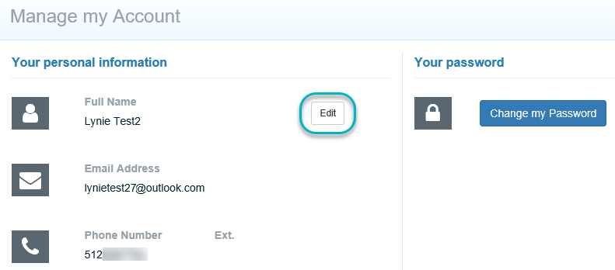
Click the Edit button.

Edit My Account Page
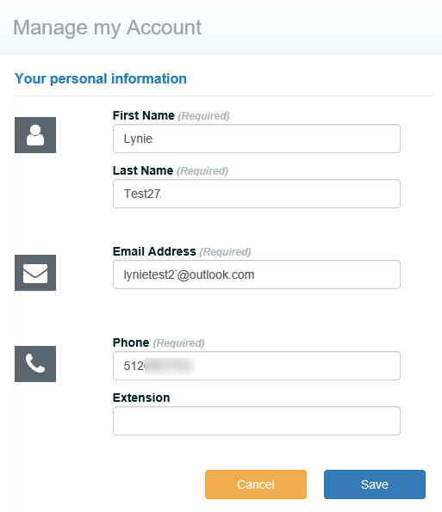
Make your changes.
Click the Save button.

Changing Your Password
When you request a password change, ERCOT sends you an email to confirm the change.

Interconnection Requests Page
Locate the Account dropdown in the upper right corner of the Interconnection Requests page.
Click the Account dropdown on the upper right side of the page and click Manage My Account.

Manage Account Page
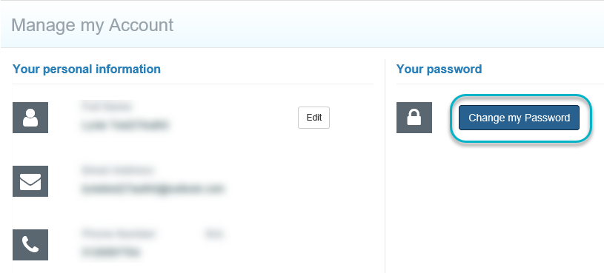
Click the Change my Password button.

Password Change Request Email Message
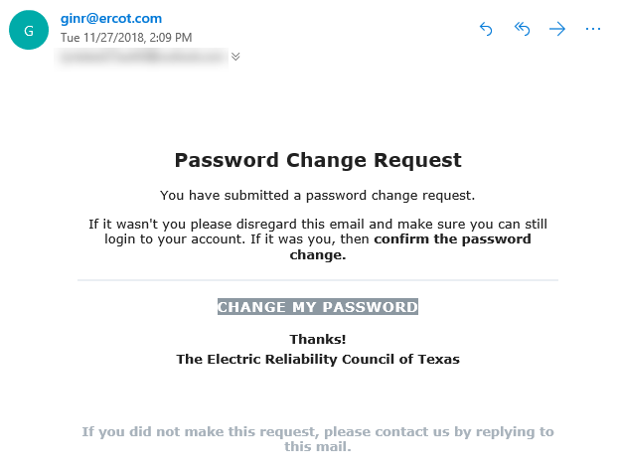
Go to your email and open the email message with Reset your Password from ercot.com.
Click the CHANGE MY PASSWORD button.

Change Password Page
Type in your new password.
Type in your new password again.
Click the Continue button.
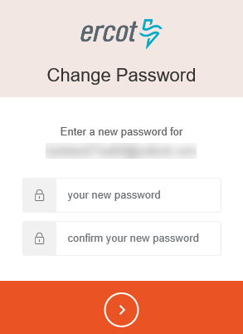

Success Page
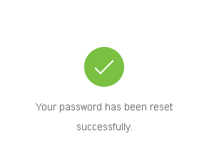

To close this page and return to the Interconnection Request List, click the link in this message or the logo at the top left of the page.

Resetting Your Forgotten Password
If you have forgotten your password, you can request to reset it.

Interconnection Services Login Page
Click the Don’t remember your password? link.

Reset Your Password Page
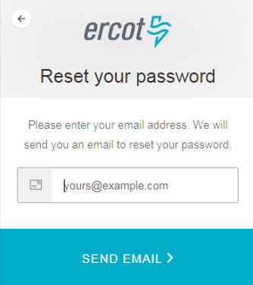
Click the SEND EMAIL > button.
Type in the email address associated with this account.

Password Change Request Email Message
Go to your email and open the email message with Reset your Password from ercot.com.
Click the CHANGE MY PASSWORD button.

Change Password Page
Click the Continue button.
Type in your new password again.
Type in your new password.

Success Page

To close this page and return to the Interconnection Request List, click the link in this message or the logo at the top left of the page.

Creating an Interconnection Request
Creating an INR for a new generation project involves starting the request by identifying details about your generation project and when, where, and who will be involved with it.
After you complete the appropriate web pages and upload required information files, you are prompted to review the information you put in your INR and make any necessary edits required to submit it.
The request is automatically saved even if you do not finish it. You can return to the Interconnection Request List and finish the request before submitting it.
When you have completed the section, the Generation Entity Information page displays for you to read and electronically sign before the Payment page displays. After following the instructions on the Payment page, you can submit your request.
The new request is displayed on your Interconnection Request List with View in the Actions column (or Finish INR if you have not submitted it).
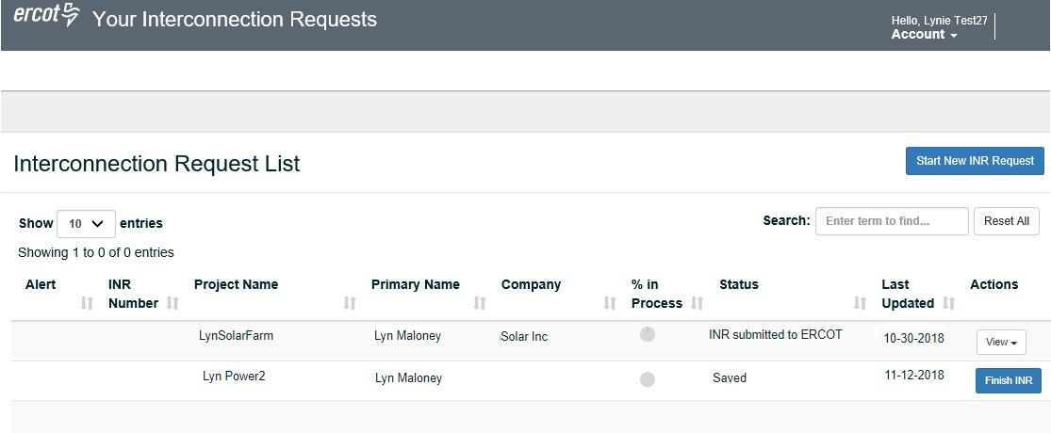
After you submit the request, ERCOT will review it and may start corresponding with you about modifications to various items before the request is considered complete. ERCOT will send you an email when your request application is complete and the Add Change request button will display in the Actions column of your INR.
To modify details or add new information after ERCOT has processed your rquest, you must submit change requests to the INR. For more information, refer to page 35.

Completing the Interconnection Request Pages.
A series of seven web pages display for gathering project information, like if your project is for a new generation site or adding generation to an existing site; if you want to move forward with a Full Interconnection Study now, the MWs of your resource. You will also identify where you plan to locate the resource and who will be working with you on the project.

Your Account Page
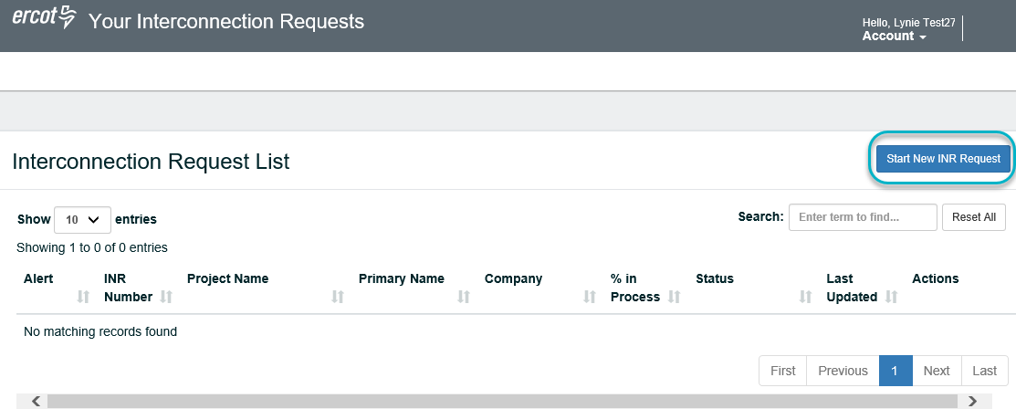
Click the Start New INR Request button.

Welcome Page
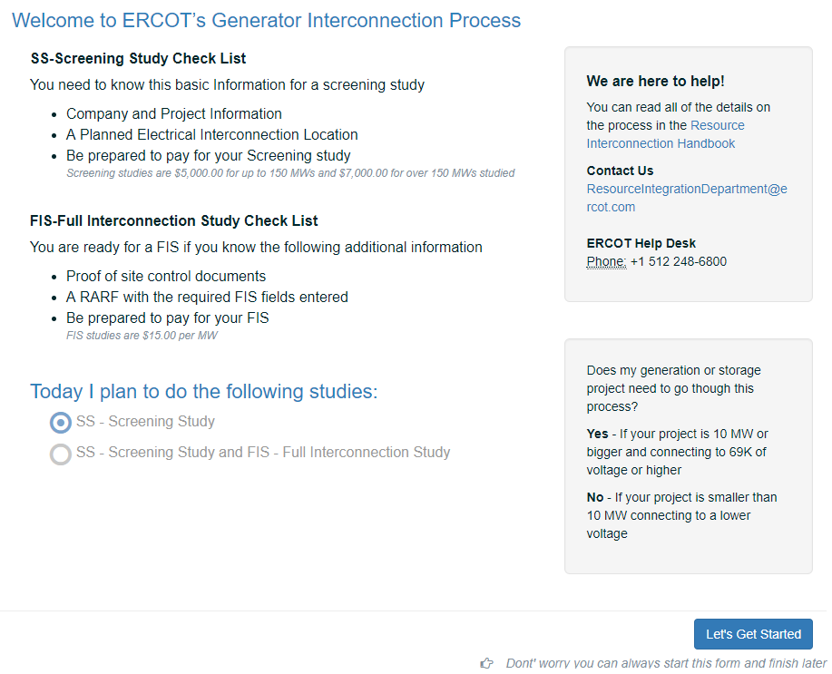
Leave SS - Screening Study selected.
Or, click the SS -Screening Study and FIS – Full Interconnection Study option if appropriate.
Scroll to the bottom of the page and click the Let’s Get Started button.

General Information Page
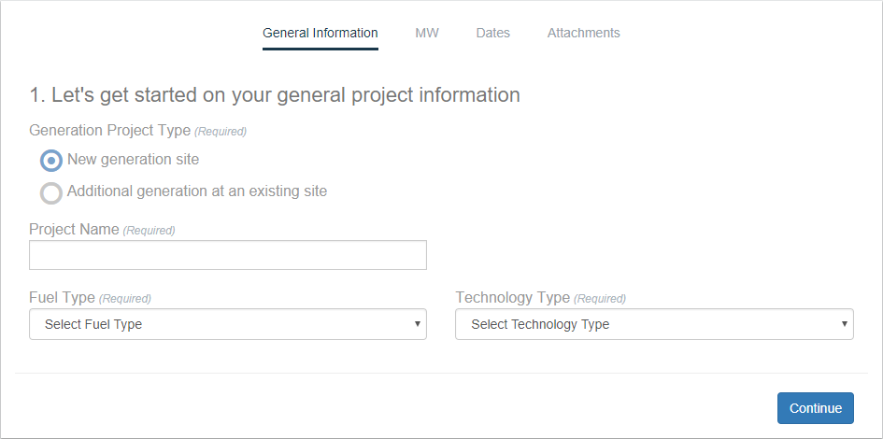
Leave the New generation site selected
Or, Click the Additional generation at an existing site option.
Type in the name of your project as you want it to appear in all your documentation. This name must be unique across the ERCOT ISO grid.
Click the Fuel Type dropdown and select the type of fuel that will be used at your project.
Click the Technolody Type dropdown and select the appropriate option for your project.
Click the Continue button.

MW Page
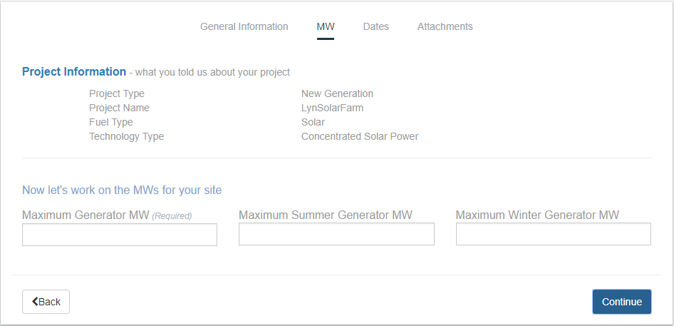
Type in the maximum MWs for the generator. The number must be less than 10,000.
Type in the MWs for summer time, which cannot exceed the overall MWs.
Type in the MWs for the generator for winter, which cannot exceed the overall MWs
Click the Continue button.

Project Dates Page
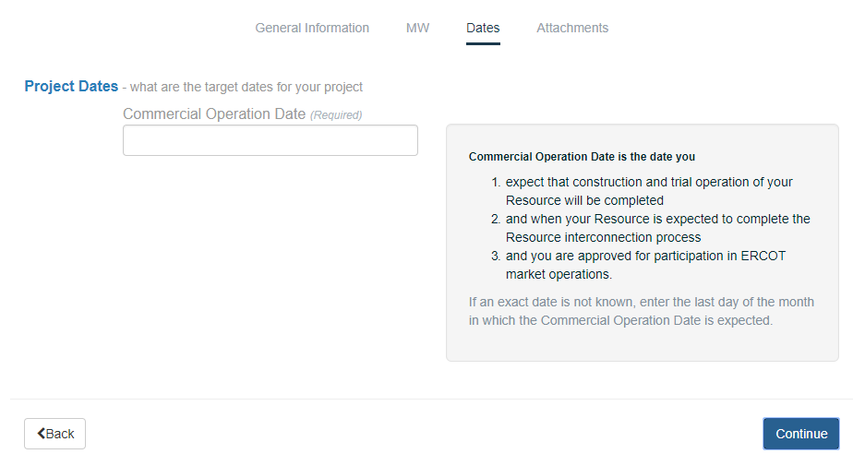
Type in the mm-dd-yy of your commercial operation date when the resource will go live.
Depending on the type of technology of this resource, you must plan at least 15 months from starting point to completion. If you do not know the exact day, use the last day of the month you are targeting.
Click the Continue button.

Attachments Page
If you selected the SS and FIS option, the message will display with more required attachments:
A RARF with FIS related fields completed
A one-line
Site Control documents
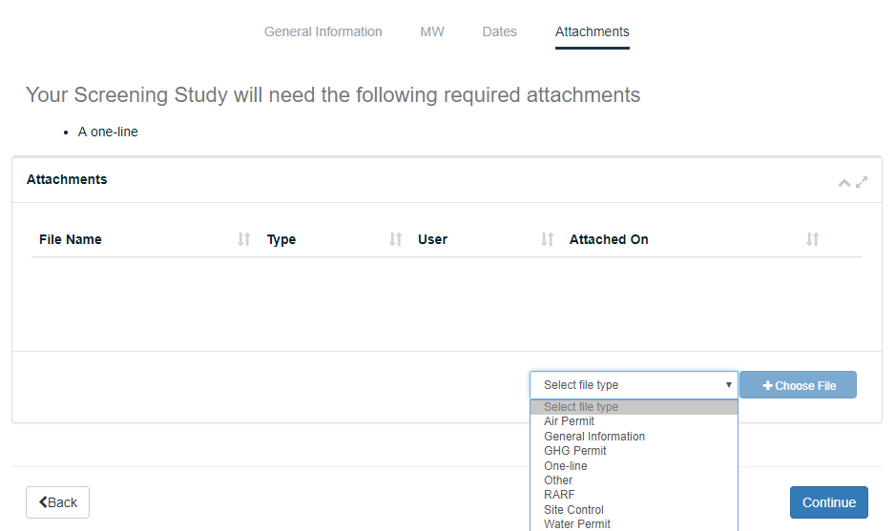
Click the Select file type dropdown and click the type of file you plan to upload.
Click the +Choose File button, navigate to the file on your computer, and click the file.
Repeat the steps above for each file you want to upload.
When you are finished, click the Continue button.
Just uploaded the wrong file? Use the trash can icon to remove it.

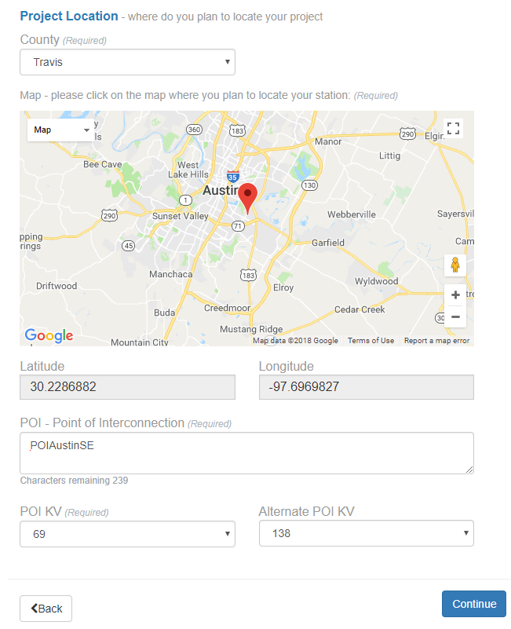
Location Page

This map displays after you select the county.
To locate a specific area, click:
to expand the map to view more of the state
to zoom in to view more street detail in the area
When you are finished, click to return the map to its original size.

Click the County dropdown and select the county where your resource will be located.
When the map displays, click the map where your resource will be located to drop a pin.
The lattitude and longitude are automatically populated based on your pin drop.
Type a description that identifies where your resource will interconnect with the grid.
Click the POI KV dropdown and select the primary kilovolt level for this point of interconnection.
If you listed a second POI, click the Alternate POI KV dropdown and select the kilovolts for the second POI interconnection
Click the Continue button.

Company and Invite Page
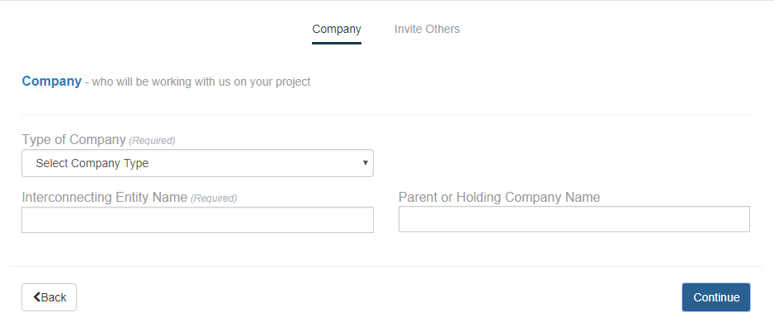
Click the Type of company dropdown and select LLC or Other.
Type in your name as the Interconnecting Entity.
If you selected the LLC option in Step 2, type in the name of your parent or holding company.
Click the Continue button.

Invite Others Page
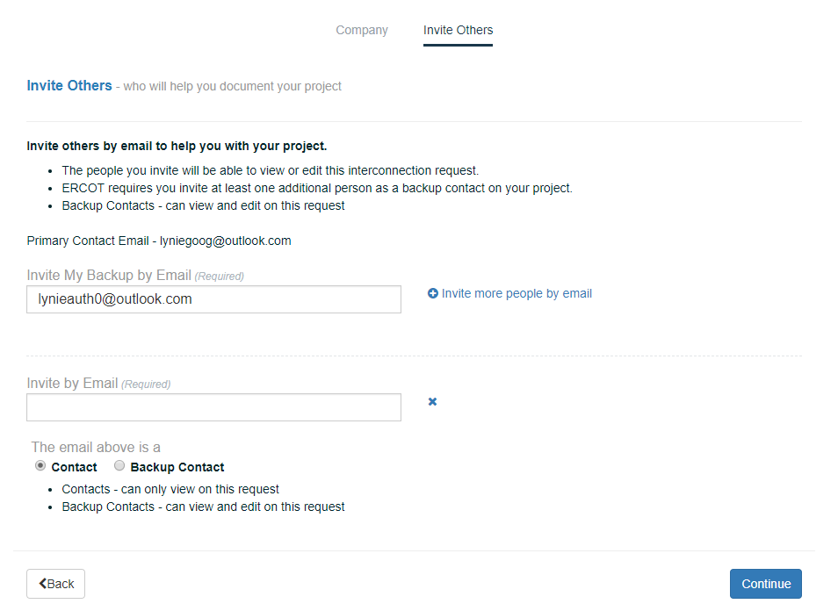
At the top of the page, click the Invite Others link.
Type in the email address of a person in your company who is the backup to work with your interconnection request. This Backup will receive an email with instructions on how to sign in and create an Interconnection Services account.
Click the + Invite more people by email link to display fields where you can add more contacts who can view or work with the request.
Type in the email address of the person to invite to serve as a contact for this request and click the appropriate Contact or Backup Contact option for this person.
To add another person, click repeat Step 3 and Step 4.
When you are finished adding contacts, click the Continue button.

Reviewing Your Interconnection Request
The review page displays after you finish identifying your Backup contact or contacts.
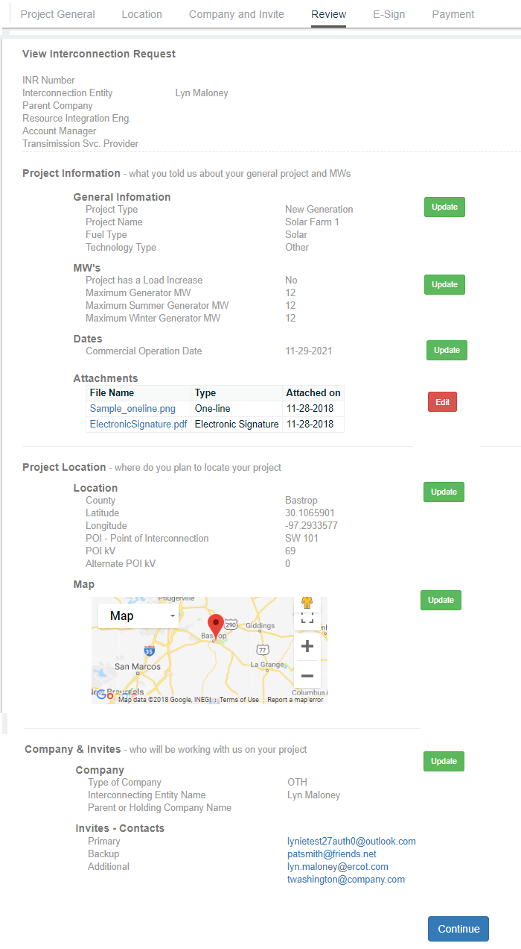
When you are finished, scroll to the bottom of the page and click the Continue button.
Click the Edit button of a sction to go back and make any required edits.

Electronically Signing and Submitting Your Request
You must carefully read through the information in the Generation Entity Information page about becoming an eligible power transmission provider customer and agreeing to provide ERCOT with the most current data as well as agreeing to comply with all regulations. After electronically signing the page, the Payment Page is displayed and you can submit your INR to ERCOT for processing.
If you have opted to have the FIS performed during the initial request along with the Screening Study, the Department of Defense (DoD) Notification is displayed before the Payment and Submission page.

Generation Entity Information Page
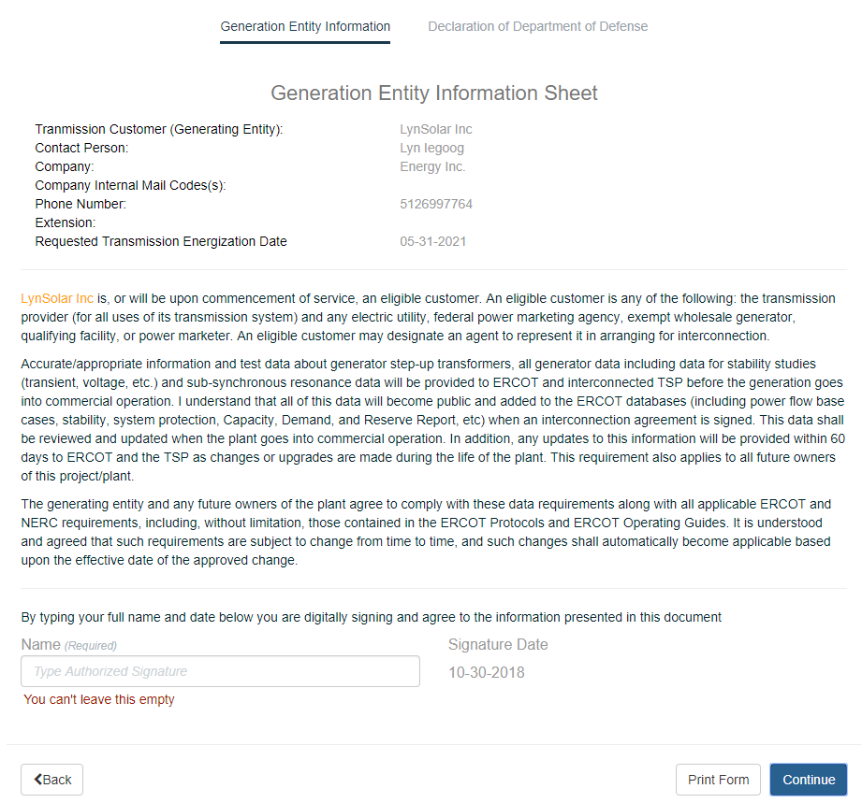
After reading the page, type in your authorized signature.
Click the Continue button.

Department of Defense Notification Page
Displays only if you indicated you wanted to perform the FIS with the Screening Study.
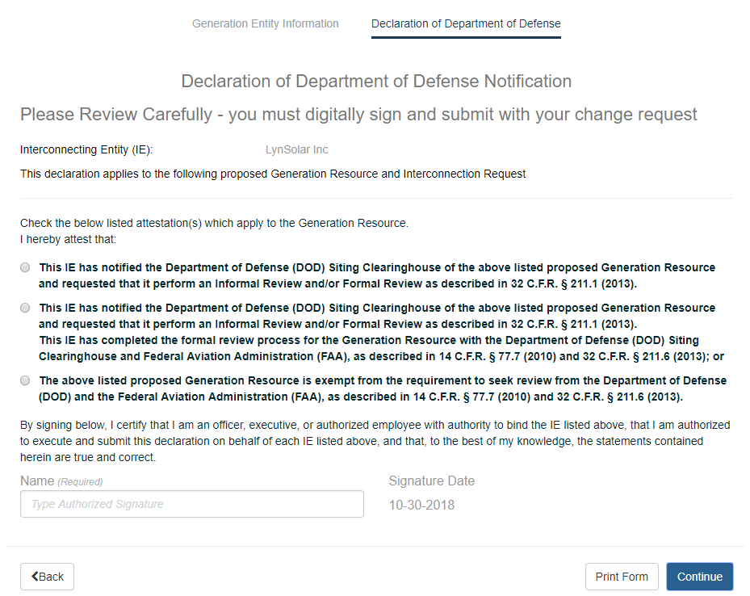
After reading the page, type in your authorized signature.
Click the Continue button.

Payment Instructions Page
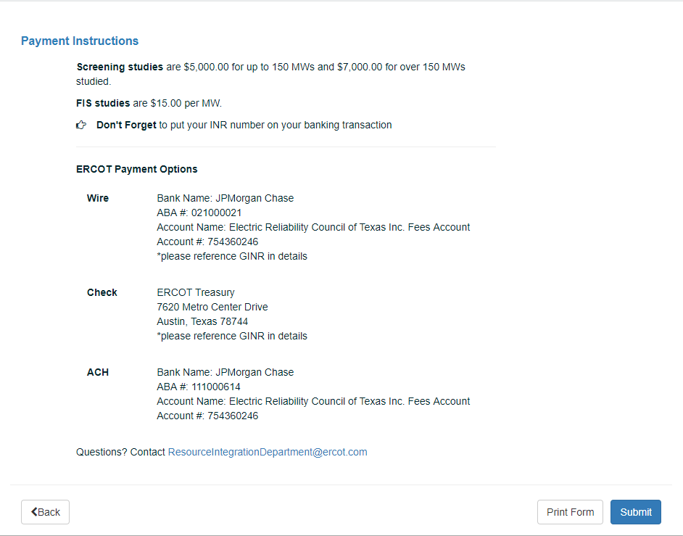
Click the Submit button.

Your Interconnection List Page
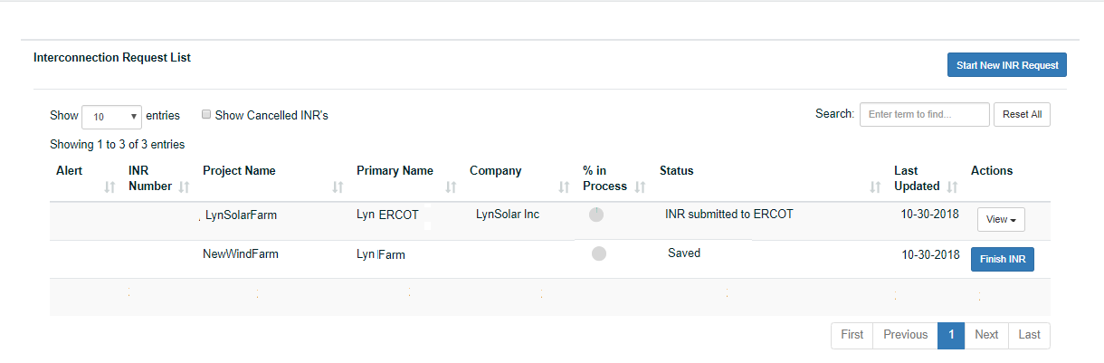
The request you just submitted displays with View in the Actions column. ERCOT may contact you within the next 10 days for any problems with it. Once the INR is processed and all information is correct, your Screening Study will begin and the Status changes to In Progress. ERCOT will send an email confirming your completed request.

Corresponding with ERCOT About Your Request
While ERCOT is reviewing your initial request, they may have questions or comments about it and will contact you with an Alert message you can open from your Interconnection List page. When ERCOT is satisfied all the information is correct, they will send an you an email confirming that your request application is complete. In Interconnection Request List, the Add Change Request button displays in the Actions column of your request.
The INR Number is important as you will need to use this INR Number in all correspondence about your project, including inserting it into the Subject line of any email.

Your Interconnection Request List Page
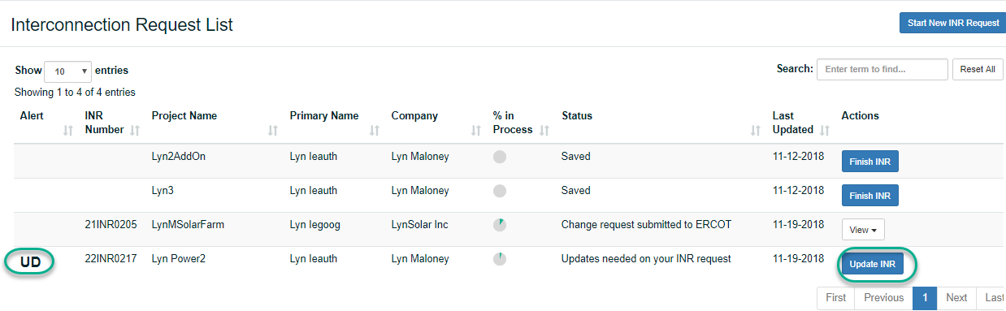
Locate the request with UD in the Alert column and click the corresponding Update INR button.

Welcome Panel
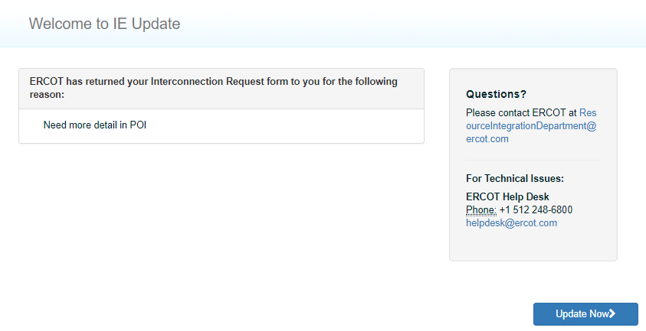
After reading the message, click the Update Now button to put the modified information into your request.

View Interconnection Request Page
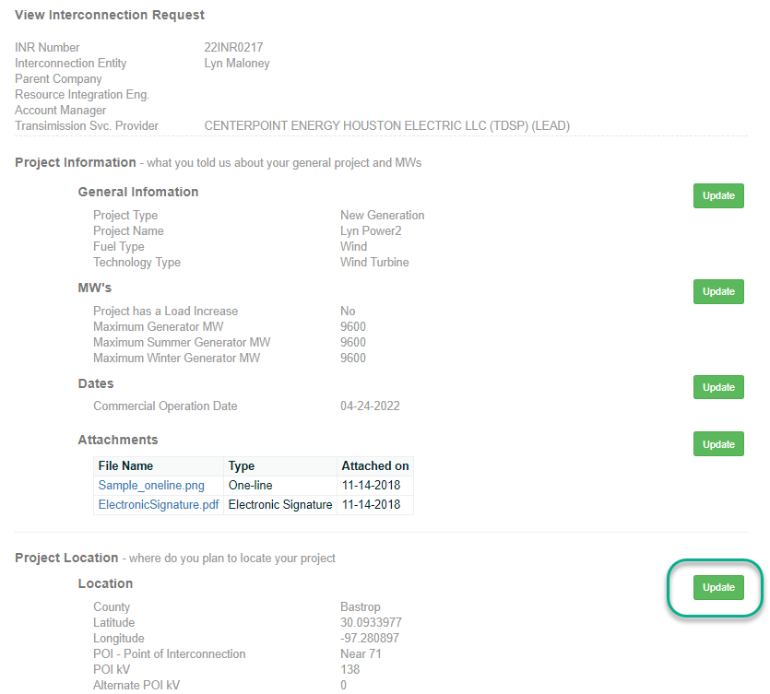
Locate the section containing the information requested and click the Update button.
After making the update, click the Continue button.
If the Generation Entity Information page displays (or other page directly connected to a change made displays), click the Continue button again.

Understanding Change Requests
To update your INR, you must add a change request to the original request in your Interconnection Request list. The types of changes are grouped in three main categories.
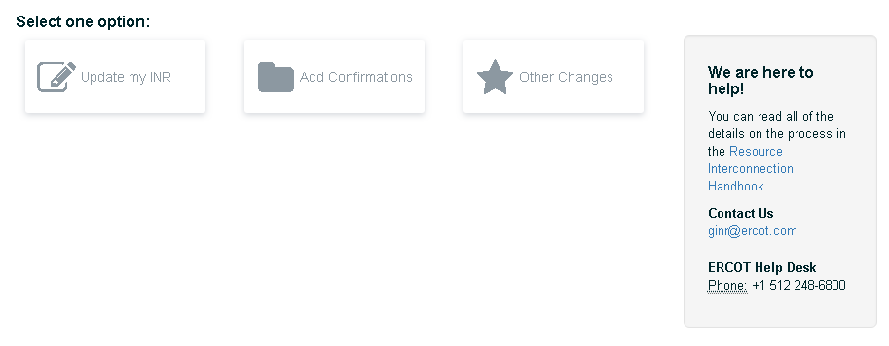
Update my INR enables you to:
- Change project details the project name, the resource MWs, and the energization, synchronization, and completion (COD) dates.
- Attach new or updated documents (like studies and updated one-lines)
- Add an air permit or greenhouse gas permit
- Submit your water rights declaration that says you have secured sufficient water to power your plant
- Make your semi-annual attestation that your project information is current.
Add confirmations enables you to electronically sign that:
- Mitigation plans for system improvements identified in the FIS and Reactive Power Study are complete
- Dynamic voltage regulation and Automatic Voltage Regulators (AVRs) will be installed as required
- The resource will be capable of Primary Frequency Response
- The resource will have a Power System Stabilizer (PSS) in service
- The interrupting capability of the main breaker on the high side of the generator step up unit transformer
- Any required subsyschronouse Resounance (SRS) mitigation equipment will be functional prior to intial Synchronozation
- The phase measurement unit (PMU) will be installed
 Other Changes enable you to:
- Request an FIS
- Report a change of ownership
When you select one of the 3 main option buttons, a green checkmark to confirm your selection.
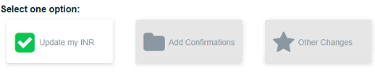
You can select as many changes as you need. Each selection is confirmed with a green checkmark.
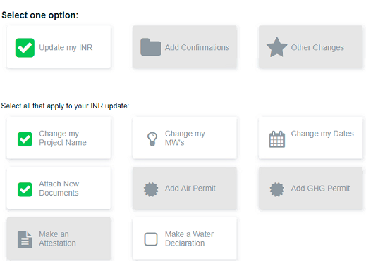
The change request navigation guides you through the process by displaying web pages with information for you to complete. When you have completed supplying required information, a review page displays with any areas that may need updates before you can submit your request.

Changing INR Details
You can change project details that you originally entered on your INR and attach updated or new documents, including permits for air and greenhouse gas (GHG).
To change project ownership, refer to Reporting a Change of Ownership on page 99.
You can select more than one option to have the appropriate option page display before the Review and Finish page and avoid starting over. For example, if you select to change project dates and add a greenhouse gas permit, the GHG page displays immediately after the Project Dates page.

Changing the Project Name
You can add a Change Request to modify or change the name of your project. Remember that project names must be unique across ERCOT.

Interconnection Request List Page
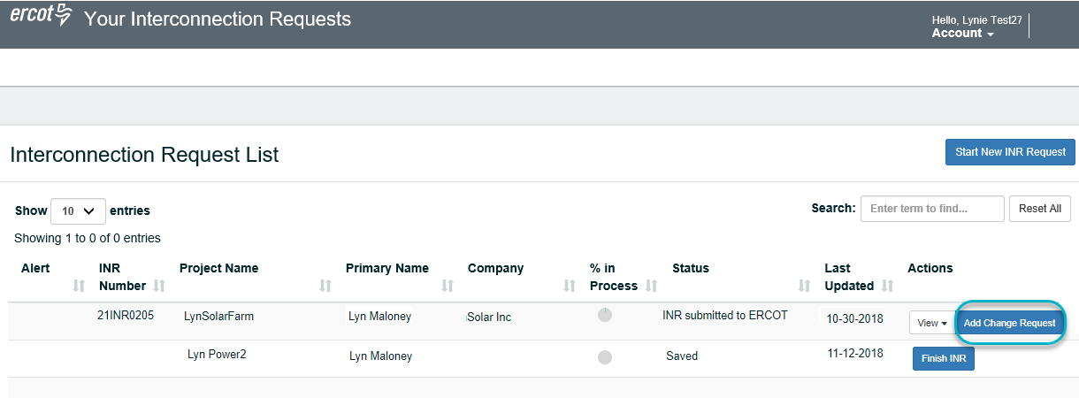
Click the Add Change Request button.

Add a Change Request Page
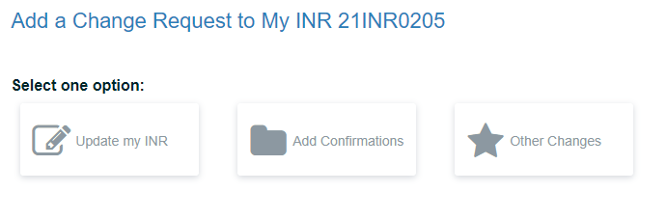
Click the Update My INR button. The page expands with the appropriate options.

Add a Change Request Page With Options
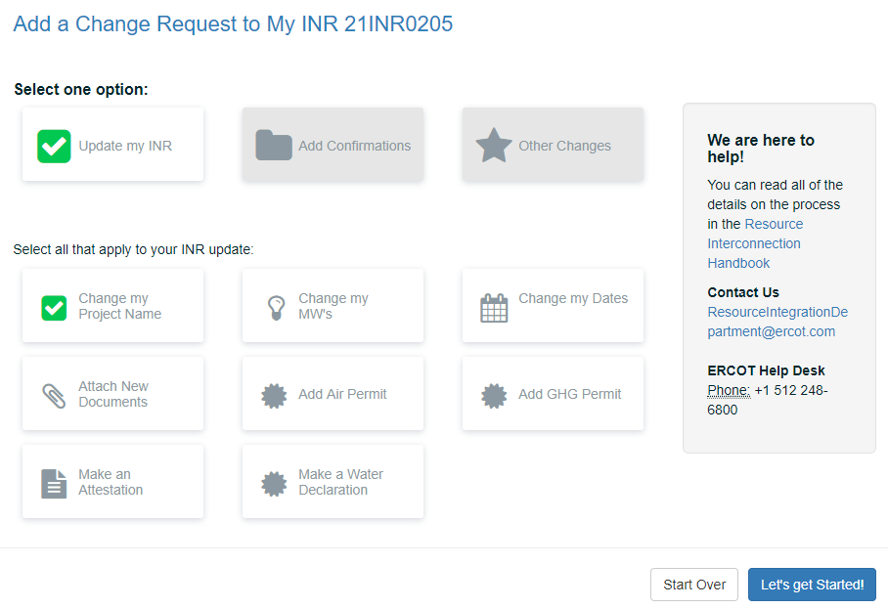
Click the Change my Project Name button and then click the Let’s get Started button.

Project Information Page
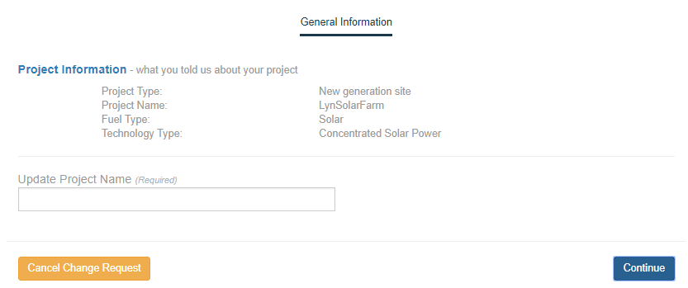
Type in your new or modified project name.
Remember that the project name must be unique across ERCOT.
Click the Continue button.
The Review and Finish your changes page displays next unless you have clicked multiple Change My INR options. If you also clicked the:
Change my MWs option, the MWs page on page 41 displays.
Changing the project dates,the Project Dates page on page 45 displays.
Attaching new documents,the Attach Document page on page 49 displays.
Adding an Air permit, the Air Permit page on page 53 displays.
Adding a GHG permit, the GHG Permit page on page 57 displays.
After you complete the options page, then a Review and Finish your changes page displays with all of the options you have changed listed.

Review and Finish your changes Page
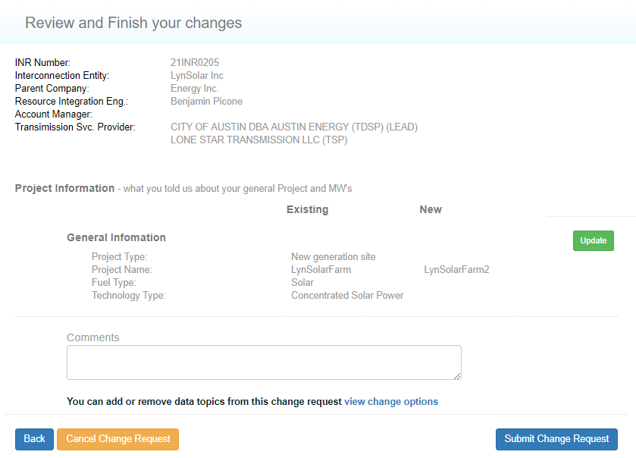
Click the Submit Change Request button.

Change Request Successfully Sent Message
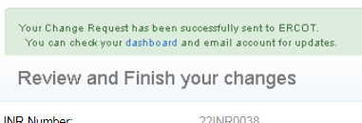
To close this page and return to the Interconnection Request List, click the link in this message or the logo at the top left of the page.

Changing the MWs
You can change the number of megawatts (MWs) you originally entered up to 20% of the amount you originally entered on your INR. If you change your summer or winter MWs, they cannot exeed 20% of the original and the overall MWs.

Interconnection Request List Page
Click the Add Change Request button.

Add a Change Request Page
Click the Update My INR button. The page expands with the appropriate options.

Add a Change Request Page With Options
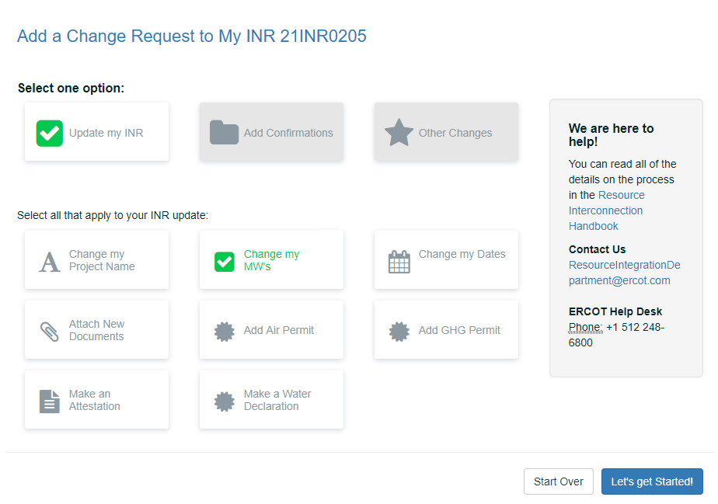
Click the Change my Project Name button and then click the Let’s get Started button.

MWs Page
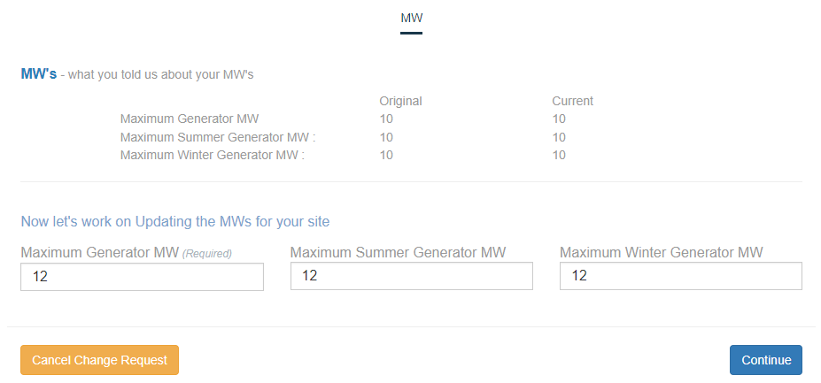
Make your changes.
Reminders:
The maximum value cannot be greater than 20% more than original displayed here.
MW must be less than 10,000.
Summer MWs and Winter MWs cannot exceed overall MWs.
Click the Continue button.
The Review and Finish your changes page displays next unless you have clicked multiple Change My INR options. If you also clicked the:
Changing the project dates, the Project Dates page on page 45 displays.
Attaching new documents, the Attach Document page on page 49 displays.
Adding an Air permit, the Air Permit page on page 53 displays.
Adding a GHG permit, the GHG Permit page on page 57 displays.
After you complete the options page, then a Review and Finish your changes page displays with all of the options you have changed listed.

Review and Finish your changes Page
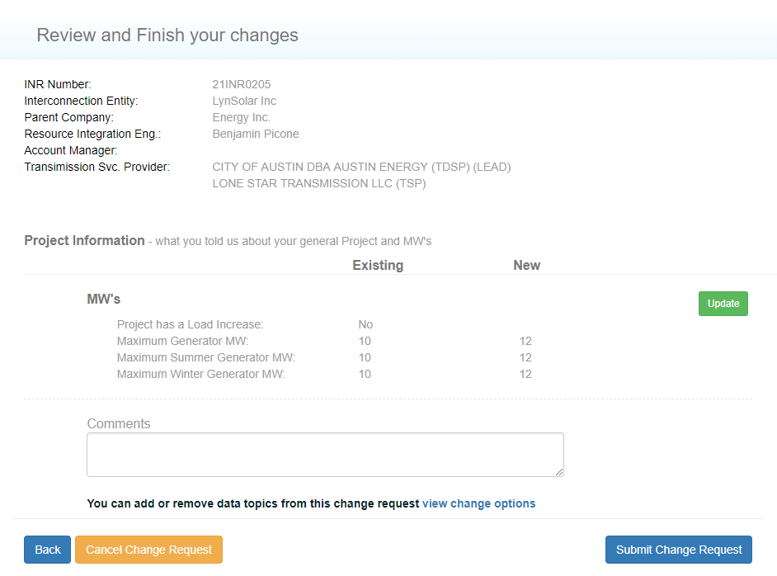
Click the Submit Change Request button.

Change Request Successfully Sent Message
To close this page and return to the Interconnection Request List, click the link in this message or the logo at the top left of the page.

Changing the Project Dates
You can change your original Commercial Operation date (COD) as well as the Energenization and Synchronization dates, or add them if you did not in your original request.
The dates must be in the order shown on the page. The Energization date must be at least 130 days before the COD and 10 days before the Synchronization date. The Synchronization date must be at least 10 days after the Energization date and 120 days before the COD.
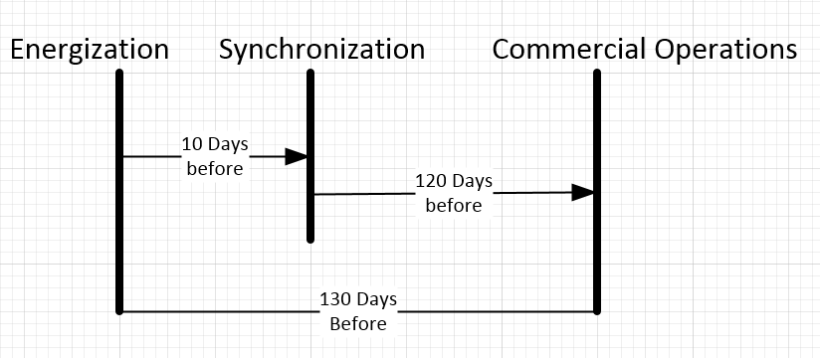

Interconnection Request List Page
Click the Add Change Request button.

Add a Change Request Page
Click the Update My INR button. The page expands with the appropriate options.

Add a Change Request Page With Options
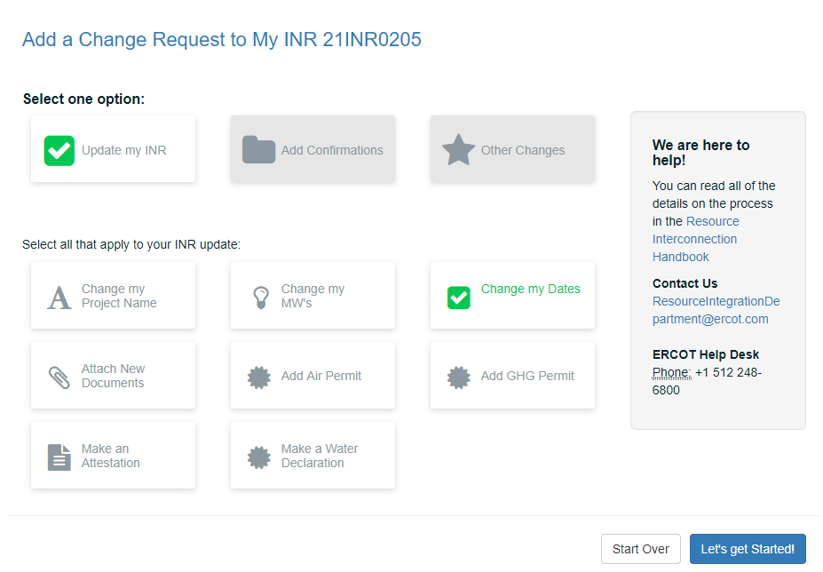
Click the Change my Dates button and then click the Let’s get Started button.

Project Dates Page
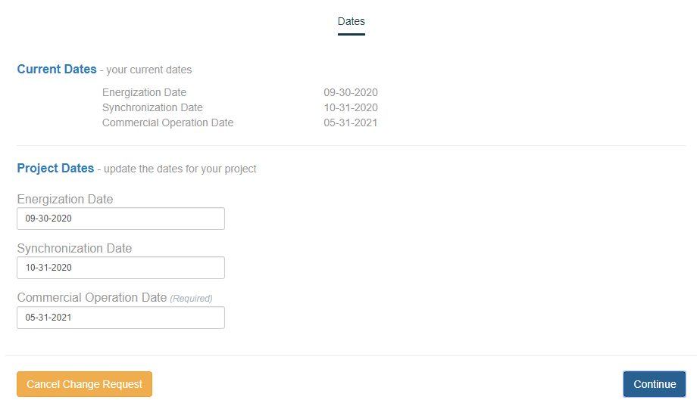
Type in your changes.
Click the Continue button

The Review and Finish your changes page displays next unless you have clicked multiple Change My INR options. If you also clicked the:
Attaching new documents, the Attach Document page on page 49 displays.
Adding an Air permit, the Air Permit page on page 53 displays.
Adding a GHG permit, the GHG Permit page on page 57 displays.
After you complete the options page, then a Review and Finish your changes page displays with all of the options you have changed listed.

Review and Finish your changes Page
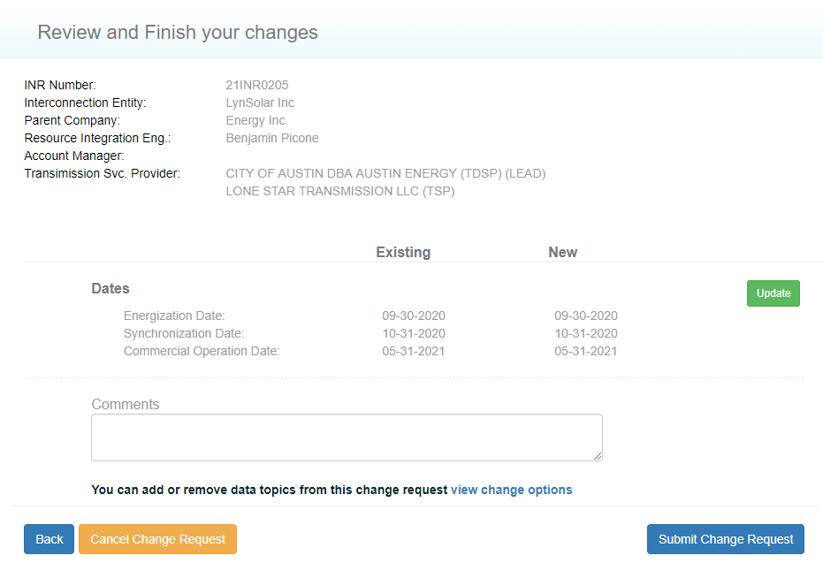
Click the Submit Change Request button.

Change Request Successfully Sent Message
To close this page and return to the Interconnection Request List, click the link in this message or the logo at the top left of the page.

Attaching New Documents
When you created your Interconnection Request, you were required to upload certain documents. You can upload modified versions of the documents plus any other documents your project needs.

Interconnection Request List Page
Click the Add Change Request button.

Add a Change Request Page
Click the Update My INR button. The page expands with the appropriate options.

Add a Change Request Page With Options
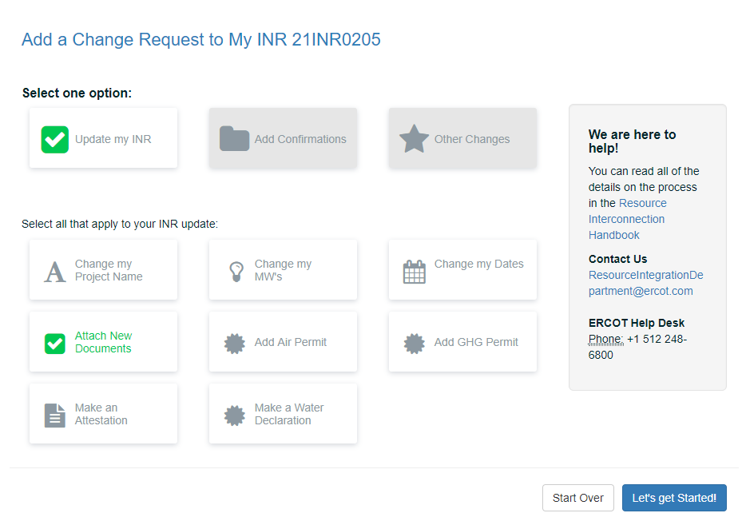
Click the Attach New Documents button and then click the Let’s get Started button.

Attachments Page
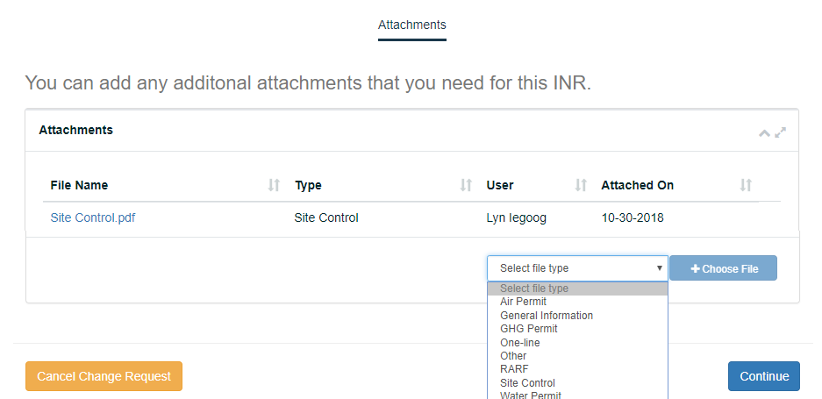
Click the Select file type dropdown and click the type of file you plan to upload.
Click the Choose File button and navigate to the file on your computer.
Repeat the steps above for each file you want to upload.
Click the Continue button.
Uploaded the wrong file? Use the Delete button to remove it.
Need to delete a submitted document? You can contact ERCOT at ginr@ercot.com

The Review and Finish your changes page displays next unless you have clicked multiple Change My INR options. If you also clicked the:
Adding an Air permit, the Air Permit page on page 53 displays.
Adding a GHG permit, the GHG Permit page on page 57 displays.
After you complete the options page, then a Review and Finish your changes page displays with all of the options you have changed listed.

Review and Finish your changes Page
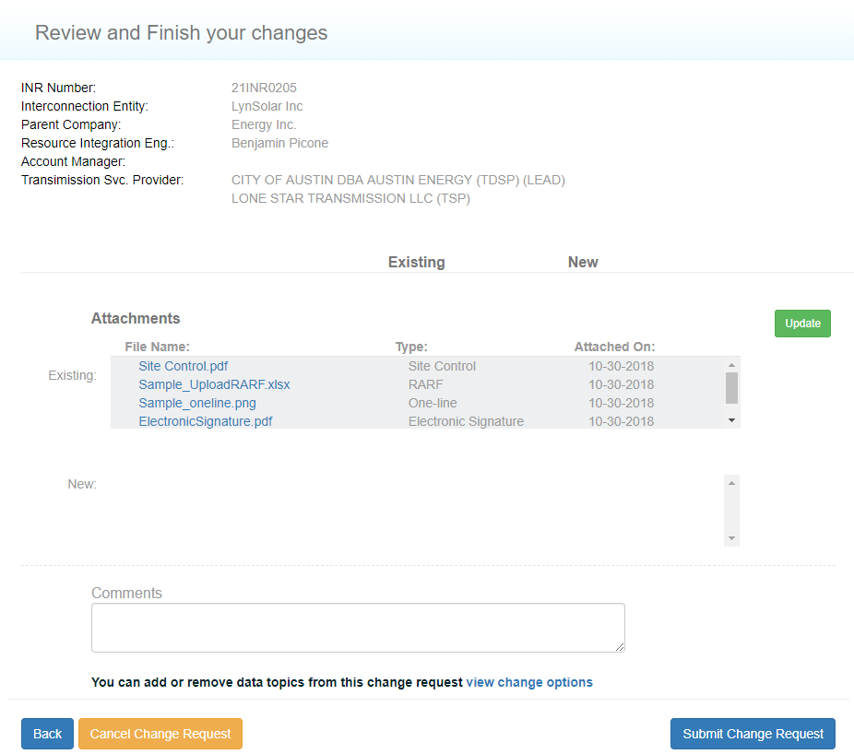
Click the Submit Change Request button.

Change Request Successfully Sent Message
To close this page and return to the Interconnection Request List, click the link in this message or the logo at the top left of the page.

Adding an Air Permit
If your project requires an Air permit, you must enter the date it was issued. You can optionally upload a file containing a copy of the permit.

Interconnection Request List Page
Click the Add Change Request button.

Add a Change Request Page
Click the Update My INR button. The page expands with the appropriate options.

Add a Change Request Page With Options
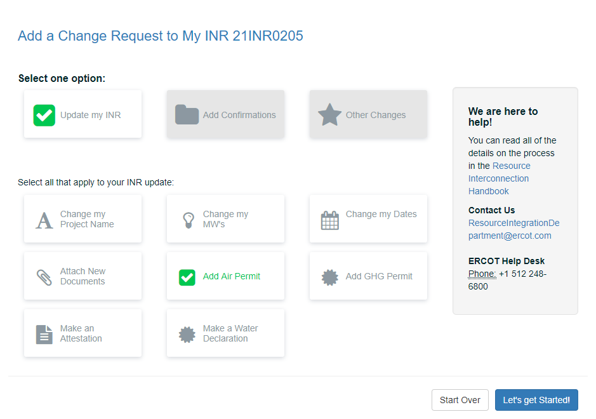
Click the Add Air Permit button.

Air Permit Page
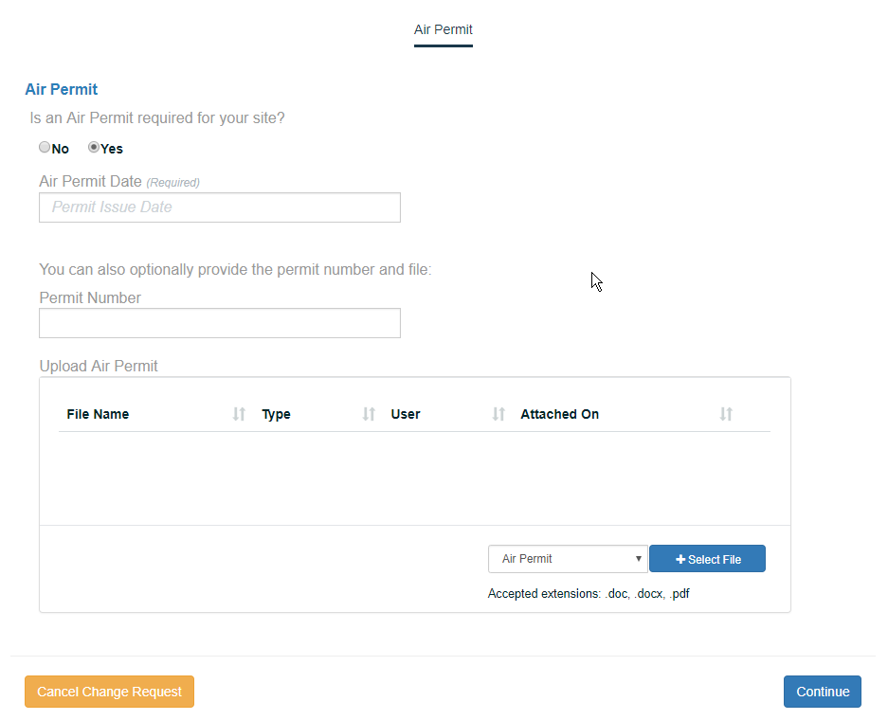
Click the Yes option.
Type in the mm-dd-yy when the permit was issued.
Type in the number of the Air Permit.
Optionally, upload a pdf file containing the Air Permit to display in the Attachments area on your account.
Click the Select file type dropdown and click the type of file you plan to upload.
Click the Choose File button, navigate to the file on your computer, and select it.
Click the Continue button.

Review and Finish your changes Page
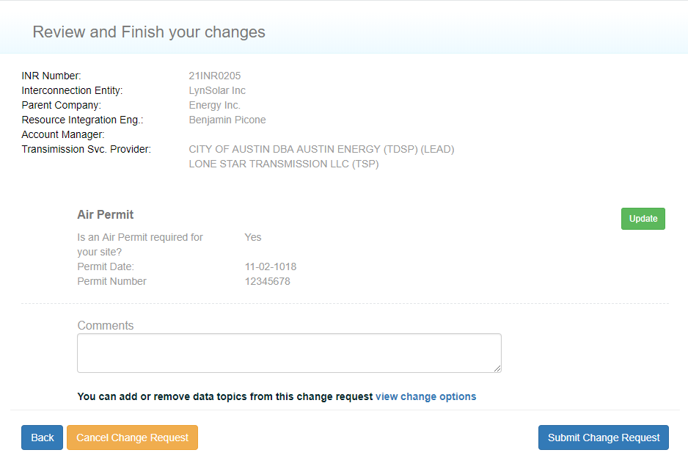
Click the Submit Change Request button.

Change Request Successfully Sent Message
To close this page and return to the Interconnection Request List, click the link in this message or the logo at the top left of the page.

The Review and Finish your changes page displays next unless you have clicked multiple Change My INR options. If you also clicked Adding a GHG permit, the GHG Permit page on page 57 displays.
After you complete the options page, then a Review and Finish your changes page displays with all of the options you have changed listed.

Adding a Green House Gas Permit
If your project requires a GHG permit, you must enter the date it was issued. You can optionally upload a file containing a copy of the permit.

Interconnection Request List Page
Click the Add Change Request button.

Add a Change Request Page
Click the Update My INR button. The page expands with the appropriate options.

Add a Change Request Page With Options
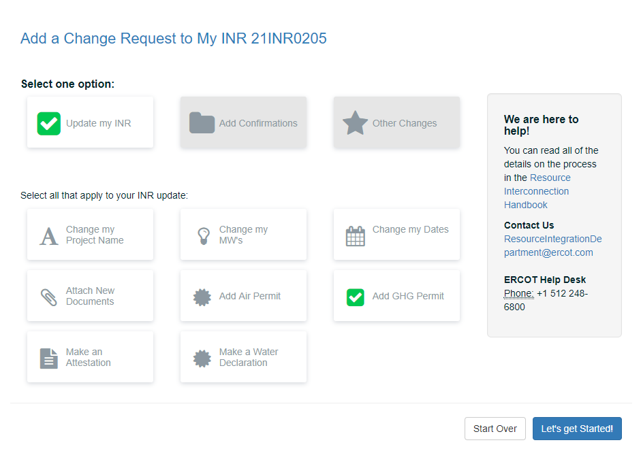
Click the Add GHG Permit button.

Greenhouse Gas Permit Page
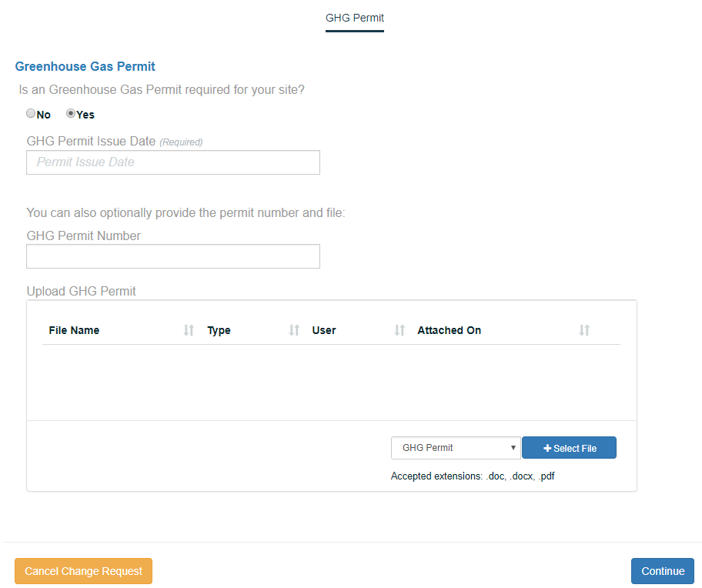
Click the Yes option.
Type in the mm-dd-yy when the permit was issued.
Type in the number of the Air Permit.
Optionally, upload a pdf file containing the Air Permit to display in the Attachments area on your account.
Click the Select file type dropdown and click the type of file you plan to upload.
Click the Choose File button, navigate to the file on your computer, and select it.
Click the Continue button.

Review and Finish your changes Page
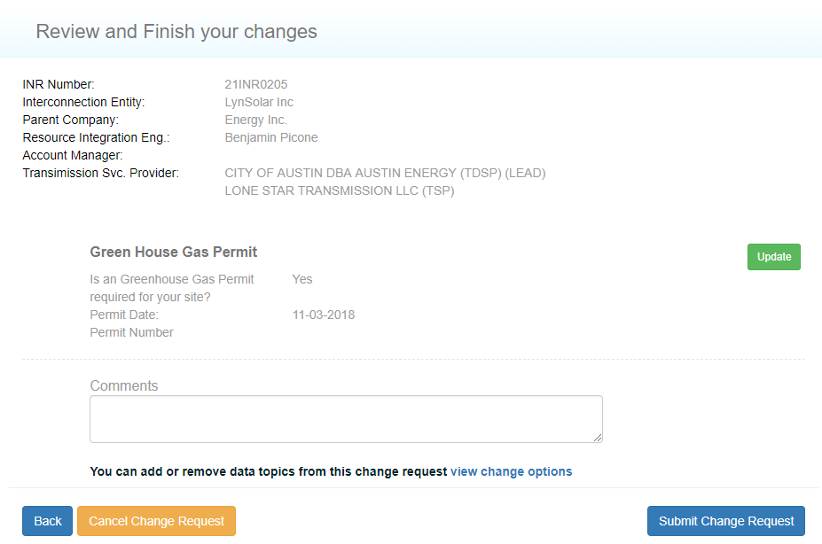
Click the Submit Change Request button.

Change Request Successfully Sent Message
To close this page and return to the Interconnection Request List, click the link in this message or the logo at the top left of the page.

Attesting that Your RARF is Current
Twice a year (in February and August), you are required to attest to having the most current resource registration data RARF uploaded.
Before you sign the attestation, you can check that your current RARF is attached to your project file by logging into your account and clicking the View button for your INR. On the View Interconnection Request page, you can scroll to the Attachments section that displays your RARF file and when it was attached.
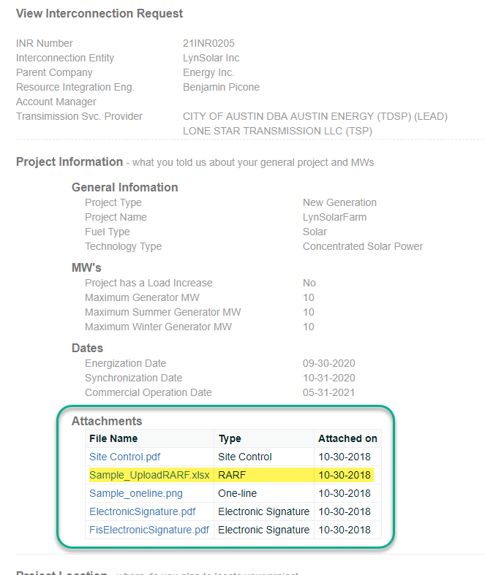

Interconnection Request List Page
Click the Add Change Request button.

Add a Change Request Page
Click the Update My INR button. The page expands with the appropriate options.

Add a Change Request Page With Options
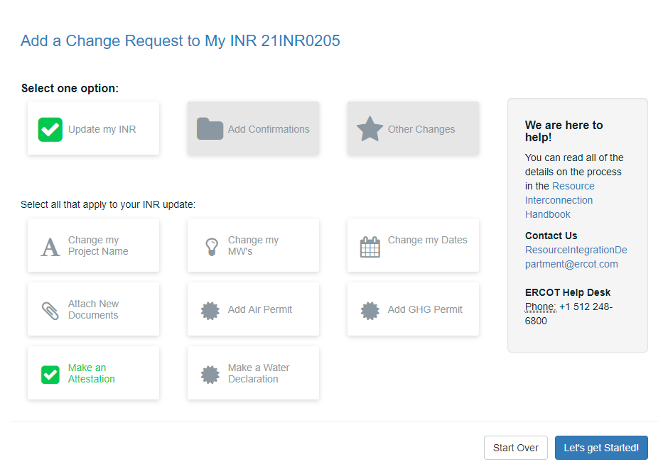
Click the Make an Attestation button and then click the Let’s get Started button.

Add RARF Attestation Page
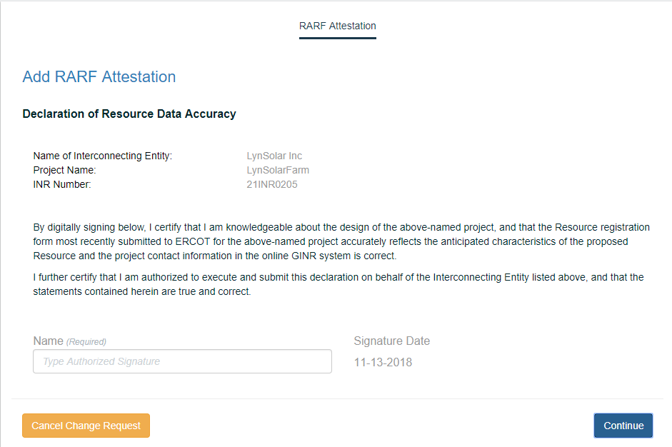
After reading the page, type in your signature.
Click the Continue button.

Review and Finish your changes Page
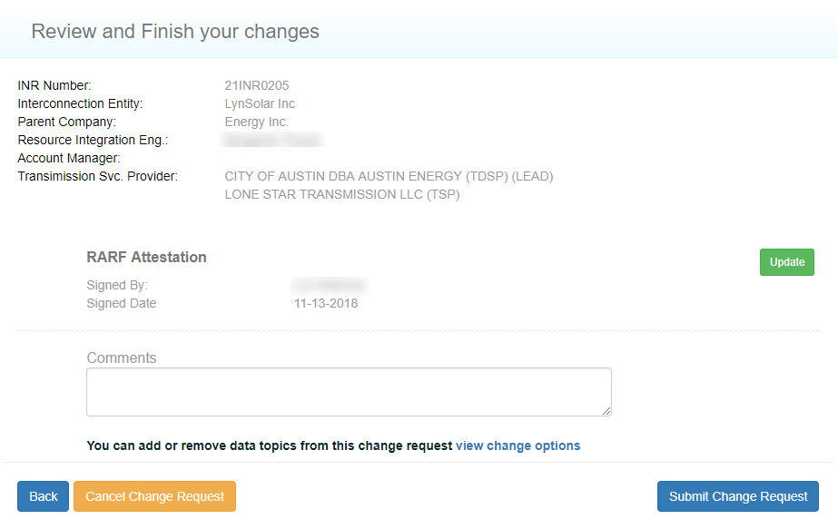
Use the Comments section to type in any notes for ERCOT or your TSP.
Click the Submit Change Request button.

Change Request Successfully Sent Message
To close this page and return to the Interconnection Request List, click the link in this message or the logo at the top left of the page.

Declaring Your Water Rights
You must submit a Change Request that confirms either you do not need water rights, contracts or groundwater supplies in order to generate electricity at your site or that you have secured them.You can attach copies of any contracts, permits and ground water adequacy studies to this declaration.

Interconnection Request List Page
Click the Add Change Request button.

Add a Change Request Page
Click the Update My INR button. The page expands with the appropriate options.

Add a Change Request Page With Options
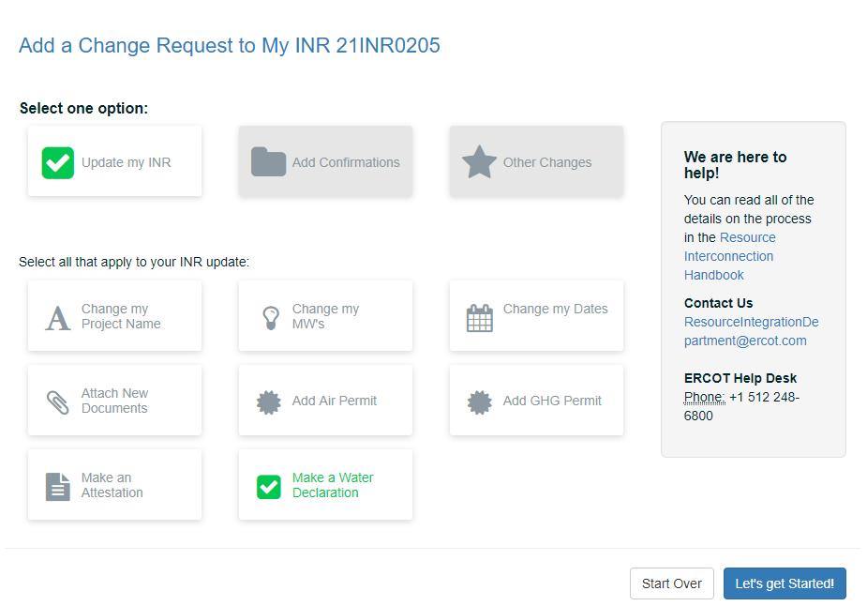
Click the Make a Water Declaration button and then click the Let’s get Started button.

Water Declaration Page
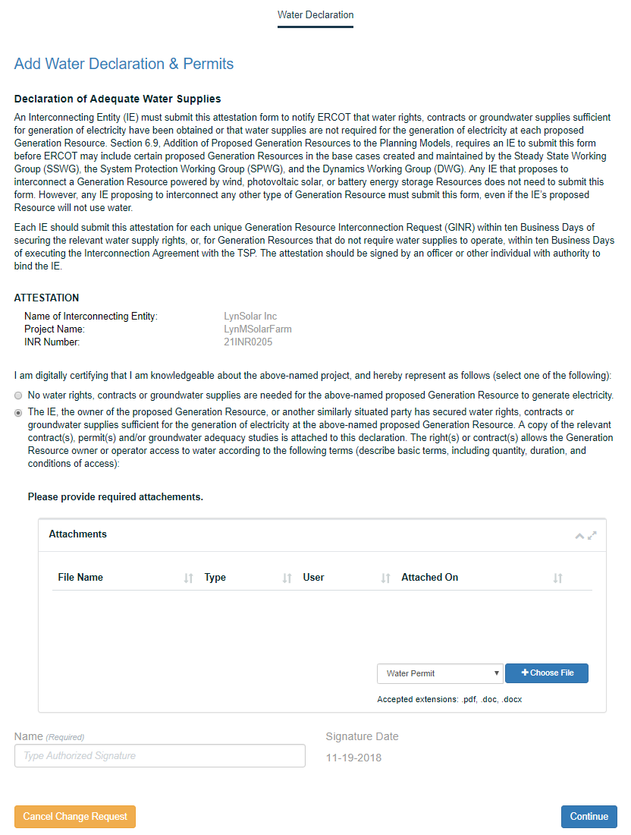
Click the Yes option. The page will expand.
To attach files containing the permit, contracts, or ground water adequacy:
Click the Select file type dropdown and click the type of file.
Click the Choose File button, navigate to the file on your computer, and select it.
Click the Continue button.

Review and Finish your changes Page
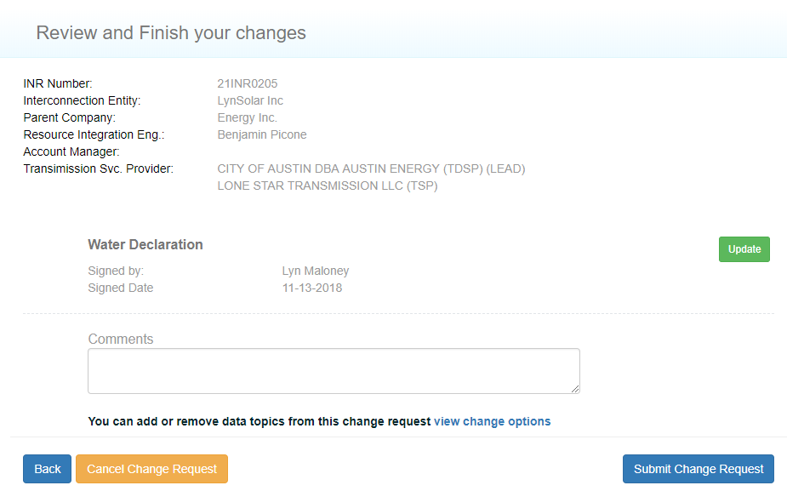
Click the Submit Change Request button.

Change Request Successfully Sent Message
To close this page and return to the Interconnection Request List, click the link in this message or the logo at the top left of the page.

Adding Confirmations
Add confirmations enables you to electronically sign to confirm that:
- Mitigation plans for system improvements identified in the FIS and Reactive Power Study are complete (on this page)
- Dynamic voltage regulators and automatic voltage regulators (AVRs) will be installed as required (page 72)
- Primary Frequency Response capability is met (page 75)
- Power System Stabilizer (PSS) will be in service (page 78)
- Interrupting capability of the main breaker is on the high side of the generator step up unit transformer (page 81)
- Subsyschronouse Resounance (SRS) mitigation equipment will be functional prior to intial Synchronization (page 85)
- Phase measurement unit (PMU) will be installed (page 88)

Confirming Study Mitigation Plans are Complete
By typing your full name and date on the Mitigation Plans page, you are digitally signing and confirming that the project will have system improvements or mitigation plans installed prior to synchronization as identified in the completed FIS Studies and an Reactive Power Study.

Your Interconnection Request List
Click the Add Change Request button.

Add a Change Request Page
Click the Add Confirmations button. The page expands with the appropriate options.

Add a Change Request Page With Options
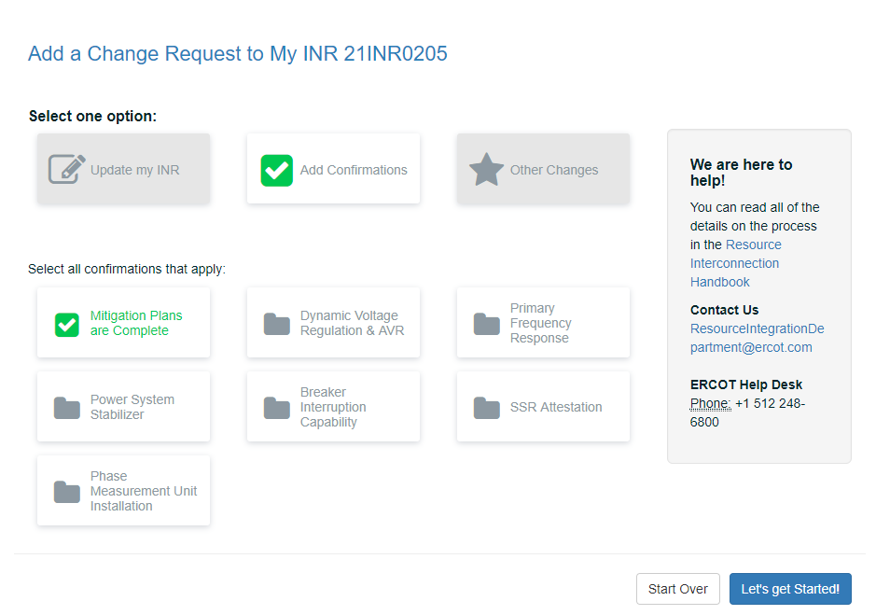
Click the Mitigation Plans are Complete button and then click the Let’s get Started button.

Mitigation Plans Page
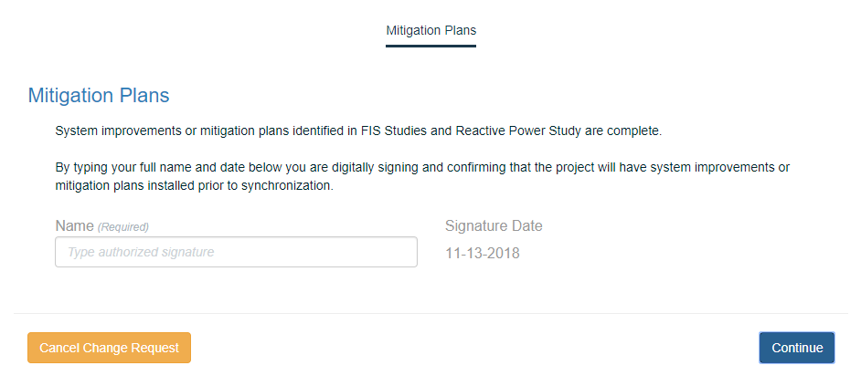
After reading the page, type in your signature.
Click the Continue button.

Review and Finish your changes Page
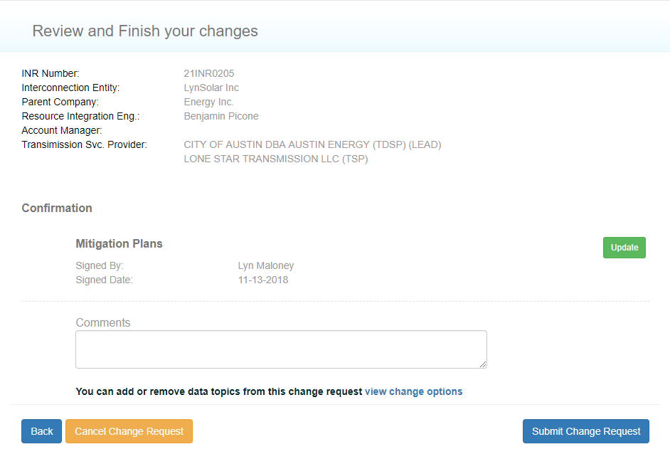
Click the Submit Change Request button.

Change Request Successfully Sent Message
To close this page and return to the Interconnection Request List, click the link in this message or the logo at the top left of the page.

Confirming the Voltage Regulations Are Met
By typing your full name and date on the DVR and AVR page, you are digitally signing and confirming that the project will have the voltage regulations as required by Nodal Protocols,

Your Interconnection Request List
Click the Add Change Request button.

Add a Change Request Page
Click the Add Confirmations button. The page expands with the appropriate options.

Add a Change Request Page With Options
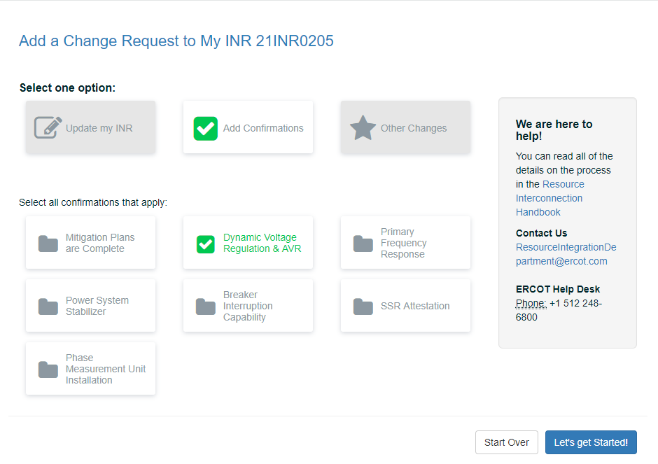
Click the Dynamic Voltage Regulation & AVR button and then click the Let’s get Started button.

DVR & AVR Page
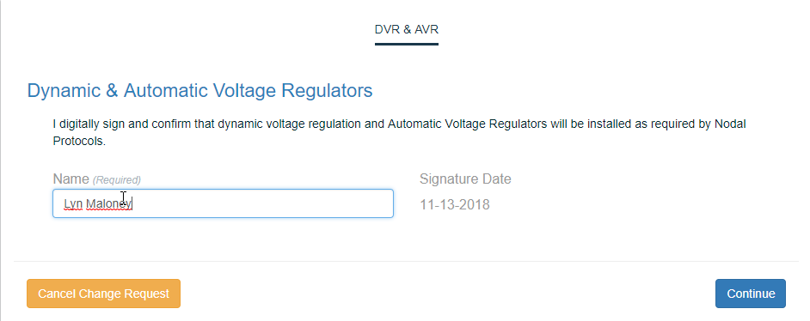
After reading the page, type in your signature.
Click the Continue button.

Review and Finish your changes Page
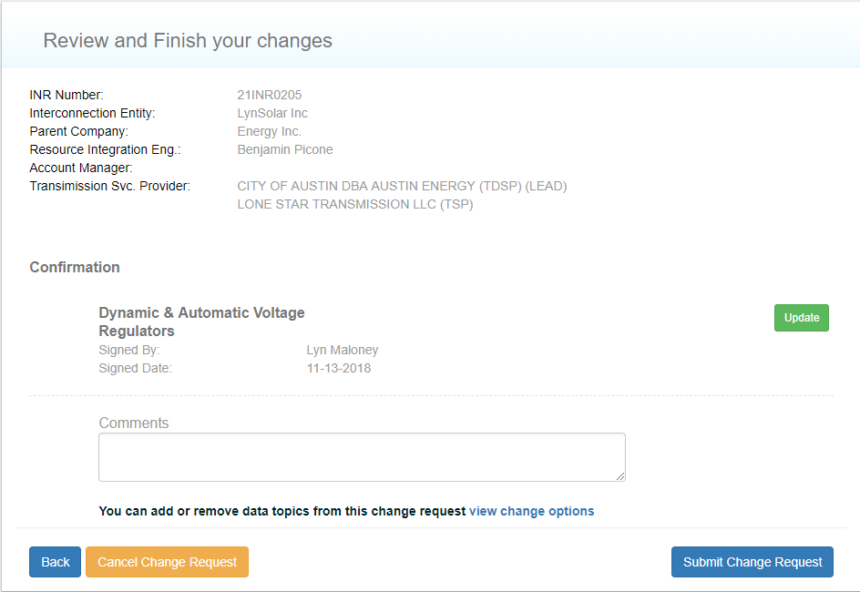
Click the Submit Change Request button.

Change Request Successfully Sent Message
To close this page and return to the Interconnection Request List, click the link in this message or the logo at the top left of the page.

Confirming the Primary Frequency Response Capablity
By typing your full name and date on the Frequency Response Page, you are digitally signing and confirming that the project will be capable of Primary Frequency Response as required by Nodal Protocols.

Your Interconnection Request List
Click the Add Change Request button.

Add a Change Request Page
Click the Add Confirmations button. The page expands with the appropriate options.

Add a Change Request Page With Options
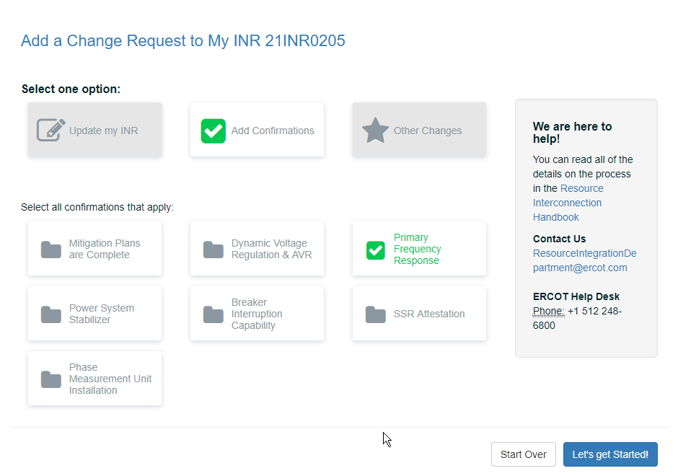
Click the Primary Frequency Response button and then click the Let’s get Started button.

Primary Frequency Response Page
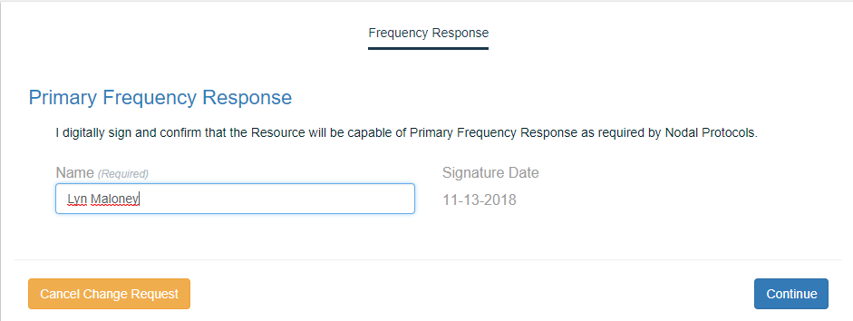
After reading the page, type in your signature.
Click the Continue button.

Review and Finish your changes Page
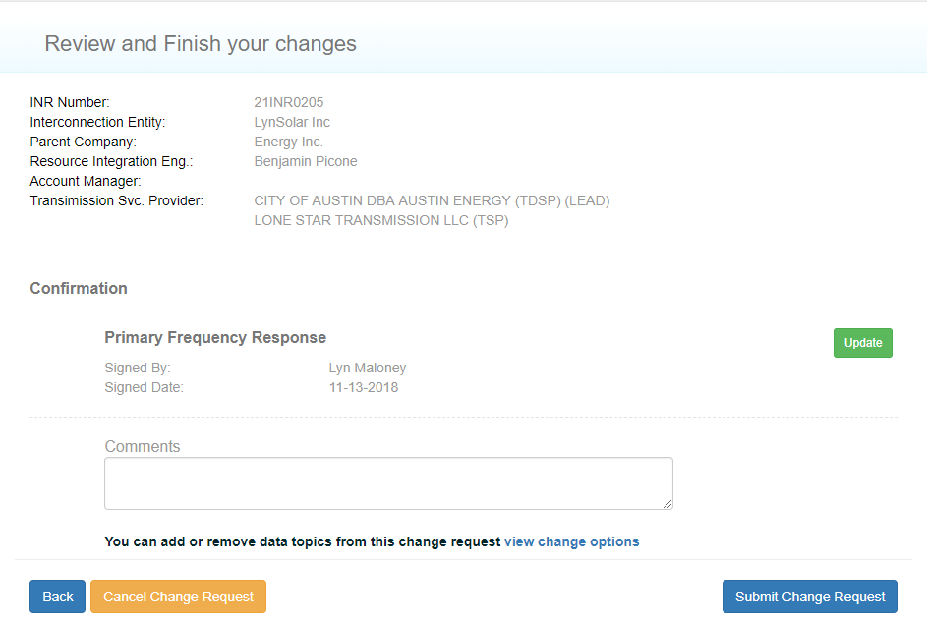
Click the Submit Change Request button.

Change Request Successfully Sent Message
To close this page and return to the Interconnection Request List, click the link in this message or the logo at the top left of the page.

Confirming that the Power System Stabilizer is In Service
By typing your full name and date on the PSS page, you are digitally signing and confirming that the resource will have a PSS in-service as required by Nodal Protocols.

Your Interconnection Request List
Click the Add Change Request button.

Add a Change Request Page
Click the Add Confirmations button. The page expands with the appropriate options.

Add a Change Request Page With Options
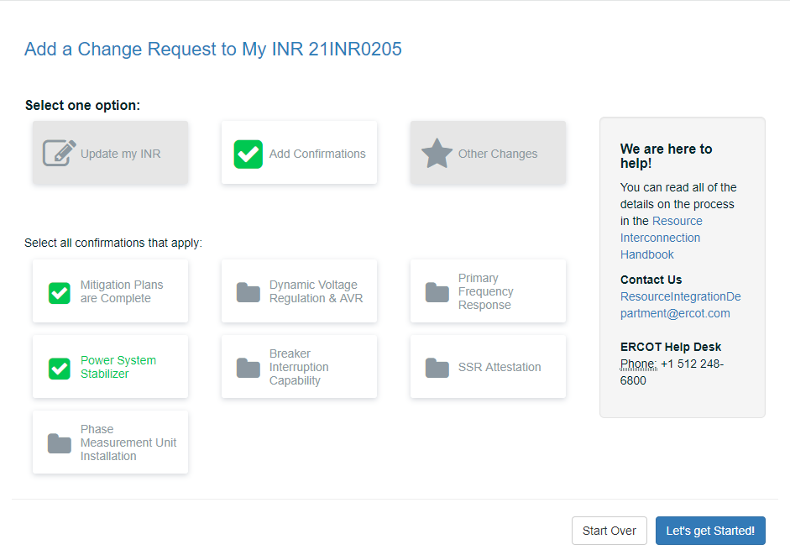
Click the Primary Frequency Response button and then click the Let’s get Started button.

Power System Stabilizer Page
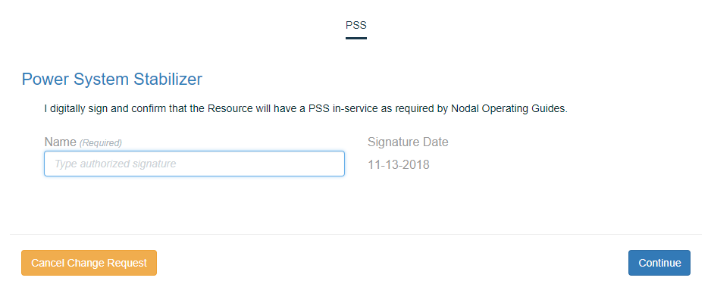
After reading the page, type in your signature.
Click the Continue button.

Review and Finish your changes Page
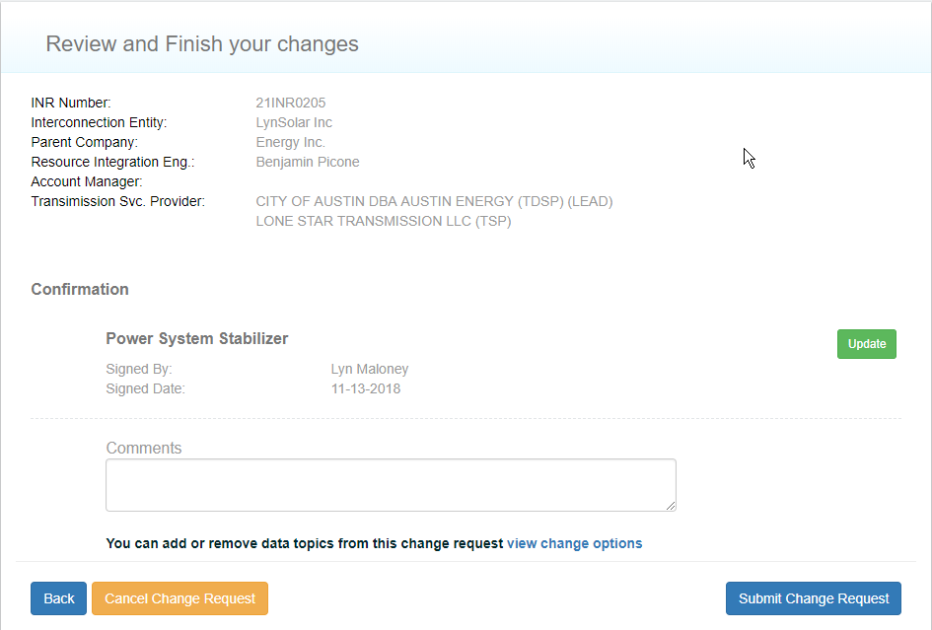
Click the Submit Change Request button.

Change Request Successfully Sent Message
To close this page and return to the Interconnection Request List, click the link in this message or the logo at the top left of the page.

Confirming Breaker Interruption Capability
By typing your full name and date on the Breaker page, you are digitally signing and confirming that the resource is capable of informing ERCOT of the interrupting capability of the main breaker on the high side of the generator step up unit transformer.

Your Interconnection Request List
Click the Add Change Request button.

Add a Change Request Page
Click the Add Confirmations button. The page expands with the appropriate options.

Add a Change Request Page With Options
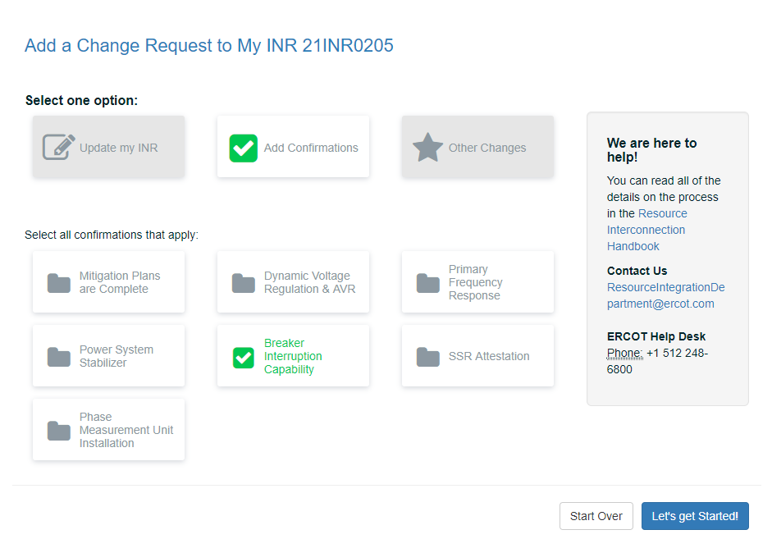
Click the Breaker Interrupiton Capabiity button and then click the Let’s get Started button.

Breaker Interruption Capability Page
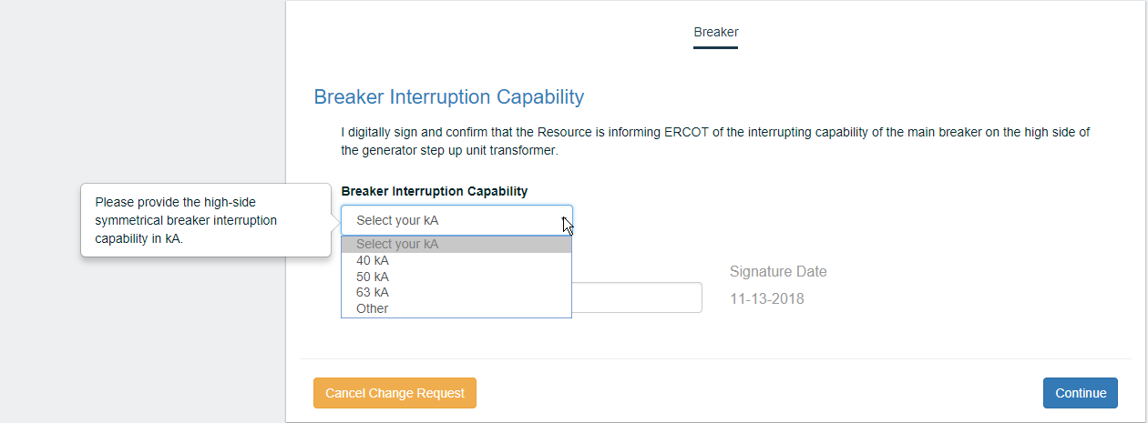
-From the Breaker Interruption Capability dropdown, click the appropriate option:
40 kA
50 kA
63 kA
Other, which displays field to type in your kA
Type in your signature.
Click the Continue button.

Review and Finish your changes Page
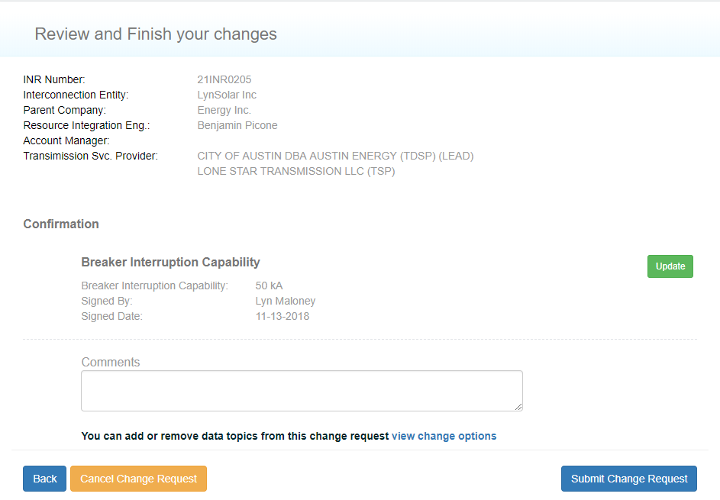
Click the Submit Change Request button.

Change Request Successfully Sent Message
To close this page and return to the Interconnection Request List, click the link in this message or the logo at the top left of the page.

Confirming Subsyschronous Resonance Mitigation
By typing your full name and date on the SSR page, you are digitally signing and confirming that any required SSR mitigation equipment will be functional prior to Initial Synchronization of the Resource as required by Nodal Protocols.

Your Interconnection Request List
Click the Add Change Request button.

Add a Change Request Page
Click the Add Confirmations button. The page expands with the appropriate options.

Add a Change Request Page With Options
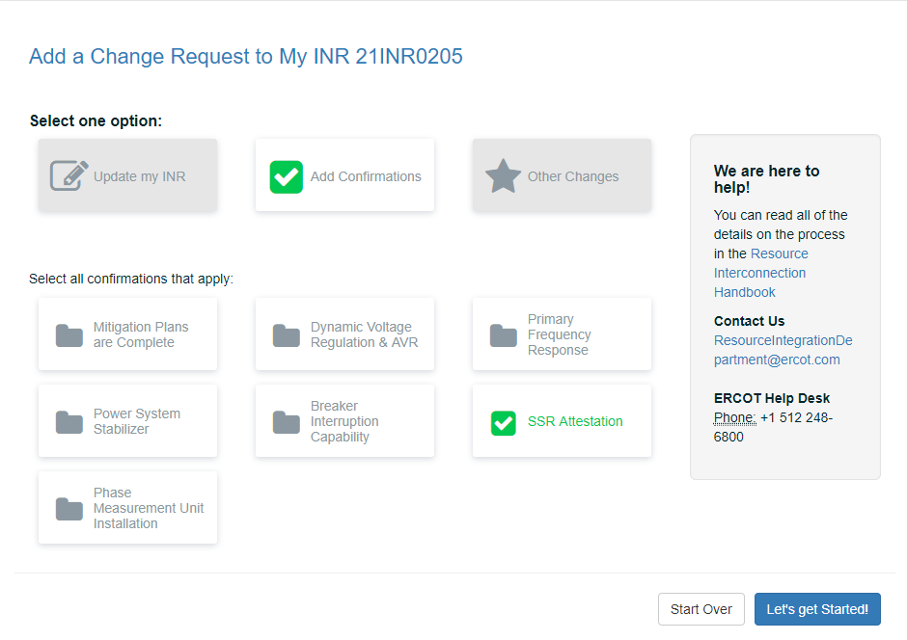
Click the SSR Attestation button and then click the Let’s get Started button.

SSR Page
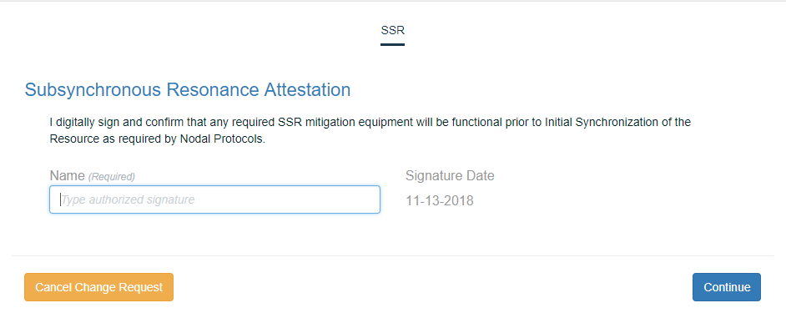
After reading the page, type in your signature.
Click the Continue button.

Review and Finish your changes Page
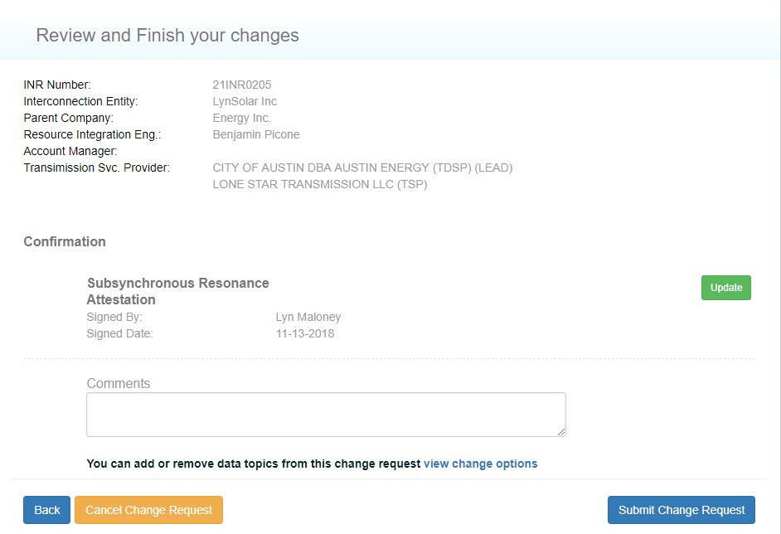
Click the Submit Change Request button.

Change Request Successfully Sent Message
To close this page and return to the Interconnection Request List, click the link in this message or the logo at the top left of the page.

Confirming the Phase Measurement Unit Installation
By typing your full name and date on the PMU page, you are digitally signing and confirming that the PMU will be installed as required by Nodal.

Your Interconnection Request List
Click the Add Change Request button.

Add a Change Request Page
Click the Add Confirmations button. The page expands with the appropriate options.

Add a Change Request Page With Options
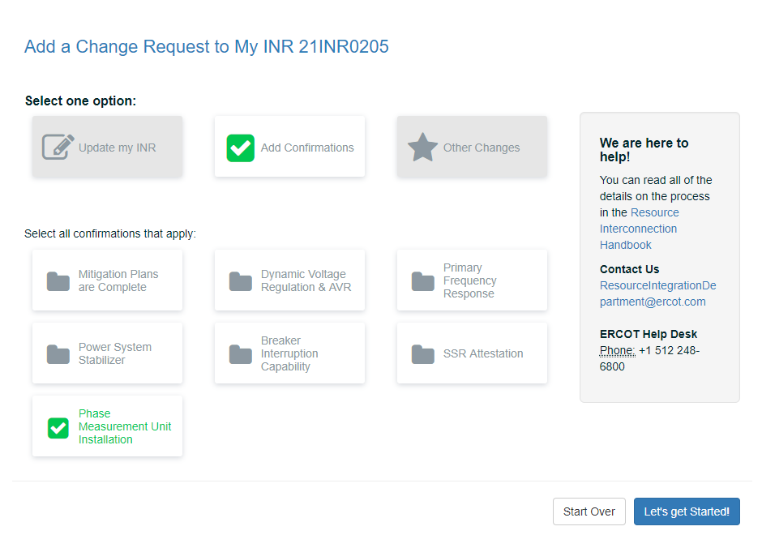
Click the Primary Frequency Response button and then click the Let’s get Started button.

Phase Measurement Unit (PMU) Installation Page
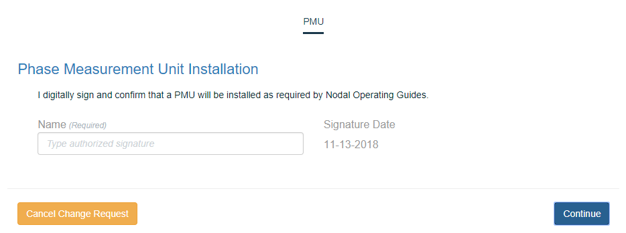
After reading the page, type in your signature.
Click the Continue button.

Review and Finish your changes Page
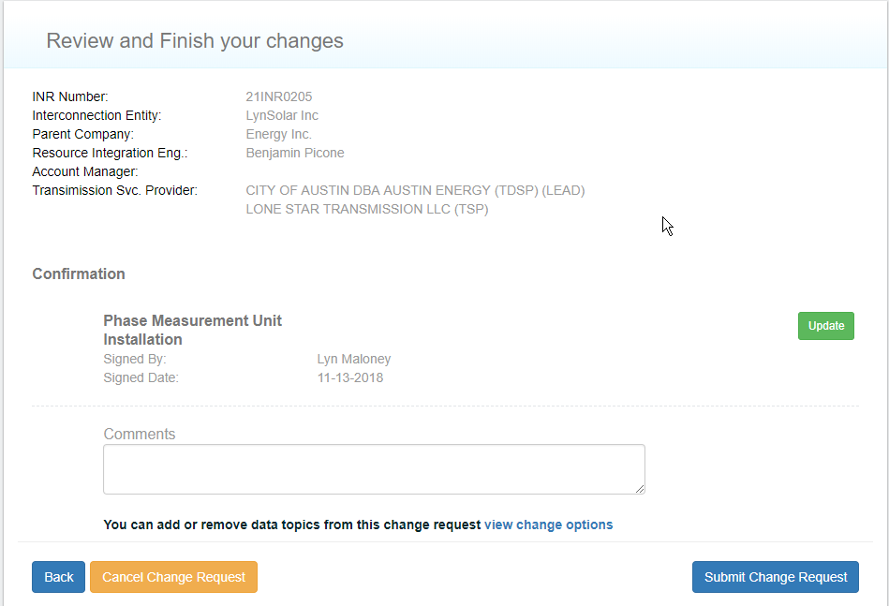
Click the Submit Change Request button.

Change Request Successfully Sent Message
To close this page and return to the Interconnection Request List, click the link in this message or the logo at the top left of the page.

Requesting an FIS
You can request ERCOT to perform a full interconnection study (FIS) on your project through a Change Request. You can update the COD and add the Synchronization and Energization dates you provided earlier and attach required documents, such as an updated one line and RARF.
After you complete these tasks, you can review what you provided and then and electronically sign a Declaration of Department of Defense (DoD) Notification.

Interconnection Request List Page
Click the Add Change Request button.

Add a Change Request Page
Click the Other Changes button. The page expands with the appropriate options.

Add a Change Request Page With Options
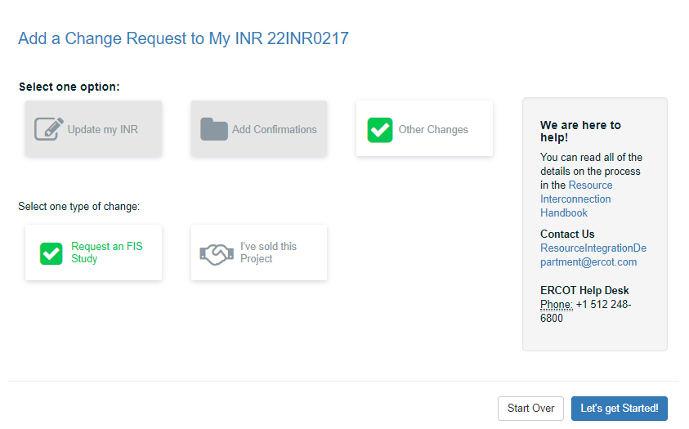
Click the Request an FIS Study button.

Project Dates Page
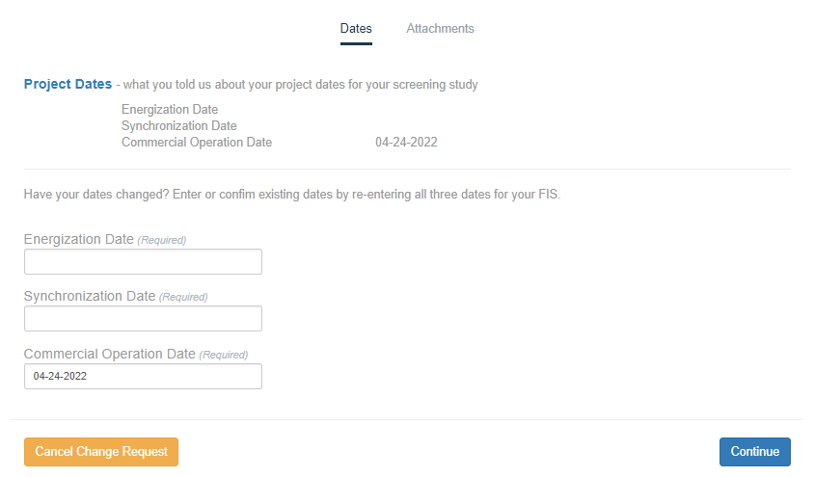
Type in the mm-dd-yy of the Energenization date. This date must be at least 10 days before the Synchronization date.
Type in the mm-dd-yy of the Synchronization date.
If you need to modify the Commercial Operation Date, type in your change.
Click the Continue button.

Attach FIS Documents
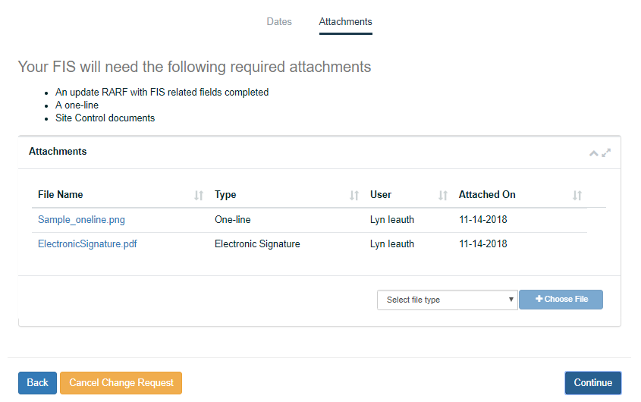
For each document you need to upload and attach (RARF and one-line):
Click the Select file type dropdown and click the type of file you plan to upload.
Click the Choose File button and navigate to the file on your computer.
Repeat the steps above for each file you want to upload.
Click the Continue button.
Just uploaded the wrong file? Use the Delete button to remove it.
Need to delete a submitted document? You can contact ERCOT at ginr@ercot.com

Review and Finish your Changes page
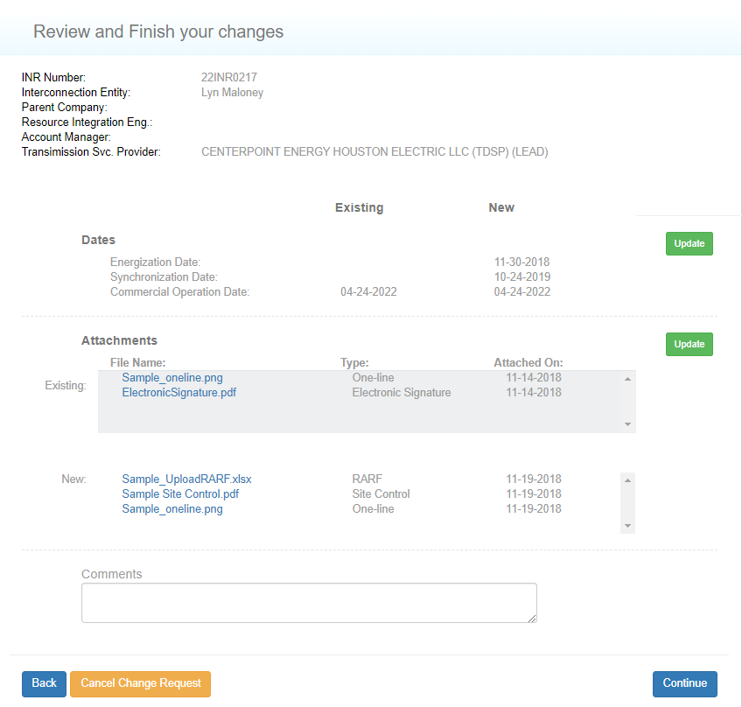
Click the Continue button.

Declaration of Department of Defense Notification Page
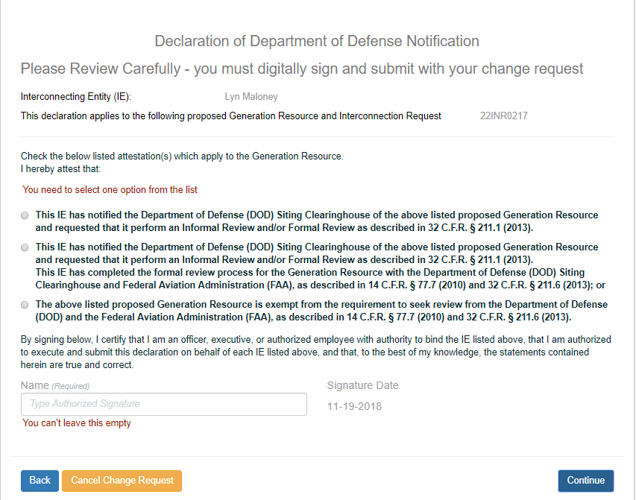
Click one of the 3 options.
Type in your authorized signature name.
Click the Continue button.

Payment/Submit Page
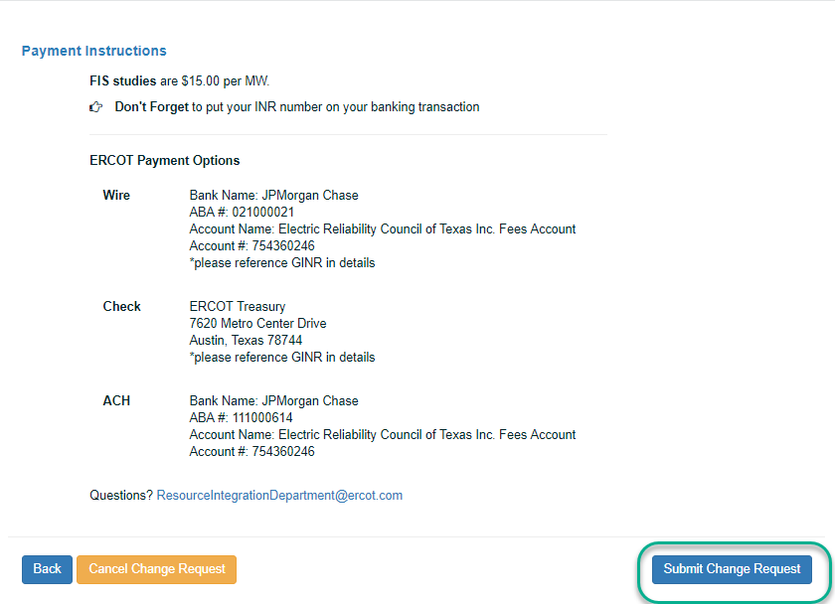
Click the Submit Change Request button.

Change Request Successfully Sent Message
To close this page and return to the Interconnection Request List, click the link in this message or the logo at the top left of the page.

Reporting a Change of Ownership
You can change the owner of the project through a Change Request where you assign the person you sold it to as the Primary Contact. You will add the email address and company information of the new primary owner or contact as well as attach required documents.

Interconnection Request List Page
Click the Add Change Request button.

Add a Change Request Page
Click the Other Changes button. The page expands with the appropriate options.

Add a Change Request Page With Options
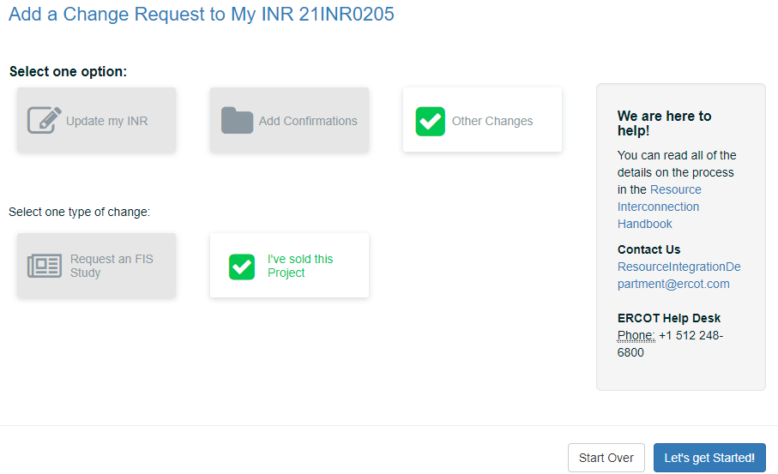
Click the I’ve sold this Project button and then click the Let’s get Started button.

Contacts Page
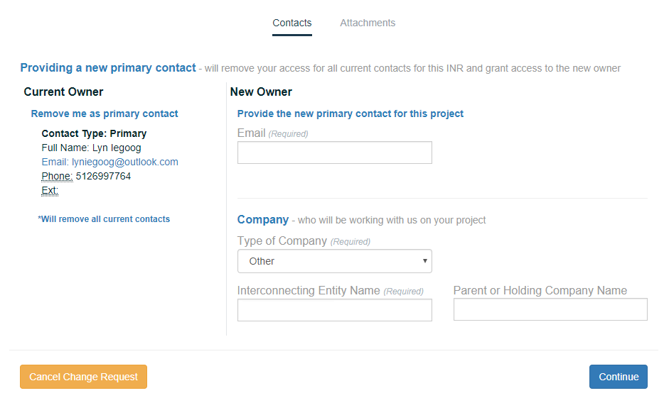
Type in the email address of the new owner.
ERCOT sends the new owner an email with instructions on how to register and log in.
Fill in the Company information.
Click the Continue button.

Attachments Page
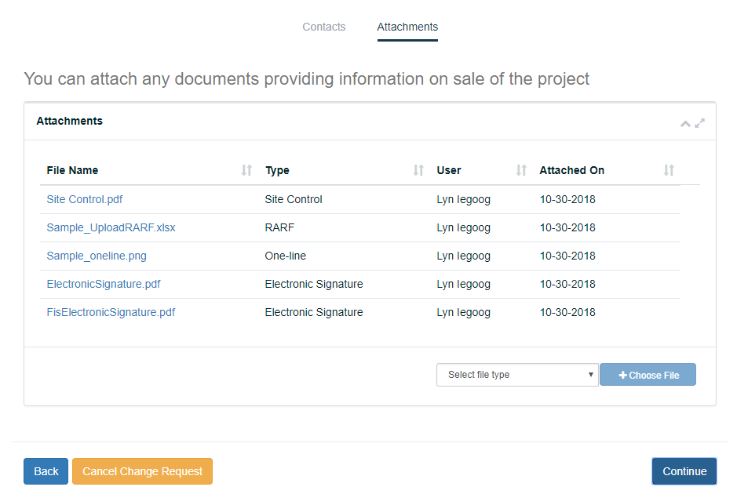
Click the Select file type dropdown and click the type of file you plan to upload.
Click the +Choose File button, navigate to the file on your computer, and click the file.
Repeat the steps above for each file you want to upload.
When you are finished, click the Continue button.
Uploaded the wrong file? Use the Delete button to remove it.

Review and Finish your changes Page
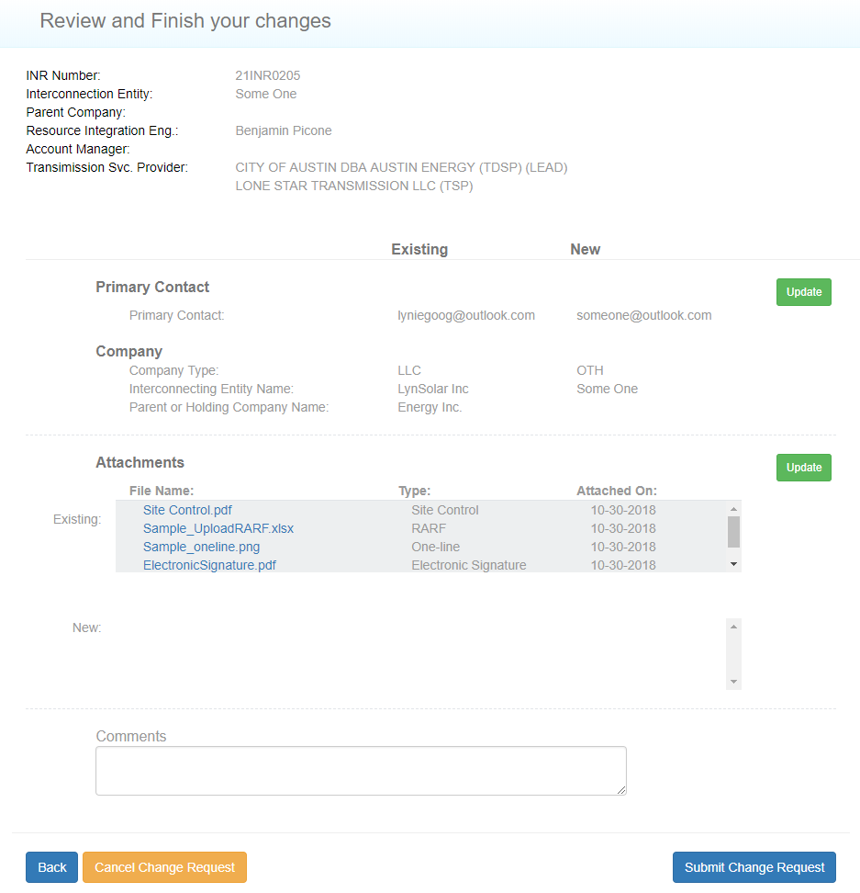
Click the Submit Change Request button.

Change Request Successfully Sent Message
To close this page and return to the Interconnection Request List, click the link in this message or the logo at the top left of the page.

Managing the Contacts On Your Project
Your backup and other contacts are displayed on cards on the All Contacts page. You can view their information and invite new contacts and backups to work with you on your project.

Viewing Project Contacts
You can vew the contact cards of people you have added to your project and determine who has joined the project.

Interconnection Request List Page
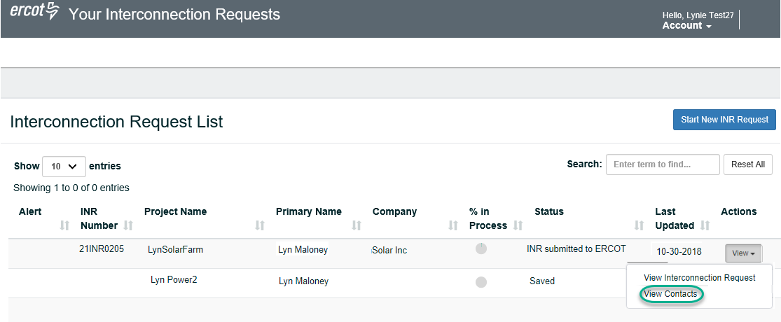
Click the View dropdown and click View Contacts.

All Contacts Page
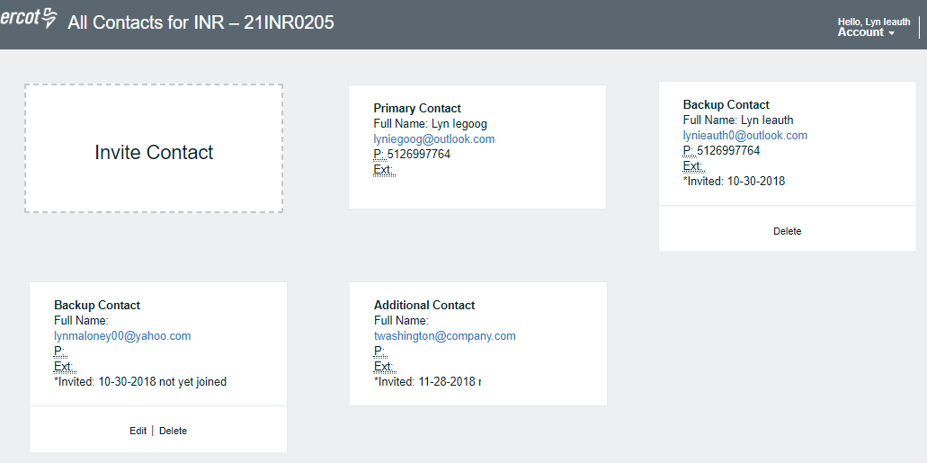

Inviting New Contacts or Backups
You can invite others to join the project and designate them as Backup Contacts who can view, edit, and invite others or Contacts who can view and edit the project request.
ERCOT sends the invited contact an email about your invitation to join with instructions on how to sign up and join the project. If contacts have already joined another INR project, ERCOT sends them an email informing them that they have been invited to join this project.

Interconnection Request List Page
Click the View dropdown and click View Contacts.

All Contacts Page
To have another person join this project, click Invite Contact.

Invite Contact Popup
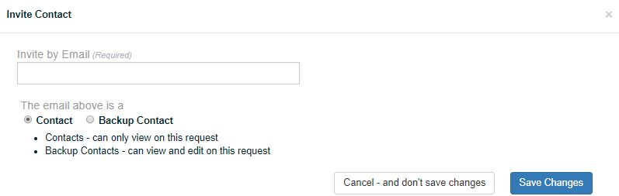
Type in the new contact email.
If this is a backup, click the Backup Contact option.
Click the Save Changes button.

Change Request Successfully Sent Message
To close this page and return to the Interconnection Request List, click the link in this message or the logo at the top left of the page.

Editing Contact Information
You can edit only the email address of contacts who have not yet joined this project.

Interconnection Request List Page
Click the View dropdown and click View Contacts.

All Contacts Page
Locate the contact and click Edit on their card.

Edit Contact Popup
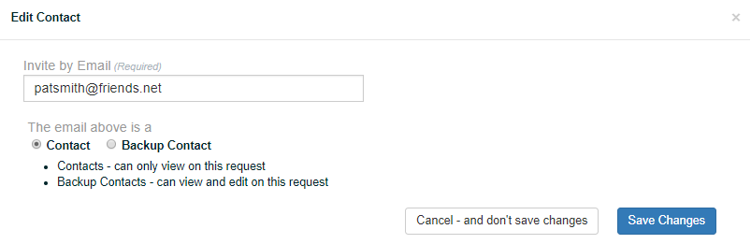
Make your changes.
If this is a backup, click the Backup Contact option.
Click the Save Changes button.

Change Request Successfully Sent Message
To close this page and return to the Interconnection Request List, click the link in this message or the logo at the top left of the page.

Removing a Contact from the Project
You can remove a contact.from your contact, unless the contact is your only Backup Contact. You should invite a new Backup Contact and, when that contact joins, you can delete their contact card.

Interconnection Request List Page
Click the View dropdown and click View Contacts.

All Contacts Page
Locate the contact and click Delete on their card.

Change Request Successfully Sent Message
To close this page and return to the Interconnection Request List, click the link in this message or the logo at the top left of the page.

Canceling INRs and Change Requests
At this time, you cannot cancel an INR after it has been submitted. To cancel an INR, contact your RI Engineer.
The feature for canceling an INR from the Interconnection Request List yourself is planned for a future release.
However, you can cancel a Change Request to an INR until ERCOT has processes it. You can cancel a Change Request from a page where the  button displays.
To cancel a change request made to an INR:

Interconnection Request List Page
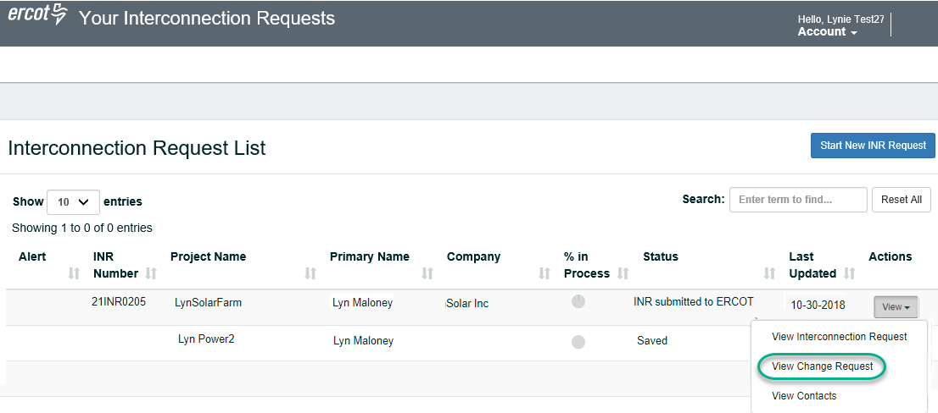
Click the View dropdown and click View Change Request.

Review your changes Page
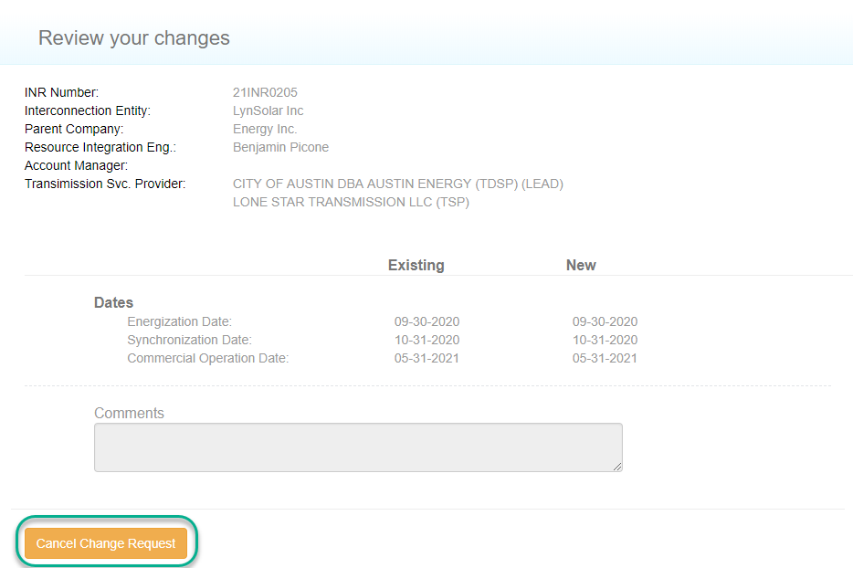
Click the Cancel Change Request button.

Cancel this change request Popup
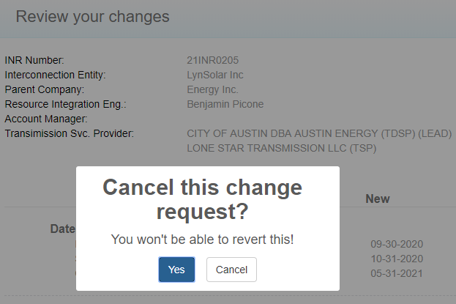
Click the Yes button.

Cancelled Change Request Confirmation on the Review Page
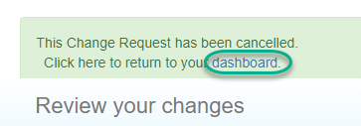

Index
accessing your account, 3
adding confirmations, 68
Air permit, 51
answer request for updates, 29
a
attaching documents, 47
attachment page, 21
attachment, file types, 21
attachments, 21
attestation for RARF, 59
Auth0 Guardian authentication, 4
Automatic Voltage Regulator confirmation, 72
backup contact, 24
backup contact, assigning, 23
breaker interruption confirmation, 81
cancelling a Change Request, 110
cancelling an INR, 110
change of ownership request, 99
change password, 9
Change Requests,understanding, 33
Commercial Operations Date (COD), 20, 43
confirmations, 68, 72, 75, 78, 81, 85, 88
contacts, 105
corresponding with ERCOT, 29
data resource attestation, 59
documents, attaching, 47
DoD Notification, 27
Energenation date, changing, 43
Energization at POI date, 20
fault capability confirmation, 81
FIS, attachments, 21
FIS mitigation plan confirmation, 68, 72
FIS option, 17
FIS request, 92
forgotten password, 12
fuel technology, 18
fuel type, 18
Generation Entity InformationSheet, 26
GHG Permit, 55
Google Authenticator, 5
INR
attaching files, 21
changing details, 35
corresponding with ERCOT, 29
fuel type, 18
MWs, 19
project dates, 20
project name, 18
reviewing, 25
start, 16
submit, 26
technology type, 18
understanding Change Requests, 33
INR, creating, 15
inviting backups and other contacts to join, 24
latitude and longitude of resource, 22
location of resource, 22
logging in, 3
Auth0 Guardian, 4
Google Authenticator, 5
SMS Authentication, 6
logging out, 6
mapping the location, 22
Megawatts for each generator, 19
mitigation plan confirmation, 68, 72
modifying account information, 7
MW, 19
MWs (megawatts)
changing, 39
name, changing, 7
other contacts, assigning, 23
ownership change, 99
password
change, 9
forgotten, 12
reset, 12
payment instructions, 28
pdfs, attaching, 47
permit
air, 51
greenhouse gas, 55
Phase Measurement Unit, 88
phone number, changing, 7
PMU confirmation, 88
POI, 22
POI KVs, 22
Power System Stablizer confirmation, 78
Primary Frequency Response confirmation, 75
project contacts, 105
project dates
COD, 20
energization at POI, 20
synchronization with the grid, 20
updating, 43
updating the COD, 43
project details
changing MWs, 39
changing project name, 35
updating dates, 43
project location, 22
project name,changing, 35
project, start, 16
RARF, attestation, 59
requesting an FIS, 92
requesting change of ownership, 99
reset password, 12
review INR, 25
screening study attachments, 21
Screening Study option, 17
SMS authentication, 6
SRS confirmation, 85
Start INR Request, 16
starting an INR, 15
submit INR, 26
subsynchous resonance confirmation, 85
Synchronization date, changing, 43
Synchronization with grid date, 20
type of company, 23
UD, 29
updating INR, 29
Voltage regulation confirmation, 72
water rights declaration, 64

