
RIOO Interconnection Services TSP Guide
Version 1
11/30/2018

About this TSP Guide
This guide provides information to assist TSPs with performing tasks in the online Resource Integration and Ongoing Operations (RIOO) system that enables them to view the Interconnection Requests (INRs) for new power generation resource projects submitted by Interconnection Entities (IEs) and then work with the IEs on their projects.

Contents
Overview of Interconnection Services for TSPs 1
Accessing and Managing Your Interconnection Services Account 3
Logging into Your Account 3
Logging Out of Your Account 6
Resetting Your Forgotten Password 7
Viewing Interconnection Requests 10
Viewing a Change Request from the IE 14
Viewing Contacts Associated with the INR 16
Reviewing Draft Documents 17
Adding Change Requests for FIS Studies 20
Adding a Change Request for an FIS Study Scope 20
Adding a Change Request for an FIS Study Start Date 23
Adding a Change Request for FIS Studies 26
Recording the Interconnection Agreement Date 29
Recording the Notice to Proceed Date 32
Recording the Financial Commitment Date 35
Index 38

Overview of Interconnection Services for TSPs
ERCOT Interconnection Services enables you, as a TSP or Lead TSP, to view the Interconnection Requests (INRs) made by IEs, the contacts involved in an INR project, and any Change Requests submitted to the INR.
You will receive emails when drafts of documents and studies attached to an INR are ready for review. You can review the document and submit your review comments about the document to the lead TSP who sends the email.
When you log in, the Interconnection Request List displays with all submitted INRs that ERCOT has processed but are not operational.
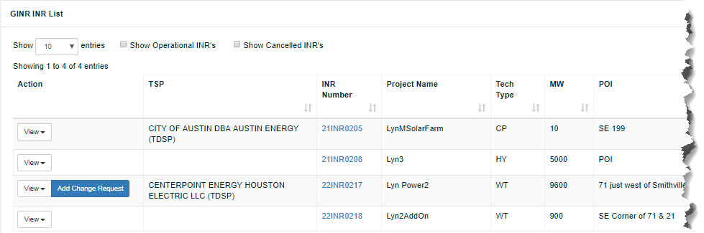
This list displays the details of each (shown above) plus all of the important dates for each one (shown below)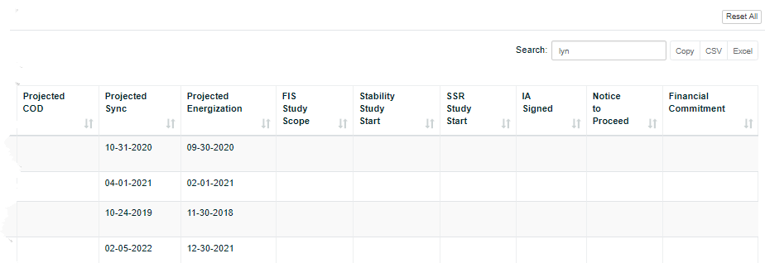
You can click the View from the Actions column to display the INR, a change request on it, and the contacts for the project. Refer to page 10.
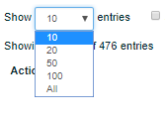
To adjust the number of records that display per page, use the Show entries dropdown and select the number of records to display on the page.
Choosing All will cause the system to slow down.
To display INRs for resources that are now operating, click the Show Operational checkbox (next to the Show entries drop-down).
You can also display the INRs that have been cancelled, which you may want for research purposes, by clicking the Show Cancelled INRs checkbox.
You can search for an INR or INRs you want to view using keywords in the Search field in the upper right of the page to locate the INR by its Project Name.
To examine and work with the data displayed for the INRs in your list view, you can convert your view to an Excel spreadsheet or dump the contents into a comma separated values (CSV) file.

Accessing and Managing Your Interconnection Services Account
Accessing your account involves logging into your Interconnection Services List with the login credentials you have been given.

Logging into Your Account
When you log into your account with your username and password, an authentication code page may display if you did not check the Remember this browser checkbox during signup. Follow the directions for authentication and then click the Remember this browser checkbox to prevent this from displaying in the future.

Log In Page
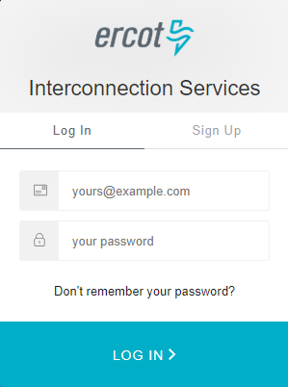
Type in the email address you entered when you signed up for the account.
Type in the password you created when you signed up for this account or modified afterwards.
Click the LOG IN > button.
The next action depends on the authentication method you are using.
For Guardian Auth0, refer to the next page.
For Google Authenticator, refer to page 5.
For SMS Text Messaging, refer to page 6.

Auth0 Guardian Authentication Page
Go to the Guardian text message on your phone and swipe to open the message.
Tap the Allow button.
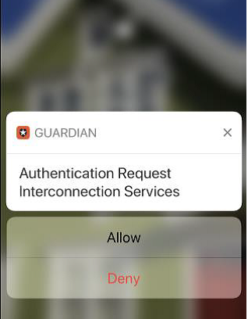

Google Authenticator Authentication Page
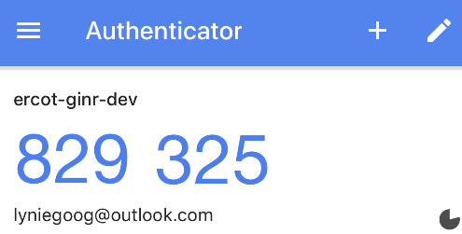
Go to your mobile phone and open Authenticator.
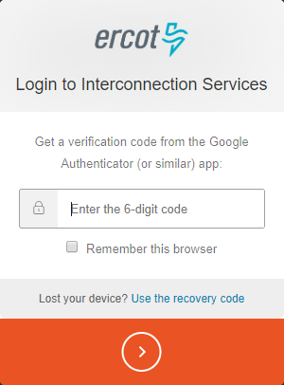
Click this Remember this browser checkbox to avoid having to do this every time you log in.
Click  to continue to the Interconnection Request List page.
Type in the 6 numbers of your new code.

SMS Authentication Page
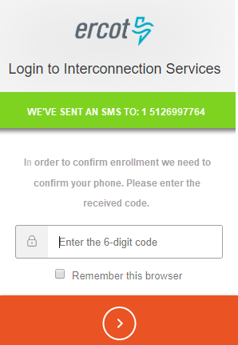
Go to your mobile phone and open the new authentication message.
Type in the 6 numbers of your new code.
Click this checkbox to avoid having to do this when you log in for the next 30 days.
Click to continue to the Interconnection Request List page.

Logging Out of Your Account
You should log out of your account when you are finished performing tasks.

Interconnection Services List Page
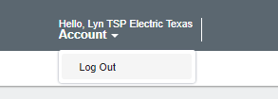
Locate the Account dropdown in the right corner of the main page.
Click the Account dropdown and click Log Out.

Resetting Your Forgotten Password

Interconnection Services Login Page
Click the Don’t remember your password? link.

Reset Your Password Page
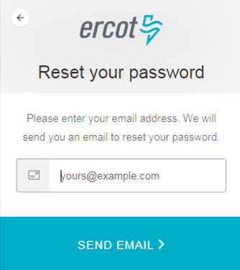
Click the SEND EMAIL > button.
Type in the email address you entered when you signed up for the account

Confirmation Email
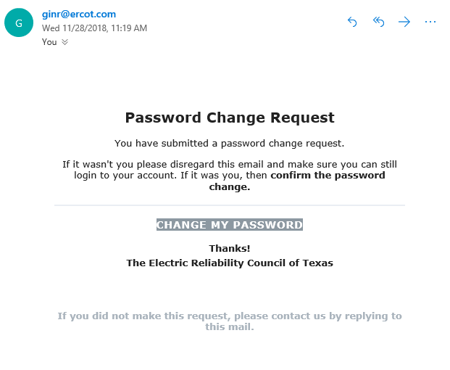
Go to your email and open the email message with Reset your ERCOT Resource Interconnection Services Password in the subject line.
Click the CHANGE MY PASSWORD button.

Change Password Page
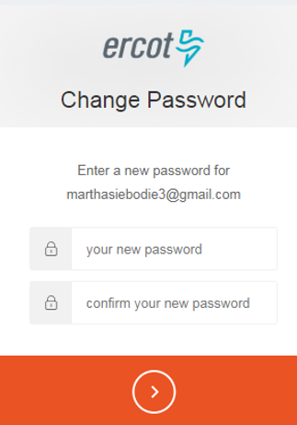
Type in a new password using the rules displayed as you type.
Type in your new password again.
Click the Continue button.

Success Page
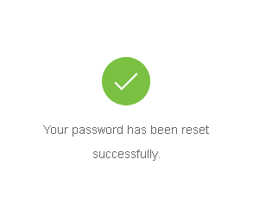

Viewing Interconnection Requests
When you view an Interconnection Request, the INR details of the project display along with links to view the Attachments and the TSP Key Milestones for the project.

Interconnection Services List
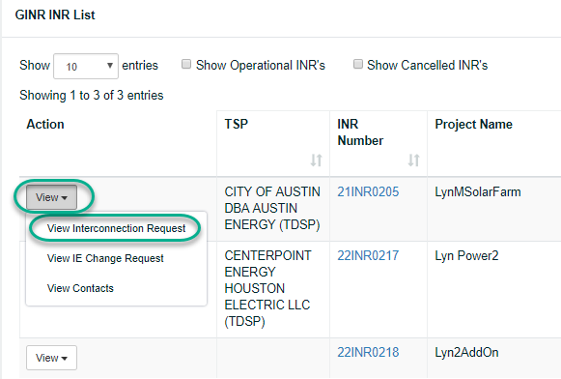
Click the View dropdown and click View Interconnection Request.

Interconnection Request Page
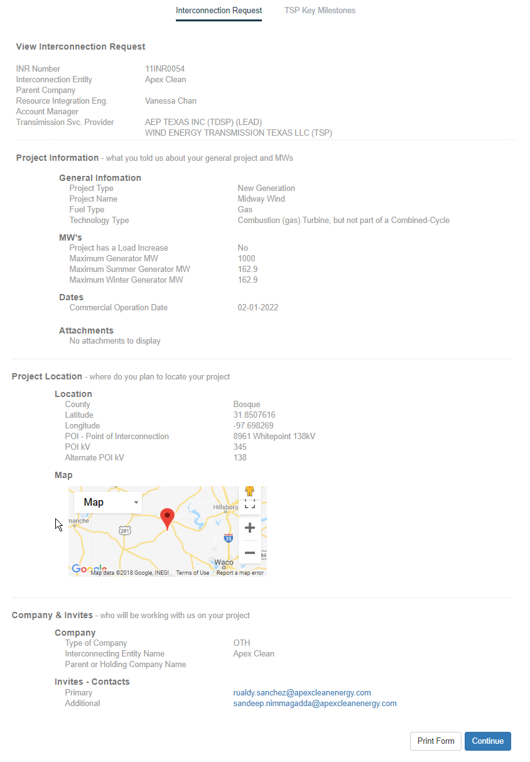
To view the TSP Key Milestones, click the Continue button at the bottom of the page or the TSP Key Milestones link at the top of the page.
Or, to leave this page and return to the Interconnection Request List, click the logo in the upper left.

TSP Key Milestones
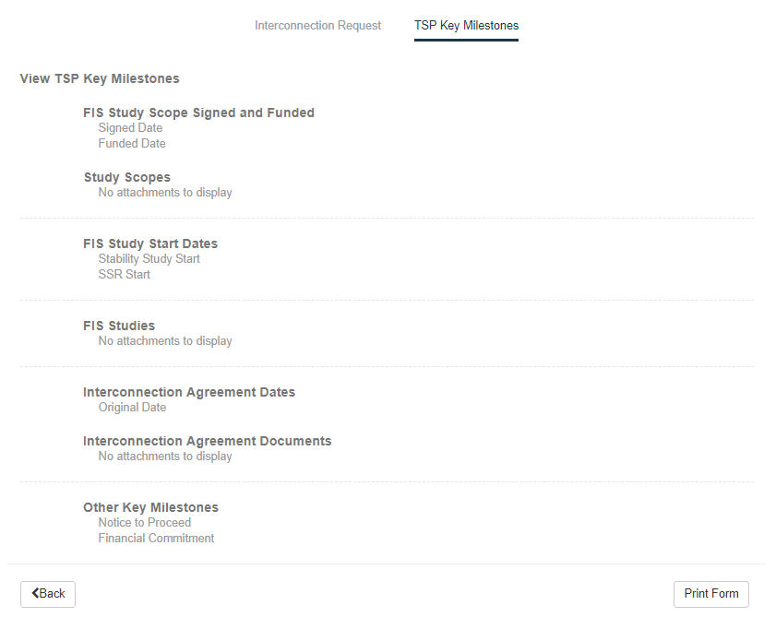
When you are finished, click the logo in the upper left to return to the Interconnection Request List.

Viewing a Change Request from the IE
When you view a Change Request the IE has submitted on their INR, the INR details of the project display along with links to view all of the attachments and the TSP Key Milestones for the project.

Interconnection Services List
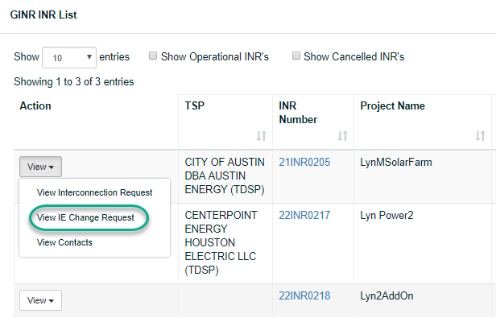
Click the View dropdown and click View IE Change Request.

Review changes Page
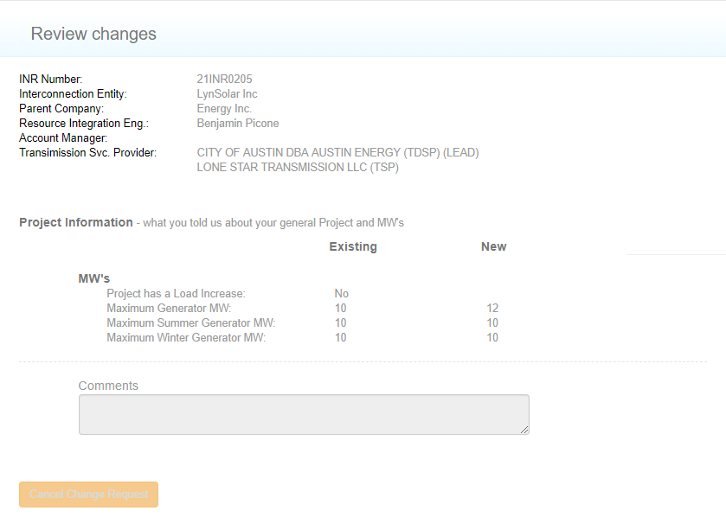
Review the information that changed.
When you are finished, click the logo in the upper left to return to the Interconnection Request List.

Viewing Contacts Associated with the INR
You can view the contacts associated with the request, which displays their email address, phone number, and when they were invited to join the project.

Interconnection Services List
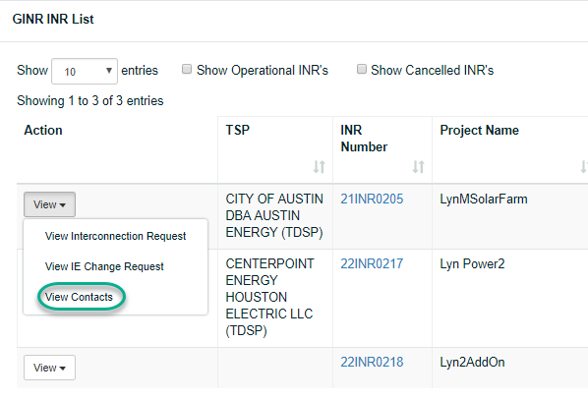
Click the View dropdown and click View IE Change Request.

All Contacts Page
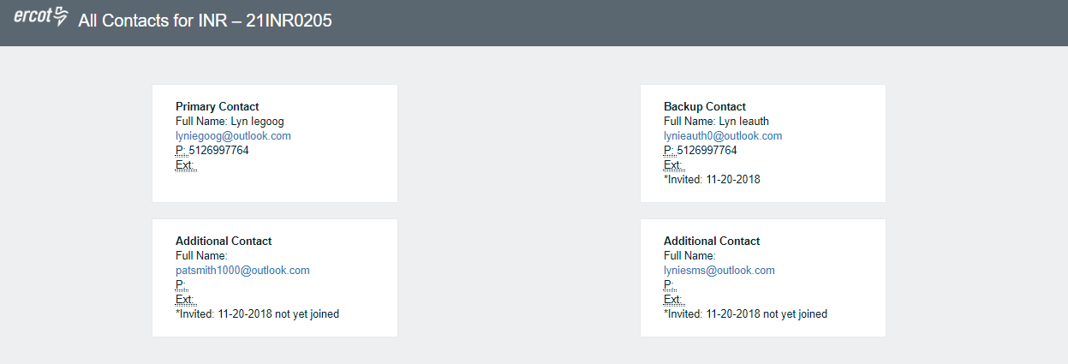
When you are finished, click the logo in the upper left to return to the Interconnection Request List.

Reviewing Draft Documents
When you receive an email about reviewing a document, you can access the document in the Attachments List off the Interconnection Services List page. You can search for the document to review by its INR number, project name, or TDSP referenced on the email as well as the IE who uploaded the document.
In addition, you can search for all attachments:
Within a date range
In a specific study phase
Of a specific attachment type
Of a type of technology
In a Texas County location
You can close the Search panel to move it out of your way and display it as a tab for easy opening, or if the panel is closed, you can click Open Search to display it.
To locate and review a document:

Interconnection Services List
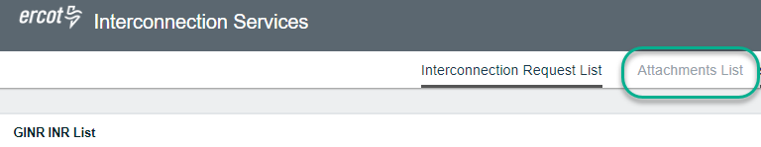
Click the Attachments List link at the top of the page.

Attachments List Page
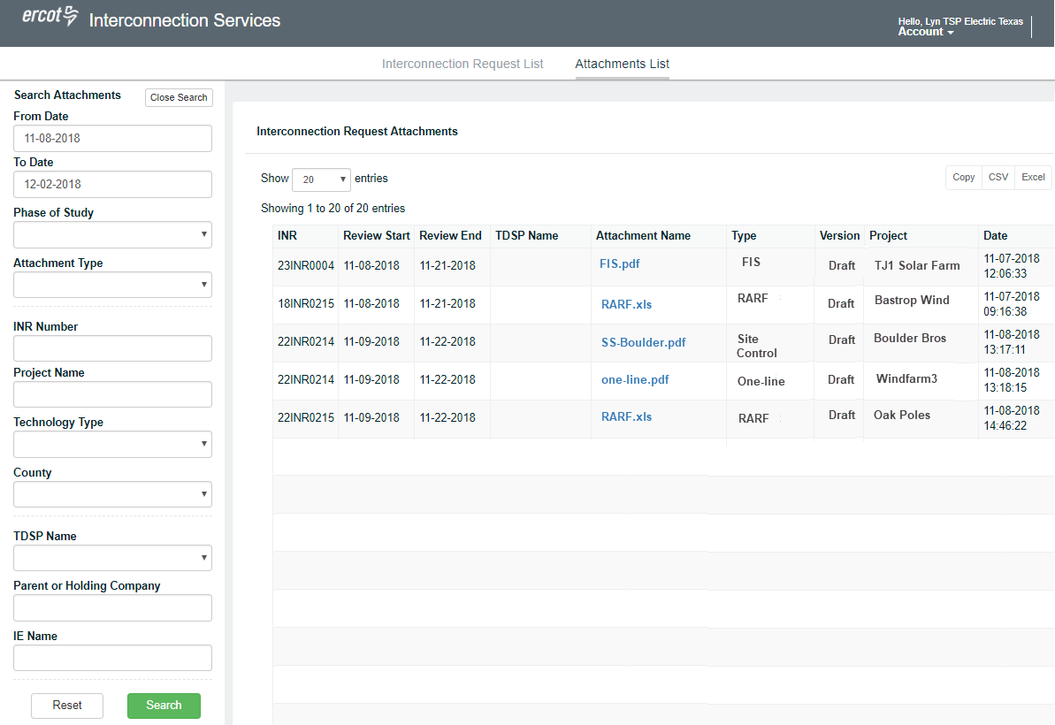
Click the link of the document to review if it is in sight OR search for the document (refer to the next page).
Prepare your review comments/changes.
Return your comment to the TDSP who sent you the review email.

Search Panel
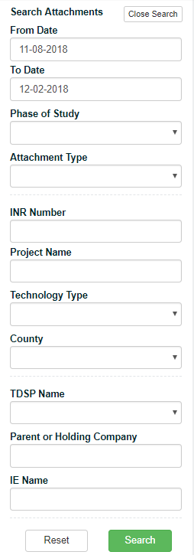
To be explained in more detail later.

Open Search Panel Tab
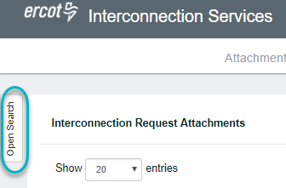
Click the Open Search tab.

Adding Change Requests for FIS Studies
You can submit a Change Request to begin an FIS Study for a project.

Adding a Change Request for an FIS Study Scope
The FIS Study Scope enables you to update the date on which the request was signed and enter a date when the payment has been received to perform the FIS. The draft and final version of Study Scope documents must also be uploaded.

Interconnection Request List
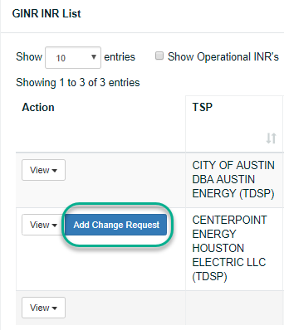
After locating the INR, click the Add Change Request button.

TDSP Change Request for Key Milestones Page
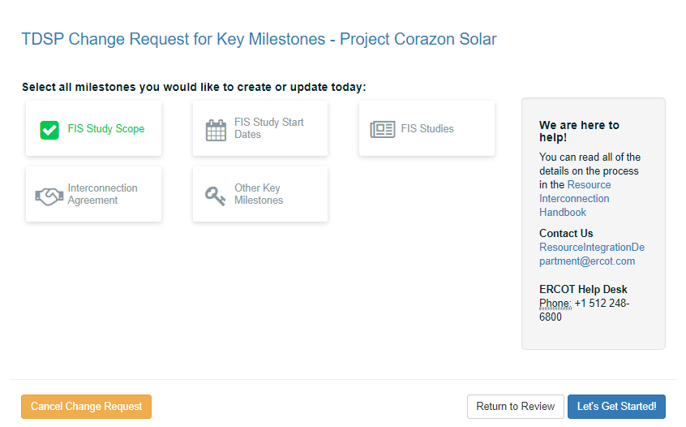
Click FIS Study Scope and then click the Let’s Get Started button.

FIS Study Scope Details Page
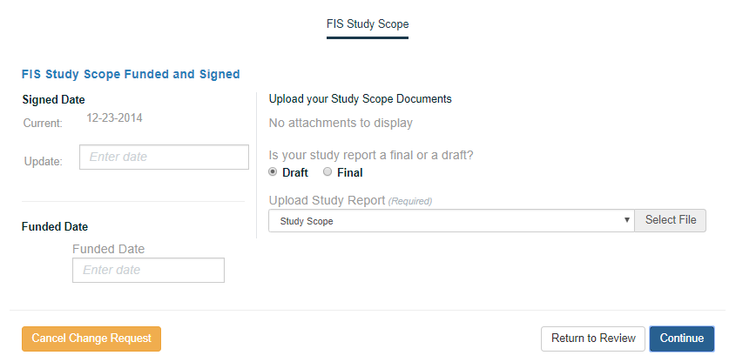
For the Signed Date, type in the date that the IE submitted and signed the request.
For the Funded Date, type in the date the payment for the FIS was received.
Click the Continue button.

TSP Key Milestones Page
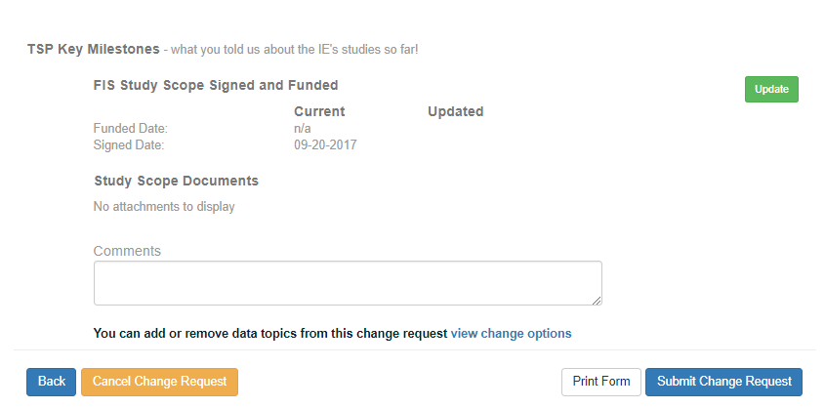
Click the Submit Change Request button.

Adding a Change Request for an FIS Study Start Date

Interconnection Request List
After locating the INR, click the Add Change Request button.

TSP Change Request for Key Milestones Page
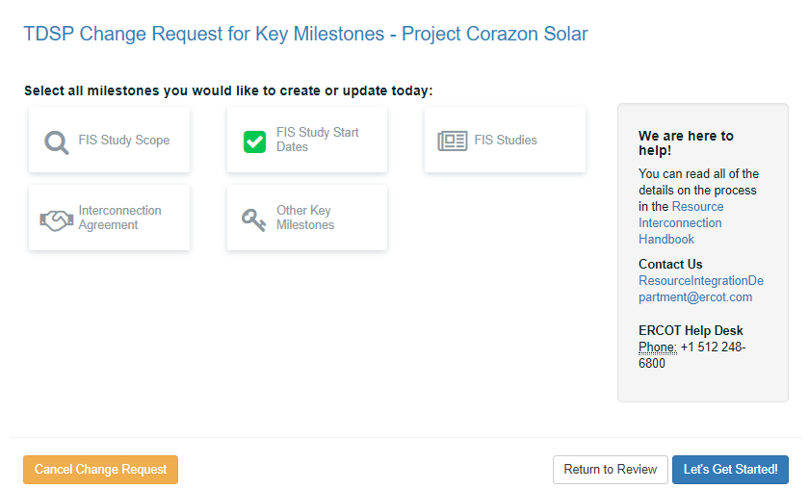
Click FIS Study Start Dates and then click the Let’s Get Started button.

FIS Study Start Dates Page
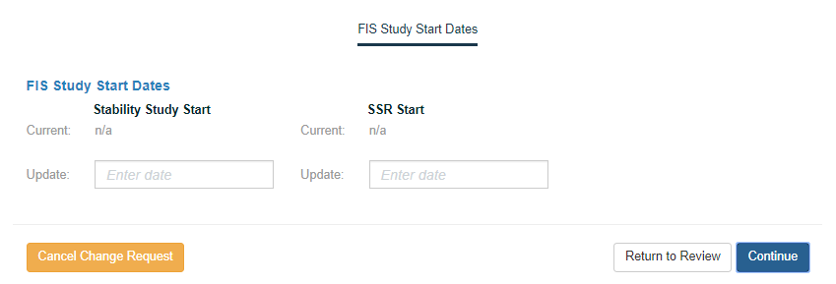
Click the button

TSP Key Milestones Page
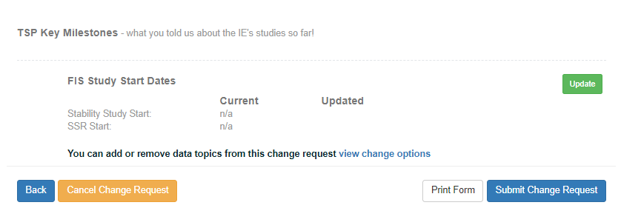
Click the Submit Change Request button.

Adding a Change Request for FIS Studies

Interconnection Request List
After locating the INR, click the Add Change Request button.

TDSP Change Request for Key Milestones Page
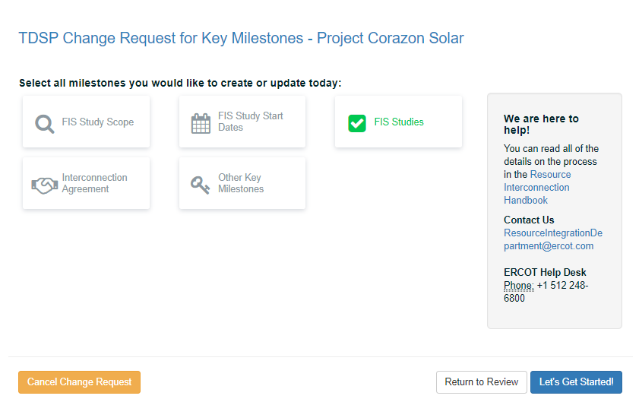
Click FIS Studies and then click the Let’s Get Started button.

FIS Studies Page
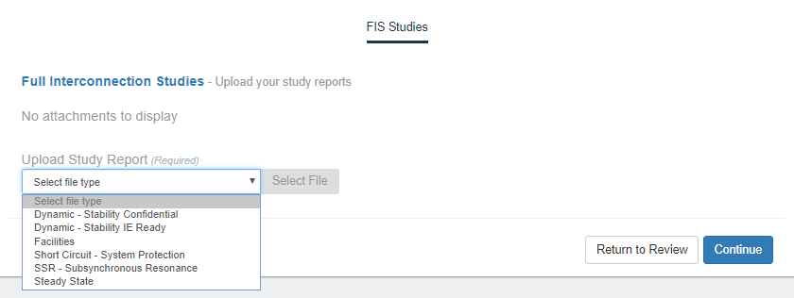
Click the File Type dropdown and click the types of studies you will upload.
For each file to upload:
Click the Select file type dropdown and click the type of file you plan to upload.
Click the +Choose File button, navigate to the file on your computer, and click the file.
When you are finished, click the Continue button.

TSP Key Milestones Page
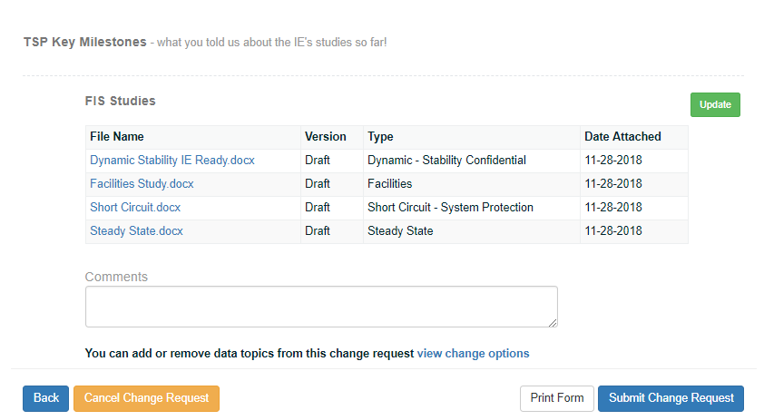
Click the Submit Change Request button.

Recording the Interconnection Agreement Date
When the Interconnection Agreement has been signed, you can record the signed date and upload a copy of the agreement file.

Interconnection Request List
After locating the INR, click the Add Change Request button.

TDSP Change Request for Key Milestones Page
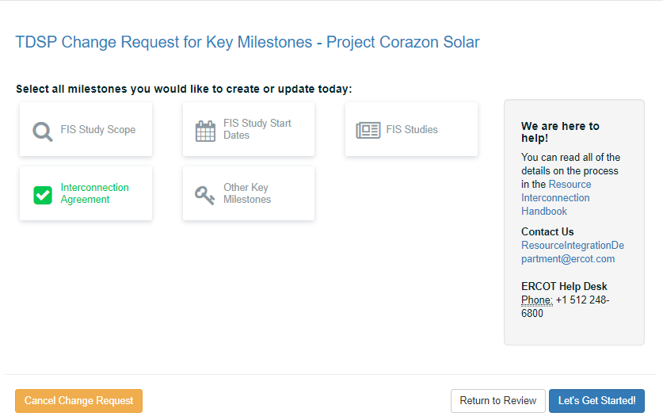
Click Interconnection Agreement and then click the Let’s Get Started button.

Interconnection Agreement Page
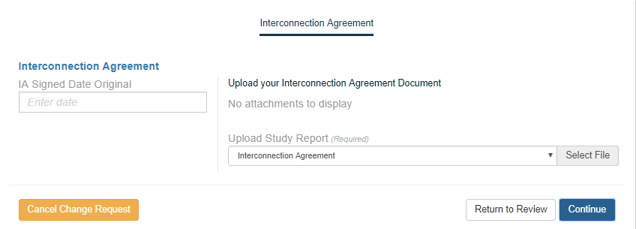
Type in the date the IA was signed.
Click the Select File button, locate the file and click Open.
Click the Continue button.

TSP Key Milestones Page
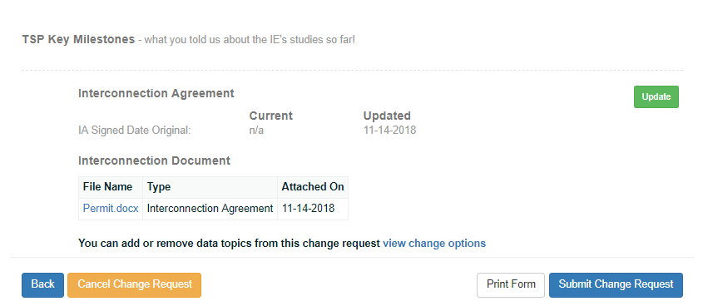
Click the Submit Change Request button.

Recording the Notice to Proceed Date
When the Notice to Proceed has been signed and received, you can record the date it was signed.

Interconnection Request List
After locating the INR, click the Add Change Request button.

TDSP Change Request for Key Milestones Page
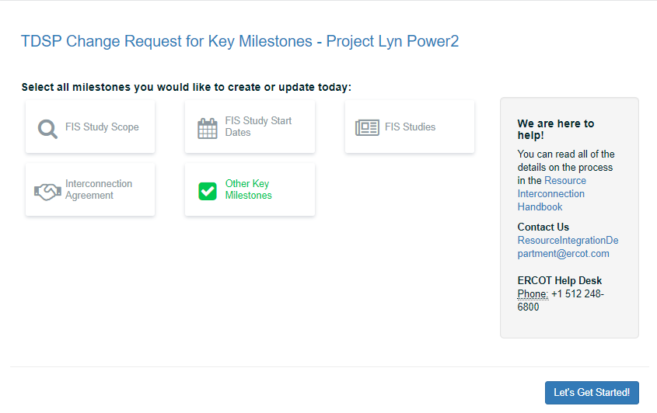
Click Other Key Milestones and then click the Let’s Get Started button.

Other Key Milestones Page
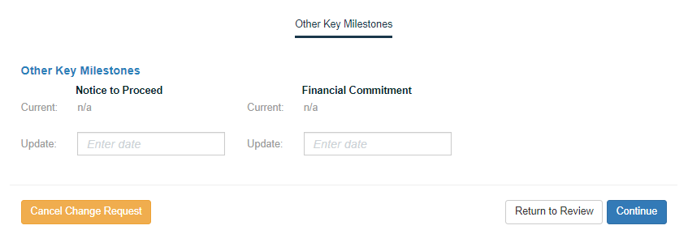
Record the date this document was signed.
Click the Continue button.

TSP Key Milestones Page
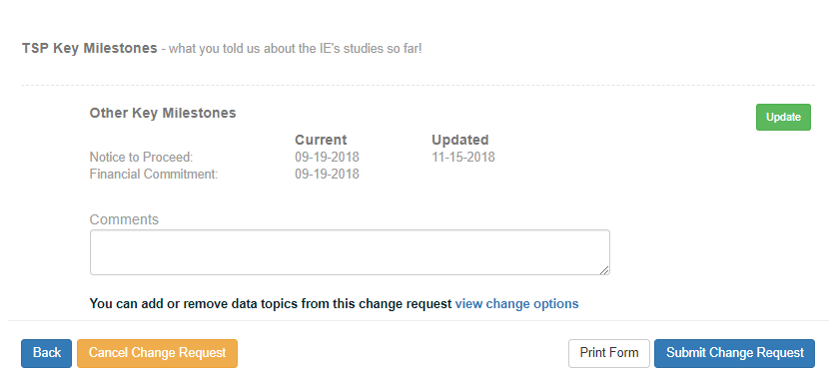
Click the Submit Change Request button.

Recording the Financial Commitment Date
When the Financial Commitment is signed, you can record the date using a Change Request.

Interconnection Request List
After locating the INR, click the Add Change Request button.

TDSP Change Request for Key Milestones Page
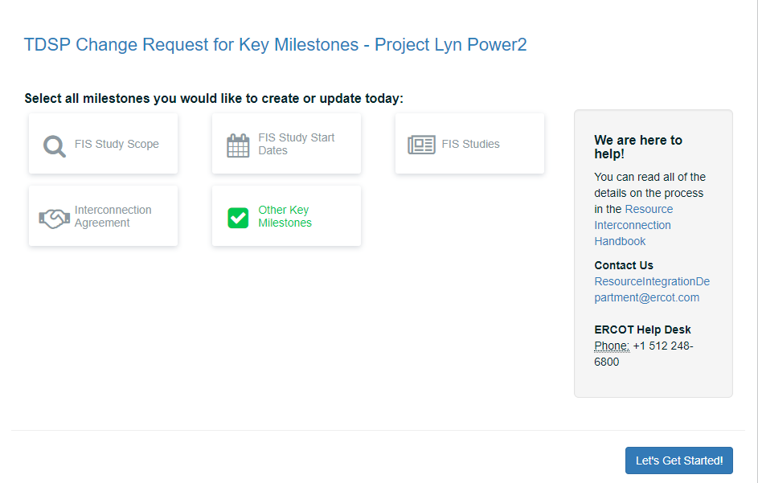
Click Other Key Milestones and then click the Let’s Get Started button.

Other Key Milestones
Type in the date the Financial Commitment was signed.
Click the Continue button.

TSP Key Milestones Page
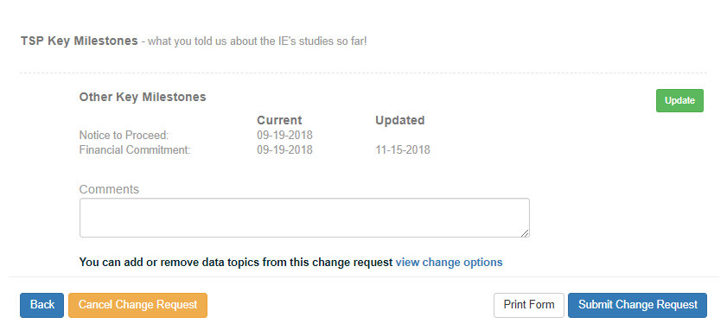
Click the Submit Change Request button.

Index

accessing your account, 3
attachments, 12
Change Request
Financial Commitment Date, 35
FIS Start Date, 26
FIS Studies, 20
FIS Study Scope, 23
IA date, 29
Notice to Proceed, 32
contacts, 16
drafts, reviewing, 17
Financial Commitment date, 13
FIS change requests, 20
FIS dates, 13
FIS Studies change request, 20
FIS Study Scope change request, 23
FIS Sudy Start Date change request, 26
forgotten password, 7
IA, record date, 29
IE Change Requests, viewing, 14
INR, viewing, 10
Interconnection Agreement date, 13
key milestones,viewing 13
logging in
accessing account, 3
Auth0 Guardian, 4
Google Authenticator, 5
SMS Authentication, 6
logging out, 6
milestones
Financial Commitment date, 13
Interconnection Agreement date, 13
Notice to Proceed date, 13
Notice to Proceed date, 13, 32
password
recovery, 7
reset, 7
recording the financial commitment date, 35
reset password, 7
reviewing drafts, 17
searching for documents, 17
view an INR, 10
viewing IE Change Requests, 14

