IE – Class Outline
- Sign Up Reference
  - With Auth0 – Guardian application and your smart phone – page 2
  - With Google Authenticator application and your smart phone – page 14
  - With SMS “Text” and your phone
Note: If you do not want to use your phone or personal phone number, you can use a free phone number like Google Voice (see Candy)
- Logging In – page 3
- Reviewing the Interconnection List

Interconnection Request List
What is In the Interconnection Request List?
Alert
Alerts tell you when ERCOT is waiting for you to respond to an Interconnection Request or change request.
- UD – ERCOT needs more information on your Interconnection Request (INR). – page 31
- – ERCOT has made a suggestion on your change request.
INR Number
Submitting your interconnection request (INR), will assign an INR number. The INR number displays the year your project is projected to be operational, the label INR, and a sequential number: YYINR0001.
Project Name
The name of your interconnection project.
Primary Name
This is who created and submitted the Interconnection Request.
Company
The name of the company you provided on the Interconnection Request.
% in Process
This is a rough estimate of how much of the interconnection process you have completed.
Status
The status of the Interconnection Request or change request.
Last Updated
The last time you or ERCOT updated the request
Actions
The tasks available for you to take on your request.

How do I work with the Interconnection Request List

Search
Type in some keywords on which you would like to search. The search finds them as you type.
Click on the button to clear and reset search.

Sort Ascending and Descending
Click on the up and down arrows in the column header to sort the column ascending. Click on the arrows a second time to reverse the order. You can only sort one column at a time.

When are my unfinished requests saved
Your request is automatically saves as soon as you begin the request.

Interconnection Requests (INR)
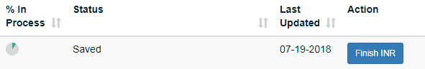
To continue working on your saved Interconnection Request from the Interconnection Request List, click on the Finish INR button

Changes Requests
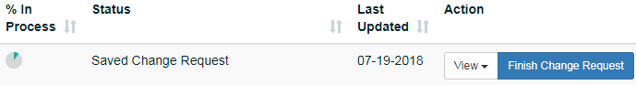
To continue working on your saved change request from the Interconnection Request List, click on the Finish Change Request button

Interconnection Flow

- Creating an Interconnection Request
  - Completing the Interconnection Request Pages - page Error! Bookmark not defined.
  - Reviewing Your Interconnection Request – page 27
  - Electronically Signing and Submitting Your Request – page Error! Bookmark not defined.
  - Corresponding with ERCOT About Your Request - page Error! Bookmark not defined.

- Understanding Change Requests
  - Create a change request for
    - Project Name - page 37
    - MW - page 41
    - Project Dates – 45

- View from Interconnection List
  - View Interconnection Request you created
  - View Change Request you created

How do I view requests and change requests?

View Interconnection Requests
From the Action column on the Interconnection Request List, select View Interconnection Request.

View Change Requests
From the Action column on the Interconnection Request List, select View Change Request.
Note: If you do not see an active View Change Request, in the list, then this Interconnection Request (INR) does not currently have a change in progress.

- Request an FIS
  - Create an FIS Change Request – page 95

- Managing the Contacts On Your Project
  - Viewing Project Contacts - page Error! Bookmark not defined.
  - Inviting New Contacts or Backups - page Error! Bookmark not defined.
  - Editing Contact Information - page Error! Bookmark not defined.
  - Removing a Contact from the Project - page Error! Bookmark not defined.

