
RIOO Interconnection Services Sign Up Reference
Version 1
11/30/2018

About this Guide
This guide describes the steps involved in signing up for an ERCOT Interconnection Services account that you can use to submit new requests for generation projects for all types of power technology including traditional, wind, and solar.
After you sign up, you can create an Interconnection Request (INR) for a new power resource or add to an existing resource.
Contents
About the Interconnection Services Account Sign Up Process 1
Signing Up with Auth0 Guardian as the Authentication App 2
Signing Up with Google Authenticator as the Authentication App 13
Signing Up With a Text Message-Enabled SMS Phone 24

About the Interconnection Services Account Sign Up Process
To request a new generation site or add a generation resource to an existing site, you must first sign up for an account on the ERCOT Interconnection Services website.
The sign up process involves working through a series of pages on the ERCOT Interconnection Services website and several screens on your mobile phone plus one verification email sent to your email account. To accomplish this you must have:
- Access to the Internet to get to the Interconnection Services website.
- An email address at which you can receive email during this sign up process. This email address also serves as your user name for the account login.
- A mobile telephone number at which you can receive text messages during this sign up process from the authentication app you select to use. If you have a smartphone, you can reduce the amount of typing required by the SMS method by downloading either the AUTH0 Guardian or Google Authenticator authentication app on your phone. (These apps are free of charge to download from the App Store or Google Play.)
After your account is created successfully, you will be prompted to log in to your new account to be sure you can view the Interconnection Services List page. Note that you will need to enter your authentication code sent to your phone as well as your login information at least the first time you log in, but you can click the Remember this browser checkbox on xxx pageso that you do not need to consult your phone for the authentication code each time you log in.
Before you begin, you should:
- Have your email account open to your Inbox so you can open the email messages sent to your account during this process
- Have a text editor (such as Notepad or Word) file open that you named something like
ERCOT Auth Information so you can easily copy in your recovery code as recommended when you work through this process
- Download either the AUTH0 Guardian or Google Authenticator authentication app from either the Apple Store or Google Play to your smartphone. (If you do not use a smartphone, you can use the SMS authentication methods described in this guide.)

Signing Up with Auth0 Guardian as the Authentication App
This section contains the steps for signing up for an Interconnection Services account, setting Google Authenticator as your authentication app, and then logging in to verify your access.

Signing Up for Your Account
To access the ERCOT Interconnection Services, click the link provided in an email from ERCOT or on ercot.com.

Log In Page
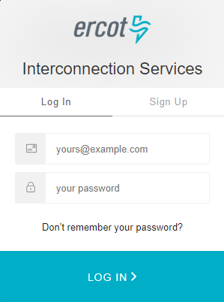
Click this Sign Up tab.

Sign Up Page
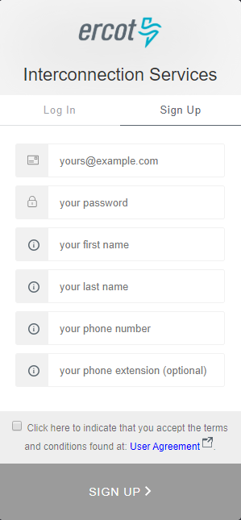
Type in, as your user name, the email address where you can receive email about this account.
Type in a password for logging into this account using the rules displayed as you type.
Type in your first name and last name to associate with this account.
Type in the telephone number to associate with this account. Type in only the numbers (no spaces). And, optionally enter an extension if one exists.
Click the User Agreement link, read the information and close the window, and then click the checkbox.
Click the SIGN UP > button.
On this page:

Authentication Method Page
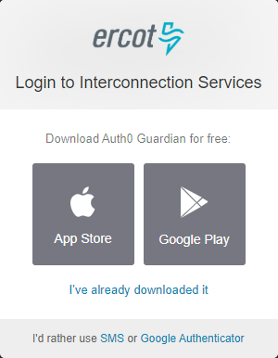
Click the I’ve already downloaded it link.
If you have not already downloaded the Auth0 Guardian app, you can download it now using one of the App Store or Google Play buttons on this page.
However, if you download the app now, Interconnection Services may time out and display the login page for you to start your sign up over again.

Bar Code Page
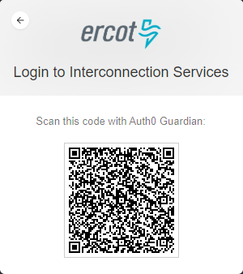
When this page displays, open your smart phone and click the  Guardian app to open it..

Scan Bar Code Page (On Phone)
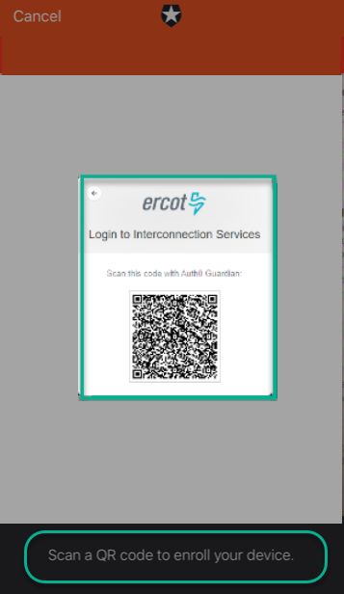
Position your phone over the bar code until the bar code border turns green to indicate it was scanned.

Recovery Code Page
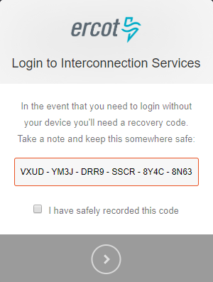
On this page:
Copy this code and paste it into the file you opened earlier for this purpose (refer to
page 1).
Click the checkbox so you do not need to get and enter an authentication code every time you log in.
Click the  to continue.

Congratulations, You are all Set Page
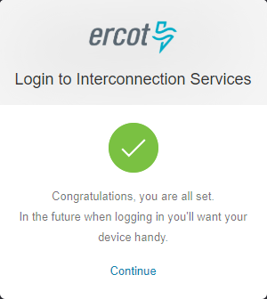
Click the Continue link.

Click the Continue link.
Sent Push and Remember This Browser Page
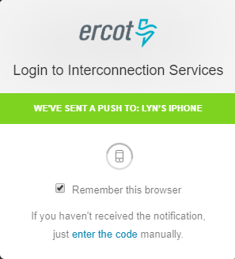
Click the Remember this browser checkbox.
Note: If you do not turn this feature on, you will be prompted to enter this code every time you log in.

Guardian Auth0 Notification (On Phone)
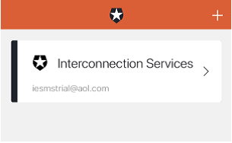
Go back to your phone and click >.

Guardian Auth0 Push Message (On Phone)
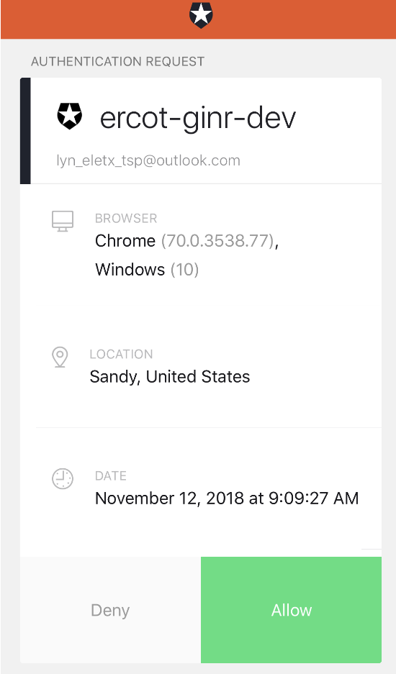
And then, click the Allow button.

Almost Done Page – Go to Your Email
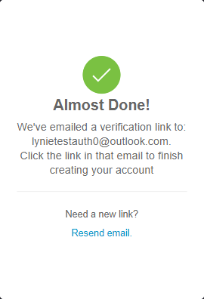
Open your email Inbox and open the Verify your email message (from ercot.com).

Verify Account Email (in Your Inbox)
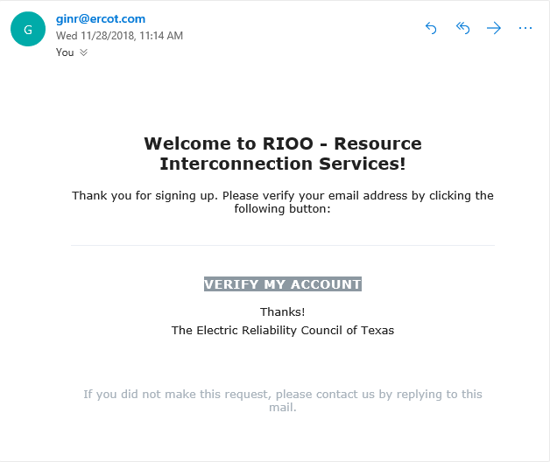
Click the VERIFY MY ACCOUNT button.

Congratulations Page
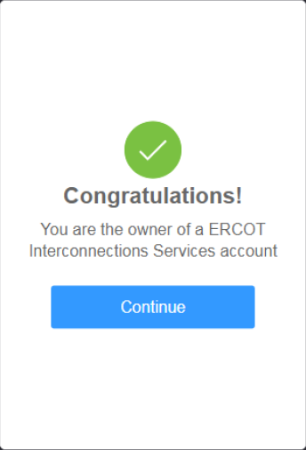
Click the Continue button.

Verifying Your Account Log In
Now you will log in using the user name (email address) and password created at sign up to be sure you can access the Interconnection Request List.

Log In Page
On this page:
Click the LOG IN > button.
Type the password you created at sign up.
Note: If you do not remember your password, click the Don’t remember your password? link. Refer to Resetting Your Forgotten Password in the User Guide.
Type the email address you used to sign up.

Authentication Request Process (On Phone)
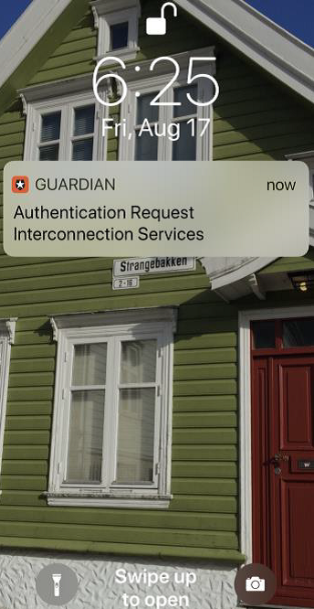
Locate the Guardian message on your phone and swipe to open it..
If you did not click the Remember this browser checkbox in an earlier step, you will need to go to your phone to authenticate again.
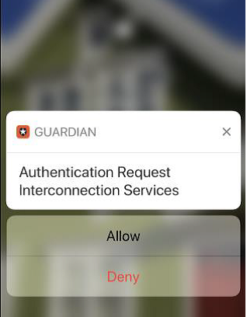
. Tap the Allow button.

Your Interconnection Request List Page
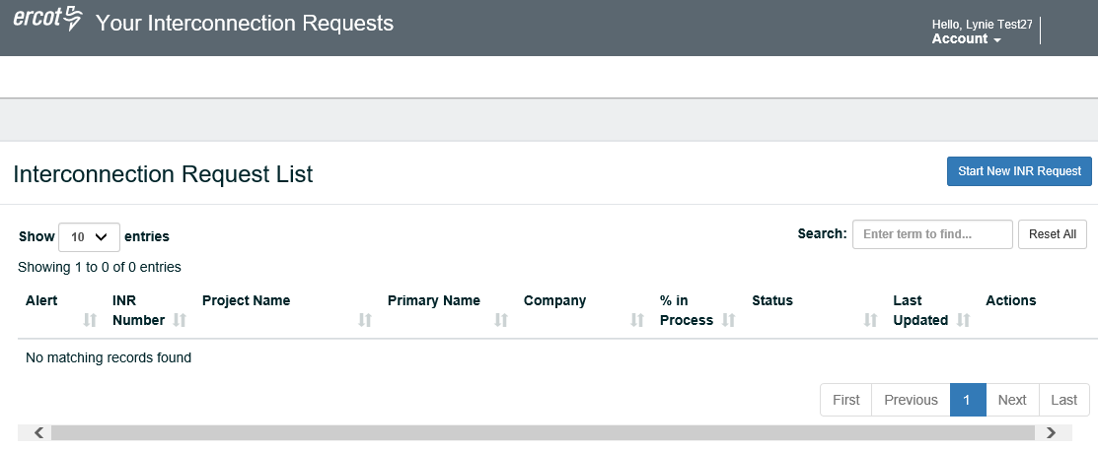

Signing Up with Google Authenticator as the Authentication App
This section contains the steps for signing up for an Interconnection Services account, setting Google Authenticator as your authentication app, and then logging in to verify your access.

Signing Up for Your Account
To access the ERCOT Interconnection Services, click the link provided in an email from ERCOT or on ercot.com.

Log In Page
Click this Sign Up tab.

Sign Up Page
On this page:
Type in, as your user name, the email address where you can receive email about this account.
Type in a password for logging into this account using the rules displayed as you type.
Type in your first name and last name to associate with this account.
Type in the telephone number to associate with this account. Type in only the numbers (no spaces). And, optionally enter an extension if one exists.
Click the User Agreement link, read the information and close the window, and then click the checkbox.
Click the SIGN UP > button.

Authentication Method Page
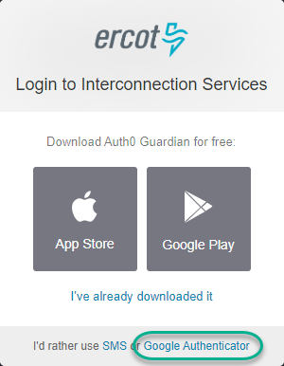
Click the Google Authenticator link.
If you have not downloaded the Google Authenticator app, you can download it now using one of the App Store or Google Play buttons on this page.
However, if you download the app now, Interconnection Services may time out and display the login page for you to start your sign up over again.

Bar Code Page
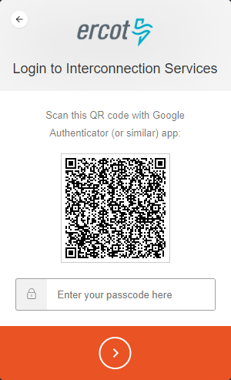
When this page displays, open your smartphone and click the Google Authenticator app to open it..

Scan Bar Code Page (On Phone)
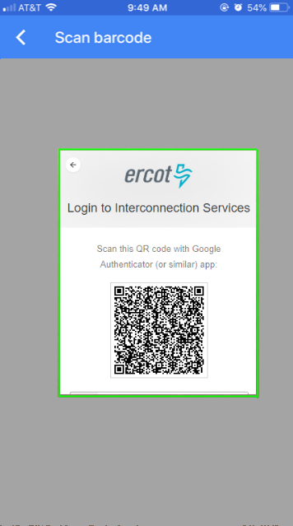
Position your phone over the bar code until the bar code border turns green to indicate it was scanned.

Recover Code Page
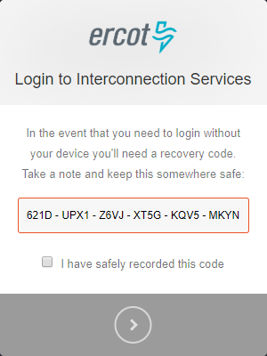
Click the checkbox so you do not need to get and enter an authentication code every time you log in.
Click the to continue.
Copy this code and paste it into the file you opened earlier for this purpose (refer to
page 1).
On this page:

Congratulations, You are all Set Page
Click the Continue link.

Authenticator App Code Page (On Phone)
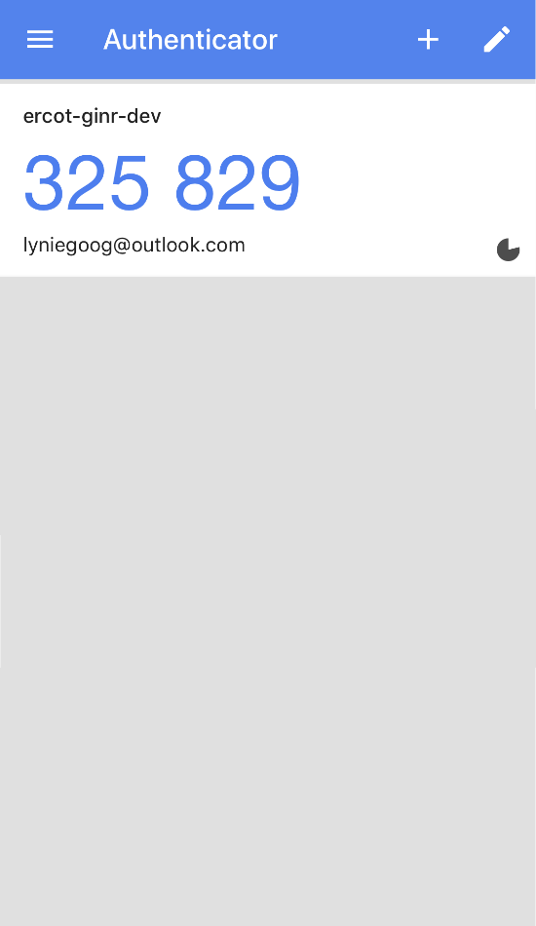
Go to your phone for your authentication code from Authenticator.

Enter Code from Authenticator Page
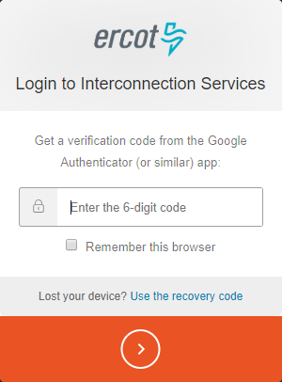
Click the  to continue.
Click the Remember this browser checkbox.
Note: If you do not turn this feature on, you will be prompted to enter this code every time you log in.
Type in the 6-digit code from the Authenticator screen on your phone
Complete the following:

Almost Done Page – Go to Your Email
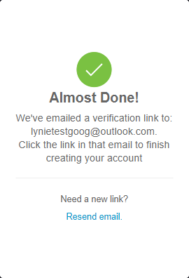
Open your email Inbox and open the Verify your email message (from ercot.com).

Verify Account Email (in Your Inbox)
Click the VERIFY MY ACCOUNT button.

Congratulations Page
Click the Continue button.

Verifying Your Account Log In
Now you will log in using the user name (email address) and password created at sign up to be sure you can access the Interconnection Request List.

Log In Page
Type the email address you used to sign up.
Type the password you created at sign up.
Note: If you do not remember your password, click the Don’t remember your password? link. Refer to Resetting Your Forgotten Password in the User Guide.
On this page:
Click the LOG IN > button.

Your Interconnection Request List Page
** If you did not click the Remember this browser checkbox earlier in the process, the Get Verification Code page displays first. Use the following instructions.

If this page displays when logging in:
Click to continue to the Interconnection Request List page.
Click this checkbox to avoid having to do this every time you log in.
Type in the 6 numbers of your new code.
Go to your mobile phone and open Authenticator. A new code should display.
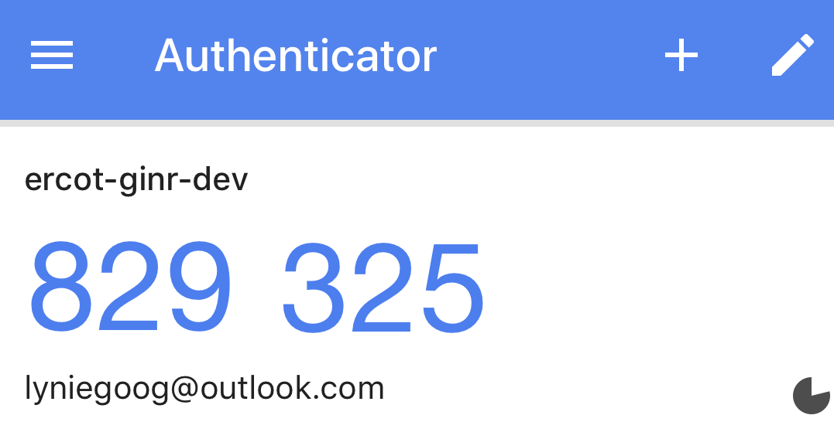

Your Interconnection Request List Page

Signing Up With a Text Message-Enabled SMS Phone
This section contains the steps for signing up for an Interconnection Services account, setting your authentication, and then logging in to verify your access.

Signing Up for Your Account
To access the ERCOT Interconnection Services, click the link provided in an email from ERCOT or on ercot.com.

Log In Page
Click this Sign Up tab.

Sign Up Page
Type in the information on this signup page:
Type in, as your user name, the email address where you can receive email about this account.
Type in a password for logging into this account using the rules displayed as you type.
Type in your first name and last name to associate with this account.
Type in the telephone number to associate with this account. Type in only the numbers (no spaces). And, optionally enter an extension if one exists.
Click the User Agreement link, read the information and close the window, and then click the checkbox.
Click the SIGN UP > button.

Authentication Method Page
Click the SMS link.
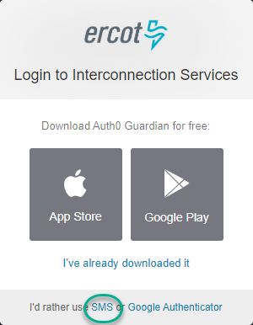

Phone Number Page
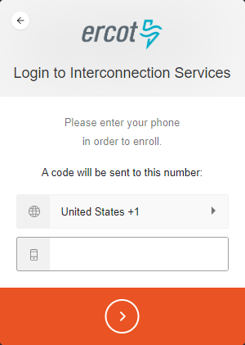
Type in a valid mobile phone number for ERCOT to send you an authentication code and then click the  button to continue to the next page.

SMS Message on Phone
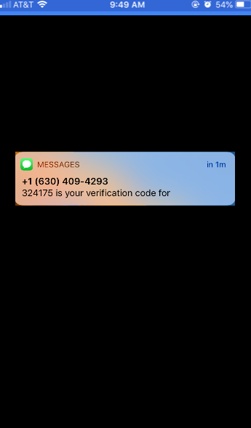
Check for the message on your phone and open it so you can view the authentication code.
On this page:

Enter the Authentication Code Page
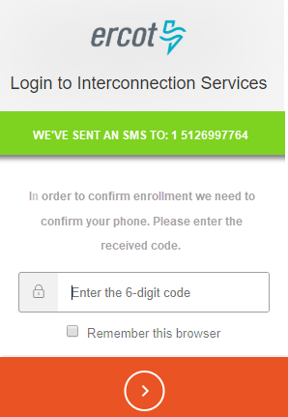
Type in the 6 numbers from your phone.
Click the button to continue to the next page.
Click the Remember this browser checkbox.
Note: If you do not turn this feature on, you will be prompted to type in this code every time you log in.

Recovery Code Page
On this page:
Copy this code and paste it into the file you opened earlier for this purpose (refer to
page 1).
Click the to continue.
Click the checkbox so you do not need to get and enter an authentication code every time you log in.

Continue Page
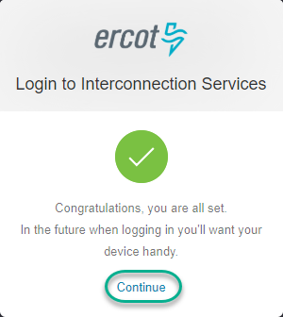
Click the Continue link.

Almost Done Page
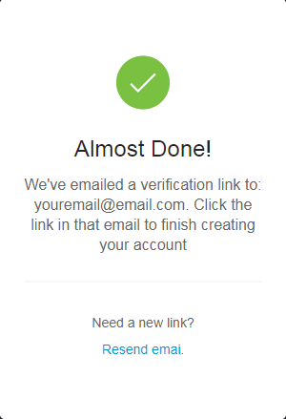
Open your email Inbox and open the Verify your email message (from ercot.com).

Confirmation Email
Click the VERIFY MY ACCOUNT button.

Congratulations Page
Click the Continue button to return to the Login page.

Verifying Your Account Log In
Now you will log in using the user name (email address) and password created at sign up to be sure you can access the Interconnection Request List.

Log In Page
On this page:
Click the LOG IN > button.
Type the password you created at sign up.
Note: If you do not remember your password, click the link. Refer to Resetting Your Forgotten Password in the User Guide.
Type the email address you used to sign up.

Authentication Code (on Phone)
Go to your phone and open the message.

Enter 6 Digit Authentication Code Page
Click the Remember this browser checkbox.
Note: If you do not turn this feature on, you will be prompted to type in this code every time you log in.
On this page:
Click the button to continue to the next page.
Type in the 6 numbers from the message on your phone.

Your Interconnection Request List Page

