PWG Meeting Notes – October 9th, 2018
WebEx only
9:30 – 10:30

Attendees:
Bill Boswell – ERCOT
Calvin Opheim - ERCOT
Sam Pak – Oncor
Sheri Wiegand – TXU
Kathy Scott – CNP
Nikki McKenna - ERCOT
Carolyn Reed – CNP
Phil Bracy, ERCOT
Jim Lee – AEP
Randy Roberts, ERCOT
Kyle Bessette
Jose Conto

- Sheri Wiegand, Chair, read Antitrust Admonition and reviewed the agenda
- Meeting minutes from July 23rd meeting were approved as proposed

- 2018 Annual Validation
Nikki presented the update on the 2018 Annual Validation reporting “it is complete”. All TDSPs have completed at least 99% of the 814_20 transactions to execute revisions
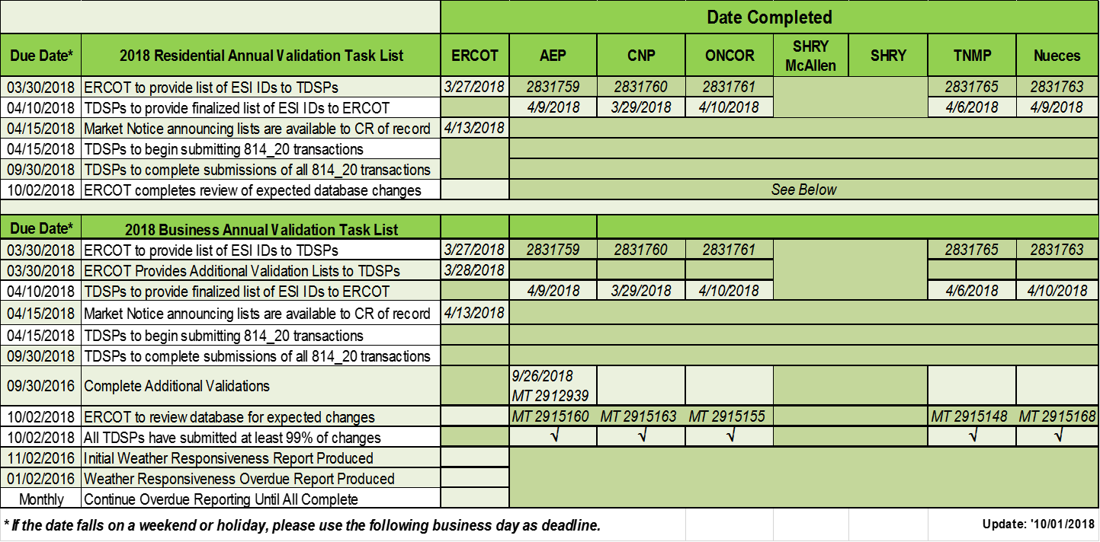

- Weather Sensitive/Non-Weather Sensitive Reporting
Randy Roberts reminded TDSPs the WS/NWS report will run at the beginning of next month and one MT will be sent to each of the affected TDSPs and the report of impacted ESIs will be available in MIS
- Questions/Issues for discussion at upcoming IDR workshop
  - There was discussion on the goal of the upcoming workshop. If the goal was to revisit a solution for availability of interval data for initial settlement for IDR Meters while considering BUSIDRRQ profiles and 4CP implications, Randy opined the workshop may be “too early” since an easier solution may be found via tariff revisions.
    - Oncor has already revised tariffs to disassociate the meter asset with 4CP demand billing. TNMP’s pending rate case also proposes the similar methodology. With the two remaining IOUs scheduled for rate cases in the next couple of years, it might be best to hold off on the workshop until the end of 2019 when the approach or vision may be decided.
    - Kathy and Jim agreed commitments could not be made at this time as to the direction of the tariffs for 2020.
    - Jim shared AEP is currently reviewing an IDR to AMS conversion project, however, still guided by ‘once an BUSIDRRQ, always a BUSIDRRQ’
      - Kathy noted such a conversion was not included in CNP’s deployment plan
- The following questions were originally proposed for consideration at the IDR Workshop to clarify TDSP processes around the designation of DG load profiles:
    - Is the DG profile assigned only if the customer intends to inject surplus generation back onto the grid?
    - Is the DG profile assigned if an interconnection agreement is made with the customer at the premise?
    - Is the DG profile assigned only if a bi-directional or two channel (in and out) meter is installed/provisioned at the premise?
    - Are bi-directional or two channel meters only installed/provisioned if the customer has the potential to inject back onto the grid?
- If a large customer has back up generation behind the meter, at what point will they be given a DG profile?
- If a customer installs PV panels, at what point will they be given a DG profile?
- Randy Roberts noted the LPG requires TDSPs to report DG via the load profile if the customer has installed any DG. It is questioned if the TDSPs follow the same process in classifying.
- After discussion about the purpose of the upcoming IDR Workshop, it was decided, Sheri and RMS leadership will discuss the need for the IDR Workshop and if ERCOT’s/market’s needs for an understanding of DG profiles can be vetted and reported through the PWG, thereby cancelling the IDR Workshop.
- In preparation for the DG load profile discussion, Jim (TDSPs) and Calvin(ERCOT) will convene to review/modify the above questions for the TDSPs to address at a later date (early 2019). The questions will be reviewed by PWG at their next meeting.
- It was also clarified the exercise conducted at the beginning of 2018 whereby ERCOT forward to the TDSPs all their BUSIDRRQ ESIs for review to report if any had DG behind the meter as known via an interconnect agreement with the customer. This exercise concluded that the population is very minimal of BUSIDRRQ ESIs with DG that do not already have a RID reporting excess generation. Therefore, system changes are not supported for DG visibility at this time.

- Other Business – Lubbock’s entry to ERCOT
  - Randy suggested the LPG will need to be revised as Lubbock moves to ERCOT. For example, the weather zone will need to be reviewed. PWG expressed to Calvin and Randy that WMS was likely the place to begin the discussion on an appropriate weather zone (new or existing, and which one). PWG will follow the decision and then can operationalize the outcome.
  - When modifications regarding Lubbock are made, at that time, it is suggested the Time of Use tab on the Decision Tree be eliminated since these sections were removed from LPG.
- Update on NPRR881 and LPGRR65
NPRR was approved at PRS on 10/13. The IA will be up for review at the 10/18 PRS. The IA is a no- impact IA for ERCOT and is expected to be approved. The paired NPRR/LPGRR will go to the Board on 12/11. If approved, the revisions will become effective 1/1/2019. Sheri will remind TDSPs the new default profile for metered non-residential ESIs will be BUSLOLF during her RMS update on 10/16.

NEXT MEETING: December 4th (After RMS) - the meeting will be F2F with a WebEx option. The proposed agenda is as follows:
- Update of WS/NWS report
- Review of DG load profile questions for the TDSPs
- Plan for 2019 Meetings
- Review 2018 Accomplishments/2019 Goals

