System Planning

Monthly Status Report
October 2018

Report Highlights
- ERCOT is currently reviewing proposed transmission improvements with a total estimated cost of $579.4 Million as of October 31, 2018.
- Transmission Projects endorsed in 2018 total $560.15 Million as of October 31, 2018
- All projects (in engineering, routing, licensing and construction) total approximately $6.49 Billion as of June 1, 2018.
- Transmission Projects energized in 2018 total about $1.120 Billion as of June 1, 2018.

Regional Planning Group Project Reviews
- Garland Power & Light and Oncor have jointly submitted the North Garland Reliability Infrastructure Project (N-GRIP). This is a Tier 1 project that is estimated to cost $78 million. The ERCOT independent review for this project is currently placed on hold per the request of GPL.
- WETT has submitted the Bearkat Area Transmission Improvements project. This is a Tier 1 project that is estimated to cost $69.9 million. ERCOT has completed the independent review and an alternate project was recommended for BOD endorsement. TAC voted unanimously to endorse the project on September 26. ERCOT BOD has endorsed the project on October 9.
- AEPSC has submitted the LRGV Import Project. This is a Tier 1 project that is estimated to cost $73.4 million. AEPSC has also requested that ERCOT provide conditional endorsement for an additional $357.2 million project. This project is currently under ERCOT Independent Review.
- Sharyland Utilities has submitted the the Driver – Einstein 138 kV Line Project. This is a Tier 2 project that is estimated to cost $19.1 million. This project is currently in the RPG study mode.
- CenterPoint Energy has submitted the Fort Bend to West Columbia Circuit 45 conversion project. This is a Tier 3 project that is estimated to cost $51.7 million. This project has been submitted for the RPG comments.

More information on current and past RPG projects can be found on the ERCOT MIS Secure (digital certificate required): https://mis.ercot.com/pps/tibco/mis/Pages/Grid+Information/RegionalPlanning
Past email communication on RPG projects can be found on the ERCOT listserve by signing up for the REGPLANGROUP list: http://lists.ercot.com/scripts/wa-ERCOT.exe?A0=REGPLANGROUP

Planning Model Activities
The short term calendar of major planning model events is as follows:
- October 15, 2018 Post 18SSWG Update 1 Base Cases and TPIT
- October 31, 2018 Post Contingency definitions and Planning Data Dictionary
The following table shows interconnection projects that met Planning Guide section 6.9(1) and 6.9(2) and were modeled in the SSWG cases as either complete or as a simple model in accordance with Planning Guide section 6.9. The 6.9(2) Deadline shown in red have received a notification that the 60 day deadline has past and the set of planning data has not been received.
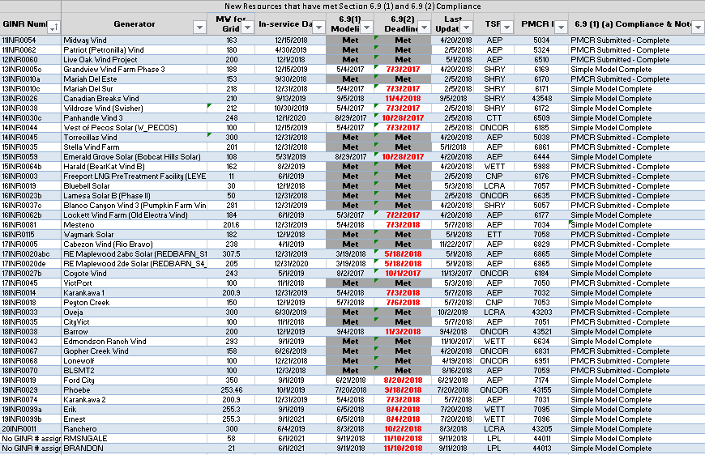

Permian Basin Oil Rig Count
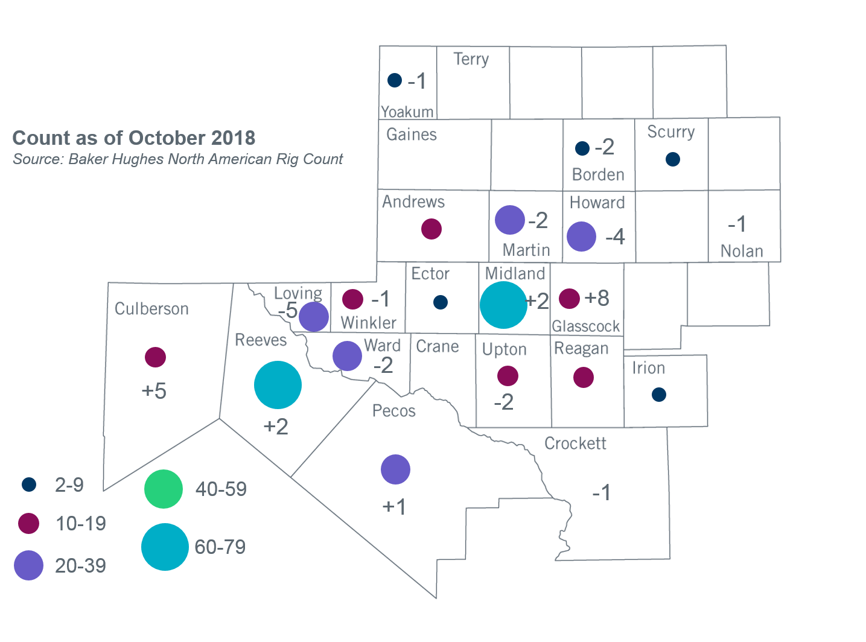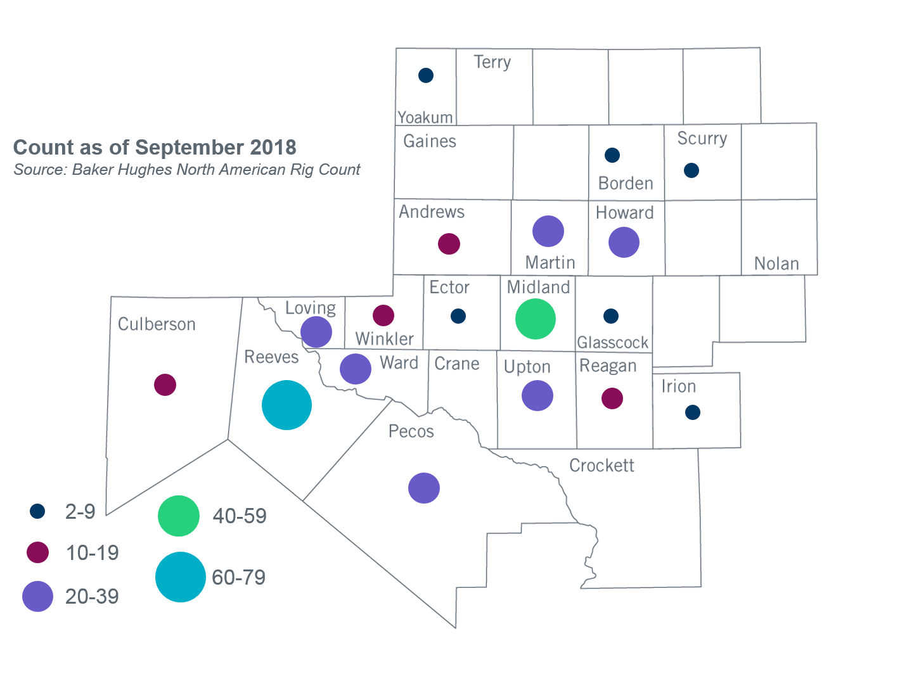

Other Notable Activities
- ERCOT continues to develop the 2018 Regional Transmission Plan (RTP) study. The preliminary secure reliability cases along with a list of transmission upgrades and additions for all study regions have been shared with the RPG as of October 1, 2018. ERCOT is currently working on additional reliability analysis which includes TPL sensitivity analysis, short-circuit analysis and long-lead time equipment analysis. ERCOT also posted the input start cases and congestion from the 2018 RTP economic analysis on September 24, 2018. Stakeholders are encouraged to review and provide feedback on the posted results.
- ERCOT continues to work on the 2018 Long-Term System Assessment (LTSA). ERCOT has completed its initial generation expansion analysis for all five scenarios. The results of these analyses were presented at the April and May RPG meetings. ERCOT is currently working on the transmission expansion analysis for the Current Trends scenario.
- The SPWG completed the 2018 CY base cases and the 2019-2023 FY cases.
- The DWG has begun the 2018-2019 flat-start case development for 2021 Summer Peak, 2022 HWLL, and 2025 Summer Peak cases.
- ERCOT is conducting the Southern Cross DC Tie Interconnection study to meet Public Utility Commission of Texas directives.
- ERCOT is conducting the study required by NERC Alert (https://www.nerc.com/pa/rrm/bpsa/Alerts%20DL/NERC_Alert_Loss_of_Solar_Resources_during_Transmission_Disturbance-II_2018.pdf) and plans to complete the study no later than December 7, 2018.

+/- symbol indicates the increase or decrease from the previous month in oil rigs present in each county. There are 383 rigs, including a total decrease of 3 oil rigs in the Permian Basin from September to October 2018.

