TDTMS Meeting
October 23, 2018
Meeting Attendees: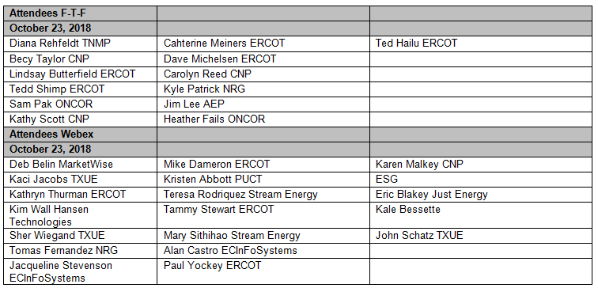
3 | TDTMS leadership election  Sam Pak was elected Chair for remaining of 2018  TDTMS decided to keep Vice Chair vacant for remaining 2018
4 | Review previous meeting notes  Approved
5 | ERCOT System Instances & MarkeTrak Monthly Performance Review  Reviewed ERCOT IT Instance reports and Sept 2018 MT performance  - All SLA targets met  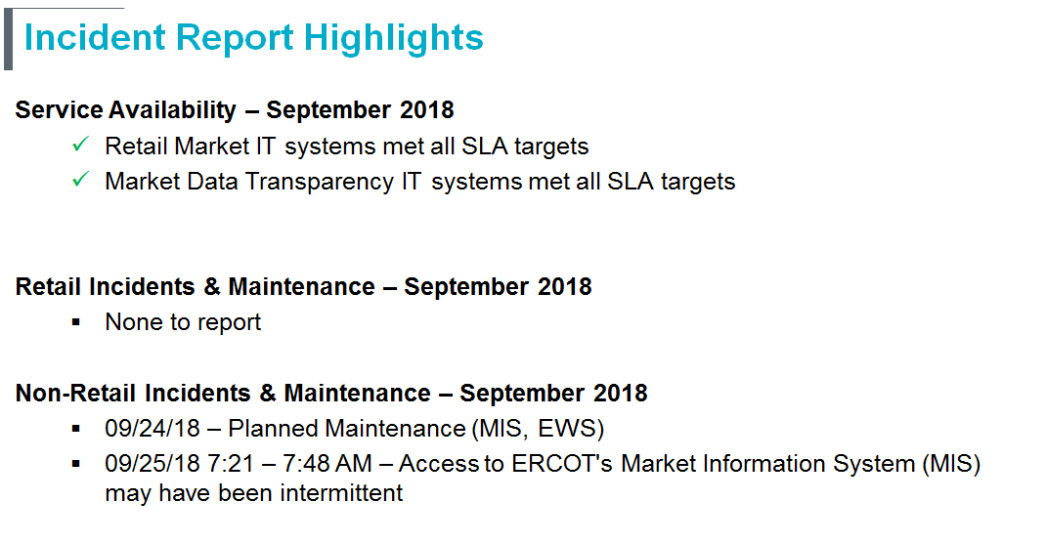  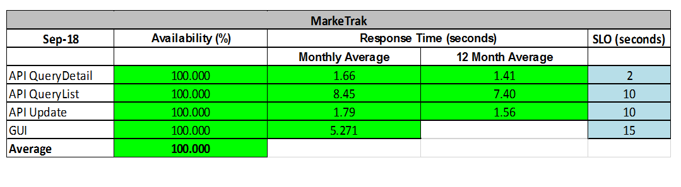
6 | 2019 Retail SLA target metrics for review  2019 Release dates were still pending from ERCOT  Suggest removing obsolete references from SLA doc:  - Removal of reference to Appendix B: Notification Lists (pg 2 & 14)  - Removal or update reference to outdated COPS Mkt Guide, Appendix A (pg 6)  SLA will be reviewed by TDTMS prior to December’s RMS meeting for approval
7 | PUCT 36141, Q2 Performance Measure Comparison
97% performance received for 867_03 sent
Per ERCOT:
The [97%] deviations that appear on this report are a result of the service provider outage we experienced earlier this year. ERCOT holds responses when our trading partner is not available which appears as longer processing times.

8 | Review and discussion on future MarkeTrak Subtype data analysis and request (tabled to December’s meeting)
 | Formats/templates and specific data elements

