October 2018 ERCOT Monthly Operations Report
Reliability and Operations Subcommittee Meeting
December 6, 2018

Table of Contents
1. Report Highlights 2
2. Frequency Control 3
2.1. Frequency Events 3
2.2. Responsive Reserve Events 4
2.3. Load Resource Events 4
3. Reliability Unit Commitment 4
4. Wind Generation as a Percent of Load 5
5. COP Error Analysis 5
6. Congestion Analysis 5
6.1. Notable Constraints 7
6.2. Generic Transmission Constraint Congestion 11
6.3. Manual Overrides 11
6.4. Congestion Costs for Calendar Year 2018 11
7. System Events 11
7.1. ERCOT Peak Load 13
7.2. Load Shed Events 13
7.3. Stability Events 13
7.4. Notable PMU Events 13
7.5. DC Tie Curtailment 13
7.6. TRE/DOE Reportable Events 14
7.7. New/Updated Constraint Management Plans 14
7.8. New/Modified/Removed RAS 14
7.9. New Procedures/Forms/Operating Bulletins 14
8. Emergency Conditions 14
8.1. OCNs 14
8.2. Advisories 14
8.3. Watches 14
8.4. Emergency Notices 14
9. Application Performance 15
9.1. TSAT/VSAT Performance Issues 15
9.2. Communication Issues 15
9.3. Market System Issues 15
10. Model Updates 15
Appendix A: Real-Time Constraints 18

Report Highlights
- The unofficial ERCOT peak for October was 60,750 MW.
- There were five frequency events in October. PMU data indicates the ERCOT system transitioned well.
- There were three instances where Responsive Reserves were deployed.
- There were five RUC commitments in October due to capacity and congestion.
- Congestions in October occurred in the North, South, Houston and West Load Zones. Congestions in the North can be mostly attributed to high generation and planned outages. Congestions in the South were mostly due to high wind generation and outages. Congestions in the West were mostly due to high West solar generation and planned outages. Congestions in the Houston area were mostly due to area load/generation pattern and planned outages. There were 16 days on the Panhandle GTC and 2 days on North-Houston GTC in October. There was no activity on the remaining GTCs during the month.
- There were three DC Tie curtailments in October.

Frequency Control

Frequency Events
The ERCOT Interconnection experienced five frequency events in October, all of which resulted from a Resource trip. The average event duration was approximately 0:04:14 .

A summary of the frequency events is provided below. The reported frequency events meet one of the following criteria: Delta Frequency is 60 mHz or greater; the MW loss is 350 MW or greater; resource trip event triggered RRS deployment. Frequency events that have been identified as Frequency Measurable Events (FME) for purposes of BAL-001-TRE-1 analysis are highlighted in blue. When analyzing frequency events, ERCOT evaluates PMU data according to industry standards. Events with an oscillating frequency of less than 1 Hz are considered to be inter-area, while higher frequencies indicate local events. Industry standards specify that damping ratio for inter-area oscillations should be 3.0% or greater. For the frequency events listed below, the ERCOT system met these standards and transitioned well after each disturbance.

Date and Time | Delta Frequency | Max/Min Frequency | Duration of Event | PMU Data |  |  | MW Loss | Load | Wind | Inertia
 | (Hz) | (Hz) |  | Oscillation Mode (Hz) |  | Damping Ratio |  | (MW) | % | (GW-s)
10/13/2018 3:23 | 0.102 | 59.908 | 0:04:58 | No PMU data available |  |  | 368.7 | 42,773 | 11% | 276,794
10/15/2018 6:29 | 0.099 | 59.904 | 0:03:18 | No PMU data available |  |  | 422 | 32,129 | 27% | 193,951
10/16/2018 20:15 | 0.109 | 59.905 | 0:05:11 | No PMU data available |  |  | 475.164 | 37,719 | 38% | 218,854
10/19/2018 15:23 | 0.140 | 59.860 | 0:04:27 | 0.70 | 14% |  | 630.429 | 40,654 | 11% | 242,389
10/27/2018 12:43 | 0.086 | 59.918 | 0:03:18 | No PMU data available |  |  | 331.217 | 38,388 | 2% | 245,887

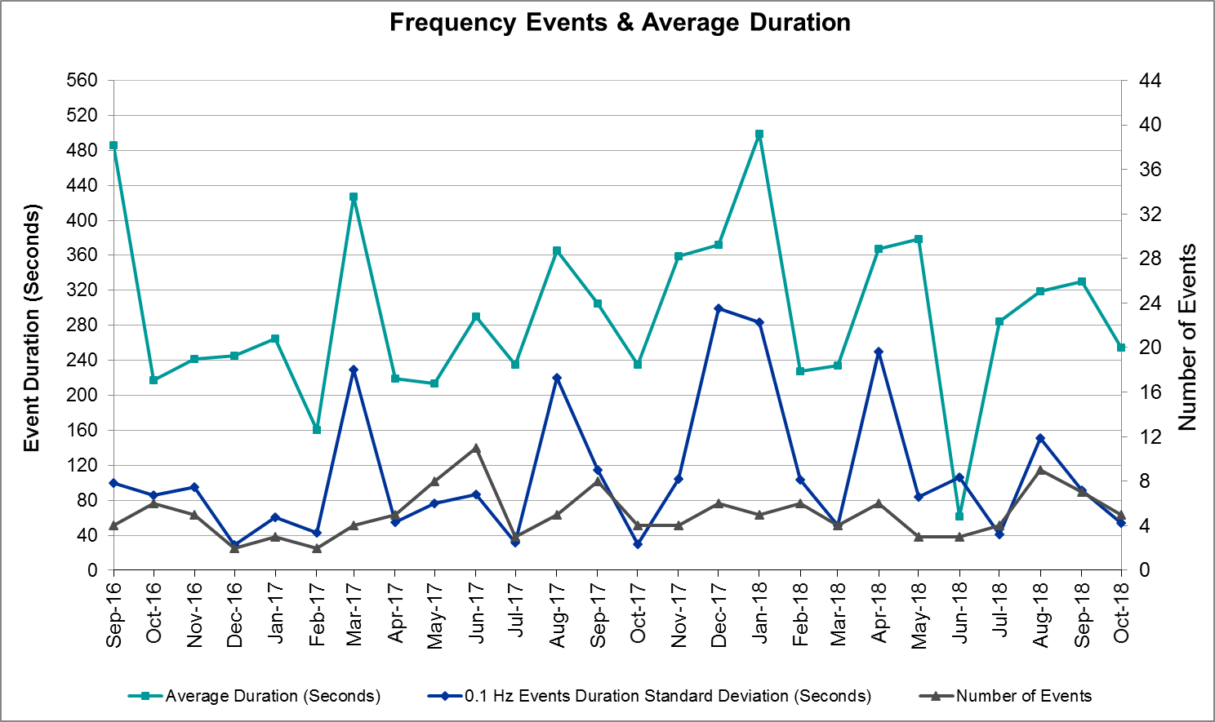
(Note: All data on this graph encompasses frequency event analysis based on BAL-001-TRE-1.)

Responsive Reserve Events
There were three events where Responsive Reserve MWs were released to SCED in October. The events highlighted in blue were related to frequency events reported in Section 2.1 above.

Date and Time Released to SCED | Date and Time Recalled | Duration of Event | Maximum MWs Released
10/6/2018 1:30 | 10/6/2018 1:36 | 0:05:44 | 1039
10/15/2018 6:29 | 10/15/2018 6:32 | 0:02:40 | 228
10/19/2018 15:23 | 10/19/2018 15:27 | 0:04:00 | 756

Load Resource Events
None.

Reliability Unit Commitment
ERCOT reports on Reliability Unit Commitments (RUC) on a monthly basis. Commitments are reported grouped by operating day and weather zone. The total number of hours committed is the sum of the hours for all the units in the specified region. Additional information on RUC commitments can be found on the MIS secure site at Grid Generation Reliability Unit Commitment.

There were no DRUC commitments in October.

There were five HRUC commitments in October.

Resource Location | # of Resources | Operating Day | Total # of Hours Committed | Total MWhs | Reason for Commitment
East | 1 | 10/1/2018 | 2 | 1,004 | Capacity
North Central | 3 | 10/4/2018 | 18 | 7,152 | Capacity
North Central | 1 | 10/5/2018 | 1 | 435 | Local Congestion
North Central | 1 | 10/8/2018 | 3 | 1,305 | Local Congestion
Southern | 1 | 10/15/2018 | 2 | 199 | Local Congestion

Wind Generation as a Percent of Load
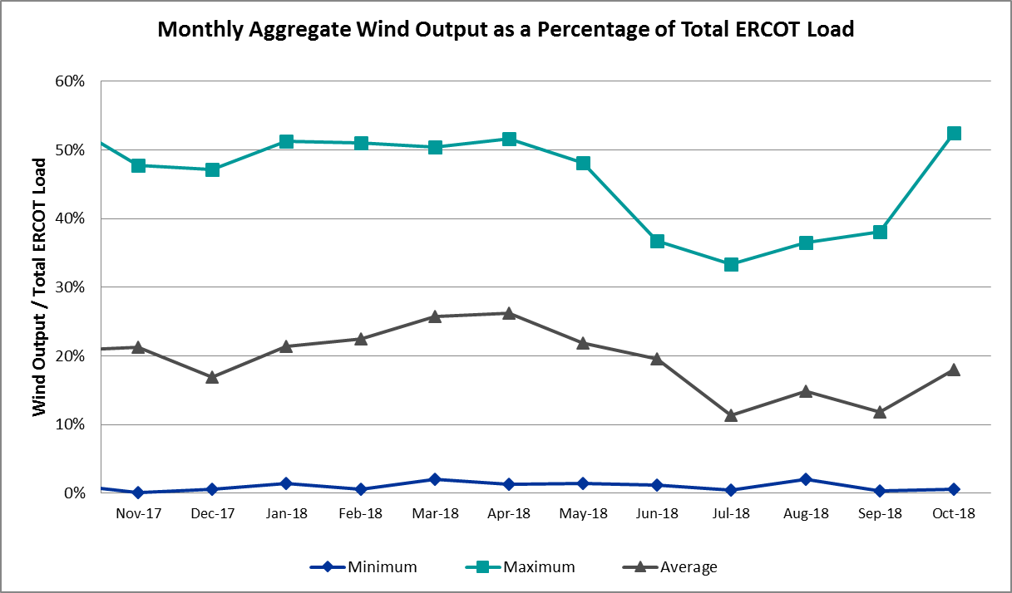

COP Error Analysis
COP Error is calculated as the capacity difference between the COP HSL and real-time HSL of the unit. Mean Absolute Error (MAE) stayed high, mostly over 8,000 MW, until Day-Ahead at 12:00, then dropped significantly to 1688 MW by Day-Ahead at 14:00. In the following chart, Under-Scheduling Error indicates that COP had less generation capacity than real-time and Over-Scheduling Error indicates that COP had more generation capacity than real-time. Under-Scheduling persisted from beginning of Day-Ahead to Day-Ahead at 16:00. Over-Scheduling occurred from 17:00 of Day-Ahead to 20:00 of Day-Ahead and at 11:00 of Operating day. Snapshot on the Operating Day considers all Operating Hours, including past hours. However, COP error for the Operating Hour freezes after the Adjustment Period.
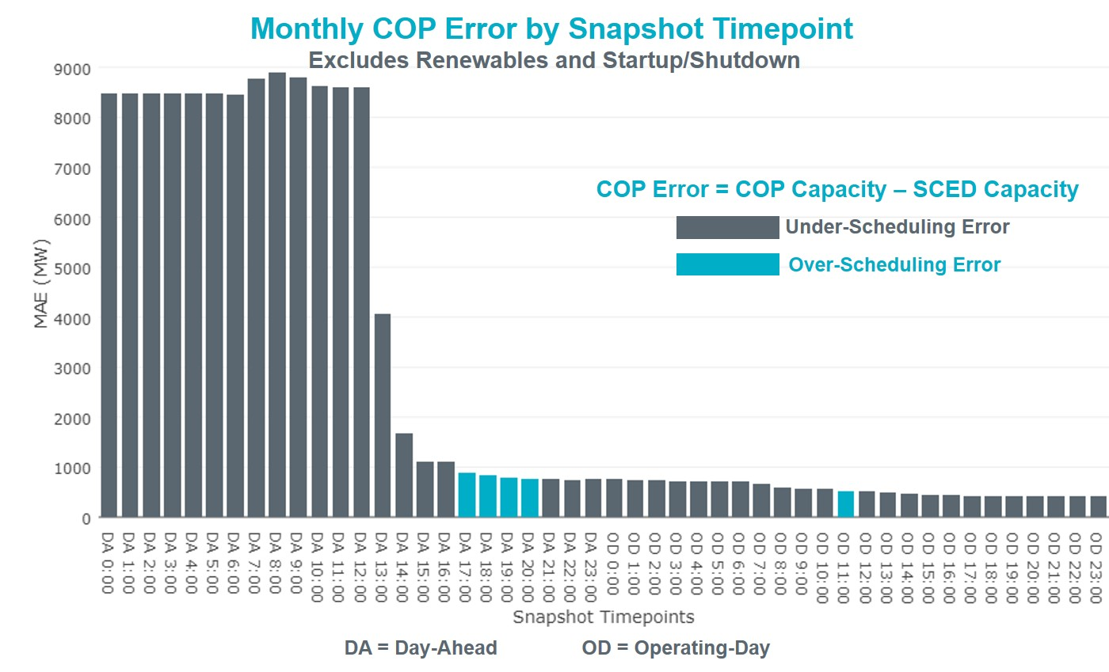
Monthly MAE for the Latest COP at the end of the Adjustment Period was 417 MW with median ranging from -339 MW for Hour-Ending (HE) 16 to 181 MW for HE 7. October 14th HE 5 had the largest Over-Scheduling Error (2,087 MW) and October 4th HE 22 had the largest Under-Scheduling Error (-3,319 MW).
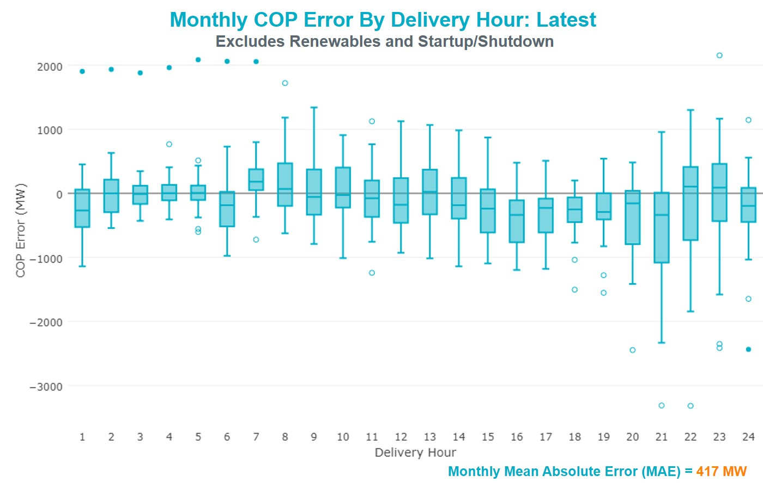
Monthly MAE for the Day-Ahead COP at 12:00 was 8,603 MW with median ranging from -11,771 MW for Hour-Ending (HE) 16 to -4,591 MW for HE 3. October 30th HE 1 had the largest Over-Scheduling Error (846 MW) and October 4th HE 16 had the largest Under-Scheduling Error (-20,194 MW).
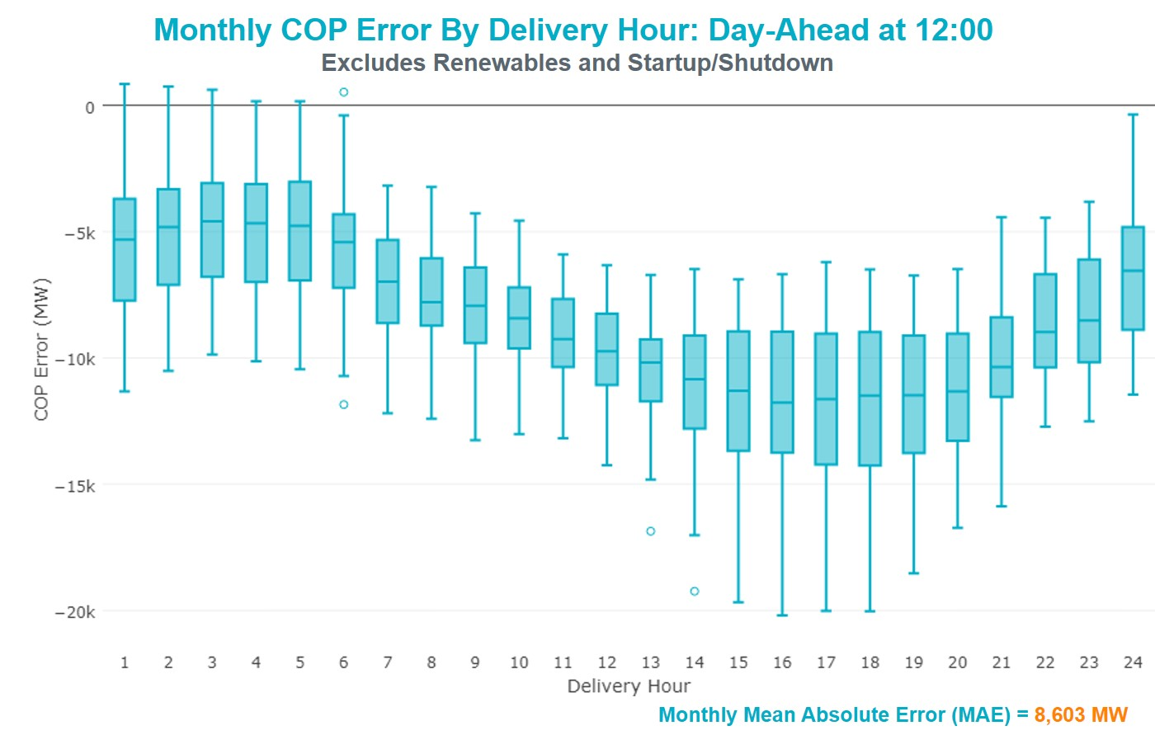

Congestion Analysis
The total number of congestion events experienced by the ERCOT system increased in October. There were 18 instances over 18 days on the Generic Transmission Constraints (GTCs) in October.

Notable Constraints
Nodal protocol section 3.20 specifies that ERCOT shall identify transmission constraints that are active or binding three or more times within a calendar month. As part of this process, ERCOT reports congestion that meets this criterion to ROS. In addition ERCOT also highlights notable constraints that have an estimated congestion rent exceeding $1,000,000 for a calendar month. These constraints are detailed in the table below. Rows highlighted in blue indicate the congestion was affected by one or more outages. For a list of all constraints activated in SCED for the month of October, please see Appendix A at the end of this report.

Contingency Name | Overloaded Element | # of Days Constraint Active | Congestion Rent | Transmission Project
EVERMAN SWITCH TRX EVRSW_3_2 345/138 | Everman Switch 345/1kV | 17 | $18,941,046.22 | Everman Switch - Forest Hill Switch - Alcon Tap 138-kV line upgrade
Hecker_White_Pt 138kv | Dupont Switch - Ingleside - Rincon 138kV | 1 | $5,943,901.44
Hecker_White_Pt 138kv | Whitepoint - Rincon 138kV | 1 | $5,778,957.43 | Whitepoint: Install 100 MVAR Reactor
Entpr-Trses & Mlses-Scses 345kV | Herty North Switch - Nacogdoches Se 138kV | 9 | $4,743,951.27 | Nacogdoches Southeast - Herty North 138 kV Line
Basecase | Omega - Horse Hollow Generation Tie 345kV | 12 | $4,059,166.03
Mbdsw-Dcses&Rkcrk 345kV | Wolf Hollow 345 Switch - Comanche Peak Ses 345kV | 1 | $3,110,443.81 | Upgrade Wolf Holllow - Comanche Peak 345 kV Line
PH ROBINSON TRX PHR_AT2 345/138 | Mainland Tnp - Alvin Tnp 138kV | 12 | $2,952,192.76 | Mainland Substation (6045)
Jewet-Sng 345kV | Btu_Jack_Creek - Twin Oak Switch 345kV | 11 | $2,771,450.27 | Houston Import Project (4458)
Lostpi-Austro&Dunlap 345kV | Fayetteville 138/1kV | 4 | $2,310,964.78
DMTSW-SCOSW 345KV | Knapp - Scurry Chevron 138kV | 16 | $1,787,467.59 | Ennis Creek - Cogdell 69 kV Line (4554) & Ennis Creek 138 kV Switching Station (6269)
Bronco to ALPINE LIN 1 | Solstice - Linterna 138kV | 15 | $1,587,297.02 | Solstice to Clovis: Build 138 kV line (4531)
COLETO CREEK to VICTORIA LIN 1 | Coleto Creek - Victoria 138kV | 11 | $1,087,251.62 | Coleto Creek to Tuleta: New 138 kV Line (16TPIT0034)
ODLAW SWITCHYARD to ASPHALT MINES LIN 1 | Hamilton Road - Maverick 138kV | 8 | $1,024,271.81 | Brackettville to Escondido: Construct 138 kV line (5206)
PH ROBINSON to MEADOW LIN A | Mainland Tnp - Alvin Tnp 138kV | 7 | $949,198.63 | Mainland Substation (6045)
CAGNON to KENDALL LIN 1 | Cico - Comfort 138kV | 6 | $939,954.23 | Boerne Cico - Comfort - Kendall Transmission Line Upgrade
Basecase | PNHNDL GTC | 16 | $802,214.92 | LP&L Option 4ow & Panhandle Loop (5180, 5208)
EVERMAN SWITCH TRX EVRSW_3_2 345/138 | Everman Switch 138/1kV | 4 | $694,291.11 | Everman Switch - Forest Hill Switch - Alcon Tap 138-kV line upgrade
Bighil-Kendal 345kV | Yellow Jacket - Treadwell 138kV | 5 | $543,909.74 | Treadwell: Build new 138 kV station (6397)
RIO HONDO to LAS PULGAS LIN 1 | Raymondville 2 138/69kV | 11 | $453,398.82 | Harlingen SS- Raymondville #2: Convert to 138 kV (6167)
PH ROBINSON TRX PHR_AT2 345/138 | Seminole Tnp - Friendswood Tnp 138kV | 4 | $451,886.86 | Friendswood Genration (13INR0049) Transmission Network (5140)
Fergus-Granmo&Wirtz-Starck 138kV | Bertram - Burnet 69kV | 12 | $442,400.22
Pig Creek to Solstice LIN 1 | Airport Tnp - 16th Street Tnp 138kV | 10 | $338,825.95
EAGLE MOUNTAIN SES to Morris Dido LIN _A | Eagle Mountain Ses - Eagle Mountain Compressor 138kV | 3 | $298,125.69
PH ROBINSON TRX PHR_AT2 345/138 | Mainland Tnp - Freeway Park Tnp 138kV | 3 | $268,048.59 | Mainland Substation (6045)
Zorn-Marion & Cleasp 345kV | Clear Springs - Geronimo 138kV | 5 | $258,173.46 | T505 Geronimo - Clear Springs MLSE Upgrade (7165)
BAKERSFIELD SWITCHYARD to Big HiLL LIN 1 | Solstice - Linterna 138kV | 7 | $255,446.96 | Solstice to Clovis: Build 138 kV line (4531)
UVALDE AEP to DOWNIE SWITCHING STATION LIN 1 | Downie Switching Station 138/69kV | 4 | $240,525.90
Berghe-Kendal 345kv & Welfar 138kv | Kendall - Cagnon 345kV | 5 | $201,994.70
AIRLINE AEP to WESTSIDE AEP LIN 1 | Holly - Southside 138kV | 10 | $140,781.66 | Airline to Holly: Build new 138 kV line (5168)
DMTSW-SCOSW 345KV | Morgan Creek Ses - Sun Switch 138kV | 3 | $134,144.39
WICHITA FALLS SOUTH SWITCH to NEWPORT BEPC LIN _E | Bowie 138/69kV | 4 | $125,497.12
DUPONT SWITCH - INGLESIDE to INGLESIDE COGEN SWITCH LIN 1 | Dupont Pp1 - Ingleside - Dupont Switch - Ingleside 138kV | 7 | $117,621.45
Lostpi-Austro&Dunlap 345kV | Bellville South - Peters 138kV | 3 | $90,562.08 | Waller 138kV Substation Reconfiguration (5717)
CENTER to PH ROBINSON LIN A | Texas - Cedar Bayou 138kV | 4 | $71,608.42 | Baytown Area Upgrades (43284F)
FORT MASON to YELLOW JACKET LIN 1 | Mason Aep - Fredricksburg Phillips Tap 69kV | 5 | $69,432.17
Basecase | Solstice - Linterna 138kV | 8 | $66,668.65 | Solstice to Clovis: Build 138 kV line (4531)
Marbfa-Lakewy &Wirtz-Palefa 138kV | Bertram - Burnet 69kV | 8 | $65,912.93
BRACKETTVILLE to HAMILTON ROAD LIN 1 | Hamilton Road - Maverick 138kV | 3 | $39,829.02 | Brackettville to Escondido: Construct 138 kV line (5206)
JARDIN to DILLEY SWITCH AEP LIN 1 | Dilley Switch Aep - Cotulla Sub 69kV | 5 | $30,622.54 | Rebuild Cotulla to Big Wells 69kV line
HCKSW-ALLNC&RNKSW 345kV | Eagle Mountain Ses - Morris Dido 138kV | 3 | $15,876.03
Bighil-Kendal 345kV | Hamilton Road - Maxwell 138kV | 3 | $12,850.88

Generic Transmission Constraint Congestion
There were 16 days on the Panhandle GTC and 2 days on North-Houston GTC in October. There was no activity on the remaining GTCs during the month.

Note: This is how many times a constraint has been activated to avoid exceeding a GTC limit, it does not imply an exceedance of the GTC occurred or that the GTC was binding.

Manual Overrides
None.

Congestion Costs for Calendar Year 2018
The following table represents the top twenty active constraints for the calendar year based on the estimated congestion rent attributed to the congestion. ERCOT updates this list on a monthly basis.

Contingency | Binding Element | # of 5-min SCED Intervals | Estimated Congestion Rent | Transmission Project
Solstice to LINTERNA LIN 1 | Yucca Drive Switch - Gas Pad 138kV | 17,620 | 251,851,642.32 | Yucca Drive-Barilla Junction (4549)
Basecase | PNHNDL GTC | 28,396 | 99,174,603.20 | LP&L Option 4ow & Panhandle Loop (5180, 5208)
CRLNW-LWSSW 345kV | Carrollton Northwest - Lakepointe Tnp 138kV | 13,115 | 60,311,425.16 | Oncor_NW Carrollton - LakePointe (5488)
LEWISVILLE SWITCH to JONES STREET TNP LIN _A | Ti Tnp - West Tnp 138kV | 3,103 | 35,839,701.17 | Congestion Management Plan # 4 and Stewart Road: Construct 345 kV cut-in (5604)
EMSES-SAGNA 138kV | Blue Mound - Wagley Robertson 138kV | 6,326 | 35,676,195.49 | Wagley Robertson (2076) - Blue Mound (2071) 138-kV line upgrade (2017RTP NC10)
NORTH EDINBURG TRX 1382 345/138 | North Edinburg 345/1kV | 1,460 | 35,354,554.62 | Stewart Road: Construct 345 kV cut-in (5604)
DMTSW-SCOSW 345KV | Knapp - Scurry Chevron 138kV | 12,652 | 23,801,509.47 | Ennis Creek - Cogdell 69 kV Line (4554) & Ennis Creek 138 kV Switching Station (6269)
Basecase | VALIMP GTC | 601 | 19,938,471.66 | La Palma Dynamic Reactive (5588) and Pharr Dynamic Reactive (5596)
EVERMAN SWITCH TRX EVRSW_3_2 345/138 | Everman Switch 345/1kV | 2,177 | 18,941,046.22 | Everman Switch - Forest Hill Switch - Alcon Tap 138-kV line upgrade
Bronco to ALPINE LIN 1 | Solstice - Linterna 138kV | 14,185 | 16,202,183.95 | Solstice to Clovis: Build 138 kV line (4531)
Ryssw-Forsw 345kV | Forney West - Forney Switch 138kV | 1,735 | 16,044,364.37
SN-STR26 & BFP-VL82 | Hofman - Basf 138kV | 1,212 | 15,639,411.86
HCKSW-ALLNC&RNKSW 345kV | Blue Mound - Wagley Robertson 138kV | 921 | 15,529,710.27 | Wagley Robertson (2076) - Blue Mound (2071) 138-kV line upgrade (2017RTP NC10)
Castrvll-Razorbac&Txresrch 138kV | Hondo Creek Switching Station - Moore Switching Station 138kV | 605 | 15,342,875.43
Elmcreek-Sanmigl 345kV | Pawnee Switching Station - Calaveras 345kV | 2,108 | 14,407,954.05
WOLF SWITCHING STATION to Monahans Tap 2 LIN _G | General Tire Switch - Southwestern Portland Tap 138kV | 2,645 | 13,959,263.32
Jewet-Sng 345kV | Btu_Jack_Creek - Twin Oak Switch 345kV | 6,339 | 13,859,000.31 | Houston Import Project (4458)
WOODWARD 1 TAP to WOODWARD 1 LIN 1 | 16th Street Tnp - Woodward 2 138kV | 2,632 | 13,666,794.32 | Far West Texas Project
NORTH PHARR to POLK AVENUE LIN 1 | North Mcallen - West Mcallen 138kV | 1,165 | 13,282,240.37 | North McAllen (8368) - West McAllen (8367) - South McAllen (8371) 138-kV line upgrades (2017 RTP S9)
MOSS SWITCH to YUCCA DRIVE SWITCH LIN _A | General Tire Switch - Southwestern Portland Tap 138kV | 2,344 | 11,535,045.00

System Events

ERCOT Peak Load
The unofficial ERCOT peak load for the month was 60,750 MW and occurred on October 4th, during hour ending 17:00.

Load Shed Events
None.

Stability Events
None.

Notable PMU Events
ERCOT analyzes PMU data for any significant system disturbances that do not fall into the Frequency Events category reported in section 2.1. The results are summarized in this section once the analysis has been completed.

Date and Time | Duration of Oscillation | Dominant Oscillation Mode | Oscillation Signals | Max Peak to Peak Oscillation
10/19/2018  12:41 | 34 Mins | 0.67 Hz | Voltage Magnitude,  Reactive Power | ~0.6 kV,  ~4 MVArs

DC Tie Curtailment
Date | DC Tie | Curtailing Period | # of Tags Curtailed | Initiating Event | Curtailment Reason
10/26/2018 | DC-R | HE 01:00 | 2 | Unable to ramp DC Tie to schedule | DC Tie Forced Outage
10/28/2018 | DC-S | HE 08:00 – HE 24:00 | 1 | DC Tie Forced Outage | DC Tie Forced Outage
10/28/2018 | DC-R | HE 18:00 | 1 | CENACE requested DC Tie be ramped to 0 | DC Tie Forced Outage

TRE/DOE Reportable Events
- CenterPoint submitted an OE-417 report for October 31, 2018 Reportable Event Type: Loss of electric service to more than 50,000 customers for 1 hour or more.

New/Updated Constraint Management Plans
None.

New/Modified/Removed RAS
None.

New Procedures/Forms/Operating Bulletins
Procedure Title | POB
DC Tie Desk | 861
Real Time Desk | 862
Scripts Desk | 863
Shift Supervisor Desk | 864
Transmission and Security Desk | 865

Emergency Conditions

OCNs
Date and Time | Description
10/1/2018 03:50 | ERCOT issued an OCN due to projected reserve capacity shortage for hours ending 15:00 through 19:00. ERCOT is requesting all QSE's to update their COPs.
10/4/2018 19:00 | ERCOT issued an OCN due to projected reserve capacity shortage for hours ending 14:00 through 19:00. ERCOT is requesting all QSE's to update their COPs.
10/31/2018 16:28 | ERCOT issued an OCN due to Possible Severe Weather events (Tornado Warnings) in the Central and Eastern ERCOT Region.

Advisories
Date and Time | Description
10/2/2018 13:24 | ERCOT issued an Advisory for postponing the deadline for the posting of the DAM Solution for Operating Day October 3, 2018 due to long running solution
10/22/2018 13:18 | ERCOT issued an Advisory for postponing the deadline for posting of the DAM solution for Operating Day Oct 23, 2018 until further notice due to internal issue that is being investigated.

Watches
None.

Emergency Notices
None.

Application Performance

TSAT/VSAT Performance Issues
None

Communication Issues
None.

Market System Issues
None.

Model Updates
The Downstream Production Change (DPC) process allows ERCOT to make changes in the on-line Network Operations Model without loading a completely new model. The purpose of this process is to allow for reliable grid operations as system conditions change between designated Network Operations Model database loads. The DPC process is limited in scope to just those items listed below, with equipment ratings updates being the most common. ERCOT has seen a rise in the use of the DPC process to make on-line updates to the Network Operations Model in recent years, instead of through the standard Network Operations Model Change Request process.

- Static Line ratings (Interim Update)
- Dynamic Line ratings (non-Interim Update)
- Autotransformer ratings (non-Interim Update)
- Breaker and Switch Normal status (Interim Update)
- Contingency Definitions (Interim Update)
- RAP and RAS changes or additions (Interim Update)
- Net Dependable and Reactive Capability (NDCRC) values (Interim Update)
- Impedance Updates (non-Interim)

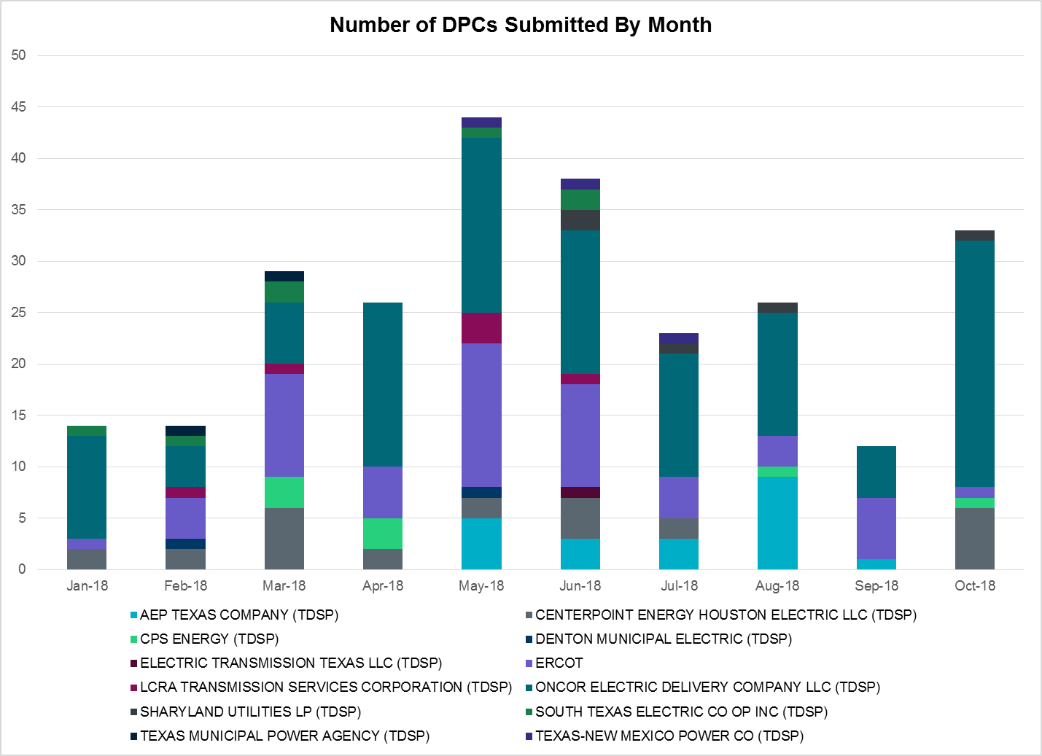

Transmission Operator | Number of DPCs in October
AEP TEXAS COMPANY (TDSP) | 0
BRAZOS ELECTRIC POWER CO OP INC (TDSP) | 0
CENTERPOINT ENERGY HOUSTON ELECTRIC LLC (TDSP) | 6
CPS ENERGY (TDSP) | 1
DENTON MUNICIPAL ELECTRIC (TDSP) | 0
ELECTRIC TRANSMISSION TEXAS LLC (TDSP) | 0
ERCOT | 0
LCRA TRANSMISSION SERVICES CORPORATION (TDSP) | 1
ONCOR ELECTRIC DELIVERY COMPANY LLC (TDSP) | 24
SHARYLAND UTILITIES LP (TDSP) | 1
SOUTH TEXAS ELECTRIC CO OP INC (TDSP) | 0
TEXAS MUNICIPAL POWER AGENCY (TDSP) | 0
TEXAS-NEW MEXICO POWER CO (TDSP) | 0

Appendix A: Real-Time Constraints
The following is a complete list of constraints activated in SCED for the month of October. Full contingency descriptions can be found in the Standard Contingencies List located on the MIS secure site at Grid Generation Reliability Unit Commitment.

Contingency | Constrained Element | From Station | To Station | # of Days Constraint Active
XEVR58 | EVRSW_MR1H | EVRSW | EVRSW | 17
BASE CASE | PNHNDL | n/a | n/a | 16
DMTSCOS5 | 6437__F | SCRCV | KNAPP | 16
SBROALP9 | LINTER_SOLSTI1_1 | LINTERNA | SOLSTICE | 15
XPH2R58 | 138_ALV_MNL_1 | ALVIN | MAINLAND | 12
BASE CASE | HHGTOM_1 | HHGT | OMEGA | 12
DFERSTA8 | 32T311_1 | BURNET | BERTRA | 12
DJEWSNG5 | JK_TOKSW_1 | TOKSW | JK_CK | 11
SVICCO28 | COLETO_VICTOR2_1 | COLETO | VICTORIA | 11
SRAYRI28 | RAYMND2_69A1 | RAYMND2 | RAYMND2 | 11
SCABWES8 | HOLLY4_SOUTH_1_1 | SOUTH_SI | HOLLY4 | 10
SCABWES8 | HOLLY4_SOUTH_1_1 | HOLLY4 | SOUTH_SI | 10
SPIGSOL8 | TNAF_TNFS_1 | TNAF | 16TH_ST | 10
SPIGSOL8 | TNAF_TNFS_1 | 16TH_ST | TNAF | 10
DENTSCS5 | 1170__A | NCDSE | HNRSW | 9
BASE CASE | LINTER_SOLSTI1_1 | LINTERNA | SOLSTICE | 8
SBRAUVA8 | HAMILT_MAVERI1_1 | HAMILTON | MAVERICK | 8
DMARPA_8 | 32T311_1 | BURNET | BERTRA | 8
SMDOPHR5 | 138_ALV_MNL_1 | ALVIN | MAINLAND | 7
SBAKBIG5 | LINTER_SOLSTI1_1 | LINTERNA | SOLSTICE | 7
SSPJFS8 | CRNJFS94_A | JFS | CRN | 7
SI_DI_48 | I_DUPP_I_DUPS2_1 | I_DUPP1 | I_DUPSW | 7
SCAGKEN5 | 74T148_1 | COMFOR | CICO | 6
SFORYEL8 | FRPHIL_MASN1_1 | MASN | FRPHILLT | 5
SFORYEL8 | FRPHIL_MASN1_1 | FRPHILLT | MASN | 5
DBIGKEN5 | TREADW_YELWJC1_1 | TREADWEL | YELWJCKT | 5
DCLEZOR5 | 505T505_1 | CLEASP | GERONI | 5
DBERWE58 | 459T459_1 | KENDAL | CAGNON | 5
SJARDIL8 | DIL_COTU_1 | DILLEYSW | COTULAS | 5
DAUSLOS5 | FAYETT_AT2L | FAYETT | FAYETT | 4
XEVR58 | EVRSW_MR1L | EVRSW | EVRSW | 4
XPH2R58 | G138_10C_1 | FRDSWOOD | SEMINOLE | 4
SLKAWFS8 | BOW_FMR1 | BOW | BOW | 4
SDOWUVA8 | DOWNIES_AX1H | DOWNIES | DOWNIES | 4
SPHRCTR5 | CD_TX_87_A | CD | TX | 4
DHCKRNK5 | 6265__A | EMSES | MRSDO | 3
DBIGKEN5 | HAMILT_MAXWEL1_1 | MAXWELL | HAMILTON | 3
SRSNEM38 | 6260__C | EMSES | EMMCP | 3
SBRAHAM8 | HAMILT_MAVERI1_1 | HAMILTON | MAVERICK | 3
DAUSLOS5 | 155T217_1 | BELLSO | PT | 3
XPH2R58 | 138_FWP_MNL_1 | MAINLAND | FRWYPARK | 3
SSCUSU28 | ROTN_WOLFGA1_1 | WOLFGANG | ROTN | 3
DMTSCOS5 | 6474__A | SUNSW | MGSES | 3
SMDLODE5 | 16TH_WRD2_1 | WOODWRD2 | 16TH_ST | 2
DVENEVR5 | 3180__A | FCRSW | CDHSW | 2
SMDOOAS5 | BCVPSA03_A | PSA | BCV | 2
SILLFTL8 | HAMILT_MAXWEL1_1 | MAXWELL | HAMILTON | 2
SMDLODE5 | ODEHV_MR1H | ODEHV | ODEHV | 2
XBLE58 | SAR_FRAN_1 | SARGNTS | FRANKC | 2
SCMNCPS5 | 651__B | CMNSW | CMNTP | 2
SCABWES8 | ARCADI_SOUTH_1_1 | ARCADIA | SOUTH_SI | 2
SCRDLOF9 | BOW_FMR1 | BOW | BOW | 2
DAUSLOS5 | FAYETT_AT2H | FAYETT | FAYETT | 2
BASE CASE | N_TO_H | n/a | n/a | 2
DFERSTA8 | 38T365_1 | WIRTZ | FLATRO | 2
DHUTGEA8 | 211T147_1 | GILLCR | MCNEIL_ | 2
DMARPA_8 | 38T365_1 | WIRTZ | FLATRO | 2
SAVMBSP8 | 6610__A | BUZSW | CHATP | 2
DSHREVR5 | EVRSW_MR1H | EVRSW | EVRSW | 2
SS_MRAI8 | GCB_100_1 | N_MCALLN | W_MCALLN | 2
DHUTHUT5 | HUTTO_MR1H | HUTTO | HUTTO | 2
XBLE58 | SAR_FRAN_1 | FRANKC | SARGNTS | 2
DWHICOT5 | TULCNYN_CROS_2_1 | TULECNYN | CTT_CROS | 2
UDUPDUP1 | VICTOR_V_DUPS1_1 | VICTORIA | V_DUPSW | 2
XPHR58 | 138_FWP_MNL_1 | MAINLAND | FRWYPARK | 2
DRILKRW5 | 6377__A | BRTSW | ORANS | 2
BASE CASE | BURNS_RIOHONDO_1 | RIOHONDO | MV_BURNS | 2
SPALFRO8 | GCB_100_1 | N_MCALLN | W_MCALLN | 2
DCALBEC8 | N3_U2_1 | CALAVERS | BRAUNIG | 2
XPHR58 | 138_ALV_MNL_1 | ALVIN | MAINLAND | 2
SWCSBOO8 | ALPINE_BRONCO1_1 | BRONCO | ALPINE | 2
SDOWMOO8 | DOWNIES_AX1H | DOWNIES | DOWNIES | 2
SBRTWEB5 | 3180__A | FCRSW | CDHSW | 2
SKLNBW35 | 651__B | CMNSW | CMNTP | 2
DVENEVR5 | EVRSW_MR1H | EVRSW | EVRSW | 2
SBRAUVA8 | SONR_69-1 | SONR | SONR | 2
SKNECNT5 | EVRSW_MR1H | EVRSW | EVRSW | 1
SDOWMOO8 | UVALDE_W_BATE1_1 | UVALDE | W_BATESV | 1
SLARLOB8 | MOLINA_SIEVIS1_1 | MOLINA | SIEVISTA | 1
SDOWUVA8 | UVALDE_W_BATE1_1 | UVALDE | W_BATESV | 1
DSAMTHS5 | 100027_D_1 | WND | WHTNY | 1
DRYSFOR5 | 1750__B | SGOVL | KLBTP | 1
DRIOHAR5 | BURNS_RIOHONDO_1 | RIOHONDO | MV_BURNS | 1
SBROALP9 | FTST_LINTER1_1 | FTST | LINTERNA | 1
DHECWHI8 | I_DUPS_RINCON1_1 | RINCON | I_DUPSW | 1
DMDBDCS5 | 151__A | WOFHO | CPSES | 1
DNAVWTR5 | 3180__A | FCRSW | CDHSW | 1
XEV2R58 | 6125__C | MSTLT | HMPHL | 1
SBISMI5 | BI_WAP50_A | WAP | BI | 1
XCOL58 | COLETO_ROSATA1_1 | COLETO | ROSATA | 1
SSWDMGS8 | ESKSW_TRNT1_1 | ESKSW | TRNT | 1
DEVRCRT5 | EVRSW_MR1H | EVRSW | EVRSW | 1
XHHG58 | HHGT_T2H | HHGT | HHGT | 1
DHECWHI8 | RINCON_WHITE_2_1 | WHITE_PT | RINCON | 1
DNAVWTR5 | 530__C | VENSW | BRTRD | 1
SMGIENW8 | 943__A | ENWSW | ENSSW | 1
DFPPLOS5 | FAYETT_AT2H | FAYETT | FAYETT | 1
SFORYEL8 | HEXT_YELWJC1_1 | YELWJCKT | HEXT | 1
SWHILON5 | NUECES_WHITE_2_1 | WHITE_PT | NUECES_B | 1
SSACSUN8 | 6474__A | SUNSW | MGSES | 1
DBWNKLN5 | 651__B | CMNSW | CMNTP | 1
SSONFRI8 | ATSO_SONR1_1 | SONR | ATSO | 1
DFRAKI28 | B4_V4_1 | V4 | B4 | 1
SCHBCBY5 | BCVPSA03_A | PSA | BCV | 1
SDBLBN28 | BNK_MIL_1 | MIL | BNK | 1
DCRLLSW5 | COOPERCK_ARCO_1 | COOPERCK | ARCO | 1
DRYSFOR5 | FORSW_MR3H | FORSW | FORSW | 1
SFORYEL8 | FRPHIL_GILLES1_1 | GILLES | FRPHILLT | 1
SBAKBIG5 | FTST_LINTER1_1 | FTST | LINTERNA | 1
STNAFTS8 | LINTER_SOLSTI1_1 | LINTERNA | SOLSTICE | 1
SWRDYN8 | NEWTGF60_A | NEW | TGF | 1
DCOTEDI5 | TULCNYN_CROS_2_1 | TULECNYN | CTT_CROS | 1
BASE CASE | 100027_D_1 | WND | WHTNY | 1
BASE CASE | 223T180_1 | LAKEWY | MARSFO | 1
DZORHAY5 | 459T459_1 | KENDAL | CAGNON | 1
DVENEVR5 | 6020__A | CRTLD | CDHSW | 1
SWLVW_F5 | 6135__A | GUNSW | GYVLM | 1
SKNADM28 | 6695__B | SNYDR | AMOTP | 1
SMYRSPR8 | BOW_FMR1 | BOW | BOW | 1
DRYSFOR5 | FORSW_MR3L | FORSW | FORSW | 1
SELMTH25 | 1030__B | BOSQUESW | RGH | 1
SWLFECT8 | 6100__G | ACSSW | AMTBT | 1
DCHBJOR5 | CD_TX_87_A | CD | TX | 1
DCHB_NB5 | CD_TX_87_A | CD | TX | 1
STRECFL8 | HAMILT_MAXWEL1_1 | MAXWELL | HAMILTON | 1
SEDEYEL9 | HEXT_YELWJC1_1 | YELWJCKT | HEXT | 1
DTWIBGL8 | HIGHLA_SAST1_1 | HIGHLAND | SAST | 1
DMARZOR5 | MAGRUD_VICTOR2_1 | VICTORIA | MAGRUDER | 1
DCOTDMT5 | TULCNYN_CROS_2_1 | TULECNYN | CTT_CROS | 1
XLOB58 | UVALDE_W_BATE1_1 | UVALDE | W_BATESV | 1
DPHRCTR5 | 138_ALV_MNL_1 | ALVIN | MAINLAND | 1
DCAGCO58 | 583T583_1 | BANDER | MASOCR | 1
DFERGRM8 | 654T654_1 | WIRTZ | STARCK | 1
DRILKRW5 | 6626__F | BTTSW | HENWE | 1
SKNEEVR5 | EVRSW_MR1H | EVRSW | EVRSW | 1
SSHRCNT5 | EVRSW_MR1H | EVRSW | EVRSW | 1
SKNEEVR5 | EVRSW_MR2H | EVRSW | EVRSW | 1
DSKYCAL5 | R5_U3_1 | BRAUNIG | CAGNON | 1
STRECFL8 | HARGRO_TWINBU1_1 | TWINBU | HARGROVE | 1

The Duration of Event is defined as the time it takes for the frequency to recover to pre-disturbance frequency or 60 Hz as applicable.
PMU reports are typically generated when frequency drops below 59.9, but PMU data is available for other events.
Delta Frequency is defined as the difference between the starting point of the frequency event (t(0) or “A-point”) and minimum/maximum frequency (“C-Point”).
Currently, the Critical Inertia Level for ERCOT is approximately 100,000 MW-s (Source: link)
This is the hourly integrated peak demand as published in the ERCOT D&E report.
All DC Tie Curtailments are posted publically on the ERCOT Market Information System. See that posting for additional details for the event(s) in question.
See DC Tie Operating Procedure (http://www.ercot.com/mktrules/guides/procedures) for more details.

