September 2018 ERCOT Monthly Operations Report
Reliability and Operations Subcommittee Meeting
November 8, 2018

Table of Contents
1. Report Highlights 2
2. Frequency Control 3
2.1. Frequency Events 3
2.2. Responsive Reserve Events 4
2.3. Load Resource Events 4
3. Reliability Unit Commitment 4
4. Wind Generation as a Percent of Load 5
5. COP Error Analysis 5
6. Congestion Analysis 5
6.1. Notable Constraints 7
6.2. Generic Transmission Constraint Congestion 10
6.3. Manual Overrides 10
6.4. Congestion Costs for Calendar Year 2018 11
7. System Events 11
7.1. ERCOT Peak Load 12
7.2. Load Shed Events 12
7.3. Stability Events 13
7.4. Notable PMU Events 13
7.5. DC Tie Curtailment 13
7.6. TRE/DOE Reportable Events 13
7.7. New/Updated Constraint Management Plans 13
7.8. New/Modified/Removed RAS 13
7.9. New Procedures/Forms/Operating Bulletins 13
8. Emergency Conditions 14
8.1. OCNs 14
8.2. Advisories 14
8.3. Watches 14
8.4. Emergency Notices 14
9. Application Performance 14
9.1. TSAT/VSAT Performance Issues 14
9.2. Communication Issues 15
9.3. Market System Issues 15
10. Model Updates 15
Appendix A: Real-Time Constraints 18

Report Highlights
- The unofficial ERCOT peak for September was 64,606 MW.
- There were seven frequency events in September. PMU data indicates the ERCOT system transitioned well.
- There were seven instances where Responsive Reserves were deployed.
- There were two RUC commitments in September due to capacity and congestion.
- Congestions in September occurred in the North, South, Houston and West Load Zones. Congestions in the North can be mostly attributed to high generation and planned outages. Congestions in the South were mostly due to high wind generation and planned outages. Congestions in the West were mostly due to high West solar generation. Congestions in the Houston area were mostly due to area load/generation pattern. There were 12 days on the Panhandle GTC and 1 day on North-Houston GTC in September. There was no activity on the remaining GTCs during the month.
- There were seven DC Tie curtailments in September. Four were due to 138 KV breaker and two were due to 138 KV transmission line trip.

Frequency Control

Frequency Events
The ERCOT Interconnection experienced seven frequency events in September, all of which resulted from a Resource trip. The average event duration was approximately 0:05:30.

A summary of the frequency events is provided below. The reported frequency events meet one of the following criteria: Delta Frequency is 60 mHz or greater; the MW loss is 350 MW or greater; resource trip event triggered RRS deployment. Frequency events that have been identified as Frequency Measurable Events (FME) for purposes of BAL-001-TRE-1 analysis are highlighted in blue. When analyzing frequency events, ERCOT evaluates PMU data according to industry standards. Events with an oscillating frequency of less than 1 Hz are considered to be inter-area, while higher frequencies indicate local events. Industry standards specify that damping ratio for inter-area oscillations should be 3.0% or greater. For the frequency events listed below, the ERCOT system met these standards and transitioned well after each disturbance.

Date and Time | Delta Frequency | Max/Min Frequency | Duration of Event | PMU Data |  |  | MW Loss | Load | Wind | Inertia
 | (Hz) | (Hz) |  | Oscillation Mode (Hz) |  | Damping Ratio |  | (MW) | % | (GW-s)
9/1/2018 10:38 | 0.117 | 59.896 | 0:05:56 | 0.67 1.17 | 20% 13% |  | 637.221 | 51,023 | 11% | 327,965
9/4/2018 19:30 | 0.174 | 59.840 | 0:04:46 | 0.64 | 20% |  | 860.34 | 54,990 | 12% | 324,953
9/19/2018 20:43 | 0.150 | 59.826 | 0:04:52 | 0.66 | 13% |  | 769.15 | 58,017 | 19% | 313,333
9/24/2018 1:39 | 0.121 | 59.857 | 0:04:30 | 0.70 | 16% |  | 653.218 | 33,181 | 10% | 251,459
9/26/2018 13:54 | 0.154 | 59.851 | 0:07:09 | 0.65 | N/A |  | 1017.98 | 48,522 | 11% | 287,656
9/28/2018 1:11 | 0.135 | 59.874 | 0:07:47 | 0.69 | 10% |  | 843.771 | 32,842 | 37% | 201,577
9/28/2018 12:00 | 0.123 | 59.858 | 0:03:32 | PMU Data Unavailable |  |  | 826.089 | 42,773 | 11% | 276,794

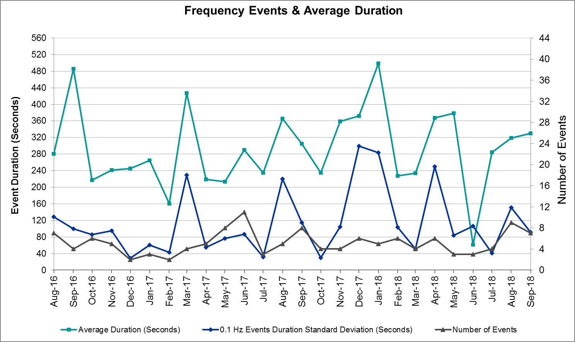
(Note: All data on this graph encompasses frequency event analysis based on BAL-001-TRE-1.)

Responsive Reserve Events
There were six events where Responsive Reserve MWs were released to SCED in September. The events highlighted in blue were related to frequency events reported in Section 2.1 above.

Date and Time Released to SCED | Date and Time Recalled | Duration of Event | Maximum MWs Released
9/1/2018 10:38 | 9/1/2018 10:43 | 0:04:44 | 228
9/4/2018 19:30 | 9/4/2018 19:34 | 0:03:43 | 756
9/19/2018 20:43 | 9/19/2018 20:47 | 0:04:15 | 1011
9/24/2018 1:39 | 9/24/2018 1:42 | 0:03:32 | 641
9/26/2018 13:54 | 9/26/2018 13:59 | 0:05:32 | 579
9/28/2018 1:12 | 9/28/2018 1:17 | 0:05:00 | 727
9/28/2018 12:00 | 9/28/2018 12:03 | 0:03:12 | 747

Load Resource Events
None.

Reliability Unit Commitment
ERCOT reports on Reliability Unit Commitments (RUC) on a monthly basis. Commitments are reported grouped by operating day and weather zone. The total number of hours committed is the sum of the hours for all the units in the specified region. Additional information on RUC commitments can be found on the MIS secure site at Grid Generation Reliability Unit Commitment.

There were no DRUC commitments in September.

There were two HRUC commitments in September.

Resource Location | # of Resources | Operating Day | Total # of Hours Committed | Total MWhs | Reason for Commitment
North Central | 2 | 9/6/2018 | 16 | 1,920 | Capacity
East | 1 | 9/6/2018 | 4 | 2,008 | Capacity

Wind Generation as a Percent of Load
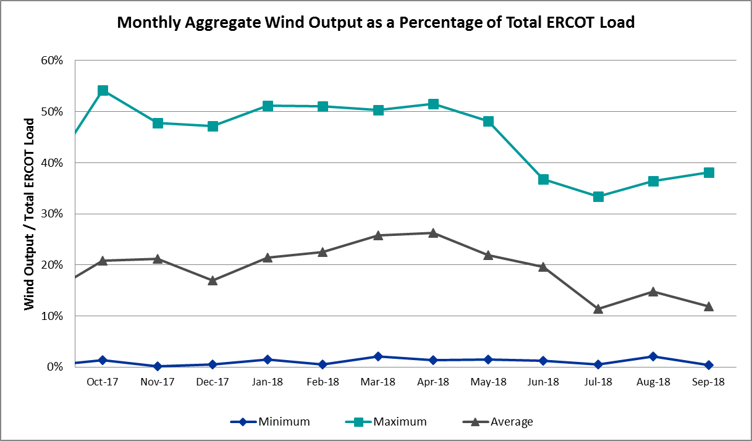

COP Error Analysis
COP Error is calculated as the capacity difference between the COP HSL and real-time HSL of the unit. Mean Absolute Error (MAE) stayed high, mostly over 10,000 MW, until Day-Ahead at 12:00, then dropped significantly to 958 MW by Day-Ahead at 14:00. In the following chart, Under-Scheduling Error indicates that COP had less generation capacity than real-time and Over-Scheduling Error indicates that COP had more generation capacity than real-time. Under-Scheduling persisted from the beginning of Day-Ahead to Day-Ahead at 13:00. Over-Scheduling persisted from 14:00 of Day-Ahead to the end of the Operating Day. Snapshot on the Operating Day considers all Operating Hours, including past hours. However, COP error for the Operating Hour freezes after the Adjustment Period.
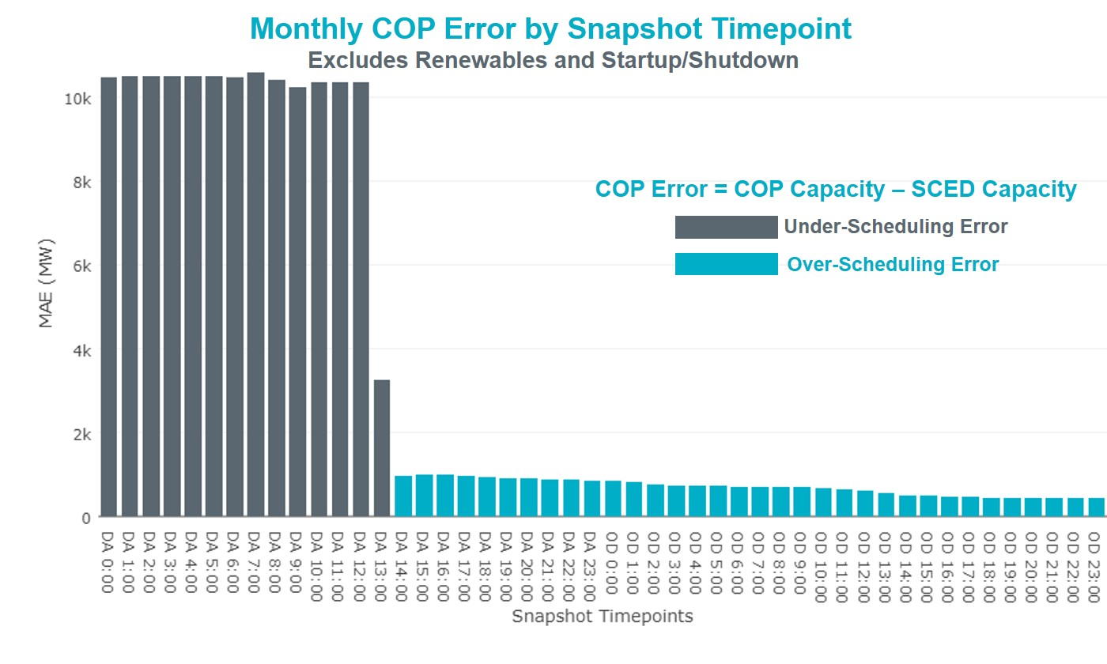
Monthly MAE for the Latest COP at the end of the Adjustment Period was 431 MW with median ranging from -174MW for Hour-Ending (HE) 15 to 421 MW for HE 22. September 27th HE 3 had the largest Over-Scheduling Error (1,604 MW) and September 17th HE 21 had the largest Under-Scheduling Error (-2,595 MW).
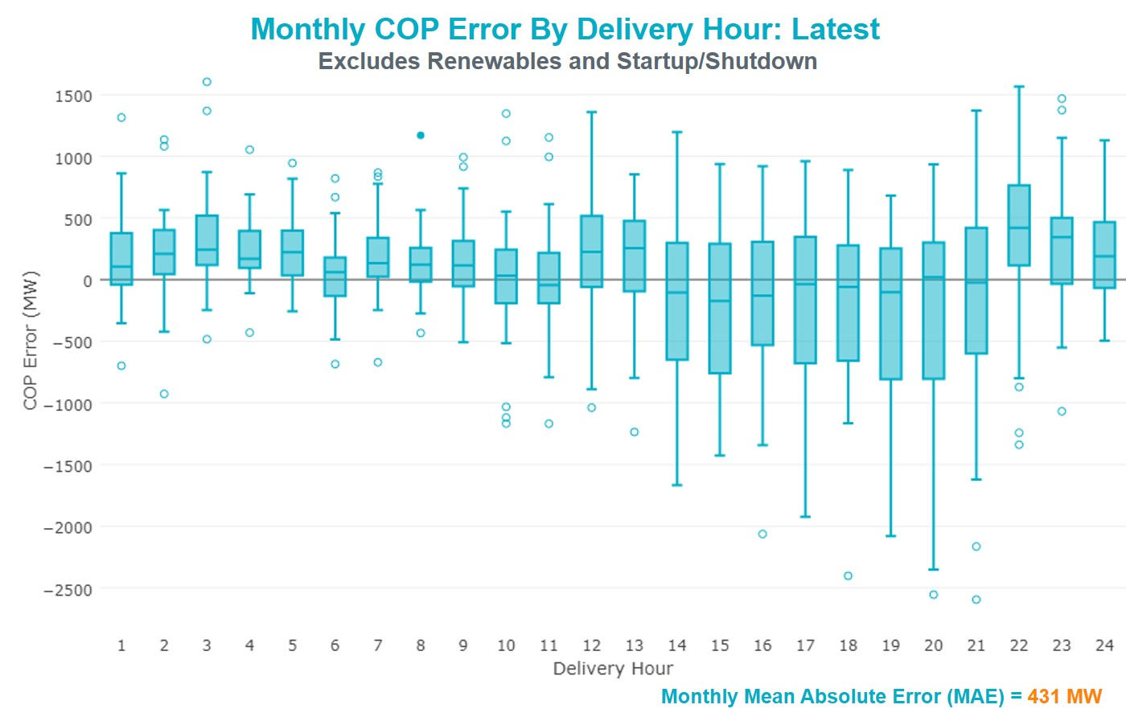
Monthly MAE for the Day-Ahead COP at 12:00 was 10,350 MW with median ranging from -13,510 MW for Hour-Ending (HE) 17 to -8,369 MW for HE 2. September 29th HE 24 had the smallest Under-Scheduling Error (-1,178 MW) and September 17th HE 18 had the largest Under-Scheduling Error (-20,185 MW).
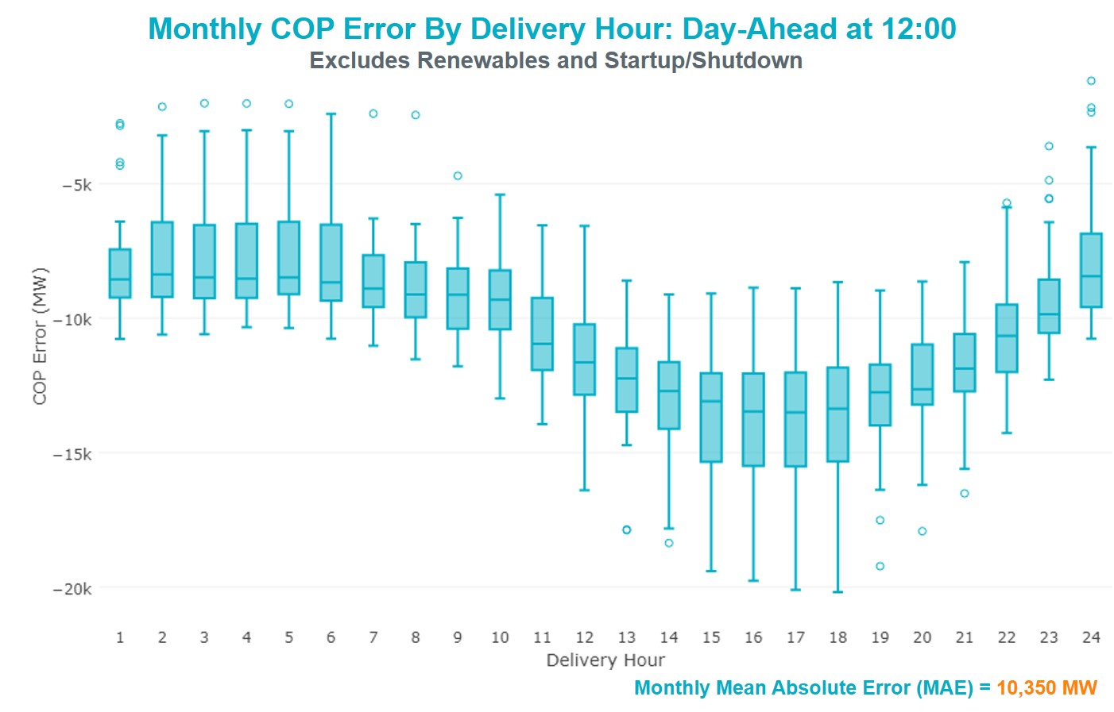

Congestion Analysis
The total number of congestion events experienced by the ERCOT system decreased in September. There were 13 instances over 13 days on the Generic Transmission Constraints (GTCs) in September.

Notable Constraints
Nodal protocol section 3.20 specifies that ERCOT shall identify transmission constraints that are active or binding three or more times within a calendar month. As part of this process, ERCOT reports congestion that meets this criterion to ROS. In addition ERCOT also highlights notable constraints that have an estimated congestion rent exceeding $1,000,000 for a calendar month. These constraints are detailed in the table below. Rows highlighted in blue indicate the congestion was affected by one or more outages. For a list of all constraints activated in SCED for the month of September, please see Appendix A at the end of this report.

Contingency Name | Overloaded Element | # of Days Constraint Active | Congestion Rent | Transmission Project
HCKSW-ALLNC&RNKSW 345kV | Blue Mound - Wagley Robertson 138kV | 3 | $13,878,112.46 | Wagley Robertson (2076) - Blue Mound (2071) 138-kV line upgrade (2017RTP NC10)
DMTSW-SCOSW 345KV | Knapp - Scurry Chevron 138kV | 16 | $4,738,134.80 | Ennis Creek - Cogdell 69 kV Line (4554) & Ennis Creek 138 kV Switching Station (6269)
Navarro - WTRML 345KV | Britton Road - Venus Switch 345kV | 2 | $3,556,162.42 | Upgrade Existing Venus-Webb/Cedar Hill Sw. Sta. 345 kV Double Ckt Line (5492)
Nedin-Mv_Wedn4&Mv_Palm4 138kV | North Edinburg - North Mcallen 138kV | 3 | $3,232,847.15 | North McAllen (8368) - North Edinburg (8380) 138-kV line upgrade (2017-S6)
NORTH PHARR to POLK AVENUE LIN 1 | North Mcallen - West Mcallen 138kV | 2 | $2,409,879.02 | North McAllen (8368) - West McAllen (8367) - South McAllen (8371) 138-kV line upgrades (2017-S9)
MESA VIEW SWITCH to FORT LANCASTER LIN 1 | Hargrove - Twin Buttes 138kV | 4 | $2,050,438.17 | Twin Buttes Autotransformer Addition (5270 B)
FERGUSON to SHERWOOD SHORES LIN 1 | Cedar Valley - Trimmier 138kV | 1 | $1,949,571.26
Fergus-Granmo&Wirtz-Starck 138kV | Flat Rock Lcra - Wirtz 138kV | 5 | $1,721,766.00 | Wirtz to FlatRock to Paleface Transmission Line Upgrade (4465)
Bronco to ALPINE LIN 1 | Solstice - Linterna 138kV | 21 | $1,596,435.46 | Far West Texas Project
EMSES-SAGNA 138kV | Blue Mound - Wagley Robertson 138kV | 6 | $1,132,426.58 | Wagley Robertson (2076) - Blue Mound (2071) 138-kV line upgrade (2017RTP NC10)
BOSQUE SWITCH to ELM MOTT LIN 1 | Bosque Switch - Rogers Hill Bepc 138kV | 4 | $720,503.65 | Bosque Switch (252) -Olsen TNP (37460) 138-kV line terminal upgrade
PH ROBINSON to MEADOW LIN A | Mainland Tnp - Alvin Tnp 138kV | 16 | $654,171.50 | Mainland Substation (6045)
ODLAW SWITCHYARD to ASPHALT MINES LIN 1 | Hamilton Road - Maverick 138kV | 12 | $640,519.69 | Brackettville to Escondido: Construct 138 kV line (5206)
Basecase | PNHNDL GTC | 12 | $544,335.10 | LP&L Option 4ow & Panhandle Loop (5180, 5208)
Jewet-Sng 345kV | Btu_Jack_Creek - Twin Oak Switch 345kV | 6 | $538,343.72 | Houston Import Project (4458)
Basecase | Omega - Horse Hollow Generation Tie 345kV | 6 | $462,687.88
North Lamar POI to LORAINE SOUTH POI LIN _A | Eskota Switch - Trent 69kV | 3 | $406,908.33 | Rehab Scott REA Tap to Eskota 69 kV line (6042)
NORTH McCAMEY to ODESSA EHV SWITCH LIN 1 | Solstice - Linterna 138kV | 4 | $312,008.93 | Far West Texas Project
RIO HONDO to LAS PULGAS LIN 1 | Raymondville 2 138/69kV | 12 | $302,672.81 | Harlingen SS- Raymondville #2: Convert to 138 kV (6167)
Entpr-Trses & Mlses-Scses 345kV | Herty North Switch - Nacogdoches Se 138kV | 5 | $295,044.70 | Nacogdoches Southeast - Herty North 138 kV Line (4821)
Marbfa-Lakewy &Wirtz-Palefa 138kV | Flat Rock Lcra - Wirtz 138kV | 5 | $219,719.98 | Wirtz to Johnson City to Mountain Top Rebuild to 138kV (6789)
PH ROBINSON to MEADOW LIN A | Seminole Tnp - Friendswood Tnp 138kV | 3 | $214,820.19 | Friendswood Genration (13INR0049) Transmission Network (5140)
Basecase | Solstice - Linterna 138kV | 18 | $213,119.24 | Far West Texas Project
MOORE SWITCHING STATION to DOWNIE SWITCHING STATION LIN 1 | Downie Switching Station 138/69kV | 11 | $197,167.08
Ferguson-Sherwood Shores & Ferguson-Granite Mountain 138kV | Starcke - Wirtz 138kV | 7 | $95,659.34
Berghe-Kendal 345kv & Welfar 138kv | Kendall - Cagnon 345kV | 3 | $82,093.77
FRIEND RANCH to SONORA LIN 1 | Atlantic Sonora - Sonora 69kV | 4 | $73,544.30 | Carver: Build new 138 kV station (5979)
LAQUINTA to LOBO LIN 1 | Bruni Sub 138/69kV | 3 | $44,853.24 | Holland 69 kV Capacitors (5805)
JARDIN to DILLEY SWITCH AEP LIN 1 | Dilley Switch Aep - Cotulla Sub 69kV | 3 | $33,883.24 | Rebuild Cotulla to Big Wells 69kV line
Pig Creek to Solstice LIN 1 | Airport Tnp - 16th Street Tnp 138kV | 4 | $28,529.67
GAS PAD to FLAT TOP TNP LIN 1 | Ih 20 Tnp - Pecos Tnp 69kV | 4 | $20,014.96
NORTH McCAMEY to ODESSA EHV SWITCH LIN 1 | Fort Stockton Plant - Linterna 138kV | 3 | $14,761.56 | Far West Texas Project
Solstice to LINTERNA LIN 1 | Alpine - Bronco 69kV | 4 | $6,718.83 | Saragosa to Solstice: Rebuild 138 kV line

Generic Transmission Constraint Congestion
There were 12 days on the Panhandle GTC and 1 day on North-Houston GTC in September. There was no activity on the remaining GTCs during the month.

Note: This is how many times a constraint has been activated to avoid exceeding a GTC limit, it does not imply an exceedance of the GTC occurred or that the GTC was binding.

Manual Overrides
None.

Congestion Costs for Calendar Year 2018
The following table represents the top twenty active constraints for the calendar year based on the estimated congestion rent attributed to the congestion. ERCOT updates this list on a monthly basis.

Contingency | Binding Element | # of 5-min SCED Intervals | Estimated Congestion Rent | Transmission Project
Solstice to LINTERNA LIN 1 | Yucca Drive Switch - Gas Pad 138kV | 17,620 | 251,851,642.32 | Yucca Drive-Barilla Junction (4549)
Basecase | PNHNDL GTC | 27,124 | 98,457,107.57 | LP&L Option 4ow & Panhandle Loop (5180, 5208)
CRLNW-LWSSW 345kV | Carrollton Northwest - Lakepointe Tnp 138kV | 13,115 | 60,311,425.16 | Oncor_NW Carrollton - LakePointe (5488)
LEWISVILLE SWITCH to JONES STREET TNP LIN _A | Ti Tnp - West Tnp 138kV | 3,103 | 35,839,701.17 | Congestion Management Plan # 4 and Stewart Road: Construct 345 kV cut-in (5604)
EMSES-SAGNA 138kV | Blue Mound - Wagley Robertson 138kV | 6,326 | 35,676,195.49 | Wagley Robertson (2076) - Blue Mound (2071) 138-kV line upgrade (2017RTP NC10)
NORTH EDINBURG TRX 1382 345/138 | North Edinburg 345/1kV | 1,460 | 35,354,554.62 | Stewart Road: Construct 345 kV cut-in (5604)
DMTSW-SCOSW 345KV | Knapp - Scurry Chevron 138kV | 11,563 | 21,960,230.71 | Ennis Creek - Cogdell 69 kV Line (4554) & Ennis Creek 138 kV Switching Station (6269)
Basecase | VALIMP GTC | 601 | 19,938,471.66 | La Palma Dynamic Reactive (5588) and Pharr Dynamic Reactive (5596)
Ryssw-Forsw 345kV | Forney West - Forney Switch 138kV | 1,735 | 16,044,364.37
SN-STR26 & BFP-VL82 | Hofman - Basf 138kV | 1,212 | 15,639,411.86
Bronco to ALPINE LIN 1 | Solstice - Linterna 138kV | 13,053 | 15,595,410.31 | Far West Texas Project
HCKSW-ALLNC&RNKSW 345kV | Blue Mound - Wagley Robertson 138kV | 921 | 15,529,710.27 | Wagley Robertson (2076) - Blue Mound (2071) 138-kV line upgrade (2017RTP NC10)
Castrvll-Razorbac&Txresrch 138kV | Hondo Creek Switching Station - Moore Switching Station 138kV | 605 | 15,342,875.43
Elmcreek-Sanmigl 345kV | Pawnee Switching Station - Calaveras 345kV | 2,108 | 14,407,954.05
WOLF SWITCHING STATION to Monahans Tap 2 LIN _G | General Tire Switch - Southwestern Portland Tap 138kV | 2,645 | 13,959,263.32
WOODWARD 1 TAP to WOODWARD 1 LIN 1 | 16th Street Tnp - Woodward 2 138kV | 2,632 | 13,666,794.32 | Far West Texas Project
NORTH PHARR to POLK AVENUE LIN 1 | North Mcallen - West Mcallen 138kV | 1,165 | 13,282,240.37 | North McAllen (8368) - West McAllen (8367) - South McAllen (8371) 138-kV line upgrades (2017 RTP S9)
Jewet-Sng 345kV | Btu_Jack_Creek - Twin Oak Switch 345kV | 5,627 | 12,081,985.71 | Houston Import Project (4458)
MOSS SWITCH to YUCCA DRIVE SWITCH LIN _A | General Tire Switch - Southwestern Portland Tap 138kV | 2,344 | 11,535,045.00
LON HILL TRX LON_HILL_3_2 345/138 | Lon Hill 345/1kV | 1,587 | 11,412,928.00 | Lon Hill: Replace 345/138 kV autotransformers (6106)

System Events

ERCOT Peak Load
The unofficial ERCOT peak load for the month was 64,606 MW and occurred on September 18th, during hour ending 17:00.

Load Shed Events
None.

Stability Events
None.

Notable PMU Events
ERCOT analyzes PMU data for any significant system disturbances that do not fall into the Frequency Events category reported in section 2.1. The results are summarized in this section once the analysis has been completed.

There were no PMU events in September.

DC Tie Curtailment
Date | DC Tie | Curtailing Period | # of Tags Curtailed | Initiating Event | Curtailment Reason
9/3/2018 | DC-R | HE 12:00 – HE 14:00 | 1 | SPOLPHA8, loss of the Polk Ave to N. Pharr 138 kV overloads the N McAllen to W McAllen 138 kV. | Local Congestion
9/4/2018 | DC-R | HE 11:00 | 1 | SPOLPHA8, loss of the Polk Ave to N. Pharr 138 kV overloads the N McAllen to W McAllen 138 kV. | Local Congestion
9/5/2018 | DC-L | HE 08:00 – HE 13:00 | 6 | Unknown reason | DC Tie Forced Outage
9/14/2018 | DC-S | HE 21:00 – HE 24:00 | 5 | 138kV breaker issue | DC Tie Forced Outage
9/15 /2018 | DC-S | HE 01:00 – HE 24:00 | 3 | 138kV breaker issue | DC Tie Forced Outage
9/21/2018 | DC-S | HE 22:00 – HE 24:00 | 2 | 138kV breaker issue | DC Tie Forced Outage
9/24/2018 | DC-S | HE 20:00 – HE 24:00 | 4 | 138kV breaker issue | DC Tie Forced Outage

TRE/DOE Reportable Events
- ERCOT submitted an EOP-004 report for September 26, 2018 Reportable Event Type: Generation Loss and Transmission Loss.
- CenterPoint submitted an EOP-004 report for September 26, 2018 Reportable Event Type: Transmission Loss.

New/Updated Constraint Management Plans
None.

New/Modified/Removed RAS
None.

New Procedures/Forms/Operating Bulletins
None.

Emergency Conditions

OCNs
Date and Time | Description
9/6/2018 00:27 | ERCOT issued an OCN due to projected reserve capacity shortage for hours ending 14:00 through 18:00. ERCOT is requesting all QSE's to update their COPs.

Advisories
Date and Time | Description
9/12/2018 14:22 | ERCOT issued an Advisory due to Physical Responsive Capability being below 3000 MW.
9/13/2018 15:44 | ERCOT issued an Advisory due to Physical Responsive Capability being below 3000 MW.
9/16/2018 15:23 | ERCOT issued an Advisory due to Physical Responsive Capability being below 3000 MW.

Watches
Date and Time | Description
9/3/2018 11:17 | ERCOT issued a Transmission Watch for the Railroad DC Tie (DC_R) due to local congestion and the curtailment of DC-Tie exports to CENACE.
9/4/2018 10:10 | ERCOT issued a Transmission Watch for the Railroad DC Tie (DC_R) due to local congestion and the curtailment of DC-Tie exports to CENACE.
9/5/2018 07:32 | ERCOT issued a Transmission Watch for the Laredo DC Tie (DC_L) due to a forced outage and curtailment of DC-Tie exports to CENACE.
9/14/2018 20:03 | ERCOT issued a Transmission Watch for the Eagle Pass DC Tie due to a forced outage and the curtailment of DC-Tie exports to CENACE.
9/21/2018 21:24 | ERCOT issued a Transmission Watch for the Eagle Pass DC Tie due to a forced outage and the curtailment of DC-Tie exports to CENACE.
9/24/2018 18:53 | ERCOT issued a Transmission Watch for the Eagle Pass DC Tie due to a forced outage and the curtailment of DC-Tie exports to CENACE.

Emergency Notices
None.

Application Performance

TSAT/VSAT Performance Issues
None

Communication Issues
None.

Market System Issues
None.

Model Updates
The Downstream Production Change (DPC) process allows ERCOT to make changes in the on-line Network Operations Model without loading a completely new model. The purpose of this process is to allow for reliable grid operations as system conditions change between designated Network Operations Model database loads. The DPC process is limited in scope to just those items listed below, with equipment ratings updates being the most common. ERCOT has seen a rise in the use of the DPC process to make on-line updates to the Network Operations Model in recent years, instead of through the standard Network Operations Model Change Request process.

- Static Line ratings (Interim Update)
- Dynamic Line ratings (non-Interim Update)
- Autotransformer ratings (non-Interim Update)
- Breaker and Switch Normal status (Interim Update)
- Contingency Definitions (Interim Update)
- RAP and RAS changes or additions (Interim Update)
- Net Dependable and Reactive Capability (NDCRC) values (Interim Update)
- Impedance Updates (non-Interim)
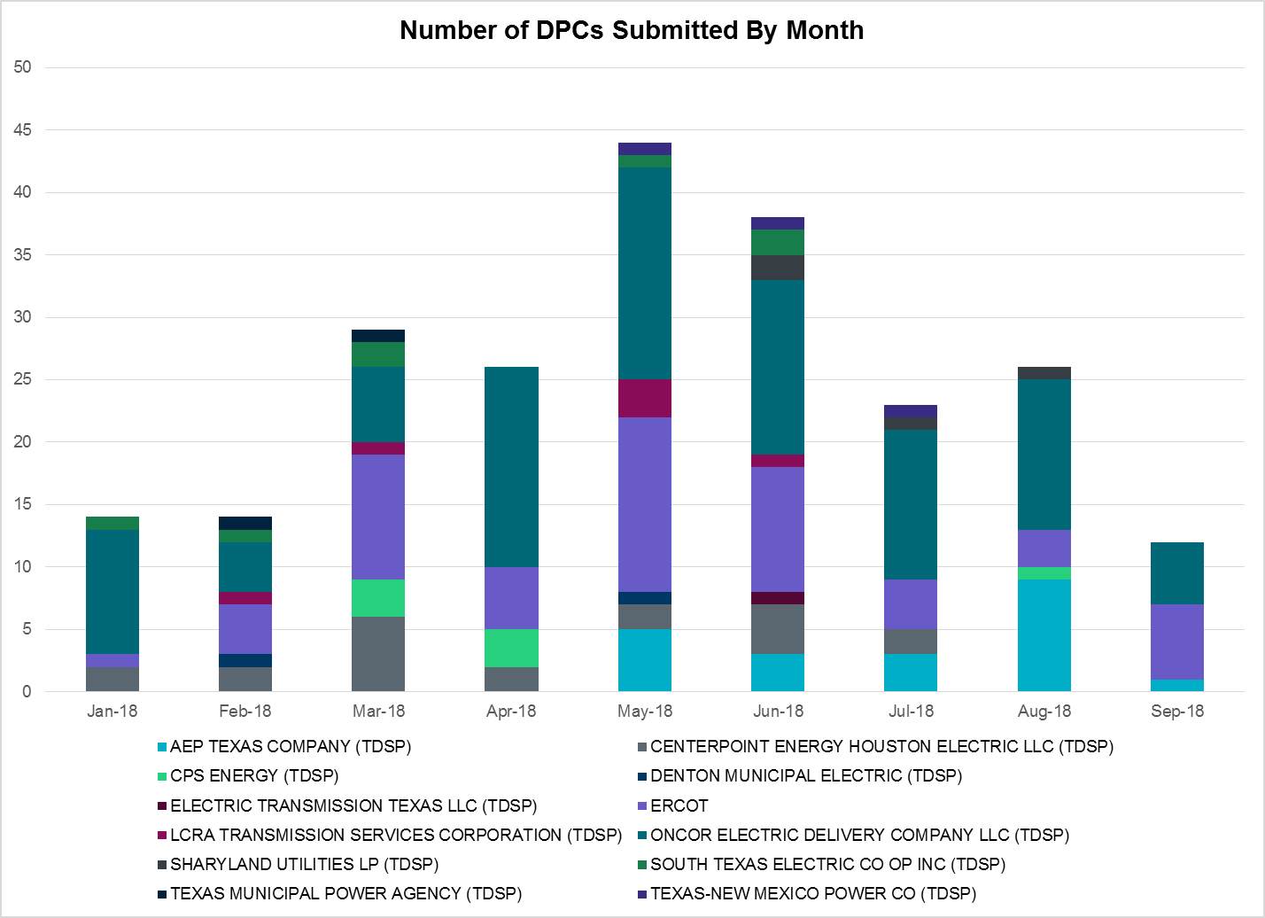

Transmission Operator | Number of DPCs in September
AEP TEXAS COMPANY (TDSP) | 1
BRAZOS ELECTRIC POWER CO OP INC (TDSP) | 0
CENTERPOINT ENERGY HOUSTON ELECTRIC LLC (TDSP) | 0
CPS ENERGY (TDSP) | 0
DENTON MUNICIPAL ELECTRIC (TDSP) | 0
ERCOT | 6
LCRA TRANSMISSION SERVICES CORPORATION (TDSP) | 0
LONE STAR TRANSMISSION LLC (TSP) | 0
ONCOR ELECTRIC DELIVERY COMPANY LLC (TDSP) | 5
SHARYLAND UTILITIES LP (TDSP) | 0
SOUTH TEXAS ELECTRIC CO OP INC (TDSP) | 0
TEXAS MUNICIPAL POWER AGENCY (TDSP) | 0
TEXAS-NEW MEXICO POWER CO (TDSP) | 0

Appendix A: Real-Time Constraints
The following is a complete list of constraints activated in SCED for the month of September. Full contingency descriptions can be found in the Standard Contingencies List located on the MIS secure site at Grid Generation Reliability Unit Commitment.

Contingency | Constrained Element | From Station | To Station | # of Days Constraint Active
SBROALP9 | LINTER_SOLSTI1_1 | LINTERNA | SOLSTICE | 21
BASE CASE | LINTER_SOLSTI1_1 | LINTERNA | SOLSTICE | 18
SMDOPHR5 | 138_ALV_MNL_1 | ALVIN | MAINLAND | 16
DMTSCOS5 | 6437__F | SCRCV | KNAPP | 16
BASE CASE | PNHNDL | n/a | n/a | 12
SRAYRI28 | RAYMND2_69A1 | RAYMND2 | RAYMND2 | 12
SBRAUVA8 | HAMILT_MAVERI1_1 | HAMILTON | MAVERICK | 12
SDOWMOO8 | DOWNIES_AX1H | DOWNIES | DOWNIES | 11
DFERGRM8 | 654T654_1 | WIRTZ | STARCK | 7
DJEWSNG5 | JK_TOKSW_1 | TOKSW | JK_CK | 6
DEMSSAG8 | 6270__C | WGROB | BLMND | 6
BASE CASE | HHGTOM_1 | HHGT | OMEGA | 6
DFERSTA8 | 38T365_1 | WIRTZ | FLATRO | 5
DENTSCS5 | 1170__A | NCDSE | HNRSW | 5
DMARPA_8 | 38T365_1 | WIRTZ | FLATRO | 5
SHACPB38 | M_69_J1_1 | IH20 | PECOS | 4
SPIGSOL8 | TNAF_TNFS_1 | TNAF | 16TH_ST | 4
SBOSELM5 | 1030__B | BOSQUESW | RGH | 4
SSONFRI8 | ATSO_SONR1_1 | ATSO | SONR | 4
SPIGSOL8 | TNAF_TNFS_1 | 16TH_ST | TNAF | 4
SNORODE5 | LINTER_SOLSTI1_1 | LINTERNA | SOLSTICE | 4
SFTLMES8 | HARGRO_TWINBU1_1 | TWINBU | HARGROVE | 4
SWCSBOO8 | ALPINE_BRONCO1_1 | BRONCO | ALPINE | 4
SSONFRI8 | ATSO_SONR1_1 | SONR | ATSO | 4
SMDOPHR5 | G138_10C_1 | FRDSWOOD | SEMINOLE | 3
DHCKRNK5 | 6270__C | WGROB | BLMND | 3
SLAQLOB8 | BRUNI_69_1 | BRUNI | BRUNI | 3
DBERWE58 | 459T459_1 | KENDAL | CAGNON | 3
SNORODE5 | FTST_LINTER1_1 | FTST | LINTERNA | 3
DNEDPAL8 | NEDIN_N_MCAL1_1 | NEDIN | N_MCALLN | 3
SJARDIL8 | DIL_COTU_1 | DILLEYSW | COTULAS | 3
SSWDMGS8 | ESKSW_TRNT1_1 | ESKSW | TRNT | 3
SBRAHAM8 | HAMILT_MAVERI1_1 | HAMILTON | MAVERICK | 2
DNAVWTR5 | 530__C | VENSW | BRTRD | 2
DSKYNAC8 | WEIDER_RAND_1 | WEIDER | W2 | 2
SPOLPHA8 | KEY_SW_PALMHR1_1 | KEY_SW | PALMHRTP | 2
SWCSBOO8 | ALPINE_PAIS1_1 | ALPINE | PAIS | 2
DBIGKEN5 | TREADW_YELWJC1_1 | TREADWEL | YELWJCKT | 2
SPOLPHA8 | GCB_100_1 | N_MCALLN | W_MCALLN | 2
SBEVASH8 | HAMILT_MAVERI1_1 | HAMILTON | MAVERICK | 2
SILLFTL8 | HAMILT_MAXWEL1_1 | MAXWELL | HAMILTON | 2
DPHRAL58 | 138_ALV_MNL_1 | ALVIN | MAINLAND | 2
DMARPA_8 | 43T365_1 | FLATRO | PALEPE | 2
DFERGRM8 | 83T196_1 | STARCK | PALEFA | 2
SVICCO28 | COLETO_VICTOR2_1 | COLETO | VICTORIA | 2
SILLFTL8 | CTHR_SONR1_1 | SONR | CTHR | 2
SLIGVEN5 | 530__C | VENSW | BRTRD | 2
SMCEABS8 | MKLT_TRNT1_1 | TRNT | MKLT | 2
SCRDLOF9 | BOW_FMR1 | BOW | BOW | 2
SMCEESK8 | MKLT_TRNT1_1 | TRNT | MKLT | 2
DFPPFAY5 | 190T152_1 | GIDEON | WINCHE | 1
DRIOHAR5 | BURNS_RIOHONDO_1 | RIOHONDO | MV_BURNS | 1
SSONFRI8 | FDR_OZNC_1 | OZNC | FRIEND_R | 1
SCOLKEN8 | MAGRUD_VICTOR2_1 | VICTORIA | MAGRUDER | 1
SJCKSTP5 | MRK_VNVL_1 | MRKHMSW | VNVLKSW | 1
BASE CASE | N_TO_H | n/a | n/a | 1
SMLSSCS5 | 1170__A | NCDSE | HNRSW | 1
DBBSRCH5 | 2310__C | NVARO | RCHLD | 1
SPIGSOL8 | 6100__G | ACSSW | AMTBT | 1
DMTSCOS5 | 6474__A | SUNSW | MGSES | 1
SFERSHE8 | 654T654_1 | WIRTZ | STARCK | 1
SCELKLE8 | CAL_ROBS_1 | CALALS | ROBSTOS | 1
SCOLPAW5 | COLETO_ROSATA1_1 | COLETO | ROSATA | 1
XCED289 | CONCHO_VRBS1_1 | CONCHO | VRBS | 1
SBROALP9 | FTST_LINTER1_1 | FTST | LINTERNA | 1
SMDOPHR5 | 138_FWP_MNL_1 | MAINLAND | FRWYPARK | 1
SLAKMA28 | 654T654_1 | WIRTZ | STARCK | 1
SCAGKEN5 | 74T148_1 | COMFOR | CICO | 1
DWLDSCO5 | KOCHTAP_VEALM_1 | VEALMOOR | KOCHTAP | 1
DBBSRCH5 | 1210__C | NVARO | HAN1 | 1
DSTEXP12 | BLESSI_LOLITA1_1 | LOLITA | BLESSING | 1
SFERSHE8 | CDRVAL_TRIM_1 | TRIMMIER | CEDARVAL | 1
DSKYNAC8 | F4_Z4_1 | Z4 | F4 | 1
SPHAPHA8 | GCB_100_1 | N_MCALLN | W_MCALLN | 1
SCABWES8 | HOLLY4_SOUTH_1_1 | HOLLY4 | SOUTH_SI | 1
SBAKBIG5 | LINTER_SOLSTI1_1 | LINTERNA | SOLSTICE | 1
SELMTH25 | 1030__B | BOSQUESW | RGH | 1
DFERWIR8 | 234T400_1 | SUNRBE | KING_1 | 1
DCHBJOR5 | BRNLAN86_A | LAN | BRN | 1
BASE CASE | BURNS_RIOHONDO_1 | RIOHONDO | MV_BURNS | 1
BASE CASE | SWEETWN3_XT2 | SWEETWN3 | SWEETWN3 | 1
DTRSENT5 | 1255__B | SCSES | STCKY | 1
SGRAFER8 | 654T654_1 | WIRTZ | STARCK | 1
DTHWZEN5 | CE_OB_25_A | OB | CE | 1
DCRLLSW5 | COOPERCK_ARCO_1 | COOPERCK | ARCO | 1
SBRAUVA8 | EAGLHY_ESCOND1_1 | EAGLHYTP | ESCONDID | 1
XNED258 | NEDIN_138H | NEDIN | NEDIN | 1
SKBBI8 | ST_TAP25_1 | ST | ST | 1
SBIGTWI5 | TREADW_YELWJC1_1 | TREADWEL | YELWJCKT | 1
SASPPAI8 | ASPM_69T1 | ASPM | ASPM | 1
BASE CASE | ENAS_SNYDERTL_1 | ENAS | WKN_BKR | 1
SSONFRI8 | FDR_OZNC_1 | FRIEND_R | OZNC | 1
DWIRSTA8 | 223T180_1 | LAKEWY | MARSFO | 1
DWIRGRA8 | 38T365_1 | WIRTZ | FLATRO | 1
SVLSANA5 | 562__B | MEMWT | VANAL | 1
SGLDSUN8 | ECRSW_FMR1 | ECRSW | ECRSW | 1
SMCEABS8 | ESKSW_TRNT1_1 | ESKSW | TRNT | 1
DBIGKEN5 | HAMILT_MAXWEL1_1 | MAXWELL | HAMILTON | 1
SSONFRI8 | HAMILT_MAXWEL1_1 | MAXWELL | HAMILTON | 1
SBEVASH8 | TURTLECK_WCRYS_1 | TURTLCRK | WCRYSTS | 1

The Duration of Event is defined as the time it takes for the frequency to recover to pre-disturbance frequency or 60 Hz as applicable.
PMU reports are typically generated when frequency drops below 59.9, but PMU data is available for other events.
Delta Frequency is defined as the difference between the starting point of the frequency event (t(0) or “A-point”) and minimum/maximum frequency (“C-Point”).
Currently, the Critical Inertia Level for ERCOT is approximately 100,000 MW-s (Source: link)
This is the hourly integrated peak demand as published in the ERCOT D&E report.
All DC Tie Curtailments are posted publically on the ERCOT Market Information System. See that posting for additional details for the event(s) in question.
See DC Tie Operating Procedure (http://www.ercot.com/mktrules/guides/procedures) for more details.

