August 2018 ERCOT Monthly Operations Report
Reliability and Operations Subcommittee Meeting
October 11, 2018

Table of Contents
1. Report Highlights 2
2. Frequency Control 3
2.1. Frequency Events 3
2.2. Responsive Reserve Events 4
2.3. Load Resource Events 4
3. Reliability Unit Commitment 4
4. Wind Generation as a Percent of Load 5
5. COP Error Analysis 5
6. Congestion Analysis 8
6.1. Notable Constraints 8
6.2. Generic Transmission Constraint Congestion 11
6.3. Manual Overrides 11
6.4. Congestion Costs for Calendar Year 2018 11
7. System Events 11
7.1. ERCOT Peak Load 13
7.2. Load Shed Events 13
7.3. Stability Events 13
7.4. Notable PMU Events 13
7.5. DC Tie Curtailment 13
7.6. TRE/DOE Reportable Events 14
7.7. New/Updated Constraint Management Plans 14
7.8. New/Modified/Removed RAS 14
7.9. New Procedures/Forms/Operating Bulletins 14
8. Emergency Conditions 14
8.1. OCNs 14
8.2. Advisories 14
8.3. Watches 15
8.4. Emergency Notices 15
9. Application Performance 15
9.1. TSAT/VSAT Performance Issues 15
9.2. Communication Issues 15
9.3. Market System Issues 15
10. Model Updates 15
Appendix A: Real-Time Constraints 18

Report Highlights
- The unofficial ERCOT peak for August was 69,889 MW.
- There were nine frequency events in August. PMU data indicates the ERCOT system transitioned well.
- There were six instances where Responsive Reserves were deployed.
- There were eight RUC commitments in August due to capacity and congestion.
- Congestions in August occurred in the North, South, Houston and West Load Zones. Congestions in the North can be mostly attributed to high generation and area load/gen pattern. Congestions in the South were mostly due to high wind generation and high load. Congestions in the West were mostly due to high West solar generation. Congestions in the Houston area were mostly due to area load/generation pattern. There were 12 days on the Panhandle GTC in August. There was no activity on the remaining GTCs during the month.
- There were three DC Tie curtailments in August. Two were due to filter bank issue and another was due to control computer failure.

Frequency Control

Frequency Events
The ERCOT Interconnection experienced nine frequency events in August, all of which resulted from a Resource trip. The average event duration was approximately 0:05:18.

A summary of the frequency events is provided below. The reported frequency events meet one of the following criteria: Delta Frequency is 60 mHz or greater; the MW loss is 350 MW or greater; resource trip event triggered RRS deployment. Frequency events that have been identified as Frequency Measurable Events (FME) for purposes of BAL-001-TRE-1 analysis are highlighted in blue. When analyzing frequency events, ERCOT evaluates PMU data according to industry standards. Events with an oscillating frequency of less than 1 Hz are considered to be inter-area, while higher frequencies indicate local events. Industry standards specify that damping ratio for inter-area oscillations should be 3.0% or greater. For the frequency events listed below, the ERCOT system met these standards and transitioned well after each disturbance.

Date and Time | Delta Frequency | Max/Min Frequency | Duration of Event | PMU Data |  |  | MW Loss | Load | Wind | Inertia
 | (Hz) | (Hz) |  | Oscillation Mode (Hz) |  | Damping Ratio |  | (MW) | % | (GW-s)
8/4/2018 8:20 | 0.061 | 59.896 | 0:03:24 | No PMU Report Created |  |  | 366 | 41,150 | 15% | 273,562
8/13/2018 22:59 | 0.192 | 59.803 | 0:04:38 | 0.67 | 12% |  | 1198 | 47,347 | 13% | 285,390
8/15/2018 18:10 | 0.090 | 59.860 | 0:03:06 | 0.63 | 18% |  | 487 | 66,884 | 13% | 359,667
8/16/2018 12:44 | 0.083 | 59.906 | 0:05:19 | No PMU Report Created |  |  | 443 | 63,278 | 10% | 360,005
8/16/2018 13:19 | 0.083 | 59.928 | 0:11:25 | No PMU Report Created |  |  | 365 | 65,325 | 9% | 273,562
8/16/2018 13:25 | 0.061 | 59.910 | 0:04:49 | No PMU Report Created |  |  | 334.28 | 65,631 | 9% | 368,852
8/18/2018 16:12 | 0.126 | 59.853 | 0:03:51 | 0.66 | 14% |  | 717.8 | 68,442 | 7% | 374,609
8/31/2018 12:03 | 0.086 | 59.902 | 0:06:37 | 0.65 | 17% |  | 526.964 | 59,405 | 7% | 273,562
8/31/2018 22:33 | 0.107 | 59.908 | 0:04:37 | 0.66 | 12% |  | 645.779 | 54,114 | 23% | 273,562

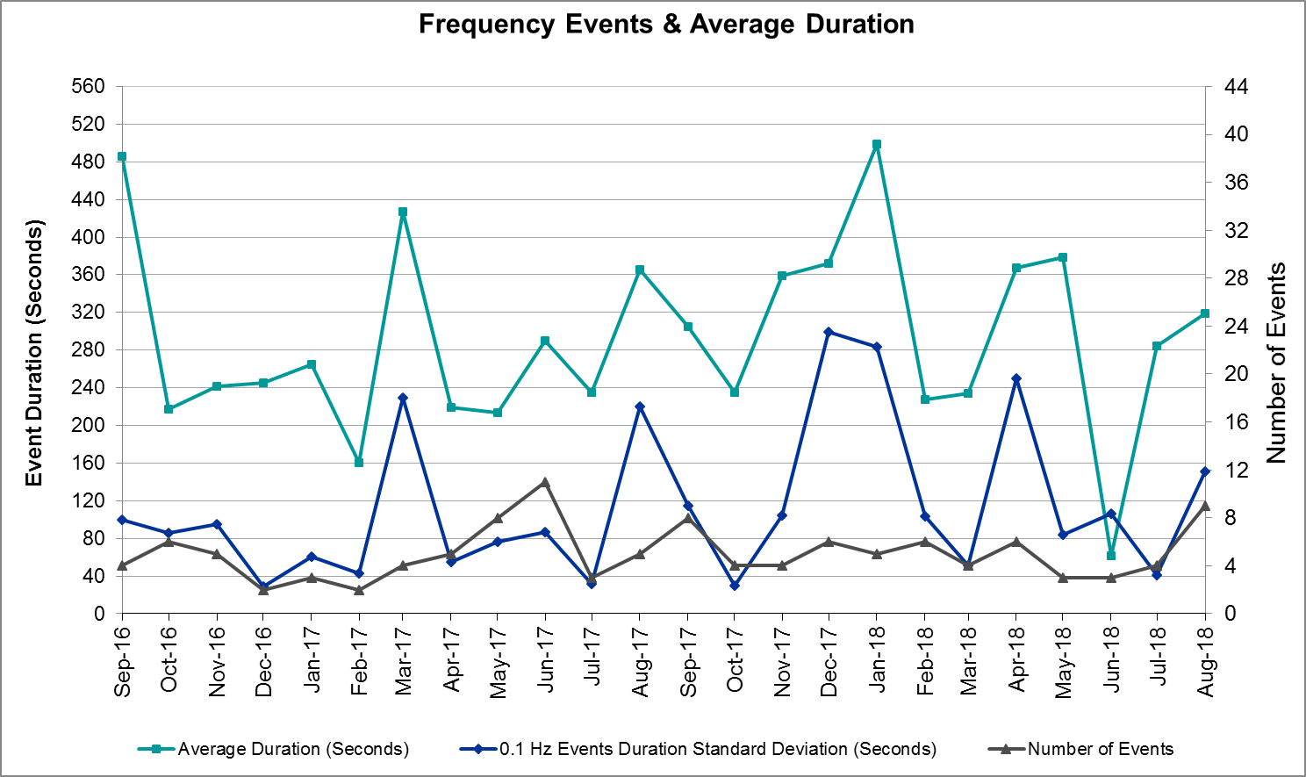
(Note: All data on this graph encompasses frequency event analysis based on BAL-001-TRE-1.)

Responsive Reserve Events

There were six events where Responsive Reserve MWs were released to SCED in August. The events highlighted in blue were related to frequency events reported in Section 2.1 above.

Date and Time Released to SCED | Date and Time Recalled | Duration of Event | Maximum MWs Released
8/4/2018 8:20 | 8/4/2018 8:24 | 0:03:24 | 554
8/13/2018 23:00 | 8/13/2018 23:03 | 0:03:36 | 1103
8/15/2018 18:10 | 8/15/2018 18:14 | 0:03:36 | 745
8/16/2018 12:44 | 8/16/2018 12:48 | 0:04:08 | 393
8/18/2018 16:12 | 8/18/2018 16:16 | 0:03:32 | 896
8/31/2018 12:04 | 8/31/2018 12:09 | 0:05:36 | 215

Load Resource Events
None.

Reliability Unit Commitment
ERCOT reports on Reliability Unit Commitments (RUC) on a monthly basis. Commitments are reported grouped by operating day and weather zone. The total number of hours committed is the sum of the hours for all the units in the specified region. Additional information on RUC commitments can be found on the MIS secure site at Grid Generation Reliability Unit Commitment.

There were no DRUC commitments in August.

There were eight HRUC commitment in August.

Resource Location | # of Resources | Operating Day | Total # of Hours Committed | Total MWhs | Reason for Commitment
Southern | 1 | 8/1/2018 | 8 | 2,120 | Capacity
North Central | 1 | 8/1/2018 | 4 | 2,092 | Capacity
East | 2 | 8/2/2018 | 4 | 1,743 | Capacity
Coast | 1 | 8/2/2018 | 8 | 4,296 | Congestion
North Central | 1 | 8/2/2018 | 4 | 1,740 | Capacity
Coast | 2 | 8/14/2018 | 12 | 1,971 | Congestion
Far West | 1 | 8/18/2018 | 2 | 134 | Congestion
North Central | 1 | 8/28/2018 | 4 | 1,740 | Congestion

Wind Generation as a Percent of Load
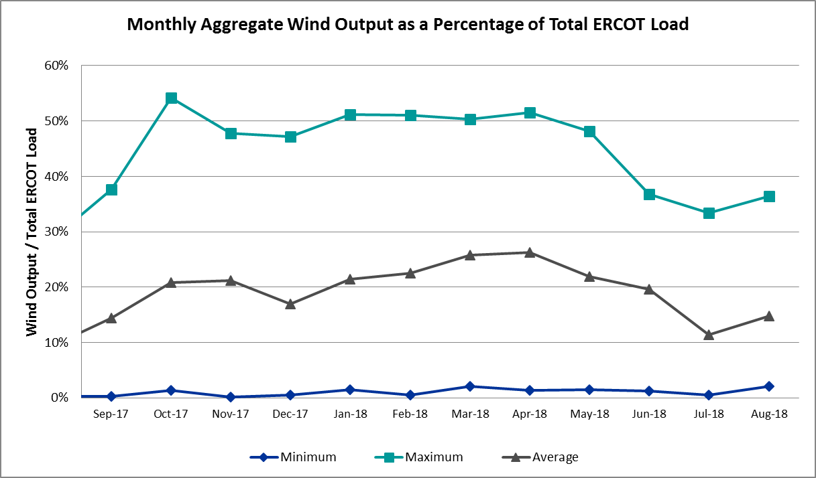

COP Error Analysis
COP Error is calculated as the capacity difference between the COP HSL and real-time HSL of the unit. Mean Absolute Error (MAE) stayed high, mostly over 10,000 MW, until Day-Ahead at 12:00, then dropped significantly to 910 MW by Day-Ahead at 14:00. In the following chart, Under-Scheduling Error indicates that COP had less generation capacity than real-time and Over-Scheduling Error indicates that COP had more generation capacity than real-time. Under-Scheduling persisted from beginning of Day-Ahead to end of the Operating Day except for Day-Ahead at 15:00. Snapshot on the Operating Day considers all Operating Hours, including past hours. However, COP error for the Operating Hour freezes after the Adjustment Period.
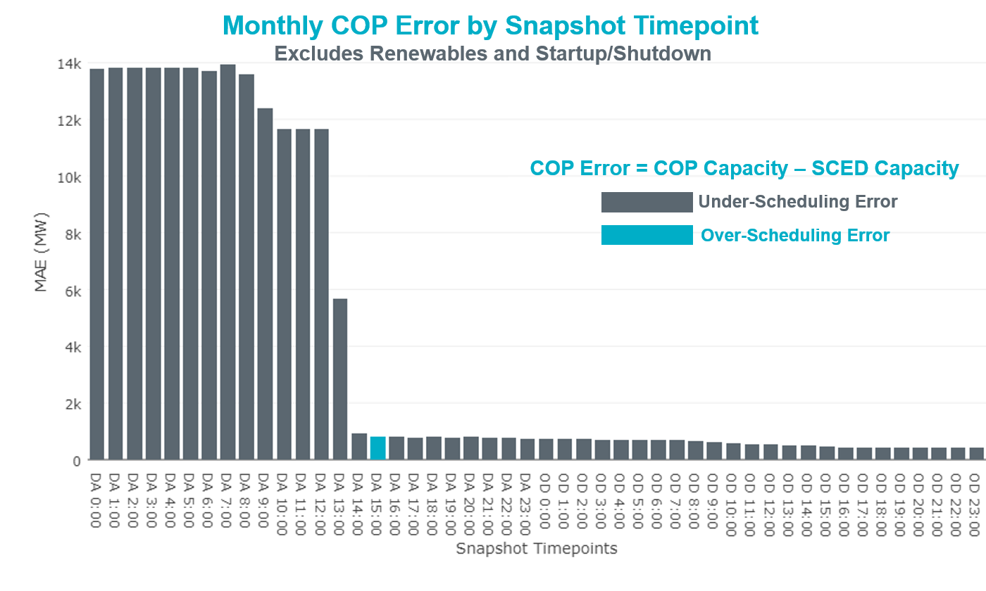

Monthly MAE for the Latest COP at the end of the Adjustment Period was 427 MW with median ranging from -628 MW for Hour-Ending (HE) 21 to 110 MW for HE 5. August 1st HE 13 had the largest Over-Scheduling Error (1,705 MW) and August 15th HE 21 had the largest Under-Scheduling Error (-2,700 MW).
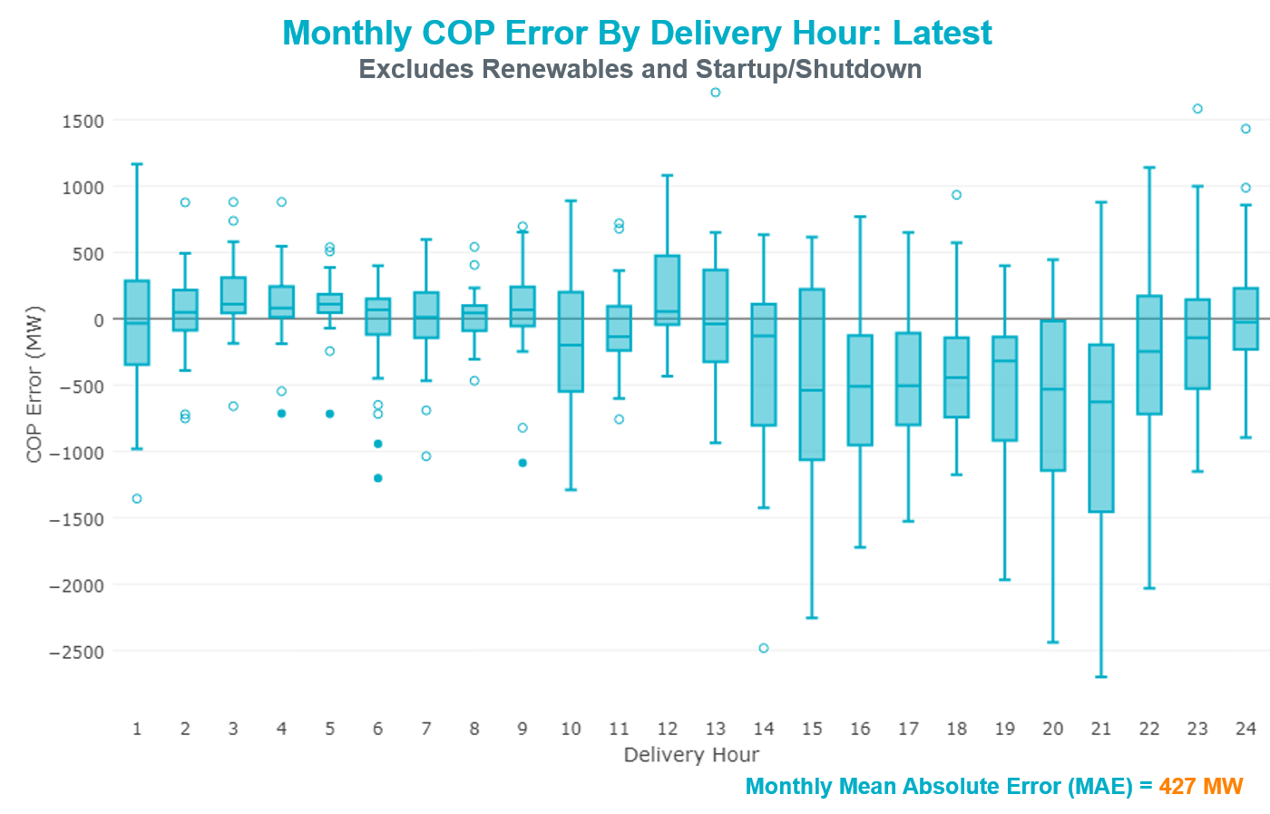

Monthly MAE for the Day-Ahead COP at 12:00 was 11,645 MW with median ranging from -17,474 MW for Hour-Ending (HE) 17 to -6,908 MW for HE 4. August 14th HE7 had the smallest Under-Scheduling Error (-3,949 MW) and August 20th HE 17 had the largest Under-Scheduling Error (-23,965 MW).

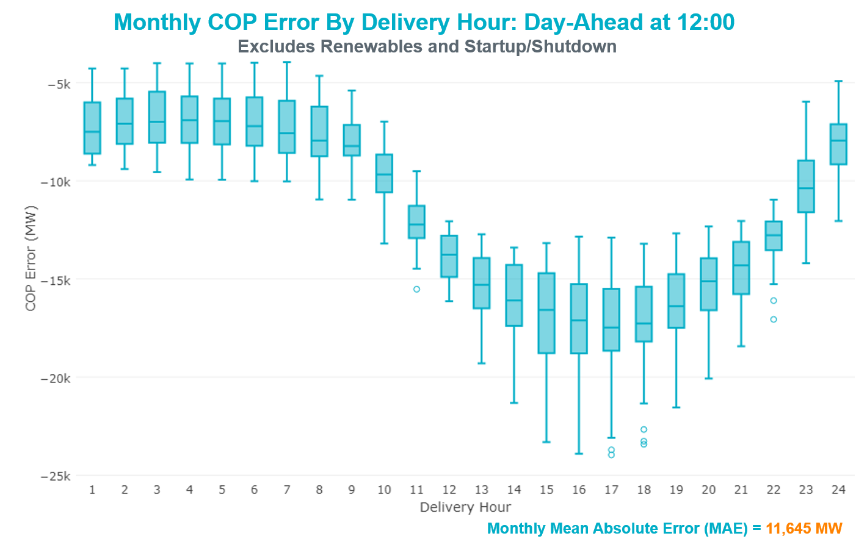

Congestion Analysis
The total number of congestion events experienced by the ERCOT system increased in August. There were 12 instances over 12 days on the Generic Transmission Constraints (GTCs) in August.

Notable Constraints
Nodal protocol section 3.20 specifies that ERCOT shall identify transmission constraints that are active or binding three or more times within a calendar month. As part of this process, ERCOT reports congestion that meets this criterion to ROS. In addition ERCOT also highlights notable constraints that have an estimated congestion rent exceeding $1,000,000 for a calendar month. These constraints are detailed in the table below. Rows highlighted in blue indicate the congestion was affected by one or more outages. For a list of all constraints activated in SCED for the month of August, please see Appendix A at the end of this report.

Contingency Name | Overloaded Element | # of Days Constraint Active | Congestion Rent | Transmission Project
EMSES-SAGNA 138kV | Blue Mound - Wagley Robertson 138kV | 15 | $7,109,289.69 | Wagley Robertson (2076) - Blue Mound (2071) 138-kV line upgrade (2017RTP NC10)
Basecase | Burns Sub - Rio Hondo 138kV | 13 | $5,892,011.87 | Rebuild Rio Hondo to East Rio Hondo (6687)
NORTH EDINBURG TRX 1382 345/138 | North Edinburg 345/1kV | 4 | $5,112,358.23 | Stewart Road: Construct 345 kV cut-in (5604)
Basecase | North Edinburg 345/1kV | 2 | $4,476,963.97 | Congestion Management Plan # 4 and Stewart Road: Construct 345 kV cut-in (5604)
DMTSW-SCOSW 345KV | Knapp - Scurry Chevron 138kV | 20 | $3,773,685.42 | Ennis Creek - Cogdell 69 kV Line (4554) & Ennis Creek 138 kV Switching Station (6269)
PH ROBINSON to MEADOW LIN A | Seminole Tnp - Friendswood Tnp 138kV | 14 | $2,554,996.84 | Friendswood Genration (13INR0049) Transmission Network (5140)
Bronco to ALPINE LIN 1 | Solstice - Linterna 138kV | 21 | $2,526,016.82 | Far West Texas Project
TWR(345) DOW-OAS18 & DOW-OAS27 | Sintek - Stratt 138kV | 3 | $2,210,838.81 | Angleton Area Ckt.26 & 82 Upgrades (3938B)
ODLAW SWITCHYARD to ASPHALT MINES LIN 1 | Hamilton Road - Maverick 138kV | 16 | $2,160,161.42 | Brackettville to Escondido: Construct 138 kV line (5206)
Ryssw-Forsw 345kV | Forney West - Forney Switch 138kV | 3 | $1,783,160.45 | Forney Sw. Sta. Second 600 MVA, 345/138 kV Autotransformer (12TPIT0080)
Entpr-Trses & Mlses-Scses 345kV | Herty North Switch - Nacogdoches Se 138kV | 23 | $1,399,039.74 | Nacogdoches - Nacogdoches Southeast 138 kV Line (17TPIT0022)
Riohondo-Nedin 345kV&Harlnsw 138kV | Burns Sub - Rio Hondo 138kV | 10 | $1,315,616.61 | Rebuild Rio Hondo to East Rio Hondo (6687)
TWR(345) CHB-KG97 & CBY-JOR99 | Brine - Langston 138kV | 8 | $1,255,916.01
Basecase | Pig Creek - Solstice 138kV | 10 | $757,321.03 | Solstice to Pig Creek: Rebuild 138 kV line (5257)
Basecase | Solstice - Linterna 138kV | 27 | $735,736.80 | Solstice to Permian Basin: Rebuild 138 kV line
RIO HONDO to LAS PULGAS LIN 1 | Raymondville 2 138/69kV | 21 | $722,460.99 | Harlingen SS- Raymondville #2: Convert to 138 kV (6167)
COLETO CREEK to PAWNEE SWITCHING STATION LIN 1 | Coleto Creek - Rosata Tap 138kV | 14 | $683,988.00 | Rosata: Build 138kV Substation (6749)
LAQUINTA to LOBO LIN 1 | Bruni Sub 138/69kV | 25 | $674,587.28 | Holland 69 kV Capacitors (5805)
PH ROBINSON to MEADOW LIN A | Mainland Tnp - Alvin Tnp 138kV | 9 | $441,708.22 | Mainland Substation (6045)
Basecase | PNHNDL GTC | 12 | $420,786.76 | LP&L Option 4ow & Panhandle Loop (5180, 5208)
BRACKETTVILLE to HAMILTON ROAD LIN 1 | Hamilton Road - Maverick 138kV | 6 | $270,381.88 | Brackettville to Escondido: Construct 138 kV line (5206)
Solstice to LINTERNA LIN 1 | Alpine - Bronco 69kV | 17 | $174,284.49 | Saragosa to Solstice: Rebuild 138 kV line
NORTH McCAMEY to ODESSA EHV SWITCH LIN 1 | Solstice - Linterna 138kV | 7 | $165,637.40 | Far West Texas Project
BAKERSFIELD SWITCHYARD to Big HiLL LIN 1 | Solstice - Linterna 138kV | 5 | $148,512.27 | Far West Texas Project
CRLNW-LWSSW 345kV | Lewisville Switch - Jones Street Tnp 138kV | 4 | $135,798.12
Bighil-Kendal 345kV | Bondroad - Sonora 69kV | 5 | $102,853.71
FRIEND RANCH to SONORA LIN 1 | Sonora 138/69kV | 6 | $97,886.53 | Carver: Build new 138 kV station (5979)
WOLF SWITCHING STATION to Monahans Tap 2 LIN _G | General Tire Switch - Southwestern Portland Tap 138kV | 6 | $83,641.34
WOODWARD 1 TAP to WOODWARD 1 LIN 1 | 16th Street Tnp - Woodward 2 138kV | 4 | $73,098.06 | Far West Texas Project
Bronco to ALPINE LIN 1 | Fort Stockton Plant - Linterna 138kV | 14 | $48,117.80 | Far West Texas Project
FLAT TOP TNP to Pig Creek LIN 2 | Pig Creek - Musquiz 138kV | 3 | $41,057.42 | Solstice to Permian Basin: Rebuild 138 kV line
PYOTE TNP to WICKETT TNP LIN 1 | Solstice - Linterna 138kV | 4 | $36,919.88 | Far West Texas Project
Basecase | Fort Stockton Plant - Linterna 138kV | 14 | $21,654.11 | Far West Texas Project
Denton Steam TRX AT1 138/69 | Hickory Substation - Locust Substation 69kV | 3 | $12,748.26 | Conversion to 138kV (54301)
SAN MIGUEL 345_138 KV SWITCHYARDS to LOBO LIN 1 | North Laredo Switch - Piloncillo 138kV | 3 | $6,605.43
HAMILTON ROAD to Maxwell LIN 1 | Sonora 138/69kV | 3 | $2,666.88 | Carver: Build new 138 kV station (5979)
McElmurray - Eskota Sw & Butman 138kV | Merkel Tap - Trent 69kV | 3 | $1,949.69

Generic Transmission Constraint Congestion
There were 12 days on the Panhandle GTC in August. There was no activity on the remaining GTCs during the month.

Note: This is how many times a constraint has been activated to avoid exceeding a GTC limit, it does not imply an exceedance of the GTC occurred or that the GTC was binding.

Manual Overrides
None.

Congestion Costs for Calendar Year 2018
The following table represents the top twenty active constraints for the calendar year based on the estimated congestion rent attributed to the congestion. ERCOT updates this list on a monthly basis.

Contingency | Binding Element | # of 5-min SCED Intervals | Estimated Congestion Rent | Transmission Project
Solstice to LINTERNA LIN 1 | Yucca Drive Switch - Gas Pad 138kV | 17,620 | 251,851,642.32 | Yucca Drive-Barilla Junction (4549)
Basecase | PNHNDL GTC | 25,379 | 97,467,227.11 | LP&L Option 4ow & Panhandle Loop (5180, 5208)
CRLNW-LWSSW 345kV | Carrollton Northwest - Lakepointe Tnp 138kV | 13,115 | 60,311,425.16 | Oncor_NW Carrollton - LakePointe (5488)
LEWISVILLE SWITCH to JONES STREET TNP LIN _A | Ti Tnp - West Tnp 138kV | 3,103 | 35,839,701.17 | Congestion Management Plan # 4 and Stewart Road: Construct 345 kV cut-in (5604)
NORTH EDINBURG TRX 1382 345/138 | North Edinburg 345/1kV | 1,414 | 35,013,707.44 | Stewart Road: Construct 345 kV cut-in (5604)
EMSES-SAGNA 138kV | Blue Mound - Wagley Robertson 138kV | 6,033 | 34,543,768.91 | Wagley Robertson (2076) - Blue Mound (2071) 138-kV line upgrade (2017RTP NC10)
Basecase | VALIMP GTC | 601 | 19,938,471.66 | La Palma Dynamic Reactive (5588) and Pharr Dynamic Reactive (5596)
DMTSW-SCOSW 345KV | Knapp - Scurry Chevron 138kV | 9,966 | 16,778,123.05 | Ennis Creek - Cogdell 69 kV Line (4554) & Ennis Creek 138 kV Switching Station (6269)
Ryssw-Forsw 345kV | Forney West - Forney Switch 138kV | 1,735 | 16,044,364.37
TWR (138) SN-STR26 & OYS-VL82 | Hofman - Basf 138kV | 1,212 | 15,639,411.86
Castrvll-Razorbac&Txresrch 138kV | Hondo Creek Switching Station - Moore Switching Station 138kV | 605 | 15,342,875.43
Elmcreek-Sanmigl 345kV | Pawnee Switching Station - Calaveras 345kV | 2,108 | 14,407,954.05
WOLF SWITCHING STATION to Monahans Tap 2 LIN _G | General Tire Switch - Southwestern Portland Tap 138kV | 2,645 | 13,959,263.32
WOODWARD 1 TAP to WOODWARD 1 LIN 1 | 16th Street Tnp - Woodward 2 138kV | 2,632 | 13,666,794.32 | Far West Texas Project
Bronco to ALPINE LIN 1 | Solstice - Linterna 138kV | 11,286 | 13,416,630.37 | Solstice to Permian Basin: Rebuild 138 kV line
NORTH PHARR to POLK AVENUE LIN 1 | North Mcallen - West Mcallen 138kV | 1,165 | 13,282,240.37 | North McAllen (8368) - West McAllen (8367) - South McAllen (8371) 138-kV line upgrades (2017 RTP S9)
MOSS SWITCH to YUCCA DRIVE SWITCH LIN _A | General Tire Switch - Southwestern Portland Tap 138kV | 2,344 | 11,535,045.00
LON HILL TRX LON_HILL_3_2 345/138 | Lon Hill 345/1kV | 1,587 | 11,412,928.00 | Lon Hill: Replace 345/138 kV autotransformers (6106)
Jewet-Sng 345kV | Btu_Jack_Creek - Twin Oak Switch 345kV | 5,145 | 10,549,206.33 | Houston Import Project (4458)
CRLNW-LWSSW 345kV | Lewisville Switch - Jones Street Tnp 138kV | 1,588 | 7,309,758.82

System Events

ERCOT Peak Load
The unofficial ERCOT peak load for the month was 69,889 MW and occurred on August 23rd, during hour ending 17:00.

Load Shed Events
None.

Stability Events
None.

Notable PMU Events
ERCOT analyzes PMU data for any significant system disturbances that do not fall into the Frequency Events category reported in section 2.1. The results are summarized in this section once the analysis has been completed.

There were no PMU events in August.

DC Tie Curtailment
Date | DC Tie | Curtailing Period | # of Tags Curtailed | Initiating Event | Curtailment Reason
8/18/2018 | DC-R | HE 04:00 – HE 08:00 | 2 | Filter Bank Issue | De-rated to 170MW
8/27/2018 | DC-R | HE 23:00 – HE 24:00 | 2 | Filter Bank Issue | De-rated to 170MW
8/31/2018 | DC-S | HE 13:00 – HE 17:00 | 4 | Control Computer Failure | Forced Outage

TRE/DOE Reportable Events
- ERCOT submitted an EOP-004 report for August 13, 2018 Reportable Event Type: Generation Loss.
- Luminant submitted an EOP-004 report for August 13, 2018 Reportable Event Type: Generation Loss.

New/Updated Constraint Management Plans
None.

New/Modified/Removed RAS
- RAP_2017_01 Removed

New Procedures/Forms/Operating Bulletins
Procedure Title | POB
DC Tie Desk | 853
Real Time Desk | 854
Reliability Risk Desk | 855
Reliability Unit Commitment Desk | 856
Resource Desk | 857
Scripts Desk | 858
Shift Supervisor Desk | 859
Transmission and Security Desk | 860

Emergency Conditions

OCNs
Date and Time | Description
8/1/2018 02:36 | ERCOT issued an OCN due to projected reserve capacity shortage for hours ending 15:00 through 20:00. ERCOT requested all QSE's to update their COPs.
8/1/2018 21:59 | ERCOT issued an OCN due to projected reserve capacity shortage on 08/02/2018 for hours ending 15:00 through 19:00. ERCOT is requesting all QSE's to update their COPs.
8/8/2018 03:44 | ERCOT issued an OCN due to projected reserve capacity shortage for hours ending 15:00 through 18:00.

Advisories
Date and Time | Description
8/9/2018 15:14 | ERCOT issued an Advisory due to Physical Responsive Capability being below 3000 MW.
8/15/2018 14:52 | ERCOT issued an Advisory due to Physical Responsive Capability being below 3000 MW.
8/18/2018 15:03 | ERCOT issued an Advisory due to Physical Responsive Capability being below 3000 MW.

Watches
Date and Time | Description
8/18/2018 03:08 | ERCOT issued a Watch for DC Railroad Tie due to the tie being de-rated.
8/27/2018 22:02 | ERCOT issued a Watch for DC Railroad Tie due to the tie being de-rated.
8/31/2018 12:09 | ERCOT issued a Watch for the forced outage of the DC Tie Eagle Pass.

Emergency Notices
None.

Application Performance

TSAT/VSAT Performance Issues
None

Communication Issues
None.

Market System Issues
None.

Model Updates
The Downstream Production Change (DPC) process allows ERCOT to make changes in the on-line Network Operations Model without loading a completely new model. The purpose of this process is to allow for reliable grid operations as system conditions change between designated Network Operations Model database loads. The DPC process is limited in scope to just those items listed below, with equipment ratings updates being the most common. ERCOT has seen a rise in the use of the DPC process to make on-line updates to the Network Operations Model in recent years, instead of through the standard Network Operations Model Change Request process.

- Static Line ratings (Interim Update)
- Dynamic Line ratings (non-Interim Update)
- Autotransformer ratings (non-Interim Update)
- Breaker and Switch Normal status (Interim Update)
- Contingency Definitions (Interim Update)
- RAP and RAS changes or additions (Interim Update)
- Net Dependable and Reactive Capability (NDCRC) values (Interim Update)
- Impedance Updates (non-Interim)

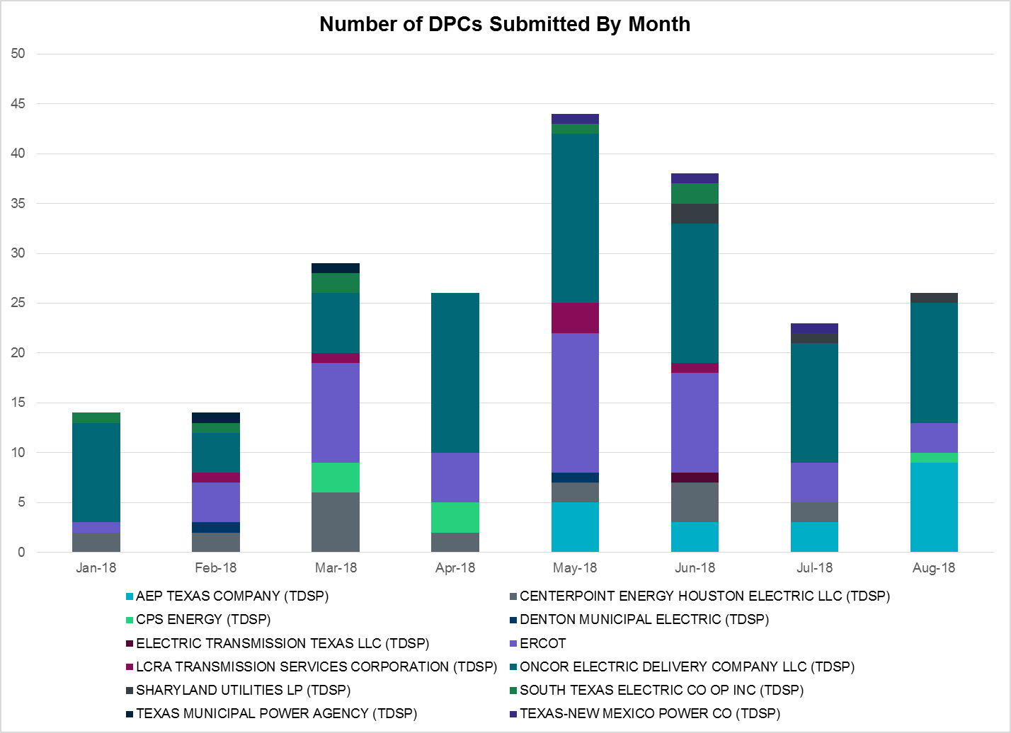

Transmission Operator | Number of DPCs in August
AEP TEXAS COMPANY (TDSP) | 9
BRAZOS ELECTRIC POWER CO OP INC (TDSP) | 0
CENTERPOINT ENERGY HOUSTON ELECTRIC LLC (TDSP) | 0
CPS ENERGY (TDSP) | 1
DENTON MUNICIPAL ELECTRIC (TDSP) | 0
ERCOT | 3
LCRA TRANSMISSION SERVICES CORPORATION (TDSP) | 0
ONCOR ELECTRIC DELIVERY COMPANY LLC (TDSP) | 12
SHARYLAND UTILITIES LP (TDSP) | 1
SOUTH TEXAS ELECTRIC CO OP INC (TDSP) | 0
TEXAS MUNICIPAL POWER AGENCY (TDSP) | 0
TEXAS-NEW MEXICO POWER CO (TDSP) | 0

Appendix A: Real-Time Constraints
The following is a complete list of constraints activated in SCED for the month of August. Full contingency descriptions can be found in the Standard Contingencies List located on the MIS secure site at Grid Generation Reliability Unit Commitment.

Contingency | Constrained Element | From Station | To Station | # of Days Constraint Active
XFTS89 | PIGTAP_SOLSTI1_1 | SOLSTICE | PIGTAP | 27
XFTS89 | PIGTAP_SOLSTI1_1 | PIGTAP | SOLSTICE | 27
DJEWSNG5 | JK_TOKSW_1 | TOKSW | JK_CK | 23
DRNS_TB5 | SNGZEN99_A | SNG | ZEN | 19
SLAQLOB8 | BRUNI_69_1 | BRUNI | BRUNI | 18
SPOLPHA8 | GCB_100_1 | N_MCALLN | W_MCALLN | 14
DGIBSNG5 | 260_A_1 | JEWET | SNG | 13
DHCKRNK5 | 6270__C | WGROB | BLMND | 12
SCOLPAW5 | COLETO_KENEDS1_1 | COLETO | KENEDSW | 8
DCBYRN28 | EXNLH_03_A | EXN | LH | 8
BASE CASE | PNHNDL | n/a | n/a | 7
SCOLLON5 | VICTO_WARBU_1A_1 | VICTORIA | WARBURTN | 6
SBRAUVA8 | HAMILT_MAVERI1_1 | HAMILTON | MAVERICK | 6
XSA2N58 | SANMIGL_ATAH | SANMIGL | SANMIGL | 6
BASE CASE | BURNS_RIOHONDO_1 | RIOHONDO | MV_BURNS | 6
DWH_STP5 | BLESSI_LOLITA1_1 | BLESSING | LOLITA | 5
SPORNCA9 | NCARBI_PV_TAP1_1 | NCARBIDE | PV_TAP | 5
SN_MNED8 | MCOLL__NEDIN1_1 | NEDIN | MCOLL_RD | 5
DVICEDN8 | LOOP_VICTORIA_1 | VICTORIA | L_463S | 4
SNORODE5 | PIGTAP_SOLSTI1_1 | SOLSTICE | PIGTAP | 4
SMDOPHR5 | G138_10C_1 | FRDSWOOD | SEMINOLE | 4
SJARDIL8 | DIL_COTU_1 | DILLEYSW | COTULAS | 4
DWH_STP5 | NORMAN_PETTUS1_1 | PETTUS | NORMANNA | 3
DELMSAN5 | PAWNEE_SPRUCE_1 | CALAVERS | PAWNEE | 3
BASE CASE | BURNS_HEIDLBRG_1 | MV_BURNS | MV_HBRG4 | 3
SMDOOAS5 | AE_LV_04_A | AE | LV | 3
SSNDPB48 | 6485__A | MOSSW | PBSES | 3
SBOSELM5 | 1030__B | BOSQUESW | RGH | 3
BASE CASE | RANDAD_ZAPATA1_1 | RANDADO | ZAPATA | 3
DCBYRN28 | CV_LH_03_A | LH | CV | 3
SMARZOR5 | 419T419_1 | CLEASP | MARION | 3
DFPPFAY5 | 101T158_1 | ZORN | POOLRO | 2
SPAWLON5 | BEEVIL_THREE_1_1 | THREE_RI | BEEVILLE | 2
SWCSBOO8 | BARL_FTSW1_1 | FTSW | BARL | 2
XESK289 | ESKSW_FMR1 | ESKSW | ESKSW | 2
DRIOHAR5 | HAINE__LA_PAL1_1 | LA_PALMA | HAINE_DR | 2
SLOBSA25 | LONHILL_PAWNEE_1 | PAWNEE | LON_HILL | 2
SLOLBLE8 | NCARBI_PV_TAP1_1 | NCARBIDE | PV_TAP | 2
SMDLODE5 | PIGTAP_SOLSTI1_1 | SOLSTICE | PIGTAP | 2
DTRCELK5 | 1760__A | SHBSW | TYLNW | 2
DTOKJK_5 | 260_A_1 | JEWET | SNG | 2
XWL2V58 | 3130__B | INDST | CMPST | 2
DPBSHLT8 | 6100__G | ACSSW | AMTBT | 2
SSIGSAN8 | NCA_SMTP_1 | SANMTAP | NCALHMS | 2
SNCAJOS8 | PV_TAP_P_LAVA1_1 | PV_TAP | P_LAVACA | 2
SFORJOS8 | NCARBI_PV_TAP1_1 | NCARBIDE | PV_TAP | 2
SECTPBS8 | 6485__A | MOSSW | PBSES | 2
DAUSSND5 | HWRDLN_1 | HWRDTP | HWRDLN | 2
SCOLLON5 | LONHILL_PAWNEE_1 | PAWNEE | LON_HILL | 2
DPBSHLT8 | PIGTAP_SOLSTI1_1 | SOLSTICE | PIGTAP | 2
SGIBSN25 | SNGXGC75_1 | GIBCRK | SNG | 2
SRDODES8 | 940__C | ENWSW | WXHCH | 2
DAUSDUN8 | CKT_972_1 | HWRDLN | MCNEIL | 2
SMDOPHR5 | G138_12_1 | ALVIN | FRWYPARK | 2
DWAP_BI5 | JN_WAP64_A | WAP | JN | 2
XNED258 | NEDIN_138H | NEDIN | NEDIN | 2
UCOLCOL1 | VAN_VNDB_1 | VANBLTSS | VANBLT69 | 2
SSCLWF28 | 6560__B | MRKLY | RICSW | 1
DHECWHI8 | RINCON_WHITE_2_1 | RINCON | WHITE_PT | 1
XKEN289 | BEEVIL_THREE_1_1 | THREE_RI | BEEVILLE | 1
SLOBSA25 | BRUNI_69_1 | BRUNI | BRUNI | 1
DCI_SA_8 | FR_THW81_A | THW | FR | 1
XWO58 | LA_NB_95_A | NB | LA | 1
DELMSAN5 | NORMAN_PETTUS1_1 | PETTUS | NORMANNA | 1
DELMSAN5 | VND_PLCE_1 | VANBLT69 | PLCEDOS | 1
SALAN_28 | B_DAVI_WOOLRI1_1 | B_DAVIS | WOOLRIDG | 1
SCOLPAW5 | COLETO_VICTOR1_1 | COLETO | VICTORIA | 1
DDPW_SC9 | GF_UN_12_A | UN | GF | 1
DFPPFAY5 | 192T175_1 | SMITHV | WINCHE | 1
DHUTGEA8 | 211T147_1 | GILLCR | MCNEIL_ | 1
DMCSCDH8 | 3160__A | CDCSW | OKCLS | 1
DFERCOR8 | 342T195_1 | GRANMO | MARBFA | 1
DWIRSTA8 | 342T195_1 | GRANMO | MARBFA | 1
SSKYSB28 | 6820__C | SBYSW | PCKTP | 1
DWH_STP5 | AIRCO4_RINCON1_1 | AIRCO4 | RINCON | 1
SADKTHW5 | LA_NB_95_A | NB | LA | 1
DELMSAN5 | SANMIGL_ATAH | SANMIGL | SANMIGL | 1
DFERHOR8 | 342T195_1 | GRANMO | MARBFA | 1
SENSENW8 | 943__A | ENWSW | ENSSW | 1
SADEDU38 | AZTECA_HEC1_1 | HEC | AZTECA | 1
DB_DPHA8 | HOLLY4_RODD_F1_1 | RODD_FLD | HOLLY4 | 1
SI_DI_48 | I_DUPP_I_DUPS2_1 | I_DUPP1 | I_DUPSW | 1
DLONWAR5 | LONHILL_PAWNEE_1 | PAWNEE | LON_HILL | 1
DSKYCAL5 | R5_U3_1 | BRAUNIG | CAGNON | 1
BASE CASE | REROCK_TLINE_1 | REROCK | LINTERNA | 1
XSA2N58 | SANMIGL_ATAL | SANMIGL | SANMIGL | 1
SLAGMAR8 | 469T469_1 | WHITES | BLOCKH | 1
SMATBEE9 | BEEVIL_THREE_1_1 | THREE_RI | BEEVILLE | 1
SMGPBRN8 | DOW_RISN_1 | DOWNING | RISNGSTR | 1
SSALFPP5 | FAYETT_AT2H | FAYETT | FAYETT | 1
DELMSAN5 | BLESSI_LOLITA1_1 | BLESSING | LOLITA | 1
SZEPCMN8 | DOW_RISN_1 | DOWNING | RISNGSTR | 1
DWH_STP5 | FANNIN_VICTOR1_1 | VICTORIA | FANNINS | 1
SZEPCMN8 | HLD_FMR1 | HLD | HLD | 1
DBI_GT_8 | HR_NS_91_A | HR | NS | 1
SCOLPAW5 | LOOP_VICTORIA_1 | VICTORIA | L_463S | 1
BASE CASE | POMELO | n/a | n/a | 1
SI_DWHI8 | RINCON_WHITE_2_1 | RINCON | WHITE_PT | 1
BASE CASE | VALIMP | n/a | n/a | 1
DELMSAN5 | VAN_VNDB_1 | VANBLTSS | VANBLT69 | 1
SLCSTH25 | 505__A | THSES | SAMSW | 1
DELMSAN5 | BEEVIL_NORMAN1_1 | NORMANNA | BEEVILLE | 1
DSTEXP12 | BLESSI_LOLITA1_1 | LOLITA | BLESSING | 1
DB_DPHA8 | B_DAVI_RODD_F1_1 | B_DAVIS | RODD_FLD | 1
MCI_ADK8 | DH_WO_81_A | WO | DH | 1
SP5CAG8 | E1_R2_1 | E1 | R2 | 1
SCOLPAW5 | LOOP_VICTORIA_1 | L_463S | VICTORIA | 1
SHIWCIT8 | MORRIS_NUECES0_1 | NUECES_B | MORRIS | 1
DRNS_TB5 | SNGZEN98_A | SNG | ZEN | 1
SMCEABS8 | 6585__A | ESKSW | TRNT | 1
BASE CASE | BR_HOC09_A | BR | HOC | 1
SWOOAIR8 | B_DAVI_RODD_F1_1 | B_DAVIS | RODD_FLD | 1
SDOWMOO8 | DOWNIES_AX1H | DOWNIES | DOWNIES | 1
SCITNUE8 | MORRIS_NUECES0_1 | NUECES_B | MORRIS | 1
SGEOSIG8 | BEEVIL_THREE_1_1 | THREE_RI | BEEVILLE | 1

The Duration of Event is defined as the time it takes for the frequency to recover to pre-disturbance frequency or 60 Hz as applicable.
PMU reports are typically generated when frequency drops below 59.9, but PMU data is available for other events.
Delta Frequency is defined as the difference between the starting point of the frequency event (t(0) or “A-point”) and minimum/maximum frequency (“C-Point”).
Currently, the Critical Inertia Level for ERCOT is approximately 100,000 MW-s (Source: link)
This is the hourly integrated peak demand as published in the ERCOT D&E report.
All DC Tie Curtailments are posted publically on the ERCOT Market Information System. See that posting for additional details for the event(s) in question.
See DC Tie Operating Procedure (http://www.ercot.com/mktrules/guides/procedures) for more details.

