

Study to Identify Impact of Southern Cross DC on ERCOT’s Ancillary Services

**Operations Analysis**

**ERCOT**

Report Date: XXX XX, XXXX

Executive Summary

TBD

Table of Contents

Executive Summary 1

Table of Contents 2

1. Background 3

2. Ancillary Services in ERCOT 4

2.1. Regulation Service 4

2.2. Non-Spin Reserve Service (NSRS) 4

2.3. Responsive Reserve Service (RRS) 5

3. Impacts of integrating SCT DC Tie on ERCOT’s Ancillary Service 6

3.1. Regulation Service 6

3.2. Non-Spin Reserve Service (NSRS) 6

3.2.1. Scenario 1 - SCT DC Tie import is limited to existing ERCOT MSSC 6

3.2.2. Scenario 2 - SCT DC Tie import is above existing ERCOT MSSC 6

3.3. Responsive Reserve Service (RRS) 7

3.3.1. Scenario 1 - SCT DC Tie import is limited to existing ERCOT MSSC 8

3.3.2. Scenario 2 - SCT DC Tie import is above existing ERCOT MSSC 8

3.3.2.1. Case Selection 8

3.3.2.2. Modeling Assumptions 9

3.3.2.3. Study Methodology 10

3.3.2.4. Study Results 10

3.4. Frequency Overshoot Study – Impact of SCT DC Tie trips when exporting 10

3.4.1. Case Selection and Case Setup 10

3.4.2. Study Methodology and Assumptions 12

3.4.3. Study Results 12

4. Conclusion/Recommendation 13

Appendix A – Headroom Information from 3 Scenario Cases 14

Background

In PUC Docket No. 45624, the Public Utility Commission of Texas (PUCT) approved the City of Garland's application for a certificate of convenience and necessity to build a new 38-mile-long, 345kV transmission line connecting ERCOT to a direct-current converter station—the Southern Cross Transmission, LLC (SCT) DC Tie—in Louisiana. SCT is proposed to be a bidirectional bipole DC Tie line which can support imports of up-to 2,000 MW and exports of up-to 2,100 MW. In PUC Project No. 46304, the PUCT issued an [Order](https://interchange.puc.texas.gov/Documents/46304_4_941374.PDF) that directs ERCOT to complete a number of tasks—set forth in 14 separate [directives](http://www.ercot.com/mktrules/puctDirectives/southernCross)—that the PUCT deemed necessary to accommodate the new DC Tie. This report focuses on one of the directives, namely, directive 9, determination regarding modifications to Ancillary Services (AS).

***Directive 9, Determination regarding modifications to Ancillary Services***

*As ordered by the Public Utility Commission of Texas (PUCT) in Project No. 46304: ERCOT shall (a) evaluate what modifications to existing and additional ancillary services, if any, are necessary for the reliable interconnection of the Southern Cross DC tie, (b) implement any needed modifications to ancillary-services procurement, (c) recommend how the costs of such required ancillary services are to be allocated, and (d) certify to the Commission when it has completed these actions.*

The following sections will provide a high level introduction to ERCOT’s current AS and will describe the study/approaches used to evaluate impacts of integrating the SCT DC Tie to ancillary services and recommend any modifications to existing AS and/or the need for additional AS for reliable interconnection of the SCT DC Tie into ERCOT’s grid.

Ancillary Services in ERCOT

Ancillary Services (AS) are procured in the Day-Ahead Market to ensure sufficient resource capacity is reserved which can be deployed in a timely manner to restore the balance between the load and generation. ERCOT currently has three types of AS namely, Regulation Service, Responsive Reserve Service (RRS) and Non-Spin Reserve Service (NSRS).

## Regulation Service

Regulation Service is deployed every 4 seconds to maintain frequency (i.e. maintain generation & demand balance) between 5-min Security Constrained Economic Dispatch (SCED) intervals. This service is provided by Generation Resources. CPS1 is performance metric used to gauge efficacy of procured Regulation reserves. Per ERCOT’s current AS Methodology minimum quantities of Regulation Up/Down Service are established based on historic (last two years) five-minute net-load variability and adjusted for growth in installed of wind generation capacity.

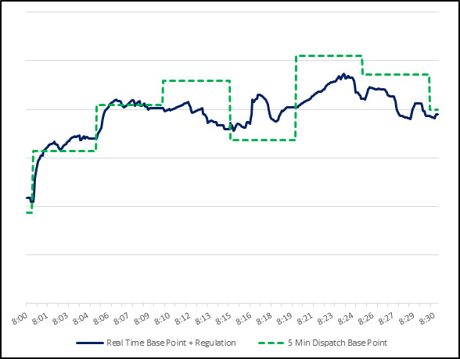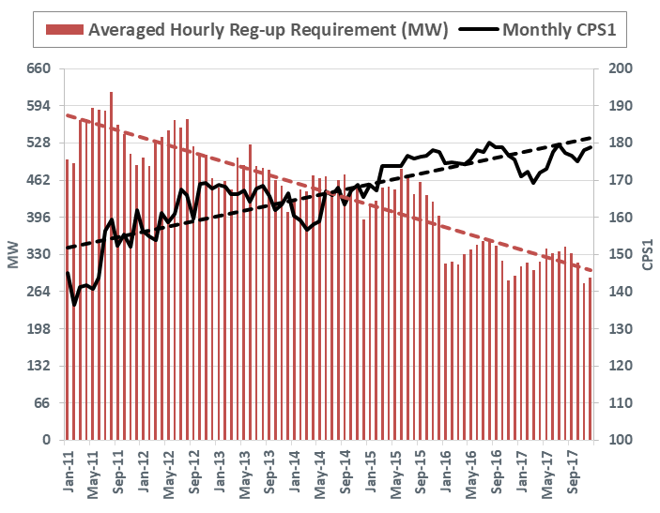

Figure 1 Regulation Service deployment & Regulation Service performance

## Non-Spin Reserve Service (NSRS)

Non-Spin Reserve Service is procured/used to ensure sufficient capacity is available to cover large Load/Wind/Solar forecast errors, or replace deployed RRS. This reserve is provided by generation resource capacity that can be started in 30 minutes or by unloaded on-line generation.

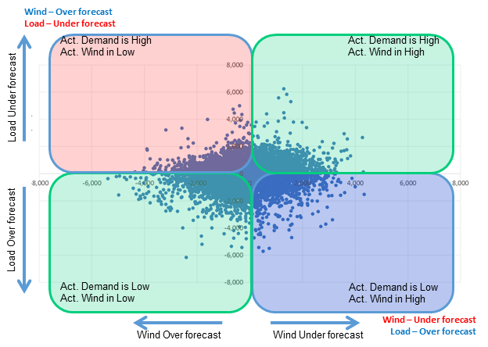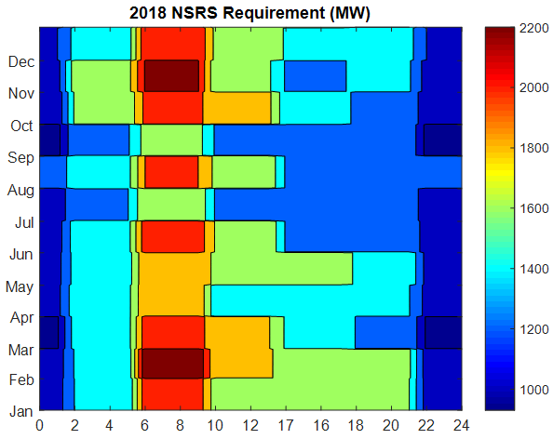

Figure 2 NSRS requirement establishment using net load errors and NSRS quantities in 2018

Per ERCOT’s current AS Methodology minimum quantities of NSRS are established based on historic (last three years) net-load forecast error and risk of net-load up ramps. NSRS quantities are also adjusted for expected growth in installed of wind generation capacity. A floor equal to ERCOT’s current Most Severe Single Contingency (MSSC) as established per BAL-002 is also applied to NSRS quantities during on-peak hours, namely, hour ending 7 through 22. Per BAL-002-2, MSSC is the Balancing Contingency Event that would result in the greatest loss of resource (MW) output. ERCOT’s current MSSC is 1,375 MW.

## Responsive Reserve Service (RRS)

Responsive Reserve Service are procured to ensure sufficient capacity is available to respond to frequency excursions during generation resource trips. This reserve is provided by capacity reserved from online generation resources via governor response and load resources via under-frequency relays. Currently up to 60% of RRS can be provided by load resources with under-frequency relays.

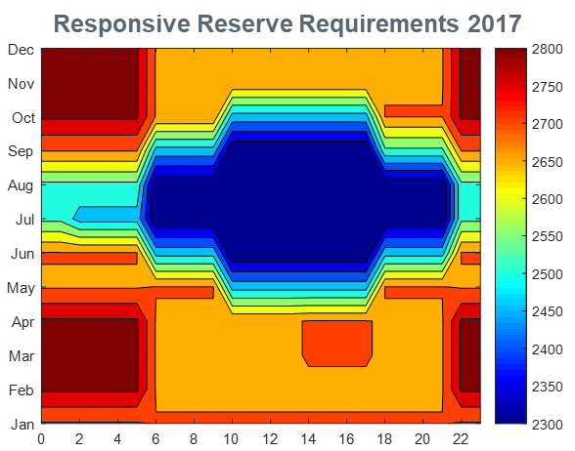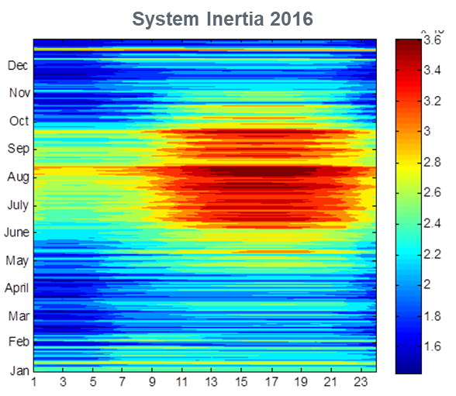

Figure 3 RRS requirement establishment using historic system inertia and RRS quantities in 2018

This reserve is designed such that for a generation resource trip that is equal to ERCOT’s Resource Contingency Criteria (RCC) as established by BAL-003, Under Frequency Load Shed (UFLS) is not triggered. ERCOT’s current RCC is 2,750 MW. Per ERCOT’s current AS Methodology minimum quantities of RRS are established based on historic (last two years) system inertia conditions and RRS studies (most recently [conducted in 2017](http://www.ercot.com/content/wcm/key_documents_lists/108744/05._RRS_Study_2017_Methodology_11022017.docx)).

Impacts of integrating SCT DC Tie on ERCOT’s Ancillary Service

This section assesses the impacts of integrating the SCT DC Tie to ERCOT’s Ancillary Services. There are broadly two flavors of discussion. First few subsections will detail the impacts on existing AS and then the last subsection will delve into assessing the impact on Frequency due to forced outage of the SCT DC Tie while exporting (frequency overshoot study).

## Regulation Service

Per the current methodology, two factors influence the minimum amount of Regulation Up/Down service will be needed namely, 5-min variations of net-load and historical regulation resource deployment. With the interconnection of the SCT DC Tie, ERCOT believes that the ideal solution would be to impose ramp restrictions (these are addressed in [directive 3](http://www.ercot.com/mktrules/puctDirectives/southernCross/159967)) and to fully integrate DC Tie schedules into ERCOT’s Generation To Be Dispatched (GTBD) calculation. Although this approach will need to be formally approved by stakeholders as part of a broader evaluation of directive 3 along with the Regulation Service component of directive 9, these changes would ensure that the interconnection of the SCT DC Tie will not have any impact on the quantities of Regulation Service.

## Non-Spin Reserve Service (NSRS)

As mentioned earlier when determining minimum quantities of NSRS per ERCOT’s current AS Methodology, a floor equal to ERCOT’s MSSC (1,375 MW) is applied during on-peak hours, namely, hour ending 7 through 22.

Upon interconnection of the SCT DC Tie there is a potential that ERCOT’s MSSC may change. Hence using the Operations Working Group’s (OWG’s) [recommendation](http://www.ercot.com/content/wcm/key_documents_lists/139277/08._Directive9_MSSC_Whitepaper__OWG_071318.docx) on directive 9, impacts on NSRS quantities will be evaluated under two scenarios namely,

* Scenario 1 - SCT DC Tie import is limited to be equal to or less than existing ERCOT MSSC
* Scenario 2 - SCT DC Tie import is above existing ERCOT MSSC up to 2,000 MW

### Scenario 1 - SCT DC Tie import is limited to existing ERCOT MSSC

If SCT DC Tie is limited to imports equal to or less than the existing ERCOT MSSC (1,375 MW), then ERCOT’s MSSC upon interconnection of SCT DC Tie will remain unchanged. As a result of this, per ERCOT’s current AS Methodology there will not be any additional impact to ERCOT’s NSRS requirements upon interconnection of SCT DC Tie.

### Scenario 2 - SCT DC Tie import is above existing ERCOT MSSC

If SCT DC Tie is allowed to import above existing ERCOT MSSC (1,375 MW) up to 2,000 MW then ERCOT’s MSSC will change upon interconnection of SCT DC Tie. As a result of this, per ERCOT’s current AS Methodology the floor applied during on-peak hours, namely, hour ending 7 through 22 for Non-Spin quantities establishment will be changed to 2,000 MW. Consequently there be an impact to ERCOT’s NSRS requirements and additional NSRS quantities will be needed upon interconnection of SCT DC Tie. Figure 4 below provides insights into the additional NSRS quantities needed in 2018 under the hypothetical scenario that the SCT DC Tie was already integrated and operational prior to start of 2018.



Figure 4 Additional NSRS needed (MW) for the year of 2018 if MSSC becomes 2000 MW

## Responsive Reserve Service (RRS)

Per ERCOT’s current AS Methodology minimum quantities of RRS are established based on historic (last two years) system inertia conditions and RRS studies (most recently [conducted in 2017](http://www.ercot.com/content/wcm/key_documents_lists/108744/05._RRS_Study_2017_Methodology_11022017.docx)). RRS Studies are setup such that for a generation resource trip that is equal to ERCOT’s Resource Contingency Criteria (RCC) as established by BAL-003, Under Frequency Load Shed (UFLS) is not triggered.

In its [petition for approval of BAL-003-1](https://www.nerc.com/FilingsOrders/us/NERC%20Filings%20to%20FERC%20DL/Petition%20and%20Exhibits%20A-J_FINAL.pdf#page=162) North American Electric Reliability Council (NERC) has explained that ERCOT’s RCC is based on largest N-2 loss-of-resource event criteria. Currently loss of 2 South Texas Project Units is recognized as the largest N-2 loss-of-resource event and as a result ERCOT’s current RCC is 2,750 MW. Upon interconnection of the SCT DC Tie there is a potential that ERCOT’s RCC may change.[1] Hence using OWG’s [recommendation](http://www.ercot.com/content/wcm/key_documents_lists/139277/08._Directive9_MSSC_Whitepaper__OWG_071318.docx) on directive 9, impacts on RRS quantities upon interconnection of SCT DC Tie will be evaluated under two scenarios namely,

* Scenario 1 - SCT DC Tie import is limited to be equal to or less than existing ERCOT MSSC
* Scenario 2 - SCT DC Tie import is above existing ERCOT MSSC up to 2,000 MW

### Scenario 1 - SCT DC Tie import is limited to existing ERCOT MSSC

If SCT DC Tie is limited to imports equal to or less than the existing ERCOT MSSC (1,375 MW), then ERCOT’s RCC upon interconnection of SCT DC Tie will remain unchanged (i.e. ERCOT’s RCC = 2,750 MW). As a result of this, per ERCOT’s current AS Methodology wherein RRS quantities are established to cover the risk for instantaneous loss of 2,750 MW, there will not be any additional impact to ERCOT’s RRS requirements upon interconnection of SCT DC Tie.

### Scenario 2 - SCT DC Tie import is above existing ERCOT MSSC

If the SCT DC Tie is allowed to import above existing ERCOT MSSC (1,375 MW) up to 2,000 MW then ERCOT’s RCC will change upon interconnection of the SCT DC Tie. As a result of this, per ERCOT’s current AS Methodology RRS quantities will need to be established to cover the risk for instantaneous loss of 3,375 MW (1,375 MW + 2,000 MW). Consequently, there would be an impact to ERCOT’s RRS requirements and additional RRS quantities will be needed upon interconnection of the SCT DC Tie. In order to get insights into the additional RRS quantities needed in 2018 under the hypothetical scenario that the SCT DC Tie was already integrated and operational prior to start of 2018, a new RRS study will be conducted. The rest of this subsection summarizes the new RRS study and its results.

#### Case Selection

Recent real-time cases between 2013 and 2017 with inertia levels varying between 134 GW·s thru 380 GW·s will be used to identify a total of TBD cases representing sixteen different inertia conditions to determine the corresponding RRS requirements. The 130 GW·s case (Case 1) was built from a 134 GW·s real time TSAT case by turning off some of the on-line generators and reducing loads. Detailed information of the selected cases is summarized in table below.

Table 1 Information for the cases selected to be included in the new RRS Study

|  |  |  |
| --- | --- | --- |
| Scenario Name | Power Flow Seed Time Stamp | Inertia (GW·s) |
| Case 1 | 02/10/17 01:00:00 | 130 |
| Case 2 | 03/31/14 02:00:00 | 140 |
| Case 3 | 03/21/14 02:00:00 | 150 |
| Case 4 | 10/23/16 00:00:00 | 160 |
| Case 5 | 11/20/16 01:00:00 | 170 |
| Case 6 | 10/28/13 00:00:00 | 180 |
| Case 7 | 02/23/16 23:00:00 | 190 |
| Case 8 | 11/24/16 15:00:00 | 200 |
| Case 9 | 04/02/14 10:00:00 | 220 |
| Case 10 | 01/18/17 11:00:00 | 230 |
| Case 11 | 10/05/13 18:00:00 | 260 |
| Case 12 | 06/01/16 22:00:00 | 270 |
| Case 13 | 05/28/14 18:00:00 | 290 |
| Case 14 | 08/11/16 05:00:00 | 300 |
| Case 15 | 09/03/13 18:00:00 | 359 |
| Case 16 | 08/07/13 17:00:00 | 376 |

#### Modeling Assumptions

In this study, initial conditions including but not limited to Generation Resources with online governors, Load Resource trip settings and tripped resource will be setup consistently across all Cases listed in Table 1. The following modelling assumptions will be applied in all the cases.

1. Governors will be activated for those Generation Resources that are needed to provide the minimum PFR of 1150 MW. The response from each Generation Resource that is used to contribute to the minimum PFR will be limited to 20% of its High Sustained Limit (i.e. this assumes that the governors have 5% droop). Governors for all other Generation Resources which will not provide PFR will be disabled.
   * In Cases where total inertia was lower than 250 GW·s, approximately 30% of the minimum PFR responsibility was provided by coal units and in Cases with an inertia greater than or equal to 250 GW·s, approximately 15% of the minimum PFR responsibility was provided by coals units. The remaining PFR responsibility was provided by gas units. This configuration is consistent with recent trends observed in the system operations.
2. In these studies, it was assumed that all Load Resources providing RRS will trip at 59.7 Hz, with a delay of 0.416 s (relay delay = 0.333 s; breaker action = 0.083 s). This assumption is consistent with the 2017 RRS Study conducted in 2017.
3. Load damping factor will be assumed to be 2% at the system level, consistent with Dynamics Working Group (DWG) flat start cases.

#### Study Methodology

The following study methodology will be followed on each of Cases in Table 1 to identify the minimum RRS requirement.

1. Trip 3,375 MW of generation simultaneously.
2. Identify the minimum amount of LRs with a PFR of 1150 MW required to ensure that the frequency nadir remains at/or above 59.40 Hz in response to the loss of 3,375 MW of generation.
3. Repeat Step 1 and Step 2 with varying minimum PFR amounts to identify LRs/PFR Equivalency Ratio. This Equivalency Ratio will then be used to compare the effectiveness of 1 MW of LRs relative to 1 MW of PFR in arresting the frequency decline in the response to 3,375 MW generation loss.

#### Study Results

TBD

## Frequency Overshoot Study – Impact of SCT DC Tie trips when exporting

Sudden instantaneous trip of SCT DC Tie when exporting could cause ERCOT grid frequency to overshoot. If the resulting frequency overshoot is too high, the high overshoot values could trigger other generation resources within ERCOT to trip on over-frequency protection, thus leading to cascading effects. The risk of this reliability concern will be evaluated in this subsection. For the purposes of this evaluation a series of dynamic simulations will be conducted to examine the impacts on grid frequency that results from tripping SCT DC Tie when it is exporting power. Note that the magnitude of frequency overshoot will depend on system inertia conditions, number of generators with governor response capability, and the capacity available to provide downward frequency response.

### Case Selection and Case Setup

In order to represent a worst case scenario, a case that represents 130 GW·s inertia (lowest inertia condition) will be built using the power flow from a recent real-time operating condition from October 27, 2017 at 1:00 am. Going forward in this section, the lowest inertia case thus built will be referred to as Base Case. General information from the Base Case summarized in Table 2 below.

Table 2 Base Case - General Information

|  |  |  |  |  |  |
| --- | --- | --- | --- | --- | --- |
| Scenario Name | Power Flow Seed Time Stamp | Inertia (GW·s) | Load  (GW) | Wind  (GW) | Synchronous Gen (GW) |
| Base Case | 10/27/2017 1:00 AM | 130 | 34 | 15.5 | 19 |

Headroom-Up (defined as HSL - MW) and Headroom-Down (defined as MW - LSL) represent the maximum capacity for a generation resource can provide in upward and downward direction respectively. A breakdown of Headroom-Up and Headroom-Down from the Base Case by resource category is summarized in Table 3 below. Note that nuclear units do not provide response to frequency events (over or under), hence the Headroom up/down for these resources is tracked as zero in the Table 3 below. Also note that in Table 2 below the total Headroom-Down from wind resources includes contribution from only the wind resources that have primary frequency response (PFR) capability (approximately 80% of wind portfolio) and Headroom-Up from wind was not computed.

Table 3 Base Case – Headroom-up and Headroom-down by resource category

|  |  |  |  |
| --- | --- | --- | --- |
| Unit Type | Headroom-up  (MW) | Headroom-Down  (MW) | Output  (MW) |
| Coal | 7707 | 1716 | 7876 |
| Gas Steam | 1316 | 63 | 180 |
| Simple Cycle | 448 | 588 | 1999 |
| Combined Cycles | 3210 | 1533 | 5191 |
| Nuclear | 0 | 0 | 4028 |
| Hydro | 283 | 0 | 0 |
| Wind | 0 | 13014 | 15511 |
| Total | **12964** | **16914** | **34784** |

For this study additional scenarios will be built as offshoots from the Base Case to simulate primary frequency response with wind generation at 5,000 MW and 10,000 MW and with the SCT DC Tie exporting at 2,100 MW. In each of these scenario cases, the reduction in wind generation will be compensated by increasing the power output from existing synchronous generation resources. To maintain system inertia at 130 GW∙s, the scenarios with low wind generation (less than 15 GW) will be built without changing unit commitment status. As can be seen in Table 3, in the Base Case there is more than 12,000 MW of Headroom available from synchronous generation resources. As an example for the scenario with 10 GW wind output, the wind generation from the base case will be reduced from 15,511 MW to 10,000 MW and the power output from Coal, Hydro, Gas, Single Cycle and Combined Cycle units will be increased from 15,245 MW to 20,755 MW. Power Output of these units will be scaled based on participation factors of the units in the Base Case. An additional scenario case is also being explored with wind generation less than 5 GW and system inertia at 130 GW∙s. Table 5 below summarizes the general power-flow information of the Base Case and three Scenarios that will be used for Frequency Overshoot Study. Note that a breakdown of Headroom-Up and Headroom-Down by resource category for each of the Scenario cases in Table 4 is summarized in Appendix A.

Table 4 Summary of Base Case and Scenarios that will be used for Frequency Overshoot Study

|  |  |  |  |  |
| --- | --- | --- | --- | --- |
| Scenario Name | Inertia (GW·s) | Load  (GW) | Wind  (GW) | Synchronous Gen (GW) |
| Base Case | 130 | 34 | 15.5 | 19 |
| Scenario 1 | 130 | 34 | 10 | 24.5 |
| Scenario 2 | 130 | 32 | 5 | 27.5 |
| Scenario 3 | 130 | 32 | 3.5 | 29 |

### Study Methodology and Assumptions

For each case listed in Table 3 above, all governors of on-line synchronous generation resources will be enabled to provide frequency response; all on-line wind farms with PFR capability will be modeled to provide downward response to over frequency; and SCT DC tie will be assumed to be exporting 2,100 MW. The following study methodology will then be allied to each of the case in Table 4 above.

1. Trip SCT DC tie while exporting 2,100 MW.
2. Record frequency trend and identify any frequency overshoot that exceeds 60.6 Hz.
3. In the cases where frequency overshoot exceeds 60.6 Hz, additional sensitivity studies will be conducted to identify an export limit on the SCT DC Tie such that frequency overshoot will not exceed 60.6 Hz.

### Study Results

TBD

Conclusion/Recommendation

TBD

Appendix A – Headroom Information from 3 Scenario Cases

Table 5, 6 and 7 below summarize Headroom-Up and headroom-Down in each of the three Scenario cases.

Table 5 Scenario 1 – Headroom-up and Headroom-down by resource category

|  |  |  |  |
| --- | --- | --- | --- |
| Unit Type | Headroom-up  (MW) | Headroom-Down  (MW) | Output  (MW) |
| Coal | 4,381 | 4,144 | 11,202 |
| Gas Steam | 1,003 | 229 | 494 |
| Simple Cycle | 151 | 837 | 2,296 |
| Combined Cycles | 1,697 | 2,669 | 6,704 |
| Nuclear | 0 | 0 | 3823 |
| Hydro | 222 | 10 | 61 |
| Wind | 0 | 8,522 | 10,000 |
| Total | **7,453** | **16,412** | **34,579** |

Table 6 Scenario 2 – Headroom-up and Headroom-down by resource category

|  |  |  |  |
| --- | --- | --- | --- |
| Unit Type | Headroom-up  (MW) | Headroom-Down  (MW) | Output  (MW) |
| Coal | 2,298 | 5,622 | 13,284 |
| Gas Steam | 801 | 405 | 696 |
| Simple Cycle | 97 | 880 | 2,349 |
| Combined Cycles | 1,075 | 3,145 | 7,326 |
| Nuclear | 0 | 0 | 3,796 |
| Hydro | 181 | 17 | 102 |
| Wind | 0 | 4,392 | 5,000 |
| Total | **4,453** | **14,462** | **32,552** |

Table 7 Scenario 3 – Headroom-up and Headroom-down by resource category

|  |  |  |  |
| --- | --- | --- | --- |
| Unit Type | Headroom-up  (MW) | Headroom-Down  (MW) | Output  (MW) |
| Coal | 1,217 | 6,475 | 14,365 |
| Gas Steam | 680 | 525 | 816 |
| Simple Cycle | 74 | 902 | 2,372 |
| Combined Cycles | 826 | 3,325 | 7,575 |
| Nuclear | 0 | 0 | 3,799 |
| Hydro | 156 | 23 | 127 |
| Wind | 0 | 3094 | 3,500 |
| Total | **2,953** | **14,344** | **32,555** |

1. Also worth mentioning is that the North American Electric Reliability Council (NERC) is currently reviewing the RCC definition as a part of the [Project 2017-01 Modifications to BAL-003-1.1](https://www.nerc.com/pa/Stand/Pages/Project201701ModificationstoBAL00311.aspx) and that this project’s recommended changes to the RCC definition may influence ERCOT’s overall RRS requirements.