MGRR Number | 34 | MGRR Title | Adding Synchronous Condenser Model
Date |  | 9/24/18
Submitter’s Information
Name |  | Mario Alberto de la Garza
E-mail Address |  | Mario.delagarza@ercot.com
Company |  | ERCOT
Phone Number |  | 512-248-4221
Cell Number
Market Segment

Comments

Overall NMMS User Benefit | Inclusion of new Synchronous Condenser model which would allow their modeling without the need to model them as HydroGeneratingUnit associated to a PrivateAreaNetwork.  Would allow TSPs and REs to submit outages to the Synchronous Condensers.
Overall NMMS User Impact | New model instance type.
ERCOT Impact | New model instance type and validation rules.

Revised Proposed Modeling Guidelines Language

Modeling SYNCHRONOUS CONDENSER

Modeling Approach
This section describes the approach for modeling a SynchronousCondenser. The SynchronousCondenser type is a child of GeneratingUnit but it does not require all the other modeling components needed to model a GeneratingUnit. The SynchronousCondenser is modeled under a VoltageLevel in a Substation. A Terminal is modeled under a SynchronousCondenser as a connection point to the circuit. SCADA values modeled under the Terminal provide the AnalogValues(MVAR and GMV) and DiscreteValue(AVR) of the SynchronousCondenser to the model.
In addition, there must be a parallel NonconformingLoad modeled next to the SynchronousCondenser in order to map the AnalogValue(MW) to reflect the real power consumption of the Synchronous Condenser while operating. This load needs to be modeled separately.
In addition, if there is an electrical separate start up motor which the SynchronousCondenser uses for startup, it start up motor should be modeled as a separate NonConformLoad.
Figure below shows the parent/child hierarchy of a SynchronousCondenser in Information Model Manager.
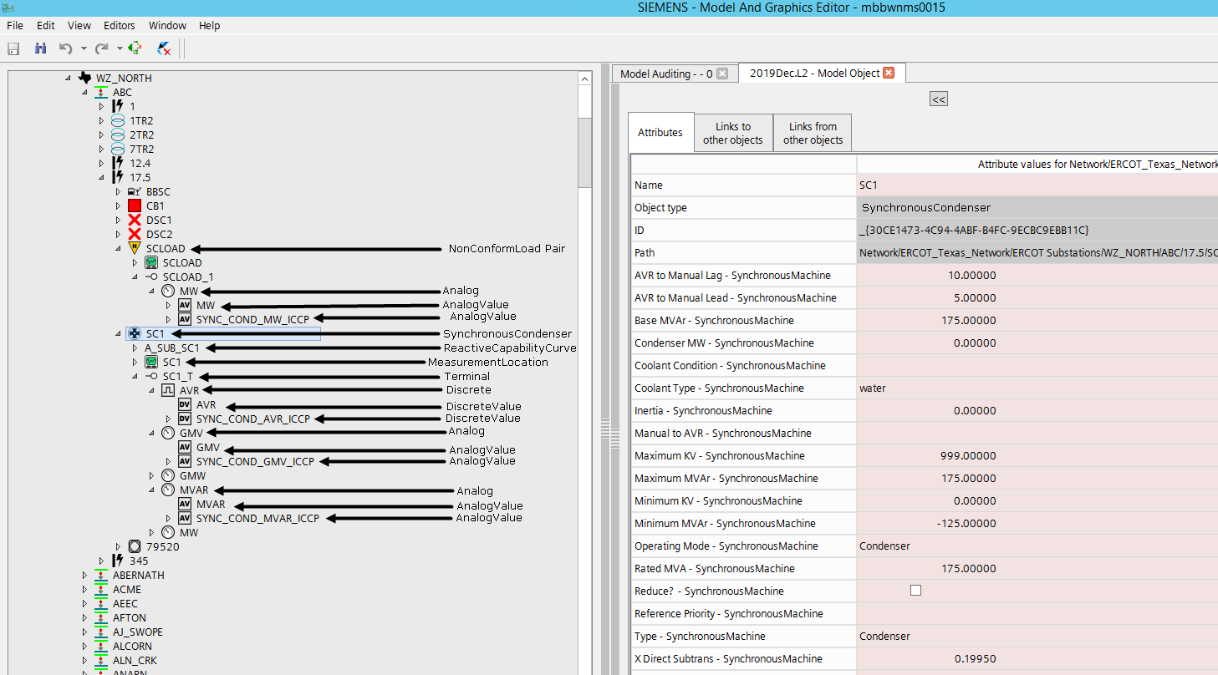

Modeling Approach
The attributes for a SynchronousCondenser are shown in the table below.

Attribute | Description | Data Type | Default Value | Sample Data
name | Name of the instance of this class | String
teid | Transmission Element ID | Integer | Auto-populated
inertia | The energy stored in the rotor when operating at rated speed. This value is used in the accelerating power reference frame for operator training simulator solutions. | Inertia | 5
Alias Name | Free text name of the object or instance. | String | None
aVRToManualLag | Time delay, in seconds, required when switching from AVR to manual for a lagging MVAr violation. | Seconds | None
aVRToManualLead | Time delay, in seconds, required when switching from Automatic Voltage Regulation to Manual for a leading MVAr violation. | Seconds | None
AVREnable | T = Automatic voltage regulation enabled. | Boolean | None
baseMVAr | Default base MVAr value. This value represents the initial MVAr that can be used by any application function. | ReactivePower | None
condenserMW | Condensor MW | ActivePower | None
coolantCondition | Temperature or pressure of coolant medium. | Float | None
coolantType | Method of cooling the machine, e.g., air, hydrogen gas, water. | EnumCoolantType | None
DAM_Monitored | The Boolean flags to indicate which process(s) monitor the branch devices and by which process the devices is secured. | Boolean | FALSE
DAM_Secured | The Boolean flags to indicate which process(s) monitor the branch devices and by which process the devices is secured. | Boolean | FALSE
Description | Description of the object or instance. | String1000 | None
loadBasedRegulationEnabled | T = Load based voltage regulation enabled. | Boolean | False
localName | The localName is a human readable name of the object. It is only used with objects organized in a naming hierarchy. The simplest naming hierarchy has just one parent (the root) giving a flat naming hierarchy. However, the naming hierarchy usually has several levels, e.g. Substation, VoltageLevel, Equipment etc. Children of the same parent have names that are unique among them. If the uniqueness requirement cannot be met IdentifiedObject.localName shall not be used, use IdentifiedObject.name instead. | String | None
manualToAVR | Time delay, in seconds, required when switching from Manual to Automatic Voltage Regulation. This value is used in the accelerating power reference frame for powerflow solutions. | Seconds | None
maximumKV | Maximum kV limit for the unit. | Voltage | None
maximumMVAr | Maximum MVAr limit. This is the maximum (nameplate) limit for the unit. | ReactivePower | None
minimumKV | Minimum kV limit for the unit. | Voltage | None
minimumMVAr | Minimum MVAr limit for the unit. | ReactivePower | None
Model Resource ID | A Model Authority issues mRIDs. Given that each Model Authority has a unique id and this id is part of the mRID, then the mRID is globally unique. | Integer | None
operatingMode | Current mode of operation, i.e., generator or condenser. | EnumSynchronousMachineOperatingMode | None
OUSPriority | An Outage Scheduler priority is included in all ConductingEquipment classes except BusbarSection and TransformerWinding. | Integer | None
pathName | The pathname is a system unique name composed from all IdentifiedObject.names in a standard naming hierarchy path from the object to the root. | String500 | None
phases | Describes the phases carried by a conducting equipment. Possible values { ABCN , ABC, ABN, ACN, BCN, AB, AC, BC, AN, BN, CN, A, B, C, N }. | PhaseCode | None
psseid | Attribute will give Information Model Manager modelers control over the PSS/E ID that the Topology Processor uses to properly name units, loads, branches, and transformers | String2 | None
r | Positive sequence resistance of the synchronous machine. | Resistance | None
r0 | Zero sequence resistance of the synchronous machine. | Resistance | None
ratedMVA | Nameplate MVA rating for the unit. | ApparentPower | None
Reduce | Attribute will be used to mark generators on low voltage systems that should be reduced and attached directly to the Transmission Level. | Boolean | FALSE
referencePriority | Priority of unit for reference bus selection. 0 = don t care (default) 1 = highest priority. 2 is less than 1 and so on. | Integer | None
remove | The equipment is removed from the network. | Boolean | FALSE
removeEnable | The equipment can be removed from the network. | Boolean | FALSE
RUC_Monitored | The Boolean flags to indicate which process(s) monitor the branch devices and by which process the devices is secured. | Boolean | None
RUC_Secured | The Boolean flags to indicate which process(s) monitor the branch devices and by which process the devices is secured. | Boolean | None
type | Modes that this synchronous machine can operate in, i.e., as a generator, condenser, or both. | EnumSynchronousMachineType | None
varManual | Manually entered MVAR overrides capability curve. | Boolean | False
x | Positive sequence reactance of the synchronous machine. | Reactance | 0.12
x0 | Zero sequence reactance of the synchronous machine. | Reactance | 0.05
xDirectSubtrans | Direct-axis subtransient reactance, also known as X'd. | Reactance | None
xDirectSync | Direct-axis synchronous reactance. The quotient of a sustained value of that AC component of armature voltage that is produced by the total direct-axis flux due to direct-axis armature current and the value of the AC component of this current, the machine running at rated speed. (Xd) | Reactance | None
xDirectTrans | Direct-axis transient reactance, also known as X”d. | Reactance | None
xSubtrans | Subtransient reactance. | Reactance | None
xTrans | Transient reactance. | Resistance | False
xQuadSubtrans | Quadrature-axis subtransient reactance, also known as X”q. | Reactance | None
xQuadSync | Quadrature-axis synchronous reactance (Xq) , the ratio of the component of reactive armature voltage, due to the quadrature-axis component of armature current, to this component of current, under steady state conditions and at rated frequency. | Reactance | None
xQuadTrans | Quadrature-axis transient reactance, also known as X'q. | Reactance | None

Linkage
The required links for a SynchronousCondenser are defined below.

Link Name | Description | Path Name
BaseVoltage | Link to the BaseVoltage the SynchronousMachine belongs to. | Network/Base Voltage
RegulationSchedule | An LTC may have a regulation schedule. | Schedules/Regulation Schedules/Schedule
LoadBasedRegulationCurve | Link to the LoadBasedRegulationCurve
Regulates (Terminal) | Terminal that is connected to this SynchronousMachine
Operatorship | The Operatorship link is used for permission rights. The Operator of equipment has the right to edit the equipment. An operator can only be assigned by the creator or owner of the equipment. Creator is the person who is submitting the entry through PTC, who is associated with the company that owns the equipment. Ownership and Operatorship point to a company whereas a creator points to a userid. | Network/Companies
Ownership | The Ownership link is used for permission rights. The owner of equipment has editing and administrative rights. An owner can only be assigned by the creator of the equipment. | Network/Companies

Rules Added | Rule Description
 | Every SynchronousMachine must be either connected to a RegulationSchedule or a LoadbasedRegulationCurve
 | The Link "RegulatingCondEq-Terminal" ("RegulatingCondEqRegulatesTerminal") of the instance of object type "SynchronousMachine" cannot be empty as the attribute "A_AVRENABLED" is set to "TRUE"
 | The Link RegulatingCondEq-RegulationSchedule (RegulatingCondEqHasARegulationSchedule) or the link RegulatingCondEq-LoadBasedRegulationCurve (RegulatingCondEqRegulatedByLoadBasedRegulationCurve) of the instance of object type SynchronousMachine cannot be empty as the attribute A_AVRENABLED is set to TRUE
 | The Maximum (X1) and Minimum (X2) values of the associated MVARCapabilityCurve should be within the The MaximumMVAR (X1) and MinimumMVAR (X2) attributes of the SynchrnousMachine
 | OperatingMode on the SynchronousCondenser should be set to Condenser
 | Type on the SynchronousCondenser should be set to Condenser

