PWG Meeting Notes – July 23, 2018
ERCOT MET Center, Room 168
10:00 – 12:30

Attendees: WebEx:
Lindsay Butterfield – ERCOT Diana Rehfeldt – TNMP
Bill Boswell – ERCOT Christian Valerio
Calvin Opheim - ERCOT Dan Mantena, ERCOT
Sam Pak – Oncor Connor Anderson, ERCOT
Sheri Wiegand – TXU Randy Roberts, ERCOT
Kathy Scott - CNP Cory Phillips, ERCOT
Carolyn Reed – CNP Pete Warnken, ERCOT
Kyle Patrick – NRG Blake Gross, AEP
Diana Coleman – OPUC Phil Bracy, ERCOT
Eric Blakey – Just Energy Debbie
Jim Lee – AEP Heddie Lookadoo, NRG
Eric Goff – Citigroup Rebecca Zerwas, NRG
Ivan Velasquez – Oncor
Paul Wattles - ERCOT

- Sheri Wiegand, Chair, read Antitrust Admonition and reviewed the agenda providing a brief summary on the analyses performed in developing the current proposed NPRR881/LPGRR065.
- Meeting minutes from June 18th meeting were approved as proposed.

- DRAFT NPRR & LPGRR, Annual Validation Process Revisions
  - To frame the discussion of alternatives based on Eric Goff’s memo to PWG proposing the conclusion of the AV process, the following questions were posed…
    - Do ESI IDs require a load profile?
    - Does the default profile need to be updated?
    - If so, when should the default profile be updated?
    - Should profiles in general be updated?
  - Calvin addressed the first question from an ERCOT view. Load profiles are used for the following reasons:
    - Initial application for ESI ID impacting settlement
    - Aggregation purposes
    - Tracking and identification of Distributed Generation (DG) sites thus allowing for the fulfillment of required PUC reporting
    - For new non-AMS territories allowing for the identification of a load shape
    - Only attribute visible to ERCOT for forecasting
  - ERCOT stated they remain neutral on the AV process and the management of load profiles
  - TDSPs stated they do not utilize load profiles for estimation of interval data nor for other processes.
  - REPs may use load profiles for a variety of reasons such as:
    - Hedging strategies
    - Forecasting
    - Pricing/Quotes
    - Marketing
    - High level identification of customer consumption patterns such as electric heating
  - Eric Goff stated the expense of the AV process is born by ERCOT and the TDSPs benefitting the REPs
  - OPUC questioned if the WG could “meet in the middle” on when AV would be performed
  - Options for Annual Validation discussed:
    - Status Quo – leave the AV process as is
    - RES AV every three years and BUS AV annually as proposed in the current NPRR/LPGRR
    - Elimination of AV process – ESIs would be assigned default profiles
    - Performing AV “as needed” for metered NIDR both RES and BUS ESIs
        - Consideration for new territories in ERCOT with NIDR ESIs
    - Propose a target end date for the AV process for both RES and BUS ESIs
  - ERCOT (Randy Roberts) confirmed there are currently ~ 100,000 ESIs that are metered NIDR ESIs
  - TDSPs also confirmed the process for updating load profiles with distributed generation are not impacted by the AV process – if the TDSP receives an interconnect agreement and deem necessary, an 814_20 transaction will be sent to the ROR notifying the load profile was updated and to expect a ‘second loop’ of generation data on future 867_03s
  - Sheri noted the current distribution of RES profiles is 48% on RESHIWR and 52% on RESLOWR. If current volumes were all placed on default profiles according to weather zone, the distribution would be 60% on RESHIWR and 40% on RESLOWR. There are currently ~6.3mm RES ESIs in ERCOT
  - Majority of ESIs in each weather zone are under default profile for that weather zone (see matrix below)
  - Eric Goff indicated he would submit comments to the current NPRR/LPGRR expanding the language to include the following:
- After a specified date, the AV process would be performed on an as needed basis for metered NIDR ESIs for both residential and business
- including an end date to the AV process for both residential and business ESIs
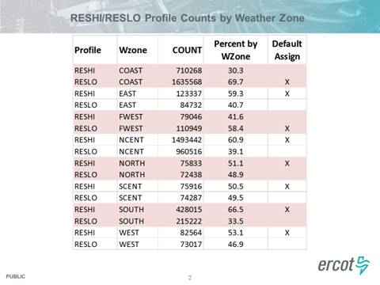

- Questions/Issues for discussion at upcoming IDR workshop
  - There seemed to be some confusion on a proposed upcoming IDR Workshop. Jim Lee, representing RMS leadership, and ERCOT were to coordinate a workshop date to discuss long term solutions for IDR Meters/BUSIDRRQ profiles/4CP implications/DG visibility for IDR Meters, etc.
  - The following questions were reviewed by the WG and will be noted by Jim Lee as discussion items at the IDR Workshop
    - Is the DG profile assigned only if the customer intends to inject surplus generation back onto the grid?
    - Is the DG profile assigned if an interconnection agreement is made with the customer at the premise?
    - Is the DG profile assigned only if a bi-directional or two channel (in and out) meter is installed/provisioned at the premise?
    - Are bi-directional or two channel meters only installed/provisioned if the customer has the potential to inject back onto the grid?
  - Clarity of these questions will assist in ERCOT assessing the amount of DG on the ERCOT grid. For example…
    - If a large customer has back up generation behind the meter, at what point will they be given a DG profile?
    - If a customer installs PV panels, at what point will they be given a DG profile?

NEXT MEETING: August 29th - at this time, the meeting will be WebEx only; it will be determined if a face to face is beneficial after the discussion at RMS.

