System Planning

Monthly Status Report
July 2018

Report Highlights
- ERCOT is currently reviewing proposed transmission improvements with a total estimated cost of $603.5 Million.
- Transmission Projects endorsed in 2018 total $393.5 Million.
- All projects (in engineering, routing, licensing and construction) total approximately $6.49 Billion as of June 1, 2018.
- Transmission Projects energized in 2018 total about $1.120 Billion as of June 1, 2018.

Regional Planning Group Project Reviews
- Garland Power & Light and Oncor have jointly submitted the North Garland Reliability Infrastructure Project (N-GRIP). This is a Tier 1 project that is estimated to cost $78 million. The ERCOT independent review for this project is currently placed on hold per the request of GPL.
- WETT has submitted the Bearkat Area Transmission Improvements project. This is a Tier 1 project that is estimated to cost $69.9 million. This project is currently under ERCOT Independent Review.
- AEPSC has submitted the LRGV Import Project. This is a Tier 1 project that is estimated to cost $73.4 million. AEPSC has also requested that ERCOT provide conditional endorsement for an additional $357.2 million project. This project is currently under ERCOT Independent Review.
- Oncor has submitted the Grapevine Switching Station project. This is a Tier 2 project that is estimated to cost $25 million. This project is currently under ERCOT Independent Review. ERCOT presented study results at the July 25th RPG meeting and is currently finalizing the EIR report.

More information on current and past RPG projects can be found on the ERCOT MIS Secure (digital certificate required): https://mis.ercot.com/pps/tibco/mis/Pages/Grid+Information/RegionalPlanning
Past email communication on RPG projects can be found on the ERCOT listserve by signing up for the REGPLANGROUP list: http://lists.ercot.com/scripts/wa-ERCOT.exe?A0=REGPLANGROUP

Planning Model Activities
The short term calendar of major planning model events is as follows:
- October 15, 2018 Post 18SSWG Update 1 Base Cases and TPIT
- October 31, 2018 Post Contingency definitions and Planning Data Dictionary
The following table shows interconnection projects that met Planning Guide section 6.9(1) and 6.9(2) and were modeled in the SSWG cases as either complete or as a simple model in accordance with Planning Guide section 6.9. The 6.9(2) Deadline shown in red have received a notification that the 60 day deadline has past and the set of planning data has not been received.
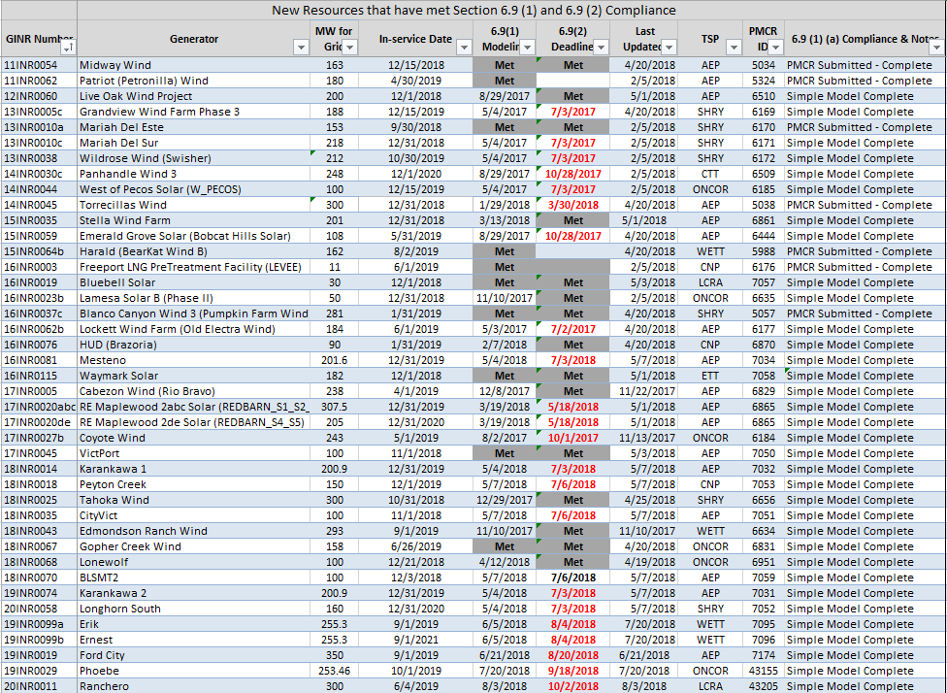

Permian Basin Oil Rig Count
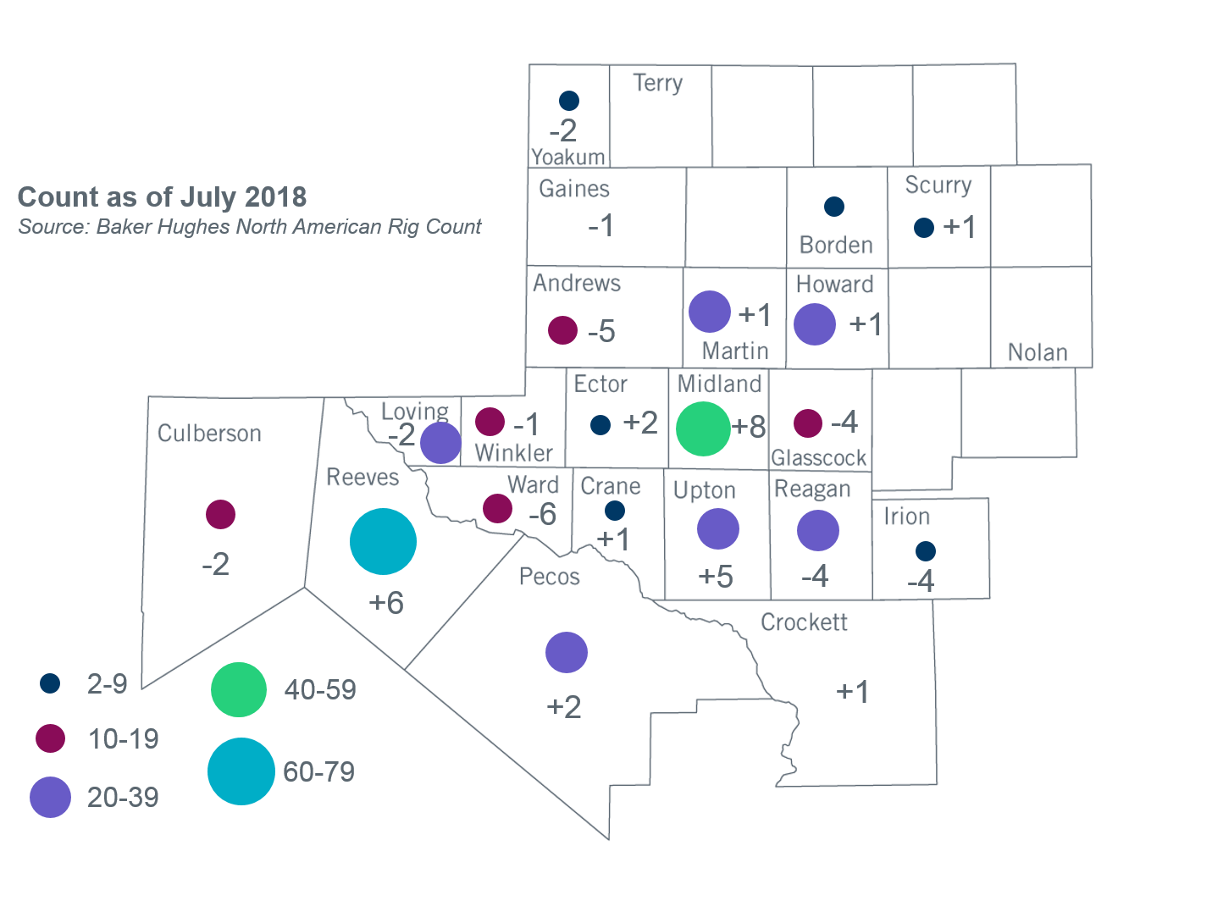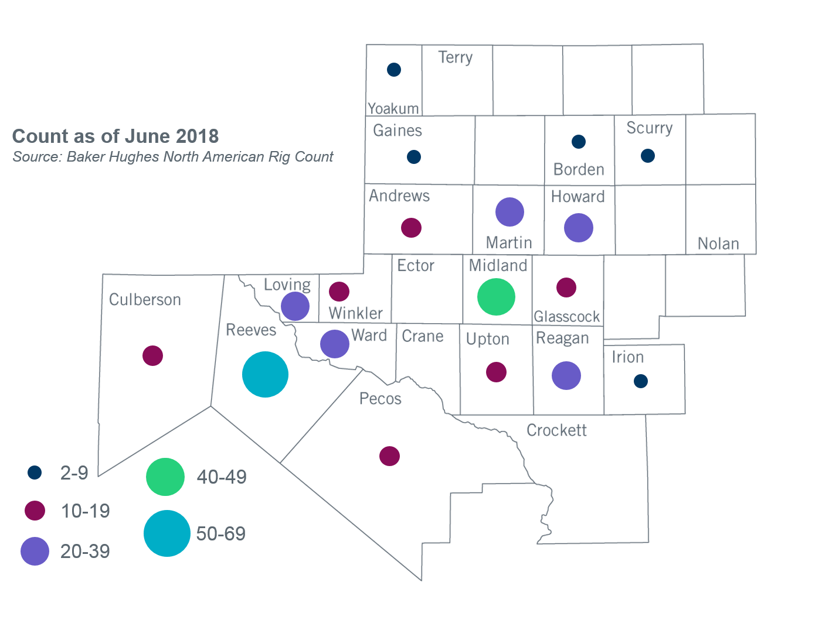

Other Notable Activities
- ERCOT continues to develop the 2018 Regional Transmission Plan (RTP) study. The preliminary N-1 secure reliability cases along with a list of transmission upgrades and additions for all study regions except West/Far West were shared with the RPG on July 5, 2018. Stakeholders are encouraged to review and provide feedback on the posted results. ERCOT is currently working on N-1 reliability analysis for West/Far West weather zones.
- ERCOT continues to work on the 2018 Long-Term System Assessment (LTSA). ERCOT has completed its initial generation expansion analysis for all five scenarios. The results of these analyses were presented at the April and May RPG meetings. ERCOT is currently working on the transmission expansion analysis for the Current Trends scenario.
- The SPWG completed the 2018 CY base cases and the 2019-2023 FY cases.

+/- symbol indicates the increase or decrease from the previous month in oil rigs present in each county. There are 376 rigs, including a total decrease of 3 oil rigs in the Permian Basin from June to July 2018.

