

July 2018 ERCOT Monthly Operations Report

Reliability and Operations Subcommittee Meeting

September 6, 2018

Table of Contents

1. Report Highlights 2

2. Frequency Control 3

2.1. Frequency Events 3

2.2. Responsive Reserve Events 4

2.3. Load Resource Events 4

3. Reliability Unit Commitment 4

4. Wind Generation as a Percent of Load 5

5. COP Error Analysis 5

6. Congestion Analysis 8

6.1. Notable Constraints 8

6.2. Generic Transmission Constraint Congestion 10

6.3. Manual Overrides 11

6.4. Congestion Costs for Calendar Year 2018 11

7. System Events 11

7.1. ERCOT Peak Load 12

7.2. Load Shed Events 12

7.3. Stability Events 12

7.4. Notable PMU Events 12

7.5. DC Tie Curtailment 12

7.6. TRE/DOE Reportable Events 13

7.7. New/Updated Constraint Management Plans 13

7.8. New/Modified/Removed RAS 13

7.9. New Procedures/Forms/Operating Bulletins 13

8. Emergency Conditions 13

8.1. OCNs 13

8.2. Advisories 13

8.3. Watches 13

8.4. Emergency Notices 14

9. Application Performance 14

9.1. TSAT/VSAT Performance Issues 14

9.2. Communication Issues 14

9.3. Market System Issues 14

10. Model Updates 14

Appendix A: Real-Time Constraints 17

# Report Highlights

* The unofficial ERCOT peak for July was 73,308 MW.
* There were four frequency events in July. PMU data indicates the ERCOT system transitioned well.
* There were three instances where Responsive Reserves were deployed.
* There was one RUC commitments in July due to congestion. Congestion in July was concentrated in the North, South, and West Load Zones. Congestion in the North can be mostly attributed to high Panhandle and West wind generation and high load. Congestion in the South was due high load. Congestion in the West was due to high West solar generation and high load. There were 5 days on the Panhandle GTC and 1 day on the Valley Import GTC in July. There was no activity on the remaining GTCs during the month.
* There were five DC Tie curtailments in July. Four were due to local congestion and another was due a Transmission Operator communication issue.

# Frequency Control

## Frequency Events

The ERCOT Interconnection experienced four frequency event in July, three of which resulted from a Resource trip. The average event duration was approximately 0:04:44.

A summary of the frequency events is provided below. The reported frequency events meet one of the following criteria: Delta Frequency is 60 mHz or greater; the MW loss is 350 MW or greater; resource trip event triggered RRS deployment. Frequency events that have been identified as Frequency Measurable Events (FME) for purposes of BAL-001-TRE-1 analysis are highlighted in blue. When analyzing frequency events, ERCOT evaluates PMU data according to industry standards. Events with an oscillating frequency of less than 1 Hz are considered to be inter-area, while higher frequencies indicate local events. Industry standards specify that damping ratio for inter-area oscillations should be 3.0% or greater. For the frequency events listed below, the ERCOT system met these standards and transitioned well after each disturbance.

|  |  |  |  |  |  |  |  |  |  |  |
| --- | --- | --- | --- | --- | --- | --- | --- | --- | --- | --- |
| **Date and Time** | **Delta Frequency** | **Max/Min Frequency** | **Duration of Event[1]** | **PMU Data[2]** | | | **MW Loss** | **Load** | **Wind** | **Inertia** |
| **(Hz)[3]** | **(Hz)** | **Oscillation Mode (Hz)** | | **Damping Ratio** | **(MW)** | **%** | **(GW-s)[4]** |
| 7/2/2018 3:36 | 0.086 | 59.920 | 0:04:44 | No PMU Report Created | | | 414 | 41,436 | 11% | 281,060 |
| 7/6/2018 13:10 | 0.131 | 59.888 | 0:04:52 | 0.65 | 10% | | 813 | 60,823 | 4% | 361,344 |
| 7/18/2018 17:44 | 0.086 | 59.891 | 0:03:50 | 0.58 | 10% | | 494 | 72,251 | 5% | 384,810 |
| 7/30/2018 14:01 | 0.153 | 59.852 | 0:05:30 | 0.61 | 10.00 | | 827 | 60,853 | 7% | 348,409 |

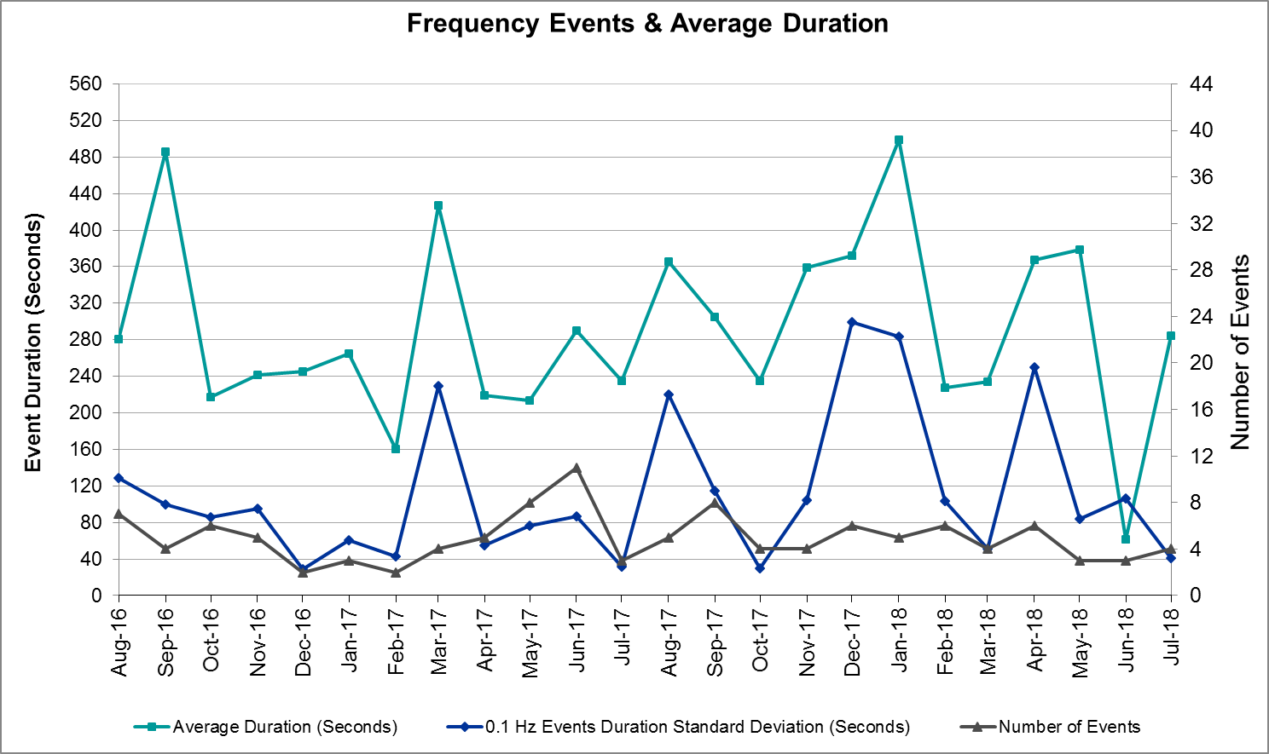

(Note: All data on this graph encompasses frequency event analysis based on BAL-001-TRE-1.)

## Responsive Reserve Events

There were three events where Responsive Reserve MWs were released to SCED in July. The events highlighted in blue were related to frequency events reported in Section 2.1 above.

|  |  |  |  |
| --- | --- | --- | --- |
| **Date and Time Released to SCED** | **Date and Time Recalled** | **Duration of Event** | **Maximum MWs Released** |
| 7/6/2018 13:11 | 7/6/2018 13:15 | 0:03:56 | 337 |
| 7/18/2018 17:45 | 7/18/2018 17:48 | 0:03:24 | 600 |
| 7/30/2018 14:01 | 7/30/2018 14:05 | 0:04:32 | 650 |

## Load Resource Events

None.

# Reliability Unit Commitment

ERCOT reports on Reliability Unit Commitments (RUC) on a monthly basis. Commitments are reported grouped by operating day and weather zone. The total number of hours committed is the sum of the hours for all the units in the specified region. Additional information on RUC commitments can be found on the MIS secure site at Grid 🡪 Generation 🡪 Reliability Unit Commitment.

There were no DRUC commitments in July.

There was one HRUC commitment in July.

|  |  |  |  |  |  |
| --- | --- | --- | --- | --- | --- |
| **Resource Location** | **# of Resources** | **Operating Day** | **Total # of Hours Committed** | **Total MWhs** | **Reason for Commitment** |
| Southern | 1 | 7/26/2018 | 4 | 139 | Congestion |

# Wind Generation as a Percent of Load

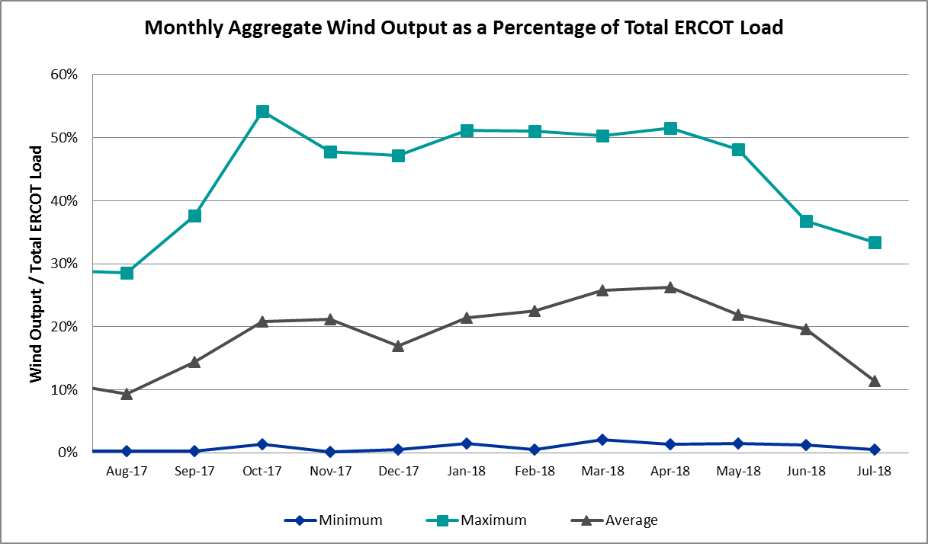

# COP Error Analysis

COP Error is calculated as the capacity difference between the COP HSL and real-time HSL of the unit. Mean AbsoluteError (MAE) stayed high, mostly over 10,000 MW, until Day-Ahead at 12:00, then dropped significantly to 1,748 MW by Day-Ahead at 14:00. In the following chart, Under-Scheduling Error indicates that COP had less generation capacity than real-time and Over-Scheduling Error indicates that COP had more generation capacity than real-time. Under-Scheduling persisted from beginning of Day-Ahead to end of the Operating Day. Snapshot on the Operating Day considers all Operating Hours, including past hours. However, COP error for the Operating Hour freezes after the Adjustment Period. 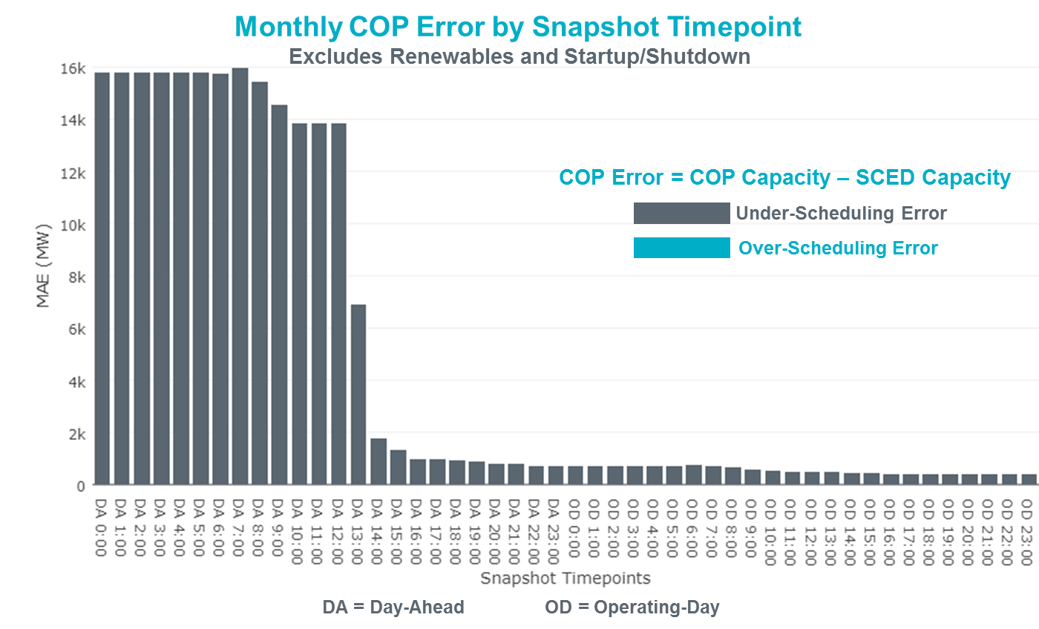

Monthly MAE for the Latest COP at the end of the Adjustment Period was 402 MW with median ranging from -707 MW for Hour-Ending (HE) 19 to 319 MW for HE 12. July 1st HE 14 had the largest Over-Scheduling Error (1,086 MW) and July 28th HE 19 had the largest Under-Scheduling Error (-3,083 MW).

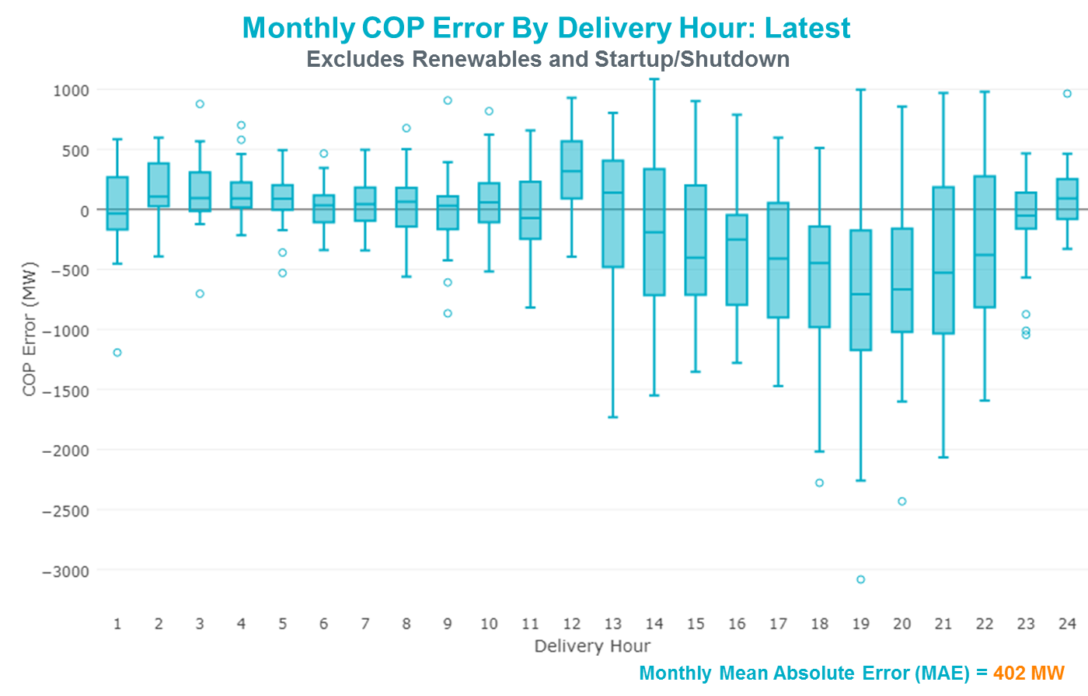

Monthly MAE for the Day-Ahead COP at 12:00 was 13,841 MW with median ranging from -19,488 MW for Hour-Ending (HE) 18 to -9,208 MW for HE 4. July 28th HE 7 had the smallest Under-Scheduling Error (-4,872 MW) and July 29th HE 17 had the largest Under-Scheduling Error (-22,648 MW).

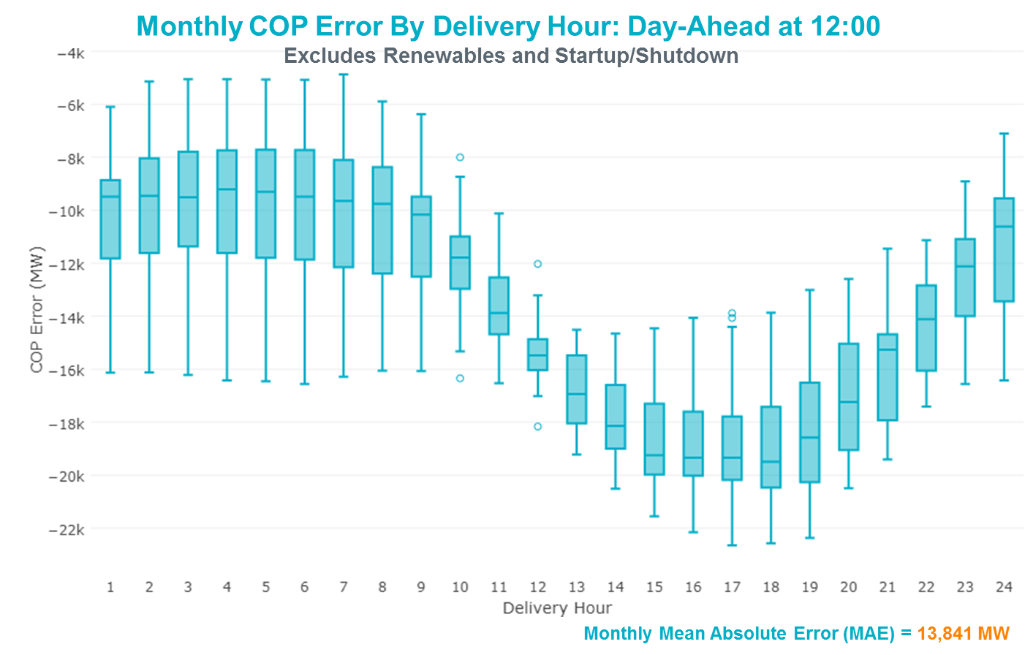

# Congestion Analysis

The total number of congestion events experienced by the ERCOT system decreased in July. There were 6 instances over 6 days on the Generic Transmission Constraints (GTCs) in July.

## Notable Constraints

Nodal protocol section 3.20 specifies that ERCOT shall identify transmission constraints that are active or binding three or more times within a calendar month. As part of this process, ERCOT reports congestion that meets this criterion to ROS. In addition ERCOT also highlights notable constraints that have an estimated congestion rent exceeding $1,000,000 for a calendar month. These constraints are detailed in the table below. Rows highlighted in blue indicate the congestion was affected by one or more outages. For a list of all constraints activated in SCED for the month of July, please see Appendix A at the end of this report.

|  |  |  |  |  |
| --- | --- | --- | --- | --- |
| **Contingency Name** | **Overloaded Element** | **# of Days Constraint Active** | **Congestion Rent** | **Transmission Project** |
|
| Solstice to LINTERNA LIN 1 | Yucca Drive Switch - Gas Pad 138kV | 24 | $73,838,528.64 | Yucca Drive-Barilla Junction (4549) |
| Ryssw-Forsw 345kV | Forney West - Forney Switch 138kV | 14 | $13,181,666.56 |  |
| Bronco to ALPINE LIN 1 | Solstice - Linterna 138kV | 30 | $6,420,332.72 | Solstice to Permian Basin: Rebuild 138 kV line |
| EMSES-SAGNA 138kV | Blue Mound - Wagley Robertson 138kV | 15 | $5,333,601.49 | Wagley Robertson (2076) - Blue Mound (2071) 138-kV line upgrade (2017RTP NC10) |
| Nedin-Mv_Wedn4&Mv_Palm4 138kV | North Edinburg - Mccoll Road 138kV | 4 | $2,323,341.94 |  |
| WEST LEVEE TO 800/900 NWK 138KV | Morrison Lane Switch - Marsh Lane 138kV | 4 | $2,170,666.03 |  |
| Vensw-Ligsw 345kV | Britton Road - Venus Switch 345kV | 4 | $2,007,001.97 | Venus - Webb/Cedar Hill Sw. Sta. 345 kV DCKT Line (5492) |
| TWR (138) SN-STR26 & OYS-VL82 | Hofman - Basf 138kV | 1 | $1,471,292.95 |  |
| WOODWARD 1 TAP to WOODWARD 1 LIN 1 | 16th Street Tnp - Woodward 2 138kV | 11 | $1,386,626.06 | Far West Texas Project |
| Entpr-Trses & Mlses-Scses 345kV | Herty North Switch - Nacogdoches Se 138kV | 9 | $1,357,837.68 | Nacogdoches Southeast - Herty North 138 kV Line (4821) |
| DMTSW-SCOSW 345KV | Knapp - Scurry Chevron 138kV | 16 | $1,202,018.33 |  |
| Mbdsw-Dcses&Wofho 345kV | Wolf Hollow 345 Switch - Comanche Peak Ses 345kV | 11 | $1,022,622.16 |  |
| DESOTO SWITCH to ENNIS SWITCH LIN _D | Ennis West Switch - Waxahachie 138kV | 7 | $947,964.74 |  |
| COLETO CREEK to PAWNEE SWITCHING STATION LIN 1 | Coleto Creek - Rosata Tap 138kV | 8 | $624,554.06 | Coleto Creek to Tuleta: New 138 kV Line (16TPIT0034) |
| Bronco to ALPINE LIN 1 | Fort Stockton Plant - Linterna 138kV | 9 | $611,787.75 | Far West Texas Project |
| NORTH PHARR to POLK AVENUE LIN 1 | North Mcallen - West Mcallen 138kV | 3 | $590,633.67 | North McAllen (8368) - West McAllen (8367) - South McAllen (8371) 138-kV line upgrades (2017 RTP S9) |
| WOODWARD 1 TAP to WOODWARD 1 LIN 1 | Woodward 2 - Rio Pecos 138kV | 8 | $499,868.59 | Far West Texas Project |
| Basecase | Solstice - Linterna 138kV | 25 | $446,643.57 | Solstice to Permian Basin: Rebuild 138 kV line |
| Solstice to LINTERNA LIN 1 | Gas Pad - Basin 138kV | 4 | $323,298.03 |  |
| Solstice to LINTERNA LIN 1 | Alpine - Bronco 69kV | 4 | $319,995.15 |  |
| FREDERICKSBURG TRX AT2 138/69 | Gillespie 138/69kV | 4 | $237,899.07 | Mountain Home Substation and Transmission Line Addition (5849C) |
| ODLAW SWITCHYARD to ASPHALT MINES LIN 1 | Hamilton Road - Maverick 138kV | 9 | $228,372.83 | Brackettville to Escondido (5206) |
| FLAT TOP TNP to Pig Creek LIN 2 | Pig Creek - Musquiz 138kV | 25 | $194,552.81 | Solstice to Permian Basin: Rebuild 138 kV line |
| LAQUINTA to LOBO LIN 1 | Bruni Sub 138/69kV | 11 | $178,403.26 |  |
| ASHERTON to Bevo Substation LIN 1 | Big Wells Sub - Cotulla Sub 69kV | 5 | $144,721.52 | Rebuild Cotulla to Big Wells 69 kV line (5217) |
| Basecase | Fort Stockton Plant - Linterna 138kV | 6 | $123,857.23 | Far West Texas Project |
| TWR(345) CHB-KG97 & CBY-JOR99 | Brine - Langston 138kV | 3 | $94,754.16 |  |
| RIO HONDO to LAS PULGAS LIN 1 | Raymondville 2 138/69kV | 3 | $79,047.64 | Harlingen SS- Raymondville #2: Convert to 138 kV (6167) |
| COLETO CREEK to VICTORIA LIN 1 | Coleto Creek - Victoria 138kV | 3 | $62,293.84 |  |
| Basecase | Pig Creek - Solstice 138kV | 11 | $36,728.40 | Solstice to Permian Basin: Rebuild 138 kV line (5257) |
| YELLOW JACKET to EDEN LIN 1 | Yellow Jacket - Hext Lcra 69kV | 3 | $32,827.57 |  |
| TRADINGHOUSE SES to LAKE CREEK SES LIN _A | Tradinghouse Ses - Sam Switch 345kV | 4 | $32,419.40 |  |
| OKLAUNION TRX OKLA_3_1 345/138 | Southwest Vernon 138/69kV | 3 | $30,232.92 |  |
| SAN MIGUEL 345_138 KV SWITCHYARDS to LOBO LIN 1 | North Laredo Switch - Piloncillo 138kV | 5 | $27,975.24 |  |
| SPENCER SWITCH to LOCUST SUBSTATION LIN 1 | Spencer Switch - Denton Steam 69kV | 3 | $7,605.19 |  |
| Denton Steam TRX AT1 138/69 | Hickory Substation - Locust Substation 69kV | 3 | $1,567.39 |  |

## Generic Transmission Constraint Congestion

There were 5 days on the Panhandle GTC and 1 day on the Valley Import GTC in July. There was no activity on the remaining GTCs during the month.

Note: This is how many times a constraint has been activated to avoid exceeding a GTC limit, it does not imply an exceedance of the GTC occurred or that the GTC was binding.

## Manual Overrides

None.

## Congestion Costs for Calendar Year 2018

The following table represents the top twenty active constraints for the calendar year based on the estimated congestion rent attributed to the congestion. ERCOT updates this list on a monthly basis.

|  |  |  |  |  |
| --- | --- | --- | --- | --- |
| **Contingency** | **Binding Element** | **# of 5-min SCED Intervals** | **Estimated Congestion Rent** | **Transmission Project** |
| Solstice to LINTERNA LIN 1 | Yucca Drive Switch - Gas Pad 138kV | 17,620 | 251,852,002.69 | Yucca Drive-Barilla Junction (4549) |
| Basecase | PNHNDL GTC | 24,282 | 97,025,319.60 | LP&L Option 4ow & Panhandle Loop (5180, 5208) |
| CRLNW-LWSSW 345kV | Carrollton Northwest - Lakepointe Tnp 138kV | 12,929 | 60,173,108.72 | Oncor_NW Carrollton - LakePointe (5488) |
| LEWISVILLE SWITCH to JONES STREET TNP LIN _A | Ti Tnp - West Tnp 138kV | 3,103 | 35,839,701.17 |  |
| NORTH EDINBURG TRX 1382 345/138 | North Edinburg 345/1kV | 1,007 | 29,901,349.20 |  |
| EMSES-SAGNA 138kV | Blue Mound - Wagley Robertson 138kV | 4,756 | 28,498,136.09 | Wagley Robertson (2076) - Blue Mound (2071) 138-kV line upgrade (2017RTP NC10) |
| Basecase | VALIMP GTC | 601 | 19,938,471.66 | La Palma Dynamic Reactive (5588) and Pharr Dynamic Reactive (5596) |
| TWR (138) SN-STR26 & OYS-VL82 | Hofman - Basf 138kV | 1,212 | 15,639,411.86 |  |
| #N/A | Hondo Creek Switching Station - Moore Switching Station 138kV | 605 | 15,342,875.43 |  |
| Elmcreek-Sanmigl 345kV | Pawnee Switching Station - Calaveras 345kV | 2,108 | 14,407,954.05 |  |
| Ryssw-Forsw 345kV | Forney West - Forney Switch 138kV | 1,629 | 14,261,203.92 |  |
| DMTSW-SCOSW 345KV | Knapp - Scurry Chevron 138kV | 8,357 | 14,137,731.08 |  |
| WOLF SWITCHING STATION to Monahans Tap 2 LIN _G | General Tire Switch - Southwestern Portland Tap 138kV | 2,347 | 13,875,621.98 |  |
| WOODWARD 1 TAP to WOODWARD 1 LIN 1 | 16th Street Tnp - Woodward 2 138kV | 2,531 | 13,603,341.44 | Far West Texas Project |
| MOSS SWITCH to YUCCA DRIVE SWITCH LIN _A | General Tire Switch - Southwestern Portland Tap 138kV | 2,344 | 11,535,045.00 |  |
| LON HILL TRX LON_HILL_3_2 345/138 | Lon Hill 345/1kV | 1,587 | 11,412,928.00 | Lon Hill: Replace 345/138 kV autotransformers (6106) |
| Bronco to ALPINE LIN 1 | Solstice - Linterna 138kV | 8,928 | 11,193,041.01 | Solstice to Permian Basin: Rebuild 138 kV line |
| NORTH PHARR to POLK AVENUE LIN 1 | North Mcallen - West Mcallen 138kV | 892 | 10,872,361.35 | North McAllen (8368) - West McAllen (8367) - South McAllen (8371) 138-kV line upgrades (2017 RTP S9) |
| Jewet-Sng 345kV | Btu_Jack_Creek - Twin Oak Switch 345kV | 5,145 | 10,549,206.33 | Houston Import Project (4458) |
| CRLNW-LWSSW 345kV | Lewisville Switch - Jones Street Tnp 138kV | 1,441 | 7,173,960.70 |  |

# System Events

## ERCOT Peak Load

The unofficial ERCOT peak load[5] for the month was 73,308 MW and occurred on July 19th, during hour ending 17:00.

## Load Shed Events

None.

## Stability Events

None.

## Notable PMU Events

ERCOT analyzes PMU data for any significant system disturbances that do not fall into the Frequency Events category reported in section 2.1. The results are summarized in this section once the analysis has been completed.

There were no PMU events in July.

## DC Tie Curtailment

|  |  |  |  |  |  |
| --- | --- | --- | --- | --- | --- |
| **Date** | **DC Tie** | **Curtailing Period** | **# of Tags Curtailed** | **Initiating Event** | **Curtailment Reason[6][7]** |
| 7/17/2018 | DC-S | HE 19:00 – HE 22:00 | 3 | Local congestion | Post-contingency loss of the Bevo to Asherton 138 kV (SBEVASH8) overloads the Big Wells to Cotulla Sub 69 kV |
| 7/23/2018 | DC-R | HE 01:00 – HE 03:00 | 1 | Local congestion | Post-contingency loss of Bentsen to Railroad (SBENRAI8) overloads South Mission to Railroad 138 kV |
| 7/23/2018 | DC-R | HE 07:00 – HE 08:00 | 1 | Local congestion | Post-contingency loss of Bentsen to Railroad 138 kV (SBENRAI8) overloads South Mission to Railroad 138 kV |
| 7/23/2018 | DC-R | HE 22:00 & HE 24:00 | 1 | Local congestion | Post-contingency loss of Bentsen to Railroad 138 kV (SBENRAI8) overloads South Mission to Railroad 138 kV |
| 7/31/2018 | DC-R | HE 21:00 – HE 24:00 | 2 | TO communication issue with DC Tie | De-rated to 100MW |

## TRE/DOE Reportable Events

None.

## New/Updated Constraint Management Plans

* MP_2018_05 Added
* MP_2018_07 Added
* MP_2018_08 Added
* RAP_2018_01 Added

## New/Modified/Removed RAS

None.

## New Procedures/Forms/Operating Bulletins

None.

# Emergency Conditions

## OCNs

|  |  |
| --- | --- |
| **Date and Time** | **Description** |
| 7/14/2018 19:00 | ERCOT issued an OCN due to extreme hot weather with forecasted temperatures to be above 103°F in the North Central and South Central weather zones. |
| 7/26/2018 09:06 | ERCOT issued an OCN due to a projected reserve capacity shortage for hours ending 14:00 through 19:00. |

## Advisories

|  |  |
| --- | --- |
| **Date and Time** | **Description** |
| 7/18/2018 15:42 | ERCOT issued an Advisory due to Physical Responsive Capability being below 3000 MW. |
| 7/19/2018 16:00 | ERCOT issued an Advisory due to Physical Responsive Capability being below 3000 MW. |
| 7/20/2018 09:30 | ERCOT issued an Advisory due to extreme hot weather with forecasted temperatures to be above 103°F in the North Central and South Central weather zones. |
| 7/25/2018 15:22 | ERCOT issued an Advisory due to Physical Responsive Capability being below 3000 MW. |
| 7/28/2018 15:23 | ERCOT issued an Advisory due to Physical Responsive Capability being below 3000 MW. |

## Watches

|  |  |
| --- | --- |
| **Date and Time** | **Description** |
| 7/17/2018 18:55 | ERCOT issued a Watch due to the post-contingency loss of the Bevo to Asherton 138 kV (SBEVASH8) overloads the Big Wells to Cotulla Sub 69 kV and curtailment of Eagle Pass DC Tie exports to CENACE. |
| 7/23/2018 00:30 | ERCOT issued a Watch due to the post-contingency loss of Bentsen to Railroad 138 kV (SBENRAI8) overloads South Mission to Railroad 138 kV and curtailment of Railroad DC Tie exports to CENACE. |
| 7/23/2018 05:50 | ERCOT issued a Watch due to the post-contingency loss of Bentsen to Railroad 138 kV (SBENRAI8) overloads South Mission to Railroad 138 kV and curtailment of Railroad DC Tie exports to CENACE. |
| 7/23/2018 21:08 | ERCOT issued a Watch due to the post-contingency loss of Bentsen to Railroad 138 kV (SBENRAI8) overloads South Mission to Railroad 138 kV and curtailment of Railroad DC Tie exports to CENACE. |
| 7/31/2018 20:33 | ERCOT issued a Watch due to de-rate of the Railroad DC-Tie and curtailment of the DC-Tie exports to CENACE. |

## Emergency Notices

None.

# Application Performance

## TSAT/VSAT Performance Issues

None

## Communication Issues

None.

## Market System Issues

None.

# Model Updates

The Downstream Production Change (DPC) process allows ERCOT to make changes in the on-line Network Operations Model without loading a completely new model. The purpose of this process is to allow for reliable grid operations as system conditions change between designated Network Operations Model database loads. The DPC process is limited in scope to just those items listed below, with equipment ratings updates being the most common. ERCOT has seen a rise in the use of the DPC process to make on-line updates to the Network Operations Model in recent years, instead of through the standard Network Operations Model Change Request process.

* Static Line ratings (Interim Update)
* Dynamic Line ratings (non-Interim Update)
* Autotransformer ratings (non-Interim Update)
* Breaker and Switch Normal status (Interim Update)
* Contingency Definitions (Interim Update)
* RAP and RAS changes or additions (Interim Update)
* Net Dependable and Reactive Capability (NDCRC) values (Interim Update)
* Impedance Updates (non-Interim)

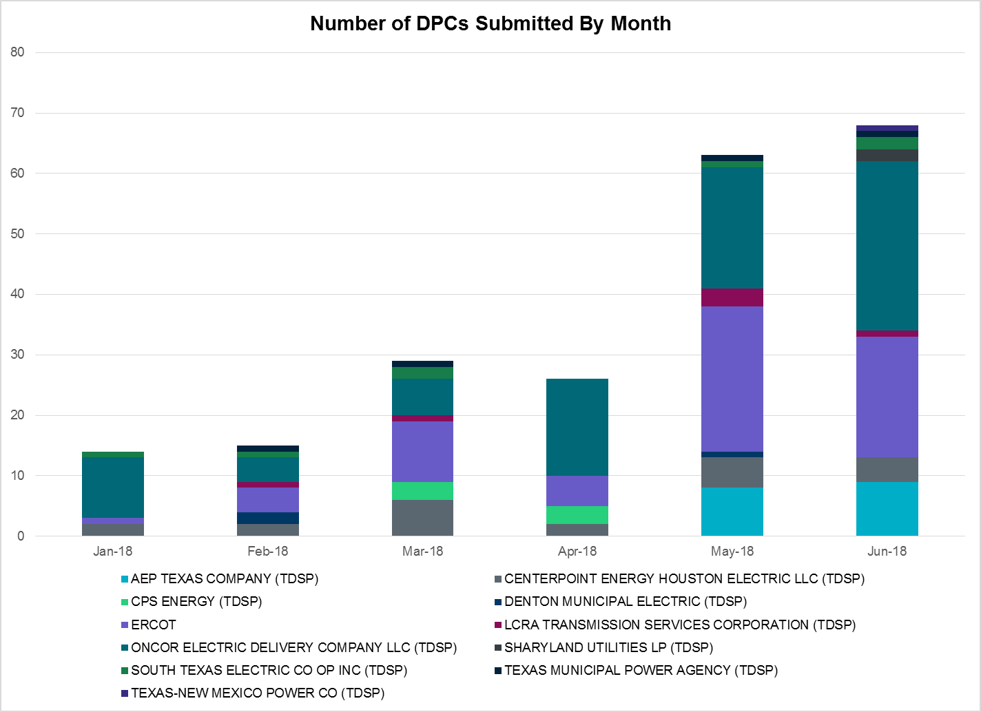

|  |  |
| --- | --- |
| **Transmission Operator** | **Number of DPCs in July** |
| AEP TEXAS COMPANY (TDSP) | 4 |
| BRAZOS ELECTRIC POWER CO OP INC (TDSP) | 1 |
| CENTERPOINT ENERGY HOUSTON ELECTRIC LLC (TDSP) | 2 |
| CPS ENERGY (TDSP) | 0 |
| DENTON MUNICIPAL ELECTRIC (TDSP) | 1 |
| ERCOT | 5 |
| LCRA TRANSMISSION SERVICES CORPORATION (TDSP) | 0 |
| ONCOR ELECTRIC DELIVERY COMPANY LLC (TDSP) | 17 |
| SHARYLAND UTILITIES LP (TDSP) | 1 |
| SOUTH TEXAS ELECTRIC CO OP INC (TDSP) | 2 |
| TEXAS MUNICIPAL POWER AGENCY (TDSP) | 0 |
| TEXAS-NEW MEXICO POWER CO (TDSP) | 1 |

# 

# Appendix A: Real-Time Constraints

The following is a complete list of constraints activated in SCED for the month of July. Full contingency descriptions can be found in the Standard Contingencies List located on the MIS secure site at Grid 🡪 Generation 🡪 Reliability Unit Commitment.

|  |  |  |  |  |
| --- | --- | --- | --- | --- |
| **Contingency** | **Constrained Element** | **From Station** | **To Station** | **# of Days Constraint Active** |
| SBROALP9 | LINTER_SOLSTI1_1 | LINTERNA | SOLSTICE | 30 |
| SFLAPIG8 | MUSQUI_PIGCRE1_1 | PIGCREEK | MUSQUIZ | 25 |
| BASE CASE | LINTER_SOLSTI1_1 | LINTERNA | SOLSTICE | 25 |
| SWCSBOO8 | 6332__A | YUCSW | GASPAD | 24 |
| DMTSCOS5 | 6437__F | SCRCV | KNAPP | 16 |
| DEMSSAG8 | 6270__C | WGROB | BLMND | 15 |
| DRYSFOR5 | 1090__A | FORWE | FORSW | 14 |
| DRYSFOR5 | 1090__A | FORSW | FORWE | 14 |
| BASE CASE | PIGCRE_SOLSTI1_1 | SOLSTICE | PIGCREEK | 11 |
| SWOORI38 | 16TH_WRD2_1 | WOODWRD2 | 16TH_ST | 11 |
| DMBDMBD5 | 151__A | WOFHO | CPSES | 11 |
| SLAQLOB8 | BRUNI_69_1 | BRUNI | BRUNI | 11 |
| SBRAUVA8 | HAMILT_MAVERI1_1 | HAMILTON | MAVERICK | 9 |
| SBROALP9 | FTST_LINTER1_1 | FTST | LINTERNA | 9 |
| DENTSCS5 | 1170__A | NCDSE | HNRSW | 9 |
| SWOORI38 | RIOPEC_WOODW21_1 | RIOPECOS | WOODWRD2 | 8 |
| SCOLPAW5 | COLETO_ROSATA1_1 | COLETO | ROSATA | 8 |
| SRDODES8 | 940__C | ENWSW | WXHCH | 7 |
| BASE CASE | FTST_LINTER1_1 | FTST | LINTERNA | 6 |
| SLOBSA25 | NLARSW_PILONC1_1 | NLARSW | PILONCIL | 5 |
| SBEVASH8 | BIG_COTU_1 | COTULAS | BIGWELS | 5 |
| BASE CASE | PNHNDL | n/a | n/a | 5 |
| SWCSBOO8 | ALPINE_BRONCO1_1 | BRONCO | ALPINE | 4 |
| DWLV89N8 | 3750__A | MSLSW | MSHLN | 4 |
| DNEDPAL8 | MCOLL__NEDIN1_1 | NEDIN | MCOLL_RD | 4 |
| SLCSTH25 | 505__A | THSES | SAMSW | 4 |
| XFRE89 | GILLES_AT1 | GILLES | GILLES | 4 |
| SWCSBOO8 | BASIN_GASPAD1_1 | GASPAD | BASIN | 4 |
| DVENLIG5 | 530__C | VENSW | BRTRD | 4 |
| DCHBJOR5 | BRNLAN86_A | LAN | BRN | 3 |
| SSPNDEN9 | HIC_LOCU_1 | LOCUST_D | HICKRY_D | 3 |
| SRAYRI28 | RAYMND2_69A1 | RAYMND2 | RAYMND2 | 3 |
| SVICCO28 | COLETO_VICTOR2_1 | COLETO | VICTORIA | 3 |
| SEDEYEL9 | HEXT_YELWJC1_1 | YELWJCKT | HEXT | 3 |
| SPOLPHA8 | GCB_100_1 | N_MCALLN | W_MCALLN | 3 |
| XOKL58 | VERS_69_1 | VERS | VERS | 3 |
| SLOCSPN9 | SPE_DEN_1 | SPNCER | DENTON | 3 |
| XBAL89 | CONCHO_VRBS1_1 | CONCHO | VRBS | 2 |
| SREDMCC8 | 102T375_1 | MCCALA | RNRD12 | 2 |
| SMGIENW8 | 921__D | ENSSW | TRU | 2 |
| SMDOPHR5 | 138_ALV_MNL_1 | ALVIN | MAINLAND | 1 |
| DELMSAN5 | COLETO_ROSATA1_1 | COLETO | ROSATA | 1 |
| SJARDIL8 | DIL_COTU_1 | DILLEYSW | COTULAS | 1 |
| DCRLLSW5 | 590__A | LWSSW | LWVJS | 1 |
| DMCNMAG8 | CKT_972_1 | MCNEIL | HWRDLN | 1 |
| SWOORI38 | LINTER_SOLSTI1_1 | LINTERNA | SOLSTICE | 1 |
| SN_MNED8 | MCOLL__NEDIN1_1 | NEDIN | MCOLL_RD | 1 |
| SMCEABS8 | MKLT_TRNT1_1 | TRNT | MKLT | 1 |
| SSONFRI8 | SONR_69-1 | SONR | SONR | 1 |
| SBOSELM5 | 1030__B | BOSQUESW | RGH | 1 |
| DPHRAL58 | 138_ALV_MNL_1 | ALVIN | MAINLAND | 1 |
| DTYGFOR5 | 1850__H | TRSES | NPKTP | 1 |
| DCNSLHS8 | 3270__B | LHSES | CNTRD | 1 |
| DPHRBBP8 | CA_DE_96_A | DE | CA | 1 |
| SPIGSOL8 | RIOPEC_WDWRDT1_1 | WDWRDTP | RIOPECOS | 1 |
| SVEROK28 | VERS_69_1 | VERS | VERS | 1 |
| SBEVASH8 | HAMILT_MAVERI1_1 | HAMILTON | MAVERICK | 1 |
| BASE CASE | VALIMP | n/a | n/a | 1 |
| DTRSENT5 | 1255__B | SCSES | STCKY | 1 |
| DWTRTRC5 | 1850__H | TRSES | NPKTP | 1 |
| XWL2V58 | 3130__B | INDST | CMPST | 1 |
| DTRCELK5 | 960__D | JKSVL | BUPOI | 1 |
| DSN_BFP8 | BSFHN_02_A | BSF | HN | 1 |
| DALNRYS5 | WYL_FIRE_1 | WYLIESW | FIRWHEEL | 1 |
| DSGVFOR5 | 1850__H | TRSES | NPKTP | 1 |
| SMDOPHR5 | G138_10C_1 | FRDSWOOD | SEMINOLE | 1 |
| SILLFTL8 | HAMILT_MAXWEL1_1 | MAXWELL | HAMILTON | 1 |
| SFLATNB8 | MUSQUI_PIGCRE1_1 | PIGCREEK | MUSQUIZ | 1 |
| BASE CASE | NEDIN_138H | NEDIN | NEDIN | 1 |
| SLOBSA25 | ASHERT_CATARI1_1 | ASHERTON | CATARINA | 1 |
| DNEDPAL8 | NEDIN_N_MCAL1_1 | NEDIN | N_MCALLN | 1 |
| SCRLCR38 | 735__G | IRVND | IRVNE | 1 |
| SWHIBUT8 | 228T333_1 | LAGOVI | NAMELE | 1 |

1. The Duration of Event is defined as the time it takes for the frequency to recover to pre-disturbance frequency or 60 Hz as applicable.
2. PMU reports are typically generated when frequency drops below 59.9, but PMU data is available for other events.
3. Delta Frequency is defined as the difference between the starting point of the frequency event (t(0) or “A-point”) and minimum/maximum frequency (“C-Point”).
4. Currently, the Critical Inertia Level for ERCOT is approximately 100,000 MW-s (Source: link)
5. This is the hourly integrated peak demand as published in the ERCOT D&E report.
6. All DC Tie Curtailments are posted publically on the ERCOT Market Information System. See that posting for additional details for the event(s) in question.
7. See DC Tie Operating Procedure (<http://www.ercot.com/mktrules/guides/procedures>) for more details.