June 2018 ERCOT Monthly Operations Report
Reliability and Operations Subcommittee Meeting
August 9, 2018

Table of Contents
1. Report Highlights 2
2. Frequency Control 3
2.1. Frequency Events 3
2.2. Responsive Reserve Events 4
2.3. Load Resource Events 4
3. Reliability Unit Commitment 4
4. Wind Generation as a Percent of Load 5
5. COP Error Analysis 5
6. Congestion Analysis 7
6.1. Notable Constraints 7
6.2. Generic Transmission Constraint Congestion 10
6.3. Manual Overrides 10
6.4. Congestion Costs for Calendar Year 2018 10
7. System Events 10
7.1. ERCOT Peak Load 11
7.2. Load Shed Events 12
7.3. Stability Events 12
7.4. Notable PMU Events 12
7.5. DC Tie Curtailment 12
7.6. TRE/DOE Reportable Events 12
7.7. New/Updated Constraint Management Plans 12
7.8. New/Modified/Removed RAS 13
7.9. New Procedures/Forms/Operating Bulletins 13
8. Emergency Conditions 13
8.1. OCNs 13
8.2. Advisories 13
8.3. Watches 13
8.4. Emergency Notices 14
9. Application Performance 14
9.1. TSAT/VSAT Performance Issues 14
9.2. Communication Issues 14
9.3. Market System Issues 14
10. Model Updates 14
Appendix A: Real-Time Constraints 17

Report Highlights
- The unofficial ERCOT peak for June was 69,102 MW.
- There was one frequency event in June. PMU data indicates the ERCOT system transitioned well.
- There were no instances where Responsive Reserves were deployed.
- There were four RUC commitments in June due to congestion. Congestion in June was concentrated in the North, South, and West Load Zones. Congestion in the North can be mostly attributed to high Panhandle and West wind generation, multiple planned and forced outages, and high load. Congestion in the South was due high load. Congestion in the West was due to high West solar generation, multiple planned and forced outages, and high load. There were 23 days on the Panhandle GTC, 2 days on the Nelson Sharpe – Rio Hondo GTC, and 1 days on the North – Houston GTC in June. There was no activity on the remaining GTCs during the month.
- There were nine DC Tie curtailments in June. Five were due to forced DC Tie outages, three were due to local congestion, and another was due an incorrectly submitted schedule.

Frequency Control

Frequency Events
The ERCOT Interconnection experienced one frequency event in June, which resulted from a Resource trip. The average event duration was approximately 0:03:04.

A summary of the frequency events is provided below. The reported frequency events meet one of the following criteria: Delta Frequency is 60 mHz or greater; the MW loss is 350 MW or greater; resource trip event triggered RRS deployment. Frequency events that have been identified as Frequency Measurable Events (FME) for purposes of BAL-001-TRE-1 analysis are highlighted in blue. When analyzing frequency events, ERCOT evaluates PMU data according to industry standards. Events with an oscillating frequency of less than 1 Hz are considered to be inter-area, while higher frequencies indicate local events. Industry standards specify that damping ratio for inter-area oscillations should be 3.0% or greater. For the frequency events listed below, the ERCOT system met these standards and transitioned well after each disturbance.

Date and Time | Delta Frequency | Max/Min Frequency | Duration of Event | PMU Data |  | MW Loss | Load | Wind | Inertia
 | (Hz) | (Hz) |  | Oscillation Mode (Hz) | Damping Ratio |  | (MW) | % | (GW-s)
6/8/2018 8:23 | 0.083 | 59.925 | 0:03:04 | No PMU Report Created |  | 423 | 43,786 | 14% | 273,562

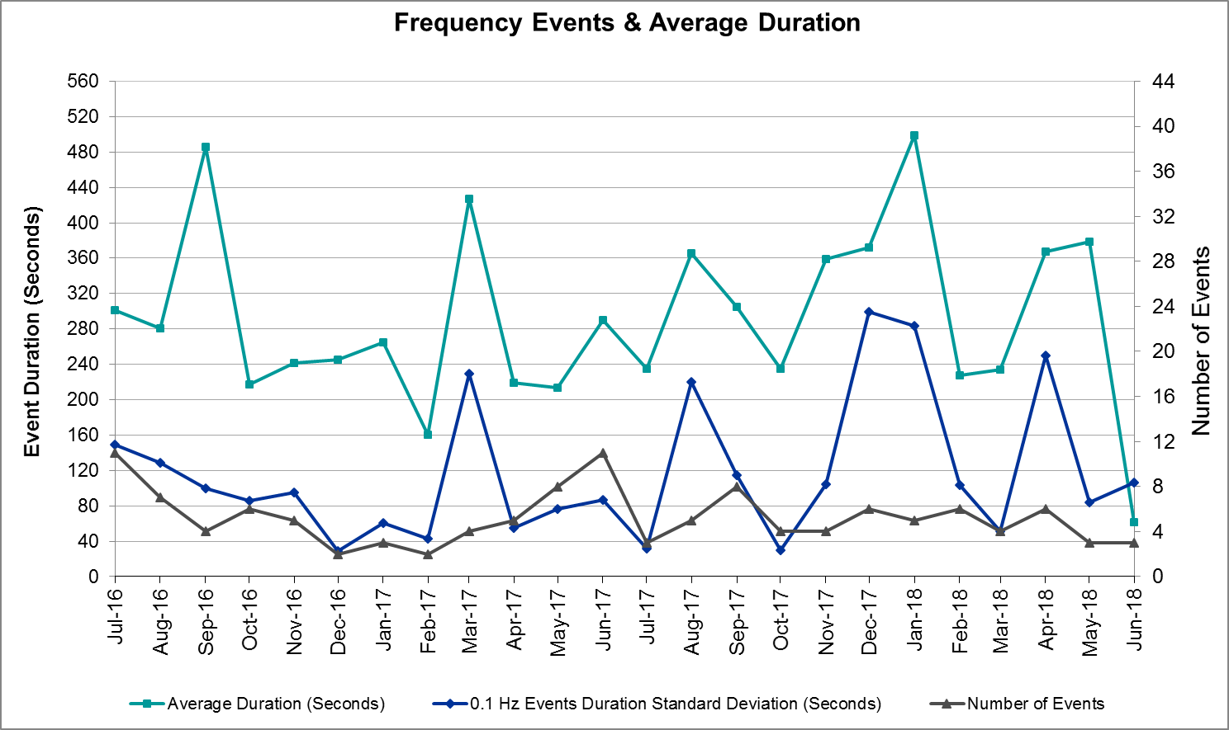
(Note: All data on this graph encompasses frequency event analysis based on BAL-001-TRE-1.)

Responsive Reserve Events
There were no events where Responsive Reserve MWs were released to SCED in June.

Load Resource Events
None.

Reliability Unit Commitment

ERCOT reports on Reliability Unit Commitments (RUC) on a monthly basis. Commitments are reported grouped by operating day and weather zone. The total number of hours committed is the sum of the hours for all the units in the specified region. Additional information on RUC commitments can be found on the MIS secure site at Grid Generation Reliability Unit Commitment.

There were no DRUC commitments in June.

There were four HRUC commitment in June.

Resource Location | # of Resources | Operating Day | Total # of Hours Committed | Total MWhs | Reason for Commitment
North | 1 | 6/2/2018 | 3 | 700 | Congestion
North Central | 2 | 6/15/2018 | 8 | 3,480 | Congestion
North Central | 1 | 6/16/2018 | 2 | 870 | Congestion
Coast | 2 | 6/30/2018 | 8 | 1,304 | Congestion

Wind Generation as a Percent of Load
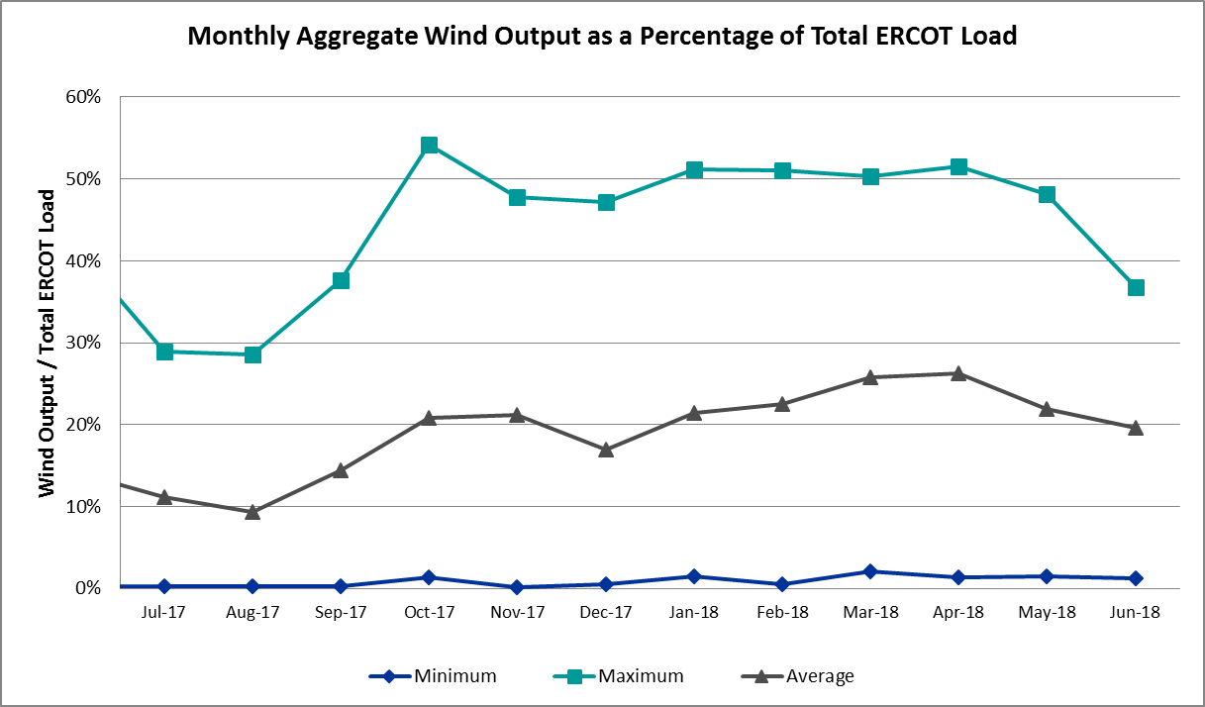

COP Error Analysis
COP Error is calculated as the capacity difference between the COP HSL and real-time HSL of the unit. Mean Absolute Error (MAE) stayed high, mostly over 10,000 MW, until Day-Ahead at 12:00, then dropped significantly to 1,786 MW by Day-Ahead at 14:00. In the following chart, Under-Scheduling Error indicates that COP had less generation capacity than real-time and Over-Scheduling Error indicates that COP had more generation capacity than real-time. Under-Scheduling persisted from beginning of Day-Ahead to end of the Operating Day. Snapshot on the Operating Day considers all Operating Hours, including past hours. However, COP error for the Operating Hour freezes after the Adjustment Period.
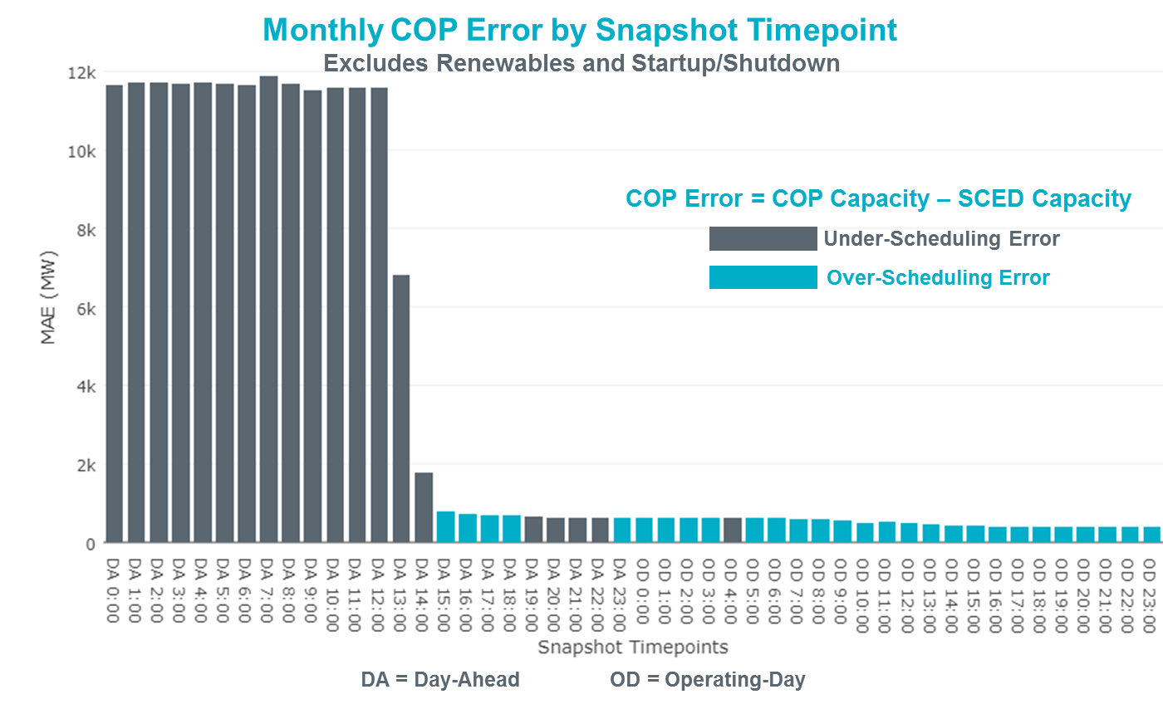

Monthly MAE for the Latest COP at the end of the Adjustment Period was 382 MW with median ranging from -414 MW for Hour-Ending (HE) 20 to 615 MW for HE 23. June 19th HE 23 had the largest Over-Scheduling Error (1,640 MW) and June 13th HE 20 had the largest Under-Scheduling Error (-2,748 MW).
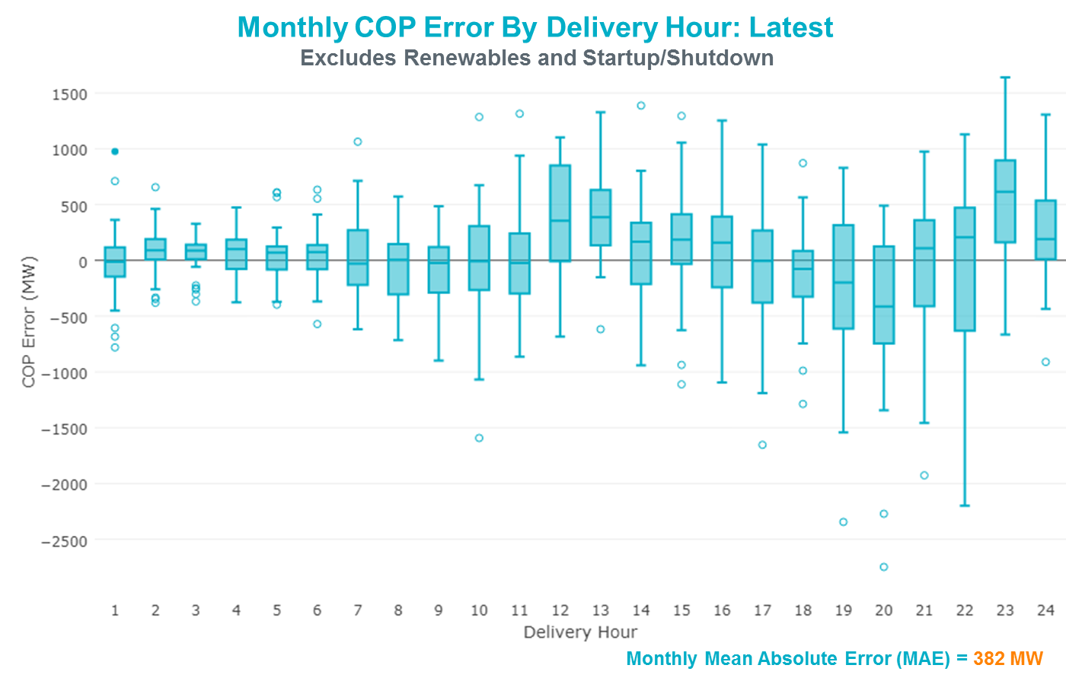

Monthly MAE for the Day-Ahead COP at 12:00 was 11,581 MW with median ranging from -16,801 MW for Hour-Ending (HE) 17 to -6,951 MW for HE 2. July 3rd HE 7 had the smallest Under-Scheduling Error (-3,599 MW) and June 21st HE 19 had the largest Under-Scheduling Error (-21,644 MW).

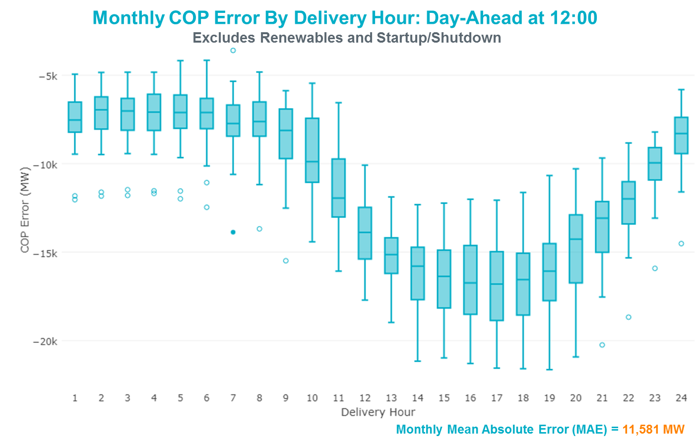

Congestion Analysis
The total number of congestion events experienced by the ERCOT system decreased in June. There were 26 instances over 24 days on the Generic Transmission Constraints (GTCs) in June.

Notable Constraints
Nodal protocol section 3.20 specifies that ERCOT shall identify transmission constraints that are active or binding three or more times within a calendar month. As part of this process, ERCOT reports congestion that meets this criterion to ROS. In addition ERCOT also highlights notable constraints that have an estimated congestion rent exceeding $1,000,000 for a calendar month. These constraints are detailed in the table below. Rows highlighted in blue indicate the congestion was affected by one or more outages. For a list of all constraints activated in SCED for the month of June, please see Appendix A at the end of this report.

Contingency Name | Overloaded Element | # of Days Constraint Active | Congestion Rent | Transmission Project
Solstice to LINTERNA LIN 1 | Yucca Drive Switch - Gas Pad 138kV | 29 | $112,580,735.79 | Yucca Drive-Barilla Junction (4549)
EMSES-SAGNA 138kV | Blue Mound - Wagley Robertson 138kV | 25 | $14,851,769.77 | Wagley Robertson (2076) - Blue Mound (2071) 138-kV line upgrade (2017RTP NC10)
TWR (138) SN-STR26 & OYS-VL82 | Hofman - Basf 138kV | 11 | $13,799,489.05
DMTSW-SCOSW 345KV | Knapp - Scurry Chevron 138kV | 26 | $4,552,706.80
WOODWARD 1 TAP to WOODWARD 1 LIN 1 | 16th Street Tnp - Woodward 2 138kV | 18 | $4,323,348.20 | Far West Texas Project
Bronco to ALPINE LIN 1 | Solstice - Linterna 138kV | 29 | $3,135,927.54 | Solstice to Permian Basin: Rebuild 138 kV line
Solstice to LINTERNA LIN 1 | Alpine - Bronco 69kV | 22 | $3,117,385.18
Basecase | Solstice - Linterna 138kV | 29 | $1,666,305.79 | Solstice to Permian Basin: Rebuild 138 kV line
Entpr-Trses & Mlses-Scses 345kV | Herty North Switch - Nacogdoches Se 138kV | 17 | $1,581,508.46 | Nacogdoches Southeast - Herty North 138 kV Line (4821)
WOODWARD 1 TAP to WOODWARD 1 LIN 1 | Woodward 2 - Rio Pecos 138kV | 11 | $1,506,244.52 | Far West Texas Project
ODLAW SWITCHYARD to ASPHALT MINES LIN 1 | Hamilton Road - Maverick 138kV | 21 | $1,488,647.97 | Brackettville to Escondido (5206)
Basecase | PNHNDL GTC | 23 | $1,451,823.84 | LP&L Option 4ow & Panhandle Loop (5180, 5208)
PH ROBINSON to MEADOW LIN A | Seminole Tnp - Friendswood Tnp 138kV | 11 | $1,430,933.53
NORTH PHARR to POLK AVENUE LIN 1 | North Mcallen - West Mcallen 138kV | 4 | $1,299,235.30 | North McAllen (8368) - West McAllen (8367) - South McAllen (8371) 138-kV line upgrades (2017 RTP S9)
Ryssw-Forsw 345kV | Forney West - Forney Switch 138kV | 11 | $1,079,537.36
Mbdsw-Dcses&Wofho 345kV | Wolf Hollow 345 Switch - Comanche Peak Ses 345kV | 12 | $1,023,179.26
LAQUINTA to LOBO LIN 1 | Bruni Sub 138/69kV | 20 | $916,848.48
PH ROBINSON to MEADOW LIN A | Mainland Tnp - Alvin Tnp 138kV | 18 | $646,093.50
COMANCHE SWITCH (Oncor) to COMANCHE PEAK SES LIN _A | Comanche Tap - Comanche Switch (Oncor) 138kV | 6 | $606,316.44
TWR(138) CBY-RNG87 & BT-CBY88 | Texas - Cedar Bayou 138kV | 3 | $512,831.30 | Baytown Area Upgrades (6585F)
Basecase | Omega - Horse Hollow Generation Tie 345kV | 4 | $331,030.56
FRIEND RANCH to SONORA LIN 1 | Sonora 138/69kV | 10 | $294,941.26
WEST LEVEE SWITCH TRX WLVEE_3_1 345/138 | Industrial Blvd - Compton Street 138kV | 5 | $211,051.53 | Cedar Crest - Industrial 138 kV line (13TPIT0059)
Bighil-Kendal 345kV | Bondroad - Sonora 69kV | 9 | $206,243.04
FREDERICKSBURG TRX AT2 138/69 | Gillespie 138/69kV | 5 | $167,553.67 | Mountain Home Substation and Transmission Line Addition (5849C)
Bronco to ALPINE LIN 1 | Fort Stockton Plant - Linterna 138kV | 14 | $165,466.07 | Far West Texas Project
COLETO CREEK to PAWNEE SWITCHING STATION LIN 1 | Coleto Creek - Rosata Tap 138kV | 9 | $94,741.54 | Coleto Creek to Tuleta: New 138 kV Line (16TPIT0034)
FLAT TOP TNP to Pig Creek LIN 2 | Pig Creek - Musquiz 138kV | 4 | $86,213.88 | Solstice to Permian Basin: Rebuild 138 kV line
SUN SWITCH to SCURRY SWITCH LIN 1 | Aspermont Aep 138/69kV | 4 | $76,360.49 | Aspermont: Replace the 138/69 kV autotransformer (6569)
KLEBERG AEP to LOYOLA SUB LIN 1 | Loyola Sub 138/69kV | 8 | $73,490.22 | AEP_Angstrom (15TPIT0069)
MCAN_SW TO RIOP 138 KV | Solstice - Linterna 138kV | 11 | $69,109.22 | Solstice to Permian Basin: Rebuild 138 kV line
BRACKETTVILLE to HAMILTON ROAD LIN 1 | Hamilton Road - Maverick 138kV | 3 | $53,977.82 | Brackettville to Escondido (5206)
FAYETTE PLANT 1 to SALEM LCRA LIN 1 | Fayetteville 138/1kV | 5 | $43,035.87
Basecase | Fort Stockton Plant - Linterna 138kV | 10 | $36,147.68 | Far West Texas Project
FORT LANCASTER to ILLINOIS #4 LIN 1 | Hamilton Road - Maxwell 138kV | 3 | $29,137.62
CRLNW-LWSSW 345kV | Lewisville Switch - Jones Street Tnp 138kV | 5 | $16,373.97
GILLESPIE LCRA to FREDERICKSBURG LIN 1 | Gillespie 138/69kV | 3 | $15,269.93 | Mountain Home Substation and Transmission Line Addition (5849C)
NORTH McCAMEY TRX NORTMC_AT2 345/138 | Solstice - Linterna 138kV | 3 | $12,329.86 | Solstice to Permian Basin: Rebuild 138 kV line
Navarro - WTRML 345KV | Britton Road - Venus Switch 345kV | 3 | $5,132.15 | Venus - Webb/Cedar Hill Sw. Sta. 345 kV DCKT Line (5492)
Ferguson-Sherwood Shores & Ferguson-Granite Mountain 138kV | Starcke - Wirtz 138kV | 3 | $2,641.31 | Wirtz Special Protection System (5769)
Basecase | Pig Creek - Solstice 138kV | 5 | $1,968.36 | Solstice to Permian Basin: Rebuild 138 kV line
SAN MIGUEL 345_138 KV SWITCHYARDS to LOBO LIN 1 | Laredo VFTN North - Milo 138 kV | 3 | $1,049.82

Generic Transmission Constraint Congestion
There were 23 days on the Panhandle GTC, 2 days on the Nelson Sharpe – Rio Hondo GTC, and 1 days on the North – Houston GTC in June. There was no activity on the remaining GTCs during the month.

Note: This is how many times a constraint has been activated to avoid exceeding a GTC limit, it does not imply an exceedance of the GTC occurred or that the GTC was binding.

Manual Overrides
None.

Congestion Costs for Calendar Year 2018
The following table represents the top twenty active constraints for the calendar year based on the estimated congestion rent attributed to the congestion. ERCOT updates this list on a monthly basis.

Contingency | Binding Element | # of 5-min SCED Intervals | Estimated Congestion Rent | Transmission Project
Solstice to LINTERNA LIN 1 | Yucca Drive Switch - Gas Pad 138kV | 13,340 | 182,640,123.86 | Yucca Drive-Barilla Junction (4549)
Basecase | PNHNDL GTC | 23,792 | 97,021,423.99 | LP&L Option 4ow & Panhandle Loop (5180, 5208)
CRLNW-LWSSW 345kV | Carrollton Northwest - Lakepointe Tnp 138kV | 12,929 | 60,173,108.72 | Oncor_NW Carrollton - LakePointe (5488)
LEWISVILLE SWITCH to JONES STREET TNP LIN _A | Ti Tnp - West Tnp 138kV | 3,103 | 35,839,701.17
NORTH EDINBURG TRX 1382 345/138 | North Edinburg 345/1kV | 1,007 | 29,901,349.20
EMSES-SAGNA 138kV | Blue Mound - Wagley Robertson 138kV | 3,469 | 22,131,368.13 | Wagley Robertson (2076) - Blue Mound (2071) 138-kV line upgrade (2017RTP NC10)
Basecase | VALIMP GTC | 600 | 19,938,471.66 | La Palma Dynamic Reactive (5588) and Pharr Dynamic Reactive (5596)
#N/A | Hondo Creek Switching Station - Moore Switching Station 138kV | 605 | 15,342,875.43
Elmcreek-Sanmigl 345kV | Pawnee Switching Station - Calaveras 345kV | 2,108 | 14,407,954.05
TWR (138) SN-STR26 & OYS-VL82 | Hofman - Basf 138kV | 1,118 | 14,168,118.91
WOLF SWITCHING STATION to Monahans Tap 2 LIN _G | General Tire Switch - Southwestern Portland Tap 138kV | 2,347 | 13,875,621.98
WOODWARD 1 TAP to WOODWARD 1 LIN 1 | 16th Street Tnp - Woodward 2 138kV | 2,079 | 12,222,535.66 | Far West Texas Project
DMTSW-SCOSW 345KV | Knapp - Scurry Chevron 138kV | 7,167 | 11,680,372.81
MOSS SWITCH to YUCCA DRIVE SWITCH LIN _A | General Tire Switch - Southwestern Portland Tap 138kV | 2,344 | 11,535,045.00
LON HILL TRX LON_HILL_3_2 345/138 | Lon Hill 345/1kV | 1,587 | 11,412,928.00 | Lon Hill: Replace 345/138 kV autotransformers (6106)
Jewet-Sng 345kV | Btu_Jack_Creek - Twin Oak Switch 345kV | 5,145 | 10,549,206.33 | Houston Import Project (4458)
NORTH PHARR to POLK AVENUE LIN 1 | North Mcallen - West Mcallen 138kV | 715 | 10,281,727.68 | North McAllen (8368) - West McAllen (8367) - South McAllen (8371) 138-kV line upgrades (2017 RTP S9)
CRLNW-LWSSW 345kV | Lewisville Switch - Jones Street Tnp 138kV | 1,392 | 7,173,642.59
Solstice to LINTERNA LIN 1 | Barrilla - Fort Stockton Switch 69kV | 6,218 | 6,633,870.62 | Far West Texas Project
Wink Sub to YUCCA DRIVE SWITCH LIN _A | Andrews County South - Amoco Three Bar Tap 138kV | 829 | 6,248,536.19 | Holt - North Andrews 138 kV Line (Amoco) (5426)

System Events

ERCOT Peak Load
The unofficial ERCOT peak load for the month was 69,102 MW and occurred on June 27th, during hour ending 17:00.

Load Shed Events
None.

Stability Events
None.

Notable PMU Events
ERCOT analyzes PMU data for any significant system disturbances that do not fall into the Frequency Events category reported in section 2.1. The results are summarized in this section once the analysis has been completed.

There were no PMU events in June.

DC Tie Curtailment
Date | DC Tie | Curtailing Period | # of Tags Curtailed | Initiating Event | Curtailment Reason
06/02/2018 | DC-S | HE 06:00 – HE 24:00 | 3 | DC Tie forced outage | No known cause – reset controllers and tested
06/10/2018 | DC-R | HE 23:00 – HE 24:00 | 1 | DC Tie de-rated to 150MW | Due to station 2 being out of service
06/13/2018 | DC-R | HE 01:00 – HE 24:00 | 8 | DC Tie forced outage | Disconnect fault tripped the bus on the CENACE side.
06/13/2018 | DC-L | 06/13 HE 20:00 – 06/15 HE 12:00 | 7 | DC Tie forced outage | Suspected relay issue. Further investigation needed.
06/15/2018 | DC-L | HE 19:00 | 1 | DC Tie forced outage | Suspected relay issue. Further investigation needed.
06/25/2018 | DC-S | HE 08:00 – HE 24:00 | 1 | Incorrectly submitted schedule | Incorrectly submitted schedule
06/26/2018 | DC-R | HE 14:00 – HE 21:00 | 7 | Local Congestion | post-contingency overload of SPOLPHA8, loss of Polk Avenue – North Pharr 138 kV overloads North McAllen – West McAllen 138 kV
06/27/2018 | DC-R | HE 19:00 – HE 24:00 | 6 | Local Congestion | Post-contingency overload of SBENRAI8 Bentsen – Railroad 138 kV overloads South Mission – Railroad 138 kV
06/28/2018 | DC-R | HE 21:00 – HE 24:00 | 3 | Local Congestion | Post-contingency overload of SBENRAI8 Bentsen – Railroad 138 kV overloads South Mission – Railroad 138 kV

TRE/DOE Reportable Events
- ERCOT submitted an EOP-004 report for June 29, 2018 Reportable Event Type: loss of ERCOT Real-Time Contingency Analysis (RTCA) > 30 minutes.

New/Updated Constraint Management Plans
Annual Review Completed.
- 1 RAP Modified. No Additions.
- 13 MPs Removed. 3 Additions.
- 2 PCAPs Removed. No Additions.

Other Mitigation Plans
- MP_2018_01 Added

New/Modified/Removed RAS
- Permian Basin RAS was retired
- Monticello B RAS was retired

New Procedures/Forms/Operating Bulletins
None.

Emergency Conditions

OCNs
None.

Advisories
Date and Time | Description
6/05/2018 15:45 | ERCOT issued an Advisory due to Physical Responsive Capability being below 3000 MW
6/07/2018 13:34 | ERCOT issued an Advisory for postponing the deadline for posting of the DAM Solution for Operating Day June 8, 2019
6/07/2018 15:43 | ERCOT issued an Advisory due to Physical Responsive Capability being below 3000 MW
6/27/2018 13:30 | ERCOT issued an Advisory for postponing the deadline for the posting of the DAM solution for operating day June 28, 2018
6/27/2018 13:44 | ERCOT issued an Advisory for timeline deviation of the Day Ahead Market, delaying the start of DRUC
6/29/2018 22:27 | ERCOT issued an Advisory due to ERCOT’s Voltage Security Assessment Tool / RTCA unavailability

Watches
Date and Time | Description
6/03/2018 16:57 | ERCOT issued a Watch for the forced outages of the Eagle Pass DC-Tie and curtailment of DC-Tie Exports to CENACE
6/12/2018 07:23 | ERCOT issued a Watch for the de-rate of the Railroad DC-Tie and curtailment of the DC-Tie exports to CENACE
6/13/2018 02:12 | ERCOT issued a Watch for the forced outage of the Railroad DC-Tie and curtailment of the DC-Tie exports to CENACE
6/13/2018 19:39 | ERCOT issued a Watch for the forced outage of the Laredo DC-Tie and curtailment of DC-Tie exports to CENACE
6/15/2018 18:30 | ERCOT issued a Watch for the forced outage of the Laredo DC-Tie and curtailment of DC-Tie exports to CENACE
6/17/2018 07:35 | ERCOT issued a Watch due to the post-contingency overload of SCHYWIN8, loss of No Trees Switch to Wink Sub 138 kV lines overloads Wink Sub 138/69 kV Auto 2, due to multiple outages in Far West Texas
6/19/2018 05:11 | ERCOT issued a Watch due to the post-contingency overload of SHSAPB38, loss of Ward Gulf Tap to Wink Sub 138 kV lines overloads Dollar Hide to No Trees Switch 138 kV line
6/25/2018 07:25 | ERCOT issued a Watch due to an Incorrectly submitted tag on the Eagle Pass DC-Tie and curtailment of DC-Tie exports to CENACE
6/26/2018 12:56 | ERCOT issued a Watch due to the post-contingency overload of SPOLPHA8, loss of Polk Avenue – North Pharr 138 kV overloads North McAllen – West McAllen 138 kV and curtailment of DC-Tie exports to CENACE
6/27/2018 18:39 | ERCOT issued a Watch due to the post-contingency overload of SPOLPHA8, loss of Polk Avenue – North Pharr 138 kV overloads North McAllen – West McAllen 138 kV and curtailment of DC-Tie exports to CENACE
6/28/2018 15:13 | ERCOT issued a Watch due to the post-contingency overload of SPOLPHA8, loss of Polk Avenue – North Pharr 138 kV overloads North McAllen – West McAllen 138 kV and curtailment of DC-Tie exports to CENACE

Emergency Notices
None.

Application Performance

TSAT/VSAT Performance Issues
- Loss of VSAT on June 29, 2018 for 45 minutes

Communication Issues
None.

Market System Issues
None.

Model Updates
The Downstream Production Change (DPC) process allows ERCOT to make changes in the on-line Network Operations Model without loading a completely new model. The purpose of this process is to allow for reliable grid operations as system conditions change between designated Network Operations Model database loads. The DPC process is limited in scope to just those items listed below, with equipment ratings updates being the most common. ERCOT has seen a rise in the use of the DPC process to make on-line updates to the Network Operations Model in recent years, instead of through the standard Network Operations Model Change Request process.

- Static Line ratings (Interim Update)
- Dynamic Line ratings (non-Interim Update)
- Autotransformer ratings (non-Interim Update)
- Breaker and Switch Normal status (Interim Update)
- Contingency Definitions (Interim Update)
- RAP and RAS changes or additions (Interim Update)
- Net Dependable and Reactive Capability (NDCRC) values (Interim Update)
- Impedance Updates (non-Interim)

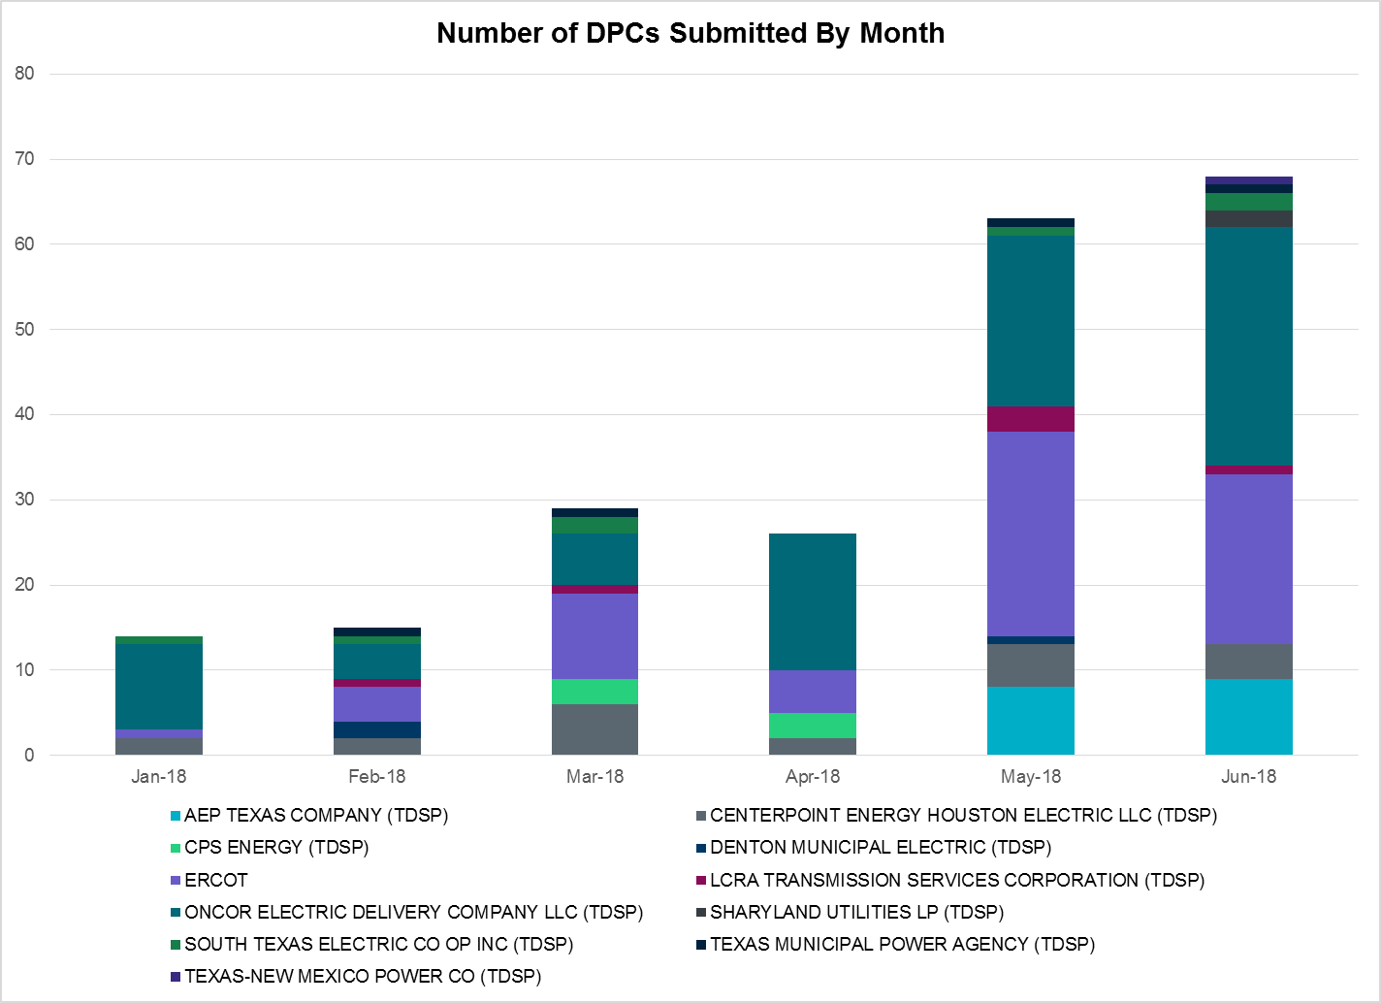

Transmission Operator | Number of DPCs in June
AEP TEXAS COMPANY (TDSP) | 9
CENTERPOINT ENERGY HOUSTON ELECTRIC LLC (TDSP) | 4
CPS ENERGY (TDSP) | 0
DENTON MUNICIPAL ELECTRIC (TDSP) | 0
ERCOT | 20
LCRA TRANSMISSION SERVICES CORPORATION (TDSP) | 1
ONCOR ELECTRIC DELIVERY COMPANY LLC (TDSP) | 28
SHARYLAND UTILITIES LP (TDSP) | 2
SOUTH TEXAS ELECTRIC CO OP INC (TDSP) | 2
TEXAS MUNICIPAL POWER AGENCY (TDSP) | 1
TEXAS-NEW MEXICO POWER CO (TDSP) | 1

Appendix A: Real-Time Constraints
The following is a complete list of constraints activated in SCED for the month of June. Full contingency descriptions can be found in the Standard Contingencies List located on the MIS secure site at Grid Generation Reliability Unit Commitment.

Contingency | Constrained Element | From Station | To Station | # of Days Constraint Active
BASE CASE | LINTER_SOLSTI1_1 | LINTERNA | SOLSTICE | 29
SWCSBOO8 | 6332__A | YUCSW | GASPAD | 29
SBROALP9 | LINTER_SOLSTI1_1 | LINTERNA | SOLSTICE | 29
DMTSCOS5 | 6437__F | SCRCV | KNAPP | 26
DEMSSAG8 | 6270__C | WGROB | BLMND | 25
BASE CASE | PNHNDL | n/a | n/a | 23
SWCSBOO8 | ALPINE_BRONCO1_1 | BRONCO | ALPINE | 22
SBRAUVA8 | HAMILT_MAVERI1_1 | HAMILTON | MAVERICK | 21
SLAQLOB8 | BRUNI_69_1 | BRUNI | BRUNI | 20
SWOORI38 | 16TH_WRD2_1 | WOODWRD2 | 16TH_ST | 18
SMDOPHR5 | 138_ALV_MNL_1 | ALVIN | MAINLAND | 18
DENTSCS5 | 1170__A | NCDSE | HNRSW | 17
SBROALP9 | FTST_LINTER1_1 | FTST | LINTERNA | 14
DMBDMBD5 | 151__A | WOFHO | CPSES | 12
SMDOPHR5 | G138_10C_1 | FRDSWOOD | SEMINOLE | 11
DSN_BFP8 | BSFHN_02_A | BSF | HN | 11
DMCARIO8 | LINTER_SOLSTI1_1 | LINTERNA | SOLSTICE | 11
DRYSFOR5 | 1090__A | FORSW | FORWE | 11
SWOORI38 | RIOPEC_WOODW21_1 | RIOPECOS | WOODWRD2 | 11
SSONFRI8 | SONR_69-1 | SONR | SONR | 10
BASE CASE | FTST_LINTER1_1 | FTST | LINTERNA | 10
DBIGKEN5 | BONDRO_SONR1_1 | SONR | BONDROAD | 9
SCOLPAW5 | COLETO_ROSATA1_1 | COLETO | ROSATA | 9
SKLELOY8 | LOYOLA_69_1 | LOYOLA | LOYOLA | 8
DPHRAL58 | G138_10C_1 | FRDSWOOD | SEMINOLE | 7
SCMNCPS5 | 651__B | CMNSW | CMNTP | 6
XWL2V58 | 3130__B | INDST | CMPST | 5
XFRE89 | GILLES_AT1 | GILLES | GILLES | 5
DCRLLSW5 | 590__A | LWSSW | LWVJS | 5
SSALFPP5 | FAYETT_AT2L | FAYETT | FAYETT | 5
BASE CASE | PIGCRE_SOLSTI1_1 | SOLSTICE | PIGCREEK | 5
SSCUSU28 | ASPM_69T1 | ASPM | ASPM | 4
SPOLPHA8 | GCB_100_1 | N_MCALLN | W_MCALLN | 4
SFLAPIG8 | MUSQUI_PIGCRE1_1 | PIGCREEK | MUSQUIZ | 4
BASE CASE | HHGTOM_1 | HHGT | OMEGA | 4
DFERGRM8 | 654T654_1 | WIRTZ | STARCK | 3
DTRSENT5 | 1255__B | SCSES | STCKY | 3
SBRAHAM8 | HAMILT_MAVERI1_1 | HAMILTON | MAVERICK | 3
SDELLAR8 | LARDVN_MILO1_1 | LARDVNTH | MILO | 3
SFREGIL8 | GILLES_AT1 | GILLES | GILLES | 3
DCBYRNG8 | CD_TX_87_A | CD | TX | 3
SILLFTL8 | HAMILT_MAXWEL1_1 | MAXWELL | HAMILTON | 3
SLOBSA25 | LARDVN_MILO1_1 | LARDVNTH | MILO | 3
DNAVWTR5 | 530__C | VENSW | BRTRD | 3
XNOR358 | LINTER_SOLSTI1_1 | LINTERNA | SOLSTICE | 3
DCPSST58 | 651__B | CMNSW | CMNTP | 2
SNORODE5 | LINTER_SOLSTI1_1 | LINTERNA | SOLSTICE | 2
DNORSD85 | 3400__A | ELVSW | NORSW | 2
SVICCO28 | COLETO_VICTOR2_1 | COLETO | VICTORIA | 2
DJEWSNG5 | JK_TOKSW_1 | TOKSW | JK_CK | 2
DCALHOT8 | N4_X3_1 | CALAVERS | X3 | 2
SPIGSOL8 | TNAF_FTS_1 | FTST | TNAF | 2
SASPPAI8 | ASPM_69T1 | ASPM | ASPM | 2
SJARDIL8 | DIL_COTU_1 | DILLEYSW | COTULAS | 2
SBRAUVA8 | EAGLHY_ESCOND1_1 | EAGLHYTP | ESCONDID | 2
SSWDMGS8 | ESKSW_TRNT1_1 | ESKSW | TRNT | 2
BASE CASE | NELRIO | n/a | n/a | 2
DDOWOAS5 | BSFHN_02_A | BSF | HN | 2
SPIGSOL8 | RIOPEC_WOODW21_1 | WOODWRD2 | RIOPECOS | 2
SSPUMW18 | ASPM_69T1 | ASPM | ASPM | 2
DAUSLOS5 | FAYETT_AT2H | FAYETT | FAYETT | 2
DHCKRNK5 | 6270__C | WGROB | BLMND | 2
SCAGKEN5 | 74T148_1 | COMFOR | CICO | 2
SLOBSA25 | NLARSW_PILONC1_1 | NLARSW | PILONCIL | 2
DBIGKEN5 | FRIR_ROCKSP1_1 | FRIR | ROCKSPRS | 2
SBEVASH8 | TURTLECK_WCRYS_1 | TURTLCRK | WCRYSTS | 2
DPHRAL58 | 138_ALV_MNL_1 | ALVIN | MAINLAND | 1
DAUSLOS5 | 171T253_1 | FAYETT | FPP138 | 1
SHSAPB38 | 6101__A | NOTSW | CHEYT | 1
SWLFMON8 | 6345__B | GNTSW | SPRTP | 1
SWCSBOO8 | BARL_FTSW1_1 | FTSW | BARL | 1
XCRD58 | CRD_CRD2 | CRD | CRD | 1
SEDEYEL9 | HEXT_YELWJC1_1 | YELWJCKT | HEXT | 1
STNAFTS8 | LINTER_SOLSTI1_1 | LINTERNA | SOLSTICE | 1
DNEDPAL8 | MCOLL__NEDIN1_1 | NEDIN | MCOLL_RD | 1
BASE CASE | NEDIN_138H | NEDIN | NEDIN | 1
BASE CASE | NEDIN_138L | NEDIN | NEDIN | 1
DTWIDIV5 | NICOLE_TENNYS1_1 | NICOLE | TENNYSON | 1
SOBWAP5 | OB_WAP98_A | WAP | OB | 1
SRDODES8 | 940__C | ENWSW | WXHCH | 1
DLONWAR5 | BONIVI_RINCON1_1 | RINCON | BONIVIEW | 1
SKMCKWA5 | KMCHI_KWASS2_1 | KMCHI | KWASS | 1
XNED258 | NEDIN_138H | NEDIN | NEDIN | 1
SNEWFAY8 | 215T215_1 | HIGH36 | BRENNO | 1
DCRLLSW5 | 591__A | LKPNT | CRLNW | 1
SWINYUC8 | 6101__A | NOTSW | CHEYT | 1
DQABSRB8 | CG_PA_06_A | CG | PA | 1
SGRMGRS8 | OLN_FMR2 | OLN | OLN | 1
SWFAFSH8 | PLVSW_FMR1 | PLVSW | PLVSW | 1
MFERSHE8 | 34T267_1 | SANDMO | CTECBU | 1
DEVRCRT5 | 530__C | VENSW | BRTRD | 1
DGRSPKR5 | 6377__A | BRTSW | ORANS | 1
MFERGRA8 | 654T654_1 | WIRTZ | STARCK | 1
XBAL89 | CONCHO_VRBS1_1 | CONCHO | VRBS | 1
DVICEDN8 | LOOP_VICTORIA_1 | VICTORIA | L_463S | 1
DFLAPLU8 | MAGRUD_VICTOR2_1 | VICTORIA | MAGRUDER | 1
SPORNCA9 | NCARBI_PV_TAP1_1 | NCARBIDE | PV_TAP | 1
SCISPUT8 | SOUTHA_VINSON1_1 | SOUTHABI | VINSON | 1
DCAGCO58 | 122T122_1 | COMFOR | RAYBAR | 1
DHUTGEA8 | 211T147_1 | GILLCR | MCNEIL_ | 1
SACSARE8 | 6101__A | NOTSW | CHEYT | 1
XMOS258 | 6345__B | GNTSW | SPRTP | 1
DRIOHAR5 | BURNS_RIOHONDO_1 | RIOHONDO | MV_BURNS | 1
DELMSAN5 | COLETO_ROSATA1_1 | COLETO | ROSATA | 1
BASE CASE | N_TO_H | n/a | n/a | 1
XSAN58 | PAWNEE_XF1 | PAWNEE | PAWNEE | 1
SCAGKEN5 | 75T243_1 | KENDAL | COMFOR | 1
SLKAWFS8 | BOW_FMR1 | BOW | BOW | 1
XGIL89 | FREDER_AT2 | FREDER | FREDER | 1
DRIOHAR5 | HAINE__LA_PAL1_1 | LA_PALMA | HAINE_DR | 1
SCOLPAW5 | LOOP_VICTORIA_1 | VICTORIA | L_463S | 1
DFERSTA8 | 38T365_1 | WIRTZ | FLATRO | 1
SLAKMA38 | 38T365_1 | WIRTZ | FLATRO | 1
SMDOOAS5 | AE_LV_04_A | AE | LV | 1
SGLDSUN8 | ECRSW_FMR1 | ECRSW | ECRSW | 1
SFORGIL8 | FRPHIL_GILLES1_1 | GILLES | FRPHILLT | 1
DMCARIO8 | FTST_LINTER1_1 | FTST | LINTERNA | 1
BASE CASE | HAMILT_MAXWEL1_1 | MAXWELL | HAMILTON | 1
SPIGSOL8 | TNAF_TNFS_1 | TNAF | 16TH_ST | 1
DAUSLOS5 | 155T217_1 | BELLSO | PT | 1
MFERSHE8 | 223T180_1 | LAKEWY | MARSFO | 1
SFAILAG8 | 38T365_1 | WIRTZ | FLATRO | 1
DVENLIG5 | 530__C | VENSW | BRTRD | 1
SHSAPB38 | 6100__F | DHIDE | NOTSW | 1
SSCUSU28 | 6780__A | ESKSW | LONGWRTH | 1
SBEVASH8 | BIG_COTU_1 | COTULAS | BIGWELS | 1
SWCSBOO8 | FTST_69T1 | FTST | FTST | 1
SBTPBNT8 | MYRA_VAL_1 | MYRA | VALYVIEW | 1
SWINYUC8 | M_69_F3_1 | WICKETT | WNKLRCO6 | 1
DGRMGRS8 | OLN_FMR2 | OLN | OLN | 1
XHAM88 | SONR_69-1 | SONR | SONR | 1

The Duration of Event is defined as the time it takes for the frequency to recover to pre-disturbance frequency or 60 Hz as applicable.
PMU reports are typically generated when frequency drops below 59.9, but PMU data is available for other events.
Delta Frequency is defined as the difference between the starting point of the frequency event (t(0) or “A-point”) and minimum/maximum frequency (“C-Point”).
Currently, the Critical Inertia Level for ERCOT is approximately 100,000 MW-s (Source: link)
All DC Tie Curtailments are posted publically on the ERCOT Market Information System. See that posting for additional details for the event(s) in question.
See DC Tie Operating Procedure (http://www.ercot.com/mktrules/guides/procedures) for more details.

