SCT Determination Summary for Directive 5, Planning Model Considerations
Date: 2/14/2018
Market stakeholder input: PLWG 9/20/2017, 10/18/2017, 11/13/2017, 1/29/2018, 2/26/2018
PLWG action: On 2/26/18, PLWG voted to endorse this Directive 5, Planning Model Considerations determination.
Directive #5 – Planning model considerations | ERCOT shall study and determine how best to model the Southern Cross DC tie in its transmission planning cases, make any necessary revisions to its standards, guides, systems, and protocols as appropriate, and certify to the Commission when it has completed these actions.

- A PGRR will be submitted by ERCOT to address details describing when any new DC tie will be added to the Planning models. Specifically, language should be added to Planning Guide Section 6 and should be similar in nature to Planning Guide Section 6.9, Addition of Proposed Generation to the Planning Models, including the requirement that new DC ties shall be added to the models once they have posted financial security with notice to proceed to the interconnecting TSP. No other changes to Protocol or Guide language are necessary at this time.

- Questions considered by PLWG:
  - Q1- How should the physical DC tie equipment be represented in the Planning models?
  - Q2- What import/ export assumptions should be used in the Planning models and planning studies?
  - Q3- What criteria should be used for evaluating transmission system upgrades related to Southern Cross and other DC ties?
  - Q4- When should Southern Cross be included in the Planning models?

  - Q1- How should the physical DC tie equipment be represented in the Planning models?
    - The existing working group (SSWG, SPWG, and DWG) procedure manuals already adequately cover the modeling of DC tie equipment. No changes are needed.

  - Q2- What import/ export assumptions should be used in the Planning models and planning studies?
    - PLWG agreed that the following table represented a good starting point for flow assumptions, but that these assumptions should be reviewed in the future based on further analysis and/or actual operating data:
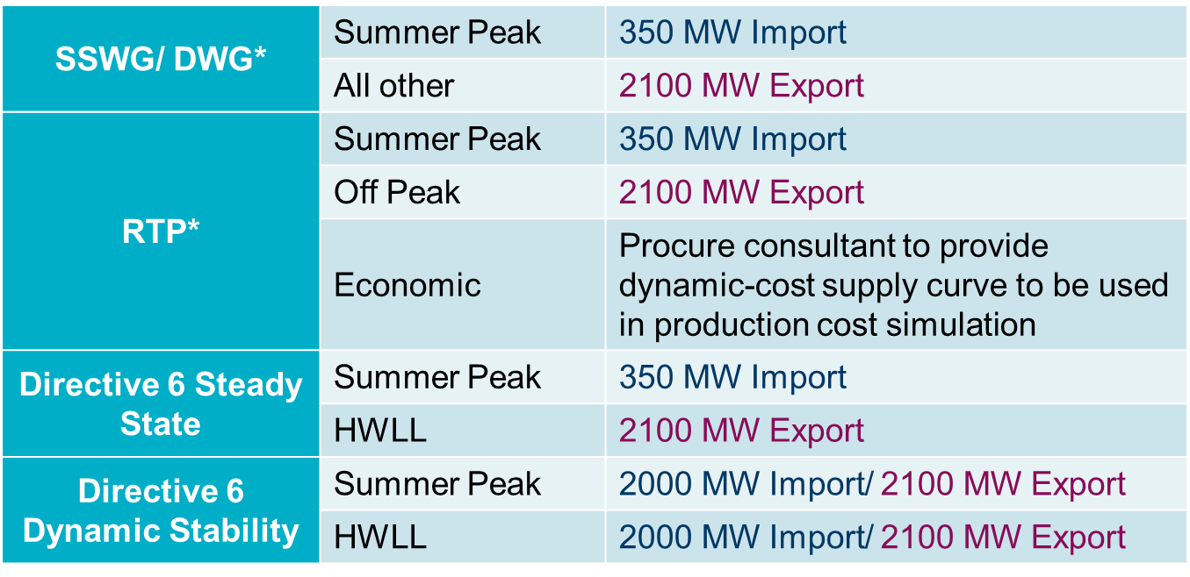
    - No changes to Protocol or Guide language are needed as SSWG and DWG can incorporate these assumptions as they deem appropriate and RPG can provide comments on the appropriateness of the assumptions in the RTP and Directive 6 study at the time the respective study scopes are discussed in that forum.

  - Q3- What criteria should be used for evaluating transmission system upgrades related to Southern Cross and other DC ties?
    - No criteria changes are needed at this time.
    - This may need to be revisited as part of the discussion of Directives 6 and 11.

  - Q4- When should Southern Cross be included in the Planning models?
    - Planning Guide Section 6.9 includes criteria for when new generation resources will be added to the Planning models. Currently, no such criteria exists for new DC ties.
    - New DC ties should be added to the Planning models when there is a high likelihood that they will be constructed. Planning Guide Section 6.9 provides an analogous criteria to use for DC ties. Specifically, when the developer of a new DC tie provides financial security and notice to proceed with construction of the interconnecting facilities to the interconnecting TSP, the DC tie should be added to the Planning models.
    - A PGRR will be required to add the requisite language to Planning Guide Section 6.
    - The PGRR should follow the development of NPRR857 in order to properly codify the responsible entities.

