 |  |  |  | System Planning
Monthly Status Report
May 2018

 |  | Report Highlights
- ERCOT is currently reviewing proposed transmission improvements with a total estimated cost of $883.5 Million.
- Transmission Projects endorsed in 2018 total $66 Million.
- All projects (in engineering, routing, licensing and construction) total approximately $7.21 Billion as of March 1, 2018.
- Transmission Projects energized in 2018 total about $220.8 Million as of March 1, 2018.

Regional Planning Group Project Reviews
- Garland Power & Light and Oncor have jointly submitted the North Garland Reliability Infrastructure Project (N-GRIP). This is a Tier 1 project that is estimated to cost $78 million. The ERCOT independent review for this project is currently placed on hold per the request of GPL.
- WETT has submitted the Bearkat Area Transmission Improvements project. This is a Tier 1 project that is estimated to cost $69.9 million. This project is currently under ERCOT Independent Review.
- Oncor has submitted the Far West Texas Dynamic Reactive Devices project. This is a Tier 1 project that is estimated to cost $86 million. ERCOT has completed the independent review and the project was recommended for BOD endorsement by TAC on May 24th. ERCOT will present the recommendation for BOD endorsement on June 12.
- AEPSC has submitted the LRGV Import Project. This is a Tier 1 project that is estimated to cost $73.4 million. AEPSC has also requested that ERCOT provide conditional endorsement for an additional $357.2 million project. This project is currently under ERCOT Independent Review.
- Oncor has submitted the Far West Texas Project 2. This is a Tier 1 project that is estimated to cost $194 million. ERCOT has completed the independent review and the project was recommended for BOD endorsement by TAC on May 24th. ERCOT will present the recommendation for BOD endorsement on June 12.
- Oncor has submitted the Grapevine Switching Station project. This is a Tier 2 project that is estimated to cost $25 million. This project is currently under ERCOT Independent Review.
- Oncor has submitted the Dallas TI – Schroeder Rd. 138 kV Upgrade project. This is a Tier 3 project that is estimated to cost $23 million. This project has completed the RPG review and ERCOT will prepare the acceptance letter.

More information on current and past RPG projects can be found on the ERCOT MIS Secure (digital certificate required): https://mis.ercot.com/pps/tibco/mis/Pages/Grid+Information/RegionalPlanning
Past email communication on RPG projects can be found on the ERCOT listserve by signing up for the REGPLANGROUP list: http://lists.ercot.com/scripts/wa-ERCOT.exe?A0=REGPLANGROUP

Planning Model Activities
The short term calendar of major planning model events is as follows:
- July 1, 2018 Post 18SSWG Base Cases and TPIT
- July 20, 2018 Post Contingency definitions and Planning Data Dictionary
The following table shows interconnection projects that met Planning Guide section 6.9(1) and 6.9(2) and were modeled in the SSWG cases as either complete or as a simple model in accordance with Planning Guide section 6.9. The 6.9(2) Deadline shown in red have received a notification that the 60 day deadline has past and the set of planning data has not been received.
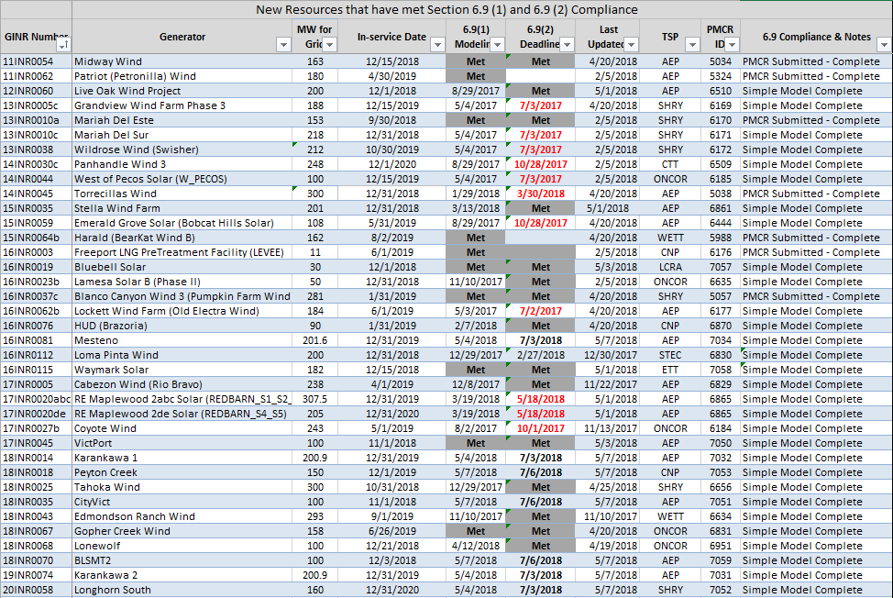

Permian Basin Oil Rig Count
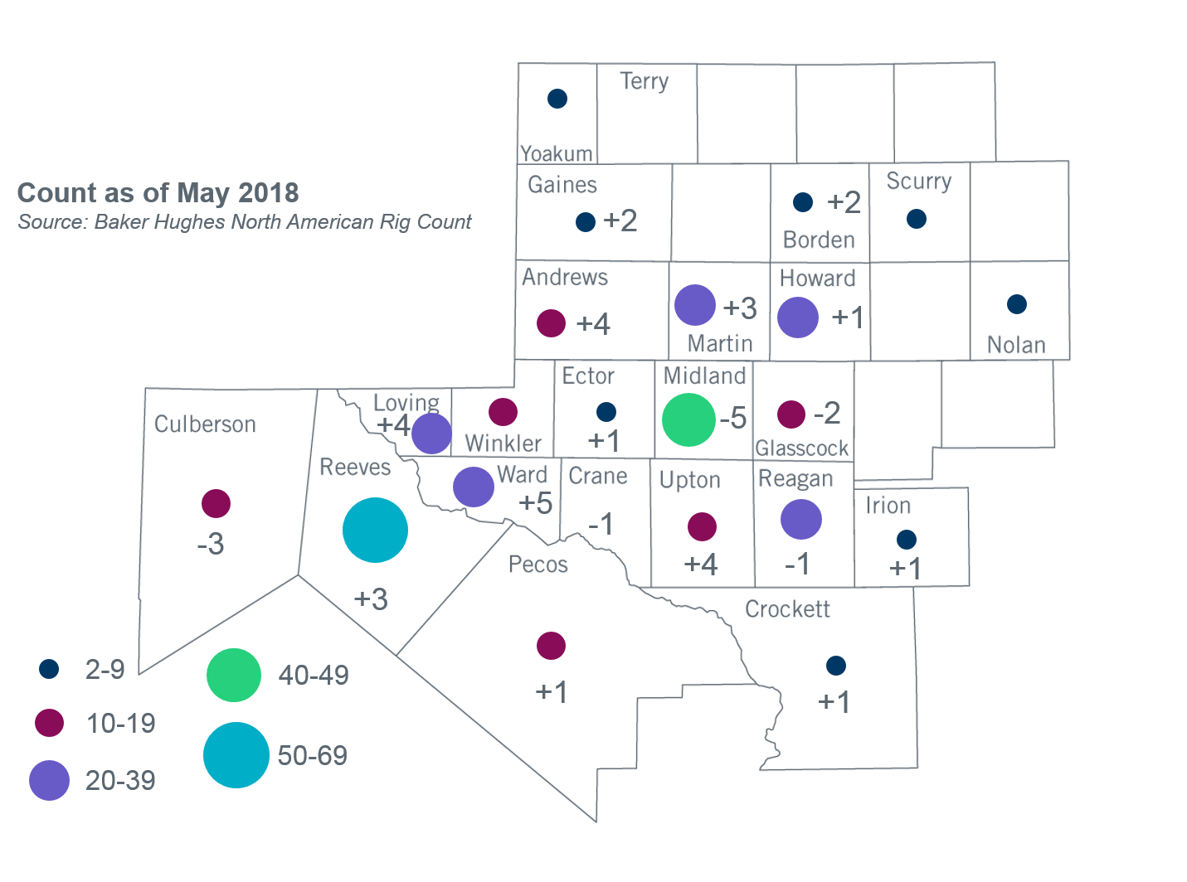
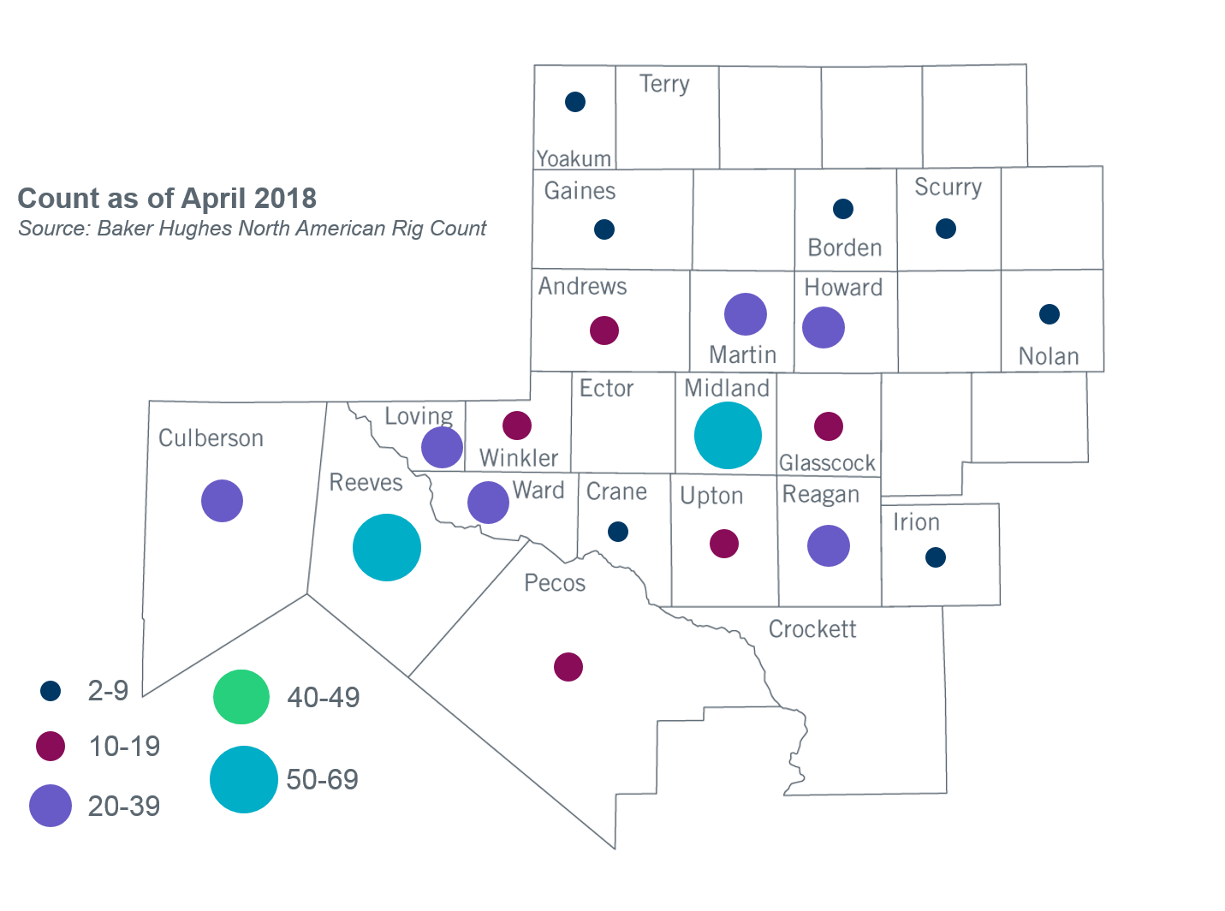

Other Notable Activities
- ERCOT continues to develop the 2018 Regional Transmission Plan (RTP) study. The initial start cases for all study regions except West/Far West and a list of criteria violations were shared with the RPG on May 4, 2018. The West/Far West weather zone load levels were finalized in May and ERCOT is in the process of creating the start cases based on the new load levels. ERCOT is also working on N-1 reliability analysis for North/North Central, South/South Central and Coast/East weather zones. At the May RPG meeting, ERCOT also presented the scope for the sensitivity analysis to be included in 2018 RTP study. Stakeholders are encouraged to review and provide feedback on the sensitivity study scope, initial start cases and violations.
- ERCOT continues to work on the 2018 Long-term System Assessment (LTSA). ERCOT presented findings from the initial generation expansion analysis for the three of the five scenarios at the April RPG meeting. ERCOT will continue working on generation expansion analysis for other scenarios and begin conducting the transmission expansion analysis for the Current Trends scenario.
- The SPWG completed the 2018 CY base cases and is working on the 2019-2023 FY cases.

+/- symbol indicates the increase or decrease from the previous month in oil rigs present in each county. There are 382 rigs, including a total increase of 20 oil rigs in the Permian Basin from April to May 2018.

