May 2018 ERCOT Monthly Operations Report
Reliability and Operations Subcommittee Meeting
July 12, 2018

Table of Contents
1. Report Highlights 2
2. Frequency Control 3
2.1. Frequency Events 3
2.2. Responsive Reserve Events 4
2.3. Load Resource Events 4
3. Reliability Unit Commitment 4
4. Wind Generation as a Percent of Load 6
5. COP Error Analysis 6
6. Congestion Analysis 8
6.1. Notable Constraints 8
6.2. Generic Transmission Constraint Congestion 13
6.3. Manual Overrides 13
6.4. Congestion Costs for Calendar Year 2018 13
7. System Events 13
7.1. ERCOT Peak Load 14
7.2. Load Shed Events 14
7.3. Stability Events 14
7.4. Notable PMU Events 15
7.5. DC Tie Curtailment 15
7.6. TRE/DOE Reportable Events 15
7.7. New/Updated Constraint Management Plans 15
7.8. New/Modified/Removed RAS 16
7.9. New Procedures/Forms/Operating Bulletins 16
8. Emergency Conditions 16
8.1. OCNs 16
8.2. Advisories 16
8.3. Watches 16
8.4. Emergency Notices 17
9. Application Performance 17
9.1. TSAT/VSAT Performance Issues 17
9.2. Communication Issues 17
9.3. Market System Issues 17
10. Model Updates 17
Appendix A: Real-Time Constraints 19

Report Highlights
- The unofficial ERCOT peak for May was 67,236 MW.
- There were three frequency events in May. PMU data indicates the ERCOT system transitioned well in each case.
- There were two instances where Responsive Reserves were deployed.
- There were twenty-one RUC commitments in May due to congestion and voltage support. Congestion in May was concentrated in the North, South, and West Load Zones. Congestion in the North can be mostly attributed to high Panhandle and West wind generation and multiple planned and forced outages. Congestion in South was due primarily to multiple planned and forced outages. Congestion in the West was due to high West solar generation, multiple planned and forced outages, and high load. There were 27 days on the Panhandle GTC and 4 days on the Valley Import GTC in May. There was no activity on the remaining GTCs during the month.
- There were six DC Tie curtailments in May. Four were due to forced DC Tie outages, one was due to the Rio Grande Valley Import limit, and another was due to high temperatures.

Frequency Control

Frequency Events
The ERCOT Interconnection experienced three frequency events in May, all of which resulted from Resource trips. The average event duration was approximately 0:06:19.

A summary of the frequency events is provided below. The reported frequency events meet one of the following criteria: Delta Frequency is 60 mHz or greater; the MW loss is 350 MW or greater; resource trip event triggered RRS deployment. Frequency events that have been identified as Frequency Measurable Events (FME) for purposes of BAL-001-TRE-1 analysis are highlighted in blue. When analyzing frequency events, ERCOT evaluates PMU data according to industry standards. Events with an oscillating frequency of less than 1 Hz are considered to be inter-area, while higher frequencies indicate local events. Industry standards specify that damping ratio for inter-area oscillations should be 3.0% or greater. For the frequency events listed below, the ERCOT system met these standards and transitioned well after each disturbance.

Date and Time | Delta Frequency | Max/Min Frequency | Duration of Event | PMU Data |  |  | MW Loss | Load | Wind | Inertia
 | (Hz) | (Hz) |  | Oscillation Mode (Hz) |  | Damping Ratio |  | (MW) | % | (GW-s)
5/5/2018 16:19 | 0.133 | 59.874 | 0:07:52 | 0.67 | 22% |  | 536 | 44,826 | 2% | 270,739
5/21/2018 8:06 | 0.110 | 59.887 | 0:05:53 | 0.74 | 4% |  | 460 | 36,389 | 32% | 190,214
5/23/2018 18:42 | 0.071 | 59.932 | 0:05:11 | No PMU Report Created |  |  | 393 | 34,363 | 13% | 216,030

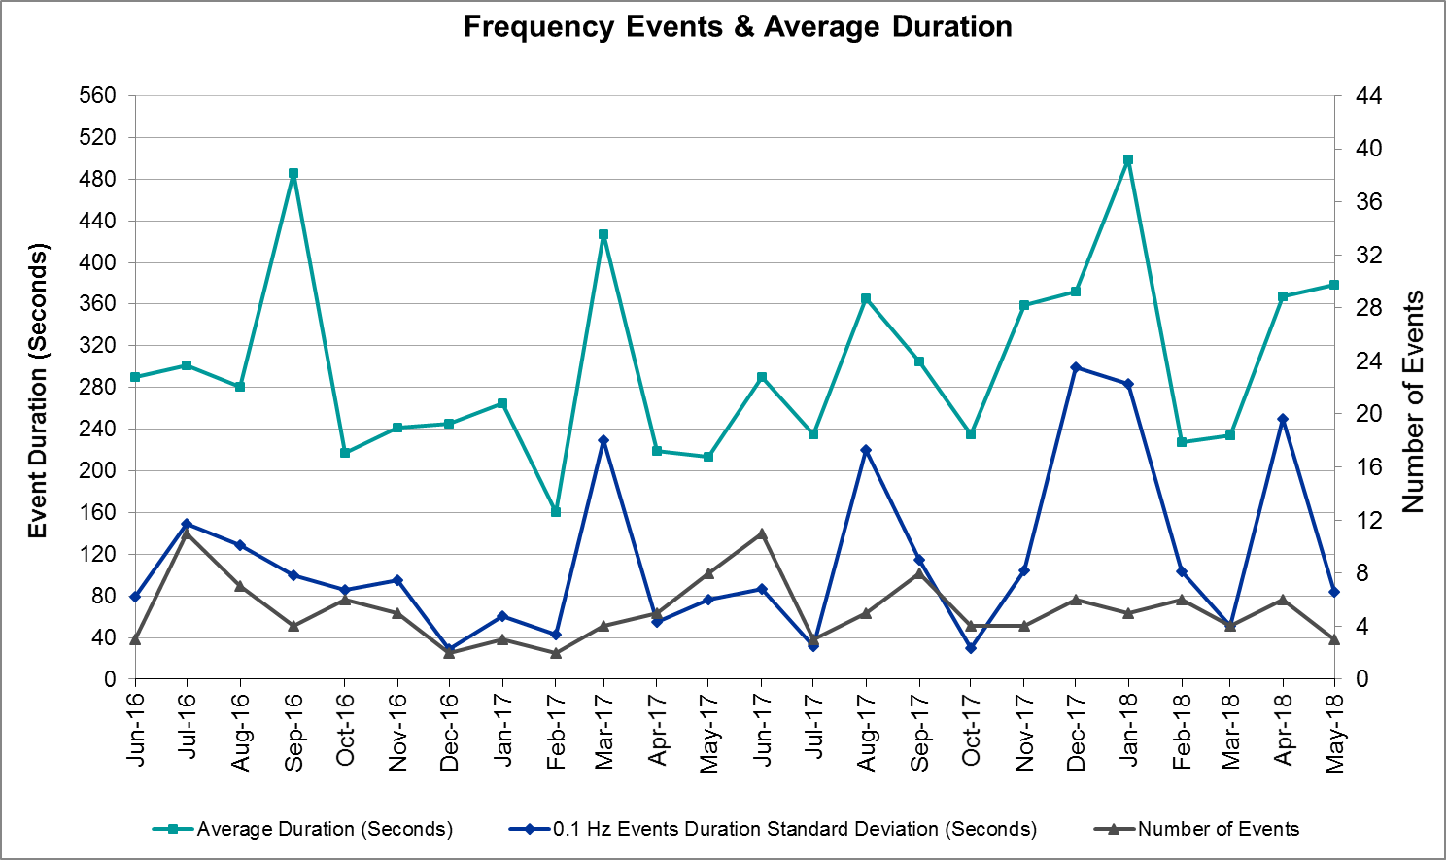
(Note: All data on this graph encompasses frequency event analysis based on BAL-001-TRE-1.)

Responsive Reserve Events
There were two events where Responsive Reserve MWs were released to SCED in May. The events highlighted in blue were related to frequency events reported in Section 2.1 above.

Date and Time Released to SCED | Date and Time Recalled | Duration of Event | Maximum MWs Released
5/5/2018 16:19 | 5/5/2018 16:23 | 0:04:00 | 534
5/21/2018 8:06 | 5/21/2018 8:10 | 0:03:28 | 254

Load Resource Events
None.

Reliability Unit Commitment
ERCOT reports on Reliability Unit Commitments (RUC) on a monthly basis. Commitments are reported grouped by operating day and weather zone. The total number of hours committed is the sum of the hours for all the units in the specified region. Additional information on RUC commitments can be found on the MIS secure site at Grid Generation Reliability Unit Commitment.

There were no DRUC commitments in May.

There were twenty-one HRUC commitment in May.

Resource Location | # of Resources | Operating Day | Total # of Hours Committed | Total MWhs | Reason for Commitment
Far West | 1 | 5/2/2018 | 2 | 132 | Voltage Support
Far West | 1 | 5/3/2018 | 1 | 67 | Voltage Support
Far West | 2 | 5/5/2018 | 23 | 1,579 | Congestion
Southern | 2 | 5/5/2018 | 6 | 1,339 | Congestion
Southern | 1 | 5/6/2018 | 4 | 1,258 | Congestion
Far West | 2 | 5/6/2018 | 34 | 2,323 | Congestion
Far West | 2 | 5/7/2018 | 26 | 1,729 | Congestion
Far West | 2 | 5/8/2018 | 28 | 1,838 | Congestion
North Central | 1 | 5/8/2018 | 8 | 976 | Congestion
Far West | 2 | 5/9/2018 | 32 | 2,095 | Congestion
Far West | 2 | 5/10/2018 | 34 | 2,248 | Congestion
Far West | 2 | 5/11/2018 | 36 | 2,418 | Congestion
Far West | 3 | 5/12/2018 | 37 | 2,457 | Congestion
Far West | 2 | 5/13/2018 | 32 | 2,128 | Congestion
Far West | 3 | 5/14/2018 | 27 | 1,791 | Congestion
Far West | 2 | 5/15/2018 | 24 | 1,588 | Congestion, Voltage Support
South Central | 1 | 5/15/2018 | 5 | 1,625 | Capacity
North Central | 1 | 5/15/2018 | 5 | 1,950 | Capacity
North Central | 1 | 5/17/2018 | 1 | 523 | Congestion
Coast | 2 | 5/19/2018 | 8 | 1,025 | Congestion
Southern | 1 | 5/28/2018 | 4 | 143 | Valley Import

Wind Generation as a Percent of Load
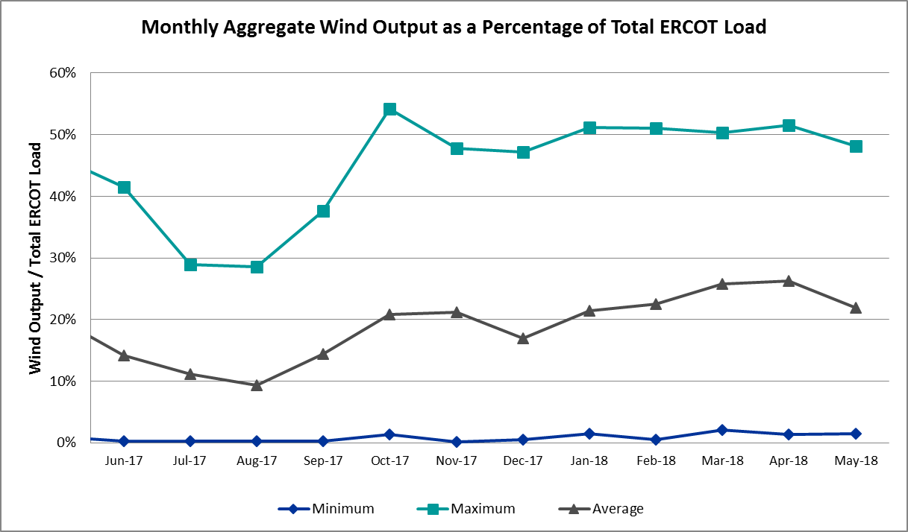

COP Error Analysis
COP Error is calculated as the capacity difference between the COP HSL and real-time HSL of the unit. Mean Absolute Error (MAE) stayed high, mostly over 10,000 MW, until Day-Ahead at 12:00, then dropped significantly to 1,856 MW by Day-Ahead at 14:00. In the following chart, Under-Scheduling Error indicates that COP had less generation capacity than real-time and Over-Scheduling Error indicates that COP had more generation capacity than real-time. Under-Scheduling persisted from beginning of Day-Ahead to end of the Operating Day. Snapshot on the Operating Day considers all Operating Hours, including past hours. However, COP error for the Operating Hour freezes after the Adjustment Period.
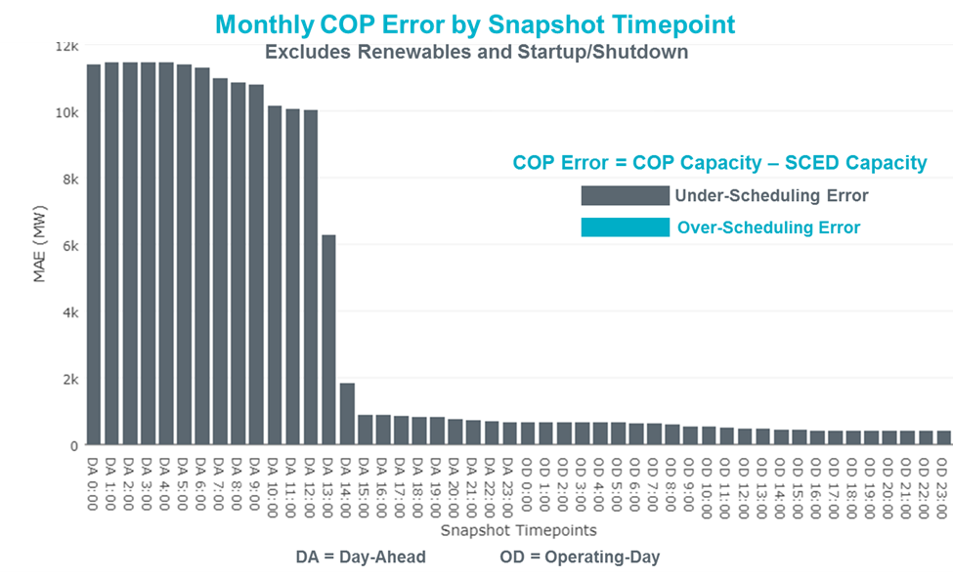

Monthly MAE for the Latest COP at the end of the Adjustment Period was 407 MW with median ranging from -624 MW for Hour-Ending (HE) 12 to 163.6 MW for HE 20. May 11th HE 24 had the largest Over-Scheduling Error (7,556 MW) and May 2nd HE 24 had the largest Under-Scheduling Error (-1,875 MW).
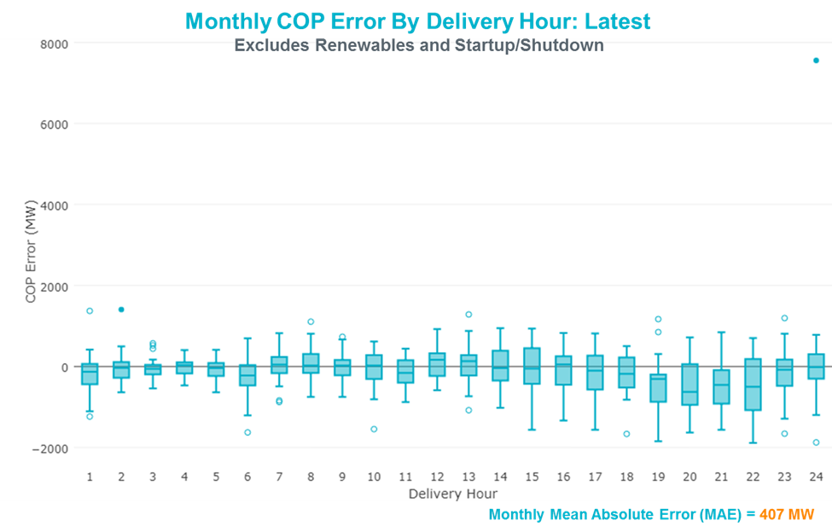

Monthly MAE for the Day-Ahead COP at 12:00 was 10,0031 MW with median ranging from -15,604 MW for Hour-Ending (HE) 16 to -6,728 MW for HE 24. May 11th HE 24 had the largest Over-Scheduling Error (5,319 MW) and May 29th HE 29 had the largest Under-Scheduling Error (-20,645 MW).

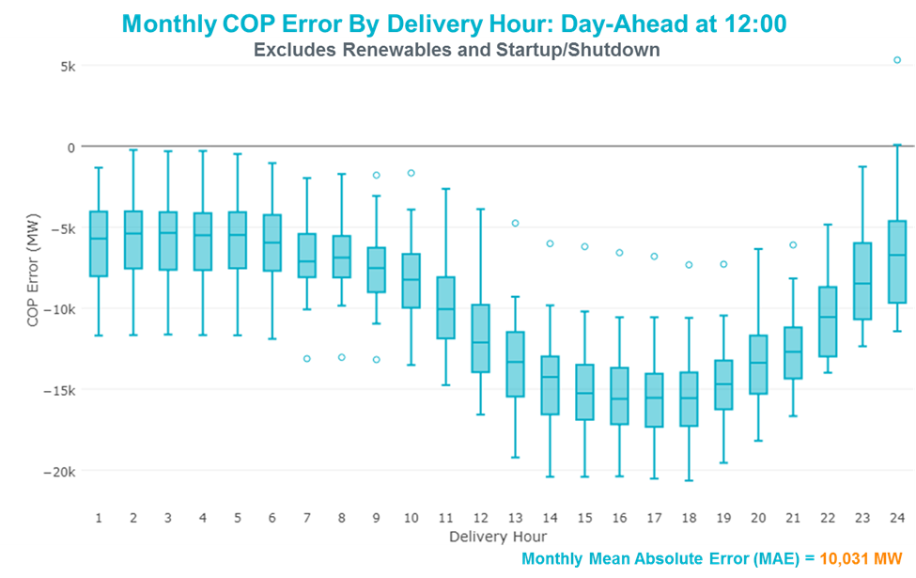

Congestion Analysis
The total number of congestion events experienced by the ERCOT system increased in May. There were 31 instances over 28 days on the Generic Transmission Constraints (GTCs) in May.

Notable Constraints
Nodal protocol section 3.20 specifies that ERCOT shall identify transmission constraints that are active or binding three or more times within a calendar month. As part of this process, ERCOT reports congestion that meets this criterion to ROS. In addition ERCOT also highlights notable constraints that have an estimated congestion rent exceeding $1,000,000 for a calendar month. These constraints are detailed in the table below. Rows highlighted in blue indicate the congestion was affected by one or more outages. For a list of all constraints activated in SCED for the month of May, please see Appendix A at the end of this report.

Contingency Name | Overloaded Element | # of Days Constraint Active | Congestion Rent | Transmission Project
Re Roserock Solar Plant to L | Yucca Drive Switch - Gas Pad 138kV | 29 | $57,461,100.46 | Yucca Drive-Barilla Junction (4549)
Jones Street Tnp to Lewisvil | Ti Tnp - West Tnp 138kV | 10 | $24,030,970.69
WOLF SWITCHING STATION to Monahans | General Tire Switch - Southwestern Portland Tap 138kV | 11 | $13,861,719.91
MOSS SWITCH to YUCCA DRIVE SWITCH | General Tire Switch - Southwestern Portland Tap 138kV | 12 | $11,535,045.00
CRLNW-LWSSW 345kV | Carrollton Northwest - Lakepointe Tnp 138kV | 14 | $8,358,317.89 | Oncor_NW Carrollton - LakePointe (5488)
EMSES-SAGNA 138kV | Blue Mound - Wagley Robertson 138kV | 5 | $7,249,107.96 | Wagley Robertson (2076) - Blue Mound (2071) 138-kV line upgrade (2017RTP NC10)
CRLNW-LWSSW 345kV | Lewisville Switch - Jones Street Tnp 138kV | 12 | $7,157,268.62
Elmcreek-Sanmigl 345kV | Pawnee Switching Station - Calaveras 345kV | 2 | $6,337,620.25
Navarro - WTRML 345KV | Britton Road - Venus Switch 345kV | 5 | $6,108,530.85 | Venus - Webb/Cedar Hill Sw. Sta. 345 kV DCKT Line (5492)
CAGNON to KENDALL LIN 1 | Comfort - Kendall 138kV | 13 | $5,481,975.51
Cby-Bt & Str 138kv | Texas - Cedar Bayou 138kV | 15 | $5,294,166.73 | Baytown Area Upgrades (6585F)
CLEARFORK to TELEPHONE ROAD - Shar | General Tire Switch - Southwestern Portland Tap 138kV | 8 | $5,292,350.54
DMTSW-SCOSW 345KV | Knapp - Scurry Chevron 138kV | 23 | $4,615,999.29
MOSS SWITCH to YUCCA DRIVE SWITCH | Pig Creek - Solstice 138kV | 11 | $3,816,642.29 | Solstice to Permian Basin: Rebuild 138 kV line
Menard Phillips to Hornet (4 | Yellow Jacket - Hext Lcra 69kV | 5 | $3,560,793.39
Basecase | 2630_CBRATING_1 GTC | 2 | $3,366,739.66
CLEARFORK to TELEPHONE ROAD - Shar | Pig Creek - Solstice 138kV | 7 | $3,347,720.12 | Solstice to Permian Basin: Rebuild 138 kV line
Cby-Qnm & Rng 138kv | Diamond Battleground - Moment 138kV | 2 | $3,230,761.79 | Baytown Area Upgrades (6585E)
NORTH PHARR to POLK AVENUE LIN 1 | North Mcallen - West Mcallen 138kV | 4 | $3,165,620.58 | North McAllen (8368) - West McAllen (8367) - South McAllen (8371) 138-kV line upgrades (2017 RTP S9)
Mcses-Cdhsw 138kV | Sargent Road - Saint Augustine Tap 2 138kV | 2 | $3,152,428.94 | Sargent Road (2941,2947,2940) - St Augustine (2951) - Southerland (2973) 138-kV line upgrades (2017 RTP NC20)
Basecase | PNHNDL GTC | 27 | $2,770,262.00 | LP&L Option 4ow & Panhandle Loop (5180, 5208)
Riohondo-Nedin 345kV&Harlnsw 138kV | Burns Sub - Rio Hondo 138kV | 10 | $2,739,367.06
Basecase | VALIMP GTC | 4 | $2,625,432.41 | La Palma Dynamic Reactive (5588) and Pharr Dynamic Reactive (5596)
WOODWARD 1 TAP to WOODWARD 1 LIN 1 | 16th Street Tnp - Woodward 2 138kV | 18 | $2,015,814.68 | Far West Texas Project
Coleto Creek to Lon Hill 345 | Warburton Road Switching Station - Victoria 138kV | 3 | $1,980,907.47
Farmersville Switch to ROYSE SWITC | Royse Switch - Farmersville Switch 345kV | 9 | $1,650,067.00 | Royse Sw. Sta. - Farmersville Sw. Sta. 345 kV DCKT Line (6291)
Cagnon-Kendal 345 & Cico-Com | Raymond F Barker - Comfort 138kV | 11 | $1,634,569.51
MOSS SWITCH to YUCCA DRIVE SWITCH | No Trees Switch - Cheyenne Tap 138kV | 11 | $1,583,196.51
Basecase | Omega - Horse Hollow Generation Tie 345kV | 18 | $1,429,932.06
Cagnon-Kendal 345 &Cico-Meng | Turtle Creek - Verde Creek 138kV | 5 | $1,332,142.77
TWR (138) QAB-SRB06 & DOL-SRB84 | Angleton - Liverpool 138kV | 1 | $1,219,865.40
PINEY CREEK to PLUM LIN 1 | Fayetteville - Frelsburg 138kV | 3 | $1,191,237.62 | Fayette Area Upgrades (5286A)
CAGNON to KENDALL LIN 1 | Cico - Comfort 138kV | 18 | $1,159,276.15
Fredericksburg to Gillespie | Gillespie 138/69kV | 4 | $1,145,053.99 | Mountain Home Substation and Transmission Line Addition (5849C)
NORTH McCAMEY to ODESSA EHV SWITCH | Pig Creek - Solstice 138kV | 10 | $1,124,815.88 | Solstice to Permian Basin: Rebuild 138 kV line
Basecase | Solstice - Linterna 138kV | 23 | $1,085,479.77 | Solstice to Permian Basin: Rebuild 138 kV line
MOSS SWITCH to YUCCA DRIVE SWITCH | Andrews County South - Amoco Three Bar Tap 138kV | 10 | $1,007,185.67 | Holt - North Andrews 138 kV Line (Amoco) (5426)
NORTH EDINBURG TRX 1382 345/138 | North Edinburg 345/1kV | 6 | $993,587.93
Bronco to ALPINE LIN 1 | Solstice - Linterna 138kV | 19 | $944,284.70 | Solstice to Permian Basin: Rebuild 138 kV line
Calavers-Kirby&Beck_Rd 138kV | Braunig - Highland 138kV | 4 | $914,509.77
HCKSW-ALLNC&RNKSW 345kV | Blue Mound - Wagley Robertson 138kV | 3 | $844,992.14 | Wagley Robertson (2076) - Blue Mound (2071) 138-kV line upgrade (2017RTP NC10)
JARDIN to DILLEY SWITCH AEP LIN 1 | Dilley Switch Aep - Cotulla Sub 69kV | 6 | $573,999.65
Basecase | Pig Creek - Solstice 138kV | 16 | $541,040.81 | Solstice to Permian Basin: Rebuild 138 kV line
Wirtz-Burnet&Starck 138kV | Lakeway - Marshall Ford 138kV | 6 | $517,983.37
ASHERTON to Bevo Substation LIN 1 | Turtle Creek Switching Station - West Crystal City Sub 69kV | 5 | $517,669.32
Fppyd1-Salem & Fayett 345kV | Austrop - Sim Gideon 138kV | 5 | $510,715.61 | Fayette Area Upgrades (5286A)
Comfort to Kendall 138 KV | Kerrville Stadium - Kendall 138kV | 4 | $470,812.51
Re Roserock Solar Plant to L | No Trees Switch - Cheyenne Tap 138kV | 4 | $463,470.14
Calavers-Hotwells&Laredo1 13 | Calaveras - Streich 138kV | 6 | $452,414.94
WEST LEVEE TO 800/900 NWK 138KV | Sargent Road - Oakland Tap 138kV | 6 | $389,148.06 | Sargent Road-East Network 138 kV Line (6790)
FAYETTEVILLE to NEW BREMEN LIN 1 | Chappel Hill - Waller 138kV | 4 | $351,613.14
Wett_Bearkat to Wett_Sand_Bl | Eiland - Polecat Creek Switch 138kV | 6 | $347,070.24
Calavers-Kirby&Beck_Rd 138kV | Braunig - Calaveras 138kV | 4 | $312,937.16
Devils River to Fermi Substa | Hamilton Road - Maverick 138kV | 4 | $295,855.52 | Brackettville to Escondido (5206)
LAQUINTA to LOBO LIN 1 | Bruni Sub 138/69kV | 9 | $268,196.51
MERCERS GAP SW to COMANCHE SWITCH | Downing - Rising Star 69kV | 3 | $264,482.14
Asphalt Mines to Blewett (3) | Hamilton Road - Maverick 138kV | 8 | $246,060.30 | Brackettville to Escondido (5206)
Rns-Rtw & Sng-Tb 345kv | Th Wharton - Zenith 345kV | 3 | $235,441.95 | Houston Import Project (4458)
Victoria-V_Dupsw 138kV | Greenlake - Weaver Road 69kV | 4 | $218,632.99
Wett_Bearkat to Wett_Sand_Bl | Carterville - Einstein 138kV | 5 | $211,822.67
COLETO CREEK to VICTORIA LIN 1 | Coleto Creek - Victoria 138kV | 6 | $206,931.35
Re Roserock Solar Plant to L | General Tire Switch - Southwestern Portland Tap 138kV | 4 | $176,465.45
Bronco to ALPINE LIN 1 | Fort Stockton Plant - Linterna 138kV | 7 | $112,815.50 | Far West Texas Project
Basecase | Burns Sub - Rio Hondo 138kV | 6 | $99,418.95
KLEBERG AEP to LOYOLA SUB LIN 1 | Loyola Sub 138/69kV | 5 | $83,115.24 | AEP_Angstrom (15TPIT0069)
Bighil-Kendal 345kV | Hamilton Road - Maverick 138kV | 3 | $82,376.58 | Brackettville to Escondido (5206)
Braunig-Coliseum&Highland 13 | Kirby - St_Hedwg 138kV | 3 | $72,176.90
Basecase | Fort Stockton Plant - Linterna 138kV | 6 | $61,990.88 | Far West Texas Project
AIRLINE AEP to HOLLY LIN 1 | Airline Aep - Cabaniss 138kV | 5 | $54,444.04
Scotland to Scotland (Oncor) | Navy Kickapoo Switch 138/69kV | 13 | $52,357.62
Lobo to San Miguel 345_138 K | Asherton - Catarina 138kV | 4 | $34,344.28
Scotland to Scotland (Oncor) | Anarene - Navy Kickapoo Switch 69kV | 14 | $34,185.65
Fergus-Corona & Granmo 138kV | Starcke - Wirtz 138kV | 7 | $30,742.50
MERCERS GAP SW to COMANCHE SWITCH | Holder 138/69kV | 3 | $26,050.62
Basecase | Randado Aep - Zapata 138kV | 15 | $22,790.90
Cottonwood Road Switch to Lo | Bowie 138/69kV | 5 | $22,646.72
WOLF SWITCHING STATION to ECTOR HA | Andrews County South - Amoco Three Bar Tap 138kV | 3 | $15,293.18 | Holt - North Andrews 138 kV Line (Amoco) (5426)
FLAT TOP TNP to Pig Creek LIN 2 | Pig Creek - Musquiz 138kV | 4 | $11,943.66 | Solstice to Permian Basin: Rebuild 138 kV line
WOODWARD 1 TAP to WOODWARD 1 LIN 1 | Woodward 2 - Rio Pecos 138kV | 3 | $9,514.28 | Far West Texas Project
Calavers-Kirby&Beck_Rd 138kV | Eagleck - Elmendrf 138kV | 3 | $3,379.33

Generic Transmission Constraint Congestion
There were 27 days on the Panhandle GTC and 4 days on the Valley Import GTC in May. There was no activity on the remaining GTCs during the month.

Note: This is how many times a constraint has been activated to avoid exceeding a GTC limit, it does not imply an exceedance of the GTC occurred or that the GTC was binding.

Manual Overrides
None.

Congestion Costs for Calendar Year 2018
The following table represents the top twenty active constraints for the calendar year based on the estimated congestion rent attributed to the congestion. ERCOT updates this list on a monthly basis.

Contingency | Binding Element | # of 5-min SCED Intervals | Estimated Congestion Rent | Transmission Project
Basecase | PNHNDL GTC | 21,650 | 96,042,798.81 | LP&L Option 4ow & Panhandle Loop (5180, 5208)
Re Roserock Solar Plant to F | Yucca Drive Switch - Gas Pad 138kV | 7,766 | 81,234,850.64 | Solstice to Permian Basin: Rebuild 138 kV line
CRLNW-LWSSW 345kV | Carrollton Northwest - Lakepointe Tnp 138kV | 12,902 | 60,173,108.72 | Oncor_NW Carrollton - LakePointe (5488)
Jones Street Tnp to Lewisvil | Ti Tnp - West Tnp 138kV | 3,103 | 35,839,701.17
NORTH EDINBURG TRX 1382 345/138 | North Edinburg 345/1kV | 970 | 29,825,995.32
Basecase | VALIMP GTC | 600 | 19,938,471.66 | La Palma Dynamic Reactive (5588) and Pharr Dynamic Reactive (5596)
Castrvll-Razorbac&Txresrch 1 | Hondo Creek Switching Station - Moore Switching Station 138kV | 605 | 15,342,875.43
Elmcreek-Sanmigl 345kV | Pawnee Switching Station - Calaveras 345kV | 2,108 | 14,407,954.05
WOLF SWITCHING STATION to Monahans | General Tire Switch - Southwestern Portland Tap 138kV | 2,311 | 13,867,453.72
MOSS SWITCH to YUCCA DRIVE SWITCH | General Tire Switch - Southwestern Portland Tap 138kV | 2,344 | 11,535,045.00
LON HILL TRX LON_HILL_3_2 345/138 | Lon Hill 345/1kV | 1,587 | 11,412,928.00 | Lon Hill: Replace 345/138 kV autotransformers (6106)
Jewet-Sng 345kV | Btu_Jack_Creek - Twin Oak Switch 345kV | 5,059 | 10,516,882.77 | Houston Import Project (4458)
NORTH PHARR to POLK AVENUE LIN 1 | North Mcallen - West Mcallen 138kV | 480 | 8,982,492.38 | North McAllen (8368) - West McAllen (8367) - South McAllen (8371) 138-kV line upgrades (2017 RTP S9)
WOODWARD 1 TAP to WOODWARD 1 LIN 1 | 16th Street Tnp - Woodward 2 138kV | 1,368 | 8,910,326.32 | Far West Texas Project
EMSES-SAGNA 138kV | Blue Mound - Wagley Robertson 138kV | 841 | 8,254,677.92 | Wagley Robertson (2076) - Blue Mound (2071) 138-kV line upgrade (2017RTP NC10)
DMTSW-SCOSW 345KV | Knapp - Scurry Chevron 138kV | 4,986 | 8,227,563.35
CRLNW-LWSSW 345kV | Lewisville Switch - Jones Street Tnp 138kV | 1,137 | 7,157,268.62
Re Roserock Solar Plant to F | Barrilla - Fort Stockton Switch 69kV | 6,212 | 6,583,397.98 | Far West Texas Project
Sn-Str26 & Bfp-Vl82 | Hofman - Basf 138kV | 297 | 6,510,985.38
Wink Sub to YUCCA DRIVE SWITCH LIN | Andrews County South - Amoco Three Bar Tap 138kV | 829 | 6,248,536.19 | Holt - North Andrews 138 kV Line (Amoco) (5426)

System Events

ERCOT Peak Load
The unofficial ERCOT peak load for the month was 67,236 MW and occurred on May 19th, during hour ending 17:00.

Load Shed Events
None.

Stability Events
None.

Notable PMU Events
ERCOT analyzes PMU data for any significant system disturbances that do not fall into the Frequency Events category reported in section 2.1. The results are summarized in this section once the analysis has been completed.

Date | Duration of Oscillation | Dominant Oscillation Mode | Oscillation Signals | Max Peak to Peak Oscillation
5/6/2018 –  5/7/2018 | 1 Hour 20 Min | 0.1 Hz | Current Magnitude,  Real Power | ~20 Amps,  ~15 MW
5/14/2018 | Intermittent over 1 Hour period | 3.8 Hz | Voltage Magnitude,  Current Magnitude,  Reactive Power | ~6.0 kV,  ~50 Amps  ~60 MVArs

DC Tie Curtailment
Date | DC Tie | Curtailing Period | # of Tags Curtailed | Initiating Event | Curtailment Reason
5/13/2018 | DC-L | 0500-2000 | 3 | Station Failure | DC Tie forced outage
5/14/2018 | DC-R | 1200 | 2 | Railroad DC Tie limited to 105MW | Transmission Outages in the Eastern Rio Grande Valley impacting delivery of power to the DC Tie. Outage was restored and DC Tie was released to operate to its previous operational limit
5/21/2018 | DC-L | 0200-0300 | 3 | DC Tie forced outage | DC Tie locked out
5/29/2018 | DC-S | 1900-2100 | 2 | DC Tie forced outage | DC Tie forced outage due to cooling issues
5/30/2018 | DC-S | 1900-2400 | 4 | DC Tie forced outage | DC Tie forced outage due to cooling issues
5/30/2018 | DC-L | 2000- 5/31/18 2400 | 2 | DC Tie de-rated to 90MW | Overheated equipment on the DC Tie

TRE/DOE Reportable Events
- AEP submitted an EOP-004 report on MayH 18, 2018 Reportable Event Type: Transmission loss.
- CenterPoint submitted an OE-417 report on May 27, 2018 Reportable Event Type: Loss of electric service to more than 50,000 customers for 1 hour or more

New/Updated Constraint Management Plans
- MP_2018_01 was created

New/Modified/Removed RAS
None.

New Procedures/Forms/Operating Bulletins
Procedure Title | POB
DC Tie Desk | 847
Reliability Risk Desk | 848
Reliability Unit Commitment Desk | 849
Scripts Desk | 844
Shift Supervisor Desk | 850
Transmission and Security Desk | 851
Real Time Desk | 840
Resource Desk | 843
Communications Protocols | 852

Emergency Conditions

OCNs
Date and Time | Description
5/14/2018 10:00 | ERCOT issued an OCN for extreme hot weather with forecasted temp above 94 degrees in the North Central and South Central Weather Zones from 05/17/20018-05/18/2018.
5/15/2018 08:50 | ERCOT issued an OCN for Projected Capacity Reserve Shortage for HE 14-18
5/23/2018 09:00 | ERCOT issued an OCN for extreme hot weather with forecasted temperatures above 94 degrees in the ERCOT Region from 05/25/20018-05/31/2018.

Advisories
None.

Watches
Date and Time | Description
5/05/2018 17:30 | ERCOT issued a Watch due to the post-contingency overload of DELMTEX5, loss of double circuit STP – Elm Creek 345 kV line overloads the Blessing - Palacios 69 kV line.
5/09/2018 16:10 | ERCOT issued a Watch for the League City, Texas City area due to multiple forced outages in the area.
5/13/2018 04:25 | ERCOT issued a Watch for the loss of the Laredo DC-Tie and curtailment of DC-Tie exports to CENACE.
5/14/2018 10:45 | ERCOT issued a Watch due to the post-contingency overload of SPOLPHA8, loss of Polk Avenue – North Pharr 138 kV overloads North McAllen – West McAllen 138 kV and curtailment of DC-Tie exports to CENACE.
5/17/2018 16:14 | ERCOT issued a Watch due to the post-contingency overload of SPHMMAS9, loss of Mason AEP - Mason Switching Station 69kV line overloads Fredericksburg Phillips Tap - Gillespie 69kV line.
5/21/2018 01:15 | ERCOT issued a Watch due to the loss of the Laredo DC-Tie and curtailment of DC-Tie exports to CENACE.
5/29/2018 17:45 | ERCOT issued a Watch due to the loss of the Eagle Pass DC-Tie and curtailment of DC-Tie exports to CENACE.
5/30/2018 17:45 | ERCOT issued a Watch due to the loss of the Eagle Pass DC-Tie and curtailment of DC-Tie exports to CENACE.
5/30/2018 18:50 | ERCOT issued a Watch due to de-rate of the Laredo DC Tie and curtailment of DC-Tie exports to CENACE.

Emergency Notices
None.

Application Performance

TSAT/VSAT Performance Issues
None.

Communication Issues
None.

Market System Issues
None.

Model Updates
The Downstream Production Change (DPC) process allows ERCOT to make changes in the on-line Network Operations Model without loading a completely new model. The purpose of this process is to allow for reliable grid operations as system conditions change between designated Network Operations Model database loads. The DPC process is limited in scope to just those items listed below, with equipment ratings updates being the most common. ERCOT has seen a rise in the use of the DPC process to make on-line updates to the Network Operations Model in recent years, instead of through the standard Network Operations Model Change Request process.

- Static Line ratings (Interim Update)
- Dynamic Line ratings (non-Interim Update)
- Autotransformer ratings (non-Interim Update)
- Breaker and Switch Normal status (Interim Update)
- Contingency Definitions (Interim Update)
- RAP and RAS changes or additions (Interim Update)
- Net Dependable and Reactive Capability (NDCRC) values (Interim Update)
- Impedance Updates (non-Interim)

Transmission Operator | Number of DPCs in May
AEP TEXAS COMPANY (TDSP) | 8
CENTERPOINT ENERGY HOUSTON ELECTRIC LLC (TDSP) | 5
CPS ENERGY (TDSP) | 0
DENTON MUNICIPAL ELECTRIC (TDSP) | 1
ERCOT | 24
LCRA TRANSMISSION SERVICES CORPORATION (TDSP) | 3
ONCOR ELECTRIC DELIVERY COMPANY LLC (TDSP) | 20
SOUTH TEXAS ELECTRIC CO OP INC (TDSP) | 1
TEXAS-NEW MEXICO POWER CO (TDSP) | 1

Appendix A: Real-Time Constraints
The following is a complete list of constraints activated in SCED for the month of May. Full contingency descriptions can be found in the Standard Contingencies List located on the MIS secure site at Grid Generation Reliability Unit Commitment.

Contingency | Constrained Element | From Station | To Station | # of Days Constraint Active
SWCSBOO8 | 6332__A | YUCSW | GASPAD | 29
BASE CASE | PNHNDL | n/a | n/a | 27
DMTSCOS5 | 6437__F | SCRCV | KNAPP | 23
BASE CASE | LINTER_SOLSTI1_1 | LINTERNA | SOLSTICE | 23
SBROALP9 | LINTER_SOLSTI1_1 | LINTERNA | SOLSTICE | 19
SWOORI38 | 16TH_WRD2_1 | WOODWRD2 | 16TH_ST | 18
BASE CASE | HHGTOM_1 | HHGT | OMEGA | 18
SCAGKEN5 | 74T148_1 | COMFOR | CICO | 18
BASE CASE | PIGCRE_SOLSTI1_1 | SOLSTICE | PIGCREEK | 16
DCBYRNG8 | CD_TX_87_A | CD | TX | 15
BASE CASE | RANDAD_ZAPATA1_1 | RANDADO | ZAPATA | 15
DCRLLSW5 | 591__A | LKPNT | CRLNW | 14
SSCLWF28 | 6840__B | NVKSW | ANARN | 14
SSCLWF28 | 6840__B | ANARN | NVKSW | 14
SCAGKEN5 | 75T243_1 | KENDAL | COMFOR | 13
SSCLWF28 | NVKSW_FMR1 | NVKSW | NVKSW | 13
SMOSYUC8 | 6345__B | GNTSW | SPRTP | 12
DCRLLSW5 | 590__A | LWSSW | LWVJS | 12
DCAGCO58 | 122T122_1 | COMFOR | RAYBAR | 11
SMOSYUC8 | PIGCRE_SOLSTI1_1 | SOLSTICE | PIGCREEK | 11
SWLFMON8 | 6345__B | GNTSW | SPRTP | 11
SMOSYUC8 | 6101__A | NOTSW | CHEYT | 11
SMOSYUC8 | 6100__G | ACSSW | AMTBT | 10
SNORODE5 | PIGCRE_SOLSTI1_1 | SOLSTICE | PIGCREEK | 10
SLWVLWS8 | 588_A_1 | LWSVW | LWVTI | 10
DRIOHAR5 | BURNS_RIOHONDO_1 | RIOHONDO | MV_BURNS | 10
SLAQLOB8 | BRUNI_69_1 | BRUNI | BRUNI | 9
SFMRRYS5 | 400__A | FMRVL | RYSSW | 9
SBRAUVA8 | HAMILT_MAVERI1_1 | HAMILTON | MAVERICK | 8
SCLETE25 | 6345__B | GNTSW | SPRTP | 8
SCLETE25 | PIGCRE_SOLSTI1_1 | SOLSTICE | PIGCREEK | 7
SBROALP9 | FTST_LINTER1_1 | FTST | LINTERNA | 7
DFERGRA8 | 654T654_1 | WIRTZ | STARCK | 7
XNED258 | NEDIN_138H | NEDIN | NEDIN | 6
DWIRSTA8 | 223T180_1 | LAKEWY | MARSFO | 6
SVICCO28 | COLETO_VICTOR2_1 | COLETO | VICTORIA | 6
DWLV89N8 | 3590__D | SARRD | OKLTP | 6
SJARDIL8 | DIL_COTU_1 | DILLEYSW | COTULAS | 6
BASE CASE | BURNS_RIOHONDO_1 | RIOHONDO | MV_BURNS | 6
DCALHOT8 | N4_X3_1 | CALAVERS | X3 | 6
BASE CASE | FTST_LINTER1_1 | FTST | LINTERNA | 6
SW_BW_25 | EILAND_PCTSW_1 | EILAND | PCTSW | 6
SAIRHOL8 | AIRLIN_CABANI1_1 | AIRLINE | CABANISS | 5
BASE CASE | NEDIN_138H | NEDIN | NEDIN | 5
SKLELOY8 | LOYOLA_69_1 | LOYOLA | LOYOLA | 5
SBEVASH8 | TURTLECK_WCRYS_1 | TURTLCRK | WCRYSTS | 5
SW_BW_25 | CRTVLE_EINSTEN_1 | EINSTEIN | CRTRVLLE | 5
SJUNYEL9 | HEXT_YELWJC1_1 | YELWJCKT | HEXT | 5
DCAGCI58 | 68T221_1 | VERDCR | TURTCR | 5
SCRDLOF9 | BOW_FMR1 | BOW | BOW | 5
DFPPFAY5 | 197T171_1 | AUSTRO | GIDEON | 5
DNAVWTR5 | 530__C | VENSW | BRTRD | 5
DEMSSAG8 | 6270__C | WGROB | BLMND | 5
SLOBSA25 | ASHERT_CATARI1_1 | ASHERTON | CATARINA | 4
SCTHHA38 | HAMILT_MAVERI1_1 | HAMILTON | MAVERICK | 4
SWOORI38 | RIOPEC_WOODW21_1 | RIOPECOS | WOODWRD2 | 4
SNEWFAY8 | 163T232_1 | CHAPHI | WALLER | 4
DCALBEC8 | N3_U2_1 | CALAVERS | BRAUNIG | 4
SSCLWF28 | 6840__A | ANARN | CRDSW | 4
SPOLPHA8 | GCB_100_1 | N_MCALLN | W_MCALLN | 4
DVICV_D8 | GREENL_WEAVER1_1 | WEAVERRD | GREENLK | 4
SFLAPIG8 | MUSQUI_PIGCRE1_1 | PIGCREEK | MUSQUIZ | 4
DCALBEC8 | Q2_U2_1 | BRAUNIG | Q2 | 4
SWOORI38 | RIOPEC_WOODW21_1 | WOODWRD2 | RIOPECOS | 4
SWCSBOO8 | 6101__A | NOTSW | CHEYT | 4
BASE CASE | VALIMP | n/a | n/a | 4
SCOMKEN8 | 115T123_1 | KENDAL | KERRST | 4
SFREGIL8 | GILLES_AT1 | GILLES | GILLES | 4
SWCSBOO8 | 6345__B | GNTSW | SPRTP | 4
DCRLLSW5 | 590__B | LWVJS | LKPNT | 3
DFRAKI28 | C4_L2_1 | C4 | L2 | 3
DCAGTA58 | 74T148_1 | COMFOR | CICO | 3
DBRABRA8 | C4_L2_1 | C4 | L2 | 3
SZEPCMN8 | HLD_FMR1 | HLD | HLD | 3
DRNS_TB5 | THWZEN98_A | ZEN | THW | 3
SPLUPIN8 | 154T176_1 | FAYETT | FRELSB | 3
DHCKRNK5 | 6270__C | WGROB | BLMND | 3
DCALBEC8 | D3_G3_1 | D3 | G3 | 3
SZEPCMN8 | DOW_RISN_1 | DOWNING | RISNGSTR | 3
SWLFECT8 | 6100__G | ACSSW | AMTBT | 3
SWLFMON8 | 6101__A | NOTSW | CHEYT | 3
DBIGKEN5 | HAMILT_MAVERI1_1 | HAMILTON | MAVERICK | 3
SCOLLON5 | VICTO_WARBU_1A_1 | VICTORIA | WARBURTN | 3
SMOSYUC8 | 6100__F | DHIDE | NOTSW | 3
SWCSBOO8 | BARL_FTSW1_1 | FTSW | BARL | 2
SPAWLON5 | NORMAN_PETTUS1_1 | PETTUS | NORMANNA | 2
SHOLWES8 | HOLLY4_SOUTH_1_1 | HOLLY4 | SOUTH_SI | 2
DNAVWTR5 | 530__B | BRTRD | WEBBS | 2
SWCSBOO8 | 6100__G | ACSSW | AMTBT | 2
SNORODE5 | LINTER_SOLSTI1_1 | LINTERNA | SOLSTICE | 2
DVICEDN8 | LOOP_VICTORIA_1 | VICTORIA | L_463S | 2
SEAGHAM8 | MAXWEL_WHITIN1_1 | MAXWELL | WHITING | 2
DMCEBUT8 | ROBY_RONDTP1_1 | ROBY | RONDTPT | 2
SRAZD18 | 2584_1 | DOWNIES | UVALDE | 2
DMCSCDH8 | 3140__F | SARRD | SATP2 | 2
SCHYWIN8 | 6345__B | GNTSW | SPRTP | 2
DBECKIR8 | C3_G3_1 | G3 | C3 | 2
DCBYRN28 | CD_TX_87_A | CD | TX | 2
SHASTNN8 | G138_09_1 | DICKNSON | LEAGCITY | 2
SSEGKMJ9 | HEXT_MASONS1_1 | HEXT | MASONSW | 2
STENCR28 | TEN_CRD1_1 | TEN | CRD | 2
DHKBCRL5 | 1140__C | DFWD1 | DFWCE | 2
DENTSCS5 | 1170__A | NCDSE | HNRSW | 2
SFMRRY25 | 381__A | FMRVL | RYSSW | 2
SCMNCPS5 | 651__B | CMNSW | CMNTP | 2
XSNY89 | 6690__E | SNYDR | SSFTP | 2
DCBYRN28 | DIBMNT21_A | DIB | MNT | 2
SFORGIL8 | HEXT_YELWJC1_1 | YELWJCKT | HEXT | 2
DELMSAN5 | PAWNEE_SPRUCE_1 | CALAVERS | PAWNEE | 2
DLONWAR5 | REFUG_VICTO_1C_1 | VICTORIA | OCONNOR | 2
SSONFRI8 | SANTIA_SAPOWE1_1 | SANTIAGO | SAPOWER | 2
SSONFRI8 | SONR_69-1 | SONR | SONR | 2
DDOWOAS5 | BSFHN_02_A | BSF | HN | 2
DWIRSTA8 | 342T195_1 | GRANMO | MARBFA | 2
DKENCA58 | 68T221_1 | VERDCR | TURTCR | 2
DEVRCPS5 | 800__C | DCSES | GODLY | 2
DB_DPHA8 | AIRLIN_B_DAVI1_1 | B_DAVIS | AIRLINE | 2
DCBYRNG8 | SRBTX_87_A | TX | SRB | 2
BASE CASE | 2630_CBRATING_1 | CRLNW | CRLNW | 2
SFORGIL8 | FRPHIL_MASN1_1 | MASN | FRPHILLT | 2
SWINPIN8 | 154T176_1 | FAYETT | FRELSB | 2
DCDHVEN5 | 3180__A | FCRSW | CDHSW | 2
DDILCOT8 | DIL_COTU_1 | DILLEYSW | COTULAS | 2
SALVTNN8 | G138_10C_1 | FRDSWOOD | SEMINOLE | 2
SMDOPHR5 | G138_10C_1 | FRDSWOOD | SEMINOLE | 2
DRIOHAR5 | HAINE__LA_PAL1_1 | LA_PALMA | HAINE_DR | 2
SDICFR28 | G138_10C_1 | FRDSWOOD | SEMINOLE | 2
SMDOPHR5 | 138_ALV_MNL_1 | ALVIN | MAINLAND | 1
SDCSMBD5 | 151__A | WOFHO | CPSES | 1
SWLFECT8 | 6101__A | NOTSW | CHEYT | 1
SYELSAP8 | 68T221_1 | VERDCR | TURTCR | 1
BASE CASE | AE_LV_04_A | AE | LV | 1
SRODHOL8 | AIRLIN_CABANI1_1 | AIRLINE | CABANISS | 1
SFT_BAL8 | CLIM_STMBOA1_1 | CLIM | STMBOAT | 1
DCC1_VIC | COLETO_VICTOR1_1 | COLETO | VICTORIA | 1
SVICCOL8 | COLETO_VICTOR1_1 | COLETO | VICTORIA | 1
XFTS89 | FTST_LINTER1_1 | FTST | LINTERNA | 1
DHOCGV89 | MIDGT_90_A | GT | MID | 1
SMDLODE5 | PIGCRE_SOLSTI1_1 | SOLSTICE | PIGCREEK | 1
SSWDMGS8 | ROBY_RONDTP1_1 | ROBY | RONDTPT | 1
DCAGCO58 | 583T583_1 | BANDER | MASOCR | 1
DRENCRL5 | 590__A | LWSSW | LWVJS | 1
DMARZOR5 | 68T221_1 | VERDCR | TURTCR | 1
SENSEN28 | 940__C | ENWSW | WXHCH | 1
SESMFRI8 | BIGLAKE_R-E1 | BIGLAKE | BIGLAKE | 1
XNC1A99 | BIGTRE_V_DUPS1_1 | V_DUPSW | BIGTRE | 1
DELMTEX5 | BLESSI_PALACI1_1 | BLESSING | PALACIOS | 1
SMYRWOL8 | BOW_FMR1 | BOW | BOW | 1
BASE CASE | BURNS_HEIDLBRG_1 | MV_BURNS | MV_HBRG4 | 1
XCLE58 | CLEASP_AT2L | CLEASP | CLEASP | 1
SCOLPAW5 | COLETO_VICTOR1_1 | COLETO | VICTORIA | 1
SMCEABS8 | CONA_SHHA1_1 | SHHA | CONA | 1
XPAD89 | CROWEL_LIBR1_1 | CROWELL | LIBR | 1
DCBYRNG8 | DIBMNT21_A | DIB | MNT | 1
DHOCGV89 | GN_TC_37_A | TC | GN | 1
SJUNYEL9 | HEXT_MASONS1_1 | HEXT | MASONSW | 1
SACSCLE5 | PIGCRE_SOLSTI1_1 | SOLSTICE | PIGCREEK | 1
DCAGCI58 | V3_W1_1 | W1 | V3 | 1
DWLV89N8 | 3070__D | NNETT | NNTWK | 1
DNORSD85 | 3150__A | OKCLS | CDCSW | 1
XMOS258 | 6100__G | ACSSW | AMTBT | 1
XBOM58 | 6558__B | FSHSW | WFALS | 1
SSASGOL8 | 663__A | MGPSW | CMNSW | 1
XDES258 | 932__B | CDHSW | EGFRD | 1
XFSH58 | BOMSW_MR1H | BOMSW | BOMSW | 1
SFT_BAL8 | CONCHO_VRBS1_1 | CONCHO | VRBS | 1
DFRAKI28 | F4_Z4_1 | Z4 | F4 | 1
DPHRCTR5 | G138_8B_1 | LEAGCITY | SOUSHORE | 1
DHOCGV89 | GV_UN_30_A | UN | GV | 1
SCTHHA38 | HAMILT_MAXWEL1_1 | MAXWELL | HAMILTON | 1
SEDEYEL9 | HEXT_YELWJC1_1 | YELWJCKT | HEXT | 1
SPHMMAS9 | KATEMC_MASN1_1 | MASN | KATEMCY | 1
SBAKBIG5 | LINTER_SOLSTI1_1 | LINTERNA | SOLSTICE | 1
DELMSAN5 | NORMAN_PETTUS1_1 | PETTUS | NORMANNA | 1
XTH158 | SA_TAP76_1 | SA | SA | 1
DCALLAR8 | U2_X3_1 | X3 | BRAUNIG | 1
DWLV89N8 | 3641__A | FRNKF | BLTLN | 1
SLIGVEN5 | 6300__C | BWNT2 | VGCRK | 1
DRNKSAG8 | 745__B | HKBRY | CPLSO | 1
SRDODES8 | 940__C | ENWSW | WXHCH | 1
DQABSRB8 | AE_LV_04_A | AE | LV | 1
SPHMMAS9 | FRPHIL_MASN1_1 | FRPHILLT | MASN | 1
SLGDSAP8 | HARGRO_TWINBU1_1 | TWINBU | HARGROVE | 1
SFORYEL8 | HEXT_MASONS1_1 | HEXT | MASONSW | 1
DDL_KR_8 | HOCKR_53_A | KR | HOC | 1
DMCARIO8 | LINTER_SOLSTI1_1 | LINTERNA | SOLSTICE | 1
SCBYCTR5 | PHR_AT2 | PHR | PHR | 1
SCHYWIN8 | PIGCRE_SOLSTI1_1 | SOLSTICE | PIGCREEK | 1
SMOUFLA8 | 144T132_1 | FLATON | HALLET | 1
SMGIENW8 | 2450__A | WXHCH | WXOCF | 1
DMARPA_8 | 318T313_1 | WIRTZ | JOHNCI | 1
DHCKRNK5 | 6277__A | EMSES | EGPOI | 1
SDHUACS8 | 6345__B | GNTSW | SPRTP | 1
SGRMGRS8 | 6840__B | NVKSW | ANARN | 1
DCOMKER8 | 77T121_1 | COMFOR | CYPRCR | 1
DELMSAN5 | BEEVIL_NORMAN1_1 | NORMANNA | BEEVILLE | 1
DSN_BFP8 | BSFHN_02_A | BSF | HN | 1
XPAD89 | CROWEL_LIBR1_1 | LIBR | CROWELL | 1
DCC3_NED | HAINE__LA_PAL1_1 | LA_PALMA | HAINE_DR | 1
DBECKIR8 | Q2_U2_1 | BRAUNIG | Q2 | 1
SBMADK8 | SA_TAP76_1 | SA | SA | 1
DCALHOT8 | U2_X3_1 | X3 | BRAUNIG | 1
DFERSTA8 | 318T313_1 | WIRTZ | JOHNCI | 1
XCDH58 | 6325__C | SHRSW | PRKRW | 1
DGRSPKR5 | 6377__A | BRTSW | ORANS | 1
BASE CASE | 654T654_1 | WIRTZ | STARCK | 1
SSWDMGS8 | 6780__A | ESKSW | LONGWRTH | 1
DCAGTA58 | 75T243_1 | KENDAL | COMFOR | 1
SWCSBOO8 | ALPINE_BRONCO1_1 | BRONCO | ALPINE | 1
DRILKRW5 | BOW_FMR1 | BOW | BOW | 1
SSPRVAL8 | BOW_FMR1 | BOW | BOW | 1
DWAP_OB5 | BSFHN_02_A | BSF | HN | 1
DQABSRB8 | CG_PA_06_A | CG | PA | 1
SSALFPP5 | FAYETT_AT2L | FAYETT | FAYETT | 1
SROCGL18 | GLIDDE_AT2 | GLIDDE | GLIDDE | 1
SKBBI8 | JN_WW_25_A | JN | WW | 1
SPHMMAS9 | KATEMC_MASN1_1 | KATEMCY | MASN | 1
SPIGSOL8 | RIOPEC_WOODW21_1 | WOODWRD2 | RIOPECOS | 1
SMCEABS8 | ROBY_RONDTP1_1 | ROBY | RONDTPT | 1
DWAPCRB8 | STFWAP09_A | WAP | STF | 1
DELMMAR5 | 293T304_1 | CIBOLO | SCHERT | 1
SVLSANA5 | 401__A | VLSES | VLYSO | 1
DCPSST58 | 651__B | CMNSW | CMNTP | 1
XNVK89 | 6845__A | LKWSW | HOLDY | 1
DMARLAK8 | 68T221_1 | VERDCR | TURTCR | 1
SN_SLON5 | AIRLIN_HOLLY41_1 | AIRLINE | HOLLY4 | 1
SESMFRI8 | BARNHR_BIGLAK1_1 | BIGLAKE | BARNHRT | 1
DLONWAR5 | BONIVI_RINCON1_1 | RINCON | BONIVIEW | 1
SBOWDCA9 | BOW_FMR1 | BOW | BOW | 1
SCOLPAW5 | COLETO_ROSATA1_1 | COLETO | ROSATA | 1
DBIGKEN5 | FRIR_ROCKSP1_1 | ROCKSPRS | FRIR | 1
DCALBEC8 | G0_Q2_1 | Q2 | G0 | 1
SMVRLA_8 | GCB_100_1 | N_MCALLN | W_MCALLN | 1
DRNS_TB5 | GT_MID90_A | GT | MID | 1
DCAGBRA5 | N5_P4_1 | CALAVERS | SKYLINE | 1
SMDOOAS5 | PHR_SOU_1 | PHR | SOUSHORE | 1
DFERSTA8 | 32T311_1 | BURNET | BERTRA | 1
SSCLWF28 | 6845__A | LKWSW | HOLDY | 1
XVE2N58 | 800__C | DCSES | GODLY | 1
XYEL88 | BALLIN_PAINTR1_1 | BALLINGE | PAINTROC | 1
SDILDIL9 | BIG_FO_PEARSA1_1 | BIG_FOOT | PEARSAL1 | 1
BASE CASE | BLESSI_PALACI1_1 | BLESSING | PALACIOS | 1
XDCA89 | BOW_FMR1 | BOW | BOW | 1
DBIGKEN5 | FRIR_ROCKSP1_1 | FRIR | ROCKSPRS | 1
DRIOHAR5 | LA_PALMA_69A1 | LA_PALMA | LA_PALMA | 1
DMCARIO8 | PIGCRE_SOLSTI1_1 | SOLSTICE | PIGCREEK | 1
SBLESTP5 | SAR_FRAN_1 | FRANKC | SARGNTS | 1
XBLE58 | SAR_FRAN_1 | FRANKC | SARGNTS | 1
SPIGSOL8 | TNAF_FTS_1 | FTST | TNAF | 1

The Duration of Event is defined as the time it takes for the frequency to recover to pre-disturbance frequency or 60 Hz as applicable.
PMU reports are typically generated when frequency drops below 59.9, but PMU data is available for other events.
Delta Frequency is defined as the difference between the starting point of the frequency event (t(0) or “A-point”) and minimum/maximum frequency (“C-Point”).
Currently, the Critical Inertia Level for ERCOT is approximately 100,000 MW-s (Source: link)
All DC Tie Curtailments are posted publically on the ERCOT Market Information System. See that posting for additional details for the event(s) in question.
See DC Tie Operating Procedure (http://www.ercot.com/mktrules/guides/procedures) for more details.

