PWG Meeting Notes – May 23rd, 2018
WebEx
9:30 am – 11:30 am

Attendees:
Lindsay Butterfield – ERCOT
Bill Boswell – ERCOT
Calvin Opheim - ERCOT
Sam Pak – Oncor
Sheri Wiegand – TXU
Kathy Scott - CNP
Carolyn Reed – CNP
Diana Rehfeldt – TNMP
Jim Lee – AEP
Randy Roberts – ERCOT

- Meeting minutes from April 25th were approved as proposed
- Randy Roberts presented ERCOT’s 2017 UFE Analysis
  - In summary, 2017 and 2013 UFE values closely align, both with negative values largely due to the forecasted transmission losses
  - Transmission losses are forecasted at the end of the calendar year for the upcoming year. Last year with two large generators off line, yet other generation on line potentially yielded higher transmission losses of 2.5%
  - Forecasted values for 2018 may again result in negative UFE
  - Entire report is posted to meeting page

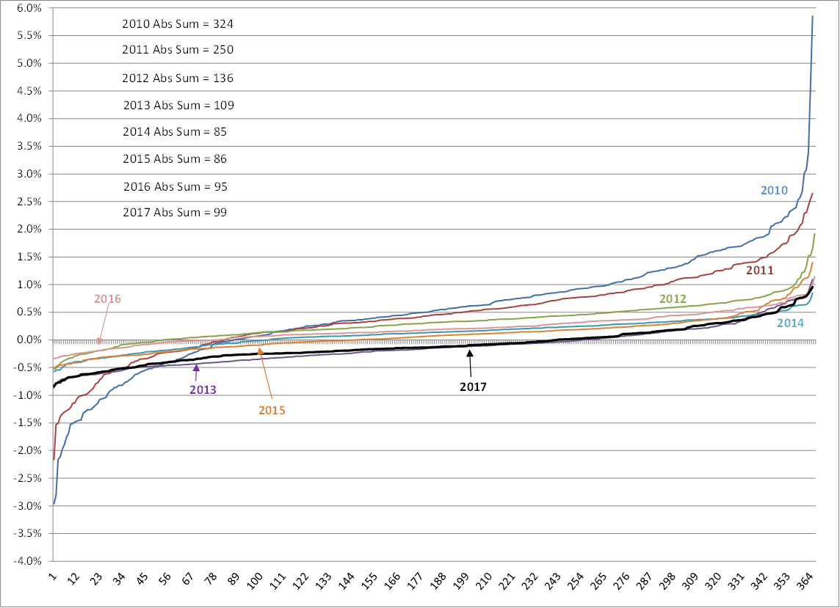

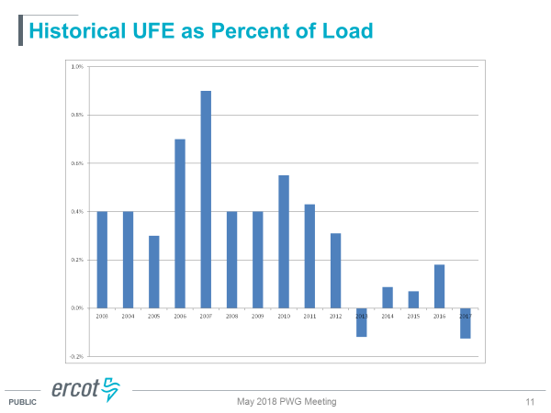

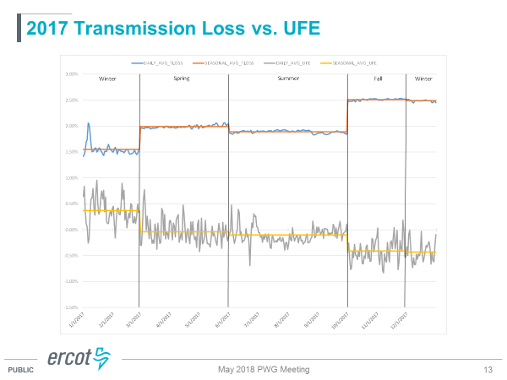

- 2018 Annual Validation Update
  - TDUs have begun sending 814_20 revisions on meter cycle dates

- Business Default Profile
  - Oncor confirmed the higher count of NIDR BUSMED profiles are a result of the old Sharyland ESIs created as Oncor ESIs during the transition. With AMS deployment scheduled for completion at the end of 2018, this count will reduce and Oncor had planned to preserve the old Sharyland profiles
  - ERCOT plotted the default profiles HI, MED, and LO on one scale and provided the MWHs from both the aggregate of ESIs to move from BUSMED to BUSHI and BUSMED to BUSLO. Given the volumes are nearly the same, changing the default from MED to LO should not be impactful.
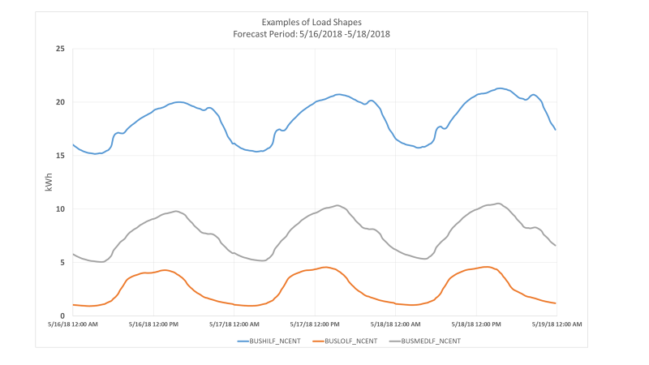

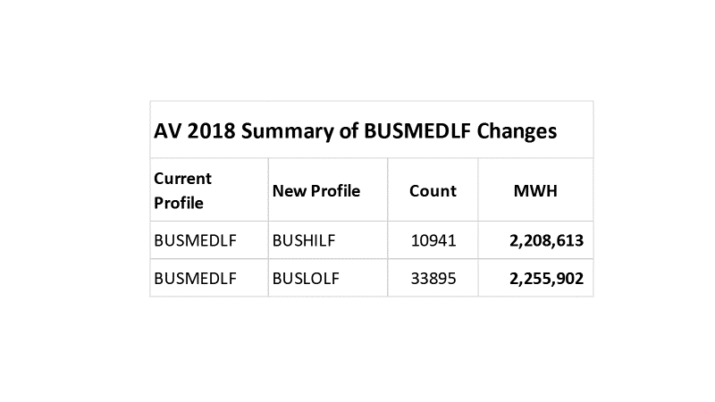
- Annual Validation Proposed Process
  - The working group reviewed language changes for the NPRR and LPGRR proposing the Annual Validation process be conducted once every three years for residential ESIs and annually for business ESIs. Also proposing the default business profile be changed from BUSMED to BUSLO based on the group’s thorough review.
  - NPRR will revise 18.4.3.1
  - LPGRR will revise Chapter 11, Chapter 19, and Appendix D – Load Profiling Decision Tree
    - Another tab was added at the end of Appendix D showing the AV Schedule for clarity on when the residential AV process would occur
  - Lindsay provided a schedule for the revision process:
    - LPGRR submitted and posted by June 25th for RMS language consideration
    - NPRR submitted and posted by July 3rd for PRS language consideration
  - Revisions would impact next year’s AV process

- BUSIDRRQ profiled ESIs for DG identification
  - Oncor is still working with ERCOT on visibility of information in DG reports already submitted
  - General question came up on self-serving ESIs with DG and interconnect agreements – TDUs indicated a profile will not be revised to a PV, WD, or DG profile unless the customer intends to provide surplus power back to the grid
  - Next PWG meeting, the working group will develop a list of questions/issues to present for the BUSIDRRQ profile workshop to ensure clarity on BUS profiles, possible solution for visibility into this bucket of customers with DG

- NEXT MEETING:
  - With LPGRR language to be posted by June 25th, the next meeting is moving from Wednesday, June 27th to Monday, June 18th at 1:30 PM
  - AGENDA:
    - Review of language for DRAFT LPGRR and NPRR – Annual Validation Process and Default BUS profile
    - Annual Validation status
    - Develop a list of questions/issues for discussion at upcoming IDR workshop
      - Visibility into DG for BUSIDRRQ profiles
      - Clarity on self-serving DG for BUS profiled customers

