MarkeTrak
Tips and Tricks Document ver 4.0

Q. Who should I call if I have issues with…
- Connectivity? Contact the ERCOT Help Desk at 512-248-6800 or helpdesk@ercot.com
- Digital Certificate? Contact your Company USA
- Adding or changing your Company’s MarkeTrak Administrator? Contact your ERCOT Account Manager or ERCOT Client Relations at 512-248-3900 or clientrelations@ercot.com
- Escalation of specific MarkeTrak Issue? Escalation contacts are in the Managed Data of MarkeTrak
- MarkeTrak Education/Training needs? Contact your ERCOT Account Manager or ERCOT Client Relations at 512-248-3900 or clientrelations@ercot.com

Q. What should I do if I have issues with logging into MarkeTrak?
- Check to make sure you are accessing the correct URL which is https://mis.ercot.com/marketrak/tmtrack/tmtrack.dll?
- Check to make sure your digital certificate was installed correctly
- Contact your company’s Administrator and make sure you are set up as a user in MarkeTrak.
- If you access MarkeTrak through MIS, the system will ask you for your digital certificate twice. This can be avoided by creating a “Favorites” link directly to MarkeTrak to avoid the additional prompt for certificate.
- Check your browser compatibility settings. MarkeTrak is supported on IE11 in Default Mode. Browser configuration specifications and settings can be found in the updated IE11.x Configuration Guide posted on the User Guides page of ERCOT.com. The Configuration Guide details running specific URLs in Default Mode.

Q. What changes were made to MarkeTrak with the version upgrade released on March 27, 2017?

- There is no significant functionality change with this upgrade. Most of the changes in the version upgrade are cosmetic only. Examples include, but are not limited to, the position of various links relocated on the Home screen and/or moved to reside in dropdown fields. In addition, the Reporting section of MarkeTrak has been modified to display the report availability and creation of reports in a tabular format.
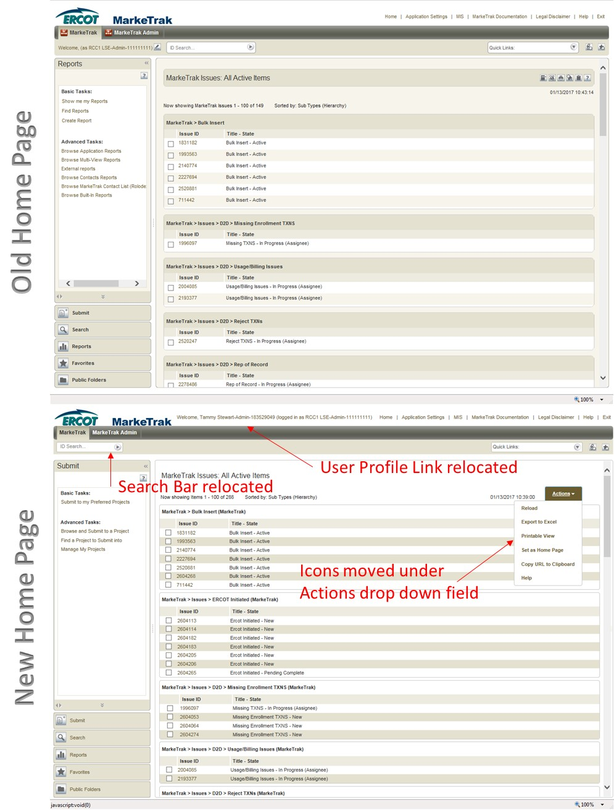
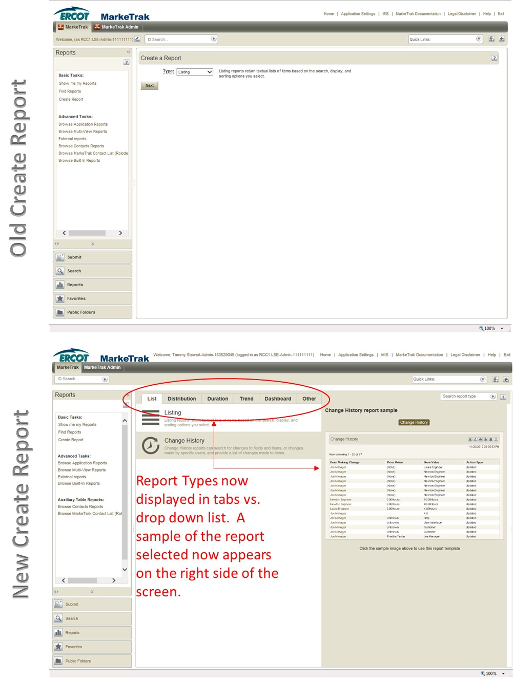
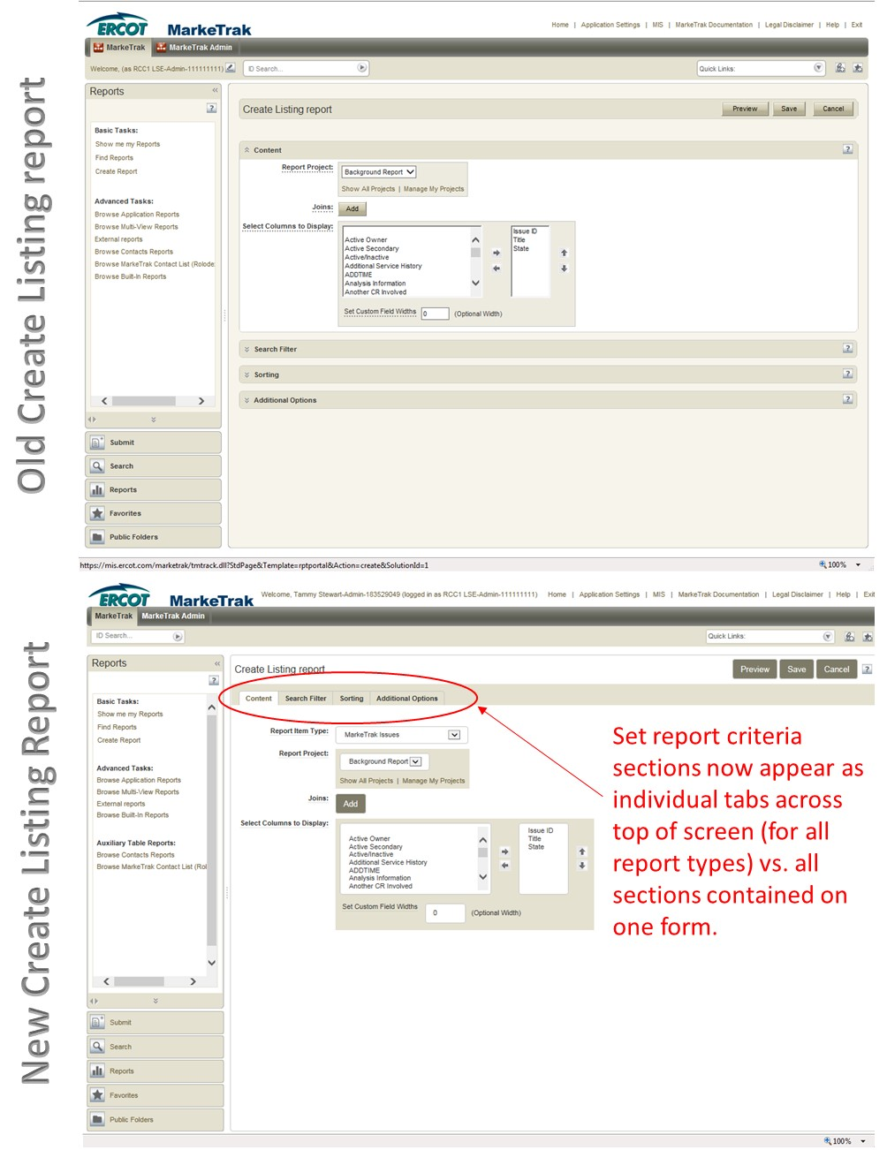
Q. What if I get the error message “No Concurrent licenses are available”?
- This means that all licenses are currently consumed and the user must wait for one of the current logged in users to logoff or timeout.
- You should wait 15 to 30 minutes and try again.

Q. What if I cannot see an issue that belongs to my company?
- From the users guide – Section1_General subsection 1.5.2 – Searching

Searching in the MarkeTrak application is largely based on the visibility model described in section Section1_General subsection 1.4.2 Issue Visibility. When searching, those issues available to the user based on login credentials will be returned in any result set.

If you are using multiple criteria then you should be using the reports feature. If you are searching for one result set then the search function should be used.

Available fields that can be utilized are:
- Issue ID: entering a number in this field will return all issues that are visible to the user and contain the value entered
- Keyword(s): compares text strings populated by the user with any text fields associated with an issue. This will allow the user to search the following fields:
  - Comments
  - Description
  - ESI ID
  - Original Tran ID
- Project(s): (Fig 5d) A selection of each of the issue Sub Types the user wishes to return in the search. Multiple selections are possible via standard Shift and Control key functionality
- Submitter: UserID of the individual who submitted a particular issue. Only those items submitted by a user with the same MP DUNS association will return.
- Active/Inactive: Allows the user to decide if the result set should include only Active, only Inactive, or both Active and Inactive issues

Q. What if I cannot see an issue that belongs to my company which was submitted before I received access to MarkeTrak?

- Navigate to: Public Folder – Public Reports – Market Reports as indicated in the screen shot below
- Execute report ‘Find Issues prior to “Last Modified Date” Selected’
- Enter a date greater than set up date of the user that needs to access the issues
- Place a check on the issues you wish to access or use Check All option
- Place a Tick in the comments field (This will allow the system to touch each record)
- Select Update Report
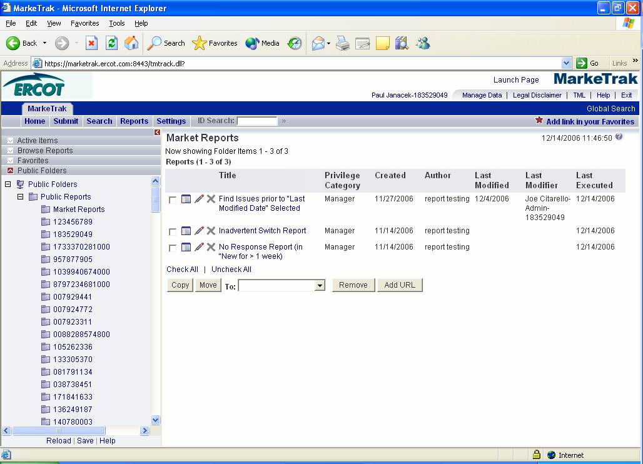

Q. If I have issues exporting to Excel, what should I do?

Complete the following steps.
- The following Internet Explorer configuration change must be performed to allow MarkeTrak report/search data to be opened or saved to Excel format.

- Open the Internet Explorer browser. Select the Tools tab in the upper selection bar. Select the Internet Options selection from the drop down list.
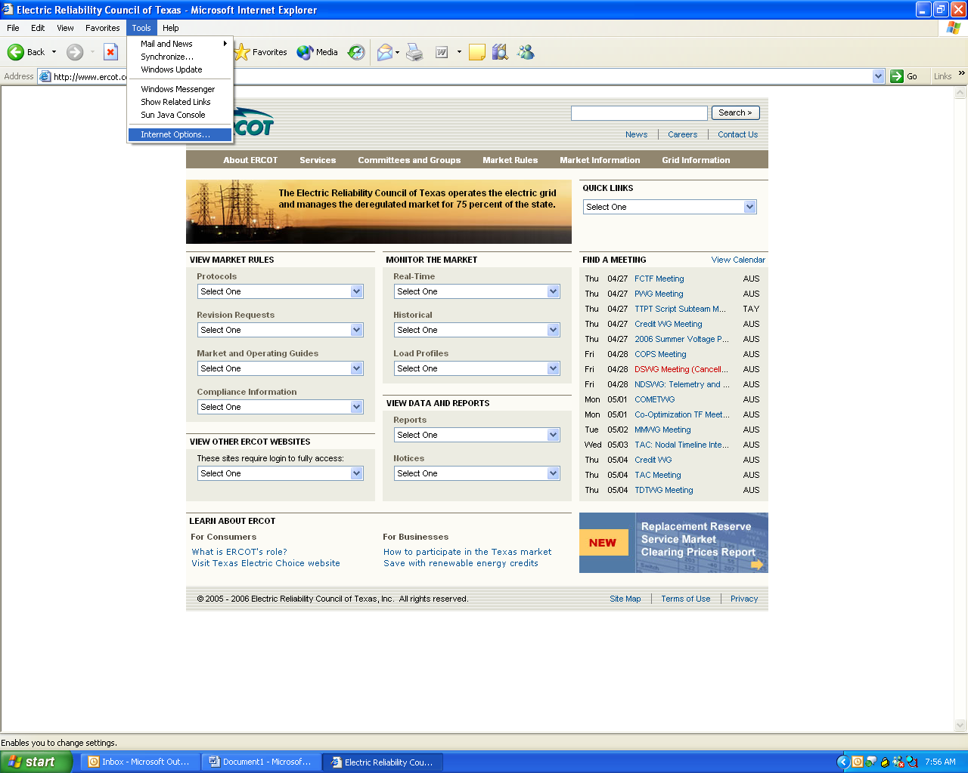

- After the Internet Options popup window displays, select the Advanced tab.

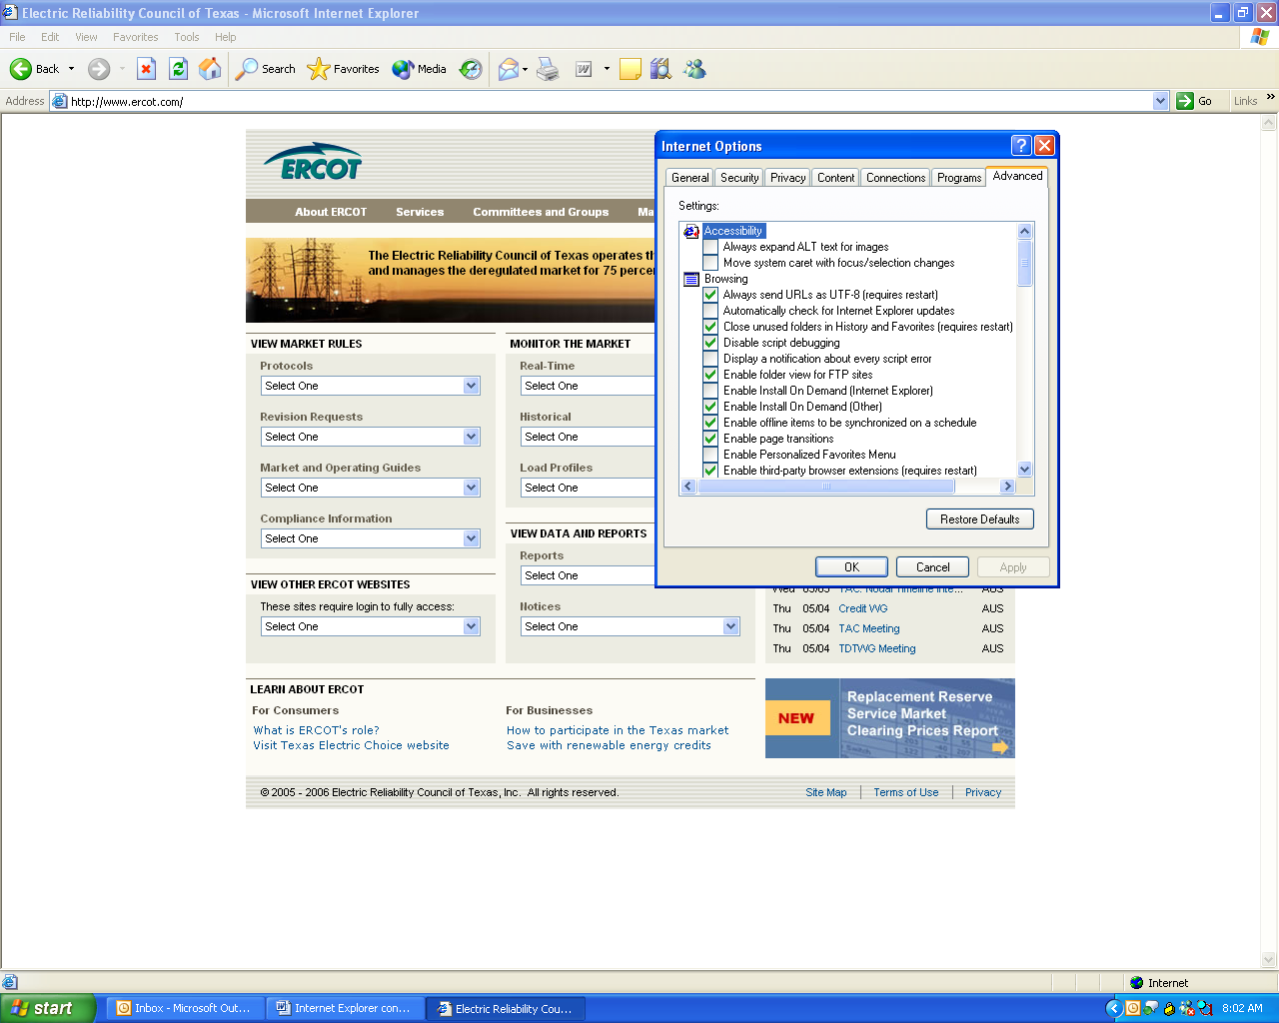
- On the Advanced tab, scroll down to the Security section. Check the box beside Do not save encrypted pages to disk. Click the OK button to save the change.

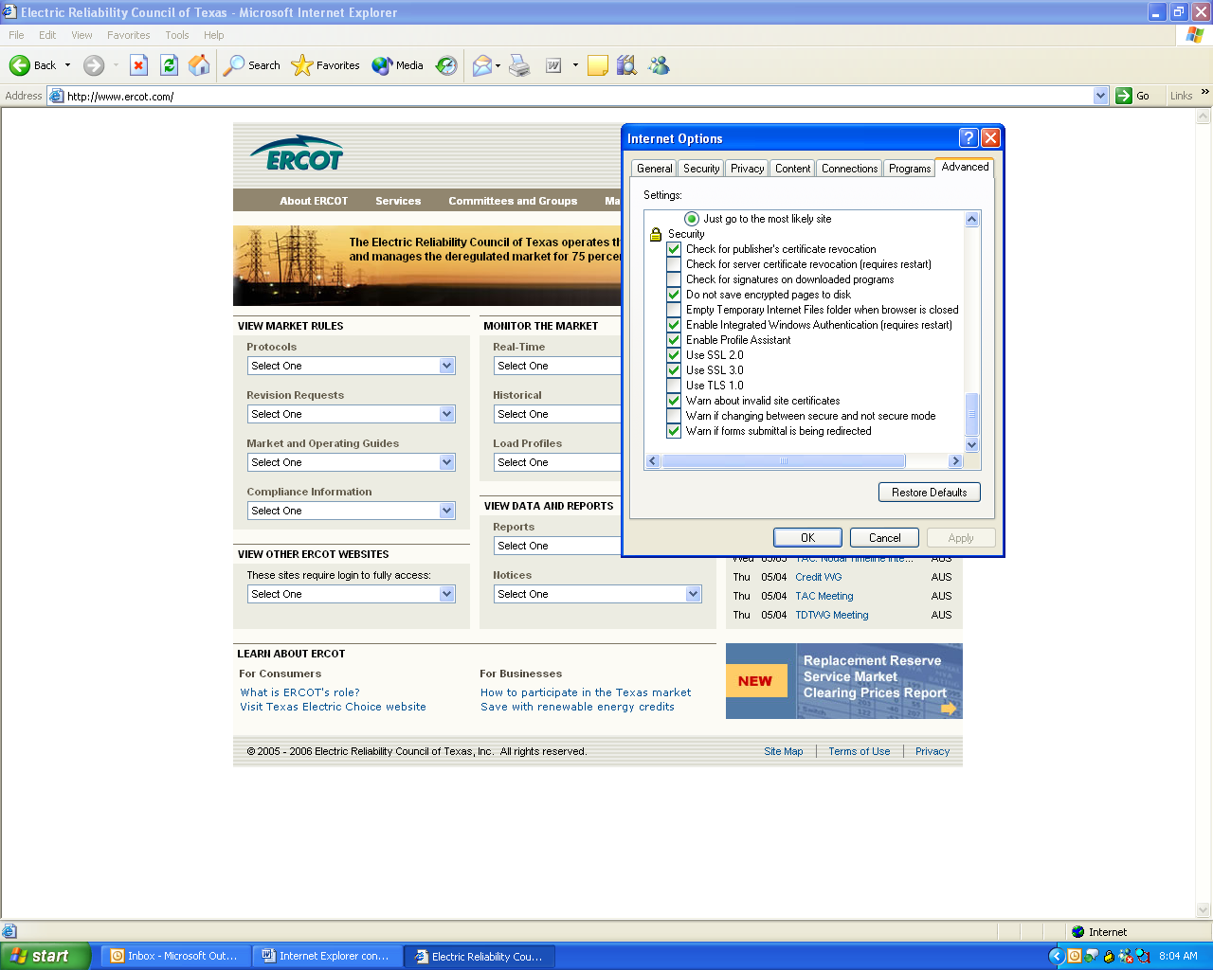

- You will now be able to open or save MarkeTrak report and search data to Excel format.

Q. If an issue becomes locked, what should I do?
  - There are three ways to unlock an issue
    - Contact the user that locked the issue and have them break the lock. Direction for breaking the lock can be found in the MarkeTrak user guide in section 9.3.
    - The user that locked the issue can log out of MarkeTrak which will unlock any locks.
    - If the user that locked the issue is not active for 30 minutes the system automatically logs the user out of the MarkeTrak tool which will unlock the issue.

Q. How do I log out of MarkeTrak correctly?
  - Logout when not in use to free up licenses
  - Do not exit out of the internet web browser by selecting the X. Please use the Exit function within the MarkeTrak tool. Select OK after Exiting

Q. If I have issues submitting a bulk insert issue, what should I look for?
  - Do not enter commas in the comments section of the bulk insert .csv file
  - Rename the .csv file when original file did not pass validation and resubmitting
  - Save the template “that works” for reference
  - Make sure date/time format is correct in the .csv file

Q. Why did the TDSP override my Switch Hold Removal objection as Rep of Record?
The TDSP makes the final decision to remove a switch hold on an ESIID. Even though the Rep of Record may select Disagree on a Switch Hold Removal issue, the TDSP can remove the Switch Hold if they determine it is appropriate. It is recommended that the Rep of Record provide documentation supporting their position on the removal of the Switch Hold. TDSPs will rarely override ROR’s decision if documentation is provided.

General Information – Understanding How Issues will be worked at ERCOT.

Q. How will DEV issues be assigned at ERCOT?
- ERCOT will be working issues in small groups
  - If assigned DEV day – team member does frequent pulls of New DEV issues (may only result in 1-10 single issues)
  - Team member conducts analysis
  - Updates back into MarkeTrak are done by single issue
  - DEV issues should only be submitted when a transaction cannot be sent to correct service history

Q. How will D2D issues be assigned at ERCOT?
- ERCOT will be working issues in small groups
  - Team member does frequent pulls of New D2D issues (may only result in 1-10 single issues)
  - Team member conducts analysis
  - Updates back into MarkeTrak are done by single issue

____________________________________________

Q. How do I know which Tran ID to use when submitting an
Inadvertent Switch?

When submitting an IAS issue as the Losing Rep, use the BGN06 from the 814_06 that you received. This will ensure that you have provided ERCOT with the correct Transaction ID.

Miscellaneous Recommendations

  - REPs should utilize the 814_12 date change transaction in lieu of ‘Cancel with Approval’ MarkeTrak
  - MarkeTrak Admins should update their ‘rolodex’ files with department mailboxes who monitor MarkeTrak issue inquiries/escalations

