

ERCOT White Paper on
Resource Definitions
in the ERCOT Protocols

Submitted to the Resource Definition Task Force (RTF) on May 23, 2018.

Document Revisions
Date | Version | Description | Author(s)
4/28/2018 | a | Initial draft outline for RTF review/discussion | ERCOT Staff
5/9/2018 | b | First revision after RTF feedback | ERCOT Staff
5/23/2018 | c | Final Draft | ERCOT staff

Table of Contents
1 Executive Summary 4
2 Introduction 6
3 Identify list of issues and methods for resolution. 7
3.1 Stage 1 - Align Definitions to identify differences 7
3.2 Stage 2 - Clarify Definitions for Transmission connected resources 7
3.3 Stage 3 - Clarify Definitions for distribution connected resources 8
4 Review of NERC, PURA, PUCT Rules and ERCOT Protocols Terms. 8
5 Development of Framework. 9
6 Existing Terms needing revision (with consensus) 17
7 New Terms (with consensus) 18
8 Terms either unresolved, or no consensus 18
9 References 18
9.1 NERC Definitions 18
9.2 Public Utility Commission Rules 19
9.3 ERCOT Definitions and Protocols 19
Appendix A – Legal Definitions 20
Appendix B – List of Issues brought up in RTF 21
Appendix C – Examples of Transmission connected Resources 22
Appendix D – Examples of PUN connected Resources 23
Appendix E – Examples of Distribution Connected Resources 24

Executive Summary
ERCOT market participants are concerned that resource definitions have become increasingly complex and confusing, which has led to inconsistent registration of small generators and sometimes contradicting terms for all generation resources. The Resource Definition Task Force (RTF) was created to ensure that the terms for Resources and other generators used within the ERCOT protocols, operating guides, and binding documents, are consistent and clear.
The RTF’s scope of work includes consideration of the following issues:
- Review previous guidance and references to Resource definitions in PURA, the ERCOT Zonal/Nodal Protocols, as well as NERC definitions.
- Identify problematic terms and potential differences that need to be resolved.
- Improve the current structure and terms where practical
- Clarify, where appropriate, existing Resource definitions, including but not limited to the term “Non-Modeled Generation” that are:
  - Transmission connected
  - Distribution connected
- Consider existing and future Resource types that may not currently be defined but should be reviewed as part of the task force.

The first stage of work consisted of comparing all of the various terms used by NERC, PURA, PUC substantive rules and ERCOT protocols to identify areas needing resolution. An overarching framework was generated to help understand the various generation resources in ERCOT, and their relation to each other. Once consensus was achieved on the new terms or definitions, a resource framework was created to capture all key issues and gaps (if any).

The second stage of work will focus on clarifying definitions for transmission-connected resources, and once the basic definitions are clarified, NPRR #1 will be submitted to revise/replace the term “Non-modeled generator”. Subsequent NPRRs may be required to resolve other transmission connected resources

The third stage of work will focus on definitions for distribution-connected resources.
This work can be in parallel with stage 2 as the work required for resolving distribution connected resources may be completely independent from the work required for transmission resources. It is expected that multiple new concepts that would take extended periods to define. Subsequent NPRRs (plural) are expected to be needed to resolve distribution connected resource issues

This whitepaper is intended to provide as summary of the first stage of work as well as the basis of understanding for the development of upcoming proposed revisions to both ERCOT protocols and other market rules. As work is completed on stages 2 and 3, addendums to this whitepaper will be made for clarification.

The RTF identified that the three areas responsible for the most confusion by market participants were: “non-modeled generator”, “distributed generation”, and lack of explicit definition for distribution connected generation greater than 10 MW. After several months of discussion and review of the protocols, the following framework is proposed.

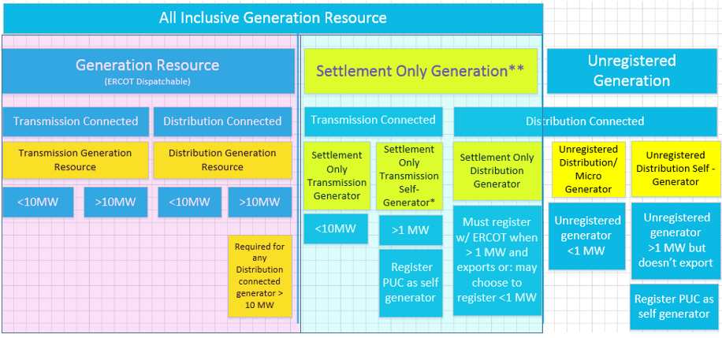
**Settlement Only generator means that they may not participate in Ancillary Services Market, RUC, SCED, or make Energy Offers.
*Settlement Only Transmission Self Generator may occasionally export, but does not generate with the intent to sell at wholesale

Figure 1 – Proposed Framework and naming convention.
The rose-colored box above contains all ERCOT-dispatchable Generation Resources and include all of the requirements for G.R. such as telemetry, COPS, as well as requiring resource nodes for energy generated (note that the overwhelming majority of generation resources in ERCOT are in this box, specifically Transmission Generation Resources greater than 10 MW).
The greenish-colored box above contains non-ERCOT dispatchable resources that don’t require telemetry, COPS, or resource nodes. These resources have in the past been registered as “non-modeled” generation, and the term “settlement only generator” is proposed in its place (shamelessly borrowed from ISO-NE) and it has been generally accepted after presentations to both the Reliability and Operations Subcommittee (ROS) and Wholesale Markets Subcommittee (WMS).
Finally, the unshaded boxes to the right represent the unregistered resources which are essentially invisible to ERCOT since they are usually behind-the-meter, and so are not included in the definition of all-inclusive resources.

Introduction
The Resource Definition Task Force was established after the Market Participants expressed concern to the Technical Advisory Committee that Resource definitions have become increasingly complex and confusing, and recommended a holistic effort to clarify the definitions. Confusion regarding definitions has led to inconsistent registration of small generators and contradicting terms for all generation resources. The RTF is focused on ensuring that the terms for Resources and other generators used within the ERCOT protocols, operating guides, and binding documents, are consistent and clear.

The RTF’s scope of work includes consideration of the following issues:
- Review previous guidance and references to Resource definitions in PURA, the ERCOT Zonal/Nodal Protocols, as well as NERC definitions.
- Identify problematic terms and potential differences that need to be resolved.
- Improve the current structure and terms where practical
- Clarify, where appropriate, existing Resource definitions, including but not limited to the term “Non-Modeled Generation” that are:
  - Transmission connected
  - Distribution connected
- Consider existing and future Resource types that may not currently be defined but should be reviewed as part of the task force.

The RTF membership consists of ERCOT staff and other interested Transmission and/or Distribution Service Providers (TDSPs), Qualified Scheduling Entities (QSEs) and Resource Entities. Meetings of the RTF are open to all interested parties. Jay Teixeira from the ERCOT Resource Integration department and David Ricketts from Vistra Energy were nominated as co-chairs to coordinate activities. Due to a reorganization within Vistra Energy, David Ricketts withdrew from the RTF and was replaced by XXX as co chair in June of 2018

Identify list of issues and methods for resolution.

Now that the Resource Definition Task Force has been engaged, a running list of issues to resolve was established. Many items were identified over the subsequent months as the group discussions progressed and. Although some of the items were within the scope of this task force to address, other items were beyond the scope of this task force to resolve, as many of them dealt with items such as market-based issues, or technical requirements. One of the limitations on the RTF was that although definitions were to be clarified, any new requirements or rules would be deemed outside of the RTF scope and should be forwarded to the appropriate working groups (ROS, WMS, etc) to address.

In addition to identifying where the issues needed to be resolved, a top priority was identifying how the issues could be resolved as well as when.
Previous attempts to address the various issues around non-modeled generation or distributed generation became bogged down, so a stepwise project approach to selectively identify and resolve issues was chosen.

Stage 1 - Align Definitions to identify differences
The first stage consisted of comparing all of the various terms used by NERC, PURA, PUC substantive rules and ERCOT protocols to identify areas needing resolution. An overarching framework was generated to help understand the various generation resources in ERCOT, and their relation to each other.
Once consensus was achieved on the new terms or definitions, a resource framework was created to capture all key issues and gaps (if any). These new terms were then published in this whitepaper along with terms or definitions without consensus.

The estimated duration for this first stage was approximately 6-8 months.

Stage 2 - Clarify Definitions for Transmission connected resources

Once the issues were identified, and the framework agreed upon, the second stage clarified definitions for transmission-connected resources.
Once the definitions were clarified, NPRR #1 was submitted to revise/replace the term “Non-modeled generator”. Subsequent NPRRs may be required to resolve other transmission connected resources.

The estimated duration for this second stage is approximately 6-8 months.

Stage 3 - Clarify Definitions for distribution connected resources

Once the “Non-modeled” definition has been resolved, the third stage envisions clarifying any definitions for distribution-connected resources.
This work can go along in parallel with stage 2 to some extent as the work required for resolving distribution connected resources is expected to be completely independent from the work required for transmission resources. In addition, there may be multiple new concepts that may take extended periods to define.
Subsequent NPRRs (plural) are expected to resolve distribution connected resource issues.

The estimated duration for this last stage is approximately 6-8 months.

Review of NERC, PURA, PUCT Rules and ERCOT Protocols Terms.
The next action was to review all of the existing definitions in PURA, NERC, the PUC substantive rules and finally the ERCOT Nodal Protocols. The goal was to see if there were any significant mismatches, gaps, or overlaps between the various rules.
ERCOT’s Legal team, assisted by Dave Ricketts, assembled a table of all of the definitions and is shown in Appendix A – Definition Review. The group reviewed the various definitions and confirmed the various areas where there were gaps and overlaps. Several of these are in the PUC substantive rules, so these will hopefully be addressed in a future rule change.
At this point
After reviewing the terms, it became apparent that an overall framework was required to provide for a reference and hierarchy of the various terms.

Development of Framework.

An overarching framework based on the existing definitions and protocols was developed by Jay Teixeira to help illustrate visually how the protocols define the resources. This visual representation is entirely a new concept and is shown below in figure 2 with the areas needing to be clarified highlighted in yellow.
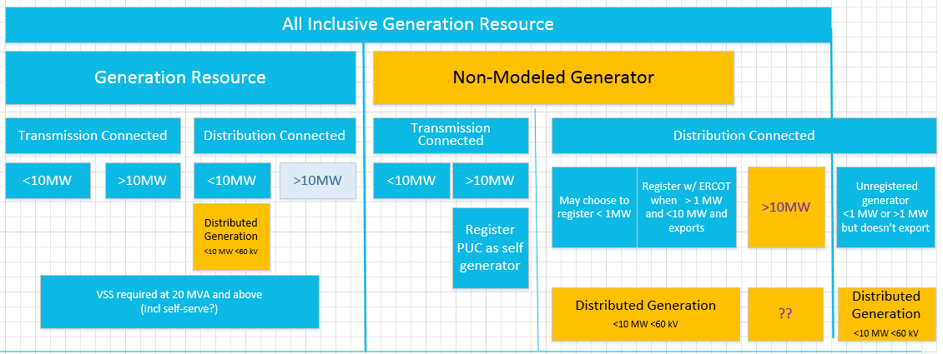
Figure 2 – Existing All Inclusive Generation Resource Framework
The above categories simply reflect how All-inclusive generation resources are classified based on their size, connection and, to some extent, market participation. This figure excludes Load Resources. One item that immediately stands out is “distributed generation”, since it spans at least four different categories of generation resources described in the ERCOT protocols. This, along with other details, led to a scrutiny of what the definitions actually mean.
A Generation Resource is defined as “a generator capable of providing energy or Ancillary Service to the ERCOT System and is registered with ERCOT as a Generation Resource. The term “Generation Resource” used by itself in these Protocols does not include a Non-Modeled Generator”, which is somewhat of a circular definition.
A Resource, “is used to refer to both a Generation Resource and a Load Resource. The term “Resource” used by itself in these Protocols does not include a Non-Modeled Generator or an ERS Resource.”
A Non-Modeled Generator is “a generator that is: (a) Capable of providing net output of energy to the ERCOT System; (b) Ten MW or less in size; or greater than ten MW and registered with the PUCT according to P.U.C. SUBST. R. 25.109, Registration of Power Generation Companies and Self-Generators, as a self-generator; and (c) Registered with ERCOT as a Non-Modeled Generator, which means that the generator may not participate in the Ancillary Service or energy markets, RUC, or SCED.

Contributing to the confusion, the various Resources are comprised of different fundamental technologies which are referenced in the Nodal protocols, but only a few of these technologies are actually in the definitions section of the protocols, but are used elsewhere in the protocols.
Although the definitions section of the protocols under the term “Resources” is several pages long, the definitions are somewhat vague, and sometimes refer to the generation technologies as Resources which is what has led to much of the confusion, since they are “categories of resources”, and not actually Resources. For example,several resource technologies, such as a natural gas simple cycle generator or solar photovoltaic system, can be the power source for almost any of the Resources above, so simply referring to a Simple Cycle Resource or Solar Photovoltaic Resource does not help define what kind of resource it actually is, since the unit could easily be under any of the generation categories shown in figure 2, from a Transmission connected generation resource to a non-modeled generator connected at distribution.
So, getting back to basics, the ERCOT protocols use connectivity and size as the first differentiating feature, which is the basis for the framework shown in figure 2.
Generation Resources also have other “attributes” or “status”, and based on those, are eligible to participate in different markets and offer different services, as defined in the Protocols. As an example, a resource that has an attribute that it can be qualified as “quick starting”can provide certain ancillary services. It should be noted that several technology categories have certain attributes that would enable them to meet those particular qualifications.
Therefore, the next step was to separate out these various technologies, attributes and services as shown in figure 3, below.

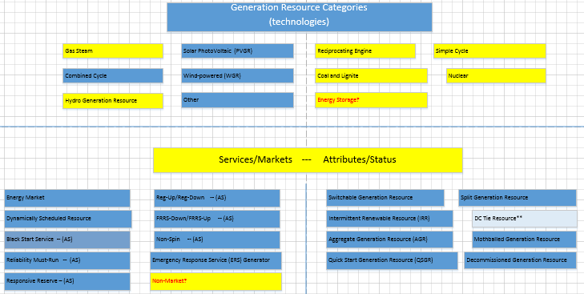
Figure 3 – Generation Attributes—Technologies, Services and Status

After these categories and attributes are recognized as being characteristics of the resources, and not the types of resources themselves, a more robust framework starts to emerge of the types of resources based on their size, connectivity, technologies, attributes and market participation.
The most contentious term, “non-modeled generation” needed to be addressed first. Historically, it has been a relative oxymoron, since ERCOT has typically modeled all “non-modled” generators connected to the transmission system for reliability. Several other ISO’s have started to address the same type of generation described by the term non-modeled, but ISO-NE has already adopted the term “Settlement Only” to describe these types of generation resources that are paid for energy exported, but are not registered as Generation Resources and are not dispatchable. As there have been no objections to “Settlement Only” yet, it is proposed as a replacement for “non-modeled” generation.
After more discussion, the following matrix emerged shown in figure 4 which takes into account the various requirements for registration with the PUC, as well as market participation.

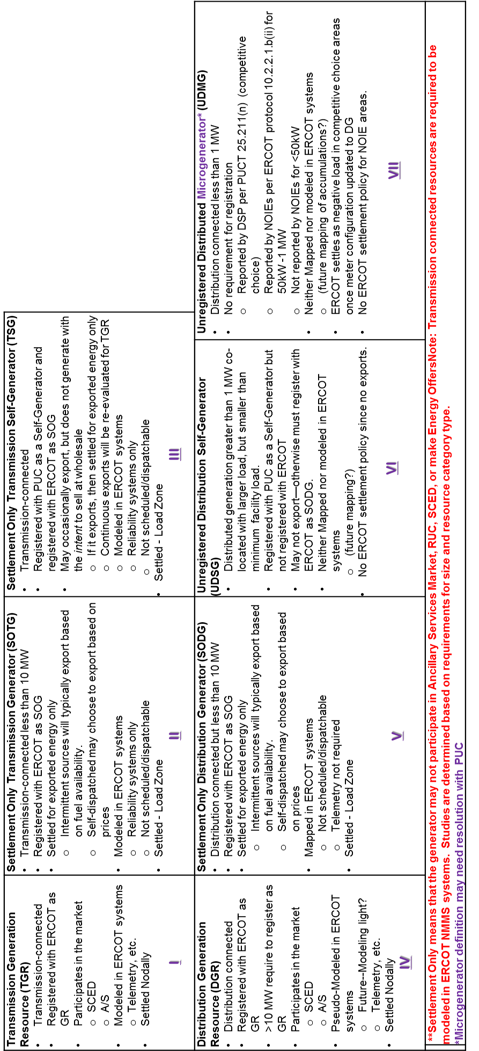
Registered Generation Resources that are ERCOT-dispatchable are shown in the first column (boxes I and IV). These resources, which represent the bulk of the generation in ERCOT, are capable of providing energy into the markets or ancillary services and have all of the requirements for G.R. such as COPS, telemetry, modeling, as well as requiring resource nodes for energy generated.
Other resources that are registered with ERCOT are the non-dispatchable resources (Settlement Only)which are shown in boxes III, IV, V. These resources are simply settled for energy exported, but may not participate in the Ancillary Services Market, RUC, SCED, or make energy offers. As a result, they do not have the requirements of telemetry, COPS, or have resource nodes assigned.
Unregistered resources as shown in boxes VI and VII on the distribution system are essentially invisible to ERCOT. Although information by premise is provided on the resources in the comptetive choice areas, and a composite value is provided from the NOIE areas, from an operations aspect they are all simply captured as negative load.
This then clarifies the framework which results in the final proposal shown in figure 5.
**Settlement Only generator means that they may not participate in Ancillary Services Market, RUC, SCED, or make Energy Offers.
*Settlement Only Transmission Self Generator may occasionally export, but does not generate with the intent to sell at wholesale

Note—The Rose colored box contains ERCOT-dispatchable Generation Resources and include all of the requirements for G.R. such as telemetry, COPS, as well as requiring resource nodes for energy generated. The greenish colored box contains non-ERCOT dispatchable resources that don’t require telemetry, COPS, or resource nodes.
Figure 5 – Proposed Resource Definition Framework.

Now that the framework has been defined, the next step is to develop a flow chart that defines the process of registration and qualification based on the generator size and desired market participation. The first flow chart (below) is for transmission connected resources, and the second flow chart (next page)is for distribution connected resources.

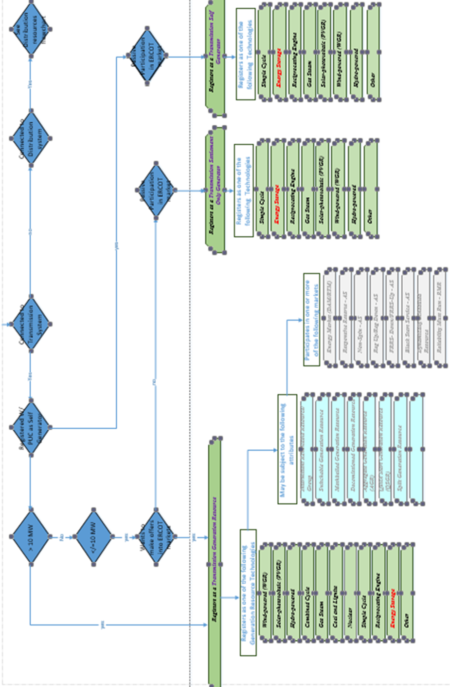
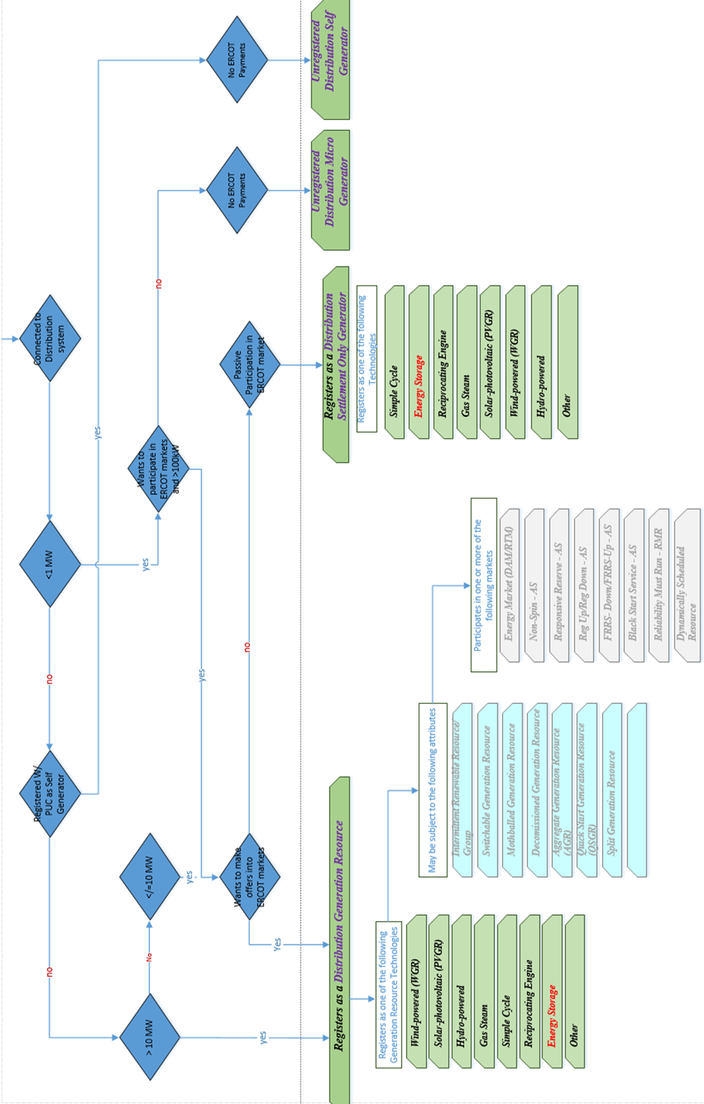

During the course of the discussions, multiple issues have been highlighted as needing to be resolved, and should be addressed by subsequent NPRRs, either originating in the RTF, or referred to another working group. Although at the time this whitepaper was proposed, stages 2 and 3 have not been completed, so a preliminary list of these issues are listed below:
Phase 2 Topics for Transmission connected resources:
- Definition of what “export” means. Currently, DG > 1MW that doesn’t “export” is not required to register, but absent of a definition for export, this term has been loosely interpreted.
- Finish introduction of the resource framework. As shown in figure 3, there are multiple “resources” defined that are actually just descriptions of attributes or services that the resource is qualified to provide. For example, “black start resource” really describes a resource unit that is qualified to provide black start services.
- Definition of Energy Storage, and other resource technologies. There are a number of technology definitions shown in figure 3 that are defined, and there are also a number of them that are missing. The missing technologies simply need to be defined as the registration and market information is already in the protocols.
Phase 3 Topics for Distribution connected resources
- Clarify that >10 MW generator connected to the distribution system must register as a Distribution Generation Resource. The existing protocols imply this essentially by stating that all-inclusive generation resources “refers to both a Generation Resource and a Non-Modeled Generator”. Since a non-modeled generator is defined as: (a) Capable of providing net output of energy to the ERCOT System; (b) Ten MW or less in size; or greater than ten MW and registered with the PUCT according to P.U.C. SUBST. R. 25.109, Registration of Power Generation Companies and Self-Generators, as a self-generator; and (c) Registered with ERCOT as a Non-Modeled Generator, which means that the generator may not participate in the Ancillary Service or energy markets, RUC, or SCED, then a generator > 10 MW can’t be non-modeled. Therefore, it must be a generation resource.
- Definition of “smaller generators” (less than 1 MW) that are not required to register with ERCOT. The PUC term for microgenerators is specific to renewable technologies.
- Definition of an aggregate distributed generation resource. The ERCOT protocols have a term for aggregated resources, but it was developed specifically for groups of transmission connected resources. Either the existing term needs to be revised, or a new suitable term needs to be developed.

Existing Terms needing revision (with consensus)
The following terms need to be addressed either by the PUC or by ERCOT as they either overlap or contradict.

Customer

Distributed Generation (DG) The existing definition, although adequate, is confusing in that it refers to multiple categories of generation resources in ERCOT.
Aggregate Generation Resource (AGR)
This term in the ERCOT protocols, currently only to transmission connected resources.
Unregistered Distributed Generation – Unregistered DG falls into two categories per PUCT rules—first: DG greater than 1 MW that is behind a large load so never exports into the ERCOT system, and second: DG 1 MW or smaller is not required to register with ERCOT. In general,

New Terms (with consensus)

Settlement Only Generator
A generator that is settled for exported energy only, but may not participate in the Ancillary Services market, Reliability Unit Commitment (RUC), Security-Constrained Economic Dispatch (SCED), or make energy offers. These units are comprised of:

Settlement Only Distribution Generator
A generator that is distribution connected with a rating of less than 10 MW and is capable of providing a net export to the ERCOT system. This generators are registered with ERCOT per Section 16.5, Registration of a Resource Entity, and will be mapped in ERCOT systems per Section 3.10.7.2.3.

Settlement Only Transmission Generator
A generator that is transmission connected with a rating of less than 10 MW. These generators are registered with ERCOT per Section 16.5, Registration of a Resource Entity, and will be modeled in ERCOT systems for reliability per Section 3.10.7.2.1.

Settlement Only Transmission Self Generator
A generator that is transmission connected with a rating of 10 MW or more and is registered with the Public Utility Commission of Texas (PUCT) as a self-generator. It may occasionally export, but does not generate with the intent to sell at wholesale Entity, and will be modeled in ERCOT systems for reliability per Section 3.10.7.3, Modeling of Private Use Networks. The generators are registered with ERCOT per Section 16.5, Registration of a Resource

Terms either unresolved, or no consensus
During discussions,

References

NERC Definitions
See the following definition:

Public Utility Commission Rules
See the following Substantive Rules:
- Electric Rules
http://www.puc.texas.gov/agency/rulesnlaws/subrules/electric/25.211/25.211.pdf

ERCOT Definitions and Protocols

See the following ERCOT Protocol sections:
- Definitions
http://www.ercot.com/content/wcm/current_guides/53528/02-030118_Nodal.doc
- Full combined protocol
http://www.ercot.com/content/wcm/libraries/148953/March_1__2018_Nodal_Protocols.pdf

Appendix A – Legal Definitions

Appendix B – List of Issues brought up in RTF

Appendix C – Examples of Transmission connected Resources

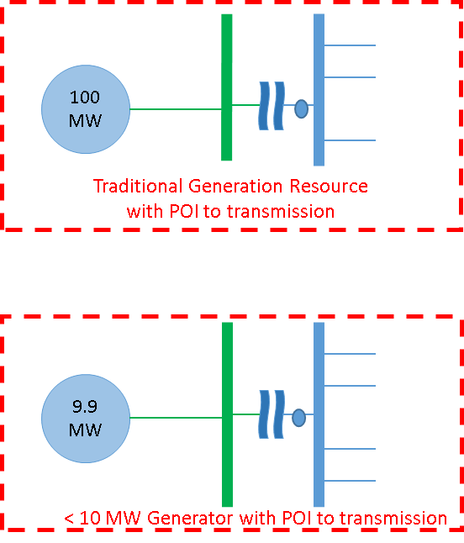

Appendix D – Examples of PUN connected Resources

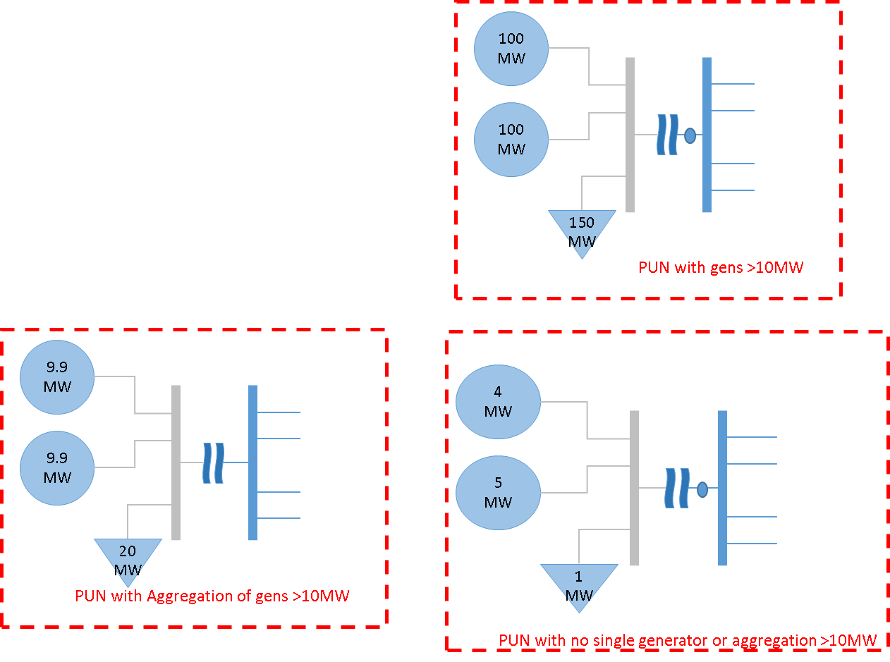

Appendix E – Examples of Distribution Connected Resources

