NPRR Number | 863 | NPRR Title | Creation of Primary Frequency Response Service Product and Revisions to Responsive Reserve
Date |  | May 24, 2018
Submitter’s Information
Name |  | Jack Farley
E-mail Address |  | jack.farley@apexcaes.com
Company |  | Apex CAES, LLC
Phone Number |  | 713-963-8100
Cell Number |  | 713-202-3887
Market Segment |  | N/A

Comments
Apex supports the Protocol revisions proposed in the comments submitted by the South Texas Electric Coop, Inc. in Nodal Protocol Revision Request (NPRR) 863 dated April 26, 2018.
The proposed Protocol changes make meaningful improvements to the Responsive Reserve (RRS) product that a) enable expanded Resource participation; b) ensure stricter Resource performance of a critical reliability service; and c) restore non-market frequency response to a fail-safe role that ensures reliability without undermining the merit-based market procurement of reliability services.

Expanded Resource participation
The modified RRS product will allow Off-Line Resources, that are able to respond within the 10-minute requirement, to participate. The current RRS Protocols disqualify Off-Line Resources from supplying the RRS product.
The Frequency Response Service (FRS) product will only require sustained deployment for up to 15 minutes per event, instead of the 60 minute deployment required by today’s RRS product. This shortened period of deployment should encourage short-duration batteries and Load Resources to participate in this market.

Stricter Resource performance for a critical reliability service
Limiting the supply qualification of a Resource by actual measured performance should be a more efficient way to ensure FRS performance. Under the current Protocols, Resources that fail to perform are subject to penalties from the Public Utility Commission of Texas (PUCT), which is a cumbersome administrative and judicial process. Proposed qualification for FRS supply will be based on actual Governor performance during frequency deviation events, or an ERCOT-administered FRS qualification test.

Improved market efficiency while maintaining non-market Primary Frequency Response for fail-safe reliability
North American Electric Reliability Corporation (NERC) Reliability Standard BAL-001-TRE, Primary Frequency Response in the ERCOT Region, mandates Primary Frequency Response (“PFR”) by onsite Governor from all On-Line Resources with “headroom” to adjust output either up or down (except nuclear units and some units with mechanical Governors), reglardless of whether the Resource is supplying RRS or any other Ancillary Service product. The broad scope of this mandate has created a reliability service with on-line capacity that is approximately 5 times larger than market-procured RRS from generators (based on 2016 estimates – see Exhibit 1).
In addition, BAL-001-TRE mandates PFR governor activation for system frequency deviations of +/- 0.017 Hz, a narrower requirement than the previous ERCOT standard of +/- 0.036 Hz. This change dramatically increased the frequency of PFR deployment. In 2013, prior to implementation of BAL-001-TRE, the 1-minute average system frequency exceeded the +/- 0.036 Hz deadband in only 2.5% of all minutes. In 2016, the 1-minute average system frequency exceeded the new, narrower +/- 0.017 Hz deadband in 24.5% of all minutes (see Exhibit 2). During 2016 PFR deployment occured in about 1 out of every 4 minutes, and thus PFR deployments provided a significant share of the energy deployed to correct system frequency throughout the course of the year. In fact, energy deployed from Resources providing mandated, non-market PFR was greater than energy deployed from market-procured RRS and Emergency Response Service (ERS) combined (see Exhibit 3).
When non-market PFR plays a large realibility role, market efficiency is undermined in both the short-term and long-term. In the short-term, heavy reliance on a reliability service that is neither procured nor dispatched based on merit-order fails to minimize system costs. For example, down deployments of wind and solar Resources during over-frequency events is less cost efficient than down deployments from high-cost gas-fired Resources. In the long-term, heavy reliance on non-market PFR, for which there is no compensation and subjects Resources to compliance/penalty costs, weakens the market signal to invest in flexible Resources.
NPRR863 would allow Resources that are not providing FRS to set their Governor Dead-Band to +/- 0.036 Hz. If eligible Resources elect to adjust their Governor setting to the wider deadband, then a) non-market PFR deployment during small system frequency deviations would be reduced (or eliminated); b) adverse market impacts from the large role of non-market PFR today would be mitigated; and c) a sizeable PFR deployment capability would still be available for use during large frequency deviations.
Apex completed three backcast analyses of the reliability impact of the wider Governor Dead-Band proposed by NPRR863. We found that the Interconnection Minimum Frequency Response (“IMFR”) would have been above the TRE system minimum for 2016 and 2017 with the wider deadband (see Exhibit 4). We also found that the event with the lowest 1-minute average frequency in 2016 (on January 26th 23:52) could have been adequately managed using only market-procured Ancillary Services and no assistance from non-market PFR (see Exhibit 5). Finally, we found that the 2016 CPS-1 score would have only been moderately lower with the wider deadband, yet still well above 140%, which is the minimum level at which additional Regulation procurement is triggered (see Exhibit 6). These back cast analyses indicate that market-procured Ancillary Services are adequate to maintain ERCOT reliability with the wider +/-0.036 HZ deadband for non-market PFR deployment. In summation, the wider deadband reduces the detrimental market impact of heavy reliance on non-market PFR, while retaining the role of mandated PFR as a fail-safe reliability service.
Exhibit 1: Average Availability Of Non-Market PFR Is ~5X Larger Than PFR Aquired Through The RRS Product
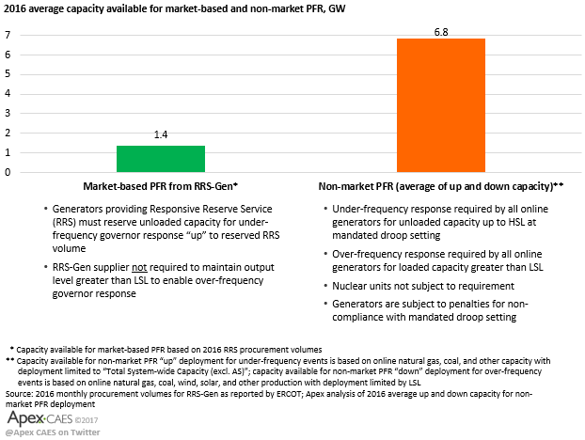

Exhibit 2: Adoption Of Tighter Frequency Deadbands Results In 10X Greater PFR Deployment; Increases From 1-in-40 To 1-in-4 Minutes
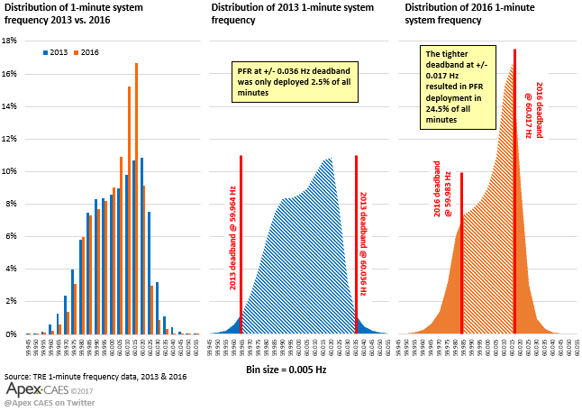

Exhibit 3: Non-Market PFR Deployements Play A Large Role In ERCOT Frequency Control
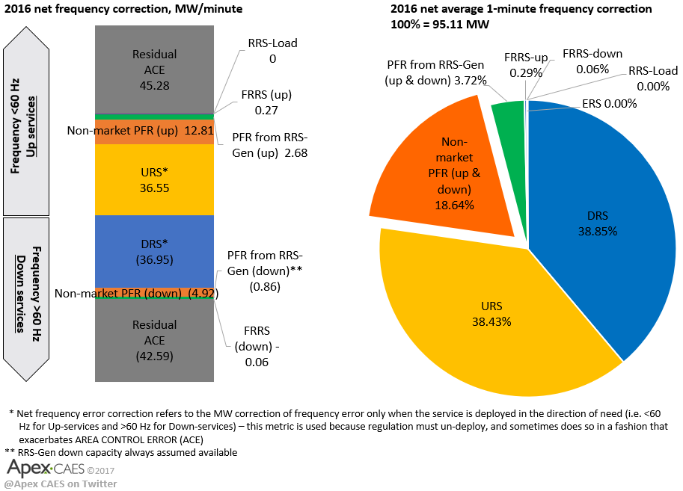

Exhibit 4: Frequency Response Without Tighter Deadbands Would Have Complied With TRE IMFR Standards In 2016 And 2017
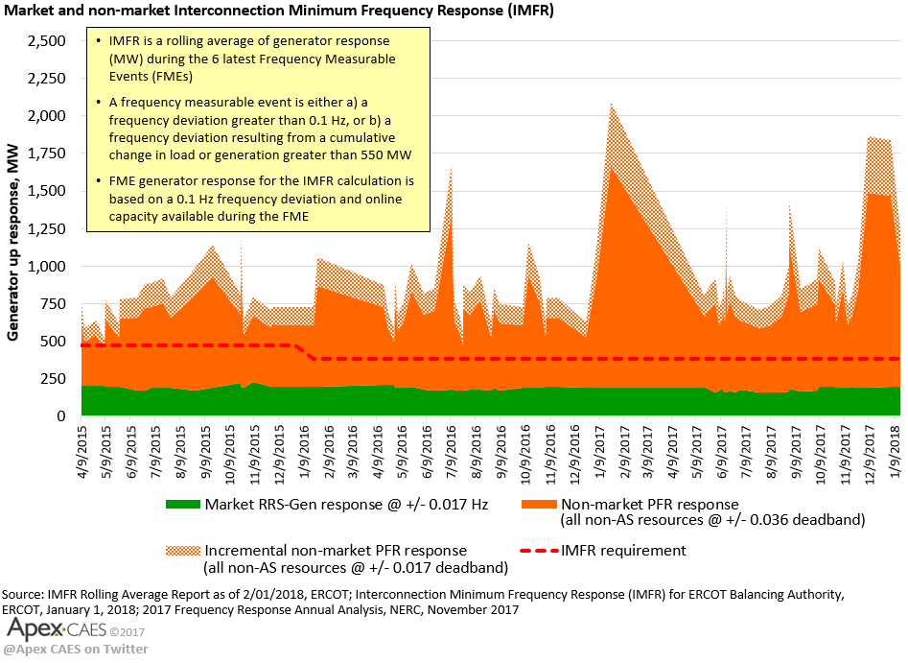

Exhibit 5: Market And Non-Market PFR Deployment During Severe Under-Frequency Event In 2016
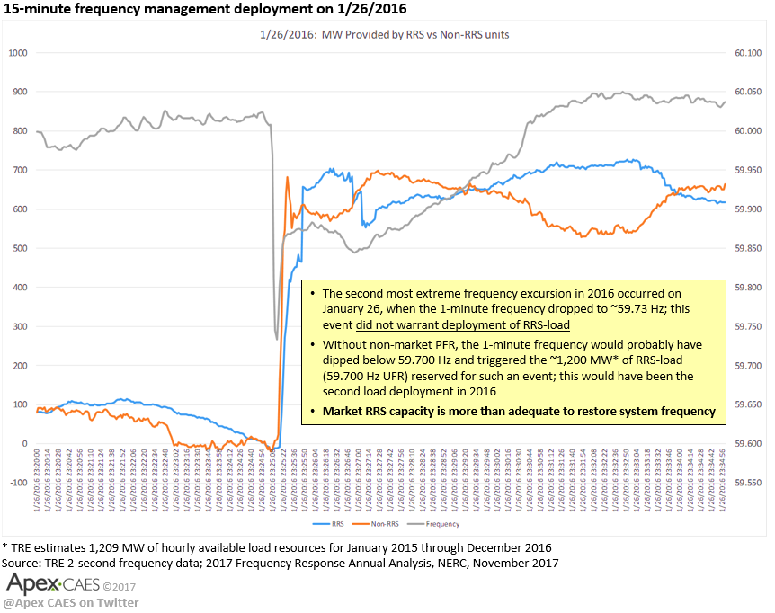

Exhibit 6: 2016 Frequency Control With Non-Market PFR Set To Wider Deadband
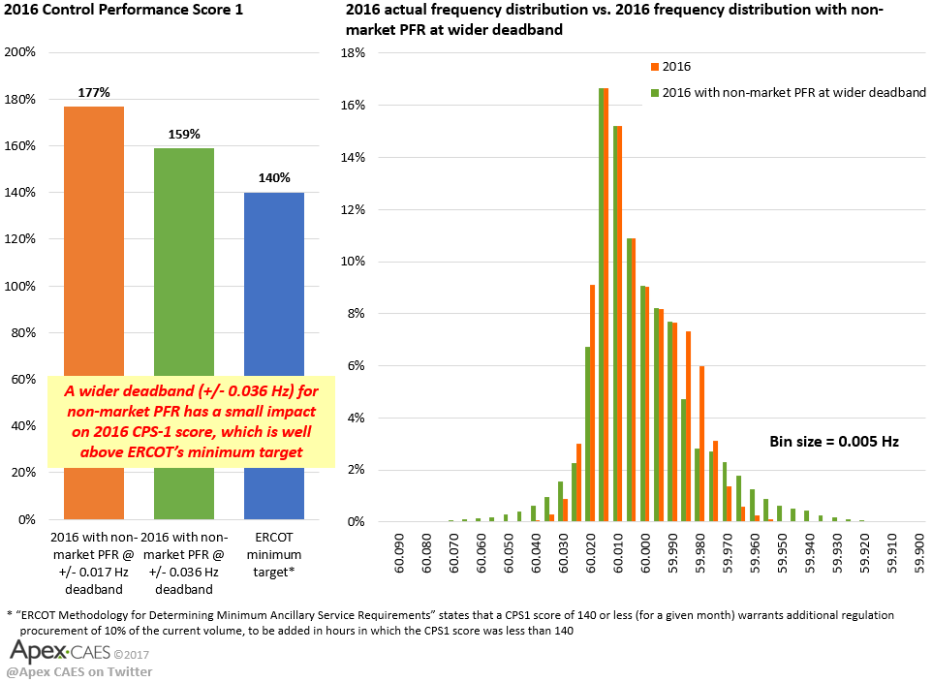
Revised Cover Page Language
None.
Revised Proposed Protocol Language
None.

