TDTMS Meeting Notes
April 20, 2018
1. Antitrust Admonition | 9:30am
2. Introductions
3. Last Month Meeting Notes – updates if any (Approved)
4. ERCOT System Instances & MarkeTrak Monthly Performance Review

Service Availability – March 2018
  - Retail Market IT systems met all SLA targets

Retail Incidents & Maintenance – March 2018
- 03/01/18 – Connectivity to ERCOT's NAESB application may have been intermittent from 7:50 AM to 9:27 AM
- 03/03/18 – ERCOT experienced issues with the service that passes 867_03 transactions to the Settlement System from March 3, 2018 at approximately 3:30 pm to March 6, 2018 at 9:15 am
  - All transactions submitted during the affected period processed on March 6, 2018, during the 3:00 pm data loading run
  - This issue only affected 867 transactions flowing to the Settlement System and did not affect retail transaction processing or AMS processing
- 03/22/18 – ERCOT experienced a processing issue impacting internal retail transaction processing between approximately 12:47 pm and 2:15 pm
  - This may have resulted in unexpected rejections or duplications
  - No data was lost and impacted transactions were reviewed and reprocessed as necessary by 03/23/18
5.NPRR778 Stabilization
- RMTE User Guide Changes
- Draft SCR- requirements to enhance current RMTE
  - To help provide testing participants additional layer of visibility into transaction statuses while sandbox testing, the proposal of a refreshed flat file or Siebel Service Extract would be of interest in exploring with ERCOT.
6. Standing Item: MT Subtype Analysis
Reviewed MT Subtype ‘CWA’ volumes year over year.
- Expected volumes dropped drastically due to NPRR 778 implementation in Dec ’17. Data was plotted below in the bar chart.
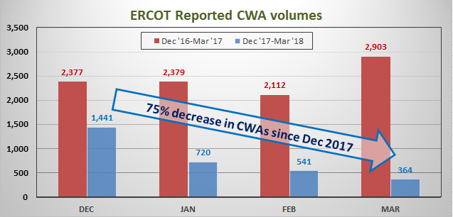

In addition, CWA volumes were compared with IAG/IAL/Customer Rescissions to assess any potential correlations or patterns with the decreased CWA volumes. There were conclusive correlations among the dataset.
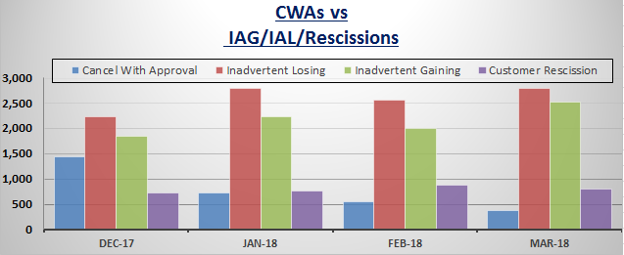
7.TXSET Collaborative Items – if any

8. Adjourned.
After review potentially limited TDTMS agenda items for May, it was concluded with the May meeting to be a combined and coordinated with TX SET.

