PWG Meeting Notes – April 25th, 2018
ERCOT Met Center, Room 168
9:30 am - 12:00 pm

Attendees: via WebEx
Lindsay Butterfield – ERCOT Diana Rehfeldt – TNMP
Bill Boswell – ERCOT Randy Roberts – ERCOT
Sam Pak – Oncor
Sheri Wiegand – TXU
Kathy Scott - CNP
Carolyn Reed – CNP
Jim Lee – AEP
Nikki McKenna - ERCOT

- Meeting minutes from March 19th were approved as proposed with one modification. TDUs indicated the below “go forward” process has not been confirmed.
  - For the initial purpose of identifying the possible population of DRG in the BUSIDRRQ segment, it was decided to leverage the existing reports submitted by the TDSPs to ERCOT (LPG - Profile Decision Tree, DG tab). On a go forward basis, TDSPs would submit an ESI with an Interconnection Agreement and ERCOT would then review if the profile was BUSIDRRQ and note accordingly.

- BUSIDRDG
  - Each of the TDUs presented an update on their progress with the respective lists of BUSIDRRQ ESIs with unregistered DG:
    - TNMP – none on list, all had RID
    - AEP – 14 ESIs in category, w/o RID
    - CNP - < 60 ESIs that did not have RID
    - Oncor – reservations on providing information – felt ERCOT already had “pieces” of information on other reports TDU is required to provide. Oncor will meet with ERCOT (Nikki and Calvin) to discuss plan. ERCOT noted the list was provided as a reconciliation of existing information.
  - Nikki confirmed the ESIs on the list that ERCOT was most interested in were those with PV as this information is used in forecast model.
  - Based on low counts in TDSP service territories, ERCOT will review and consider plan for identification of ESIs on a ‘go-forward’ basis.

- 2018 Annual Validation (AV)
  - Bill Boswell presented the status of the 2018 Annual Validation process…
    - lists of ESIs has been sent to TDSPs
    - Market notice to CRs to request list of impacted ESIs
    - CR reports are available

- Default Profiles
  - RESIDENTIAL default profiles
    - ERCOT was asked to review current distribution of residential profiles by weather zone to validate the default profiles. All weather zones confirmed the larger percentage align with default profile. Only two weather zones have a difference less than 3% - NORTH and SCENT.
    - This information supports the accuracy of the default classifications and review every three years.
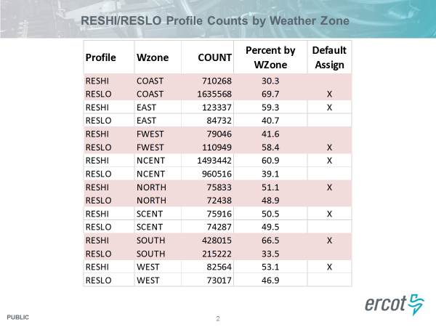

- BUSINESS default profiles
  - ERCOT presented the below information to address the distribution of NIDR profiles. There was a question on the larger number of NIDR counts in Oncor’s territory if this represented the old Sharyland ESIs
  - Understanding the AV process, these transitioned ESIs would not have been included since there was little historical consumption
  - Oncor was asked to confirm if previous Sharyland profiles were preserved when establishing the new Oncor ESIs (if they were revised after initial creation using the default profile). Sam Pak to confirm.
  - Bill presented the three BUS profile graphs – HI, MED, and LO. Nikki will plot all three on the same scale to determine the impact on possible settlement.
  - FOLLOW UP QUESTION (from Sheri)- Can ERCOT provide the total MWHs (in aggregate) for the ESIs moving from BUSMED to BUSHI and those from BUSMED to BUSLO? This should address Clayton’s inquiry regarding a few ‘big ones’ outweighing many ‘small ones’.
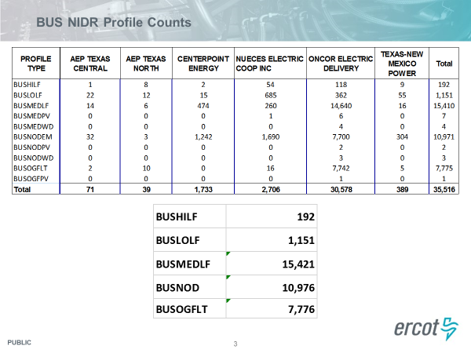

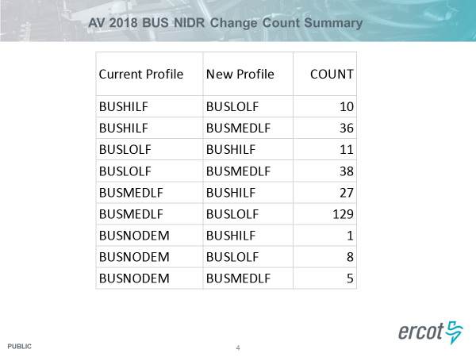

- Annual Validation Proposed Process Revisions
- There have been no REP concerns voiced on the proposed AV process – BUS ESIs annually, RES ESIs every three years
- Prior to submitting an NPRR/LPGRR to codify the proposal, Sheri wanted to present the new findings on default profiles to the market via COPS.
- The WG has prepared DRAFT language for an LPGRR and NPRR should the WG choose to proceed. The revisions are embedded here.

- NEXT MEETING: Wednesday, May 23rd @ 9:30 am, WebEx only

- PROPOSED AGENDA for 5/23
1. Update on BUSIDRRQ profiles ESIs for DG identification need on a go-forward basis
2. 2018 Annual Validation status
3. Review of BUS default profile shapes and clarification of Oncor NIDR counts
4. Annual Validation Proposed Process – discuss feedback

