

ERCOT White Paper on
Resource Definitions
in the ERCOT Protocols

Submitted to the Resource Definition Task Force (RTF) on MM YY, 2018.

Document Revisions
Date | Version | Description | Author(s)
4/28/2018 | a | Initial draft outline for RTF review/discussion | ERCOT Staff
5/9/2018 | b | First revision after RTF feedback | ERCOT Staff

Table of Contents
1 Executive Summary 4
2 Introduction 7
3 Identify list of issues and methods for resolution. 7
3.1 Stage 1 - Align Definitions to identify differences 8
3.2 Stage 2 - Clarify Definitions for Transmission connected resources 8
3.3 Stage 3 - Clarify Definitions for distribution connected resources 8
4 Review of NERC, PURA, PUCT Rules and ERCOT Protocols Terms. 11
5 Development of Framework. 11
6 Existing Terms needing revision (with consensus) 13
7 New Terms (with consensus) 14
8 Terms either unresolved, or no consensus 14
9 References 14
9.1 NERC Definitions 14
9.2 Public Utility Commission Rules 15
9.3 ERCOT Definitions and Protocols 15
Appendix A – List of Issues brought up in RTF 16
Appendix B -

Executive Summary
ERCOT market participants are concerned that resource definitions have become increasingly complex and confusing, which has led to inconsistent registration of small generators and sometimes contradicting terms for all generation resources. The Resource Definition Task Force (RTF) was created to ensure that the terms for Resources and other generators used within the ERCOT protocols, operating guides, and binding documents, are consistent and clear.
The RTF’s scope of work should include consideration of the following issues:
- Review previous guidance and references to Resource definitions in PURA, the ERCOT Zonal/Nodal Protocols, as well as NERC definitions.
- Identify problematic terms and potential differences that need to be resolved.
- Improve the current structure and terms where practical
- Clarify, where appropriate, existing Resource definitions, including but not limited to the term “Non-Modeled Generation” that are:
  - Transmission connected
  - Distribution connected
- Consider existing and future Resource types that may not currently be defined but should be reviewed as part of the task force.

The first stage of work consisted of comparing all of the various terms used by NERC, PURA, PUC substantive rules and ERCOT protocols to identify areas needing resolution. An overarching framework was generated to help understand the various generation resources in ERCOT, and their relation to each other. Once consensus was achieved on the new terms or definitions, a resource framework was created to capture all key issues and gaps (if any).

The second stage of work will focus on clarifying definitions for transmission-connected resources, and once the basic definitions are clarified, NPRR #1 will be submitted to revise/replace the term “Non-modeled generator”. Subsequent NPRRs may be required to resolve other transmission connected resources

The third stage of work will focus on definitions for distribution-connected resources.
This work can be in parallel with stage 2 as the work required for resolving distribution connected resources may be completely independent from the work required for transmission resources. It is expected that multiple new concepts that would take extended periods to define. Subsequent NPRRs (plural) are expected to be needed to resolve distribution connected resource issues

This whitepaper is intended to provide as summary of the first stage of work as well as the basis of understanding for the development of upcoming proposed revisions to both ERCOT protocols and other market rules. As work is completed on stages 2 and 3, addendums to this whitepaper will be made for clarification.

An initial overall framework representing the registration requirements from the ERCOT protocols is shown in figure 1. Terms highlighted in yellow boxes were identified as key items to resolve.

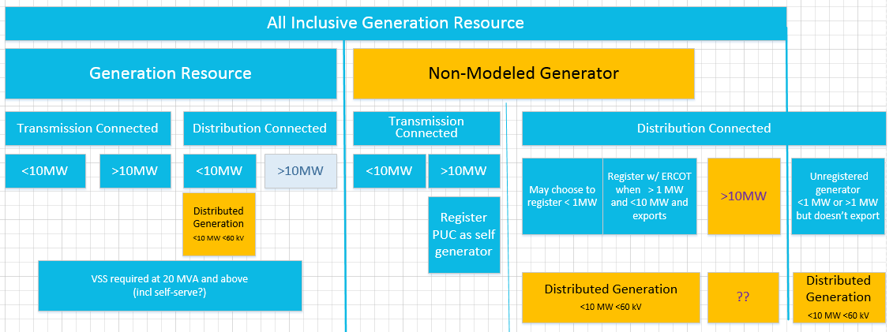
Figure 1 – Initial Framework

The three areas responsible for the most confusion were “non-modeled generator”, “distributed generation”, and lack of explicit definition for distribution connected generation greater than 10 MW. The first item to be addressed was to propose the term “settlement only generator” (borrowed from ISO-NE) in place of the term “non-modeled generator” and it has been generally accepted. After additional discussion, a better understanding of the framework based on generator size, connection and market participation emerged, and is shown in figure 2.
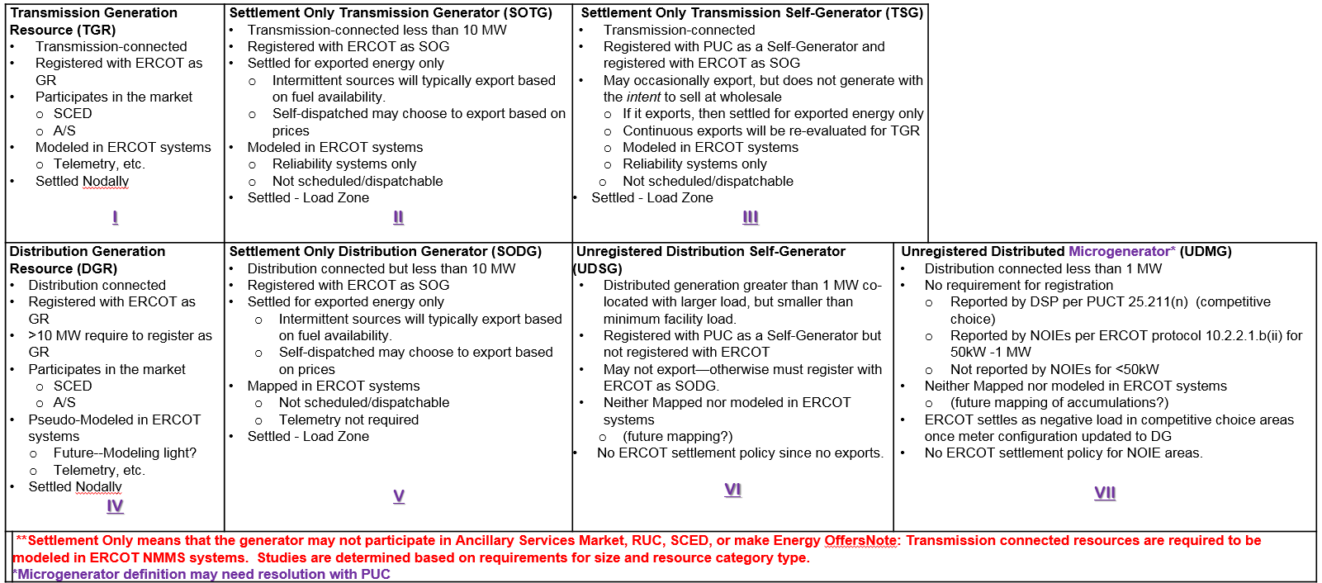
Figure 2 – Proposed Categories with registration and market requirements

This proposal clearly identifies Generation Resources (capital G capital R) as the left two blocks (I and IV) in this matrix. The next blocks for Settlement Only (II, III, V) are resources paid for power exported, but are not dispatchable by ERCOT. Finally, the unregistered resources (blocks VI, VII), are invisible to ERCOT. The final proposed framework is shown in Figure 3.
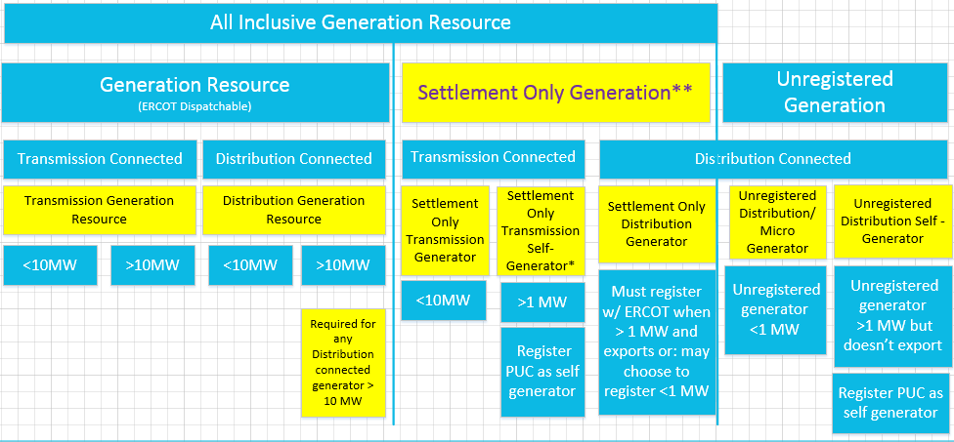
**Settlement Only Generators can’t participate in Ancillary Services market, RUC, SCED or make energy offers.
*Transmission Self Generator may occasionally export, but does not generate with the intent to sell at wholesale.

Figure 3 – Proposed Framework and naming convention.

Introduction
The Resource Definition Task Force was established after the Market Participants expressed concern to the Technical Advisory Committee that Resource definitions have become increasingly complex and confusing, and recommended a holistic effort to clarify the definitions. Confusion regarding definitions has led to inconsistent registration of small generators and contradicting terms for all generation resources. The RTF is focused on ensuring that the terms for Resources and other generators used within the ERCOT protocols, operating guides, and binding documents, are consistent and clear.

The RTF’s scope of work should include consideration of the following issues:
- Review previous guidance and references to Resource definitions in PURA, the ERCOT Zonal/Nodal Protocols, as well as NERC definitions.
- Identify problematic terms and potential differences that need to be resolved.
- Improve the current structure and terms where practical
- Clarify, where appropriate, existing Resource definitions, including but not limited to the term “Non-Modeled Generation” that are:
  - Transmission connected
  - Distribution connected
- Consider existing and future Resource types that may not currently be defined but should be reviewed as part of the task force.

The RTF membership consists of ERCOT staff and other interested Transmission and/or Distribution Service Providers (TDSPs), Qualified Scheduling Entities (QSEs) and Resource Entities. Meetings of the RTF are open to all interested parties. Jay Teixeira from the ERCOT Resource Integration department and David Ricketts from Vistra Energy were nominated as co-chairs to coordinate activities.

Identify list of issues and methods for resolution.

Now that the Resource Definition Task Force has been engaged, a running list of issues to resolve was established. Many items were identified over the subsequent months as the group discussions progressed and . Although some of the items were within the scope of this task force to address, other items were beyond the scope of this task force to resolve, as many of them dealt with items such as market-based issues, or technical requirements. Those items outside of the RTF scope have been summarized below and will be forwarded to the appropriate working groups (ROS, WMS, etc) to address.

In addition to identifying where the issues needed to be resolved, a top priority was identifying how the issues could be resolved as well as when.
Previous attempts to address the various issues around non-modeled generation or distributed generation became bogged down, so a stepwise project approach to selectively identify and resolve issues was chosen.

Stage 1 - Align Definitions to identify differences
The first stage consisted of comparing all of the various terms used by NERC, PURA, PUC substantive rules and ERCOT protocols to identify areas needing resolution. An overarching framework was generated to help understand the various generation resources in ERCOT, and their relation to each other.
Once consensus was achieved on the new terms or definitions, a resource framework was created to capture all key issues and gaps (if any). These new terms were then published in this whitepaper along with terms or definitions without consensus.

The estimated duration for this first stage was approximately 6-8 months.

Stage 2 - Clarify Definitions for Transmission connected resources

Once the issues were identified, and the framework agreed upon, the second stage clarified definitions for transmission-connected resources.
Once the definitions were clarified, NPRR #1 was submitted to for revise/replace the term “Non-modeled generator”. Subsequent NPRRs may be required to resolve other transmission connected resources.

The estimated duration for this second stage is approximately 6-8 months.

Stage 3 - Clarify Definitions for distribution connected resources

Once the “Non-modeled” definition has been resolved, the third stage envisions clarifying any definitions for distribution-connected resources.
This work can go along in parallel with stage 2 to some extent as the work required for resolving distribution connected resources is expected to be completely independent from the work required for transmission resources. In addition, there may be multiple new concepts that may take extended periods to define.
Subsequent NPRRs (plural) are expected to resolve distribution connected resource issues.

The estimated duration for this last stage is approximately 6-8 months.

Figure X – Issues List of items to be resolved

Review of NERC, PURA, PUCT Rules and ERCOT Protocols Terms.
The next action was to review all of the existing definitions in PURA, NERC, the PUC substantive rules and finally the ERCOT Nodal Protocols. The goal was to see if there were any significant mismatches, gaps, or overlaps between the various rules.
ERCOT’s Legal team, assisted by Dave Ricketts, assembled a table of all of the definitions and is shown in Appendix A – Definition Review. The group reviewed the various definitions and confirmed the various areas where there were gaps and overlaps. Several of these are in the PUC substantive rules, so these will hopefully be addressed in a future rule change.
At this point
After reviewing the terms, it became apparent that an overall framework was required to provide for a reference and hierarchy of the various terms.

Development of Framework.

An overarching framework based on the existing definitions and protocols was developed by Jay Teixeira to help illustrate visually how the protocols define the resources. This visual representation is entirely a new concept and is shown below in figure X with the areas needing to be clarified highlighted in yellow.
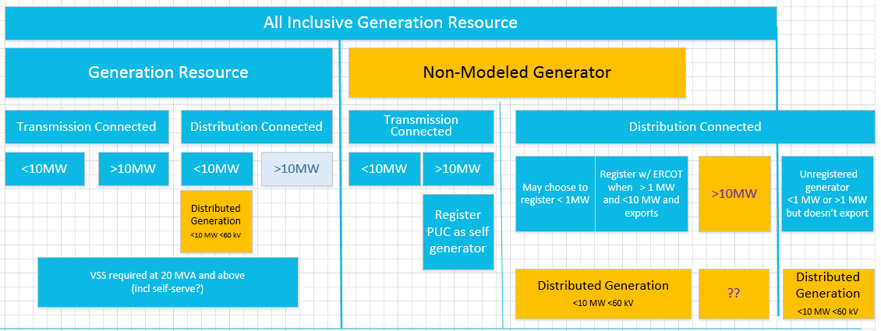
Figure 4 – Existing All Inclusive Generation Resource Framework
The above categories simply reflect how All-inclusive generation resources are classified based on their size, connection and, to some extent, market participation. This figure excludes Load Resources. One item that immediately stands out is “distributed generation”, since it spans at least four different categories of generation resources described in the ERCOT protocols. This, along with other details, led to a scrutiny of what the definitions actually mean.
A Generation Resource is defined as “a generator capable of providing energy or Ancillary Service to the ERCOT System and is registered with ERCOT as a Generation Resource. The term “Generation Resource” used by itself in these Protocols does not include a Non-Modeled Generator”, which is somewhat of a circular definition.
A Resource, “is used to refer to both a Generation Resource and a Load Resource. The term “Resource” used by itself in these Protocols does not include a Non-Modeled Generator or an ERS Resource.”
A Non-Modeled Generator is “a generator that is: (a) Capable of providing net output of energy to the ERCOT System; (b) Ten MW or less in size; or greater than ten MW and registered with the PUCT according to P.U.C. SUBST. R. 25.109, Registration of Power Generation Companies and Self-Generators, as a self-generator; and (c) Registered with ERCOT as a Non-Modeled Generator, which means that the generator may not participate in the Ancillary Service or energy markets, RUC, or SCED.

Contributing to the confusion, the various Resources are comprised of different fundamental technologies which are referenced in the Nodal protocols, but only a few of these technologies are actually in the definitions section of the protocols, but are used elsewhere in the protocols.
Although the definitions section of the protocols under the term “Resources” is several pages long, the definitions are somewhat vague, and sometimes refer to the generation technologies as Resources which is what has led to much of the confusion, since they are “categories of resources”, and not actually Resources. For example,several resource technologies, such as a natural gas simple cycle generator or solar photovoltaic system, can be the power source for almost any of the Resources above, so simply referring to a Simple Cycle Resource or Solar Photovoltaic Resource does not help define what kind of resource it actually is, since the unit could easily be under any of the generation categories shown in figure 4, from a Transmission connected generation resource to a non-modeled generator connected at distribution.
So, getting back to basics, the ERCOT protocols use connectivity and size as the first differentiating feature, which is the basis for the framework shown in figure 4.
Generation Resources also have other “attributes” or “status”, and based on those, are eligible to participate in different markets and offer different services, as defined in the Protocols. As an example, a resource that has an attribute that it can be qualified as “quick starting”can provide certain ancillary services. It should be noted that several technology categories have certain attributes that would enable them to meet those particular qualifications.
Therefore, the next step was to separate out these various technologies, attributes and services as shown in figure 5, below.

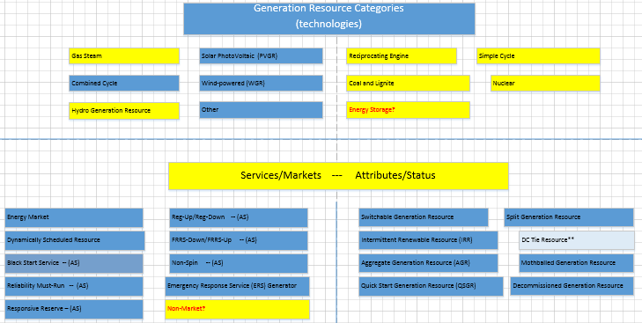
Figure 5 – Generation Technologies, Services and Attributes

After these categories and attributes are recognized as being characteristics of the resources, and not the types of resources themselves, a more robust framework starts to emerge of the types of resources based on their size, connectivity, technologies, attributes and market participation.
The most contentious term, “non-modeled generation” needed to be addressed first. Historically, it has been a relative oxymoron, since ERCOT has typically modeled all “non-modled” generators connected to the transmission system for reliability. Several other ISO’s have started to address the same type of generation described by the term non-modeled, but ISO-NE has already adopted the term “Settlement Only” to describe these types of generation resources that are paid for energy exported, but are not registered as Generation Resources and are not dispatchable. As there have been no objections to “Settlement Only” yet, it is proposed as a replacement for “non-modeled” generation.
After more discussion, the following matrix emerged shown in figure 6 which takes into account the various requirements for registration with the PUC, as well as market participation.

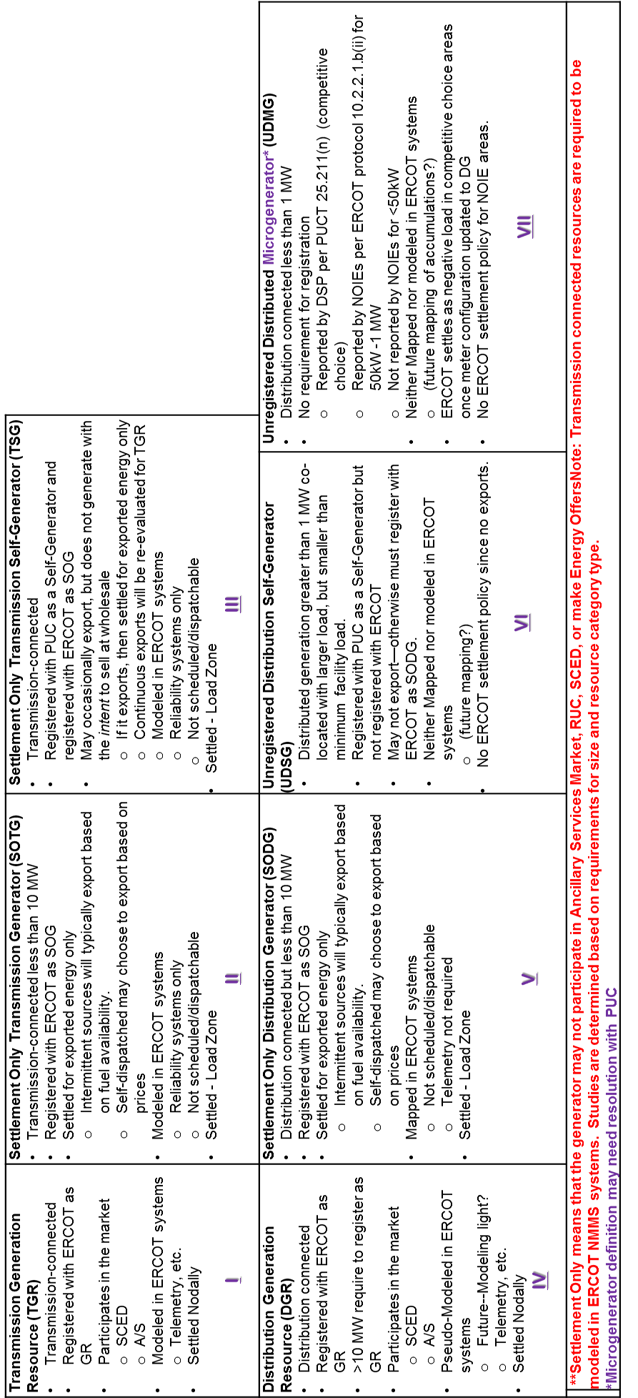
ERCOT-dispatchable Generation Resources are shown in the first column (boxes I and IV) and include all of the requirements for G.R. such as telemetry, modeling, as well as requiring resource nodes for energy generated.

This then clarifies the framework which results in the final proposal shown in figure 7.
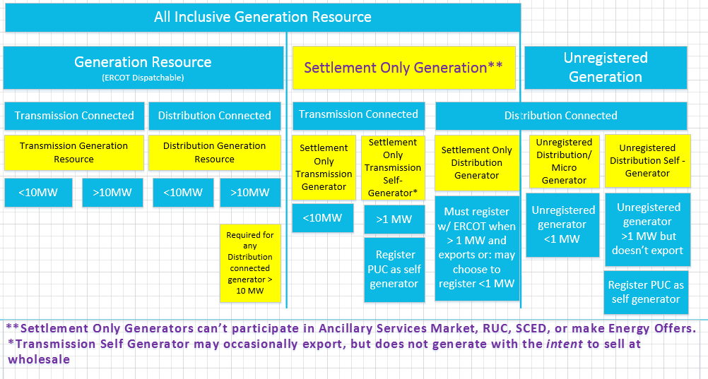
Figure 7 – Proposed Resource Definition Framework.

Therefore, a flow chart can be developed that now defines the process of registration and qualification.

Existing Terms needing revision (with consensus)
The following terms need to be addressed either by the PUC or by ERCOT as they either overlap or contradict.

Customer

Distributed Generation (DG) The existing definition, although adequate, is confusing in that it refers to multiple categories of generation resources in ERCOT.
Distributed Renewable Generation (DRG) This term adds confusion as it is only used in reference to the Renewable Energy Credit program.
Aggregate Generation Resource (AGR)
This term in the ERCOT protocols, currently only to transmission connected resources.

New Terms (with consensus)

Distributed Generation (DG)
An electrical generating facility located at a retail electric Customer’s point of delivery (point of common coupling) ten megawatts (MW) or less and connected at a voltage less than or equal to 60 kilovolts (kV) which may be connected in parallel operation to the utility system.
Distributed Renewable Generation (DRG)
Electric generation with a capacity of not more than 2,000 kW provided by a renewable energy technology that is installed on a retail electric Customer’s side of the meter.
Aggregate Generation Resource (AGR)
A Generation Resource that is an aggregation of non-wind generators, each of which is less than 10 MW in output, which share identical operational characteristics and are interconnected at the same POI and located behind the same Generator Step-Up (GSU) transformer (with a high-side voltage greater than 60 kV).

Terms either unresolved, or no consensus

References

NERC Definitions
See the following definition:

Public Utility Commission Rules
See the following Substantive Rules:
- Electric Rules
http://www.puc.texas.gov/agency/rulesnlaws/subrules/electric/25.211/25.211.pdf

ERCOT Definitions and Protocols

See the following ERCOT Protocol sections:
- Definitions
http://www.ercot.com/content/wcm/current_guides/53528/02-030118_Nodal.doc
- Full combined protocol
http://www.ercot.com/content/wcm/libraries/148953/March_1__2018_Nodal_Protocols.pdf

Appendix A – List of Issues brought up in RTF

Appendix B – Examples of Transmission Connected Resources

Appendix C – Examples of Distribution Connected Resources

