 |  |  |  | System Planning
Monthly Status Report
March 2018

 |  | Report Highlights
- ERCOT is currently reviewing proposed transmission improvements with a total estimated cost of $903.5 Million.
- Transmission Projects endorsed in 2018 total $43 Million.
- All projects (in engineering, routing, licensing and construction) total approximately $7.21 Billion as of March 1, 2018.
- Transmission Projects energized in 2018 total about $220.8 Million as of March 1, 2018.

Regional Planning Group Project Reviews
- Garland Power & Light and Oncor have jointly submitted the North Garland Reliability Infrastructure Project (N-GRIP). This is a Tier 1 project that is estimated to cost $78 million. The ERCOT independent review for this project is currently placed on hold per the request of GPL.
- WETT has submitted the Bearkat Area Transmission Improvements project. This is a Tier 1 project that is estimated to cost $69.9 million. This project is currently under ERCOT Independent Review.
- Oncor has submitted the Far West Texas Dynamic Reactive Devices project. This is a Tier 1 project that is estimated to cost $86 million. This project is currently under ERCOT Independent Review.
- AEPSC has submitted the LRGV Import Project. This is a Tier 1 project that is estimated to cost $73.4 million. AEPSC has also requested that ERCOT provide conditional endorsement for an additional $357.2 million project. This project is currently in the RPG study mode.
- Oncor has submitted the Far West Texas Project 2. This is a Tier 1 project that is estimated to cost $194 million. This project is currently under ERCOT Independent Review.
- Oncor has submitted the Grapevine Switching Station project. This is a Tier 2 project that is estimated to cost $25 million. This project is currently under ERCOT Independent Review.
- CenterPoint Energy has submitted the Southwyck - Algoa Corner Rebuild project. This project was initially classified as a Tier 3 project with an estimated cost of $20 million. The project has completed RPG comments, and it was re-classified as a Tier 4 Neutral project.
More information on current and past RPG projects can be found on the ERCOT MIS Secure (digital certificate required): https://mis.ercot.com/pps/tibco/mis/Pages/Grid+Information/RegionalPlanning
Past email communication on RPG projects can be found on the ERCOT listserve by signing up for the REGPLANGROUP list: http://lists.ercot.com/scripts/wa-ERCOT.exe?A0=REGPLANGROUP

Planning Model Activities
The short term calendar of major planning model events is as follows:
- July 1, 2018 Post 18SSWG Base Cases and TPIT
- July 20, 2018 Post Contingency definitions and Planning Data Dictionary
The following table shows interconnection projects that met Planning Guide section 6.9(1) and 6.9(2) and were modeled in the SSWG cases as either complete or as a simple model in accordance with Planning Guide section 6.9. The 6.9(2) Deadline shown in red have received a notification that the 60 day deadline has past and the set of planning data has not been received.
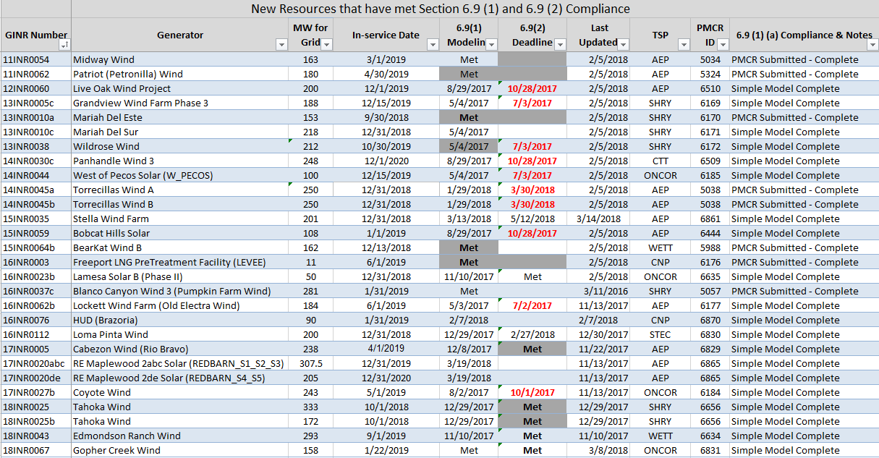

Permian Basin Oil Rig Count
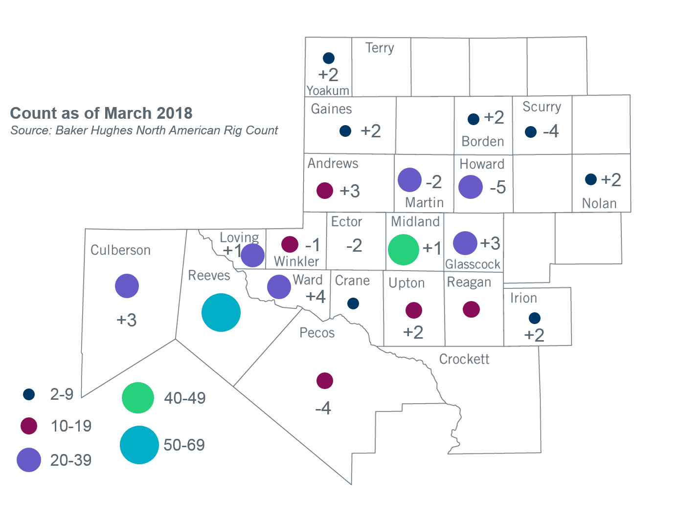
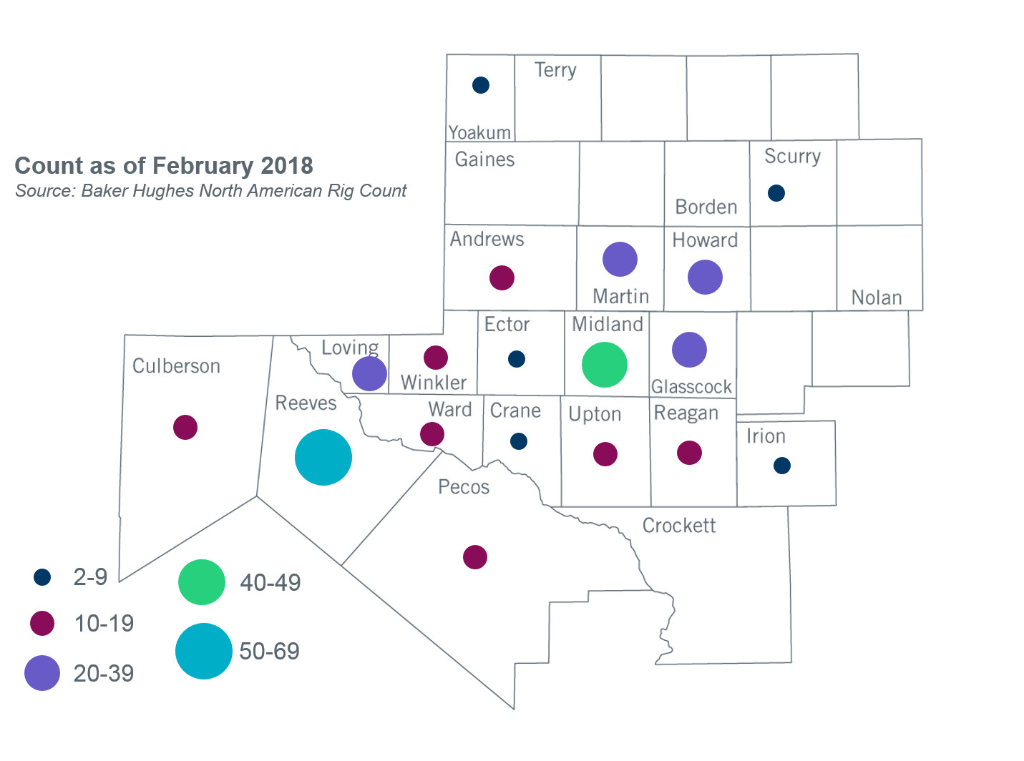

Other Notable Activities
- ERCOT is developing the 2018 Regional Transmission Plan (RTP) study. ERCOT shared an udpated draft of scope and assumptions document for the 2018 RTP at the March RPG meeting. Stakeholders are encouraged to provide feedback for the 2018 RTP study. ERCOT is currently performing load review required by PG 3.1.7. Loads for all weather zones except Far West have been finalized. ERCOT is currently coordinating its load review with TPs that have load-serving substations in the Far West weather zone.
- ERCOT continues to work on the 2018 Long-term System Assessment (LTSA). ERCOT presented findings from the initial generation expansion analysis for the Current Trends scenario at the February RPG meeting. ERCOT will continue working on generation expansion analysis for other scenarios and begin conducting the transmission expansion analysis for the Current Trends scenario.
- The SPWG completed the 2018 CY base cases and is working on the 2019-2023 FY cases.

+/- symbol indicates the increase or decrease from the previous month in oil rigs present in each county. There are 352 rigs, including a total increase of 9 oil rigs in the Permian Basin from February to March 2018.

