March 2018 ERCOT Monthly Operations Report
Reliability and Operations Subcommittee Meeting
May 3rd, 2018

Table of Contents
1. Report Highlights 2
2. Frequency Control 3
2.1. Frequency Events 3
2.2. Responsive Reserve Events 4
2.3. Load Resource Events 4
3. Reliability Unit Commitment 4
4. Wind Generation as a Percent of Load 5
5. COP Error Analysis 5
6. Congestion Analysis 7
6.1. Notable Constraints 7
6.2. Generic Transmission Constraint Congestion 11
6.3. Manual Overrides 11
6.4. Congestion Costs for Calendar Year 2018 11
7. System Events 12
7.1. ERCOT Peak Load 12
7.2. Load Shed Events 12
7.3. Stability Events 12
7.4. Notable PMU Events 12
7.5. DC Tie Curtailment 13
7.6. TRE/DOE Reportable Events 13
7.7. New/Updated Constraint Management Plans 13
7.8. New/Modified/Removed RAS 13
7.9. New Procedures/Forms/Operating Bulletins 13
8. Emergency Conditions 13
8.1. OCNs 13
8.2. Advisories 14
8.3. Watches 14
8.4. Emergency Notices 14
9. Application Performance 14
9.1. TSAT/VSAT Performance Issues 14
9.2. Communication Issues 14
9.3. Market System Issues 14
10. Model Updates 14
Appendix A: Real-Time Constraints 16

Report Highlights
- The unofficial ERCOT peak for March was 46,799 MW.
- There were four frequency events in March. PMU data indicates the ERCOT system transitioned well in each case.
- There was three instances where Responsive Reserves were deployed.
- There were no RUC commitments in March.
- Congestion in March was concentrated in the West, South, and North Load Zones. Congestion in the West and North can be mostly attributed to varying wind generation patterns in the Panhandle as well as multiple planned and forced outages. There were 48 instances over 31 days on the Generic Transmission Constraints (GTCs) in March, including 29 days on the Panhandle GTC, 16 days on the Nelson Sharpe – Rio Hondo GTC, 2 days on the North to Houston GTC, and 1 day on the Valley Import GTC. There was no activity on the remaining GTCs during the month.
- There were five DC Tie curtailments in March. Four of them were due to DC Tie Forced Extensions, 3 of which included only 1 tag curtailment, the 4th including 2. The fifth was due to local congestion and included one tag curtailment.

Frequency Control

Frequency Events
The ERCOT Interconnection experienced four frequency events in March, all of which resulted from Resource trips. The average event duration was approximately 0:03:54.

A summary of the frequency events is provided below. The reported frequency events meet one of the following criteria: Delta Frequency is 60 mHz or greater; the MW loss is 350 MW or greater; resource trip event triggered RRS deployment. Frequency events that have been identified as Frequency Measurable Events (FME) for purposes of BAL-001-TRE-1 analysis are highlighted in blue. When analyzing frequency events, ERCOT evaluates PMU data according to industry standards. Events with an oscillating frequency of less than 1 Hz are considered to be inter-area, while higher frequencies indicate local events. Industry standards specify that damping ratio for inter-area oscillations should be 3.0% or greater. For the frequency events listed below, the ERCOT system met these standards and transitioned well after each disturbance.

Date and Time | Delta Frequency | Max/Min Frequency | Duration of Event | PMU Data |  | MW Loss | Load | Wind | Inertia
 | (Hz) | (Hz) |  | Oscillation Mode (Hz) | Damping Ratio |  | (MW) | % | (GW-s)
3/5/2018 6:51 | 0.097 | 59.88 | 0:04:35 | 0.73 | 12% | 513 | 35,955 | 35% | 204,030
3/24/2018 20:47 | 0.158 | 59.85 | 0:04:29 | 0.63 | 11% | 797 | 41,179 | 17% | 253,274
3/28/2018 20:35 | 0.073 | 59.91 | 0:02:43 | No PMU Report Created |  | 354 | 39,280 | 11% | 241,593
3/29/2018 16:09 | 0.085 | 59.89 | 0:03:50 | 0.65 | 7% | 434 | 41,131 | 8% | 250,169

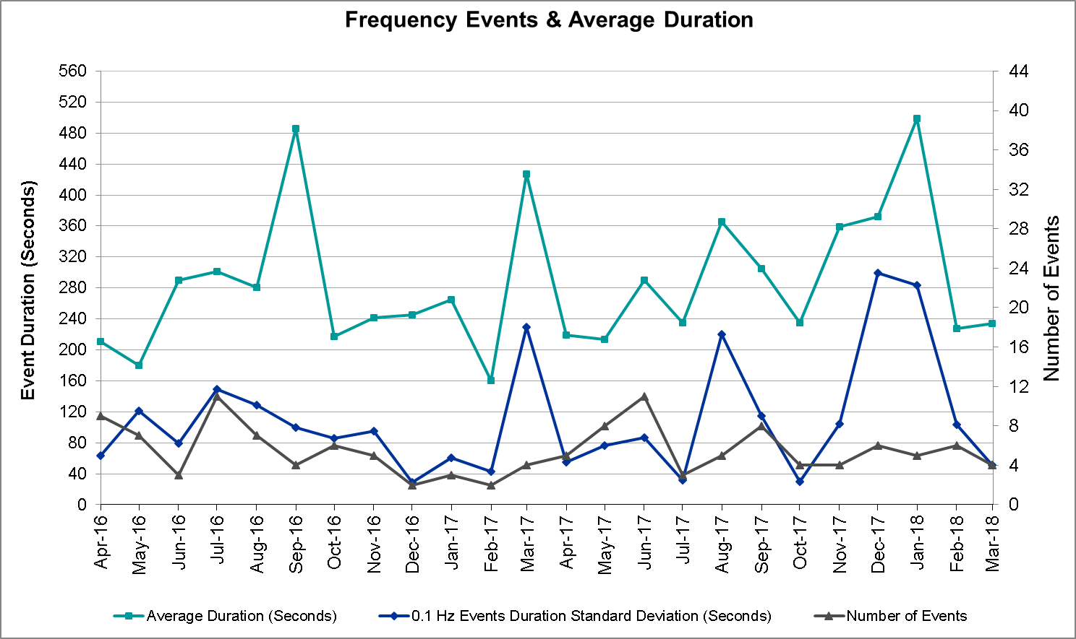
(Note: All data on this graph encompasses frequency event analysis based on BAL-001-TRE-1.)

Responsive Reserve Events
There were three events where Responsive Reserve MWs were released to SCED in March. The events highlighted in blue were related to frequency events reported in Section 2.1 above.

Date and Time Released to SCED | Date and Time Recalled | Duration of Event | Maximum MWs Released | Comments
3/5/2018 6:51:28 | 3/5/2018 6:52:28 | 0:01:00 | 461.85
3/24/2018 20:47:21 | 3/24/2018 20:50:40 | 0:03:19 | 701.88
3/29/2018 16:09:48 | 3/29/2018 16:13:24 | 0:03:36 | 369.44

Load Resource Events
Date and Time Released | Date and Time Recalled | Duration of Event | Maximum MW
3/18/2018 21:57 | 3/19/2018 2:00 | 0:04:03 | 3.1

Reliability Unit Commitment
ERCOT reports on Reliability Unit Commitments (RUC) on a monthly basis. Commitments are reported grouped by operating day and weather zone. The total number of hours committed is the sum of the hours for all the units in the specified region. Additional information on RUC commitments can be found on the MIS secure site at Grid Generation Reliability Unit Commitment.

There were no DRUC commitments in March.

There were no HRUC commitments in March.

Wind Generation as a Percent of Load
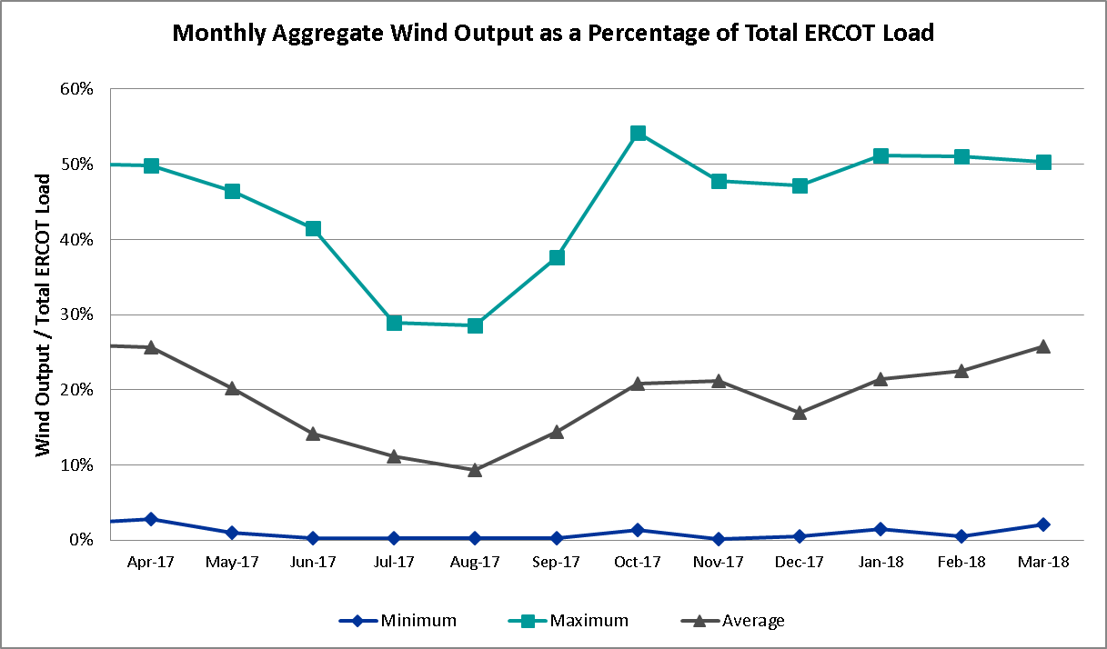

COP Error Analysis
COP Error is calculated as the capacity difference between the COP HSL and real-time HSL of the unit. Mean Absolute Error (MAE) stayed high over 9,000 MW until Day-Ahead at 12:00, then dropped significantly to 1,708 MW by Day-Ahead at 14:00. In the following chart, Under-Scheduling Error indicates that COP had less generation capacity than real-time and Over-Scheduling Error indicates that COP had more generation capacity than real-time. Under-Scheduling persisted from beginning of Day-Ahead to end of the Operating Day. Snapshot on the Operating Day considers all Operating Hours, including past hours. However, COP error for the Operating Hour freezes after the Adjustment Period.
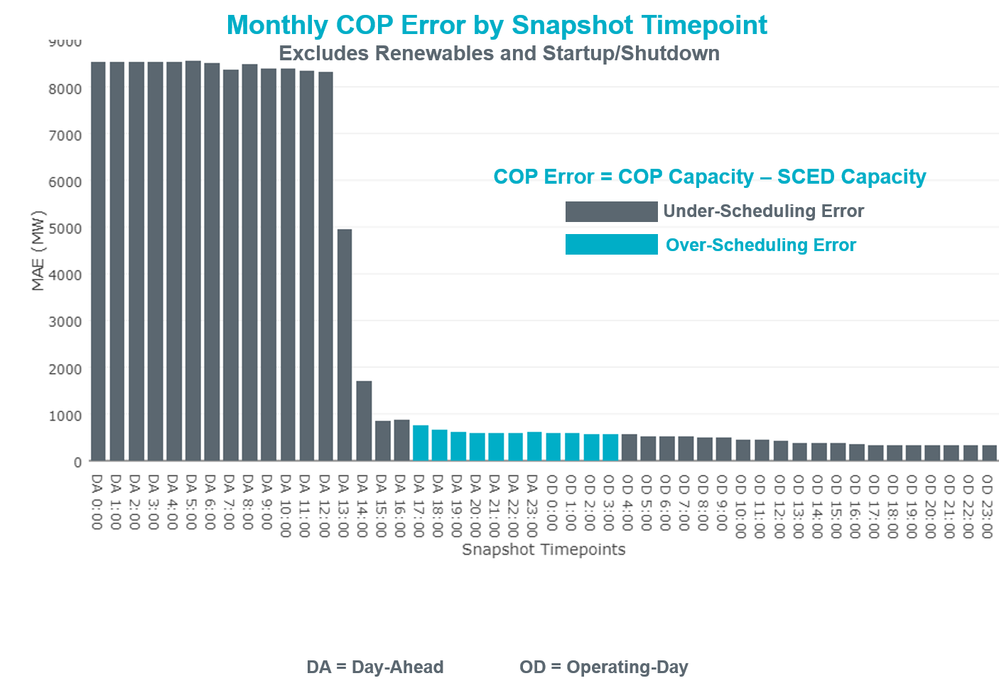

Monthly MAE for the Latest COP at the end of the Adjustment Period was 331 MW with median ranging from -328 MW for Hour-Ending (HE) 6 to -46 MW for HE 7. March 25th HE 18 had the largest Over-Scheduling Error (1,831 MW) and Mar 20th HE 22 had the largest Under-Scheduling Error (-2,218 MW).
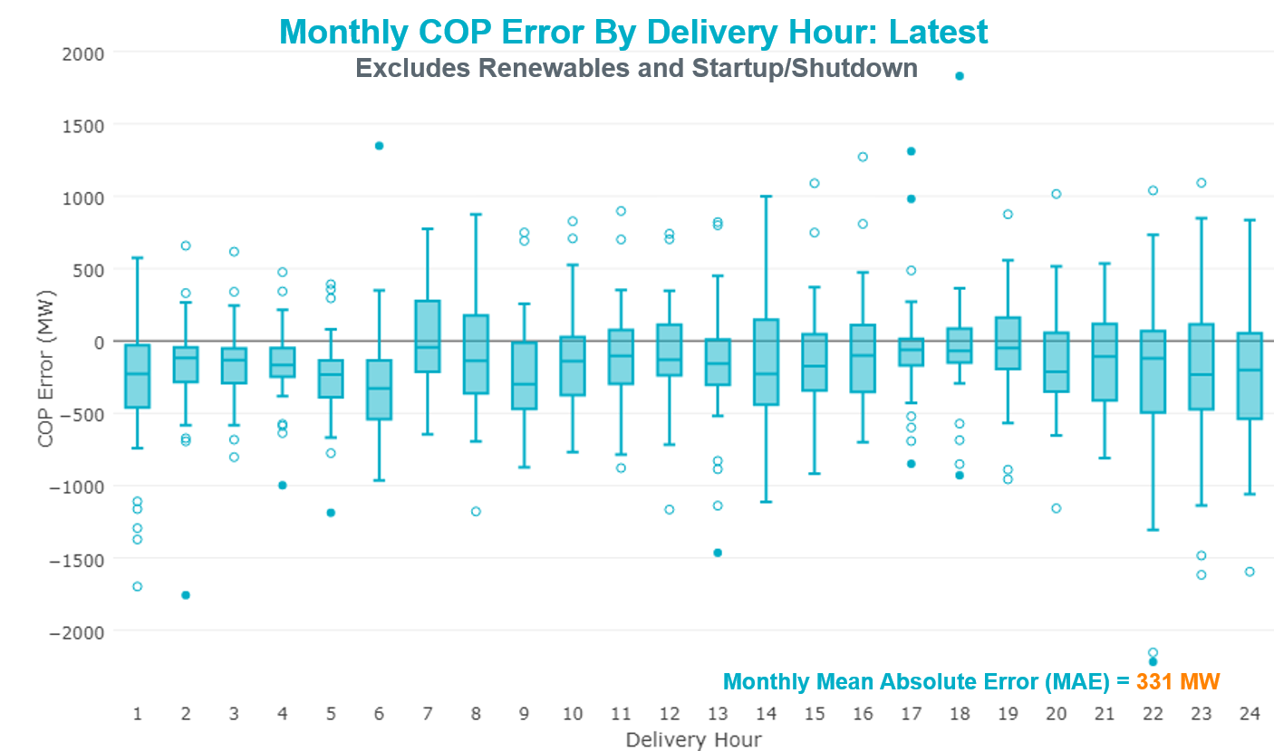
Monthly MAE for the Day-Ahead COP at 12:00 was 8,303 MW with median ranging from -10,736 MW for Hour-Ending (HE) 16 to -6,036 MW for HE 2. March 4th HE4 had the smallest Under-Scheduling Error (-628 MW) and March 26th HE 18 had the largest Under-Scheduling Error (-16,186 MW).

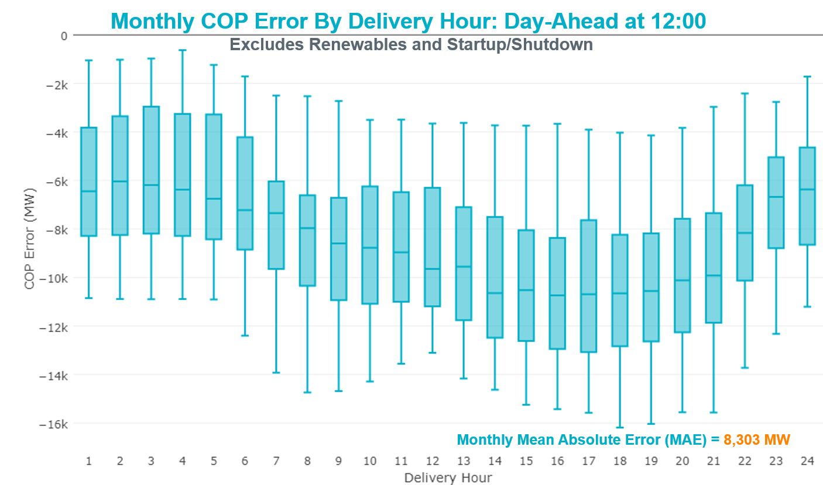

Congestion Analysis
The total number of congestion events experienced by the ERCOT system increased in March. There were 48 instances over 31 days on the Generic Transmission Constraints (GTCs) in March.

Notable Constraints
Nodal protocol section 3.20 specifies that ERCOT shall identify transmission constraints that are active or binding three or more times within a calendar month. As part of this process, ERCOT reports congestion that meets this criterion to ROS. In addition ERCOT also highlights notable constraints that have an estimated congestion rent exceeding $1,000,000 for a calendar month. These constraints are detailed in the table below. Rows highlighted in blue indicate the congestion was affected by one or more outages. For a list of all constraints activated in SCED for the month of March, please see Appendix A at the end of this report.

Contingency Name | Overloaded Element | # of Days Constraint Active | Congestion Rent | Transmission Project
Basecase | PNHNDL GTC | 29 | $26,112,327 | LP&L Option 4ow & Panhandle Loop (5180, 5208)
CRLNW-LWSSW 345kV | Carrollton Northwest - Lakepointe Tnp 138kV | 23 | $11,465,013 | Oncor_NW Carrollton - LakePointe (5488)
LON HILL TRX LON_HILL_3_2 345/138 | Lon Hill 345/1kV | 12 | $11,412,928
WOODWARD 1 TAP to WOODWARD 1 LIN 1 | 16th Street Tnp - Woodward 2 138kV | 2 | $5,835,170
Re Roserock Solar Plant to Linterna | Yucca Drive Switch - Gas Pad 138kV | 18 | $4,360,336 | Yucca Drive-Barilla Junction (4549)
NORTH PHARR to POLK AVENUE LIN 1 | North Mcallen - West Mcallen 138kV | 1 | $3,874,535
NORTH McCAMEY to SANTA RITA LIN 1 | Santiago - San Angelo Power Station 138kV | 1 | $2,706,490
Wink Sub to YUCCA DRIVE SWITCH LIN | Winkler County 6 Tnp - Wickett Tnp 69kV | 5 | $2,229,240
Elmcreek-Sanmigl 345kV | Pawnee Switching Station - Calaveras 345kV | 9 | $2,057,277
Wink Sub to YUCCA DRIVE SWITCH LIN | Andrews County South - Amoco Three Bar Tap 138kV | 2 | $1,958,633
Chevron Has to Ward Gulf Tap | Winkler County 6 Tnp - Wickett Tnp 69kV | 5 | $1,904,697
CPSES-JONSW&EVRSW 345kV | Parker Switch - Benbrook Switch 345kV | 1 | $1,485,644
Jewet-Sng 345kV | Btu_Jack_Creek - Twin Oak Switch 345kV | 17 | $1,333,399 | Houston Import Project (4458)
Basecase | NELRIO GTC | 16 | $1,143,592
Gby-Dav& Tnk-Crn138kv | Bigvue - Power Systems-Arco Cogen 138kV | 4 | $1,086,236
Cagnon-Kendal 345 &Cico-Meng | Medina Lake - Tally_Rd 138kV | 11 | $1,055,122
CAGNON to KENDALL LIN 1 | Cico - Comfort 138kV | 17 | $949,277
AIRLINE AEP to WESTSIDE AEP LIN 1 | Celanese Bishop - Nelson Sharpe 138kV | 9 | $843,560
BARNEY DAVIS to ALAZAN LIN 1 | Celanese Bishop - Nelson Sharpe 138kV | 14 | $755,980
Basecase | Pig Creek - Solstice 138kV | 26 | $753,528 | Solstice to Permian Basin: Rebuild 138 kV line
Bighil-Kendal 345kV | Hamilton Road - Maverick 138kV | 8 | $552,114 | Brackettville to Escondido (5206)
Cagnon-Kendal 345 &Cico-Meng | Txresrch - Tally_Rd 138kV | 5 | $535,625
Asphalt Mines to Blewett (3) | Hamilton Road - Maverick 138kV | 9 | $422,676 | Brackettville to Escondido (5206)
Devils River to Cauthorn (6) | Hamilton Road - Maverick 138kV | 8 | $401,942 | Brackettville to Escondido (5206)
KLEBERG AEP to LOYOLA SUB LIN 1 | Loyola Sub 138/69kV | 10 | $398,872 | AEP_Angstrom (15TPIT0069)
CITGO N OAK PARK to NUECES BAY LIN | Morris Street - Nueces Bay 138kV | 3 | $378,070
LAQUINTA to LOBO LIN 1 | Bruni Sub 138/69kV | 12 | $344,357
Basecase | Omega - Horse Hollow Generation Tie 345kV | 14 | $322,225
Esmeralda to FRIEND RANCH LIN 1 | Midway Lane - Ozona 69kV | 4 | $298,536
ALAMITO CREEK to MARFA LIN 1 | Alpine - Paisano 69kV | 19 | $292,649
Lostpi-Austro&Dunlap 345kV | Fayetteville 345/1kV | 5 | $274,386
Lostpi-Austro&Dunlap 345kV | Fayetteville - Winchester 138kV | 8 | $234,006
MCAN_SW TO RIOP 138 KV | Pig Creek - Solstice 138kV | 7 | $177,938 | Solstice to Permian Basin: Rebuild 138 kV line
JARDIN to DILLEY SWITCH AEP LIN 1 | Dilley Switch Aep - Cotulla Sub 69kV | 6 | $160,331 | STEC_Dilley-Cotulla Rebuild (5222)
ASHERTON to Bevo Substation LIN 1 | Turtle Creek Switching Station - West Crystal City Sub 69kV | 3 | $158,818
TUNAS CREEK to RIO PECOS LIN 1 | Santiago - San Angelo Power Station 138kV | 8 | $140,059
NORTH McCAMEY to ODESSA EHV SWITCH | Pig Creek - Solstice 138kV | 3 | $134,271 | Solstice to Permian Basin: Rebuild 138 kV line
MITCHELL BEND SWITCH to COMANCHE P | Wolf Hollow 345 Switch - Comanche Peak Ses 345kV | 3 | $124,415
WEIL TRACT to LON HILL LIN 1 | Champlin - Weil Tract 138kV | 3 | $105,424 | AEP_Nueces Area 69kV Reinforcement (4487)
Elmcreek-Stp 345kv | Blessing - Lolita 138kV | 6 | $92,313
Fergus-Granmo&Wirtz-Starck 138kV | Bertram - Burnet 69kV | 3 | $91,484
Riohondo-Nedin 345kV&Harlnsw 138kV | Burns Sub - Rio Hondo 138kV | 3 | $85,445
Elmcreek-Stp 345kv | Blessing - Palacios 69kV | 3 | $73,493 | AEP_RebuildBlessing-Palacios (6110)
Elmcreek-Stp 345kv | Vanderbilt Switching Station - Vanderbilt 69 Sub 69kV | 4 | $67,278
Elmcreek-Stp 345kv | Danevang Switching Station - Blessing 138kV | 4 | $51,082
TUNAS CREEK to RIO PECOS LIN 1 | Hamilton Road - Maverick 138kV | 5 | $44,545 | Brackettville to Escondido (5206)
Re Roserock Solar Plant to L | Barrilla - Fort Stockton Switch 69kV | 8 | $42,493 | Far West Texas Project
ENNIS SWITCH to ENNIS WEST SWITCH | Ennis West Switch - Ennis South 138kV | 4 | $39,658
JEFFERSON to COLLEGE LIN A | Jefferson - South Channel 138kV | 7 | $32,686
TWR (345) JN-WAP64 & JN-WAP72 | Bellaire - Wa Parish 345kV | 3 | $27,778
Wirtz-Burnet&Starck 138kV | Granite Mountain - Marble Falls 138kV | 15 | $20,163
Basecase | Randado Aep - Zapata 138kV | 9 | $18,866
Lostpi-Austro&Dunlap 345kV | Bellville South - Peters 138kV | 4 | $12,363
Lostpi-Austro&Dunlap 345kV | Fayetteville - Frelsburg 138kV | 5 | $10,822
South Texas # 1 & # 2 | Loop 463 Sub - Victoria 138kV | 3 | $9,504
ENNIS SWITCH to ENNIS WEST SWITCH | Ennis Switch - Ennis West Switch 138kV | 5 | $1,867

Generic Transmission Constraint Congestion
There were 29 days on the Panhandle GTC, 16 days on the Nelson Sharpe – Rio Hondo GTC, 2 days on the North to Houston GTC, and 1 day on the Valley Import GTC in March. There was no activity on the remaining GTCs during the month.

Note: This is how many times a constraint has been activated to avoid exceeding a GTC limit, it does not imply an exceedance of the GTC occurred or that the GTC was binding.

Manual Overrides
None.

Congestion Costs for Calendar Year 2018
The following table represents the top twenty active constraints for the calendar year based on the estimated congestion rent attributed to the congestion. ERCOT updates this list on a monthly basis.

Contingency | Binding Element | # of 5-min SCED Intervals | Estimated Congestion Rent | Transmission Project
Basecase | PNHNDL GTC | 13,886 | $82,007,899 | LP&L Option 4ow & Panhandle Loop (5180, 5208)
NORTH EDINBURG TRX 1382 345/138 | North Edinburg 345/1kV | 661 | $28,832,407
CRLNW-LWSSW 345kV | Carrollton Northwest - Lakepointe Tnp 138kV | 7,324 | $25,866,547 | Oncor_NW Carrollton - LakePointe (5488)
Basecase | VALIMP GTC | 359 | $17,313,039
Castrvll-Razorbac&Txresrch 1 | Hondo Creek Switching Station - Moore Switching Station 138kV | 605 | $15,342,875
LON HILL TRX LON_HILL_3_2 345/138 | Lon Hill 345/1kV | 1,587 | $11,412,928
Jewet-Sng 345kV | Btu_Jack_Creek - Twin Oak Switch 345kV | 4,498 | $9,930,572 | Houston Import Project (4458)
WOODWARD 1 TAP to WOODWARD 1 LIN 1 | 16th Street Tnp - Woodward 2 138kV | 141 | $5,835,170
NORTH PHARR to POLK AVENUE LIN 1 | North Mcallen - West Mcallen 138kV | 237 | $5,816,872
Rns-Rtw & Sng-Tb 345kv | Singleton - Zenith 345kV | 1,919 | $5,195,375 | Houston Import Project (4458)
East Harrison to La Palma 69 | Haine Drive - La Palma 138kV | 471 | $5,189,980
Re Roserock Solar Plant to Fort Stockton | Yucca Drive Switch - Gas Pad 138kV | 1,369 | $5,080,297 | Yucca Drive-Barilla Junction (4549)
Elmcreek-Sanmigl 345kV | Pawnee Switching Station - Calaveras 345kV | 1,466 | $4,527,430
Re Roserock Solar Plant to Fort Stockton | Barrilla - Fort Stockton Switch 69kV | 4,896 | $4,357,829 | Far West Texas Project
Wink Sub to YUCCA DRIVE SWITCH LIN | Winkler County 6 Tnp - Wickett Tnp 69kV | 775 | $3,230,884
Cagnon-Kendal 345kV & Mengcr-Ranch | Marion 345/1kV | 220 | $2,971,734
NORTH McCAMEY to SANTA RITA LIN 1 | Santiago - San Angelo Power Station 138kV | 43 | $2,706,490
Basecase | NELRIO GTC | 4,456 | $2,662,754
CAGNON to KENDALL LIN 1 | Cico - Comfort 138kV | 1,772 | $2,612,012
NELSON SHARPE TRX XF1 345/138 | Rodd Field - Holly 138kV | 738 | $2,597,024

System Events

ERCOT Peak Load
The unofficial ERCOT peak load for the month was 46,799 MW and occurred on March 26th during hour ending 17:00.

Load Shed Events
None.

Stability Events
None.

Notable PMU Events
None.

DC Tie Curtailment
Date | DC Tie | Curtailing Period | # of Tags Curtailed | Initiating Event | Curtailment Reason
3/10/2018 | Eagle Pass | HE 2000 – 2100 | 1 | DC Tie Forced Outage due to cooling system alarm. | DC Tie not available
3/13/2018 | Eagle Pass | HE 1900 - 2200 | 1 | DC Tie Forced Outage Extension due to cooling system alarm. | DC Tie not available
3/14/2018 | Eagle Pass | HE 2100 - 2200 | 1 | DC Tie Forced Outage Extension due to cooling system alarm. | DC Tie not available
3/15/2018 | Eagle Pass | HE 1900 - 2400 | 2 | DC Tie Forced Outage Extension due to cooling system alarm. | DC Tie not available
3/27/2018 | Railroad | HE 2200 - 2300 | 1 | High Rio Grande Valley area load and wind output. | Base Case overload on Rio Hondo – Burns MVEC 138 kV and Randado – Zapata 138 kV.

TRE/DOE Reportable Events
- ONCOR submitted an EOP-004 report on March 08, 2018
  - Reportable Event Type: Physical Threat and Damage or Destruction of a Facility to a Facility.
- ERCOT ISO submitted an EOP-004 report on March 18, 2018
  - Reportable Event Type: Transmission Loss
- AEP Transmission submitted an EOP-004 report on March 20, 2018
  - Reportable Event Type: Loss of Firm Load and Transmission Loss
- ONCOR submitted an EOP-004 report on March 23, 2018
  - Reportable Event Type: Physical Threat and Damage or Destruction of a Facility to a Facility.
- ONCOR submitted an EOP-004 report on March 26, 2018
  - Reportable Event Type: Physical Threat and Damage or Destruction of a Facility to a Facility.

New/Updated Constraint Management Plans
None.

New/Modified/Removed RAS
None.

New Procedures/Forms/Operating Bulletins
Procedure Title | POB
DC Tie Desk | 832
Reliability Risk Desk | 833
Reliability Unit Commitment Desk | 834
Scripts Desk | 835
Shift Supervisor Desk | 836
Transmission and Security Desk | 837
Real Time Desk | 838

Emergency Conditions

OCNs
None.

Advisories
Date and Time | Description
3/7/2018 13:23 | ERCOT issued an Advisory for postponing the deadline for the posting of the DAM Solution for Operating Day March 08, 2018.
3/9/2018 13:33 | ERCOT issued an Advisory for postponing the deadline for the posting of the DAM Solution for Operating Day March 10, 2018.
3/19/2018 12:15 | ERCOT issued an Advisory due to ERCOT’s Voltage Security Assessment Tool is currently unavailable.
3/20/2018 12:02 | ERCOT issued an Advisory due to ERCOT’s Voltage Security Assessment Tool is currently unavailable.

Watches
Date and Time | Description
3/10/2018 17:43 | ERCOT issued a Watch due to a forced outage of Eagle Pass DC Tie.
3/11/2018 03:51 | ERCOT issued a Watch due to HRUC not completing for HE05 due to timeline deviation.
3/13/2018 17:49 | ERCOT issued a Watch due to forced extension of Eagle Pass DC Tie.
3/14/2018 19:52 | ERCOT issued a Watch due to forced extension of Eagle Pass DC Tie.
3/15/2018 17:50 | ERCOT issued a Watch due to forced extension of Eagle Pass DC Tie.
3/18/2018 22:26 | ERCOT issued a Transmission Watch due to a post-contingency overload in Far West Texas.
3/27/2018 21:04 | ERCOT issued a Transmission Watch for the Rio Grande Valley due to local congestion in the Rio Grande Valley.

Emergency Notices
None.

Application Performance

TSAT/VSAT Performance Issues
None.

Communication Issues
None.

Market System Issues
None.

Model Updates
The Downstream Production Change (DPC) process allows ERCOT to make changes in the on-line Network Operations Model without loading a completely new model. The purpose of this process is to allow for reliable grid operations as system conditions change between designated Network Operations Model database loads. The DPC process is limited in scope to just those items listed below, with equipment ratings updates being the most common. ERCOT has seen a rise in the use of the DPC process to make on-line updates to the Network Operations Model in recent years, instead of through the standard Network Operations Model Change Request process.

- Static Line ratings (Interim Update)
- Dynamic Line ratings (non-Interim Update)
- Autotransformer ratings (non-Interim Update)
- Breaker and Switch Normal status (Interim Update)
- Contingency Definitions (Interim Update)
- RAP and RAS changes or additions (Interim Update)
- Net Dependable and Reactive Capability (NDCRC) values (Interim Update)
- Impedance Updates (non-Interim)

Transmission Operator | Number of DPCs
CENTERPOINT ENERGY HOUSTON ELECTRIC LLC (TDSP) | 6
CPS ENERGY (TDSP) | 3
ERCOT | 10
LCRA TRANSMISSION SERVICES CORPORATION (TDSP) | 1
ONCOR ELECTRIC DELIVERY COMPANY LLC (TDSP) | 6
SHARYLAND UTILITIES LP (TDSP) | 2
TEXAS MUNICIPAL POWER AGENCY (TDSP) | 1

Appendix A: Real-Time Constraints
The following is a complete list of constraints activated in SCED for the month of March. Full contingency descriptions can be found in the Standard Contingencies List located on the MIS secure site at Grid Generation Reliability Unit Commitment.

Contingency | Constrained Element | From Station | To Station | # of Days Constraint Active
BASE CASE | PNHNDL | n/a | n/a | 29
BASE CASE | PIGCRE_SOLSTI1_1 | SOLSTICE | PIGCREEK | 26
DCRLLSW5 | 591__A | LKPNT | CRLNW | 23
SMARALM9 | ALPINE_PAIS1_1 | PAIS | ALPINE | 19
SMARALM9 | ALPINE_PAIS1_1 | ALPINE | PAIS | 19
SWCSBOO8 | 6332__A | YUCSW | GASPAD | 18
SCAGKEN5 | 74T148_1 | COMFOR | CICO | 17
DJEWSNG5 | JK_TOKSW_1 | TOKSW | JK_CK | 17
BASE CASE | NELRIO | n/a | n/a | 16
DWIRSTA8 | 342T195_1 | GRANMO | MARBFA | 15
SALAN_28 | CELANE_N_SHAR1_1 | N_SHARPE | CELANEBI | 14
BASE CASE | HHGTOM_1 | HHGT | OMEGA | 14
SLAQLOB8 | BRUNI_69_1 | BRUNI | BRUNI | 12
XLO2N58 | LON_HILL_381H | LON_HILL | LON_HILL | 12
DCAGCI58 | 460T460_1 | MEDILA | W1 | 11
SKLELOY8 | LOYOLA_69_1 | LOYOLA | LOYOLA | 10
SCABWES8 | CELANE_N_SHAR1_1 | N_SHARPE | CELANEBI | 9
BASE CASE | RANDAD_ZAPATA1_1 | RANDADO | ZAPATA | 9
SBRAUVA8 | HAMILT_MAVERI1_1 | HAMILTON | MAVERICK | 9
SCABWES8 | CELANE_N_SHAR1_1 | CELANEBI | N_SHARPE | 9
DELMSAN5 | PAWNEE_SPRUCE_1 | CALAVERS | PAWNEE | 9
DBIGKEN5 | HAMILT_MAVERI1_1 | HAMILTON | MAVERICK | 8
DAUSLOS5 | 176T165_1 | FAYETT | WINCHE | 8
STUNRIO8 | SANTIA_SAPOWE1_1 | SAPOWER | SANTIAGO | 8
STUNRIO8 | SANTIA_SAPOWE1_1 | SANTIAGO | SAPOWER | 8
SWCSBOO8 | BARL_FTSW1_1 | FTSW | BARL | 8
SCTHHA38 | HAMILT_MAVERI1_1 | HAMILTON | MAVERICK | 8
SSPJFS8 | JFSSC_06_A | JFS | SC | 7
DMCARIO8 | PIGCRE_SOLSTI1_1 | SOLSTICE | PIGCREEK | 7
DFERGRA8 | 654T654_1 | WIRTZ | STARCK | 7
DELMTEX5 | BLESSI_LOLITA1_1 | BLESSING | LOLITA | 6
SJARDIL8 | DIL_COTU_1 | DILLEYSW | COTULAS | 6
DCAGCI58 | V3_W1_1 | W1 | V3 | 5
DAUSLOS5 | 154T176_1 | FAYETT | FRELSB | 5
SWINYUC8 | M_69_F3_1 | WICKETT | WNKLRCO6 | 5
SHSAPB38 | M_69_F3_1 | WICKETT | WNKLRCO6 | 5
DAUSLOS5 | FAYETT_AT2H | FAYETT | FAYETT | 5
STUNRIO8 | HAMILT_MAVERI1_1 | HAMILTON | MAVERICK | 5
SENSENW8 | 943__A | ENWSW | ENSSW | 5
DELMTEX5 | DANEVANG_1 | BLESSING | DANEVA | 4
DGBYCRN8 | BCVPSA03_A | PSA | BCV | 4
DAUSLOS5 | 155T217_1 | BELLSO | PT | 4
SES2FRI8 | MIDW_OZONA1_1 | OZONA | MIDW | 4
DELMTEX5 | VAN_VNDB_1 | VANBLTSS | VANBLT69 | 4
SBCVPSA8 | JFSSC_06_A | JFS | SC | 4
SENSEN28 | 941__C | ENWSW | ENSSO | 4
SDCSCPS5 | 151__A | WOFHO | CPSES | 3
DSTEXP12 | LOOP_VICTORIA_1 | VICTORIA | L_463S | 3
DWAP_JN5 | BI_WAP50_A | WAP | BI | 3
SNORODE5 | PIGCRE_SOLSTI1_1 | SOLSTICE | PIGCREEK | 3
DCAGCO58 | 583T583_1 | BANDER | MASOCR | 3
DELMTEX5 | BLESSI_PALACI1_1 | BLESSING | PALACIOS | 3
DKENCA58 | V3_W1_1 | V3 | W1 | 3
DKENCA58 | V3_W1_1 | W1 | V3 | 3
SCITNUE8 | MORRIS_NUECES1_1 | NUECES_B | MORRIS | 3
SBEVASH8 | TURTLECK_WCRYS_1 | TURTLCRK | WCRYSTS | 3
DFERSTA8 | 32T311_1 | BURNET | BERTRA | 3
SWEILON8 | CHAMPL_WEIL_T1_1 | WEIL_TRC | CHAMPLIN | 3
DRIOHAR5 | BURNS_RIOHONDO_1 | RIOHONDO | MV_BURNS | 3
SBOSELM5 | 1030__B | BOSQUESW | RGH | 2
DJFSIND8 | JFSSC_06_A | JFS | SC | 2
XALM589 | ALMC_69T1 | ALMC | ALMC | 2
BASE CASE | LINTER_SOLSTI1_1 | LINTERNA | SOLSTICE | 2
SMOUFLA8 | 144T132_1 | FLATON | HALLET | 2
DFERGRA8 | BURNET_AT3 | BURNET | BURNET | 2
SBRAUVA8 | SANTIA_SAPOWE1_1 | SANTIAGO | SAPOWER | 2
SCTHHA38 | EAGLHY_ESCOND1_1 | EAGLHYTP | ESCONDID | 2
BASE CASE | N_TO_H | n/a | n/a | 2
SVANRAY8 | VND_PLCE_1 | PLCEDOS | VANBLT69 | 2
XTYG58 | ELKTN_MR3H | ELKTN | ELKTN | 2
SN_SLON5 | LOYOLA_69_1 | LOYOLA | LOYOLA | 2
SBOSWHT8 | OLKW_BOS_1 | BOSQUESW | LKWHITNY | 2
SWOORI38 | 16TH_WRD2_1 | WOODWRD2 | 16TH_ST | 2
UCOLCOL1 | BLESSI_LOLITA1_1 | BLESSING | LOLITA | 2
SCOLKEN8 | BEEVIL_NORMAN1_1 | BEEVILLE | NORMANNA | 2
DAUSLOS5 | 608T608_1 | GIDEON | BASTCI | 2
SWINYUC8 | 6100__G | ACSSW | AMTBT | 2
DSTPDOW5 | CKT_3124_1 | STP | HLJ | 2
BASE CASE | BURNS_RIOHONDO_1 | RIOHONDO | MV_BURNS | 2
SBOSELM5 | 1030__A | RGH | ELMOT | 1
DMARGPI8 | 290T305_1 | CIBOLO | MCQUEE | 1
SGILCLE5 | 505T505_1 | CLEASP | GERONI | 1
SCLETE25 | 6095__D | LMESA | JPPOI | 1
XBOM58 | 6558__B | FSHSW | WFALS | 1
DCALHOT8 | N4_X3_1 | CALAVERS | X3 | 1
SFRIFTL8 | SANTIA_SAPOWE1_1 | SAPOWER | SANTIAGO | 1
DAUSLOS5 | 144T132_1 | FLATON | HALLET | 1
DELMSAN5 | BEEVIL_NORMAN1_1 | BEEVILLE | NORMANNA | 1
SSALFPP5 | FAYETT_AT2L | FAYETT | FAYETT | 1
SWCOASH8 | LVOK_SANTIA1_1 | SANTIAGO | LVOK | 1
SBAKBIG5 | PIGCRE_SOLSTI1_1 | SOLSTICE | PIGCREEK | 1
DFPPLOS5 | 176T165_1 | FAYETT | WINCHE | 1
DFERSTA8 | 318T313_1 | WIRTZ | JOHNCI | 1
DCPSJON5 | 6000__A | BNBSW | SYCRK | 1
SENSEN28 | 941__B | ENNIS | ENSSW | 1
UCOLCOL1 | BLESSI_PALACI1_1 | BLESSING | PALACIOS | 1
DDILCOT8 | DIL_COTU_1 | DILLEYSW | COTULAS | 1
DSTEXP12 | HAMILT_MAVERI1_1 | HAMILTON | MAVERICK | 1
DJFSCGR8 | JFSSC_06_A | JFS | SC | 1
SFORJOS8 | LOLITA_VICTOR1_1 | VICTORIA | LOLITA | 1
SLGDSAP8 | NORTMC_SANTAR1_1 | NORTMC | SANTARIT | 1
SPIGSOL8 | 6332__A | YUCSW | GASPAD | 1
SCELN_S8 | AIRLIN_CABANI1_1 | AIRLINE | CABANISS | 1
SKENCO28 | BEEVIL_NORMAN1_1 | BEEVILLE | NORMANNA | 1
DB_DAIR8 | CELANE_N_SHAR1_1 | N_SHARPE | CELANEBI | 1
BASE CASE | COTPLNSTL_1 | COTPLNS | WHIT_RVR | 1
STUNRIO8 | EAGLHY_MAVERI1_1 | MAVERICK | EAGLHYTP | 1
BASE CASE | HAMILT_MAVERI1_1 | HAMILTON | MAVERICK | 1
SBRAHAM8 | HAMILT_MAVERI1_1 | HAMILTON | MAVERICK | 1
SSONFRI8 | HAMILT_MAXWEL1_1 | MAXWELL | HAMILTON | 1
DLONWAR5 | NORMAN_PETTUS1_1 | PETTUS | NORMANNA | 1
DBIGKEN5 | SAPOWE_YELWJC1_1 | SAPOWER | YELWJCKT | 1
BASE CASE | VALIMP | n/a | n/a | 1
DJEWSNG5 | 258_A_1 | LEG | TOKSW | 1
SWINYUC8 | 6100__F | DHIDE | NOTSW | 1
DB_DAIR8 | AIRLIN_CABANI1_1 | AIRLINE | CABANISS | 1
DDILCOT8 | BEVO_BRUNDAGE_1 | BEVO | BRUNDGS | 1
BASE CASE | LGD_SANTIA1_1 | LGD | SANTIAGO | 1
XLAS95 | LINTER_SOLSTI1_1 | LINTERNA | SOLSTICE | 1
DWAP_OB5 | PK_MID90_A | MID | PK | 1
DNAVWTR5 | 530__C | VENSW | BRTRD | 1
DCPSJON5 | 6042__A | PKRSW | BNBSW | 1
DCPSJON5 | 651__B | CMNSW | CMNTP | 1
SCOLPAW5 | COLETO_ROSATA1_1 | COLETO | ROSATA | 1
BASE CASE | EAGLHY_ESCOND1_1 | EAGLHYTP | ESCONDID | 1
DFRAKI28 | F1_O9_1 | SUTHRLND | F1 | 1
DCC3_NED | NORMAN_PETTUS1_1 | PETTUS | NORMANNA | 1
SWINYUC8 | 6101__A | NOTSW | CHEYT | 1
DLONWAR5 | AIRCO4_RINCON1_1 | AIRCO4 | RINCON | 1
SCOLPAW5 | COLETO_VICTOR1_1 | COLETO | VICTORIA | 1
DFRAPAR8 | F4_Z4_1 | Z4 | F4 | 1
SCABWES8 | KINGSV_KLEBER1_1 | KLEBERG | KINGSVIL | 1
SALAN_28 | N_SHARPE_PS3 | N_SHARPE | N_SHARPE | 1
SSANNOR8 | SANTIA_SAPOWE1_1 | SAPOWER | SANTIAGO | 1
DCPSJON5 | 6017__A | MBDSW | DCSES | 1
SCRDLOF9 | BOW_FMR1 | BOW | BOW | 1
SN_SLON5 | CELANE_N_SHAR1_1 | N_SHARPE | CELANEBI | 1
SCOLBAL8 | DRSY_SANA_T1_1 | SANA_TAP | DRSY | 1
SCTHHA38 | EAGLHY_MAVERI1_1 | MAVERICK | EAGLHYTP | 1
SPIGSOL8 | FTST_LINTER1_1 | LINTERNA | FTST | 1
SPOLPHA8 | GCB_100_1 | N_MCALLN | W_MCALLN | 1
SBRAUVA8 | MAXWEL_WHITIN1_1 | MAXWELL | WHITING | 1
DLONWAR5 | NORMAN_PETTUS1_1 | NORMANNA | PETTUS | 1
DPZ_GN28 | PK_MID90_A | MID | PK | 1

The Duration of Event is defined as the time it takes for the frequency to recover to pre-disturbance frequency or 60 Hz as applicable.
PMU reports are typically generated when frequency drops below 59.9, but PMU data is available for other events.
Delta Frequency is defined as the difference between the starting point of the frequency event (t(0) or “A-point”) and minimum/maximum frequency (“C-Point”).
Currently, the Critical Inertia Level for ERCOT is approximately 100,000 MW-s (Source: link)
All DC Tie Curtailments are posted publically on the ERCOT Market Information System. See that posting for additional details for the event(s) in question.
See DC Tie Operating Procedure (http://www.ercot.com/mktrules/guides/procedures) for more details.

