

ERCOT White Paper on
Resource Definitions
in the ERCOT Protocols

Submitted to the Resource Definition Task Force (RTF) on MM YY, 2018.

Document Revisions
Date | Version | Description | Author(s)
4/28/2018 | a | Initial draft outline for RTF review/discussion | ERCOT Staff

Table of Contents
1 Executive Summary 4
2 Introduction 5
3 Identify list of issues and methods for resolution. 5
3.1 Stage 1 - Align Definitions to identify differences 6
3.2 Stage 2 - Clarify Definitions for Transmission connected resources 6
3.3 Stage 3 - Clarify Definitions for distribution connected resources 6
4 Review of NERC, PURA, PUCT Rules and ERCOT Protocols Terms. 9
5 Development of Framework. 9
6 Existing Terms needing revision (with consensus) 11
7 New Terms (with consensus) 12
8 Terms either unresolved, or no consensus 12
9 References 12
9.1 NERC Definitions 12
9.2 Public Utility Commission Rules 13
9.3 ERCOT Definitions and Protocols 13
Appendix A – Distributed Generation Profile Segment Assignment 14

Executive Summary
ERCOT market participants have had concerns about registration of resources in ERCOT. This concept paper is intended to serve as a catalyst for development of new Protocols and other market rules affecting DERs in the ERCOT region and ERCOT wholesale markets, centered goals:
This document contains the following recommendations:

As the ISO for its region, ERCOT has jurisdiction limited to the operation of the electric system at transmission (≥60 kV) voltage. Responsibility for operation of the distribution grid resides with the Distribution Service Providers (DSPs). ERCOT does not propose to alter this structure; rather, ERCOT proposes only to enhance visibility into the distribution system for the ISO and market participants, and to create a market environment that provides appropriate market signals for DERs.

Introduction
The Resource Definition Task Force was established since the Market Participants expressed concern to the Technical Advisory Committee that Resource definitions have become increasingly complex and confusing, and recommended a holistic effort to clarify the definitions. The RTF is focused on ensuring that the terms for Resources and other generators used within the ERCOT protocols, operating guides, and binding documents, are consistent and clear.

The RTF’s scope of work should include consideration of the following issues:
- Review previous guidance and references to Resource definitions in PURA, the ERCOT Zonal/Nodal Protocols, as well as NERC definitions.
- Identify problematic terms and potential differences that need to be resolved.
- Improve the current structure and terms where practical
- Clarify, where appropriate, existing Resource definitions, including but not limited to the term Non-Modeled Generation
  - Transmission connected
  - Distribution connected
- Consider existing and future Resource types that may not currently be defined, but should be reviewed as part of the task force.

The RTF membership consists of ERCOT staff and other interested Transmission and/or Distribution Service Providers (TDSPs), Qualified Scheduling Entities (QSEs) and Resource Entities. Meetings of the RTF are open to all interested parties. Jay Teixiera from the ERCOT modeling group and Dave Ricketts from Entergy were nominated as co-chairs to coordinate activities.

Identify list of issues and methods for resolution.

Now that the Resource Definition Task Force was engaged, a running list of issues to resolve was established. Many items were identified over the subsequent months as the group discussions progressed. Although some of the items were within the scope of this group to address, other items were beyond the scope of this task force to resolve, as many of them dealt with items such as market-based issues, or technical requirements. Those items have been summarized below and will be forwarded to the appropriate working groups (ROS, WMS, etc) to address.

In addition to identifying where the issues needed to be resolved, a top priority was identifying how the issues could be resolved as well as when.
Previous attempts to address the various issues around non-modeled generation or distributed generation have become bogged down, so a stepwise project approach to selectively identify and resolve issues was chosen.

Stage 1 - Align Definitions to identify differences
The first stage envisions comparing all of the various terms used by NERC, PURA, PUC substantive rules and ERCOT protocols to identify areas needing resolution. An overarching framework will also be generated to help understand the various generation resources in ERCOT, and their relation to each other.
Once consensus is achieved on the new terms or definitions, then a resource framework would be revised to capture all key issues and gaps (if any). These new terms would then be published in this resulting whitepaper along with terms or definitions without consensus.

The estimated duration for this first stage is approximately 6-8 months.

Stage 2 - Clarify Definitions for Transmission connected resources

Once the issues have been identified, and the framework agreed on, the second stage envisions clarifying any definitions for transmission-connected resources.
In addition, the first NPRR for revising/replacing the term “Non-modeled generator” would be submitted. Subsequent NPRRs may be required to resolve other transmission connected resources.

The estimated duration for this second stage is approximately 6-8 months.

Stage 3 - Clarify Definitions for distribution connected resources

Once the “Non-modeled” definition has been resolved, the third stage envisions clarifying any definitions for distribution-connected resources.
This work can go along in parallel with stage 2 to some extent as the work required for resolving distribution connected resources is expected to be completely independent from the work required for transmission resources. In addition, there may be multiple new concepts that may take extended periods to define.
Subsequent NPRRs (plural) are expected to resolve distribution connected resource issues.

The estimated duration for this last stage is approximately 6-8 months.

Figure X – Issues List of items to be resolved

Review of NERC, PURA, PUCT Rules and ERCOT Protocols Terms.
The next action was to review all of the existing definitions in PURA, NERC, the PUC substantive rules and finally the ERCOT Nodal Protocols. The goal was to see if there were any significant mismatches, gaps, or overlaps between the various rules.
ERCOT’s Legal team, assisted by Dave Ricketts, assembled a table of all of the definitions and is shown in Appendix A – Definition Review. The group reviewed the various definitions and confirmed the various areas where there were gaps and overlaps. Several of these are in the PUC substantive rules, so these will hopefully be addressed in a future rule change.
At this point
After reviewing the terms, it became apparent that an overall framework was required to provide for a reference and hierarchy of the various terms.

Development of Framework.

An overarching framework based on the existing definitions and protocols was developed by Jay Teixeira to help illustrate visually how the protocols define the resources. This visual representation is entirely a new concept and is shown below in figure X with the areas needing to be clarified highlighted in yellow.
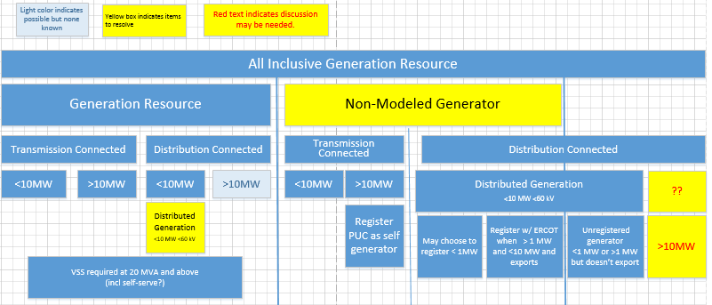
Figure X – Existing All Inclusive Generation Resource Framework
The above categories simply reflect how All-inclusive generation resources are classified based on their size, connection and, to some extent, market participation. This figure excludes Load Resources.
A Generation Resource is defined as “a generator capable of providing energy or Ancillary Service to the ERCOT System and is registered with ERCOT as a Generation Resource. The term “Generation Resource” used by itself in these Protocols does not include a Non-Modeled Generator”, which is somewhat of a circular definition.
A Resource, “is used to refer to both a Generation Resource and a Load Resource. The term “Resource” used by itself in these Protocols does not include a Non-Modeled Generator or an ERS Resource.”
Contributing to the confusion, the various Resources are comprised of different fundamental technologies which are referenced in the Nodal protocols, but only a few of these technologies are actually defined.
The definitions are somewhat vague, and sometimes refer to the technologies as Resources which is what has led to much of the confusion, since they are “categories of resources”, and not actually Resources. For example,several resource technologies, such as a natural gas simple cycle generator or solar photovoltaic system, can be the power source for almost any of the Resources above, so simply referring to a Simple Cycle Resource or Solar Photovoltaic Resource does not help define what kind of resource it actually is, since the unit could just as easily be under the current category of Non-Modeled Generation. The protocols start out be defining connectivity and size as the first differentiating feature, which is the basis for the framework shown in figure X.
Generation Resources also have other “attributes” or “status”, and based on those, are eligible to participate in different markets and offer different services, as defined in the Nodal Protocols. As an example, a resource that has an attribute that it can be qualified as “quick starting”can provide certain ancillary services. It should be noted that several technology categories have certain attributes that would enable them to meet those particular qualifications.
Therefore, the next step was to define these various technologies, attributes and services are shown in figure Y, below.

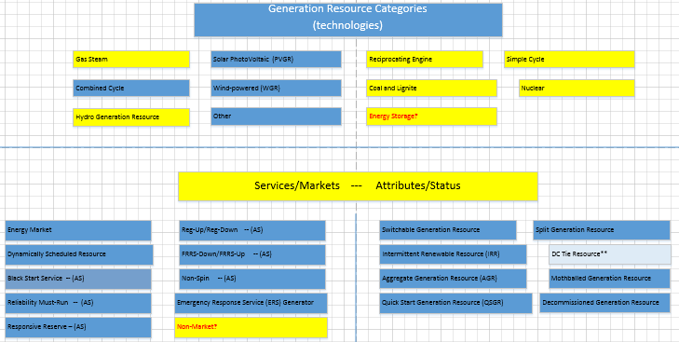

In this way, a framework starts to emerge of the types of resources based on their size, connectivity, technologies, attributes and market participation. Therefore, a flow chart can be developed that now defines the process of registration and qualification.

Existing Terms needing revision (with consensus)
The following terms need to be addressed either by the PUC or by ERCOT as they either overlap or contradict.

Customer

Distributed Generation (DG) The existing definition, although adequate, is confusing in that it refers to multiple categories of generation resources in ERCOT.
Distributed Renewable Generation (DRG) This term adds confusion as it is only used in reference to the Renewable Energy Credit program.
Aggregate Generation Resource (AGR)
This term in the ERCOT protocols, currently only to transmission connected resources.

New Terms (with consensus)

Distributed Generation (DG)
An electrical generating facility located at a Customer’s point of delivery (point of common coupling) ten megawatts (MW) or less and connected at a voltage less than or equal to 60 kilovolts (kV) which may be connected in parallel operation to the utility system.
Distributed Renewable Generation (DRG)
Electric generation with a capacity of not more than 2,000 kW provided by a renewable energy technology that is installed on a retail electric Customer’s side of the meter.
Aggregate Generation Resource (AGR)
A Generation Resource that is an aggregation of non-wind generators, each of which is less than 10 MW in output, which share identical operational characteristics and are interconnected at the same POI and located behind the same Generator Step-Up (GSU) transformer (with a high-side voltage greater than 60 kV).

Terms either unresolved, or no consensus

References

NERC Definitions
See the following definition:

Public Utility Commission Rules
See the following Substantive Rules:
- Electric Rules
http://www.puc.texas.gov/agency/rulesnlaws/subrules/electric/25.211/25.211.pdf

ERCOT Definitions and Protocols

See the following ERCOT Protocol sections:
- Definitions
http://www.ercot.com/content/wcm/current_guides/53528/02-030118_Nodal.doc
- Full combined protocol
http://www.ercot.com/content/wcm/libraries/148953/March_1__2018_Nodal_Protocols.pdf

Appendix A – Distributed Generation Profile Segment Assignment
Appendix B – Examples of Transmission Connected Resources

Appendix C – Examples of Distribution Connected Resources

