PWG Meeting Notes – March 19, 2018
ERCOT Met Center, Room 168
10:00 am – 1:00 pm

Attendees: via WebEx
Lindsay Butterfield – ERCOT Kelly Brink – ERCOT
Bill Boswell – ERCOT Mark Ruane – ERCOT
Sam Pak – Oncor Dave Michelson - ERCOT
Sheri Wiegand – TXU Kathy Scott - CNP
Diana Rehfeldt – TNMP Chris Dominguez - CNP
Carolyn Reed – CNP Karen Mahlky - CNP
Randy Roberts – ERCOT John Moschos - Tenaska
Jim Lee – AEP Sonja Collins - CNP
Sam Morris – ERCOT Kimaniece George - CNP
JP Wick – Golden Spread Diana Rios - ERCOT

- Meeting minutes from February 21st were reviewed and approved as proposed.

- BUSIDRDG
  - Bill Boswell presented data showing the growth in DG (RES and BUS) over the years in the ERCOT footprint – ESI ID count of DG profiles excluding non-modeled generators (> 1 MW and/or those assigned a Resource ID - RID)
  - 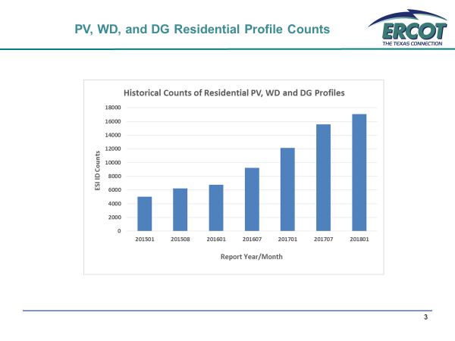

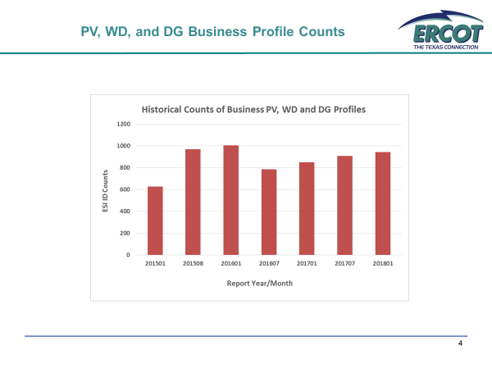
  - GOAL is for ERCOT to gain visibility into the BUSIDRRQ profiled ESIs with unregistered DG including those that self-serve
    - Identify population
    - Report DG capacity
    - Include (negative) generation into settlement
  - Original proposed solutions included the addition of 24 new profiles (8 Weather Zones x PV, WD, DG) and/or the repurposing an existing attribute
  - Randy Roberts presented a proposal to repurpose the existing Time of Use (TOU) profiles – possibly creating a legend for TOU1 to reflect PV, TOU2 for WD, etc.
    - It was noted market participants (outside of ERCOT) may have logic developed in their systems for these TOU profiles which would require system revisions if utilized
  - For the initial purpose of identifying the possible population of DRG in the BUSIDRRQ segment, it was decided to leverage the existing reports submitted by the TDSPs to ERCOT (LPG - Profile Decision Tree, DG tab). On a go forward basis, TDSPs would submit an ESI with an Interconnection Agreement and ERCOT would then review if the profile was BUSIDRRQ and note accordingly .
    - For existing ESIs, ERCOT (Randy Roberts) will provide respective lists to each TDSP for all BUSIDRRQ profiled ESIs noting if they are associated with an existing RID.
    - TDSPs will then determine if any have an existing interconnect agreement (IA).
    - For those with an IA, TDSP will also note potential capacities.
  - Once the scope (potential population) has been defined, this effort may align with other market efforts, such as the IDR metering data for earlier settlement, to create synergies on any potential market spends.

- 2018 Annual Validation (AV)
  - Bill Boswell presented the preliminary data for the 2018 AV changes
  - In light of the ongoing discussion to streamline the AV process, the BUS default profile of BUSMED was questioned. In quickly reviewing the distribution of BUS profiles, the predominant BUS profile is BUSLO. Also, given the number of upcoming changes from BUSMED to BUSLO and those from BUSLO to BUSMED, it was suggested market participants consider changing the default profile to BUSLO.
  - Market participants including ERCOT are to review the consideration. Sheri Wiegand is to check with NRG on a past proposal regarding default profile. (It was thought this proposal was around BUSNODEM for initial temporary services)

- Annual Validation Proposed Process Revisions
  - PWG leadership presented a summary of the earlier proposals for Annual Validation revisions
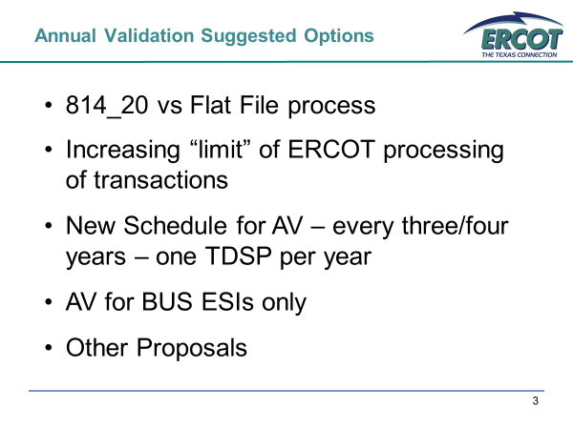
- Dave Michelson clarified ERCOT has 60,000 transactions for the 814-20 ‘set’ in terms of the amount designated for processing within protocol timelines. ERCOT may ‘hold and process’ more than 60K transactions if necessary.
- Jim Lee presented the joint TDSP’s proposal for streamlining… they agree to the following:
  - BUS ESIs annually
  - Adopt a schedule of every 3 years for RES ESI processing - all TDSPs would process at the same time (every three years)
- Sheri Wiegand has proposed any new RES ESIs be evaluated when 3 years of data become available. (For example, if a new ESI is created at the end of 2019, it would not have 3 years of data until 2022, but not be evaluated until the next rotation in 2024 – so the ESI will remain under the default profile for 5 years)
- The default profiles for RES ESIs was also reviewed. Bill Boswell will provide RESHI and RESLO profile counts by Weather Zone to see if these align with the current default profiles.
- 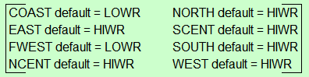
- Market participants (including ERCOT) are asked to review the proposal to determine if these changes impact any business processes such as forecasting, procurement, etc before an LPGRR is drafted.
- PWG leadership will present the proposal at both RMS and COPS for feedback at the next PWG meeting (April 25th)

- LPGRR064 – Updates to LPG for TAC Subcommittee Restructuring
  - Lindsay presented at a high level the proposed changes
    - redlining COPS and replacing with RMS
    - redlining PWG and replacing with RMS
  - Given the upsurge of activity of PWG, Jim suggested removing the deletions of PWG via comments. He will provide an initial draft to PWG leadership to be reviewed and submitted by PWG leadership.

- NEXT MEETING: Wednesday, April 25th @ 9:30 am, ERCOT Met Center

- PROPOSED AGENDA for 3/19/18
1. 2018 Annual Validation update
2. Review of BUS default profile
3. Update on BUSIDRRQ lists provided to TDSPs for DG identification
4. Annual Validation Process
- Review of RES profile distributions per weather zone
- Discuss any feedback on AV proposed process
  - BUS review annually
  - RES review every three years (next review would be 2021)
5. Review comments for proposed LPG associated with TAC SRC

