 |  |  |  | System Planning
Monthly Status Report
February 2018

 |  | Report Highlights
- ERCOT is currently reviewing proposed transmission improvements with a total cost of $903.5 Million.
- Transmission Projects endorsed in 2018 total $43 Million.
- All projects (in engineering, routing, licensing and construction) total approximately $7.07 Billion as of October 15, 2017.
- Transmission Projects energized in 2017 total about $805.4 Million as of October 15, 2017.

Regional Planning Group Project Reviews
- Garland Power & Light and Oncor have jointly submitted the North Garland Reliability Infrastructure Project (N-GRIP). This is a Tier 1 project that is estimated to cost $78 million. The ERCOT independent review for this project is currently placed on hold per the request of GPL.
- WETT has submitted the Bearkat Area Transmission Improvements project. This is a Tier 1 project that is estimated to cost $69.9 million. This project is currently under ERCOT Independent Review.
- Oncor has submitted the Far West Texas Dynamic Reactive Devices project. This is a Tier 1 project that is estimated to cost $86 million. This project is currently under ERCOT Independent Review.
- AEPSC has submitted the Pecos County project. This is a Tier 3 project that is estimated to cost $43 million. This project has completed the RPG review and ERCOT will prepare the RPG acceptance letter.
- AEPSC has submitted the LRGV Import Project. This is a Tier 1 project that is estimated to cost $73.4 million. AEPSC has also requested that ERCOT provide conditional endorsement for an additional $357.2 million project. This project is currently in the RPG study mode.
- Oncor has submitted the Far West Texas Project 2. This is a Tier 1 project that is estimated to cost $194 million. This project is currently under RPG study mode.
- Oncor has submitted the Grapevine Switching Station project. This is a Tier 2 project that is estimated to cost $25 million. This project has been submitted for RPG comments.
- CenterPoint Energy has submitted the Southwyck - Algoa Corner Rebuild project. This project is initially classified as a Tier 3 project with an estimated cost of $20 million. After the completion of RPG review, the project will be re-classified as a Tier 4 Neutral project. This project has been submitted for RPG comments.

Planning Model Activities
The short term calendar of major planning model events is as follows:
- March 1, 2018 Post 17SSWG Update 2 Base Cases and TPIT
- March 31, 2018 Post Contingency definitions and Planning Data Dictionary
The following table shows interconnection projects that met Planning Guide section 6.9(1) and 6.9(2) and were modeled in the SSWG cases as either complete or as a simple model in accordance with Planning Guide section 6.9. The 6.9(2) Deadline shown in red have received a notification that the 60 day deadline has past and the set of planning data has not been received.
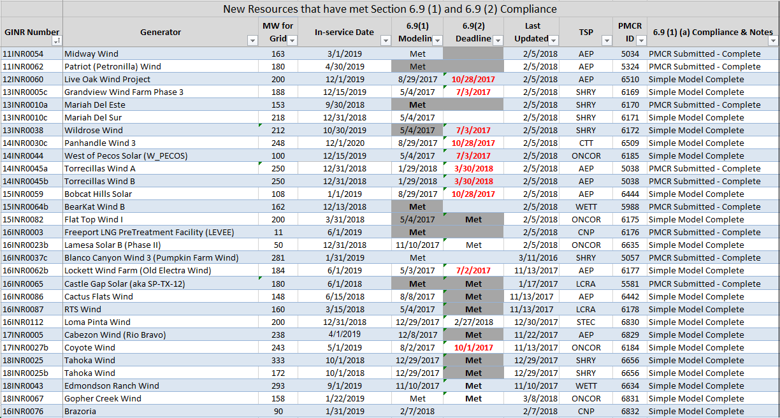

Permian Basin Oil Rig Count
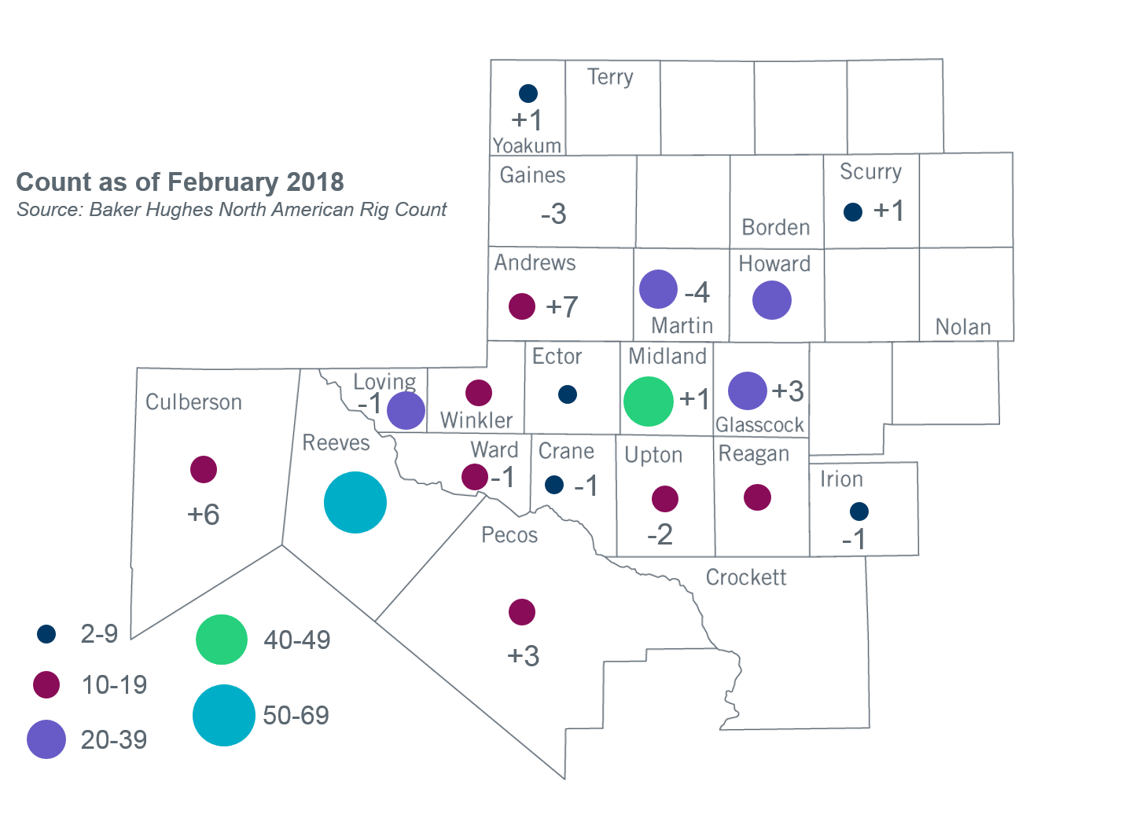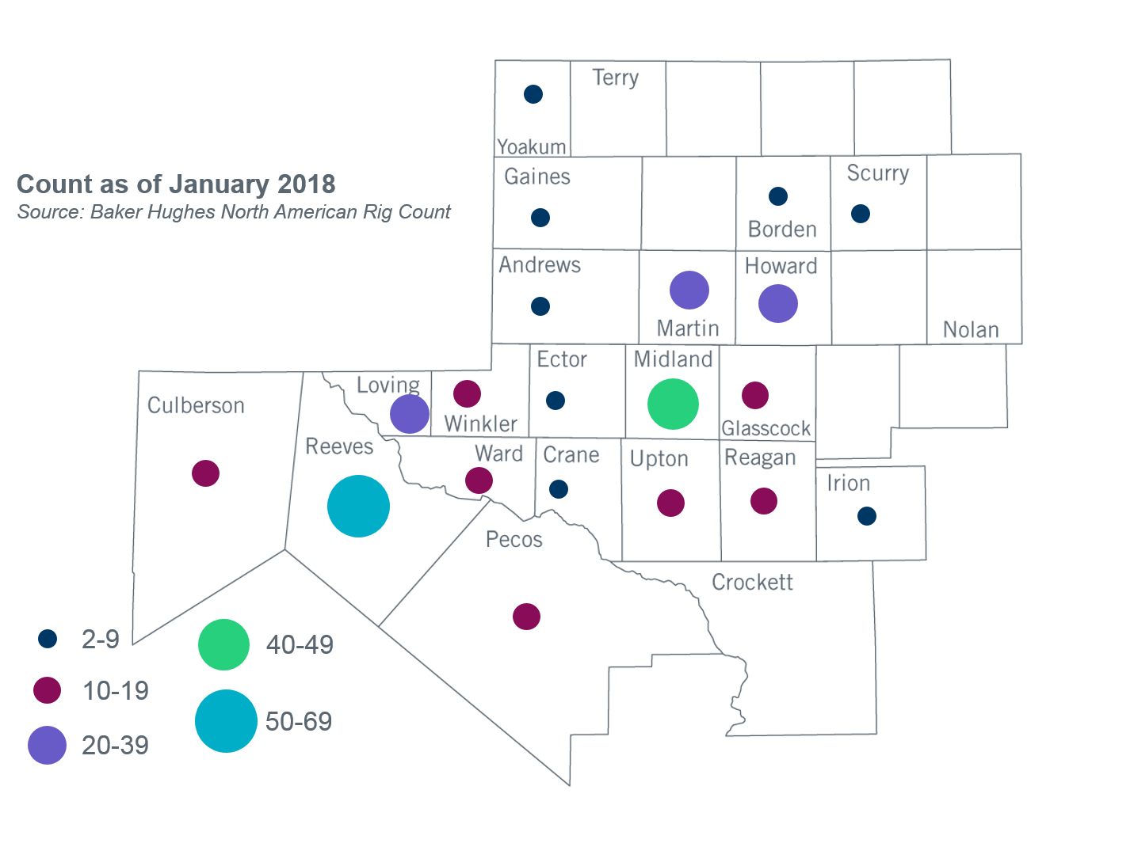

Other Notable Activities
- ERCOT has started preparation for the 2018 Regional Transmission Plan (RTP) study. ERCOT shared the draft of scope and assumptions document for the 2018 RTP at the November RPG meeting. Stakeholders are encouraged to provide feedback for the 2018 RTP study. In addition to the scope, to facilitate load review required by PG 3.1.7, ERCOT also shared the results of the initial bounded higher of comparison and resulting preliminary power flow cases. TDSP feedback on the load review was due by February 28, 2018.
- ERCOT continues to work on the 2018 Long-term System Assessment (LTSA). ERCOT presented findings from the initial generation expansion analysis for the Current Trends scenario at the February RPG meeting. ERCOT will continue working on generation expansion analysis for other scenarios and begin preparation for transmission expansion analysis for the Current Trends scenario.
- The SPWG is currently working on the 2018 FY base cases.

+/- symbol indicates the increase or decrease from the previous month in oil rigs present in each county. There are 343 rigs, including a total increase of 8 oil rigs in the Permian Basin from January to February 2018.

