

Inertia:
Basic Concepts and Impacts on the ERCOT Grid

Document Revisions

Ver. | Description | Revision Date
0 | Initial version of inertia whitepaper | 4/4/2018
1 | Updated version of inertia whitepaper | 6/20/2023
2 | Updated version of inertia whitepaper | 12/2/2024

Abstract

Power system inertia is defined as the ability of a power system to oppose changes in system frequency due to resistance provided by rotating masses. The level of inertia present in a system at any time is dependent on the amount of kinetic energy stored in rotating masses of synchronously-interconnected machines, including various types of generators as well as synchronously operating motor loads.
As penetration levels of non-synchronous, inverter-based generation resources (e.g., wind, solar, batteries) increase in the ERCOT generation mix, the system’s synchronous inertia will inevitably decline, especially during low load conditions.
System inertia determines the initial rate of frequency decline after a sudden loss of generation. As system inertia declines, the Rate of Change of Frequency (RoCoF) after an event increases. Events with very high RoCoF may leave insufficient time for various frequency response mechanisms to deploy and arrest frequency decay above the system’s under-frequency load shed set points. This, in turn, may result in involuntarily load disconnection.
This white paper describes ERCOT staff’s initiatives to track the trends of historical inertia on the ERCOT system and to develop tools and methods to mitigate negative impacts of low inertia conditions that could arise in the future.
The paper is structured as follows:
Section 3 describes the basics of synchronous inertia and provides information about typical inertia contribution from various resource types in the ERCOT generation fleet.
Section 4 discusses factors influencing generator commitment patterns and, consequently, affecting system inertia in ERCOT.
Section 5 illustrates historic inertia trends in ERCOT between 2013 and 2024.
Section 6 presents a methodology for determining critical inertia (i.e., the minimum level of system inertia at or above which the ERCOT system can be operated reliably with current frequency control practices).
Section 7 summarizes current practices for control room monitoring and maintaining of inertia equal to or greater than the critical inertia level.
Section 8 presents analysis of future base-level inertia (i.e., inertia that is expected based on specific resources’ characteristics and protocol requirements). The section also attempts to estimate additional generation that will be needed to serve future load and its inertia contribution.
Section 9 shows how various frequency control parameter changes influence critical inertia levels.
Section 10 provides an international review of inertia related challenges and mitigation measures in power systems of similar size and renewable penetration levels as those of ERCOT.
Section 11 presents a summary and conclusions.

Acronyms

LR: Load Resources
SIR: Synchronous Inertial Response
RoCoF: Rate of Change of Frequency
RRS: Responsive Reserve Service
PUNs: Private Use Networks
SASM: Supplemental Ancillary Service Market
EMS: Energy Management System
ESR: Energy Storage Resource

Basics of Synchronous Inertia

Generators and motors that are synchronously connected to a power system store kinetic energy. In response to a sudden loss of generation, kinetic energy will automatically be extracted from the synchronous machines, causing them to slow down. As a consequence, system frequency decays. This property of the synchronous generators and motors is called inertial response. Inertial response provides an important contribution to reliability of the system in the initial moments following a generation trip event and determines the initial Rate of Change of Frequency (RoCoF) (see Figure 1).

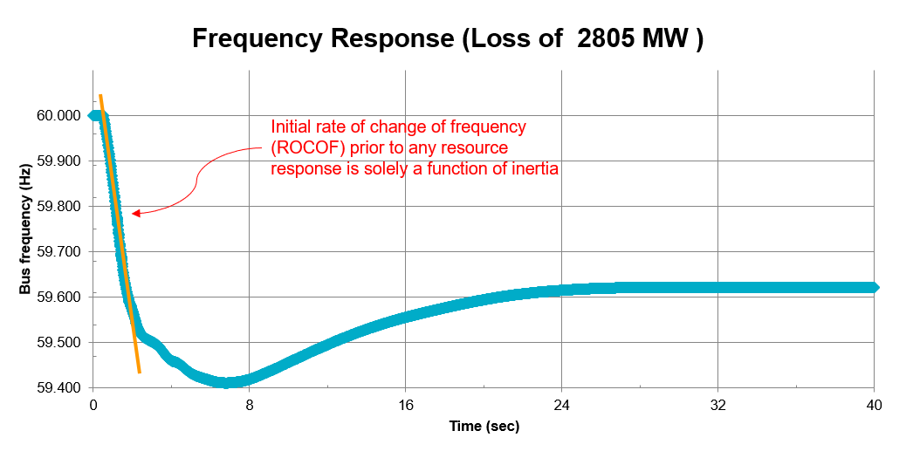
Figure 1: Frequency trace after loss of 2,805 MW and initial RoCoF after the event

The amount of inertia present in a system depends on the number and size of on-line generators and motor loads synchronized to the system. It may be difficult to account for motor loads as this information typically is not available to the system operator; therefore, inertial response of motor load is usually lumped into load damping constant.
For any hour, synchronous inertial response (SIR) from generators (M_{sys}) is calculated as follows:
$M_{sys}=\sum_{i∈I}{H_{i}*{MVA}_{i}}$
where I is the set of on-line synchronous generators or condensers; MVA_{i} is MVA base of on-line synchronous generator or synchronous condenser I; and H_{i} is the inertia constant for an on-line generator or synchronous condenser i in a system (in seconds on machine MVA base, MVA_{i}).
Table 1 shows the range of inertia constants for different generation types in ERCOT. It indicates that Hydro, Simple Cycle Combustion Turbine, Gas Steam, and Coal have smaller inertia constant than Nuclear and Combined Cycle; while non-synchronous, inverter-based, resources like wind, solar, and battery storage do not contribute to synchronous inertia.

Table 1: Inertia constant, MVA base, and inertial response contribution ranges by Resource type in ERCOT.
 | MVA base range | Inertia constant range. H (in seconds) using corresponding generator MVA base | Inertial response contribution range,  H* MVA base (in MW*s)
Nuclear | 1,410 - 1,504 | 3.79 – 5.09 | 5,344 – 7,659
Coal | 194 - 1,120 | 2.43 – 5.2 | 737.2 – 3,378
Combustion Turbine | 7.47 - 340 | 0.07 – 9.3 | 5 – 2,250
Gas Steam | 22.1 – 913.9 | 1.18 – 4.68 | 73.8 – 2,295
Combined Cycle | 5.8 - 568 | 1.2 – 9.3 | 63.4 – 1,952
Hydro | 9 – 53.5 | 2 - 3 | 19 – 99
Reciprocating Engine | 10 - 70 | 0.2 - 2 | 13 - 91
Wind | - | 0 | 0
Solar PV | - | 0 | 0
Battery Storage | - | 0 | 0

System inertia determines the RoCoF after an event, which may be a generation trip or, potentially, a step-change increase in load. If system inertia is low, the RoCoF after an event is higher (see Figure 2). At very high RoCoF, there may be insufficient time for various frequency response mechanisms to deploy and arrest frequency decay above under-frequency load shed set points. This, in turn, may result in involuntarily load disconnection.

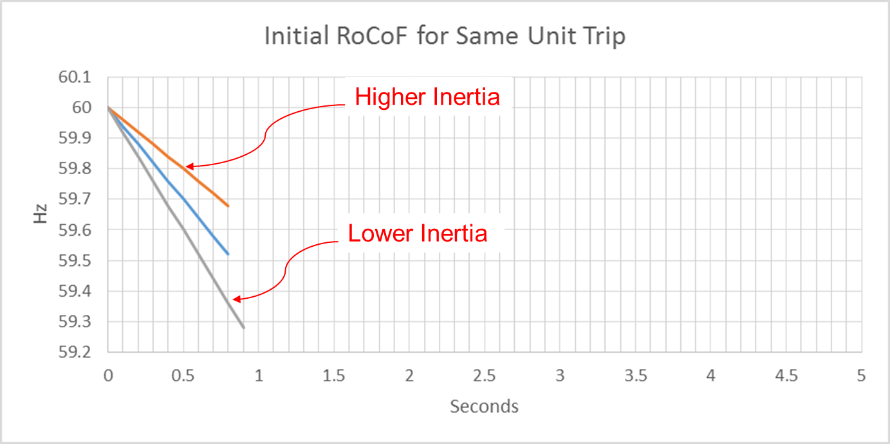

Figure 2: Initial RoCoF after the same unit trip at different inertia conditions.

Inertia at ERCOT

System inertia varies by hour of the day and season of the year as the number and type of on-line synchronous generators changes. Figure 3 shows the fluctuations in system inertia values for all 8,760 hours in 2023. The general trend is that system inertia tends to be highest in the summer and lowest in the shoulder months. This is attributed to the fact that more synchronous generators are on-line to serve the higher load in the summer.

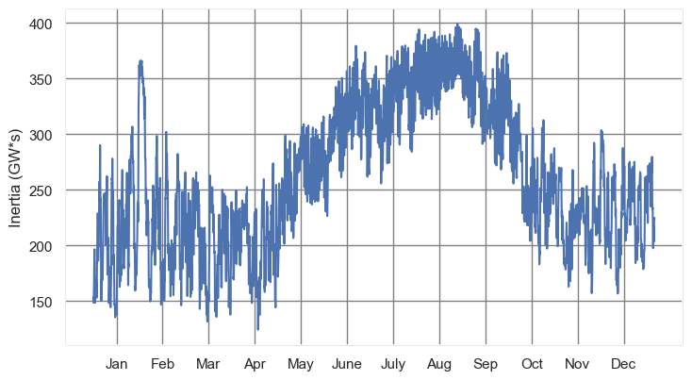

Figure 3: Inertia in 2023.
Synchronous generation commitment patterns are strongly affected by both system load and by the amount of non-synchronous (wind and solar) generation on the system which can be considered as the systems net load (load minus aggregated wind and solar generation). If there is an abundant amount of wind or solar generation at times of low load conditions, wholesale energy market prices may be low or even negative. During these conditions, synchronous generators may choose to remain offline for economic reasons, which reduces system inertia. The scatter plot in Figure 4, depicts the 8,760-hour inertia conditions from 2019 to 2023 and corresponding hourly net load and as can be seen there continues to be strong correlation of net load and resulting inertia.
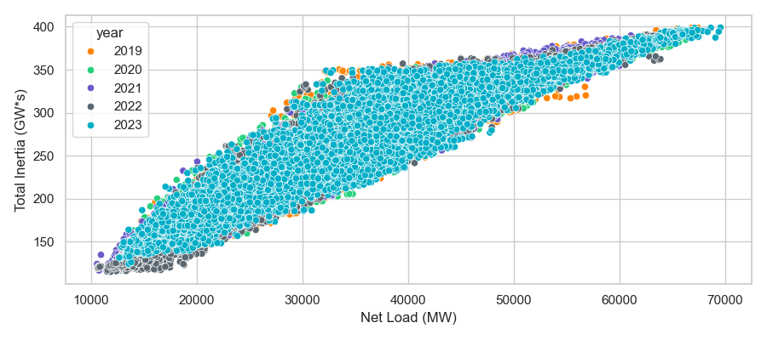
Figure 4: Correlation between Net Load and Inertia in 2019-2023.

Generator commitments at any given moment, and, consequently, system inertia is also affected by wind/solar and load conditions expected in the near future (in the next few hours). Different unit types have different commitment constraints due to their characteristics (start-up times, start-up costs, minimum up and down times, maintenance costs, unit production costs, etc.). These commitment constraints affect total system inertia. For example, generators with longer start-up times will start up earlier in the anticipation of the morning net load pickup and, thus, system inertia at nighttime may be higher than what would otherwise be expected from solely looking at real-time net load conditions.

Historical Synchronous Inertia Trends

Figure 5 shows a boxplot of ERCOT’s system inertia for the past 11 years (2013-2024) and Table 2 provides the details of system conditions for the lowest inertia instance in each of these years.
Since 2017, a network-model-driven inertia calculation was implemented into the ERCOT EMS system. This calculation uses telemetered Resource Status for tracking the on-line status of Private Use Network Resources and net output for identifying the on-line status of all other resources (if net output of a Resource exceeds 5 MW, a unit is considered on-line). Inertia contribution of each on-line unit is calculated as its inertia constant in seconds multiplied by corresponding MVA base as provided in the unit’s Resource Asset Registration Form (RARF).
Inertia contributions for recent 5 years (2019-2023) broken down by unit type are shown in the Appendix.

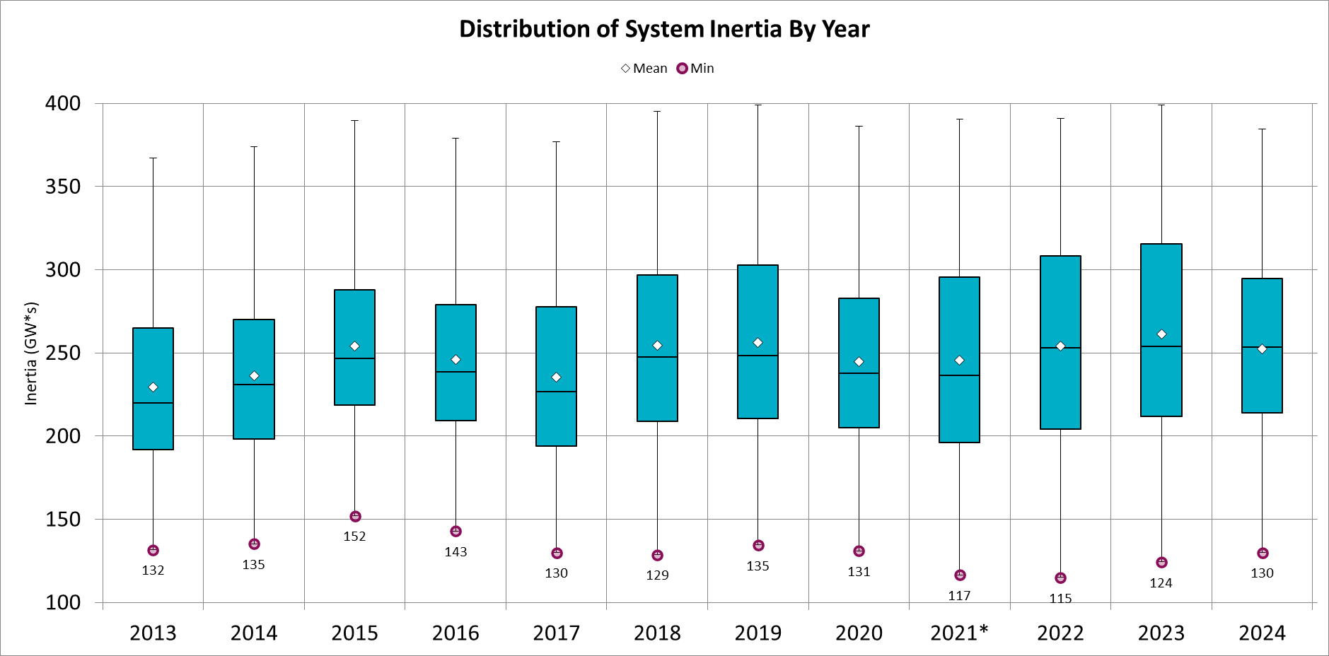
Figure 5: Boxplot of the system inertia in ERCOT from 2013-2024*.
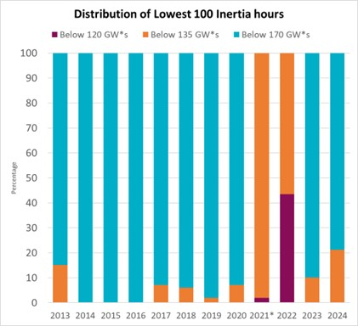
Figure 6: Distribution of lowest 100 inertia hours from 2013-2024.

Table 2: Lowest inertia in different year (GW*s)
Date and Time | 2013  3/10  03:00 AM | 2014  3/30 3:00 AM | 2015  11/25  2:00 AM | 2016  4/10  2:00 AM | 2017  10/27  4:00 AM | 2018  11/03  3:30 AM | 2019  3/27  1:00 AM | 2020  05/01  2:00 AM | 2021  03/22  00:00 AM | 2022  03/21  01:00 AM | 2023  04/18  02:00 AM | 2024  03/29  03:00 AM
Min synch. Inertia (GW*s) | 132 | 135 | 152 | 143 | 130 | 129 | 135 | 131 | 109 | 115 | 124 | 130
System load at minimum synch. Inertia (MW) | 25,067 | 24,540 | 27,190 | 27,831 | 28,425 | 28,397 | 29,883 | 30,679 | 32,599 | 33,365 | 35,799 | 37,297
Non-synch. Gen. in % of System Load | 29 | 34 | 42 | 47 | 54 | 53 | 50 | 57 | 65 | 66 | 61 | 68
As shown in Figure 5while installed renewable capacity tripled in the ERCOT region from 2013-2020, so far, the overall range and yearly minimum inertia have not changed drastically. Additionally, Figure 6 illustrates the distribution of low inertia hours for each year from 2013-2024 is trending toward higher inertia are trending op in recent years. Factors such as growth in ERCOT’s minimum load, transmission constraints that limit renewable production and relatively low fuel prices have influenced the thermal unit commitments and total system inertia.
A breakdown of generation and inertia at the annual minimum system inertia hours from 2019 to 2023 is shown in Figure 7, and similar trends are observed. As the inertia contribution from combined cycle gas turbines diminished from 2019 to 2022, it was offset by a corresponding increase in the inertia contribution from coal, combustion turbine-simple cycle, and nuclear units. Compared to 2022, at the hours of minimum system inertia in 2023, the inertial contribution of combined cycle gas turbines increased significantly from 40 GW*s to 58 GW*s, while the contribution of other units decreased.
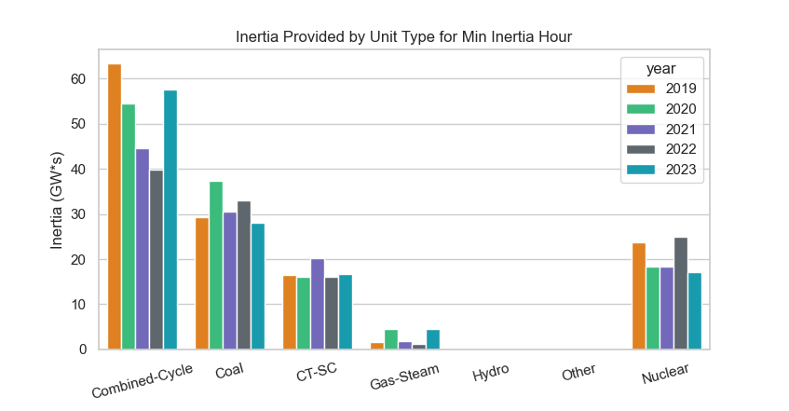
Figure 7: Breakdown of inertia contribution by resource type at lowest inertia hours in 2019-2023.

Determining Critical Inertia

Critical Inertia is the minimum level of system inertia that is necessary to ensure ERCOT’s fast frequency responsive resources can be effectively deployed before frequency drops below 59.3 Hz following the simultaneous loss of 2,805 MW.

Note that Critical Inertia is not a defined term in ERCOT Nodal Protocols; rather, it is being defined and referenced for the purposes of this paper.
Following a resource trip, the initial RoCoF immediately after the event is a function of the inertia of the synchronous machines that are on-line and the magnitude of generation loss. Load Resources with high-set under-frequency relays (UFRs) providing Responsive Reserve Service (RRS) respond in about 0.416 seconds (or 25 cycles) after the frequency drops below their frequency set point.
ERCOT has defined Critical Inertia as the minimum inertia level at which a system can be reliably operated with current frequency control practices. If the system inertia is below the Critical Inertia level, frequency response from Load Resources may not have sufficient time to deploy and aid in arresting system frequency decay before it reaches the first-stage Under-Frequency Load Shed (UFLS) trigger level, which is 59.3 Hz in ERCOT. Thus, for ERCOT, Critical Inertia is the inertia level at which, for a generation loss of 2,805 MW (the two largest units in the system), frequency would take 0.416 seconds to decline from 59.7 Hz to 59.3 Hz. Figure 8 below illustrates the concept by showing a frequency response after the loss of 2,805 MW during a period of particularly low system inertia. In this case, it takes less than 0.416 seconds, denoted as T_{f}, for system frequency to decrease from 59.7 Hz to 59.3 Hz; thus, UFLS would be triggered before any frequency response mechanism has time to trigger.

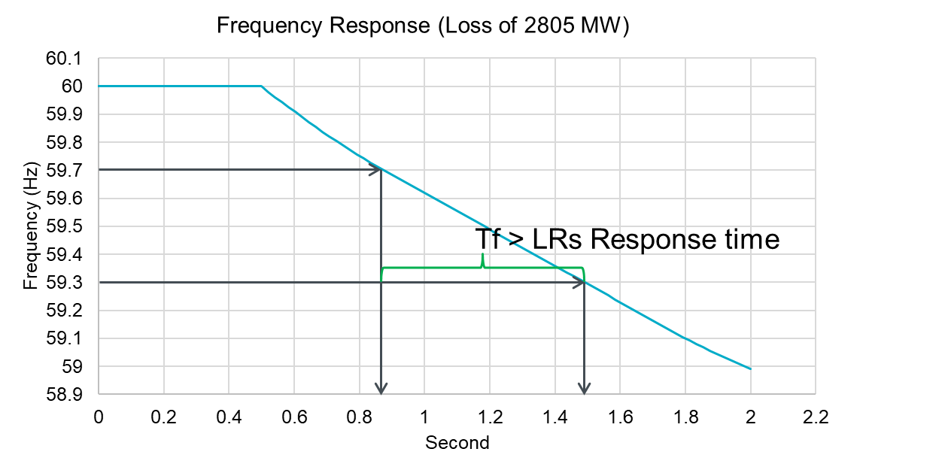

Figure 8: Frequency Response after loss of 2,805 MW and time it takes for frequency to reach 59.3 Hz.

ERCOT has conducted a series of dynamic simulations for the cases with inertia conditions ranging from 108 GW*s to 224 GW*s to investigate the time the frequency takes to decrease from 59.7 Hz to 59.3 Hz when there is 1,390 MW of primary frequency response from generation and no response from Load Resources. Figure 9 shows the corresponding frequency response in each of these studies. Figure 10 summarizes the observed time for frequency to decrease from 59.7 Hz to 59.3 Hz in each of these simulations.
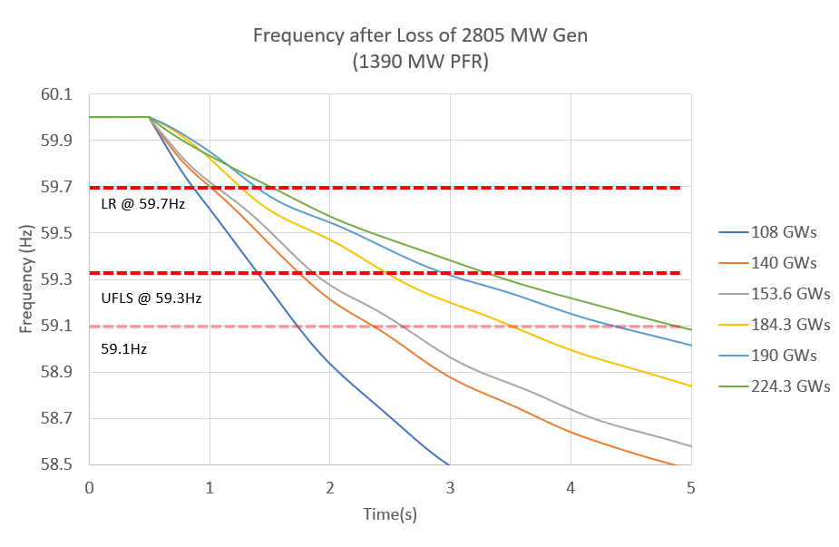

Figure 9: Frequency Response after loss of 2,805 MW for 6 cases with different inertia levels.

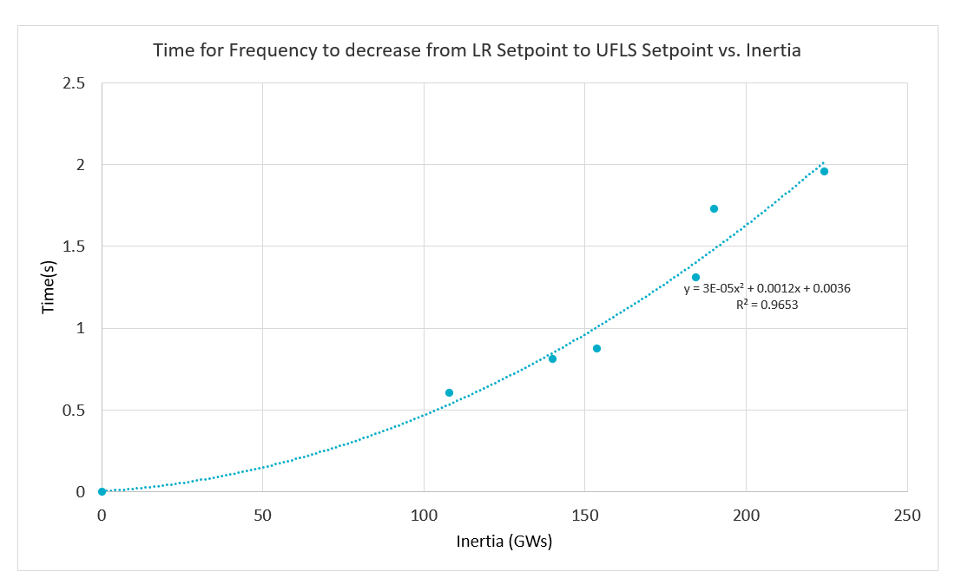
Figure 10: Time for the frequency to decrease from 59.7 Hz to 59.3 Hz from 6 inertia cases and trend line.

A regression curve approximation $T_{f}=3∙{10}^{-5}∙{Inertia}^{2}+0.0012∙Inertia+0.0036$ can be used to estimate the relationship between the time for the frequency to decrease from 59.7 Hz to 59.3 Hz and inertia. Using the relationship, Critical Inertia was found to be 99 GW*s when T_{f} is 0.416 sec.
Based on this analysis, and with a safety margin, ERCOT has identified its Critical Inertia to be 100 GW*s. Operating the grid reliably below this inertia level would require changes to ERCOT’s current operating practices. The lowest inertia experienced in ERCOT to date is 109 GW*s on March 22, 2021. Section 7 provides insights into the approach ERCOT will use to maintain Critical Inertia in Real-Time operations and Section 9 discusses approaches that can be utilized to reduce ERCOT’s Critical Inertia System Operating Limit.

Monitoring and Maintaining Critical Inertia

Continuous growth of non-synchronous generation as well as retirements of traditional thermal generation resources bring more uncertainties to grid operations and a greater need to monitor system inertia in real-time. Monitoring synchronous inertia and frequency deviation after the largest category C (N‐2) event (2,805MW in ERCOT) was recommended Measures from NERC Essential Reliability Services Working Group (ERSWG). These Measures have been passed on to NERC Resource Subcommittee in order to start data collection from all Balancing Authorities and Interconnections in NERC.
To meet ERCOT’s Critical Inertia System Operating Limit (SOL), total ERCOT-wide system inertia is calculated in EMS, as discussed in Section 5, and monitored in Real-Time. The following three-level-based visual alarming approach (as shown in Figure 11) has been implemented to ensure situational awareness in the Control Room:
- ≥120,000 MW*s (normal conditions) – the inertia value is highlighted with green
- ≥110,000 MW*s to ≤119,999 MW*s – the inertia value is highlighted with yellow
- ≥100,001 MW*s to ≤109,999 MW*s – the inertia value is highlighted with orange
- ≤100,000 MW*s – the inertia value is highlighted with red

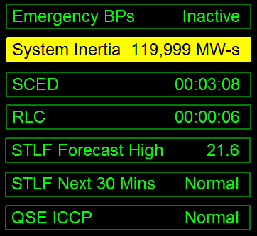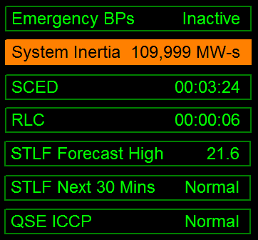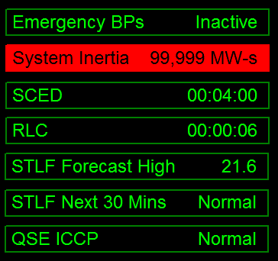
Figure 11: Information an Operator would see for different levels of low inertia in ERCOT

The ERCOT Control Room will monitor grid conditions closely when system inertia drops below 120,000 MW*s. When system inertia drops below 105,000 MW*s, the ERCOT Control Room will take actions to restore system inertia to levels at or above 105,000 MW*s. A few possible mitigation measures that may be used under these conditions include deploying Non-Spin from Offline Generation Resources, committing remaining Quick Start Generation Resources (QSGR) that are not carrying a Non-Spin responsibility, and, lastly, committing Generation Resources that can be started within an hour. Historically, Generation Resources that have carried Offline Non-Spin (including QSGRs that carry Non-Spin) can on an average provide inertia increment of approximately 4,000 MW*s, while QSGRs that do not carry Non-Spin can on an average provide ~6,000 MW*s inertia increment.
Additionally, a new RRS Sufficiency Monitoring tool was implemented in the ERCOT control room in March 2017. This tool conducts a rolling 24-hour look-ahead study to assess the adequacy of procured RRS reserves for expected system inertia conditions, derived from the latest Current Operating Plans submitted by the Generation Resources. This tool also has the ability to monitor the sufficiency of available RRS reserves during Real-Time, based on actual system conditions. The Reliability Risk desk uses this tool and takes necessary actions per its current procedures. Though the tool has been created for RRS Sufficiency Monitoring, underlying data can be used to monitor forecasted inertia with respect to Critical Inertia.

Analysis of Future Base-Level System Inertia

ERCOT has conducted an assessment of system inertia that can be expected in the future under conditions where the absolute minimal amount of conventional generation is considered on-line. For this assessment, the following baseline assumptions were used based on historic data from 2013 through 2017, as illustrated in Figure 12:
- At least two nuclear units are on-line at all times with 12 GW*s of inertia.
- There is a minimum requirement for Responsive Reserve Service from generation. As can be seen in Figure 11 below, ESRs carry most of RRS-PFR. Only a small portion of the Responsive Reserve Service requirement is provided by thermal Resources. The inertia of generation units providing RRS in the hundred lowest inertia hours in each year of 2023 and 2024 ranged between 0 and 8.5 GW*s as seen in table XX in Appendix. .
- The minimum inertia from generation at Private Use Networks was 27 GW*s in the past five years. Using the hundred lowest inertia hours in each year of 2023 and 2024 i, this number ranged between 35GW*s and 42 GW*s, as seen in Table XX.in Appendix
- About 430 MW was also reserved for Regulation (based on 2024 Regulation requirements at night time between January and April). However, it is possible that Regulation is carried by the same units that carry RRS and, therefore, Regulation requirements may not result in additional generation being committed.
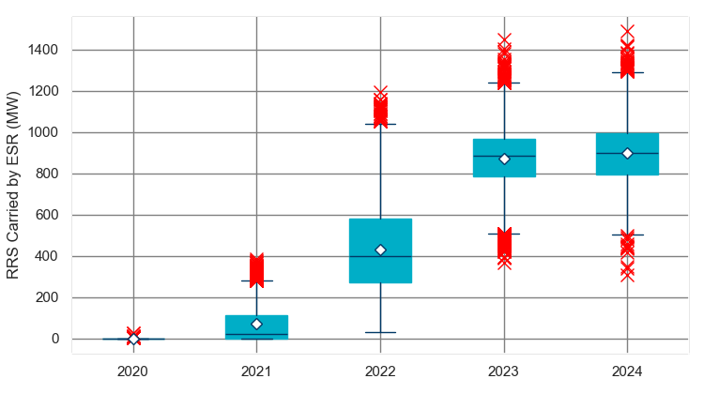
- Figure 12: Boxplot of the RRS Carried by ESR from 2020-2024.
The above considerations lead to a minimum inertia that is always on-line of about 12+0+35=47 GW*s. Assuming that trends from the recent low inertia instances from 2023 and 2024 prevail, the minimum inertia that is always on-line could be slightly higher: 12+0+42=54 GW*s which can be seen in Figure 13.

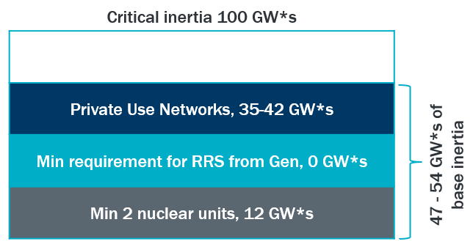
Figure 13: Base-level inertia based on historic data 2013-2017

Next step is to understand how much load can be supplied by generation that is always on-line. Currently, 1,185 MW of RRS is required to be provided by using PFR (based on 2024 RRS requirements at night time during the months of January through April). On average about 200 MW of this is provided by hydro units. Thermal resources cannot offer more than 20% of their generator capacity towards RRS and non-Thermal Resources can offer up to 100% of their capacity as RRS. Further, increasingly larger volumes of RRS-PFR is being provided by ESRs as seen in Figure 11. During the hundred lowest inertia hours in each year of 2023 and 2024, there were instances where 0 MW of RRS was carried on thermal resources. Given that installed capacity of ESRs is expected to increase for the purpose of this analysis, it is assumed that no RRS-PFR MW will come from thermal resources during periods with high renewable low load.
An additional analysis was conducted to assess inertia and resource commitment trends as ESR penetration in the Ancillary Services (AS) market has increased. Considering data from 2022 through October 2024, ERCOT calculated the hourly inertia contribution from Thermal and CC resources with AS Responsibilities. As shown in Figure 14, the yearly average inertia contributions from AS providers have declined from 2022 to 2024, while the yearly average system inertia has remained relatively constant. This means that even thermal resources have stayed online during lower net load periods for reasons other than providing AS. This trend is likely the result of increasing net load, renewable generation curtailments due to transmission constraints and lower gas prices and can be expected to continue in the near future. During the two hundred lowest inertia hours in 2023 and 2024, non-PUN, non-RRS carrying thermals generated a minimum of 4,348 MW and contributed 53.85 GW*s of inertia. And if only thermals that were carrying ECRS and Non-Spin are considered during these lowest inertia periods, thermals generated a minimum of 3,196 MW and contributed 39.37 GW*s of inertia.
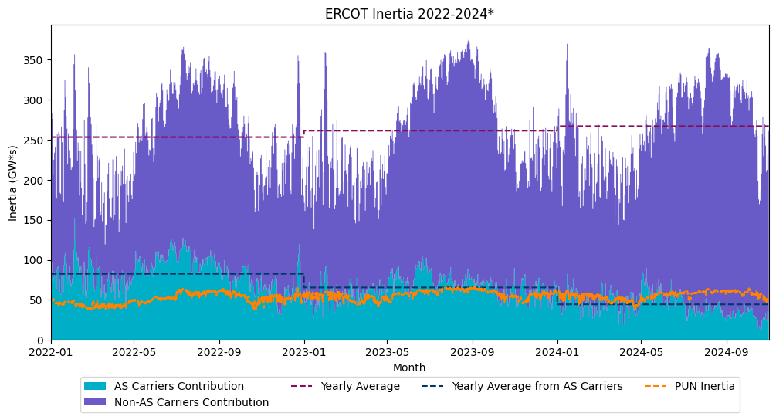
Figure 14: Inertia Contributions from Ancillary Service (AS) Carriers

With two nuclear units producing 2,575 MW combined, about 2,575 + 0 + 3,196 MW = 5,771 MW of net load can be supplied by generation that is already on-line for the provision of other AS , as well as nuclear generation. Any additional net load above 5,771 MW will require additional conventional generation to be committed.
ERCOT currently estimates that by the end of 2027, there will be approximately 44.7 GW of installed wind capacity and 64.0 GW of installed solar capacity. Based on this projection, future wind profiles, and the long-term load forecast, the minimum net load in 2027 is estimated to be around 8.7 GW. Net load is evaluated only for the days in shoulder seasons, when wind generation is consistently high throughout the day and produces above 50% of installed capacity all day long. During these days, it is likely there will be low system inertia at night. This net load of 8.7 GW would require at least additional 2.9 GW (8.7 GW – 5.771 GW = 2.9 GW) of conventional generation to be brought on-line.
Summarizing the analysis above, with 44.7 GW of installed wind generation and 64.0 GW of solar generation by the end of 2027, ERCOT can expect synchronous inertia to be from 96 GW*s (12+35+9.66=96) to 108 (12+42+14.64=108) GW*s during high renewable and low load conditions.
It should be noted that this analysis is based on conservative assumptions and is subject to uncertainties such as changes in PUN behavior or changes in the mix of Resources providing RRS and other AS. Further ERCOT expects transmission improvement projects such as the additional six synchronous condensers were approved and are expected to be implemented by 2027 and the advanced grid support requirements for Inverter-Based ESRs that is being discussed in the Stakeholder process under NOGRR272, to impact inertia and improve system stability during high renewable low load periods. Taking impact of these in account as the effort mature further will also be important in informing in this inertia trending analysis. ERCOT therefore will continue detailed inertia trending and analysis in the future.

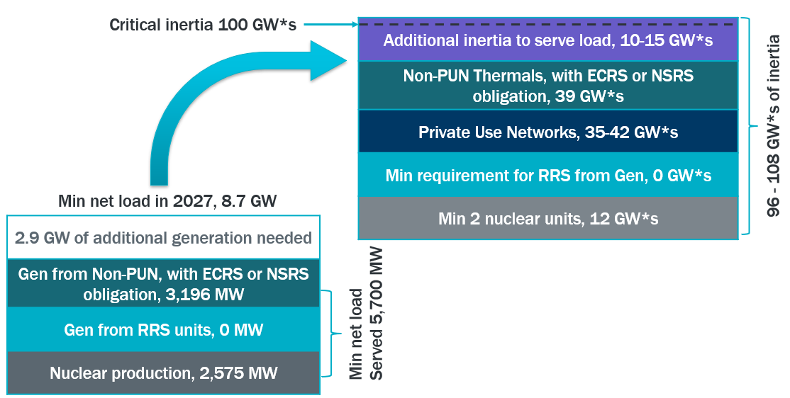
Figure 154: Base-level inertia based on historic data 2013-2017

Impact of Parameter Changes on Critical Inertia

ERCOT’s Critical Inertia is sensitive to parameters, such as the response characteristics of the LRs that provide RRS, UFLS settings, and the size of the critical contingency. By changing one or more of these parameters, Critical Inertia may be reduced. ERCOT has assessed the impacts of the following parameter changes; the impacts of each are discussed below.
- “Faster” frequency response for Load Resource providing RRS
- “Earlier” frequency response (FFR) from Load Resources providing RRS
- Lower UFLS trigger
- Reduction of Resource Contingency and FFR
“Faster” Frequency Response
Currently, full response from Load Resources is provided within 0.416 seconds after frequency reaches 59.7 Hz. ERCOT conducted studies to test the impact obtaining full response from Load Resources in 15 cycles rather than 25 cycles; other parameters in the studies were same as the ones used in typical RRS determination studies. In this scenario, Critical Inertia was reduced from 99 GW*s to 73 GW*s, as seen in Figure 16.

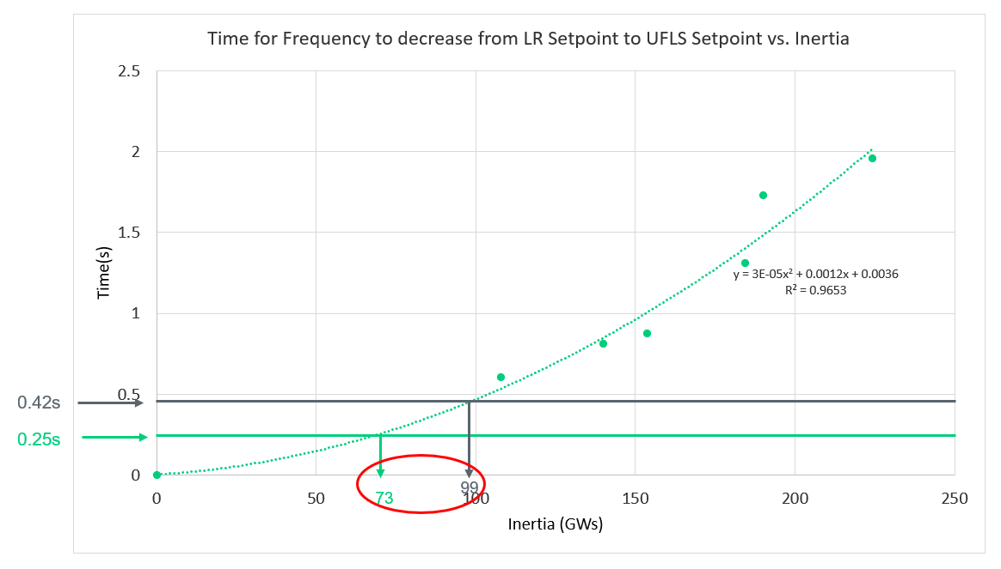
Figure 16: Time for the frequency to decrease from LR setting to UFLS setting versus inertia and the impact on Critical Inertia of shortening LR response time
“Earlier” Frequency Response
ERCOT’s Load Resources (LR) are currently triggered at 59.7Hz with a delay that is less than 50 ms. Under low inertia conditions, where frequency declines drastically for a loss of generation event, having resources that can provide earlier frequency response (at higher frequency set-point) will slow down the frequency decline and allow more time for the existing LR fleet providing RRS to respond, thus impacting Critical Inertia. ERCOT conducted studies to test the impact of having up to 450 MW of fast frequency response (FFR) triggered at 59.85 Hz with a delay time of 10 cycles. With 450 MW of FFR, Critical Inertia was reduced to 87 GW*s. Figure 17 summarizes the impact on Critical Inertia with different amount of FFR triggered.

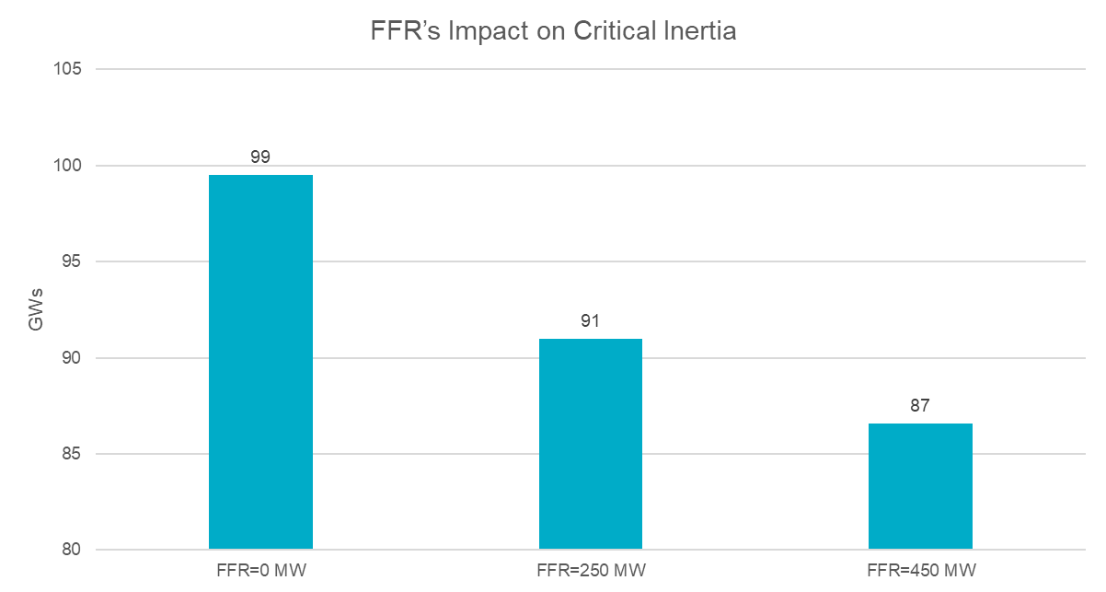
Figure 17: Critical Inertia w/ FFR
Lower UFLS Settings
ERCOT Nodal Operating Guides Section 2.6.1 prescribes Transmission Service Providers’ responsibilities for providing ERCOT’s UFLS. Under current rules, 5% of the Load on the ERCOT System would be shed if frequency reaches 59.3 Hz; an additional 10% of the System would shed at 58.9 Hz; and an additional 10% would be shed at 58.5 Hz.
ERCOT conducted studies to investigate the impact from changing the first stage of UFLS from 59.3 Hz to 59.1 Hz. In this scenario, as can be seen in Figure 18, Critical Inertia reduces from 99 GW*s to 75 GW*s.
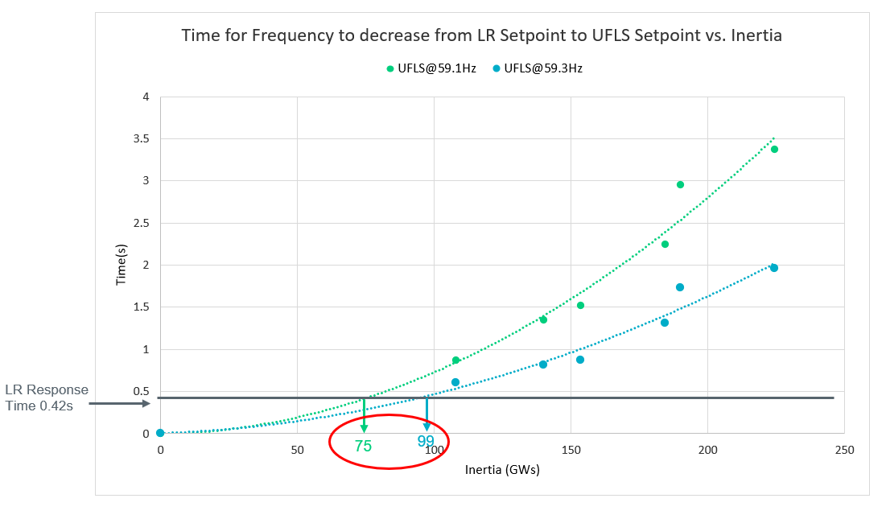
Figure 18: Time for the frequency to decrease from LR setting to UFLS setting vs Inertia and impact on Critical Inertia from lowering UFLS trigger from 59.3 Hz to 59.1 Hz
Table 4 summarizes the impacts of lowering the UFLS trigger and/or shortening the response time for Load Resources providing RRS on Critical Inertia.

Table 4: Impact on Critical Inertia from lowering UFLS trigger and/or shortening response times for LR
 | UFLS @59.3Hz | UFLS @59.1Hz
0.42s LR Response Time | 99 GW*s | 75 GW*s
0.25s LR Response Time | 73 GW*s | 57 GW*s
Reduction of largest possible loss of generation and Available FFR
The Resource Contingency Criteria (RCC) for ERCOT, as defined in the NERC BAL-003 standard, is the simultaneous loss of the two largest units on the system, currently the two South Texas Nuclear Project units totaling 2,805 MW.
ERCOT has conducted sensitivity studies to assess the impact of changing the RCC and the amount of available FFR on Critical Inertia. Figure 19 illustrates the Critical Inertia under a series of scenarios with various generation losses and FFR levels.

Figure 19: Critical Inertia at Resource Contingencies of different sizes from 2,000 to 2,805 MW and FFR of different levels from 0 to 450 MW

International Review of Inertia Related Challenges and Mitigation Measures

This section has not been updated under the current revision and will revised in Q1, 2025.

Other bulk power systems in the world are experiencing challenges associated with changes in their resource mix that are similar to ERCOT’s. Table 5 lists some relevant parameters of the systems currently facing low inertia issues. Note that the Hydro Quebec and Nordic (Sweden, Norway, Finland, and part of Denmark) systems do not have particularly high capacity from non-synchronous generation (wind and solar). However, these systems are notable for having large amounts of hydroelectric generation, which means that inertia is relatively low (see Table 1) and primary frequency response is relatively slow. The size of the system’s RCC with respect to the system size (i.e., minimum inertia level) is also an important factor, which indicates that the South Australia system is at the forefront of this problem at the moment.

Table 5: Countries experiencing low inertia challenges
System | Ireland | UK | Nordic | Quebec | South Australia
Peak Demand, GW | 6.4 | 53 | 70 | 39 | 3
Capacity from Wind and Solar | 4 GW | >26 GW | 10% | 7% | 35%
Minimum Inertia, GW*s | 20 | 135 | 125 | 60 | 2
Resource Contingency Criteria, MW | 500 | 1000 | 1450 | 1700 | 650
Issues | Lack of synchronizing torque, at RoCoF ≥0.5 Hz/s significant amounts of non-synchronous generation will trip | At RoCoF of 0.125 Hz/s some non-synchronous generation will trip; at 1 Hz/s all non-synchronous generation will trip | Slow PFR (hydro), time to UFLS is a concern | Low inertia (hydro), high RCC, slow PFR (hydro), time to UFLS is a concern | High (1-3 Hz/s) RoCoF after RCC, at which synchronous generation may trip and UFLS may malfunction

Table 6 lists different measures used by these systems to reduce Critical Inertia and/or keep inertia above critical levels. All of the systems monitor both inertia and the largest possible contingency in Real-Time. Ireland and the UK additionally forecast inertia from the Day-Ahead into Real-Time, similarly to ERCOT, as described in Section 7 above.

Table 6: Mitigation measures to reduce Critical Inertia and to keep inertia above critical level
 | Ireland | UK | Nordic | Quebec | South Australia | ERCOT
Monitor inertia & possible contingencies in Real-Time | ✓ | ✓ | ✓ | ✓ | ✓ | ✓
Forecasts Inertia from DA into Real-Time | ✓ | ✓ |  |  |  | ✓
Dynamic Assessment of Reserves based on inertia conditions and largest resource contingency |  | ✓ |  |  |  | ✓
Limit RCC based on inertia conditions | ✓ | ✓ |  | ✓ | ✓
Synchronous Condensers (for inertia) | ✓ | ✓ |  |  | ✓  (particularly looking at high inertia SCs)
Enforce minimum inertia limit | ✓ | ✓ |  |  | ✓  (for minimum inertia req.) | ✓
Inertia market/auction/service inertia | ✓ |  |  |  | ✓ (for above minimum inertia levels)
Faster Responding Reserves | FFR | Enhanced Frequency Response Service |  | Synthetic inertia from wind | “Contingency” FFR (frequency trigger) and “Emergency” FFR (direct event detection) | Load Resources providing RRS
Note: Planned mitigation measures are shown in blue, while already-existing mitigation measures are shown in black.

Synthetic inertia provision from wind generation, listed in Table 6 under fast-responding reserves for Hydro Quebec, is a capability that is enabled on Type 3 and Type 4 wind generation resources. In this construct, when a wind turbine plant controller senses a drop in system frequency, it extracts kinetic energy from the rotating mass of the wind turbine — hence the term “synthetic inertia” — which is seen from the grid as an increase in active power injection. Following initial active power injections, there is a recovery phase in which active power production from a wind turbine may decrease to below pre-disturbance level. In some scenarios the recovery phase may have an adverse impact on system frequency recovery. The effectiveness of the response and the recovery of the wind generation resource to its pre-disturbance state depends on the operating conditions of a wind generation resource. Therefore, this type of fast frequency response requires careful, centralized coordination to ensure reliable system operation. While synthetic inertial response capability is already included as a part of interconnection requirements in Hydro Quebec, this technique has not yet been commercially implemented at a large scale.

Conclusions and Summary

This paper presents basic concepts about synchronous inertia, examines the impacts of diminishing inertia on the ERCOT grid, and tracks historic trends, current monitoring tools, and options for maintaining inertia above the critical level. The intent is to demonstrate how changes to various frequency control parameters — such as shortening the time allowed for frequency response, raising the frequency response trigger point, lowering UFLS settings, and decreasing the size of largest contingency — can lower and thus improve the critical inertia level. The international review has shown that some of these measures are being implemented in other systems with characteristics similar to the ERCOT grid. Other systems are beginning to address low inertia challenges through emerging technologies, including the use of synthetic inertia capability from wind generation resources and installing high inertia synchronous condensers. Each of these mitigation measures is likely to have its own pros and cons, which will be analyzed in future studies and analyses along with exploring ideas of creating a market for inertial response, possibly similar to the 2015 proposed outline. ERCOT will continue working with its stakeholders to develop reliable, efficient, and, where possible, market-based solutions to address low inertia issues.

References

Eto, Joseph H. "Use of frequency response metrics to assess the planning and operating requirements for reliable integration of variable renewable generation." Lawrence Berkeley National Laboratory (2011).

Essential Reliability Services Task Force (ERSTF) and Essential Reliability Services Working Group, NERC, 2014-2016.

Prabha Kundur, Power Systems Stability and Control, McGraw Hill, 1993.

ENSTO-E Report, “Future System Inertia”, project report by Nordic Transmission System Operators.

Appendix

Figures 20-24 illustrate inertia by unit fuel type based on historic data from 2019 through 2023. As shown in Figures 20-21, the inertia contribution from coal units has dropped since 2019; although this drop has been offset by increases in inertia provided by Gas Steam and Simple Cycle Combustion Turbine. Gas steam units account for only a small portion of system inertia, as shown in Figure 22. Inertia provided by Simple Cycle Combustion Turbine units (Figure 23) and Private Use Network units (Figure 24) has increased since 2019.
Based on 2019-2023 data, the contribution to inertia from PUNs consistently remained above 30 GW*s, except during winter storm Uri in 2021 (Figure 24). The steady system inertia level provided by PUNs can be explained by the steadiness of steam demand at the PUN sites, while the upward trend is likely the result of lower natural gas prices.

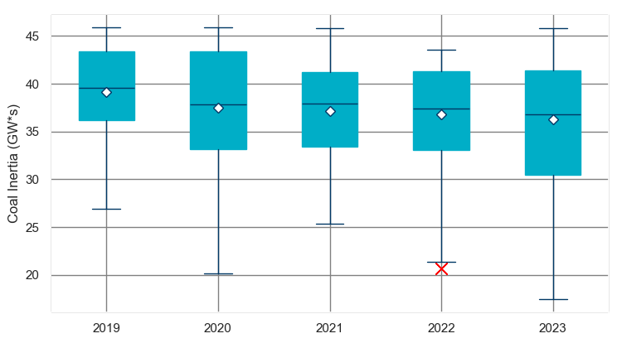
Figure 20: Boxplot of the inertia by Coal units 2019-2023
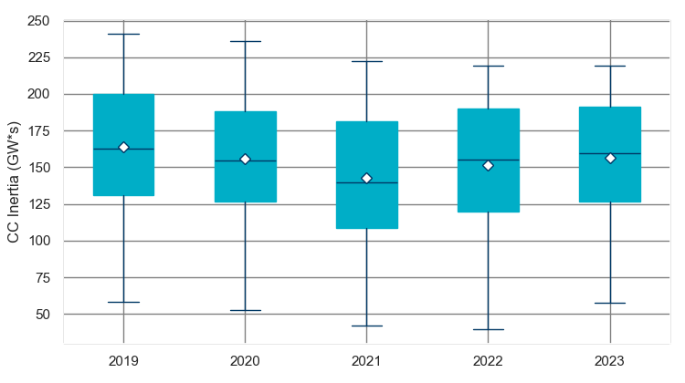
Figure 21: Boxplot of the inertia by Combined Cycle units 2019-2023

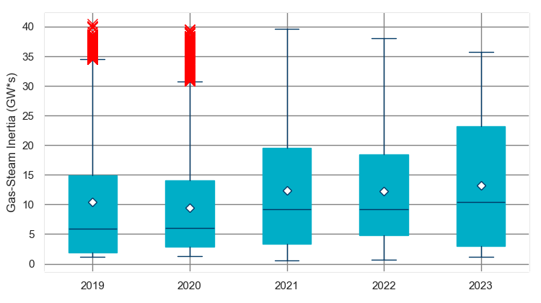
Figure 22: Boxplot of the inertia by Gas Steam units 2019-2023
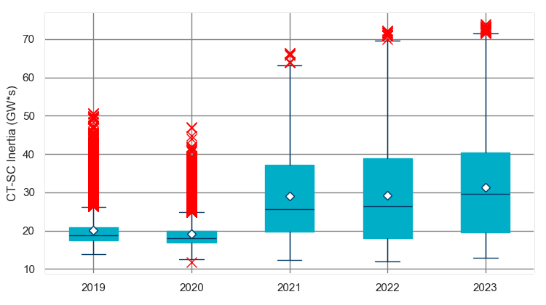
Figure 23: Boxplot of the inertia by Combustion Turbines (Simple Cycle) 2019-2023

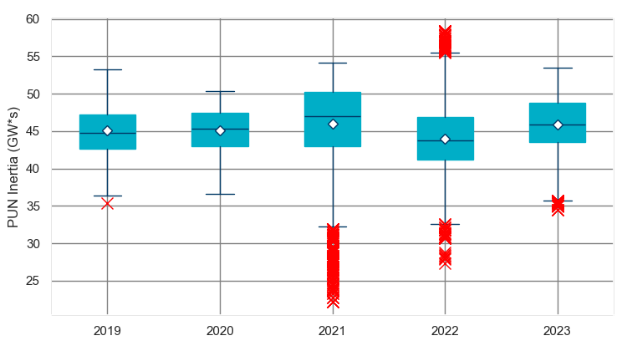
Figure 24: Boxplot of the inertia from PUNs 2019-2023

For some types of load (e.g., motor load) MW consumption will change depending on system frequency. Load damping constant is used to represent percentage change in total system load in response to frequency change. Load damping constant can be estimated based on historic frequency events.
The kinetic energy of a synchronous machine rotating at its rated speed can be normalized (divided) by an arbitrary MVA base, typically set equal to the machine nameplate rating. The normalized value is referred to as inertia constant H in seconds. Conversely, by multiplying H by the MVA base we obtain the kinetic energy of the synchronous machine rotating at its nominal speed.
MVA base is used to normalize kinetic energy (in MW*s) of a synchronous machine rotating at rated speed. Kinetic energy normalized by MVA base is called inertia constant H. MVA base is typically assumed equal to machine nameplate rating.
On each box, the central mark is the median; the edges of the box (in blue) are the 25th and 75th percentiles; the whiskers correspond to +/- 2.7 sigma (i.e., representing 99.3% coverage, assuming the data are normally distributed);. If necessary, the whiskers can be adjusted to show a different coverage.
MW*s (or converted to GW*s) is an industry standard way of expressing the amount of stored kinetic energy on a system. Inertia constant H multiplied by the machine’s MVA base is the machine’s inertial response in energy terms. For example, a 200 MVA generation unit with an inertia constant of 3 seconds would use up all of its kinetic energy in 3 seconds if producing at full output.
Pursuant to ERCOT Nodal Operating Guides Section 2.3.1.2 (6), Load Resources’ under-frequency relays must be set no lower than 59.7 Hz. Some RRS participants choose higher thresholds.
The ERSWG has a multi-faceted purpose that includes developing a technical foundation of ERS; educating and informing industry, regulators, and the public about ERS; developing an approach for tracking and trending ERS; formulating recommendations to ensure the complete suite of ERS is provided and available. The ERSWG reconciled a collection of analytical approaches and Measures for understanding potential reliability impacts as a result of increasing variable resources and how those impacts can affect system configuration, composition, operation and the need for increased ERS.
RRS portion provided by generation may change in the future with implementation of Nodal Protocols Revision Request 815 (NPRR815) that increased Load Resource participation limit up to 60% of total RRS requirement (previously the limit was 50%).
Based on 2016 data.
Based on ERCOT’s Resource Capacity Trend Charts for July 2024.
Based on ERCOT’s Resource Capacity Trend Charts for July 2024.
Pursuant to Nodal Operating Guide Section 2.3.1.2 (6), the UFR must have a delay of no more than 20 cycles (or 0.33 seconds for relays that do not count cycles). Total time from the time frequency first decays to a value low enough to initiate action of the under-frequency relay(s) to the time Load is interrupted should be no more than 30 cycles (0.5 seconds), including all relay and breaker operating times. The “0.416 seconds” reference is based on historical performance.
Under lowest inertia conditions (~108,000 MW*s), 370 MW of generation loss is adequate to trigger frequency response at 59.85 Hz with 15 cycles response time. Studies shows that at up to 450 MW of such frequency response can be retained; beyond 450 MW, post trigger frequency overshoot exceeds 60.09 Hz (ERCOT’s current Balancing Area Alarming Limit (BAAL) per NERC BAL-001).
Early on the UK and Ireland enforced the use of loss of mains protection at non-synchronous generation plants in their distribution networks. The protection would trip wind or solar generation once a particular RoCoF was detected (0.125 Hz/s in the UK and 0.5 Hz/s in Ireland). This is because high RoCoF was historically used as an indication of an island forming in the distribution grid. As these systems saw more non-synchronous generation installed, system inertia declined and system-wide RoCoF increased after a large generation loss to a point where 0.125 Hz/s (or 0.5 Hz/s in Ireland) RoCoF was no longer exclusively an indicator of an island in a distribution system. With RoCoF protection still in place at non-synchronous generation plants, this may potentially trip large amounts of non-synchronous generation, further worsening the conditions on already perturbed system. The UK system has increased the trigger on loss of mains protection from 0.125 Hz/s to 1 Hz/s for all resources installed after April 2014.
Type 3 refers to variable speed wind generator with partial-scale frequency converter. Type 4 refers to variable speed wind generator with full-scale frequency converter. For additional information about various wind turbine types see for example http://www.site.uottawa.ca/~rhabash/ELG4126WindGenerators.pdf
PUN generation in ERCOT is mainly comprised of Combined Cycle, Combustion Turbine Simple Cycle, and Gas Steam units.

